Name
Role
Place of Work
Sector
Line Manager
Local Authority
GTCS Number

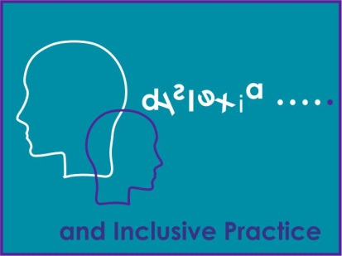

Module 2 – ‘Supporting Literacy, Dyslexia and Inclusive Practice’

Reflective Log

Module 2 Reflective Log
As you work through this course, what you write in this log forms an important part of the learning process. You will want to revisit the log regularly and you may want to look at it again after you’ve completed the course or use it as evidence of what you’ve achieved and of your development. You will be able to use the information in this log as evidence of your professional development, reflective practice and critical self-evaluation, all of which contribute towards your GTC Scotland professional update. Combined with your Module 1 reflective log, this log will also support your completion of the 3 online modules, the third of which could be used to support an application for Professional Recognition.
Make sure that you save this Reflective Log after you start to fill it in. Use a filename like ‘Supporting Dyslexia and Inclusive Practice’ so that it’s easy to find. The next time you are prompted to add to the log, you should open the file you saved and add the new material to it.
Tables have been included with the activities to support your written answers; however, you can adapt this log and present your reflections of the question in alternative ways to suit your needs.

Activity 1.
Use the tables below to write and complete the Self-evaluation Wheel: Professional Actions in Career –Long Professional Learning
(You can also download this template as an individual file or complete it within this log).

1 | - The professional actions you took following the completion of module 1  - What learning stands out  - Any reflections following the completion of module 1
2 | What you hope to achieve in studying this module.

3. Self-evaluation Wheel: Professional Actions in Career –Long Professional Learning
Self-evaluation should support you to:
- Reflect on what you have done
- Think about what you might do next
- Consider your own progress and development
- Deeply understand your professional practice, your professional learning and the impact of this on your thinking, professional actions, those you work with/support and the pupils and their learning
The Self-Evaluation Wheel is a valuable tool for:
- Exploring current reality,
- Support self-evaluation
- Helping to critically reflect on yourself as a professional and your practice
- Perform a simple gap analysis - for example where are you now and where would you like to be?

The example below highlights how to use the self- evaluation wheel.
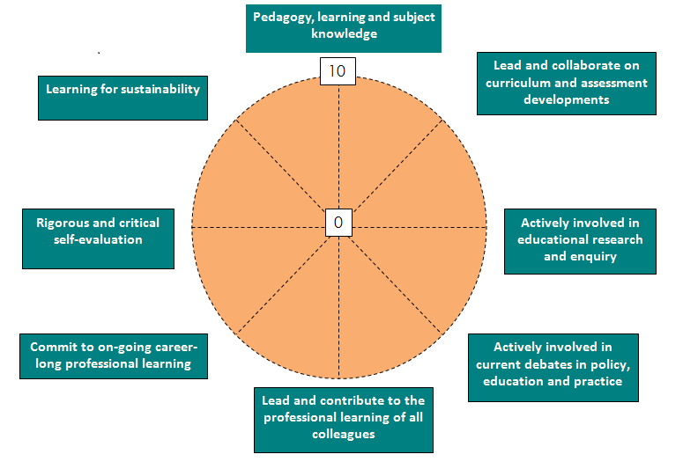
Using the wheel:
- Consider each point on the wheel in turn, (see summary or check with full version of Standard if helpful)
- Think about where you might gauge yourself on the wheel:

0 = really not confident/lots of areas to develop or work on;
10 = feel very confident/accomplished in this area.

Think about ‘why’ you place yourself on that point
- Looking at areas you have identified, what should/could be your next steps to help take PU forward?

Self-evaluation Wheel: Professional Actions in Career –Long Professional Learning (CLPL)

Pedagogy, learning and subject knowledge
Lead and collaborate on curriculum and assessment developments
Actively involved in educational research and enquiry
Actively involved in current debates in policy, education and practice
Lead and contribute to the professional learning of all colleagues
Learning for sustainability
Rigorous and critical self-evaluation
Commit to on-going career-long professional learning
0
10

The Professional Actions in Career-Long Professional Learning - Summary
Pedagogy, Learning and Subject Knowledge
  - demonstrate deep subject knowledge and pedagogical leadership.
  - lead curriculum development with a deep understanding of the place of subject knowledge and the wider purposes of education.
  - demonstrate a critical understanding of approaches to teaching and learning, pedagogy and practice.
  - deploy an enhanced understanding of pedagogy and how constructive relationships with learners can be developed.
  - demonstrate a critical understanding of digital technologies and how these can be used to support learning.
  - understand and develop the most appropriate contexts and environments for learning including outdoor learning, and be able to apply appropriate pedagogies for these environments
Curriculum and Assessment
- understand and apply the principles of curriculum and assessment design to address changing educational needs.
- lead and collaborate with others to plan innovative curricular programmes.
- lead and work with others to ensure effective practice in the assessment of learning, including a deep knowledge and understanding of the policies and practices of assessment as required by awarding bodies
Enquiry and Research
- develop and apply expertise, knowledge and understanding of research and impact on education.
- develop and apply expertise, knowledge, understanding and skills to engage in practitioner enquiry to inform pedagogy, learning and subject knowledge.
- lead and participate in collaborative practitioner enquiry.
Educational contexts and current debates in policy, education and practice
- understand and explore the contexts and complexity in which teachers operate and the dynamic and complex role(s) of professionals within the educational community.
- actively consider and critically question the development(s) of policy in education.
- develop culture where learners meaningfully participate in decisions related to their learning and school.
- develop and apply political literacy and political insight in relation to professional practice, educational change and policy development
Sustaining and Developing Professional Learning
- develop skills of rigorous and critical self-evaluation, reflection and enquiry including how to investigate and evidence impact on learners and professional practice.
- commit to on-going career-long professional learning, including postgraduate study as appropriate.
- lead and contribute to the professional learning of all colleagues, including students and probationers.
Learning for Sustainability
- understand the environmental, social and economic conditions of learners to inform teaching and learning.
- have a critical understanding of and engage with the ways in which natural, social, cultural, political and economic systems function and are interconnected.
- develop the knowledge, skills and practices needed to take decisions which are compatible with a sustainable future in a just and equitable world.
- connect learners to their dependence on the natural world and develop their sense of belonging to both the local and global community
Professional Values and Personal Commitment
- How are the Professional Values reflected in my Professional Actions?
- How have my professional values been developed and informed by knowledge and experience?
- How do I critically reflect on my own assumptions, beliefs and values?
- Who am I as a teacher? What has influenced me? What sustains me?
Social Justice Integrity
Trust and Respect Professional Commitment
For the full version of Standard for Career-long Professional Learning please see General Teaching Council Scotland - www.gtcs.org.uk

As you complete this module consider the following reflective questions highlighted above within GTCS Professional Values and Personal Commitment section which are applicable to all GTCS registered teachers.

Professional Values and Personal Commitment
Social Justice Trust and Respect Professional Commitment Integrity
How are the Professional Values reflected in my Professional Actions?
How have my professional values been developed and informed by knowledge and experience?
How do I critically reflect on my own assumptions, beliefs and values?
Who am I as a teacher?
What has influenced me?
What sustains me?

1. The Scottish context for dyslexia and inclusive practice

Activity 2 - Reflective practice task
Note down some of the factors which you feel contribute towards the complex process of ensuring inclusion and equity for all learners.

Activity 4

Question 1 - Reflective questions for professional dialogue with colleagues
The following questions can be used when engaging in professional dialogue during professional learning opportunities and discussions with colleagues. The outcomes from these discussions can support planning for professional learning opportunities and improvement plans.

Why does inclusion matter?
Colleagues’ response:

How can the legislation and policies within Scottish education be supported into practice?
Colleagues’ response:

Activity 6 notes

Activity 8 Reflective questions for professional dialogue with colleagues
The following questions can be used when engaging in professional dialogue during professional learning opportunities and discussions with colleagues. The outcomes from these discussions can support planning for professional learning opportunities and improvement plans.

How well does inclusive education ensure improved outcomes for children and young people with dyslexia?
Colleagues’ response:

How effectively does the provision of education support and secure improved achievement and attainment for children and young people with dyslexia and with literacy difficulties?

Colleagues’ response:

Activity 8 - Question 2 - Reflections on your practice
Consider how you have supported a learner with dyslexia to raise their attainment
- What have I done?
- How do I know attainment was improved?
- What made the difference?
- How can I build on this learning to support more learners?

What have I done to support a learner with dyslexia to raise their attainment?
How do I know attainment was improved?
What made the difference?
How can I build on this learning to support more learners?

Activity 9
1. Think about the concept of inclusive practice and consider the following questions:
What does inclusive practice mean for you?
What does this mean for your learners?
What have I done to make my teaching practice inclusive?

2. Complete the following table to establish the current practice in your class or department and identify if any actions can be taken to support improvements.

Key features of Dyslexia Friendly schools | In my class/department this means | Actions
Effective leadership and management
Multi-sensory teaching approaches
Effective early identification

Effective transition support

Learner engagement

Parental engagement

Learning and teaching resources which can accessed by dyslexia
learners

Activity 10 notes

Activity 11

Have we successfully established an inclusive school community? How do we know – what is the evidence and impact?
Are all our school policies and planning methods inclusive – do they fulfil the statutory and professional duties?

How do we consult with and involve all stakeholders in the self-evaluation of inclusive practice and support for dyslexia?

Activity 14
Note down other factors which you feel can impact on the development of literacy skills.

Activity 15 Reflective questions for professional dialogue with colleagues
The following questions can be used when engaging in professional dialogue during professional learning opportunities and discussions with colleagues. The outcomes from these discussions can support planning for professional learning opportunities and improvement plans.

How successfully do we use the most appropriate teaching methods to support dyslexic learners in acquiring the tools for reading and developing higher order comprehension skills? How well do we choose suitable tasks, activities and resources?

Colleagues’ response:

Do our teaching staff have the required knowledge and understanding to teach literacy and how do we know?

Colleagues’ response:

Activity 17

Note down your experience of learning about the resources and information on Addressing Dyslexia Toolkit and Education Scotland website
and the impact of them when used with learners.
Home | Addressing Dyslexia
Dyslexia and inclusive practice: An overview | Research | National Improvement Hub (education.gov.scot)
Dyslexia and Inclusive Practice: Professional Learning Resource | Learning resources | National Improvement Hub (education.gov.scot)

Activity 18 Reflective questions for professional dialogue with colleagues
The following questions can be used when engaging in professional dialogue during professional learning opportunities and discussions with colleagues. The outcomes from these discussions can support planning for professional learning opportunities and improvement plans.

Discuss the impact of “responsibility for all”
Is there a connection with inclusion and ‘responsibility for all’?

Activity 20 Reflective questions for professional dialogue with colleagues
The following questions can be used when engaging in professional dialogue during professional learning opportunities and discussions with colleagues. The outcomes from these discussions can support planning for professional learning opportunities and improvement plans.

For those learners with dyslexia, how well is their health and wellbeing and in particular mental, social and emotional wellbeing addressed in your classroom or school?

Colleagues’ response:

How well does your department/faculty or school explore the behaviour of learners? Are potential or unsupported additional support needs such as dyslexia considered to be possible causal factors?

Colleagues’ response:

Activity 21

Note down:

What makes the difference to supporting a learner feel comfortable and confident?
What are the ingredients for supporting wellbeing?

Activity 23

Reading and Writing Circles - Planning Tools

Use one of circle’s planning tool on the next 2 pages to establish the literacy needs of a learner you are working with and develop a plan to support the learner’s literacy needs.

Share this approach and any impact it has with your colleagues and line manager.

Reading Circle Planning Tool
Access the online version of the Reading Circle or the PDF Summary Reading Circle. Use this planning tool to record areas
of strength, difficulties and next steps. The information can be used to evaluate progress within an agreed time scale.
Name |  | Class |  | School |  |  |  | Date
Reading Comprehension: |  | 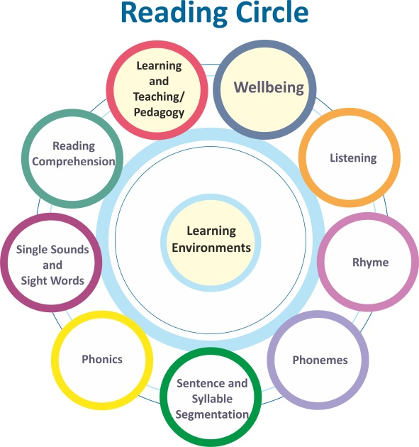 |  |  |  |  | Wellbeing:
Single Sound and Sight Words: |  |  |  |  |  |  | Listening:
Phonics: |  |  |  |  |  |  | Rhyme:
Sentence and Syllable Segmentation: |  |  |  |  |  |  | Phonemes:
Learning Environment:

Next Steps:

Writing Circle Planning Tool
Access the online version of the Writing Circle or the PDF Summary Reading Circle. Use this planning tool to record areas
of strength, difficulties and next steps. The information can be used to evaluate progress within an agreed time scale.
Name |  | Class |  | School |  |  |  | Date
Accurate spelling and Punctuation: |  | 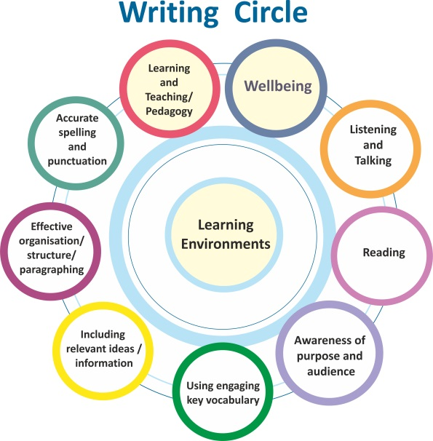 |  |  |  |  | Wellbeing:
Effective Organisation/Structure/Paragraphing: |  |  |  |  |  |  | Listening and Talking:
Including Relevant Ideas /Information: |  |  |  |  |  |  | Reading:
Using Engaging Key Vocabulary: |  |  |  |  |  |  | Awareness of Purpose and Audience:
Learning Environment:

Next Steps:

Activity 25

In your reflective log consider how well do your current transition arrangements ensure a smooth, seamless transfer with particular reference to:

A common understanding of assessment approaches and standards
Planning continuity and progression in learning

Building on children’s and young people’s achievements

Activity 26

Consider how you are able to engage with the 5 roles of support for learning and identify the next steps and areas for improvement.

 |  | Engagement | Next steps | Areas for improvement
1 | Consultancy/consultation
2 | Planning learning and teaching; including co-operative teaching with class teachers
3 | Identification and assessment
4 | Partnership with specialist services
5 | Contributing and supporting professional development

Activity 27

Consider and reflect on how you have communicated the process of identification to:

- Parents
- Learners
- Colleagues

 | Parents | Learners | Colleagues
How did I do it?
What made the difference?
How can I improve the experience for all involved?

Activity 29

‘A Framework for Assessment’
Use the table below to write your reflections and evaluation of the roles and responsibilities in assessment in relation to inclusive practice with regards to the stakeholders and inclusive practice

Stakeholders | My perspective on the roles and responsibilities in assessment and inclusive practice
Learners

Teachers and other practitioners

Parents

Curriculum planners and managers in pre-school, school, community, college and other settings (including head teachers, depute head teachers, faculty heads/principal teachers, curriculum leaders and service managers)

Education authorities

Reflection for improvement

Activity 30

Consider the following questions

What might be the issues that you need to address in planning assessment opportunities, recognising “that learners will progress in different ways” and can “demonstrate their achievement in different ways”?
How will you address the challenges of assessing the broad range of learning across all contexts and settings in which the curriculum is experienced?

Activity 32

Consider your practice and what types of differentiation you have or are currently providing for your learners. This activity can be used to focus on a whole class, small groups or individual learners.

Activity 34

Consider the following 3 questions

What are the most appropriate teaching methods to support our dyslexic learners in reading and do they need alternative resources?
Should teachers in Scotland be required to participate in training to carry out the identification of dyslexia?
What are the approaches used in your school to support learners with literacy difficulties develop their skills and how does the school/ you know they have a positive impact?

Activity 35

The role of a support for learning teacher/pupils support teacher involves contributing towards professional learning within the school community. Further details are available in section 6.

Note any activities and approaches you have tried to support professional learning in your department, faculty or school and any impact they have had. 3 examples are below:

- Engaging in an audit to find out how accessible the curriculum is for learners with dyslexia

- Leading collegiate sessions to share the information gained from module 1 and this module.

- Sharing your local authority guidance/policy on dyslexia and inclusion.

This may be an area which you wish to support and focus on in terms of your own professional development and professional practice and can be discussed with your line manager.

Supporting Professional Learning
Activities and approaches | Audience | Impact

What next?
Activity 36
For the final entry in your Reflective Log for this module consider the following 2 questions.

1. ‘How will the completion of this module impact on your professional practice?

2. Professional Values

- Social Justice
- Trust and Respect
- Professional Commitment
- Integrity

It would be helpful to look back at your responses to the reflective questions at the start of this module and evidence your professional learning and reflections below now that you have completed module 2. If you plan to apply for GTC Scotland Professional Recognition after the completion of Module 3 this task will contribute towards the evidence, you provide in the application process.

Professional Values and Personal Commitment
Social Justice Trust and Respect Professional Commitment Integrity
How are the Professional Values reflected in my Professional Actions?
How have my professional values been developed and informed by knowledge and experience?
How do I critically reflect on my own assumptions, beliefs and values?
Who am I as a teacher?
What has influenced me?
What sustains me?

