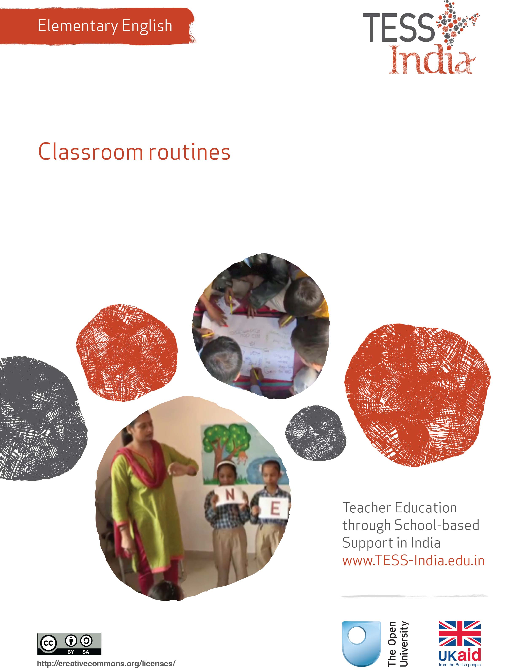
TESS-India (Teacher Education through School-based Support) aims to improve the classroom practices of elementary and secondary teachers in India through the provision of Open Educational Resources (OERs) to support teachers in developing student-centred, participatory approaches. The TESS-India OERs provide teachers with a companion to the school textbook. They offer activities for teachers to try out in their classrooms with their students, together with case studies showing how other teachers have taught the topic and linked resources to support teachers in developing their lesson plans and subject knowledge.
TESS-India OERs have been collaboratively written by Indian and international authors to address Indian curriculum and contexts and are available for online and print use (http://www.tess-india.edu.in/). The OERs are available in several versions, appropriate for each participating Indian state and users are invited to adapt and localise the OERs further to meet local needs and contexts.
TESS-India is led by The Open University UK and funded by UK aid from the UK government.
Video resources
Some of the activities in this unit are accompanied by the following icon: . This indicates that you will find it helpful to view the TESS-India video resources for the specified pedagogic theme.
The TESS-India video resources illustrate key pedagogic techniques in a range of classroom contexts in India. We hope they will inspire you to experiment with similar practices. They are intended to complement and enhance your experience of working through the text-based units, but are not integral to them should you be unable to access them.
TESS-India video resources may be viewed online or downloaded from the TESS-India website, http://www.tess-india.edu.in/). Alternatively, you may have access to these videos on a CD or memory card.

Version 2.0 EE01v2
All India - English
Except for third party materials and otherwise stated, this content is made available under a Creative Commons Attribution-ShareAlike licence: http://creativecommons.org/licenses/by-sa/3.0/

What this unit is about
This unit is about developing your routines for using English in the classroom. The focus is on the key language skills of speaking and listening.
Think of all the things you and your students say, at the start and end of the school day, and in between formal lessons. These moments are all regular opportunities for language teaching and learning.
You are probably the most important source of English for your students, especially if they are not exposed to English in their homes or their community.
Maybe you do not feel 100% confident about your own English. But English is acceptably spoken in a very wide range of accents, and with different levels of competence, everywhere in the world.
Everyone can learn English with encouragement and practice. The activities, case studies and resources in this unit are designed to help you get started to develop routines for using English in your classroom.

What you can learn in this unit
- To increase classroom routines for English speaking and listening.
- To use English language games with your students.
- To practise English at your level.

1 Using teacher talk
You start by thinking about ‘teacher talk’ and how you can use this for English.

Activity 1: ‘Teacher talk’: a planning activity
Have you seen small children play ‘Teacher Teacher’? Maybe you played this game as a child. Students like to imitate the teacher and can learn ‘teacher talk’, or the language of ‘classroom management’, even though no one actually ‘teaches’ them these words and phrases. So whatever you say and do in the classroom, your students will also begin to say and do. You can use this knowledge to generate language practice, spontaneously and with variations.
Read the sentences below in English. Read them aloud, to yourself or with a colleague.
Tick the ones you already use in the classroom with your students.
- ‘Good morning/good afternoon/good evening, students/class.’
- ‘Please sit down/Yes, you may sit down now.’
- ‘Please stand up. Thank you!’
- ‘Please stand up when you speak.’
- ‘Who knows this word?’
- ‘Put your hands up, please! Those who know the answer!/Those who have finished their work! Hands down!’
- Yes, come in, please.’
- ‘Please wait.’
- ‘Let the others speak!’
- ‘One at a time, please.’
- ‘Please come to the board and write the date.’
- ‘Thank you. Please go back to your place now.’
- ‘Open your books/notebooks. Close your books.’
- ‘You may go out.’
- ‘See you tomorrow.’
Are there other words or sentences in English you already use that are not on this list?
Now choose sentences from the list that you have not tried out before. Practise these sentences aloud, at home or with a fellow teacher. See if you can vary or improvise on the sentences.
Gestures will help students understand you. How would you mime sentences such as ‘Open your books’, and ‘Come in’? Practise the gestures as you say the sentences.
When you are confident about a phrase, try using it with your students. Gradually increase the number of English phrases you use with your students each week. Don’t give up if at first they don’t respond to you – by using gestures the students will slowly learn these English phrases.
In Case Study 1, see how a teacher tries to improve his own English so that he can practise along with his students.
Case Study 1: Mr Meganathan practises English
Mr Meganathan teaches all the subjects to his Class III students. They are all first generation students. When Mr Meganathan started his job as a teacher, English was not taught at primary level. But after a few years, the state government decided to introduce English from Class I. All the primary teachers of the state were given five days of training in the methodology of teaching the English language.
Even after the training, I still felt insecure. My own knowledge of English was very limited and I felt uncomfortable speaking English, worrying that I was making mistakes. I decided to listen to English language radio programmes every day. I also asked my wife to converse in English with me every evening, because her English was better than mine.
I also practised speaking simple sentences in English such as ‘How are you?’, ‘My name is Mr Meganathan’, ‘I am a teacher’ and ‘I live in Bangalore’ by recording these sentences on my mobile phone. I would play them back, listen to them and re-record myself to improve further. I must admit, sometimes I felt a bit silly ‘rehearsing’ like this, but I found that it really did improve my English and made me feel more confident.
I prepared a list of everyday classroom instructions with another teacher in school, for example: ‘Sit down now, please’, ‘Everybody up’, ‘Can you come to the board?’, ‘I want you to make two lines’ and ‘Can you make a big circle?’ I practised saying these instructions loudly and clearly at home. I started giving instructions in English in the classroom, speaking slowly and using gestures and actions.
The students responded well. I try not to worry about the mistakes I make or the students make – I don’t want them to be afraid to take part. I know that mistakes happen when we learn anything new. I try to make sure my students feel rewarded for having a go rather than punished for getting it wrong.

Pause for thought
- What were the sources of English for Mr Meganathan?
- What else could Mr Meganathan do to improve his English?
- What do you do to practise English?
- Who can you practise with?
- What sources of English can you listen to regularly?

2 Establishing classroom routines to use more English

Activity 2: Increase your use of English
Think about the activities that you routinely do in the class and what you say to students before, during and after these activities. Rework what you usually say in Hindi or the local language to English.
Make a copy of Table 1 and fill in what you would say on the right-hand side. We have provided one example for you.
Table 1 Increasing your use of English.
Getting ready for a game | ‘Are you ready to start?’
Beginning a lesson
Instructions for using a book
Maintaining discipline
Ending a lesson
Organising students to move
Practise saying these words in English, aloud, slowly and then a bit faster. Work out appropriate gestures or actions for each instruction or comment. Practise with a friend, relative or colleague.
When you feel confident, try out your new English sentences in the classroom. Use gestures, and encourage students to respond in English or in Hindi or in the local language.
Make it a habit to greet students in English, and to give instructions in English for things that you do every day in your classroom.
Teach students to say ‘thank you’, ‘please’ and other polite words for requests by using these words yourself when you speak to them. Also, teach them to say ‘good morning’, ‘sorry’ and ‘excuse me’ to you and to each other; and to use the appropriate expressions for permission to enter, go out or speak – for example, ‘May I …?’ and ‘Can I …?’ Use English to talk about keeping the classroom tidy, or to count the number of students who are present. When you do these things regularly, your own confidence in English will also improve.
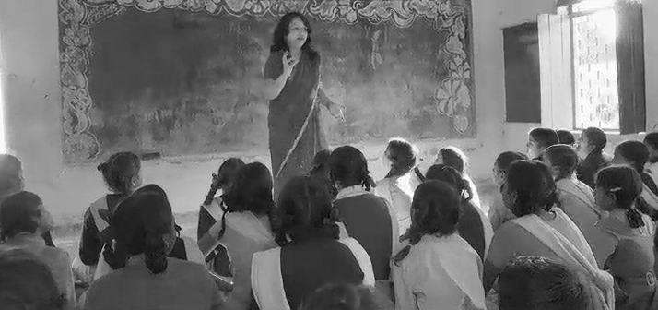
When you evaluate students listening and speaking in English, you may observe that they understand the general meaning without understanding individual words. For example, when you say ‘See you tomorrow’, every day when school time is over, students will pick up this phrase. They may understand that it is a form of saying ‘Goodbye’, because of when you say it, but they will not know the meaning of each word in isolation.
You can note, over time, students who remember words and sentences they have heard repeated or routinely, and students who start to use their learning in new situations. Students who recall ‘See you tomorrow’ will learn the word ‘tomorrow’ and will start to use it in new ways – for instance, ‘Tomorrow I go to the city.’ Or they might say ‘See you’ as a way of saying ‘Goodbye’.
You can assess these informal, unplanned opportunities for spontaneous language practice. Support students’ speaking by encouraging all the efforts that they make to speak English, no matter how small. Try to listen carefully when they speak, and do not interrupt to correct small errors. For evaluation, keep a large notebook with a page or two for each student. Use this to build evidence for records of achievement. Note down which students speak easily and confidently, and which students are still too shy to speak. Give the shy ones more opportunities and encouragement to say something in English, and praise them for doing so.
If you have a large class, you can prepare a simple table of checklists to evaluate the students’ progress.
Table 2 Student progress checklist.
Students’ names | Uses words occasionally | Uses sentences occasionally | Uses words frequently | Uses sentences frequently | Feels too shy to speak
See Resource 1, ‘Talk for learning’ to learn more about the value of classroom routines for speaking and listening.

Activity 3: Record yourself in the classroom
Take your mobile phone into your classroom and record the first ten minutes of a lesson where you normally use English. (It does not have to be a language lesson.)
Listen back to what you recorded two or three times and answer these questions:
- How much English did you speak? What words or phrases did you use?
- Were you surprised at how much English you used? Was it more or less than you predicted?
- Did the students use English in response to you? How did you know that they understood what you said?
- Did you switch to Hindi or a local language during the ten minutes? When did you do this, and why?
- Listen to the sections where you used Hindi or the local language. Can you now think of words and sentences in English that would say the same things? Write these down – use a dictionary if you are not sure about the words, or ask another teacher or friend. Your challenge is to start using these English words in your classroom routines.

3 Language games
One way of introducing routines into the classroom is to use language games. In Case Study 2, a new teacher introduces a language game as a way to improve her and her students’ English speaking and listening.
Case Study 2: Miss Shyamala introduces games in English
Miss Shyamala was a new teacher who was not very confident in English. She also wanted to improve her classroom management skills.
I decided to have a daily listening activity in English, but a fun one. I introduced the game ‘Do What I Say’ [see Resource 2]. It uses simple commands and requires the students to listen carefully and respond to what I say. I started by doing gestures with the words. When students became familiar with the commands, I gradually began to just say the words. It took time to focus the class, and for me to speak clearly.
With this game, I reinforced my role as teacher (giving instructions) and the students’ attention was on following my instructions and listening carefully. They learned the names of simple actions and parts of the body, and they enjoyed the game. I could also feel my own English confidence improving as I practised the instructions.
My class was large, so once I made sure that all students understood the game, I made smaller groups of eight to ten students. In each group one student took the turn of a ‘teacher’ and gave instructions to the rest of the group. I was surprised to see Shekar, who is normally withdrawn, participating with enthusiasm in the game. I realised that we had labelled him a ‘slow learner’. He must have realised that with English all of us were beginners – and this could have given him confidence to participate.
One day after school, I was walking through the village and I saw a group of my students playing ‘Do What I Say’ in English. They were teaching the game to their younger brothers and sisters. But I worried that their pronunciation and vocabulary were not accurate.

Pause for thought
- Miss Shyamala used the game for language teaching. What were the other benefits of the game?
- Are there students like Shekar in your class? Do you think games will give them opportunities to participate?
- What is the significance of her students playing the game after school and teaching it to other children?
- Do you use any games that involve English with your students? If so, is this a regular routine or something you do infrequently?
- What should Miss Shyamala do about her worries?
Students like to play games with words and actions. You can use simple games in the classroom for English language learning. When you do this, your own English skills and confidence will improve.

Activity 4: English language games
Take time to read carefully through the games and activities in Resource 2 and Resource 3. Maybe you can share this reading with a colleague and exchange ideas.
After you have read through them, choose one that you would like to try out in the classroom. Practise the words and phrases with a fellow teacher, or with someone at home. Think about how you would organise the class for the game. Would you play it inside or outside? Would you incorporate home languages into the game?
Try out your chosen game, from Resource 2 or Resource 3, with your students. When they become familiar with one game, you can introduce a new game to practise English. If students like a game, encourage them to play it outside class.
Keep one day of the week for a language game, or play a game twice a month.
For evaluation, note which students are careful listeners, and who can respond with good understanding even if just by shaking their head. Make a note of students who make good guesses, and who try to form their own questions or statements in English.

Video: Talk for learning
http://tinyurl.com/video-talkforlearning

4 Summary
In this unit you have been introduced to active and participatory language learning, for yourself as much as for your students. The focus has been on the key language skills of speaking and listening, reinforced in daily classroom routines.
To learn English well, your students need frequent speaking and listening practice – not just in the language lesson. Try to increase your use of English at different times of the school day. Your classroom routines offer regular opportunities to do this.
Other Elementary English teacher development units on this topic are:
- Using the textbook creatively
- Songs, rhymes and word play
- Learning English in the creative arts
- English and subject content integration
- Community resources for English.

Resources
Resource 1: Talk for learning
Why talk for learning is important
Talk is a part of human development that helps us to think, learn and make sense of the world. People use language as a tool for developing reasoning, knowledge and understanding. Therefore, encouraging students to talk as part of their learning experiences will mean that their educational progress is enhanced. Talking about the ideas being learnt means that:
- those ideas are explored
- reasoning is developed and organised
- as such, students learn more.
In a classroom there are different ways to use student talk, ranging from rote repetition to higher-order discussions.
Traditionally, teacher talk was dominant and was more valued than students’ talk or knowledge. However, using talk for learning involves planning lessons so that students can talk more and learn more in a way that makes connections with their prior experience. It is much more than a question and answer session between the teacher and their students, in that the students’ own language, ideas, reasoning and interests are given more time. Most of us want to talk to someone about a difficult issue or in order to find out something, and teachers can build on this instinct with well-planned activities.
Planning talk for learning activities in the classroom
Planning talking activities is not just for literacy and vocabulary lessons; it is also part of planning mathematics and science work and other topics. It can be planned into whole class, pair or groupwork, outdoor activities, role play-based activities, writing, reading, practical investigations, and creative work.
Even young students with limited literacy and numeracy skills can demonstrate higher-order thinking skills if the task is designed to build on their prior experience and is enjoyable. For example, students can make predictions about a story, an animal or a shape from photos, drawings or real objects. Students can list suggestions and possible solutions about problems to a puppet or character in a role play.
Plan the lesson around what you want the students to learn and think about, as well as what type of talk you want students to develop. Some types of talk are exploratory, for example: ‘What could happen next?’, ‘Have we seen this before?’, ‘What could this be?’ or ‘Why do you think that is?’ Other types of talk are more analytical, for example weighing up ideas, evidence or suggestions.
Try to make it interesting, enjoyable and possible for all students to participate in dialogue. Students need to be comfortable and feel safe in expressing views and exploring ideas without fear of ridicule or being made to feel they are getting it wrong.
Building on students’ talk
Talk for learning gives teachers opportunities to:
- listen to what students say
- appreciate and build on students’ ideas
- encourage the students to take it further.
Not all responses have to be written or formally assessed, because developing ideas through talk is a valuable part of learning. You should use their experiences and ideas as much as possible to make their learning feel relevant. The best student talk is exploratory, which means that the students explore and challenge one another’s ideas so that they can become confident about their responses. Groups talking together should be encouraged not to just accept an answer, whoever gives it. You can model challenging thinking in a whole class setting through your use of probing questions like ‘Why?’, ‘How did you decide that?’ or ‘Can you see any problems with that solution?’ You can walk around the classroom listening to groups of students and extending their thinking by asking such questions.
Your students will be encouraged if their talk, ideas and experiences are valued and appreciated. Praise your students for their behaviour when talking, listening carefully, questioning one another, and learning not to interrupt. Be aware of members of the class who are marginalised and think about how you can ensure that they are included. It may take some time to establish ways of working that allow all students to participate fully.
Encourage students to ask questions themselves
Develop a climate in your classroom where good challenging questions are asked and where students’ ideas are respected and praised. Students will not ask questions if they are afraid of how they will be received or if they think their ideas are not valued. Inviting students to ask the questions encourages them to show curiosity, asks them to think in a different way about their learning and helps you to understand their point of view.
You could plan some regular group or pair work, or perhaps a ‘student question time’ so that students can raise queries or ask for clarification. You could:
- entitle a section of your lesson ‘Hands up if you have a question’
- put a student in the hot-seat and encourage the other students to question that student as if they were a character, e.g. Pythagoras or Mirabai
- play a ‘Tell Me More’ game in pairs or small groups
- give students a question grid with who/what/where/when/why questions to practise basic enquiry
- give the students some data (such as the data available from the World Data Bank, e.g. the percentage of children in full-time education or exclusive breastfeeding rates for different countries), and ask them to think of questions you could ask about this data
- design a question wall listing the students’ questions of the week.
You may be pleasantly surprised at the level of interest and thinking that you see when students are freer to ask and answer questions that come from them. As students learn how to communicate more clearly and accurately, they not only increase their oral and written vocabulary, but they also develop new knowledge and skills.
Resource 2: Two English language games
You can encourage active listening in English with your students, and prompt them to respond to the English that you use. You can observe how much students understand what you say. Students can also learn by observing their peers. In games, you can use home languages as well as English, to encourage participation.
‘Do What I Say’
The teacher gives instructions orally and the students must listen and do the actions.
Start with simple instructions.
As students make progress, make the game more advanced. You can also adapt the game to different topics.
- ‘Touch your nose.’
- ‘Touch your partner’s back.’
- ‘Hold up five fingers.’
- ‘Point to someone who has long hair.’
- ‘Put your pencil on the floor.’
- ‘Put your pencil under the chair.’
- ‘If you like mangoes, clap your hands.’
- ‘If you don’t like bananas, make a face.’
- ‘If Delhi is capital of India, put up your hands.’
- ‘If plants grow with the help of sunlight, nod your head.’
Some students would copy others, of course, but the point of the game is that everyone is hearing and responding to English. As students do this, they can learn vocabulary for physical descriptions, for positions, likes and dislikes, language for specific subjects, and language for general knowledge.
When you try out this kind of activity in your classroom, make sure that you choose actions and situations appropriate for the students and their level of knowledge. You may demonstrate the actions linked to the English, especially when these are new words, or when the students are having difficulty. Give the students time to listen and respond. They do not need to produce any English – they must only show that they understand you. You and the students can mix English and home languages in the game, to encourage participation.
‘Guess Who’
Divide the class into two groups. Group 1 has to secretly think of a thing or a person; Group 2 has to ask questions to guess who or what is it. Group 1 can only answer only ‘yes’ or ‘no’. As the teacher you must help Group 2 to ask their questions. Prepare for the game in the following way:
Think of six things and people that Group 1 can choose as their secret – these can be familiar to the students, such as a chair, a table, a spoon, a tiffin box, a water bottle or a book. For people, think of professions like postman, driver, cook, teacher, doctor, nurse or policeman/woman. Then think of all the words that could be used to describe these things and people. Next, think of how questions could be asked using these words.
Let Group 1 choose one of the six things or people as their secret. Remind the students in Group 1 that women as well as men can be found in all the occupations. Here are some examples:
- For people (postman, driver, cook, teacher, doctor, nurse or policeman/woman):
- ‘Is it a man or a woman?’
- ‘Does the person wear a uniform?’
- ‘Is the uniform white?’
- ‘Does the person use chalk/a stethoscope/a thermometer/a bicycle?’
- ‘Does the person work in a hospital/school/kitchen/police station?’
- For things (a chair, a table, a spoon, a tiffin box, a water bottle, and a book):
- Size words: ‘Is it big? Is it small?’
- Shape words: ‘Is it round? Is it square? Is it long?’
- Colour words: ‘Is it white? Is it black? Is it coloured?’
- Material words: ‘Is it made of plastic/paper/wood/leather/steel?’
- Used-for words: ‘Is it used for writing/reading/cutting/keeping things?’
- Location words: ‘Is it here in your bag/in this room/in school/in every house?’
Before you play the game in class, most importantly, make time for yourself to practise the words in English. If possible, play ‘Guess Who’ with a fellow teacher, as a partner.
Resource 3: Activities to encourage speaking and listening in English
(This is an extract from Krishna Kumar’s book The Child’s Language and the Teacher.)
These are just some of the dozens of activities any teacher can organise in any ordinary classroom. Each time an activity is repeated with some little change, it will be received with even greater enthusiasm by the children than it got last time. So do each activity any number of times, adding something new each time. Keep a record of the variations so that you can introduce your innovations to a new colleague. Nearly each activity described here can become the starting point of a dozen variations.
1 ‘What Did You See?’
Stage 1: Ask one child to go out of the room, see what is happening outside, and tell the class what he saw. For instance, he might report that he saw a truck, two shops and a bicycle.
Stage 2: Now the rest of the children, preferably sitting in a circle, will ask him questions, one by one, and one question per child. For instance, a child may ask: ‘What was hanging from the bicycle’s handle?’ The reply may be: ‘A basket.’ The next question may be, ‘What colour was the basket?’
Stage 3: When one round of questioning is complete, the teacher will ask the child who has gone out: ‘Who asked the best question?’ Supposing he says, ‘Shashi asked the best question; the teacher will ask: ‘What was the question?’
Stage 4: The next round starts with Shashi. Ask her to see something that the earlier child had not seen. When she comes back, ask children to come up with new questions – not the ones they have already asked.
2 ‘Asking the Explorers’
Send a small group of children, no more than five or six, to study some specific object or place near the school or even inside the school building. For example, they may be sent to examine a cluster of trees, a tea stall, a broken bridge, or a nest. Ask them to explore it carefully and discuss among themselves everything they notice.
While the explorer group is away, tell the rest of the class about the object in some detail. For example, if the explorers have gone to examine a tea stall, tell the class about the things available at the stall, who runs it, where do the things available there come from, etc.
When the explorer group comes back, it will face questions from the class. The teacher can also have her turn. Next time, send a different group.
3 ‘Guess What I Saw’
One child goes out, stands at the door or at some distance from the class, and selects one of the hundreds of things she sees around (it could be anything – tree, leaf, squirrel, bird, wires, pole, grass, stones). When she comes back, she says just one sentence about the thing she has in mind. For example, she might say, ‘What I saw is brown.’
Now every child in the class gets one chance to ask more about the thing and guess what it was. For example, questioning may go like this:
Child 1: ‘Is it thin?’
Answer: ‘No.’
Child 2: ‘How big is it?’
Answer: ‘It’s quite big.’
Child 3: ‘Is it as big as a chair?’
Answer: ‘No, it’s smaller than a chair.’
Child 4: ‘Can it turn?’ …
Finally when the thing has been guessed correctly, some children may object to the answers they got for their questions. For instance, someone may point out that the colour was not brown but clay-like. In such situations, the teacher’s role is very important, as someone who can help children establish subtle distinctions between meanings.
4 ‘Doing What Was Said’
Ask children to listen and do what you tell them to do. Start with simple things to do, and ask the whole class to do them together. Examples:
‘Touch your head.’
‘Close your right eye.’
‘Clap on your head.’
Divide the class in two groups. The teacher will give instructions to the first group, and the children of this group will now give similar instructions to the second group. Gradually make your instructions more complicated, for example:
‘Touch your head with both hands, then touch your right ear with your right hand.’
‘Close both eyes, touch your neighbour, ask him to give you his left hand.’
When children of one group give instructions to the other group, they need not repeat everything they have heard. Encourage them to make up new instructions.
5 ‘Comparing’
Make sets of similar-looking things, such as leaves of two or more trees, flowers of different plants, stones, pieces of paper cut in different shapes, etc.
Ask children to listen to the description you give of one of the things in a set, and on the basis of the description they must decide which one you are thinking of. Example:
‘I’m thinking of a leaf that is smooth and long, and it has even edges.’
After doing this activity a few times, ask children to take turns to choose and describe. Change things each time you do this activity. Identify more subtle features each time.

Additional resources
- Teachers of India classroom resources: http://www.teachersofindia.org/en
- ‘Children talk their way into literacy’ by Gordon Wells: http://people.ucsc.edu/~gwells/Files/Papers_Folder/Talk-Literacy.pdf

References/bibliography
Amritavalli, R. (2007) English in Deprived Circumstances: Maximising Learner Autonomy. Department of Linguistics, The English and Foreign Languages University, University Publishing Online. Foundation Books.
Cummins, J. (undated) ‘BICS and CALP’ (online), Jim Cummins’ Second Language Learning and Literacy Development Web. Available from: http://iteachilearn.org/cummins/bicscalp.html (accessed 2 July 2014).
Cummins, J. (2000) Language, Power, and Pedagogy: Bilingual Children in the Crossfire. Bristol: Multilingual Matters.
Gibbons, P. (2002) Scaffolding Language, Scaffolding Learning: Teaching Second Language Learners in the Mainstream Classroom. Portsmouth, NH: Heinemann.
Krashen, S. (1981) Second Language Acquisition and Second Language Learning. Oxford: Pergamon Press.
Krashen, S. (1982) Principles and Practice in Second Language Acquisition. Oxford: Pergamon Press.
Kumar, K. (1986) The Child's Language and the Teacher: A Handbook. United Nations Children's Fund.
Mohan, B. (1986) Language and Content. Reading, MA: Addison-Wesley.
Mohan, B., Leung, C. and Davison, C. (eds) (2001) English as a Second Language in the Mainstream: Teaching, Learning and Identity. New York, NY: Longman.
Wells, G. (2009) The Meaning Makers: Learning to Talk and Talking to Learn, 2nd edn. Bristol: Multilingual Matters.

Acknowledgements
Except for third party materials and otherwise stated below, this content is made available under a Creative Commons Attribution-ShareAlike licence (http://creativecommons.org/licenses/by-sa/3.0/). The material acknowledged below is Proprietary and used under licence for this project, and not subject to the Creative Commons Licence. This means that this material may only be used unadapted within the TESS-India project and not in any subsequent OER versions. This includes the use of the TESS-India, OU and UKAID logos.
Grateful acknowledgement is made to the following sources for permission to reproduce the material in this unit:
Resource 3: extracts from The Child's Language and the Teacher: A Handbook, Krishna Kumar, United Nations Children's Fund, 1986.
Every effort has been made to contact copyright owners. If any have been inadvertently overlooked the publishers will be pleased to make the necessary arrangements at the first opportunity.
Video (including video stills): thanks are extended to the teacher educators, headteachers, teachers and students across India who worked with The Open University in the productions.

