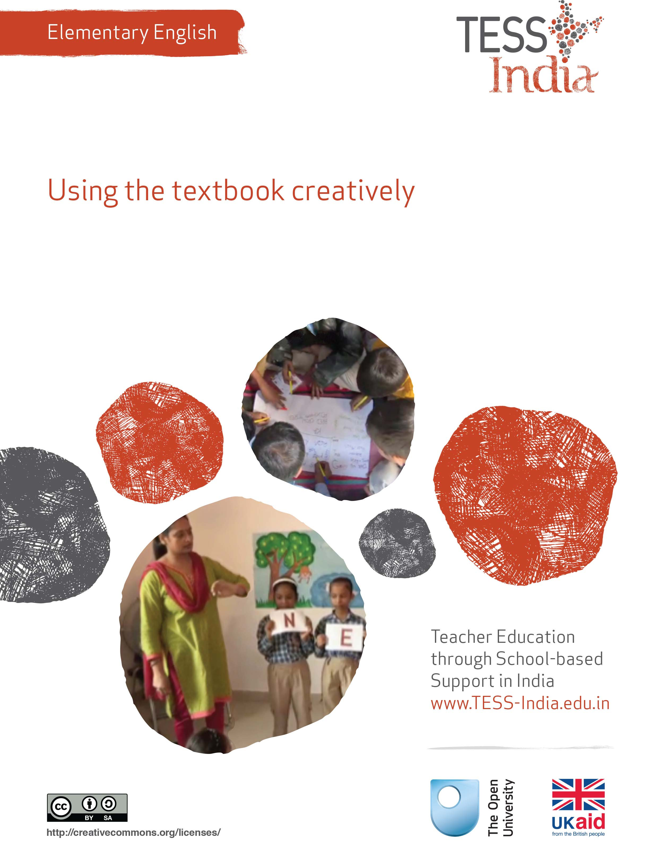
TESS-India (Teacher Education through School-based Support) aims to improve the classroom practices of elementary and secondary teachers in India through the provision of Open Educational Resources (OERs) to support teachers in developing student-centred, participatory approaches. The TESS-India OERs provide teachers with a companion to the school textbook. They offer activities for teachers to try out in their classrooms with their students, together with case studies showing how other teachers have taught the topic and linked resources to support teachers in developing their lesson plans and subject knowledge.
TESS-India OERs have been collaboratively written by Indian and international authors to address Indian curriculum and contexts and are available for online and print use (http://www.tess-india.edu.in/). The OERs are available in several versions, appropriate for each participating Indian state and users are invited to adapt and localise the OERs further to meet local needs and contexts.
TESS-India is led by The Open University UK and funded by UK aid from the UK government.
Video resources
Some of the activities in this unit are accompanied by the following icon: . This indicates that you will find it helpful to view the TESS-India video resources for the specified pedagogic theme.
The TESS-India video resources illustrate key pedagogic techniques in a range of classroom contexts in India. We hope they will inspire you to experiment with similar practices. They are intended to complement and enhance your experience of working through the text-based units, but are not integral to them should you be unable to access them.
TESS-India video resources may be viewed online or downloaded from the TESS-India website, http://www.tess-india.edu.in/). Alternatively, you may have access to these videos on a CD or memory card.

Version 2.0 EE10v1
All India - English
Except for third party materials and otherwise stated, this content is made available under a Creative Commons Attribution-ShareAlike licence: http://creativecommons.org/licenses/by-sa/3.0/

What this unit is about
This unit is about using your textbook as a starting point to develop ongoing additional English language learning in lessons. The textbook is an important resource for you in your lessons. This unit shows you how you can use the textbook flexibly, and build on the ideas in it to make your lessons more interesting and to improve student learning.
To learn English, your students need plenty of speaking and listening practice – not just in the language lesson. Frequent and short listening and speaking activities can supplement your English language lessons and can also improve your own confidence in using English in the classroom.
When you adapt and extend language textbook lessons to your own students, you can encourage them to use English for many different purposes. You also improve your own English confidence and teaching skills. The case studies and activities in this unit are designed to help you plan these opportunities in your classroom.

What you can learn in this unit
- To use the English textbook flexibly for oral work.
- To introduce new English words.
- To relate English lessons to the life of your students.

1 Using the textbook
Short activities done regularly can help you and your students practise English and develop confidence, as the first case study demonstrates.
Case Study 1: Ms Sheela uses textbook lessons to develop language routines
Ms Sheela used her language textbook to reinforce speaking, listening and vocabulary in Class III.
The textbook begins with a story about a baby elephant that likes fruit, and takes away different kinds of fruit from a shop. In the story, he is taught to say ‘please’, ‘thank you’ and ‘sorry’. These words are important in the story. I started to use these words regularly in the class as part of our everyday talk. I encouraged students to use them, and I set the example by using the words myself – even though my accent isn’t perfect.
The textbook also has a poem about the days of the week. I brought a calendar to class and hung it on the wall. I taught the poem, and I also taught the months of the year, which is not in the lesson. Then I started a daily routine where every morning one student gets up to announce the day, date and month at the start of each class: ‘Good morning, class. Today is Monday, October the thirteenth, two thousand and fourteen.’
Now that we have some regular English routines, I have more opportunities to assess students’ English and to improve my own English too.

Pause for thought
- How much extra planning do you think Ms Sheela needs to do, when she extends the textbook lessons in these ways?
- Would Ms Sheela’s routines be effective for all students in the class, regardless of their level of competence? Why or why not?
- What English routines do you have which are outside the language textbook lesson?
- What opportunities do you have to assess students’ spoken English outside the language textbook lesson?
If you give your students plenty of ongoing opportunities to practise English, not just in the language lesson but at other times of the school day, you will have more opportunities to listen, observe and assess them. If students only hear or write English from the textbook lesson, their progress will be slower and you will have fewer opportunities to assess them. In the next activity you will extend the potential of your language textbook for students. This is also an opportunity for you to practise and extend your own use of English.
Listening, observing and assessing students learning English.
Activity 1: Using the textbook − a planning activity
Look at the next lesson or unit in your English textbook that you plan to teach. Answer these questions in your notebook:
- What is this lesson or unit about? How much does the topic relate to the experiences of your students?
- Make a list of the key words and sentences that the students can learn from this lesson.
- What words from this list do your students already know?
- Can you think of times during the school day when you could use these key words or sentences?
- What additional resources or activities could help you extend the use of the key words?
Now choose one or two of the key words or sentences on your list. Use these words or sentences in your everyday classroom routines.
You should practise and do this for at least two weeks. How does this feel to you? Easy or difficult? How do the students respond? Does their use of English improve? How can you tell?
See Resource 1, ‘Using questioning to promote thinking’, to learn more about encouraging all your students to participate and learn.

2 Pictures and words
In Case Study 1, Ms Sheela looked for ways to get the most out of her textbook, picking up on words or sentences that she and the students can continue to use when the language lesson is over. In the next case study, a teacher improvises on a textbook topic, using pictures to develop students’ English speaking and vocabulary.
Case Study 2: Mr Aman uses pictures to develop language
Mr Aman used Class IV students’ existing knowledge about their family to teach English.
Unit 1 in the textbook was about a child and her family. I showed the students the ‘family’ words and pictures in the textbook. We said the words aloud and I wrote them out on the board.
Then I told them to draw pictures of their own father, mother, grandfather, grandmother and so on, and then to label the pictures in English. They began to ask me questions such as:
- ‘Does English not have different names for the father’s mother and the mother’s mother?’
- ‘Is the word for elder sister the same as for younger sister?’
I taught them to say ‘elder sister’ and ‘younger sister’, and ‘mother’s mother’ and ‘father’s mother’, even though these expressions are not in the textbook. Then I demonstrated how to form sentences orally, using the students’ drawings as examples:
This is my mother. This is my elder sister.
This is Rajiv’s father.
This is Amrita’s grandmother, her mother’s mother.
We practised saying these sentences aloud together. It was good practise for my own English.
Later in the week, I extended the lesson. First I had students circle the ‘he’ and ‘she’ words in the textbook. Then I demonstrated aloud, using their pictures, how to add to their first sentences using new vocabulary:
This is my mother. She is pretty.
This is my elder sister. She is tall.
This is my brother. He is crying.
This is Amrita’s grandmother. She is nice.
This is Sushant’s father. He is a farmer.
I put the students in pairs and had them practise sentences with each other, showing their drawings to demonstrate their words. As they did this, I could observe and make notes on their confidence and skills.
Some of my students come from the local orphanage and have no family. I asked them to draw pictures of their friends or other people they know in the village. I did this carefully, without singling them out and making them feel unduly self-conscious. To involve the less confident students, I pointed to their pictures and asked ‘Is this your father? Is this your sister? Is this your friend? Is this the farmer?’ They answered ‘yes’ or ‘no’, or just shook their head, so I could assess their understanding.

Pause for thought
- Looking back at Mr Aman’s account, how many lessons do you think his activities took up?
- Try to write out his lesson plans in note form.

Video: Using pair work
http://tinyurl.com/video-usingpairwork

Activity 2: Using pictures
Using Case Study 2 as an example, plan and teach a lesson where students use pictures to practise English.
Using pictures to practise English.
Take a textbook lesson. The lesson might be about family, animals, food, travel or the environment. It can be a lesson you have already taught, or a new lesson. You may teach this over several lessons.
- Explain the topic, showing students the pictures and practising the vocabulary together.
- Have students make their own pictures and label their pictures in English.
- Teach them to use simple sentences in English, based on their pictures.
How will you assess the students? Will you listen to them as they work? Or will you have them explain their work to you, or perform to the class?
What will you do for students who need additional support? Some students may need extra time to complete the task, or help to overcome shyness to speak. Your plan should be flexible to accommodate these needs. If you have a large or multi-grade class, direct the able or older students to help the younger ones. Organise groups so that you can focus on students who need your attention.

Video: Using groupwork
http://tinyurl.com/video-usinggroupwork
In Case Study 2, Mr Aman improvised from the textbook. In the next case study, the teacher also improvises to use new words in English with her students.
Case Study 3: Ms Trishna and her students use new words
What English words do your students already know, and what English words would they like to learn? Ms Trishna, a Class III teacher in Lucknow, found out.
I was teaching a textbook lesson about ‘A Busy Road’. Before I wrote vocabulary about this topic on the board, I asked students for words they already knew in English. They were giving me words like ‘traffic’, ‘traffic police’, ‘policeman’, ‘cars’, ‘bicycle’, ‘traffic jam’, ‘rush’ and ‘zebra crossing’.
Then one student said ‘shor’ and asked, ‘Ma’am, what is “shor” in English?’ I added a new English word to the class vocabulary: ‘noise’. I tried to reinforce this new word in English by using it at different times of the school day, and in different forms, for example, I would say:
- ‘Can you hear the noise from the street?’
- ‘What a lot of noise!’
- ‘You are very noisy!’
And I also tried to use the opposite word, for example:
- ‘When you are quiet, you can go outside.’

Pause for thought
- Ms Trishna started the lesson with English words her students already knew. Why do you think she started in this way?
- She took time to listen to a student’s question. Do you think this was a good use of her time?
- She tried to use the new English word (‘noise’) in everyday classroom talk, and she tried to use the opposite word (‘quiet’). Can you think of two other opposite words in English that you could use in everyday ‘teacher talk’?

3 Bringing a textbook lesson to life
Language learning is more effective, and memorable, when students can use the language they learn in real-life situations. In the next case study, the teacher goes outside the classroom to help students experience and practise English.
Case Study 4: Mrs Suresh brings a textbook lesson to life
Mrs Suresh teaches English in Class VI in a regional medium school in a deprived locality of Bangalore.
The lesson in the English textbook was on transport. I started by asking the students to list names of vehicles that they know in English. They did this without any problems. The board was filled with the names of a variety of vehicles, including brand names of cars and motorcycles.
I soon learned that only two students had ever travelled on a train, and that none of them had travelled in the recently commissioned Metro. I felt this was unfortunate, since the Metro tracks run right in front of the school building and students see it every day.
I proposed to the headmistress that the school should take the students for a ride in the Metro. The headmistress gained permission for the trip and funding for the tickets from the Block Education Officer.
The week before the journey, I prepared the students with a series of language activities:
- reading bilingual pamphlets in Kannada and in English, listing ‘dos and don’ts’ while travelling on the Metro
- teaching them how to ask for a ticket at the counter in Kannada and in English
- having them practise in English what they might say to fellow passengers, such as ‘Good afternoon’ and ‘This is my class’.
I took 32 very excited students for their first ride on the Metro, accompanied by another teacher. The normally boisterous students were on their best behaviour. They tried hard to use what I had taught them in the English lessons:
- to ask at the ticket counter for a ticket, and the price
- to say ‘thank you’ to the ticket seller and the guard on duty
- to read the billboards on the platform
- to listen to the station announcements in Kannada and in English
- to say ‘Hello’ and ‘How are you?’ to other passengers.
The journey lasted less than an hour but it was a memorable experience.
I felt the trip was well worth the effort that went into organising it, and the amount of English that the students learned exceeded my expectations. The textbook lesson on transport became more relevant.
The journey changed the way that I teach English. Before I teach any lesson from the English textbook, I now look for ways to prepare students for the topic by giving them a personal experience where they can practise reading, speaking and listening to English.

Pause for thought
- On this trip, the students learned English for different purposes. Can you name some of these purposes?
- If you cannot take your class to a Metro station, how could you create these same language activities in the classroom?
Role play and drama are effective ways to practise language for specific purposes. In the example of the Metro, students can take on the roles of ticket sellers, conductors, passengers and shopkeepers. Metro posters, announcements, pamphlets and tickets can be made in English. The classroom can become a Metro station for a day, with students making imaginary journeys between lessons and practising their English for travelling as they go!

Video: Using questioning to promote thinking
http://tinyurl.com/video-usingquestioning

Activity 3: Bring a textbook lesson to life − a planning activity
You can explore real-life connections for your students in every English textbook unit. For example, a unit in a Class IV language textbook is about ‘Going to Buy a Book’. This topic immediately prompts a number of questions and potential activities:
- Who has been to a bookshop, or to a library? What did you see there?
- Would you see other reading materials in English besides books?
- What English words and sentences do we hear in a bookshop or library?
- What English signs and labels would we read?
- How would we speak politely to people in these places?
- What questions would we ask?
- What information would we find?
- Can we make a library or bookshop in our classroom?
- Can we invite someone from a local bookshop or library to talk to the class?
Now turn to the next lesson in your own language textbook.
With a colleague (if possible), think of questions and potential activities – even if you can’t do these activities right away.
List your ideas. Could you try out one of these ideas together? What would you need to do to make it a success?

4 Summary
Your textbook can be a ‘magic box’ for language activities. The textbook is a useful guide and source of ideas, but as the teacher you must build on it. Use the textbook as a resource and a means to learn language, rather than as an end in itself. This way you can adapt the textbook to meet the specific needs of your students. Of course, you can also create a variety of activities based on any story or poem of your choice, a story or poem that students choose, or a local place or local event.
Rehearsal and practice will enable you and your students to get used to the sound of your own voices speaking English often, rather than just occasionally. You might feel a bit feel foolish when you rehearse and practise English, but this can create a vicious cycle of not rehearsing because you feel foolish and then never get any better. We hope this unit has suggested some creative activities to break this cycle.
Other Elementary English teacher development units on this topic are:
- Classroom routines
- Songs, rhymes and word play
- Learning English in the creative arts
- English and subject content integration
- Community resources for English.

Resources
Resource 1: Using questioning to promote thinking
Teachers question their students all the time; questions mean that teachers can help their students to learn, and learn more. On average, a teacher spends one-third of their time questioning students in one study (Hastings, 2003). Of the questions posed, 60 per cent recalled facts and 20 per cent were procedural (Hattie, 2012), with most answers being either right or wrong. But does simply asking questions that are either right or wrong promote learning?
There are many different types of questions that students can be asked. The responses and outcomes that the teacher wants dictates the type of question that the teacher should utilise. Teachers generally ask students questions in order to:
- guide students toward understanding when a new topic or material is introduced
- push students to do a greater share of their thinking
- remediate an error
- stretch students
- check for understanding.
Questioning is generally used to find out what students know, so it is important in assessing their progress. Questions can also be used to inspire, extend students’ thinking skills and develop enquiring minds. They can be divided into two broad categories:
- Lower-order questions, which involve the recall of facts and knowledge previously taught, often involving closed questions (a yes or no answer).
- Higher-order questions, which require more thinking. They may ask the students to put together information previously learnt to form an answer or to support an argument in a logical manner. Higher-order questions are often more open-ended.
Open-ended questions encourage students to think beyond textbook-based, literal answers, thus eliciting a range of responses. They also help the teacher to assess the students’ understanding of content.
Encouraging students to respond
Many teachers allow less than one second before requiring a response to a question and therefore often answer the question themselves or rephrase the question (Hastings, 2003). The students only have time to react – they do not have time to think! If you wait for a few seconds before expecting answers, the students will have time to think. This has a positive effect on students’ achievement. By waiting after posing a question, there is an increase in:
- the length of students’ responses
- the number of students offering responses
- the frequency of students’ questions
- the number of responses from less capable students
- positive interactions between students.
Your response matters
The more positively you receive all answers that are given, the more students will continue to think and try. There are many ways to ensure that wrong answers and misconceptions are corrected, and if one student has the wrong idea, you can be sure that many more have as well. You could try the following:
- Pick out the parts of the answers that are correct and ask the student in a supportive way to think a bit more about their answer. This encourages more active participation and helps your students to learn from their mistakes. The following comment shows how you might respond to an incorrect answer in a supportive way: ‘You were right about evaporation forming clouds, but I think we need to explore a bit more about what you said about rain. Can anyone else offer some ideas?’
- Write on the blackboard all the answers that the students give, and then ask the students to think about them all. What answers do they think are right? What might have led to another answer being given? This gives you an opportunity to understand the way that your students are thinking and also gives your students an unthreatening way to correct any misconceptions that they may have.
Value all responses by listening carefully and asking the student to explain further. If you ask for further explanation for all answers, right or wrong, students will often correct any mistakes for themselves, you will develop a thinking classroom and you will really know what learning your students have done and how to proceed. If wrong answers result in humiliation or punishment, then your students will stop trying for fear of further embarrassment or ridicule.
Improving the quality of responses
It is important that you try to adopt a sequence of questioning that doesn’t end with the right answer. Right answers should be rewarded with follow-up questions that extend the knowledge and provide students with an opportunity to engage with the teacher. You can do this by asking for:
- a how or a why
- another way to answer
- a better word
- evidence to substantiate an answer
- integration of a related skill
- application of the same skill or logic in a new setting.
Helping students to think more deeply about (and therefore improve the quality of) their answer is a crucial part of your role. The following skills will help students achieve more:
- Prompting requires appropriate hints to be given – ones that help students develop and improve their answers. You might first choose to say what is right in the answer and then offer information, further questions and other clues. (‘So what would happen if you added a weight to the end of your paper aeroplane?’)
- Probing is about trying to find out more, helping students to clarify what they are trying to say to improve a disorganised answer or one that is partly right. (‘So what more can you tell me about how this fits together?’)
- Refocusing is about building on correct answers to link students’ knowledge to the knowledge that they have previously learnt. This broadens their understanding. (‘What you have said is correct, but how does it link with what we were looking at last week in our local environment topic?’)
- Sequencing questions means asking questions in an order designed to extend thinking. Questions should lead students to summarise, compare, explain or analyse. Prepare questions that stretch students, but do not challenge them so far that they lose the meaning of the questions. (‘Explain how you overcame your earlier problem. What difference did that make? What do you think you need to tackle next?’)
- Listening enables you to not just look for the answer you are expecting, but to alert you to unusual or innovative answers that you may not have expected. It also shows that you value the students’ thinking and therefore they are more likely to give thoughtful responses. Such answers could highlight misconceptions that need correcting, or they may show a new approach that you had not considered. (‘I hadn’t thought of that. Tell me more about why you think that way.’)
As a teacher, you need to ask questions that inspire and challenge if you are to generate interesting and inventive answers from your students. You need to give them time to think and you will be amazed how much your students know and how well you can help them progress their learning.
Remember, questioning is not about what the teacher knows, but about what the students know. It is important to remember that you should never answer your own questions! After all, if the students know you will give them the answers after a few seconds of silence, what is their incentive to answer?

Additional resources
- Teachers of India classroom resources: http://www.teachersofindia.org/en

References/bibliography
Amritavalli, R. (2007) English in Deprived Circumstances: Maximising Learner Autonomy. Department of Linguistics, The English and Foreign Languages University, University Publishing Online: Foundation Books.
Cummins, J. (undated) ‘BICS and CALP’ (online), Jim Cummins’ Second Language Learning and Literacy Development Web. Available from: http://iteachilearn.org/cummins/bicscalp.html (accessed 2 July 2014).
Cummins, J. (2000) Language, Power, and Pedagogy: Bilingual Children in the Crossfire. Bristol: Multilingual Matters.
Gibbons, P. (2002) Scaffolding Language, Scaffolding Learning: Teaching Second Language Learners in the Mainstream Classroom. Portsmouth: Heinemann.
Hastings, S. (2003) ‘Questioning’, TES Newspaper, 4 July. Available from: http://www.tes.co.uk/article.aspx?storycode=381755 (accessed 22 September 2014).
Hattie, J. (2012) Visible Learning for Teachers: Maximising the Impact on Learning. Abingdon: Routledge.
Krashen, S. (1981) Second Language Acquisition and Second Language Learning. Oxford: Pergamon Press.
Krashen, S. (1982) Principles and Practice in Second Language Acquisition. Oxford: Pergamon Press.
Mohan, B. (1986) Language and Content. Reading, MA: Addison-Wesley.
Mohan, B., Leung, C. and Davison, C. (eds) (2001) English as a Second Language in the Mainstream: Teaching, Learning and Identity. New York, NY: Longman.
Wells, G. (2003) ‘Children talk their way into literacy’, published as ‘Los niños se alfabetizan hablando’ in García, J.R. (ed.) Enseñar a escribir sin prisas … pero con sentido. Sevilla, Spain: Publicaciones MCEP. Available from: http://people.ucsc.edu/~gwells/Files/Papers_Folder/Talk-Literacy.pdf (accessed 8 July 2014).
Wells, G. (2009) The Meaning Makers: Learning to Talk and Talking to Learn, 2nd edn. Bristol: Multilingual Matters.

Acknowledgements
This content is made available under a Creative Commons Attribution-ShareAlike licence (http://creativecommons.org/licenses/by-sa/3.0/), unless identified otherwise. The licence excludes the use of the TESS-India, OU and UKAID logos, which may only be used unadapted within the TESS-India project.
Every effort has been made to contact copyright owners. If any have been inadvertently overlooked the publishers will be pleased to make the necessary arrangements at the first opportunity.
Video (including video stills): thanks are extended to the teacher educators, headteachers, teachers and students across India who worked with The Open University in the productions.

