Inclusive Teaching Practice
Facilitator’s Guide
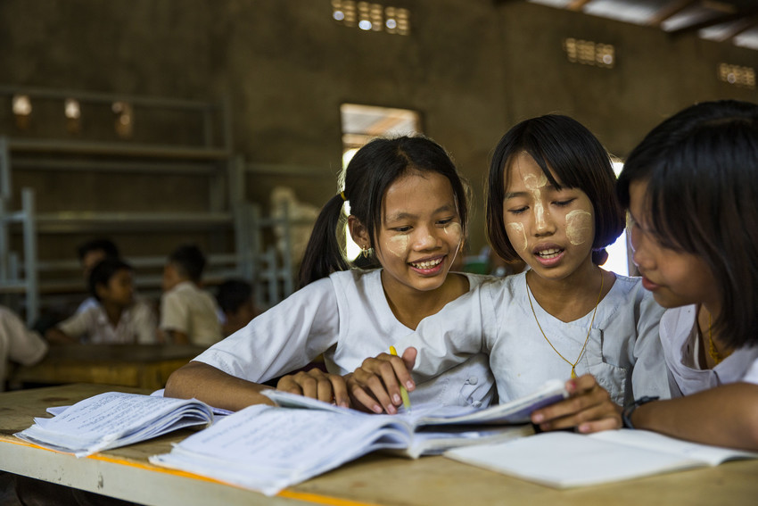
Source: VSO Image library

Module 11:
Supporting all students through differentiation

Module 11: Supporting all students through differentiation

Overview
This is the eleventh of fifteen modules that look at how we create a positive Inclusive Learning Environment for all. You will see how inclusive teaching practices encourage, develop and use the 21st century skills of critical thinking, communication, collaboration and creativity. These modules are for any educators or those studying in education in Myanmar. The terms student and learner are used interchangeably throughout the module.

Module number | Module title
1 | What is an Inclusive School, Classroom and Teacher?
2 | Knowing your learners
3 | Planning learning outcomes for all
4 | Participating through learner centred approaches
5 | Creating a positive learning environment
6 | Effective questioning and feedback
7 | Active participation
8 | Peer, cooperative and collaborative learning
9 | Supporting students’ emotional and social wellbeing
10 | Legal framework and policies around Inclusion in Myanmar
11 | Supporting all students through differentiation
12 | Identifying specific learning difficulties
13 | Supporting all learners with differences or disabilities
14 | Positive behaviour management
15 | Assessment for student achievement

Learning Journal
Please ensure all participants are aware of the learning journal and its purpose for the module. Point them to the advice given in their participants’ copy of the best way to complete. All answers to activities need to be written in their journal. Remember, reflection is an important part of the learning process and a worthy activity alone. Encourage participants to make a note of new and interesting words/phrases/terms as they make their way through the module.

Study tips
It is important to explain how to approach completing the module. Participants need to take their time, develop a suitable timetable and where possible check their answers with colleagues. The use of think / pair / share is a good way for them to collaborate, share ideas, ask questions, check their work, and give feedback.

Background to the Inclusive Practice CPD modules.
There are 3 key themes explored in the modules that reflect the educational reform taking place in all education settings: Inclusion, Gender Equity and 21st century skills. These themes are key in all areas of curriculum, and vital not only for Myanmar’s educational ambitions and sustainable development but equally vital for the global future.
This course has been designed to help participants engage in this discussion by challenging their beliefs and attitudes about their own teaching, their students’ learning and the impact their educational institution has on inclusion. It is expected that as a facilitator, you will challenge their beliefs and attitudes throughout the modules.
It is also important for you as a facilitator to embed many of the teaching and learning techniques associated with inclusion in education into this course. Encourage participants to work at their own pace and consider their own abilities, interests and skills.
The modules look at how we create a positive Inclusive Learning Environment for all. You will see how inclusive teaching practices support gender equity and encourage, develop and use the 21st century skills of critical thinking, communication, collaboration and creativity.
Each module is made up of a series of activities participants can work through at their own pace. Once they have completed the module, they will have a multiple-choice quiz to complete.

Learning outcomes for Module 11
By working through this module, you will be able to:
- Understand how to use differentiation to support Inclusion.
- Understand how to use differentiation strategies, such as graphic organisers, writing frames and other multisensory activities can be used to support learning.
- Adapt lesson plans for your students using differentiation.
- Plan and deliver a multisensory activity to a small group of peers.
- Write lesson plans with differentiated Learning Outcomes

In this eleventh module, continue to encourage the participants to think about what inclusion means to them, why we need inclusion and what the features are of an inclusive educational institution and teacher. The activities in the module will take them approximately 7 hours to complete. This module will help participants think about how they support students through differentiation. The key learning in this module is ensuring that participant’s understand what they can do to adapt the learning process to differentiate the way they present their delivery of learning, the activities they present or the output (what they hope students will achieve or how they will present their learning at the end of a lesson). Their role as an educator will be considerably different to a more traditional style of teaching.

Extra instructions for the activities in module 11
Activity | Additional points to consider
Prior knowledge assessment | The first task is a recap assessment of module 10. This reminds the learner of the previous module contents and helps them to recall important information in preparation for this module. After the first attempt, suggest the learners refer to the module to check their answers. Discuss any ways that the learning from Module 10 has been used to enable students to be more aware of the policies around inclusion. What impact has this had on teaching and learning?
Introduction | Ask participants what they understand around supporting all students’ differentiation. This may be a new concept for the participants and so encourage open questions. Remind them that no thoughts, comments of questions are wrong. Briefly cover the learning outcomes of this module and explain that they will be learning how to adapt lessons, utilise multisensory activities and write lessons plans with differentiated outcomes.
1st Self- assessment | Some participants may need encouragement to be honest in their self-assessment. The results from this self-assessment will be compared to another self-assessment at the end of the module, allowing participants to make comparisons and reflect on their learning.
1.1.1 – Link to previous learning | Ask participants to look at activity 1.1.1. which asks them to match the term to the legal framework about policies around inclusion in Myanmar. This exercise links back to module 10, so encourage participants to look at previous learning.
2 – Differentiation and how it links in with inclusion | Explain that inclusion is about finding and removing barriers to learn. In small groups, ask participants to think about their experience at school and as an educator and list the factors that mean that some students would require differentiated instruction and learning.
Activity 11.2 | In small groups, ask participants to complete differentiation definition (15 minutes) and bring the group to plenary to explore the terms. Then move onto exploring how educators can implement differentiated learning. Highlight that this links back to the importance of knowing your students.
3 – Four ways to differentiate instruction | Explore the four ways to differentiate instruction. Write the terms – content, process, product and environment on piece of paper and ask participants to note them in their learning journals. Explore the diagram as a group, and the importance of reflecting on four ways to differentiate learning. Participants should then read appendix 1 article on differentiation. Participants should discuss learning and reflections with a colleague. Groups could explore one part and present that part back to the rest of the class.
3.1 – Whole class teaching and differentiation | Review the information about whole class teaching and differentiation. Read the case study of teacher Aye Myat Thu and her choral answer approach. Reflect as a group as to why this may not be meeting the needs of all the students.
3.2 Differentiation through content | Reflect on how educators need to consider the objective of the lesson and how to provide students with different adaptions of the content to meet the objective. Explore the case study of Aye Myat Thu and how she adapted her lesson by grouping her students based on ability. One group reviews the previous lesson, group 2 use the new phrase and group 3 have new vocabulary to use. Reflect on why this is a good technique for educators to adopt.
Activity 11.4 – Content who is it for? | Explore activity 11.4 (45 minutes). In small groups, ask participants to read the subheading and match with the corresponding description. Review the answers and ensure that everyone understands the correct responses. Remind participants of Bloom’s taxonomy. Highlight how recalling facts and basic concepts falls lower down the pyramid, and that applying knowledge and creating original work is higher up Bloom’s taxonomy. Emphasise the need for educators to utilise different techniques (pair work, group work etc) with their students based around shared standards and objectives.
Activity 11.5 – video on DARTs | Watch the video as a group and explore DARTs. Ask participants to reflect on strategies that can be used by students. Examples include gap fillings, sequences, grouping, completing tables, label diagrams, predicting what happens next and questions. Complete activity 11.5 and review answers together as a group to address any misconceptions.
3.3 Differentiation through process | Remind participants that we have looked at differentiating the process of learning and how students learn. We refer to this approach as process differentiation. Draw the group together for a discussion about the case study of Aye Myat Thu, specifically the three groups requiring teacher support, working in groups and working independently. Ask participants to reflect on the assessment method that could be used to determine which group students are placed into.
3.3.1 – Process | In a previous module (4) we explored the need for more modern approaches to teaching, specifically learner centred approaches. Look at the images provided and think of specific examples of when educators might use either individual, pair, group or whole class techniques. Bring in the concept of learning styles and explain the role that learning styles plays in the classroom. Ask participants to reflect on how they personally like to learn and highlight the image lifted from activity 2.12 on multi-sensory learning. Now show the videos (30 minutes) on video freeze framing and video hot seating. In small groups, participants should decide on a technique and plan a lesson. Remind them that it would be best practice to plan groups prior to the lesson and that this is linked to the age or grade of students. Once the groups have presented a lesson, ask for feedback from the wider group and encourage discussion. Specifically, participants should think about the advantages and disadvantages of grouping students. They should use their learning journals to note down any techniques or reflections for differentiation that they would like to use in their classrooms.
3.4 – Differentiation though products | Another important tool that educators can use it think about how students will show their learning within a lesson. Ideas could be with reports, songs, speeches and drawings. These can be referred to as products or performances, which allow students to demonstrate their understanding. Reflect on the image of a jigsaw and how educators should see learning and products fitting within a larger puzzle. This links back to module 8 and the importance of learning pyramids. Focus especially on the advice from Dale (1946) about the need to combine learning activities to embed a concept for students. Complete activity 11.7 – differentiating products and listen to feedback in a group as to which example is the most appropriate and why.
3.4.1 – Challenge | Sometimes educators will need to add an extra challenge or stretch to the learning of students further. Remind participants of the need for depth of understanding. Complete activity 11.8 and the scenario of grade 1 student Mi Mi and pre assessment. Discuss the case study and explore why pre assessment is important. In small groups, participants should think of activities that the teacher could use if Mi Mi already knew the lesson that the teacher planned to deliver. Participants should think of other activities that her teacher could feasibly use in this situation. Draw attention to potential suggested activities for Mi Mi and ask participants to note down in their learning journals any techniques that they would like to use in situations where some students might already understand the topic of the lesson.
3.4.3 – providing a template or using a graphic organiser | Highlight how providing a template or using a graphic organiser could help students, especially as it can help teachers have some control over what the students will produce. These can be mind-maps, writing down key questions or graphic organisers. Remind participants that we have previously explored tables, Venn diagrams and a fishbone diagram. Move onto activity 11.9 – graphic organisers. Participants should read the information and choose an example to think about. This can be in small groups or pairs. They should explore writing frames and bring in the idea of scaffolding, which is where educators provide support (or scaffold) to support students. Participants might like to use one of these strategies in a lesson they are planning. Allow time for discussion in which might be most appropriate for the lesson they are planning.
Activity 11.10 – Reading and 11.11 Planning to differentiate | Watch the video Talking for Writing. Highlight the 3 stages of imitation, innovation and invention. As a group, reflect on the questions provided. For activity 11.11, explore the case study of Aye Myat Thu case study and think about tasks that could be suitable for the groups. Remind participants of the styles of learning and to consider the level of understanding for each group and how the outcome of their learning may differ. Encourage discussion in pairs and complete the table.
3.5 - Differentiation through environment | Changing how we order the classroom or arrange the desks is an example of environment differentiation. The learning environment is the physical layout of the classroom and the way that the positive learning environment can support each student. Ask participants to read the information and discuss the examples of differentiating learning environments. You could allow some time for them to research UDL (Universal Design for Learning, as this will be explored further in the next module.
4 – Differentiating learning outcomes | Remind participants of SMART (module 3) and ask them to explain what each letter stands for. Explore the lesson outcome for a geography lesson about continents and oceans and how to use SMART. Move onto activity 11.12 using the case study of Aye Myat and create learning outcomes involving all, most and some. Write 3 differentiated learning outcomes for a lesson in your subject and work with a colleague to see if they can order them. Remind participants that differentiation is not about lowering expectations and that educators should know their students and how best to adapt learning for their students. Participants should be able to distinguish between under achievement and any difficulties arising from specific educational needs.
6 – Wrap up | Remind participants of the work covered in module 11 by reading through the key points from this module. Participants should reflect and write thoughts into their learning journal.
7 – End of module 11 quiz | Complete the quiz and ensure that all participants understand the correct answers. Encourage participants to complete activity 11.13 and reflect on how they can improve your own teaching practice.
Self-assessment | The self-assessment duplicates the first self-assessment. Ask participants to reflect on their confidence and discuss comparisons between scores.
The 11th promise | Ask participants to think of one thing they will take away from module 11 and make a promise to their learners about what they will improve. Ask them to evaluate that promise and recognise changes (after x weeks). Encourage participants to reflect on any impact that change has had on teaching and learning and how to improve it further. This reflects the beginning of the action research cycle and can be built on in future modules to create an ongoing action plan for development. Participants are encouraged to make a section in their learning journal entitled ‘Promises’. There will be a total of 15 promises.

End of module 11 quiz - Answers
Participants can attempt the questions as many times as they like to reach 100% pass. This allows them the opportunity to become confident. (Answers in bold)
Q1 – The 3 key elements of inclusion for all students are; (Choose 1 answer)
a) Collaboration, participation and differentiation
b) Presence, participation and achievement
c) Effective questioning, step by step learning and cooperation

Q2 - You can differentiate instruction by: (Choose 2 answers)
a) Adapting the process in which the lesson is delivered.
b) Asking all students to repeat and answer in chorus
c) Assessing students prior learning and planning an activity to meet their needs
d) Asking all students to complete the same task every lesson

Q3 - The amount of students in your class will affect the success of group work. (Choose 2 answers)
a) Don’t use group work as it is too confusing for students
b) Think about the size of groups and individual learners within them.
c) If students are finding group work difficult, let them choose their own groups.
d) If students do not have lots of experience of working in a group, you might start with smaller sizes and build up.

Q4 – The following are examples of Directed Activities Related to Texts (DARTs) (Choose 2)
a) providing true/false statements to check understanding,
b) story boarding,
c) hot seating
d) freeze frame

Q5 – Differentiation can be achieved in the physical environment by; (Choose 2)
    - rearranging desks to allow students to work together
    - rearranging desks so students are sitting in groups and not allowing any interaction or discussion in the lesson
    - sitting all students in rows and not allowing any interaction
    - sitting all students in rows, allocating students specific spaces

Explanation: If we rearrange the desks but do not allow students to talk to each other within a lesson, the rearrangement of desks is not inclusive as it doesn’t allow students to work together and support each other. By allocating spaces to students, the teacher can sit certain students next to each other. This will allow students to support each other through paired discussion.

