Urban Sanitation and Solid Waste Management

About OpenWASH

OpenWASH learning resources provide an innovative curriculum of study designed to be used in education and training programmes in the water, sanitation and hygiene (WASH) sector in Ethiopia. They have been written by Ethiopian WASH experts with the support of teaching specialists from The Open University UK (OU). The name ‘OpenWASH’ is derived from this link with the OU and also indicates that the resources are free to use as open educational resources.
The OpenWASH resources are the output from a partnership agreement between the OU, World Vision Ethiopia (WVE) and UNICEF. They are part of the capacity-building component of WVE’s Urban WASH programme. This is part of UNICEF’s One WASH plus programme, which is funded by UK aid from the UK Government as a contribution to the Ethiopian Government’s One WASH National Programme (OWNP).
The modules are designed for people engaged across a range of positions and levels in the WASH sector. The main audience is intended to be students who are training to work in the sector, but the modules may also be used for in-service training of new employees and by more experienced practitioners seeking to improve knowledge and skills in specific areas. The material could also contribute to training of community groups, in schools, etc.
There are five OpenWASH modules covering a range of WASH subjects, with an emphasis on WASH in urban settings. The module titles are:
- Ethiopia’s One WASH National Programme
- WASH: Context and Environment
- Urban Water Supply
- Urban Sanitation and Solid Waste Management
- Urban WASH: Working with People.
They have been written in such a way that they can be used separately or together. As a set of five, the modules provide a comprehensive set of resources that introduce students to a wide range of essential skills and knowledge about urban WASH. They can also be used individually or as a group of two or more modules to support particular training needs. Each module consists of 15 separate ‘study sessions’ that follow a consistent structure and length thus facilitating effective learning.
The modules are accompanied by the OpenWASH Trainers’ Handbook, which provides guidance on how the modules can be used in a variety of teaching contexts.

This Module, Urban Sanitation and Solid Waste Management, was prepared by a team of Ethiopian authors with support from experts in blended learning pedagogy at The Open University UK. It was first published in February 2016. The contributors of original material are:
Mulugeta Chernet, Tigray Regional Health Bureau
Dr Alemayehu Haddis, College of Public Health, Jimma University
Birhanu Genet, Independent Consultant
The Academic Editors of Urban Sanitation and Solid Waste Management are Dr Stephen Burnley, Senior Lecturer in Environmental Engineering in the Faculty of Mathematics, Computing and Technology, and Pam Furniss, Senior Lecturer in Environmental Systems in the Faculty of Mathematics, Computing and Technology, The Open University UK.
Additional thanks to:
Michele Paba, Urban WASH Specialist, UNICEF Ethiopia
Rahel Kaba, Urban WASH Specialist, UNICEF Ethiopia
Tamene Gossa, Urban WASH Specialist, UNICEF Ethiopia
Dr Sam Godfrey, Chief of WASH, UNICEF Ethiopia
Dereje Alemu, WASH Operations Director, World Vision Ethiopia
Felipe Chaparro, Team Leader Urban WASH Project, World Vision Ethiopia
Nicholas Owuor, Team Leader Urban WASH Project, World Vision Ethiopia
Ellen Scott, OpenWASH Project Manager
Gail Vardy, OpenWASH Project Coordinator
Hannah Juma, OpenWASH Curriculum Manager
This Module should be cited as follows:
OpenWASH (2016) Urban Sanitation and Solid Waste Management, The Open University UK/World Vision Ethiopia/UNICEF.

Contents

Study session | Title | Page
 | Introduction to Urban Sanitation and Solid Waste Management | 7
1 | Introduction to Sanitation and Waste Management | 9
2 | The Effects of Poor Sanitation and Waste Management | 21
3 | Rapid Assessment of Urban Sanitation and Waste Management | 31
4 | Liquid Wastes: Sources, Types and Characteristics | 43
5 | Latrine Technology Options for Urban Areas | 51
6 | Liquid Waste Management and Treatment | 67
7 | Solid Waste: Sources, Composition and On-site Storage | 81
8 | Solid Waste Reduction, Reuse and Recycling | 93
9 | Storage, Collection, Transfer and Transport of Solid Waste | 103
10 | Disposal of Solid Wastes | 113
11 | Integrated Solid Waste Management | 125
12 | Institutional Sanitation and Waste Management | 135
13 | Commercial Opportunities in Urban Sanitation and Waste Management | 145
14 | Emergency Sanitation and Waste Management | 155
15 | Monitoring and Evaluation | 165
 |  | 175
Notes on the Self-Assessment Questions (SAQs) for
Urban Sanitation and Solid Waste Management
 | Key terms | 193
 | References | 195
 | Acknowledgements

Introduction to Urban Sanitation and Solid Waste Management

Improved sanitation has proven benefits for human health, quality of life and poverty reduction. It is important for WASH practitioners to understand the drivers and barriers to sanitation in any given context to best serve communities and users. This module is designed to equip students with knowledge of the importance of sanitation, the benefits, the methods and the main challenges. It also covers the disposal of solid domestic waste and the benefits of an integrated approach to waste management.

Learning Outcomes for this Module
After you have studied this Module you should be able to:
- Understand the principles of sanitation and the sanitation ladder.
- Describe the technical options for liquid waste management in urban and peri-urban settings.
- Explain the waste management hierarchy and identify opportunities to minimise solid waste production.
- Describe the complete process for both liquid and solid waste management, including collection, storage, transportation and treatment.
- Understand the role and potential of private sector engagement in solid and liquid waste management.

How to use this Module
This Module is designed for independent study, although you may in fact be studying in a group with others. Either way, we recommend that you use a Study Notebook that you keep with you as you work through the Module to note down answers to questions and keep a note of any important points.
The Module is divided into 15 separate study sessions, each expected to take about two hours to study if you are learning on your own. You will see that the study sessions all have a similar structure. Following a brief introduction, each study session has a set of learning outcomes that are linked to self-assessment questions (SAQs) at the end of the session. Within the text, there are in-text questions (ITQs) with answers immediately following. When you come across one of these questions, try to answer it in your head or by noting down your answer in your notebook before you read the response that is given. This will help you to learn.
Each session ends with a summary, which lists the key points that have been made, and the SAQs. Each SAQ tests one or more of the learning outcomes that were stated at the beginning of the session. When you have finished reading, you should work through the SAQs, writing answers in your notebook. Writing your answers, rather than just thinking about them, will reinforce your learning and enable you and anyone else to check how well you have achieved the learning outcome. You can check your answer with the notes on the SAQs from all sessions, which you will find collected together at the back of this book.
Important terms are highlighted in bold and defined in the text. You will find that the first learning outcome for all study sessions is to be able to understand and use these key terms. All the key terms from this Module are listed alphabetically at the back of this book with a reference to the study session where they are defined.
You will see that the sources of information used in the text are indicated by the name of the author or organisation followed by the date of publication in brackets, for example ‘(Haddis and Genet, 2012)’. Full details of these sources are listed alphabetically by author in the list of references at the back of the book. If an article has more than two authors, we have used the notation ‘Faris et al., 2012’, where ‘et al.’ is a shortened form of the Latin words for ‘and others’.
Please note that we have used UK English spellings rather than US spellings. Please also note that all years are according to the Gregorian rather than Ethiopian calendar, unless otherwise stated.

Study Session 1 Introduction to Sanitation and Waste Management

Introduction
All humans produce wastes of various types; for example, urine and faeces, wastes from washing and cooking, and solid wastes produced at home and in workplaces, schools, hospitals and other public buildings. All these wastes need to be controlled and managed for the benefit of people and the environment that they live in. In urban areas where people live close together and space can be limited, managing these wastes is a difficult problem.
In this study session we will introduce you to the main topics and issues related to sanitation and waste management, which will be discussed in detail in the rest of this Module.

Learning Outcomes for Study Session 1
When you have studied this session, you should be able to:
1.1 Define and use correctly all of the key words printed in bold. (SAQs 1.1, 1.2 and 1.3)
1.2 Describe the similarities and differences between ‘sanitation’ and ‘waste management’. (SAQ 1.2)
1.3 Describe the sanitation ladder and the waste hierarchy. (SAQ 1.3)
1.4 Describe the particular features of urban areas that influence sanitation and waste management. (SAQ 1.4)
1.5 Understand the current status of sanitation and waste management in Ethiopia and the policies that exist to improve the situation. (SAQ 1.5)

1.1 What are sanitation and waste management?
We can think of sanitation as the prevention of human contact with wastes, or as the provision of facilities and services for the safe disposal of human faeces and urine. More formally, the World Health Organization (WHO, n.d.) defines sanitation as:
the provision of facilities and services for the safe disposal of human urine and faeces, the maintenance of hygienic conditions, through services such as garbage collection and wastewater disposal.
By ‘facilities’, we mean the structures that are used to provide sanitation. This ranges from latrines and toilets, the system for collecting the excreta from latrines, through to sewage treatment systems. By ‘services’ we mean the whole scheme for providing sanitation; providing facilities, maintaining them, treating the wastes from them and organising finance and payments.
The WHO (n.d.) goes on to state that:
inadequate sanitation is a major cause of disease world-wide and improving sanitation is known to have a significant beneficial impact on health both in households and across communities.
Waste management is defined in the European Union’s Waste Framework Directive (European Commission, 2008) as:
the collection, transport, recovery and disposal of waste, including the supervision of such operations and the after-care of disposal sites, and including actions taken as a dealer or broker.
The two terms – sanitation and waste management – both refer to waste, but sanitation is primarily concerned with liquid waste and waste management is primarily concerned with solid waste. Liquid wastes are any wastes in a liquid form such as wastewater and sewage. Faeces and the contents of pit latrines and septic tanks are also classed as liquid wastes. Solid wastes are anything in solid form that is discarded as unwanted.
You will find that, in practice, sanitation and waste management are used in ways that overlap and some organisations include solid waste management as part of sanitation. Throughout this Module, we will be using the following definitions:
- Sanitation means preventing people from coming into contact with wastes by providing facilities and services for the treatment and disposal of human excreta and other liquid wastes produced in homes, workplaces and public buildings.
- Waste management is the collection, treatment and disposal of solid wastes produced in the home, workplace and public buildings.
Some of the consequences of a lack of waste management and sanitation can be seen in Figures 1.1 and 1.2.
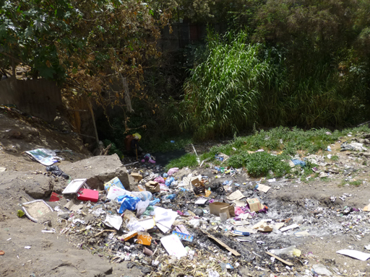 | 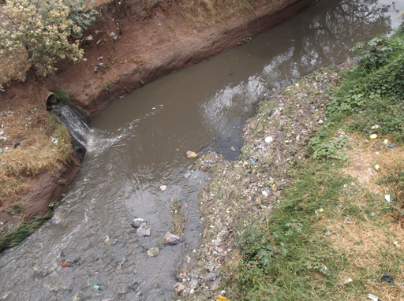
Figure 1.1 The effect of no waste management: paper, plastics and other solid waste litter the environment. | Figure 1.2 The effect of poor sanitation: liquid wastes are discharged into rivers and streams that may be used as a water source.
Although sanitation and waste management address different issues using different techniques, they have a number of features in common. For example, they both:
- deal with wastes
- are concerned with safeguarding human health and preventing disease
- cause major problems if not done correctly
- help to reduce environmental pollution (introduction into the environment of substances liable to cause harm)
- need to be paid for by the users, the city authorities or the government.

1.2 Types of liquid and solid waste
The aim of this section is to introduce the different types of solid and liquid wastes and to clarify what we mean by the term ‘waste’. The Basel Convention (an international agreement on the exporting of hazardous waste) states that (UNEP, 2011):
‘wastes’ are substances or objects which are disposed of or are intended to be disposed of or are required to be disposed of by the provisions of national law.
You should note that this definition includes both solids and liquids. Solid and liquid wastes are usually transported and treated in different ways, so in this Module we will consider the two wastes separately. Note that all human excreta (urine and faeces) are considered to be liquid wastes.

1.2.1 Types of liquid waste
The types and characteristics of liquid wastes are discussed in Study Session 4, but a useful general classification of domestic liquid waste is as follows:
- Blackwater – is wastewater that contains or consists of urine and faeces. It contains pathogens (disease-causing agents).
- Greywater, or sullage, is wastewater from human washing and bathing, kitchen sinks, clothes washing, etc. It does not contain excreta.
- Stormwater (or surface run-off or rainwater run-off) is wastewater that flows on the surface of the land to join streams. Note that this is considered as wastewater because it contains many different contaminants.
- Sewage is a combination of wastewater coming from any of the above sources and flows in underground sewers or open ditches.
- Excreta is a combination of urine and faeces.

1.2.2 Types of solid waste
There are different ways of classifying solid wastes according to the source of generation or the nature of the waste. Solid waste can be categorised as follows:
- Residential waste: from households and residential areas. This is sometimes called household waste. Garbage, rubbish, trash and refuse are other terms for residential waste.
- Commercial waste: from businesses such as food and drink establishments, shops, etc.
- Industrial waste: from various types of industrial processes, e.g. food processing, paper manufacture, manufacture of chemicals and metal processing.
- Institutional waste: from public and government institutions, e.g. offices, religious institutions, schools, universities, etc. This is similar to residential and commercial waste in composition.
- Municipal waste (or municipal solid waste) covers all the above wastes produced in an urban area. It is similar in composition to residential waste but excludes some industrial wastes.
- Healthcare waste: any solid waste produced in hospitals, clinics, health posts and other health facilities.
- Agricultural waste: waste that comes from farming.
- Waste from open areas: street sweepings, contents of roadside dustbins, ditches and other public places.
- Construction and demolition waste: from various types of building and demolition activities in urban areas.
- Electronic and electrical waste (e-waste): wastes generated from used electronic devices and household appliances.
There are other ways of classifying wastes and we will look at these in Study Session 7.

1.3 The sanitation ladder and waste hierarchy
Generally speaking, all countries are aiming to improve their standards of sanitation and waste management, and have many policies and regulations to try and achieve these improvements. We will look at some of these regulations in later study sessions, but the sanitation ladder and the waste hierarchy provide an excellent summary of these aims.

1.3.1 The sanitation ladder
The sanitation ladder provides a measure of progress towards the provision of adequate sanitation facilities for every household. The WHO/UNICEF Joint Monitoring Programme (JMP) version of the ladder is shown in Figure 1.3.
The lowest rung of the ladder is open defecation, where people without access to latrines or toilets deposit their faeces in open spaces. Unimproved facilities are one step above open defecation and include latrines that do not ensure the separation of faeces from humans. The next stage is shared facilities, which are facilities that would be classed as improved, but are shared by two or more households. At the top of the ladder are the improved facilities, where human contact with faeces is avoided. Different types of latrine facilities are discussed in Study Session 6.
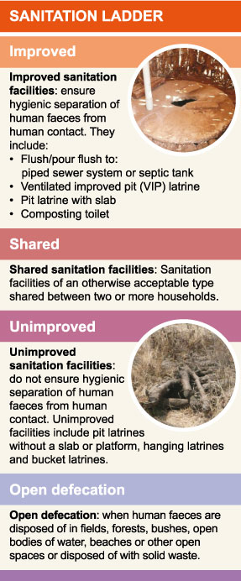
Figure 1.3 The WHO/UNICEF Joint Monitoring Programme (JMP) sanitation ladder.

1.3.2 The waste hierarchy
The waste hierarchy is shown in Figure 1.4 and is discussed in Study Session 9. The hierarchy ranks the different ways of dealing with waste in order of desirability. At the top is waste reduction, which means not generating waste in the first place or minimising the amount of waste produced. Below that is waste reuse (for example, refilling a drinks bottle), followed by recycling (processing of wastes into new raw materials). A fourth option is the recovery of energy by burning or biological treatment. Disposal, ideally in a landfill site, is the final option for any wastes that cannot be dealt with in any other way. A landfill site is an area of land set aside for the final disposal of solid waste.
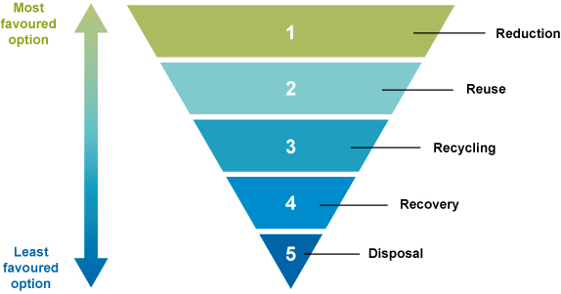
Figure 1.4 The waste hierarchy.
The top three stages of the hierarchy (reduction, reuse and recycling) are often referred to as the ‘3 Rs’, a term we will use throughout this Module.
- What are some of the ways that you could reuse wastes at home.
- Some suggestions are to:
- use empty food containers to store food that was bought loose
- refill plastic drinks bottles with water
- use clothes from your oldest child to dress younger children
- use worn-out clothes as cleaning cloths
- give books to friends when you have finished with them.

1.4 Sanitation and waste management in urban areas
Sanitation and waste management can cause problems in any community, regardless of its size. In urban areas, where people live close together these problems can have a much greater effect on people’s health and on their surroundings. The following sections explore some of these issues.

1.4.1 The trend of urbanisation
Most of the population in the world lives in urban areas. The United Nations Department of Economic and Social Affairs (2014) predicts that between 2014 and 2050 the global urban population will rise from 3.9 billion to 6.4 billion people, and that about 90% of this increase will be in Asia and Africa. In Ethiopia, the proportion of people living in urban areas is still low, but the growth in urbanisation (the increase in the numbers of people living in urban areas) is greater than in many other countries, as shown in Figure 1.5.
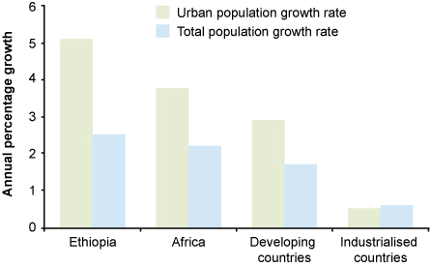
Figure 1.5 Population growth rate per year in Ethiopia and other regions of the world (Haddis et al, 2013).
- Explain in a few sentences what Figure 1.5 shows.
- Figure 1.5 shows that the urban population of Ethiopia is growing at slightly more than 5% per year, which is more than twice the growth rate for the country as a whole. In Africa and other developing countries, the urban growth rate is much greater than the overall growth rate, but the difference is not as great as in Ethiopia. In contrast, the overall growth rate in industrialised countries is much lower than that of the developing world, and their urban growth rate is slightly lower than the overall growth rate.
Many cities in Ethiopia have developed in a rapid and unplanned way as people migrate to the cities seeking employment and a better life. This growth affects the provision of sanitation and waste management facilities and other infrastructure such as water supply, roads and electricity supplies. As an example, the city of Addis Ababa receives settlers from every corner of the country, many of whom live in illegal settlements without sanitary facilities and other infrastructure. As shown in Figure 1.5, statistical reports indicate that Ethiopia has a total population growth rate of 2.5% a year, with urban centres growing at a rate of 5.1% (Haddis et al., 2013). It is expected that by 2020, one in five Ethiopians will be living in urban areas, and by 2030, half of the country’s population will be living in urban centres (Teller et al., 2007).
As a result of rapid and unplanned urban growth, the sanitation problem of Addis Ababa is one of the worst in the country. For instance, 26% of the houses and the majority of slum-dwellers have no latrine facility, so they use rivers, ditches and open spaces (UN-Habitat, 2008).
Rapid urbanisation creates a number of health and environmental risks to the population (Bai et al., 2012) in addition to those caused by inadequate sanitation and waste management. These include:
- infectious diseases among crowded communities with substandard living conditions
- acute and chronic respiratory and other illnesses as a result of air pollution
- chronic and non-communicable diseases that are on the rise with unhealthy urban lifestyles (physical inactivity, unhealthy diets, tobacco smoking, and the harmful use of alcohol)
- injuries resulting from motor vehicle collisions, violence and crime
- health risks related to climate change, such as heat stress and changed patterns of infectious disease, which are considered to be one of the biggest health risks in the twenty-first century.
In the next section we will look at some of these challenges in more detail.

1.4.2 Environmental challenges
Urbanisation can have a major effect on the environment in the following areas.

Challenges emerging from rural-urban interaction
Urban centres are usually surrounded by rural communities and the two areas depend on each other to supply many of their needs. Urban areas depend on the rural areas to provide food, fuel and construction materials. In return, the rural community depends on urban areas to supply employment, commercial products, advanced healthcare provision, education and equipment, machinery, and other industrial outputs. Having said this, problems may arise when there is a large temporary influx of people from the rural to the urban areas. Examples include:
- the increased demand for sanitation facilities in the area around a city market
- the manure generated by animals that are brought for sale or used for transport (Figure 1.6)
- the congestion caused by the number of people and animals using the roads.
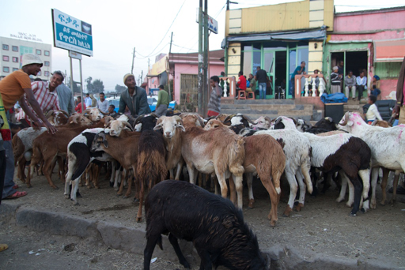
Figure 1.6 An animal market in Addis Ababa.

Challenges emerging from the urban situation
Even without the influxes from rural areas, urban centres are congested and crowded. They have often grown without any planning, so the problems arising from the lack of sanitation, waste management and the other infrastructure mentioned above are present. Urban growth also means that there is an increase in the area of land covered with concrete and other hard surfaces.
- Why would an increase in the area of land covered with concrete or other hard surface be a problem?
- When rainwater falls on soil it will usually soak in. When it falls on concrete it runs off the surface and can cause flooding if the rainfall is heavy.
Urban development reduces the ability of the ground to absorb rainwater. In urban areas a high proportion of the ground is paved, which prevents the absorption of rainwater. Also, unplanned developments usually lack the drainage ditches or channels necessary to carry away surface waters. These two factors combine to create an increased risk of flooding and the outbreak of waterborne disease that can follow floods.

Challenges from industrial discharges
Most industries in developing countries discharge untreated or partially treated liquid wastes to sewers, where these are available, or to rivers, streams or ditches. Industries also release waste gases that may contain harmful substances and produce solid wastes that may contain hazardous materials (such as poisons, strong acids, infectious material, etc. that can cause harm to humans because of their properties). As a result, unregulated industries can harm human health and the environment in many ways.

Challenges from transport
We have already mentioned problems from traffic congestion, but the use of a large number of often badly maintained petrol- and diesel-fuelled cars, lorries and buses cause additional health problems. The exhaust gases from these vehicles contain fine particles, partly burned fuel and acidic substances that make breathing difficult and cause irritation of the lungs. While this is a problem for all people, it is much worse for the old, the very young and the ill, especially those with heart problems or who suffers from asthma.

1.4.3 Challenges to society
Increasing urbanisation puts pressures on society as a whole as well as on the environment. People who migrate to cities may become unemployed and then need to be provided for. This puts pressure on welfare provision and on the charities that provide assistance to the hungry and the homeless. Even people who have jobs find it difficult to find somewhere to live and may develop illegal unplanned settlements that affect the planning and service provision of the government sectors. These settlements also add to the city’s sanitation and waste problems.
The urban population requires daily supplies of food, fuel and other goods which can put pressure on the infrastructure needed to deliver and sell these goods. Once goods reach the end of their lives they become waste, increasing the pressure on the waste collection and treatment systems.

1.4.4 Challenges to administration
A growth in population creates more work for the city’s administration. If funds are not available to increase staff numbers to deal with this demand, problems will occur. In the case of sanitation and waste management, as well as services not being provided to the whole of the city, the additional workload can reduce the effectiveness of the governance of these programmes, which can result in lower standards and a poorer service for the entire city.
To deal with the problems of population growth, various organisations need to work together; for example, water, sanitation and health service providers, and non-governmental organisations (NGOs). When growth is rapid, these organisations can be overwhelmed and so coordination can break down. This may mean that in some cases, efforts are duplicated, and sometimes there will be gaps in addressing some aspects of the programme.
If public administration and regulation is already weak, the entire system can fail. In the absence of good regulation, standards of sanitation and waste provision can fall, increasing pressures in other areas such as health services.

1.5 The present state of sanitation in Ethiopia
The WHO/UNICEF Joint Monitoring Programme (JMP) collects and publishes data for water supply and sanitation for all the countries of the world. The JMP data for sanitation coverage in Ethiopia in 2012 is shown in Figure 1.7.
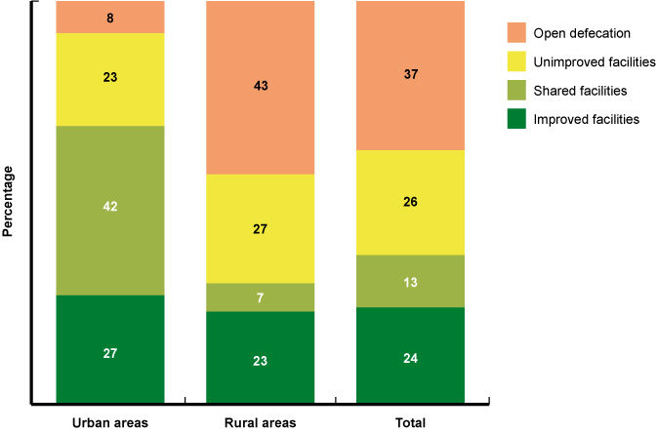
Figure 1.7 Sanitation facilities used in Ethiopia by people living in urban areas, rural areas and by the total population. (JMP, 2014)
There has been a marked reduction in the practice of open defecation throughout Ethiopia in recent years, particularly in rural areas. This has been accompanied by a rise in the use of latrine facilities, but there is still a long way to go to eliminate open defecation and provide all people with access to improved facilities.
There is far less information available on solid waste management in Ethiopia than there is on sanitation. Outside Addis Ababa and other large cities, household waste is not collected and people tend to dispose of their waste in informal ‘open dumpsites’ where no records are kept. Organic materials (e.g. food, paper) eventually decompose, but other materials such as plastics accumulate or are blown around by the wind. Not surprisingly, there are no reliable figures for the amount of waste produced outside the main cities. In Addis Ababa, Basha (2007) estimated that around 2000 tons of waste were generated each day, around 75% of which was residential waste. Of this total:
- around 50–60% was collected by the city authority and taken to a local disposal site (Figure 1.8)
- 5–10% was recycled
- the remainder was either burned in open fires or dumped in open spaces, in watercourses or by the roadside.
Clearly, there is much progress to be made in collecting city waste and in finding a safe way of disposing of it.
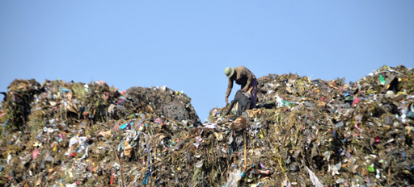
Figure 1.8 Repi waste disposal site in Addis Ababa.

1.6 Policies, strategies and programmes
There are several national policies, strategies and programmes that are relevant to improving sanitation and hygiene in Ethiopia. Key policies are:
- The Health Policy (1993) which stresses that environmental health, occupational health and safeguarding the environment are priority issues.
- The Environmental Policy (1997) which promotes the use of renewable resources and recycling, and includes specific policies for industrial waste.
- The Water Resources Management Policy (1999) which describes the conservation, exploitation, use and protection of water resources.
These policies are reinforced by proclamations such as the Public Health Proclamation No. 200/2000, the Ethiopia Water Resources Management Proclamation No. 4/1995, and the Proclamation for the Establishment of the Ethiopian Environmental Protection Authority 2002. These proclamations provide support for regions, zones and woredas to develop a regulatory framework for their activity in the water, sanitation and hygiene sector.
The National Hygiene and Sanitation Strategy of 2005 (MoH, 2005) sets out a ‘sanitation vision’ for Ethiopia that is:
100% adoption of improved (household and institutional) sanitation and hygiene by each community which will contribute to better health, a safer, cleaner environment, and the socio-economic development of the country.
The goal of 100% access to basic sanitation has been carried forward to other policies and programmes, and is one of the targets of the new One WASH National Programme. (‘WASH’ stands for ‘water, sanitation and hygiene’.) The One WASH National Programme (OWNP), as the name suggests, is a single programme that combines the three interlinked components. Announced in 2013, it aims to address the WASH challenges in Ethiopia by adopting a unified and collaborative approach. The overall objective of the OWNP (FDRE, 2014) is:
to improve the health and well-being of communities in rural and urban areas in an equitable and sustainable manner by increasing access to water supply and sanitation and adoption of good hygiene practices.
The OWNP is unlike previous WASH programmes because it takes a sector-wide approach and involves the federal ministries of Water, Irrigation and Energy, Health, Education, and Finance and Development.
The four ministries have signed a memorandum of understanding (MoU) that sets out their roles and responsibilities. It therefore cuts across the traditional separation of responsibilities between ministries and has structures and processes designed to ensure closer cooperation and collaboration between all the stakeholders.
In comparison with the WASH sector, there are fewer policies and regulations relevant to solid waste. The Solid Waste Management Proclamation of 2007 has the objective to ‘enhance at all levels capacities to prevent the possible adverse impacts while creating economically and socially beneficial assets out of solid waste’ (FDRE, 2007). It sets out the obligation for urban administrations to create the right conditions to promote investment in solid waste management services and ensure the participation of local communities in the process of designing and implementing their solid waste management plans. It also sets out requirements for the supply and management of specific types of waste, including glass, tin cans, plastic bags, used tyres, food-related waste, household waste, and construction and demolition waste.

Summary of Study Session 1
In Study Session 1, you have learned that:
- ‘Sanitation’ and ‘waste management’ both refer to the appropriate management of waste to protect people and the environment. Sanitation generally focuses on liquid waste and waste management on solid waste.
- Liquid waste includes all types of wastewater and includes human excreta. Solid waste is any solid material discarded by people and is often classified according to its source.
- The ‘sanitation ladder’ illustrates the different types of sanitation provision in order of desirability.
- The waste hierarchy is a guide to the different ways of treating wastes from waste reduction (the best option) through to disposal (the worst option).
- The challenges of rapid and unplanned population growth and urbanisation in Ethiopia make it difficult to achieve acceptable levels of sanitation and waste management quickly.
- Sanitation in Ethiopia has shown significant improvement in recent years. There is less data for trends in waste management.
- There are several Ethiopian policies, strategies, proclamations and programmes that address sanitation and waste management issues.

Self-Assessment Questions (SAQs) for Study Session 1
Now that you have completed this study session, you can assess how well you have achieved its Learning Outcomes by answering these questions. You can check your answers with the Notes on the Self-Assessment Questions at the end of this Module.

SAQ 1.1 (tests Learning Outcome 1.1)
On a piece of paper, write down each of the key words printed in bold in this study session. Cut the paper into strips with one word on each strip; fold them and put them in a bowl. Take a strip, read the word and write a definition in your notebook. Then check your definitions with those in the study session.

SAQ 1.2 (tests Learning Outcomes 1.1 and 1.2)
Arrange the following phrases under the correct heading in the table below.
- aims to protect people from disease
- management of e-waste
- mainly concerned with solid waste
- options are described as a ladder
- management of industrial wastes
- aims to prevent pollution
- mainly concerned with liquid waste
- options described as a hierarchy
- management of human excreta.
Sanitation | Waste management | Both sanitation and waste management

SAQ 1.3 (tests Learning Outcomes 1.1 and 1.3)
Rearrange the following into two separate lists, one in the correct order to form the sanitation ladder and the other in the correct order for the waste hierarchy. Put the best option at the top of your lists.
- pour flush toilet
- old cardboard box, flattened out, used as door mat
- defecating on waste ground
- broken wooden box used for firewood
- simple pit latrine with no ventilation or slab
- refilling a plastic bottle with cooking oil

SAQ 1.4 (tests Learning Outcome 1.4)
Name three ways in which urbanisation creates challenges for effective sanitation and solid waste management.

SAQ 1.5 (tests Learning Outcome 1.5)
There have been significant improvements in sanitation provision in Ethiopia in recent years, but progress is not so good for solid waste management. What reasons can you think of that might explain this difference?

Study Session 2 The Effects of Poor Sanitation and Waste Management

Introduction
Many people in Ethiopia have limited knowledge and understanding of the good hygiene practices that reduce the health risks from poor sanitation and waste management. The Health Extension Programme (HEP) was established by the Ethiopian government in 2004 to address this problem within the broader aim of creating a healthy society and providing accessible health care at community level. Initially the HEP focused on rural communities but this has since been extended to pastoral areas and, in 2010, to urban communities. An important part of the programme is to improve hygiene and environmental sanitation and give people information about good health and hygiene practices (Health Extension and Education Center, 2007). Creating a healthy society also depends on improvements to sanitation and waste management and as an urban WASH worker you will be supporting this activity.
In this study session you will learn about the risks to people’s health and to the environment that result from poor sanitation and waste management. You will also look at ways of reducing these risks.

Learning Outcomes for Study Session 2
When you have studied this session, you should be able to:
2.1 Define and use correctly each of the terms printed in bold. (SAQ 2.1)
2.2 Name the main groups of human pathogens and give examples of the diseases they cause. (SAQ 2.1)
2.3 Briefly describe how sanitation and waste management affect human health and explain how good hygiene can prevent disease transmission. (SAQ 2.2)
2.4 Describe the influence of sanitation and waste management on education, the economy and the environment. (SAQ 2.3)

2.1 Health effects of poor sanitation and waste management
Ethiopia’s urban and peri-urban areas are characterised by poor sanitation conditions, indiscriminate dumping of wastes and open urination and defecation. (Peri-urban areas are the areas surrounding a town between the urban and rural areas. They are often settled in by migrants from the countryside who suffer from extreme poverty, overcrowding and a lack of sanitation facilities.) Urban and peri-urban pollution and overcrowding create significant vulnerabilities for the overall urban population, particularly the poor. Diarrhoeal disease is one of the leading causes of morbidity (illness) and mortality (death) in developing countries, especially among children younger than five years of age. It is estimated that up to 60% of the current disease burden in Ethiopia is attributable to poor sanitation and 15% of deaths are due to diarrhoea (MoH, 2005).
Many human infections are spread through contact with human excreta. Bacteria, viruses, protozoa and parasitic worms cause many diseases that are spread by direct contact with faeces or indirectly via contaminated food and soil. These different types of pathogens or infectious agents are described in Box 2.1. Diseases may also be transmitted through a carrier organism or vector. Vectors are organisms that do not cause diseases themselves, but carry or transmit disease-causing agents. For example, mosquitoes carry the protozoa that cause malaria and infect people with the disease through mosquito bites. Other examples of disease vectors are lice, ticks, fleas and rats.

Box 2.1 Main types of infectious agents
- Bacteria are very simple microscopic organisms. Some types of bacteria are essential to human life, playing a part in the digestive system. Others have other benefits, such as decomposing wastes. Pathogenic bacteria are responsible for many diseases, including tuberculosis and pneumonia and several waterborne diseases such as typhoid and cholera (Figure 2.1).
- Viruses are not living organisms themselves but are infectious agents able to invade cells and cause them to manufacture more virus material. Polio, HIV/AIDS, influenza and rotavirus are examples of diseases caused by viral infections.
- Protozoa are the simplest members of the animal kingdom. They are microscopic, consist of a single cell and are found in water, soil and the sea. Some types are beneficial to humans, breaking down pollutants in water, but others are parasitic, causing diseases including malaria, amoebic dysentery (Figure 2.2) and sleeping sickness.
- Parasitic worms live inside the bodies of their human host, usually in the intestines. There are several different types of parasitic worm including tapeworms, flukes and roundworms. Roundworms, also known as nematodes, include Ascaris, hookworm and whipworm (Figures 2.3 and 2.4). Most worm infections are not fatal, but they do cause long-term debilitating illness. Parasitic worms are sometimes collectively known as helminths. Note however, that there are many types of worm that are not parasitic or harmful in any way. For example, earthworms decompose dead plant matter and improve soil structure and fertility.
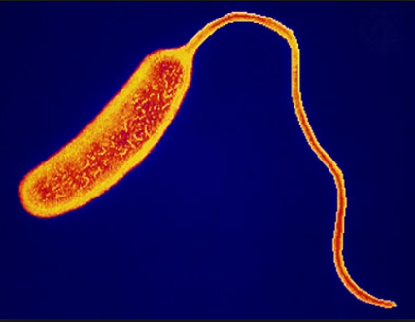 | 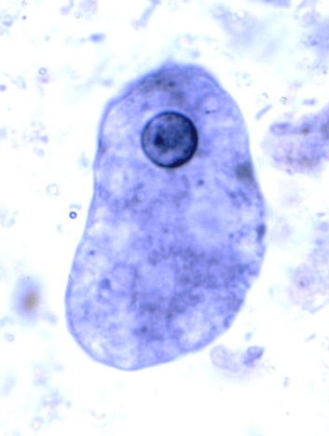
Figure 2.1 Vibrio cholerae: the bacteria responsible for cholera (0.5–0.8 µm wide and 1.4–2.6 µm long). | Figure 2.2 Entamoeba histolytica: the protozoa that causes amoebic dysentery (up to 60 µm in size).
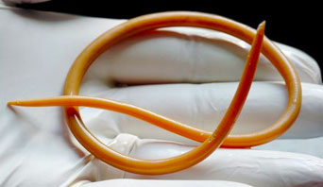
Figure 2.3 Ascaris lumbricoides or roundworm: these intestinal parasites can be very large – up to 35 cm long. | Figure 2.4 Trichuris trichiura or whipworm: these can reach 4 cm in length.
Table 2.1 lists some of the diseases that are caused by the many different types of pathogens and are linked to poor sanitation and waste management.
Table 2.1 Health problems associated with poor sanitation and management of wastes.
Disease-causing agent | Disease | Description
Bacteria | Shigellosis | Causes abdominal pains and diarrhoea (see below).
 | Typhoid | Mild to severe fever lasting from a few days to several weeks.
 | Cholera | An infection of the intestines that can cause watery diarrhoea leading to dehydration.
 | Diarrhoeal diseases  (note these can also be caused by viruses) | Production of frequent watery faeces that can lead to dehydration. Can be fatal, particularly among young children.  Diarrhoea is a symptom of several other diseases in this table.
Viruses | Hepatitis A | An infection of the liver that can cause pain, diarrhoea and jaundice.
 | Polio | Can cause temporary or permanent muscle weakness, and sometimes death.
Protozoa | Amoebiasis (also known as amoebic dysentery) | Infection that can occur up to several years after exposure to the protozoa. Can cause mild to severe diarrhoea and liver damage.
 | Giardiasis | Infection of the small intestine. It is usually symptomless but can have a variety of intestinal symptoms, such as chronic diarrhoea, abdominal cramps, gas production and frequent loose, pale and greasy stools.
Parasitic worms | Ascariasis (roundworm) | One in four of the world’s population has this infection, which can lead to weight loss, malnutrition and anaemia. It is very common in Ethiopia.
 | Hookworm infection | Two species of nematodes that inhabit the small intestine, from where they suck blood, leading to anaemia.
 | Tapeworm infection | A worm that normally lives in the intestines which can cause anaemia and malnutrition. This is usually spread through eating improperly cooked food that contains the worm or its eggs.
 | Bilharzia or schistosomiasis | A disease caused by the Schistosoma worm that can cause diarrhoea and blood in the urine and faeces. In the long term, it can lead to liver and kidney damage.

2.2 Routes for disease transmission
Most infections occur through the faecal-oral route where pathogens enter a person’s mouth through ingesting (eating or drinking) contaminated food or water, or when contaminated fingers are placed in the mouth. The different transmission routes are shown in Figure 2.5, which is known as the ‘F diagram’. Pathogens contained in faeces enter a new host (a person’s body) through the ‘Fs’ – fluids, fingers, flies or fields/floors. Effective sanitation, clean water and good hygiene behaviour provide barriers to this transmission.
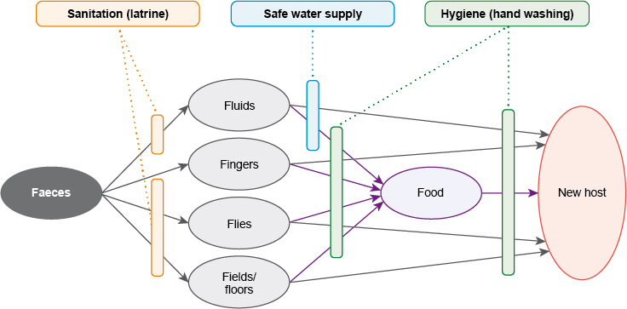
Figure 2.5 The F diagram showing how diseases can pass from faeces to a new host. Sanitation (using a latrine), safe water supply and good hygiene are barriers to disease transmission.
The faeces (on the left of the diagram) comes from an infected person. The new host (on the right of the diagram) could be any man, woman or child who is not currently infected with the disease. Infections can be transmitted from faeces to the new host as follows:
- Infection from fluids usually involves drinking or cooking with water contaminated with faecal organisms.
- In the fingers pathway, a person ingests the organisms (usually during eating) if they have come into contact with faeces and have not washed their hands properly afterwards. This contact can occur from defecation, from cleaning a child’s bottom, from touching dirty surfaces or eating food prepared in an unhygienic manner.
- Flies and cockroaches often thrive on excreta. If they land on food they can transfer faecal matter that can be subsequently ingested by a person.
- Field (or soil) infection can occur by the ingestion of unwashed raw vegetables and fruit grown in soil contaminated with faeces. Contaminated soil may be transported by feet or shoes for long distances. Infections can also be transmitted through dirty floors, perhaps if food is dropped on the floor and then picked up and eaten.
- Name two vectors involved in faecal-oral disease transmission.
- Flies and cockroaches are two examples of vectors that can carry pathogens from faeces on to food that is then eaten.
There are other disease vectors linked to poor sanitation and waste management. For example, piles of food waste and other garbage not only provide good breeding sites for flies but they also encourage rats. Rats can contaminate food stores and also carry fleas.
Poor personal hygiene also contributes to disease transmission. Infrequent or inadequate washing of the body and clothes can encourage external body parasites such as fleas and lice, which may carry typhus.
An important example of a disease that is closely related to poor sanitation but is not transmitted by ingestion of contaminated food or water is schistosomiasis, also known as bilharzia. Schistosomiasis is widely distributed in Ethiopia (Dufera et al., 2014). The disease is caused by a parasitic worm that has a complicated life cycle. Its primary host is humans, but its secondary host is a type of freshwater snail. The disease is linked to poor sanitation because it is caused by the faecal contamination of water. However, the worm gets into the body not by the faecal-oral route, but by penetrating through the skin when someone washes, swims or stands in water inhabited by infected snails.

2.3 Safeguarding health with good hygiene
In some of the later study sessions we will look at technologies that can reduce the health impacts of poor sanitation and waste management. This study session concentrates on simple practices that can be carried out by everyone to reduce these risks. These practices generally relate to good hygiene, which means any practice that prevents the spread of disease-causing organisms or substances that cause harm to humans.

2.3.1 Handwashing
Everyone should wash their hands thoroughly at certain critical times, as listed in Box 2.2. Washing should be done using clean water that has not been used by anyone else and with soap or a soap substitute such as ash. Ideally, the water should be hot. After washing, the hands should be dried using a clean cloth or allowed to dry in the air.

Box 2.2 Critical times for handwashing
The occasions in everyday activity when hands should be washed include:
- after using the latrine or toilet (or disposing of human or animal faeces)
- after cleaning a child’s bottom or changing a baby’s nappy and disposing of the faeces
- after contact with blood or body fluids (e.g. vomit)
- immediately after touching raw food, especially meat, when preparing meals
- before preparing and handling cooked or ready-to-eat food
- before eating food or feeding children
- after contact with contaminated surfaces (e.g. rubbish bins, cleaning cloths, food-contaminated surfaces)
- after handling pets and domestic animals
- after wiping or blowing the nose or sneezing into the hands
- after handling soiled tissues (your own or others’, e.g. children).

This list is frequently summarised as five critical times, which are:
- after using the latrine
- after cleaning a child’s bottom
- before preparing food
- before eating
- before feeding a child.

2.3.2 Food hygiene
Many diseases are caused by eating food that has been contaminated with an infectious agent, usually from faeces. If these diseases lead to diarrhoea or vomiting they are easily spread further if sanitation provision is poor. Food hygiene refers to practices and behaviours that can prevent contamination. For example, food and water should be stored in the home in closed containers to prevent contact with flies, rodents and other vectors. These containers should not be used for any other purpose and must be kept clean. Raw and cooked meats should not be stored together, and meat and dairy produce should be kept in a cool place, ideally in a refrigerator. Food should be prepared on clean surfaces and cooked at the correct temperature for the required time. Particular care should be taken over meat, poultry, fish and dairy produce.

2.3.3 Control of vectors
As mentioned above, all food should be stored in a way that it is not accessible to flies, rodents and other potential vectors. Storing wastes properly is also an important way of controlling vectors. Food waste should be disposed of immediately or stored in a closed container before disposal to discourage the presence of flies, etc. Household solid waste storage containers should be emptied frequently. If the waste is disposed of in a pit it should be covered with soil immediately.
Waste management can also play a part in controlling mosquitoes. Mosquitoes need water to breed, but they can also do this successfully in very small temporary puddles of rainwater. Plastic bags and other plastic waste that is carelessly discarded can hold enough water to enable mosquitoes to reproduce. Collecting and disposing of plastic correctly by burial or burning ensures this opportunity for mosquito breeding is removed.
- According to the F diagram (Figure 2.5), which of the three barriers to faecal-oral disease transmission would be most effective in preventing infection?
- The three barriers in the F diagram are sanitation (using a latrine), safe water supply and good hygiene, specifically handwashing. The first two are effective barriers to some of the steps in disease transmission, but hygiene cuts across all the lines of transmission. If the person who is the potential new host washes their hands at all critical times, this will be the single most effective method of preventing infection.
You have seen how poor sanitation and waste management can contribute to the spread of many different communicable diseases. The following sections describe how these negative effects on health can have further impacts on education and the economy.

2.4 Impacts on children and education
Diseases linked to poor sanitation and hygiene have a significant impact on children’s health and education. 38% of Ethiopian school children are infected with parasitic worms (Mahmud et al. 2015). These infections contribute to malnutrition because the parasites prevent the child’s body from absorbing nutrients from the food that they eat. Long-term malnutrition retards children's physical and intellectual development. The Young Lives survey (2014) reported that around 30% of Ethiopian children are stunted, which is a sign of long-term malnutrition. (Stunted means that a child’s height is less than expected for their age.)
Children are frequently ill as a result of parasites and other infections, which leads to poor school attendance and performance. Furthermore, if the school attended by an infected child does not have good sanitation and handwashing facilities the infections are likely to spread to healthy children.
There are also social impacts of poor sanitation provision in schools. An absence of latrines with separate facilities for girls and boys means that post-pubescent girls are more likely to stop attending schools, especially when menstruating (this is covered in Study Session 12). When healthy children attend a school with well segregated sanitation facilities, they are present more regularly and are better learners. This, in turn, makes them better able to find jobs that demand higher-level skills on finishing school; an advantage to them, their families and the community as a whole. This contributes to wider economic benefits, as discussed in the following section.

2.5 Impacts on the economy
A healthy community has many economic advantages over an unhealthy one. If people are healthy they will spend less money on health care and the loss of work days due to diarrhoea and other related infections is reduced. Illness can affect both the sick person and their family, for example when women have to take time off work to care for sick children.
Improving solid waste management has economic advantages in addition to the health advantages discussed above. Consider the following example.
It is said that a firm that throws something away pays towards it three times over. Imagine a firm that uses raw materials and puts them through a manufacturing process to make a final product. First, the firm has to pay its suppliers for the raw materials. Secondly, it pays its staff to transform the raw materials into products, and pays for the water and energy that it uses. Finally, the firm has to pay for disposal of what it throws away. So a firm that reduces the amount of waste it produces makes savings in all three areas.
A firm that uses basic materials such as glass or metal faces large energy bills for the processes required in converting these materials into products. But if they follow the principles of the 3 Rs (reduce, reuse and recycle) and substitute some of their input raw material with scrap glass or metal, they can reduce their energy bills and buy less raw materials. These materials are often imported, so using recycled scrap reduces Ethiopia’s expenditure abroad, which benefits the national economy as well as individual firms.
There are further benefits from recycling. The initial stages in the recycling process (collecting material from households and businesses) is labour-intensive and provides employment for the poorest people in society. Giving them an income improves their health, which, in turn, reduces the country’s healthcare expenditure.
- A householder in an urban area goes shopping for food. How can they apply the 3 Rs when it comes to packaging materials?
- They can reduce packaging waste by buying loose fruit and vegetables rather than pre-packaged goods.
The can reuse carrier bags to take the shopping home rather than picking up new bags each time they shop.
They can recycle by taking any glass or metal food containers to collection points or by giving them to people who earn their living by collecting recyclable wastes.

2.6 Impacts on the environment
What do we mean by ‘the environment’? You may think of it as your immediate surroundings in the town or kebele where you live or work. However, it can also mean the wider natural world on a much larger, even global, scale. Poor sanitation and waste management have direct impacts on the local environment, but human practices can also have broader consequences.
There are obvious local environmental benefits from improved sanitation. This means that defecation only takes place in properly constructed latrines, areas of land are not contaminated with faeces and watercourses no longer act as sewers. This in turn allows plant life, fish and other aquatic organisms to flourish.
Improving waste management improves the local environment and also benefits the national and even the global environment. Good waste management means less litter in the streets and in the neighbourhood of waste disposal sites (Figure 2.6). It also reduces the smell in the streets from decomposing wastes.
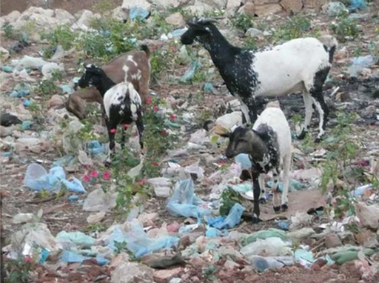
Figure 2.6 Carelessly discarding plastic bags and other solid wastes has a negative visual impact and is hazardous to grazing animals.
Applying the 3 Rs saves energy because the energy used to recycle metals, paper, glass, etc. is far less than the energy used in producing these materials from raw materials. Energy production is a major source of greenhouse gases. Greenhouse gases, such as carbon dioxide and methane, contribute to human-induced climate change that is causing the overall warming of the Earth and changing weather and rainfall patterns. Recycling (and reduction and reuse) reduce the emissions of these gases. Improving the standards of landfills also reduces greenhouse gas emissions and lowers the risk of polluting local watercourses and the surrounding land.

Summary of Study Session 2
In Study Session 2, you have learned that:
- Many health problems are associated with poor sanitation and waste management, principally caused by contact with human faeces.
- The main types of infectious agent responsible for communicable diseases are bacteria, viruses, protozoa and parasitic worms.
- The F diagram shows how infectious agents from faeces can be ingested by someone who then becomes infected.
- Poor sanitation and waste management create conditions that may encourage flies and other disease vectors.
- Good hygiene behaviour, especially handwashing with soap at critical times, can significantly reduce health risks.
- Diseases associated with poor sanitation affect children’s physical development and school attendance. Poor sanitation facilities in schools also affect attendance, especially for girls.
- Healthy people are more productive, which brings economic benefits to them and to the wider community.
- In industry, minimising the amount of waste can reduce costs throughout the manufacturing process.
- Environmental impacts of poor sanitation and waste management at a local level include pollution of land and watercourses, the visual impact of litter, and bad odours. At a global level, applying the 3 Rs to solid waste management can reduce energy use which will reduce greenhouse gas emissions.

Self-Assessment Questions (SAQs) for Study Session 2
Now that you have completed this study session, you can assess how well you have achieved its Learning Outcomes by answering these questions. You can check your answers with the Notes on the Self-Assessment Questions at the end of this Module.

SAQ 2.1 (tests Learning Outcomes 2.1 and 2.2)
Insert the words below into the table to match the headings.
- animals that live inside humans, usually in the intestines
- ascariasis
- bacteria
- infectious agents that invade cells
- malaria
- parasitic worms
- polio
- protozoa
- simple micro-organisms
- single-celled animals that live inside humans
- typhoid
- viruses.
Pathogen type | What it is | One disease caused

SAQ 2.2 (tests Learning Outcome 2.3)
Imagine that you are working with the mother of a two-year-old child. Use the F diagram (Figure 2.5) to give her some examples of how she could reduce the child’s exposure to faecal pathogens.

SAQ 2.3 (tests Learning Outcome 2.4)
How do good sanitation and waste management practices bring a positive effect to urban inhabitants? Give examples for effects on:
- health
- education
- economic conditions
- the environment.

Study Session 3 Rapid Assessment of Urban Sanitation and Waste Management

Introduction
In Study Session 2 you learned about the effects of poor sanitation and waste management. In this study session you will learn how to make a rapid assessment of the state of sanitation and waste management in an urban community. This assessment can then be used to identify the needs for improvements in sanitation and hygiene, and decide which improvements are the most important. Therefore, making these assessments is a key part of the urban WASH practitioner’s work. Reliable data is needed to ensure that interventions properly target populations (especially in slum areas and among disadvantaged groups), and bring about the desired changes.

Learning Outcomes for Study Session 3
When you have studied this session, you should be able to:
3.1 Define and use correctly each of the terms printed in bold. (SAQ 3.1)
3.2 Explain the purpose of urban sanitation and waste management assessment. (SAQ 3.2)
3.3 Describe the methods that may be used for assessment. (SAQs 3.1 and 3.3)
3.4 Explain the uses of an assessment report. (SAQ 3.4)

3.1 What is rapid assessment?
Rapid assessment of urban sanitation and waste management is the process of collecting information from households and institutions to get a quick overview of the situation in an urban community. The results can then be used to identify the areas that need to be improved and suggestions of possible solutions. The assessment involves observations of the community and discussions and meetings with target households and other community members. Some examples of the type of question that could be asked are:
- How many households and schools have sanitary facilities (including handwashing provision) and how are these facilities being used?
- How convenient are the facilities? Do they provide the necessary access and privacy and preserve dignity?
- What is the current level of sanitation and waste management knowledge among the community?

3.2 Why do an assessment?
There are a number of reasons why a WASH team may need to carry out an assessment. Usually this relates to the need to get information on the state of sanitation and waste management in a particular town or part of a city and have the ‘facts on hand’ to inform others (particularly political leaders and community members) as they make action plans for improvements.
The assessment can also be used as a monitoring exercise to provide a quick overview of how an urban community has been using its sanitation facilities and waste management system. This could be used to identify the individuals or groups of people who are at the greatest risk of harm from poor WASH practices.
Assessments are also used to help plan WASH facilities in an emergency situation: after a mass movement of people to a refugee camp, for example, or while recovering from a natural disaster. You will learn more about emergency WASH in Study Session 14.
Note that the assessments discussed in this study session are classed as ‘rapid’. This is because they are intended to provide a quick view of the situation and to identify the key areas for immediate action. In the longer term, it is important to assess the effectiveness of any WASH programme. An initial assessment might be done before the start of the programme to find out the baseline position (the situation before any improvement programmes are implemented). This would be followed by further assessments during and at the end of the programme to determine its progress. Finally, an assessment carried out some time after the end of the active phase of the programme would help to determine any long-term benefits achieved. This type of longer-term assessment is part of the more rigorous process of ‘monitoring and evaluation’, which you will learn about in Study Session 15.

3.3 The assessment team
These assessments are most effectively carried out by a mixed team of people, rather than an individual, to make sure that all the necessary skills and experiences are present (Visscher et al., 2014). This could be the Woreda WASH Team and may also involve environmental health workers, Health Extension Workers, urban health supervisors and others. In any event, at least some of the team members should have basic public health training, experience of rapid assessment surveys and familiarity with best practices in sanitation and waste management. Teams should include both men and women because people may not want to discuss sensitive subjects such as latrine use with a member of the opposite sex.
- Why is it better to use a team of people rather than one individual?
- A team could undertake an assessment of a larger area and/or complete the task more quickly than someone alone. Also, a single person will have less experience than an entire team and may not have the knowledge and skills required. A team including both men and women who have a variety of experiences and backgrounds will be better able to cover all aspects of the assessment.

3.4 The assessment process
The first part of any assessment is to agree on why the assessment is being carried out and to identify any specific aspects of WASH that need to be looked at. An assessment that is carried out as part of a project to determine the need for latrines, for example, would need very different information than one looking at the possibility of setting up a waste composting scheme. This first part will normally be done by the team leaders working with the organisation that requested the survey or provided the funding for the work. It is important that representatives of the community being assessed should be part of this process so that they can influence the decisions and remain informed. The output from this initial stage of the process will be an overall aim, together with a series of objectives (you can think of objectives as the aims for each smaller piece of the work).
All assessments should end with the production of a report, and it is important at the start to consider who this report is for. This will determine what data needs to be collected and what sort of data analysis is done. This in turn will determine some of the skills required of the project team and may identify where specialised computer data processing software is required.
Based on the aim and objectives, the team should prepare a checklist of the information that needs to be collected. The advantages of using a checklist are that it:
- provides a standardised approach to what is reviewed during assessment
- helps supervisors to cover all issues without forgetting anything
- provides a means of documenting assessment findings in a simple manner that can be referred to in the future
- provides a record for tracking performance changes over time
- provides a basis for identifying needs for follow-up actions.
The information gathered during the assessment will come from both primary and secondary sources. Primary sources are the information obtained by the survey team through observations, questionnaires and other methods, which are discussed in the next section. Secondary sources consist of the results of work that has already been done, such as previous surveys in the same area or in other locations that are similar to the survey area. Reviewing existing documents and reports can also provide valuable background information for the planned assessment. For example, demographic data such as the total population of the study area, the number of people of different age groups and the proportion of men and women will be useful.
Having prepared the plan and agreed the process with community representatives, at the start of the survey the team should arrive at the community or kebele as scheduled and on time. The visit should start with introductions to the community (usually done through a small group of community representatives), including descriptions of each person’s position and responsibility in the project. The team leader should explain the objective of the assessment and agree with the community representatives how the assessment will proceed. The time required for interviews, reviews, discussion and action planning should be set at this stage.
It is important to make sure that the community is aware that it is not being ‘judged’ in any way, but that the work is to find the best way of improving WASH in the community. At this point, the community should be reassured that all discussions with individuals and questionnaire responses will be treated in the strictest confidence.

3.5 Assessment methods
Assessing the key sanitation and hygiene aspects of a community requires the use of a number of investigation methods. The main methods (Asefa and Tessema, 2000; Feleke et al., 2003) are listed below:
- Interviews are conversations between the investigator and members of the community, usually on a one-to-one basis. Depending on the information required, different types of interviews and questions can be used, as described in Box 3.1. The interviewer takes notes of the interview or uses a voice recorder. When conducting interviews it is important to gain the interviewee’s consent before starting and to make it clear how the information will be used. Generally, interviewee’s comments should not be used in reports in a way that allows the person to be identified.
- Observation is often combined with interviews. Observation simply means recording what you see or are aware of. For example, while visiting households, interviewers observe the availability and quality of the sanitation and waste facilities, such as the household latrine, solid waste storage and disposal, and handwashing provision. In addition, the interviewer will try and gain a picture of the use of these facilities through observation and discussions. At the same time, the general condition of the housing, water management and food handling can also be observed. There is a risk that the observer will assess the position against their own personal views (a subjective view), so it is important to have a set of standards to be used by all observers to make the assessment as objective (based on things that can be measured or counted and not influenced by personal opinion) as possible. General observations can be made simply by walking around the area and noting the condition of the town. A typical observation sheet to be completed while observing a household is shown in Table 3.1.
- Discussions with the community can provide valuable information about the concerns and health situation of community members that can help to confirm the findings of the interviews and observation (Figure 3.1). For example, one would expect a high incidence of diarrhoea to be reported if an absence of latrines and handwashing facilities had been identified.
Table 3.1 Observation sheet to be completed by survey team member.
Kebele: ____________________ Location: ____________________
1. Where is the latrine located?
(a) Inside or attached to dwelling | (c) Outside premises
(b) Elsewhere on premises | (d) No latrine available  (Please ignore questions 2–4)
2. How far is the latrine from the living quarters?
(a) Less than 10 m | (c) Over 50 m
(b) 10 to 50 m | (d) Can’t see
3. Are there signs that the latrine is in regular use?
(a) Yes | (b) No
4. Are there obstacles in the path from the house to the latrine?
(a) The path is clear | (d) Dense vegetation
(b) Waste or debris in the path | (e) Mud
(c) The entrance is blocked | (f) Other observation: __________________
5. Is the solid waste container covered?
(a) Yes | (c) No container
(b) No
6. Is refuse lying on the compound?
(a) Yes | (b) No
7. Are any of the following within 200 m of the house?
(a) A place to put waste for collection by the kebele?
(b) An enclosed place to dump waste used by the community?
(c) An informal uncontrolled dump site?
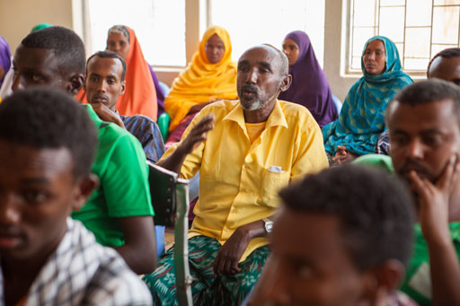
Figure 3.1 Community discussions can be useful as part of an assessment process.
- Focus groups can also be useful to find out what people think about a specific issue. A focus group consists of a group of about ten people who represent the community as a whole in terms of age, gender, employment etc. The group is coordinated by one of the team whose role is to introduce the subject and pose a few initial questions. The group then discusses the issue in question while the observer makes notes so that they can produce a summary of the group’s views and ideas. The coordinator should take as little part in the discussions as possible and only intervene if arguments develop or if the discussion strays far from the subject under discussion. An example of an informal all-male ‘focus group’ is shown in Figure 3.2.
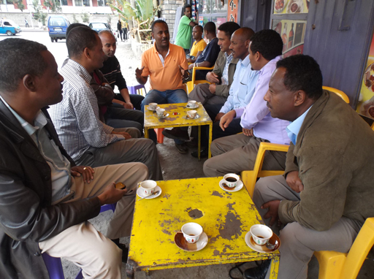
Figure 3.2 Focus groups discuss specific issues.
- Questionnaires are another possible assessment method. A questionnaire consists of a set of written questions that is given to a group of people for them to complete. Questionnaires require less input from the investigators than interviews, so it is possible to get the views of a larger number of people. However, there is no opportunity for a ‘conversation’ to develop, so some useful information may be missed. A typical sample questionnaire for use by householders is shown in Table 3.2. The number of questionnaires used is always a compromise. A very large sample means that the results will be more likely to represent the entire community, but a smaller sample size will reduce the costs and the time necessary to deliver, collect and process the questionnaires. As a rule of thumb, at least 15–20 households should be surveyed in each kebele. If householders are not able to complete the questionnaire themselves, it can be used as the basis for structured interviews (see Box 3.1).
Table 3.2 Household assessment questionnaire.
Kebele: ___________________ Questionnaire number: __________ (to be entered by survey team)
This questionnaire is about your household’s latrine and how you get rid of solid waste (kitchen waste, broken items, etc.). The results will be used to help us to improve the sanitation and waste services in your kebele. We will treat the results confidentially and will not be able to identify you or your family from this form.
Please answer all the questions below by placing a tick in the box next to the answer or by writing a few words.
Questions 1–6 are about the latrine used by members of your household while at home.
1. Does your household have access to a latrine?
(a) Yes (Please go on to answer questions 2–9)
(b) No (Please answer questions 7–9)
Table 3.2 Household assessment questionnaire (continued).
2. Who usually uses this latrine facility? (Tick all that apply)
(a) Mother | (e) Only females
(b) Father | (f) Only males
(c) All children | (g) Other (please specify): ______________
(d) Older sons and daughters
3. When is the latrine facility used?
(a) Day and night | (c) Night-time only
(b) Daytime only | (d) Don’t know
4. Which seasons is the latrine facility used in?
(a) Rainy season | (c) Throughout the year
(b) Dry season | (d) Don’t know
5. How many households share this latrine facility?
(a) Not shared | (c) Four or more households
(b) Two to three households | (d) Don’t know
6. For how long has your household used a latrine?
(a) Less than two years | (d) More than ten years
(b) Two to five years | (e) I can’t remember
(c) Six to ten years
Questions 7–9 are about how you deal with solid waste in your household.
7. Where do you get information about household waste management from?
(a) Radio or TV | (e) Place of worship
(b) Newspapers or magazines | (f) Other (please specify): _______________
(c) Health professional | (g) Don’t know
(d) Health Extension Workers
8. Where do you keep your solid waste until you get rid of it?
(a) Stored in a container in the house | (c) Take it directly to disposal
(b) Stored in a container outside | (d) Other (please specify): _______________
9. What is the main way you use to dispose of your solid waste?
(a) A waste pit in my yard | (e) A waste pit/dump outside my yard used by other households
(b) In my yard without using a pit
(c) Burned in my yard | (f) Dumped anywhere outside my household
(d) Taken to a collection point in the street | (g) Other (please specify): _______________

Box 3.1 Interviews and questions
Interviews and questionnaires may use closed or open questions. Closed questions offer a list of possible answers that the respondents must choose from. For example, ‘Does your household have its own latrine?’ These are very useful for obtaining this type of information, but the interviewer needs some background information about the area and the subject to know which questions to ask.
Alternatively, open questions permit free responses that should be recorded in the respondent’s own words. For example, the interviewer may say, ‘Tell me about your experiences with the shared latrine’.
A structured interview uses a standardised set of questions. These are usually closed questions with a limited range of possible answers. Each interviewee is asked the same set of questions. Structured interviews are used to obtain straightforward factual information such as the proportion of households in the kebele that have their own latrine.
In a semi-structured interview, the interviewer has a list of topics for discussion and a number of set questions (both closed and open) to help start a discussion, but he or she allows the conversation to progress in ways that are determined by the answers to previous questions. This allows the interviewee to have some say in the subjects covered and can often bring out information that the interviewer was unaware of or originally considered to be unimportant.
An in-depth Interview is a detailed conversation between the interviewer and interviewee about the subject as a whole. It is designed to allow the respondents to relate their experiences in their own way, while ensuring that anything that the interviewer wants to explore is also covered.

3.6 After the assessment
It is important to keep proper records during the assessment process. Notes of interviews and observations should be made in a notebook and not on scraps of loose paper. These notes should be transcribed onto a computer as soon as possible after taking them. After the assessment work has been completed, the notes and data can be analysed and the results prepared and presented in a report.

3.6.1 Analysing the findings
Using more than one method for the assessment will produce more complete information but it will also generate a lot of data that needs to be summarised. The standard method is to gather the information together and incorporate it into a set of tables. This should be done as soon as possible after the end of the survey. Table 3.3 shows an example of a blank table that would be completed for each kebele in a survey area.
Table 3.3 Kebele data summary sheet.
Kebele name:
 | Number | %
Demographic information
Total population
Male population and percentage of total population
Female population and percentage of total population
Total number of households
Sanitation information
Number of households and the percentage of total households:
that understand the benefits of having a latrine
that practise open defecation
with a traditional latrine type
with an improved latrine type
with a latrine pit hole cover
with handwashing facilities
where residents wash their hands after using the latrine
Solid waste information
Number of households and the percentage of total households:
with a covered waste container
that sort waste at household level (separate organic and inorganic)
that recycle/reuse waste at household level
with a waste pit in their yard
that use a municipal refuse container
that dispose of waste in open areas
The data can then be analysed and interpreted, and used to make decisions and recommendations for improvement. For example, suppose the analysis of a survey and observational results in a kebele showed that latrine use is lower than it should be; the questionnaire survey indicated that many of the local people were unaware of the benefits of good sanitation; observations showed that many of the latrines were of poor construction and, after discussions with community leaders, the survey team learned that the Health Extension Worker (HEW) had been away from the kebele for an extended period for training. Table 3.4 shows how the survey team summarised the problem and identified a number of possible solutions.
Table 3.4 Example of problem analysis for a kebele’s low sanitation coverage.
Main cause | Other causes | Possible solutions
Lack of awareness of the benefit of sanitation | History of open defecation | Produce better information leaflets and posters.  Encourage HEWs and select model households to promote latrine use.
Low quality of latrine construction (the pit walls often collapse during the rainy season) | Most of the latrines do not have pit linings | Investigate possible local sources of lining materials.  Look at the options for micro-finance systems to allow households to build better latrines.
The HEW has been away from the kebele on training | Lack of other staff to cover for the HEW | Encourage community members to look after some of the HEW’s work during absences.  Investigate sources of funding to employ or train more HEWs (longer term).

3.6.2 Reporting
The findings of the investigation and analysis need to be summarised and incorporated into a report. The report should always refer explicitly to the aims of the assessment that were agreed at the beginning and say how well these have been achieved. Depending on what the aims were, the report may identify the areas where action is necessary and make recommendations for a programme to implement the action plan (like the example shown in Table 3.4). The report will often make suggestions about any additional survey work that may be needed.
It is also useful to produce a brief factsheet that summarises the findings of the survey and to hold a meeting with the kebele administration at the end of the project and share the report’s findings with them.
The report will be distributed to the organisation that commissioned the work. They may ask that the report is also sent to other interested organisations. In any event, the report should only be sent to other organisations with the specific permission of the funding organisation.
Case Study 3.1 describes an assessment that was made of a town in Tigray region as part of a large WASH improvement project. Read the case study and then answer the question that follows.

Case Study 3.1 Baseline survey of Wukro, Tigray.
In 2014, a baseline survey of the town of Wukro and its surrounding villages was undertaken. The assessment was reported in the form of a six-page summary made up of text tables, charts and photographs. Like many good reports, it presented the main findings as a series of bullet points on the first page. These were that:
- coverage of the town water supply system was high – the majority of users accessed the piped system through household connections rather than public standposts
- reliability of water supplies was poor and most town residents used less than 20 litres per person per day
- household coverage with improved sanitation facilities was also reasonably high
- public standposts in the town were under high demand and queues were long, while poor functionality of water points was a concern in the satellite villages
- the majority of public institutions had improved sanitation facilities.
More detail was then presented on the assessment results in the areas of water services, sanitation and hygiene and institutional WASH. For example, the section on sanitation and hygiene included the data shown in Table 3.5.
Table 3.5 Household access to sanitation.
Type of sanitation Total Rural Urban
Improved sanitation Flush toilet to piped sewer system 1% 0% 1%
Ventilated improved pit latrine 4% 0% 6%
Pit latrine with slab 45% 12% 60%
Composting toilet 4% 7% 3%
Unimproved sanitation Public latrine 1% 0% 1%
Other unimproved sanitation facility 1% 2% 0%
Pit latrine without slab 25% 29% 24%
Bush/open defecation 15% 50% 4%
The report ended with a plan for recommended WASH interventions in the area.
(UNICEF, 2014)
- Based on the findings in Table 3.5, compare (a) the use of improved sanitation facilities and (b) open defecation in urban and rural parts of the Wukro study area.
- The answers are as follows:
        - In urban parts of the study area, the majority of households (70%) make use of improved sanitation but in rural areas only 19% have improved facilities.
        - The proportion of households practising open defecation is much higher in rural areas (50%) than urban areas (4%).

Summary of Study Session 3
In Study Session 3, you have learned that:
- Rapid assessment of sanitation and waste management provides information that will identify improvements needed and indicate possible solutions. It is also used in emergency situations where rapid response is needed.
- Assessment is normally carried out by a survey team of people with a range of skills and experience.
- The process begins with agreeing the scope of the assessment and setting the aims and objectives. This should involve all interested parties, including the community.
- Assessment methods include interviews, observation, community discussions, focus groups, and questionnaires. These should be supported by a review of existing documents and reports.
- The data obtained should be summarised in the form of tables and text as soon as the survey is completed. The data should then be analysed to determine any problems, the cause of the problems and possible solutions. This analysis should then be incorporated into a written report.

Self-Assessment Questions (SAQs) for Study Session 3
Now that you have completed this study session, you can assess how well you have achieved its Learning Outcomes by answering these questions. You can check your answers with the Notes on the Self-Assessment Questions at the end of this Module.

SAQ 3.1 (tests Learning Outcomes 3.1 and 3.3)
Rewrite the paragraph below using terms from the list provided to fill the gaps.
closed; in-depth; open; questionnaires; semi-structured; structured.
Interviews are frequently part of a rapid assessment process. ……………… interviews involve asking a set of questions that are decided in advance. These are usually ……………… questions that have a limited number of possible answers. This type of question is also often used in ……………… Questions that allow people to answer more freely are called ……………… questions. They are used in ……………… interviews. Both types of question are used in ……………… interviews.

SAQ 3.2 (tests Learning Outcome 3.2)
Imagine that in your kebele you have already noticed there is a low rate of latrine use by the householders. You think it would be helpful to conduct a rapid assessment in coordination with Health Extension Workers and other local team members. Write an overall aim and three possible objectives for such an assessment for your immediate supervisor.

SAQ 3.3 (tests Learning Outcome 3.3)
In a few sentences, say which methods you could use in the assessment mentioned in SAQ 3.2.

SAQ 3.4 (tests Learning Outcome 3.4)
What is the purpose of the report of a rapid assessment and who should receive copies of the report?

Study Session 4 Liquid Wastes: Sources, Types and Characteristics

Introduction
You were introduced to the main types of liquid waste in Study Session 1. This study session is the first of three that builds on that introduction and describes liquid wastes in more detail. We begin with a closer look at the sources and characteristics of liquid wastes. Study Session 5 focuses on the different types of latrine available for urban areas in Ethiopia. In Study Session 6 you will learn about the management and treatment of liquid wastes.
The type and composition of liquid waste depends on the source. In urban areas, the main sources are households, commercial establishments and industries. We need accurate information on the characteristics of liquid wastes in order to establish proper waste management processes to deal with them. In this study session you will learn about the main sources of liquid wastes and about different ways of characterising them. We also briefly describe some of the laboratory tests used to analyse liquid waste. The session ends with some specific examples of liquid wastes from industry.

Learning Outcomes for Study Session 4
When you have studied this session, you should be able to:
4.1 Define and use correctly all of the key words printed in bold. (SAQ 4.1)
4.2 Identify the main sources of liquid wastes and outline the differences between them. (SAQ 4.2)
4.3 Describe the characteristics of liquid wastes and give examples of tests used in their analysis. (SAQs 4.2 and 4.3)
4.4 Identify the main sources of industrial liquid waste in Ethiopia and outline the characteristics of the wastewaters they produce. (SAQ 4.4)

4.1 Sources of liquid waste
Liquid waste was defined in Study Session 1 as any waste in liquid form. The composition of liquid waste, also known as wastewater, is highly varied and depends principally on its source. In towns and cities, the three main sources are residential, commercial and industrial areas.

4.1.1 Liquid wastes from residential areas
- List three liquid wastes from your daily life.
- I’m sure you thought of several. Examples include the wastewaters from washing your face in the morning, from washing clothes, from taking a shower and from washing dishes. You may also have mentioned human bodily waste, which is also classified as liquid waste.
In urban areas, the liquid wastes from residential areas are often referred to as domestic wastewaters. These wastewaters come from our day-to-day living and include those from food preparation, washing, bathing and toilet usage. As you read in Study Session 1, different terms are used to describe wastewater from these various domestic sources.
- What is the difference between blackwater, greywater and sullage?
- Blackwater is wastewater that contains human excreta (faeces and/or urine). Greywater is wastewater from activities such as washing and food preparation and does not contain excreta. Sullage is another name for greywater.
Blackwater and greywater are produced from domestic dwellings with access to a piped water supply and also from business premises and the various institutions, such as schools and health centres, found in residential areas. The term sewage is used to describe a combination of all these types of liquid waste, frequently also with surface run-off.
In many towns and cities in the world, sewage is collected in underground sewers that carry the effluents to a sewage treatment works (Figure 4.1). (Effluent is another term for wastewater that flows out from a source.) At the treatment works, the sewage is cleaned by various physical and biological processes before being discharged into a river or lake. It may be possible to reuse the treated water, typically for irrigation. (Sewage treatment is described in Study Session 6.)
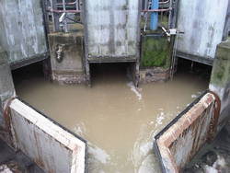
Figure 4.1 Sewage entering a sewage treatment works.
The quantity and type of liquid waste generated in a residential area depends on several factors, such as population size, standard of living, rate of water consumption, habits of the people and the climate. It also depends on the number and type of institutions such as schools and health centres in the area.

4.1.2 Liquid wastes from commercial areas
The wastewaters from commercial areas (Figure 4.2) – comprising business establishments, shops, open market places, restaurants and cafes – will mostly resemble those from households. This is because only human-related activities are undertaken in such areas, as opposed to other activities such as industrial production. Effluent from restaurants and cafes may contain high levels of oil from cooking processes but this can be overcome by using a grease trap (Figure 4.3) in their outlet pipes. A grease trap consists of a small tank or chamber which slows the speed of effluent flow. In the grease trap, fats, oils and grease float to the top of the wastewater and form a layer of scum that is contained within the tank. This can then be removed and disposed of as solid waste. Relatively clean water exits from the grease trap for disposal.
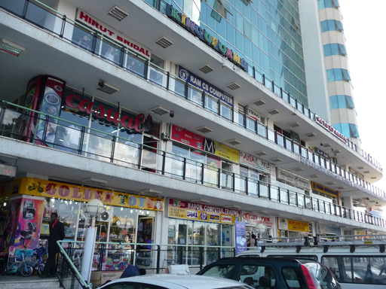
Figure 4.2 A commercial area of Addis Ababa.
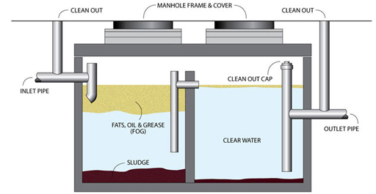
Figure 4.3 Cross-sectional diagram of a grease trap. Effluent flows into the chamber on the left and fats and oils float to the surface. This example has a second chamber to make the process more effective.
The quantity of wastewater generated per person in a commercial area will be less than it would be at home because the only time spent there is during the working day, and so activities such as bathing are not usually undertaken at these establishments.

4.1.3 Liquid wastes from industrial areas
In industrial areas liquid wastes are generated by processing or manufacturing industries and service industries, such as car repair shops. The type of industry determines the composition of the waste. The wastewaters from facilities that make food products will not be harmful to humans, but those from other industries may contain a variety of chemical compounds, some of which may be hazardous (and therefore potentially harmful). Industrial wastewaters which contain hazardous substances must be treated, and the substances removed before the wastewater is discharged to the environment. We will consider some specific examples of industrial wastes in Section 4.3.
The presence of hazardous materials is one way in which industrial wastewaters are often different from domestic wastewaters. Another difference is that the flow rate can vary dramatically in some industries, for example, where production rates vary with the season, such as in the processing of certain food crops.

4.1.4 Stormwater
Although not a form of liquid waste in the same way as wastes from residential, commercial and industrial areas, stormwater is also a form of wastewater. Stormwater can be contaminated with many different types of pollutant such as faecal matter, soil, rubber from vehicle tyre wear, litter, and oil from vehicles. Many parts of Ethiopia are faced with large volumes of stormwater during the rainy season (Figure 4.4). Where there is a sewerage network (a system of sewers), stormwater may be channelled into the sewers, or it may flow into open ditches.
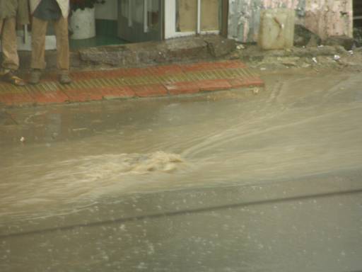
Figure 4.4 Stormwater flow during the rainy season in Ethiopia can sometimes exceed the capacity of the drains.

4.2 Characteristics of liquid wastes
Liquid wastes can be described according to their physical, chemical, and biological characteristics.

4.2.1 Physical characteristics of liquid wastes

Solids
Wastewaters may contain particles of solid material carried along in the flow. These may be settleable solids or suspended solids. Settleable solids sink to the bottom (settle out) when the speed of flow is reduced, for example, when the wastewater is stored in a tank. Suspended solids are small particles that remain in suspension in the water; they do not dissolve in the wastewater but are carried along in it. The solids content can be measured by filtering out and weighing the solids in a given volume of water. The laboratory procedure is to weigh a filter paper, pour a measured volume of water through the paper, then dry it and weigh again. The difference in mass equals the mass of solids which can be expressed in terms of milligrams of solid matter per litre of water, in units of mg l⁻¹.

Temperature
Wastewaters are generally warmer than the ambient temperature. This is because warm or hot water may be included in the waste stream from domestic activities such as showering or from industrial processing. The temperature is given in degrees Celsius (ºC).

Odour
Wastewaters can have an odour, usually due to generation of gases as a result of biodegradation in the wastewater. Biodegradation is the breaking down (decomposition) of organic substances by bacteria and other micro-organisms. Organic matter is any substance that is derived from living organisms, such as human and animal wastes, food waste, paper and agricultural wastes. Detecting odour tends to be a subjective process but it is possible to measure it in terms of odour units.

4.2.2 Chemical characteristics of liquid wastes

Organic matter
Wastewaters from many different sources contain organic matter, which is a frequent cause of pollution in surface waters. If organic matter is released into a river or lake, bacteria and other micro-organisms that are naturally present in fresh water will degrade the waste and in the process they use dissolved oxygen from the water. If there is a lot of organic matter, then most or all of the dissolved oxygen may be used up, thus depriving other life forms in the water of this essential element. The oxygen taken up in degrading the organic matter is referred to as its oxygen demand. This can be determined by a measure called the biochemical oxygen demand (BOD). BOD tests are carried out in a laboratory and involve measuring the amount of oxygen used, usually over a period of five days, as the organic matter in the wastewater breaks down. The result is the amount of oxygen used in degrading the organic matter in the wastewater, which is expressed in milligrams per litre (mg l⁻¹).
There is also a chemical method of determining the quantity of organic matter called the chemical oxygen demand (COD) test. This test is much quicker than the BOD test, taking only about two hours to carry out. It depends on chemical oxidation of the organic matter rather than biological degradation. It involves boiling a sample of wastewater with a mixture of concentrated acids and a measured quantity of oxidising agent to oxidise the organic matter. The amount of oxidising agent remaining at the end of the test is measured. The amount that has been used up is equivalent to the amount of organic matter in the sample. The result is again expressed in mg l⁻¹. COD tends to give higher results than BOD because the chemical process can oxidise more material than the biological process.

Inorganic material
Wastewater also contains inorganic chemicals. This means any substance that has not come from animals or plants, so it includes a wide range of different chemicals as well as inert solids like sand and silt. Many inorganic chemicals are dissolved in the water and although some are harmless, others are pollutants that can damage aquatic life such as fish and other organisms that live in water. One example is ammonia (NH₃) which is present in human and animal excreta. Like organic matter, ammonia is broken down in the environment by natural processes. If ammonia is released into a river it is converted by the action of bacteria to nitrate (NO₃), which is less harmful. This natural conversion of ammonia to nitrate requires oxygen and is limited if there are excessive quantities of ammonia. Other examples of inorganic chemicals in wastewaters are chloride (from salt), phosphates (from chemical fertilisers and from human and animal wastes), and metal compounds (from mining operations or metal-plating plants).

4.2.3 Biological characteristics of liquid wastes
Liquid wastes contain many different types of bacteria and other micro-organisms originating from human wastes and other sources. Many of these bacteria are beneficial and are responsible for the biodegradation of organic components of the wastes; others may be pathogenic. The presence of bacteria in wastewater is normal and expected, but it becomes a problem if the waste is not kept separate from people or if it contaminates clean water or food. The safe management and disposal of any waste containing human excreta is the most critical aspect of sanitation and hygiene and is essential to prevent the spread of infectious disease.

4.3 Industrial wastewaters in Ethiopia
The composition of industrial wastewater will vary depending on the type of industry, the raw materials used, and the processes undertaken. Three of the most important producers of industrial wastewater in Ethiopia are the food industry, the textile industry and tanneries.

4.3.1 The food industry
Food production is a priority in Ethiopia and plays a major part in the economy, with factories producing bread, beverages, sugar and several other products. Many of the production processes require large volumes of water and so most of the factories are located near rivers or boreholes.

Canneries
The volume of clean water required differs between canneries and the products they are preparing, but ensuring cleanliness is obviously essential. For tomato paste, a popular food product in Ethiopia, it takes about 220 litres of water to produce 10 kilograms of tomato paste. Canning factories that produce tomato paste, such as the Merti Processing Factory in Oromia, generate both solid and liquid waste. The quantity of solid tomato waste may be as much as 15-30% of the total quantity of product (Faris et al., 2002). The wastewater from a cannery will contain organic solids, primarily from washing raw materials such as tomatoes, cleaning equipment, spillage and from floor-washing.

Meat packaging
Wastewaters are generated at animal yards, slaughterhouses and packing houses. The main sources are animal faeces, urine, blood and water that has been used for washing floors and surfaces. The pollutants in the wastewaters are organic and can decompose rapidly, generating unpleasant odours. If discharged to a water body, they will cause severe environmental pollution. The meat industry utilises thousands of litres of water per day depending on the size of the facility and the number of animals processed.
- What will be the effect of the organic waste from meat packaging if it is discharged into a river?
- The organic waste will exert an oxygen demand as it is broken down by bacteria. This could deplete the oxygen available for other living organisms in the water such as fish.

Dairy industry
Wastewaters from dairies may come from receiving stations (where milk is delivered from individual farms), bottling plants, creameries, ice cream plants, cheese production units and dried milk production plants. The wastewater from spillage, cleaning and washing usually contains milk which has a very high polluting potential. The polluting potential is the potential of the wastewaters to cause pollution, i.e. damage to the condition, health, safety, or welfare of animals, humans, plants or property.

4.3.2 Textile industry
The raw materials for the textile industry are wool, cotton and synthetic fibres. The processing of wool and cotton involves removing natural impurities, such as dust, and imparting particular qualities relating to appearance, feel and durability. Water is used for washing at various stages, producing effluent that is likely to contain suspended solids and organic material from processing the fibres. It may also contain dyes and other chemicals, depending on the specific processes used in the factory. The outputs from these processes are used to make clothing and other textile products (Figure 4.5).
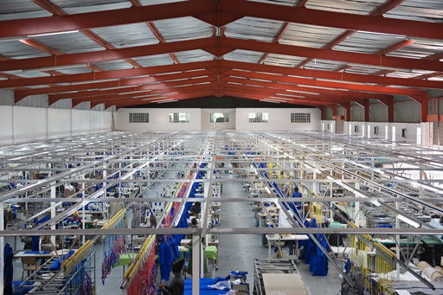
Figure 4.5 Textile factories may be clean and dry but they depend on the previous processing of raw materials that produces liquid effluents.

4.3.3 Tanneries
Ethiopia has the largest livestock population of all countries in Africa (TAM Consult, 2008) and tanning of animal hides is an important economic activity. There are 26 major tanneries in Ethiopia (UNIDO, 2012) producing a range of products from sheep, goats and cows including partly processed hides and finished leather (Figure 4.6).
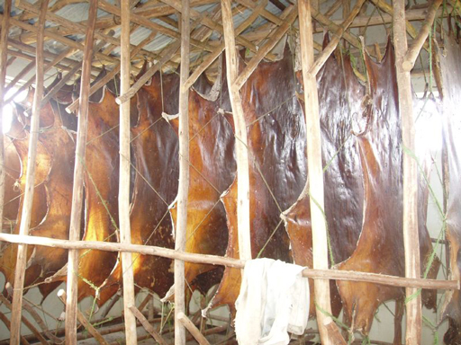
Figure 4.6 Animal skins drying in a tannery.
Tannery effluent is highly polluting and is often discharged directly to nearby rivers without adequate treatment. It contains toxic (poisonous) chemicals such as chromium, sulphides and organic acids, as well as organic matter and solids. Chromium is a particular problem because it is an example of a heavy metal. Heavy metals are a group of toxic chemical pollutants that persist in the environment, i.e. they do not get broken down by natural processes. Tannery wastewaters are produced in large volumes and are considerably more polluting than wastewaters from most other industries. The treatment of tannery waste involves removing solids and organic matter from the effluent. These processes are described in Study Session 6.

Summary of Study Session 4
In Study Session 4, you have learned that:
- The composition of liquid waste depends on its source. The three main sources are residential, commercial, and industrial areas. Stormwater is also a source of liquid waste.
- Liquid waste from domestic sources can be classified as blackwater, which contains excreta, and greywater, which does not.
- Liquid waste from commercial areas is broadly similar to wastewater from residential areas. Fats and oil from restaurants and cafes can be removed using a grease trap.
- The characteristics of industrial wastewaters depend on the type of industry. Some industrial wastewaters are hazardous.
- The characteristics of wastewaters can be described in physical, chemical and biological terms.
- Physical characteristics include the amount of suspended solids, the temperature and odour. The amount of suspended solids is measured by filtering a known volume of wastewater and weighing the solids retained on the filter.
- The quantity of organic matter in liquid waste is an important measure of its polluting potential. If discharged into a river or lake, organic matter exerts an oxygen demand which can reduce the availability of oxygen for fish and other aquatic organisms.
- Organic matter is measured in terms of biochemical oxygen demand or chemical oxygen demand.
- Three examples of industries in Ethiopia that produce liquid wastes are food, textiles and tanneries. They each produce polluting liquid wastes that should be treated before being discharged into the environment.

Self-Assessment Questions (SAQs) for Study Session 4
Now that you have completed this study session, you can assess how well you have achieved its Learning Outcomes by answering these questions. You can check your answers with the Notes on the Self-Assessment Questions at the end of this Module.

SAQ 4.1 (tests Learning Outcome 4.1)
Rewrite the paragraph below using terms from the list provided to fill the gaps. (Note that some of these terms have been defined in earlier study sessions.)
biochemical oxygen demand, biodegradation, blackwater, chemical oxygen demand, effluent, greywater, hazardous, heavy metals, inorganic, liquid waste, oxygen demand, pathogenic, polluting potential, sewage, sewers, sullage, suspended solids, wastewater.
When we use water for any purpose and it becomes unclean after we used it, we refer to it as ……………… or ……………… In our homes we generate two types of ……………… The type from toilets which contains excreta is called ………………, while other wastewaters (e.g. from clothes washing) that are not contaminated by excreta are referred to as ……………… Another word for the latter type of wastewater is ……………… Domestic wastewater is sometimes referred to as ………………… In many towns and cities around the world domestic wastewater goes into underground pipes called ……………… that take the wastewater to treatment works.
The solids in wastewater that are carried along in flowing water are called ……………… Organic matter in water may cause odours due to ……………… It also creates ………………, which can be measured by its ……………… or ……………… If faecal matter is in the water, there may be ……………… micro-organisms present. ……………… chemicals in wastewaters are likely to include nitrates and phosphates. Industrial wastewaters may have significant ……………… for example, tannery waste frequently contains persistent ……………… pollutants that contain ………………

SAQ 4.2 (tests Learning Outcomes 4.2 and 4.3)
Suggest two ways in which wastewater from residential areas may differ from wastewater from
  - commercial areas
  - industrial areas.

SAQ 4.3 (tests Learning Outcome 4.3)
- Worknesh is a laboratory technician. She is analysing a sample of wastewater collected from a pipe that discharges effluent into a river. Name two tests Worknesh could perform to assess the physical characteristics of the effluent.
- As part of the analysis she also does a BOD test on the sample and gets an unusually high result. What does the high BOD tell her about the wastewater? What effect could it have on the river?

SAQ 4.4 (tests Learning Outcome 4.4)
Which of the following statements are false? In each case explain why it is incorrect.
- Effluent from food processing factories is safe to discharge to rivers without treatment.
- The manufacture of clothing material often uses coloured dyes that may be discharged in effluent from the factory.
- Tannery waste is highly polluting because it contains large quantities of suspended solids.
- Wastewater from slaughterhouses contains blood, animal excreta and washing water.

Study Session 5 Latrine Technology Options for Urban Areas

Introduction
Ethiopia is one of many countries that has a limited sewerage system and lacks established facilities to treat sewage. On-site latrines are the most appropriate method of dealing with human wastes in this situation. This is the main focus of this study session, which goes into detail on the various latrine technology options that are available for urban areas.

Learning Outcomes for Study Session 5
When you have studied this session, you should be able to:
5.1 Define and use correctly each of the terms printed in bold. (SAQ 5.1)
5.2 Describe the various latrine technology options available in urban areas. (SAQ 5.2)
5.3 Calculate the size of a pit latrine given appropriate data. (SAQ 5.3)
5.4 Briefly describe the key factors that should be considered when selecting a latrine system. (SAQ 5.4)

5.1 Trends in latrine use in Ethiopia
- Think back to Study Session 1 and explain what you understand by the sanitation ladder.
- The sanitation ladder measures progress towards providing adequate sanitation facilities for every household. It ranks sanitation provision in increasing order of desirability, as listed below:
- open defecation (least desirable)
- unimproved facilities
- shared facilities
- improved facilities (most desirable).
Figure 5.1 shows the changes in sanitation coverage in Ethiopia from 1990 to 2012 for urban and rural populations, and the total for the whole country. The columns in the diagram show the coverage according to the categories of the sanitation ladder. The sloping lines between 1990 and 2012 indicate the change over that time.
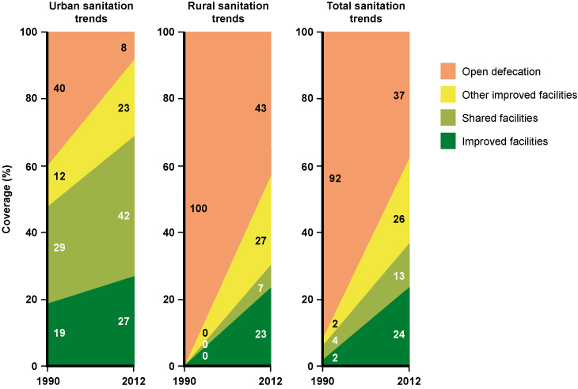
Figure 5.1 Changing sanitation coverage in Ethiopia. (Data from JMP, 2014)
- How has the situation changed with respect to open defecation in urban areas from 1990 to 2012?
- The practice of open defecation in urban areas has reduced by $\frac{\text{40 – 8}}{\text{40}}$ × 100 = 80%. This is good news indeed!
Open defecation leads to the spread of disease and environmental pollution, so even the basic latrine is an improvement. The following sections of this study session describe the different types of latrine that come above open defecation on the sanitation ladder.

5.2 Unimproved latrines
As you know from Study Session 1, unimproved latrines, such as traditional pit latrines, do not ensure hygienic separation of human excreta from human contact.

5.2.1 Traditional pit latrines
A traditional pit latrine (Figure 5.2) consists of a pit in the ground without any slab. The pit may be wholly or partially lined to prevent it collapsing. The Central Statistical Agency (2014) found in a survey that 44.4% of households in urban areas of Ethiopia use traditional pit latrines. The quality of these latrines is far below acceptable standards and, consequently, they pose great health risks to users and pollution risks to the environment. The Ministry of Water and Energy (2011), reported that the quality of latrines is generally poor, with more than 50% structurally unsafe and 50% unhygienic. Latrines of this type frequently generate bad smells and are prone to insect infestation.
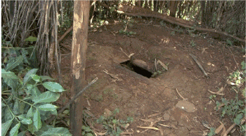
Figure 5.2 Traditional pit latrine with no slab.

5.3 Shared latrines
Shared latrines are household latrines used by two or more households. They can be of a high standard, but there is always a risk that nobody takes responsibility for keeping them clean, meaning that they are not looked after properly. Communal latrines and public latrines (Figure 5.3) are also classed as shared latrines. The Central Statistics Agency survey (2014) found that about 33.3% of urban residents in Ethiopia use shared latrines.
Public latrines provide a much-needed service to local people and can be hygienic as long as they are properly maintained and managed. They also create employment for cleaners and attendants, who collect money from users. However, the operation and management of many shared latrines in Ethiopia needs improving.
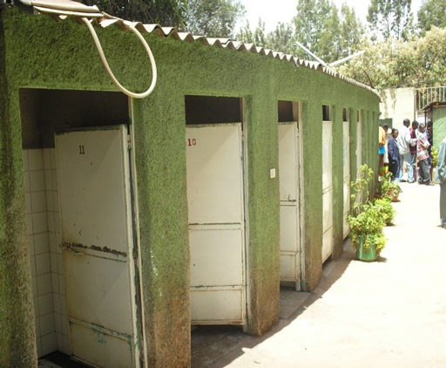
Figure 5.3 A clean, well-maintained public latrine in Addis Ababa.

5.4 Improved latrines
For a latrine to be classed as ‘improved’ (Figure 5.4), it should satisfy the following requirements:
- it should be safe to use (the pit may need to be lined)
- it should have a structurally sound and cleanable slab floor
- handwashing facilities should be available (Figure 5.5)
- there should be no contamination of groundwater or surface water
- the squat hole should be fitted with a lid so that excreta is not accessible to flies or other creatures
- it should be free from odours or unsightly conditions
- there should be no need for people to handle the excreta.
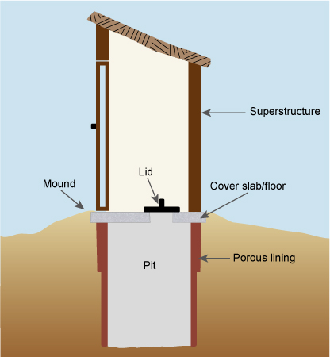 | 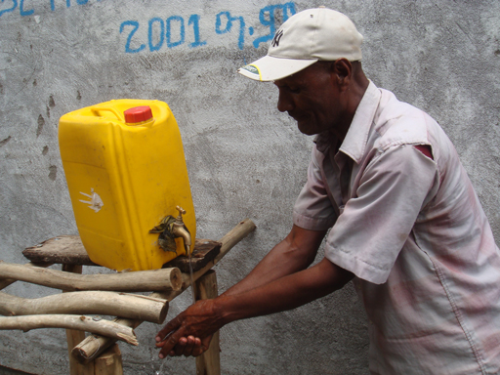
Figure 5.4 An improved pit latrine. | Figure 5.5 Handwashing facility at a latrine.
If possible, the latrine should be 6–10 m from the home, and located downwind from the house. It is best not to build a latrine in areas where groundwater is used as a water source, but if this has to be done, the base of the pit should be at least 2 m above the water table. On sloping ground, it should be located below the level of any well or water source, so that any liquid seeping out of the pit flows away from the water source. The minimum horizontal distance between the pit and water source varies with location, soil type and geology. Generally, the pit should be at least 15 m away from a water source, although some authorities recommend a minimum distance of 30 or 50 m (Graham and Polizzotto, 2013). In Ethiopia, federal guidelines state that latrines must be sited at least 30 metres from any water source to be used for human consumption and if on sloping ground be lower than the source (MoH, 2004).
The latrine should be on a mound so that any water runs away rather than into the pit, and diversion ditches should be prepared around the latrine. Diversion ditches intercept surface run-off that may flow towards the pit and channel (divert) it away in another direction.
If the soil formation is unstable and liable to collapse, the wall of the pit should be lined for at least the top 0.5 m. The diameter of the pit should be at least 1 m, but should not exceed 1.5 m because this increases the risk of the pit collapsing.
The lifetime of a pit latrine depends on several factors, such as the depth of the pit, the number of users, the type of anal cleansing materials used (e.g. water, degradable material such as paper, leaves or sticks, or non-degradable material such as stones), and the rate of decomposition of the faecal material in the pit. The pit should be designed for three to five years of use.
The accumulation rate of sludge on average, is 40–60 litres per person per year (Tilley et al., 2014). The depth of a pit latrine should be at least 1.5 m, but the figure can be calculated more precisely using the following formula (Faris et al., 2002):
Depth of pit = $\frac{\text{P} \text{×} \text{S} \text{×} \text{N}}{\text{A}}$ + 0.5 m
where:
P = average number of users
S = sludge accumulation rate in m³ per person per year
N = minimum useful life required in years
A = cross-sectional area of the pit in m²
Note that in this formula the sludge accumulation rate is required in units of cubic metres per person per year. The additional 0.5 m is so that the latrine can be covered with 0.5 m of soil at the end of its life.
- Using the above formula, calculate the required pit depth for a 1 m diameter latrine that has to last five years for a five-person household. Assume the sludge accumulation rate is 50 litres per person per year. In this case:
P = 5
S = 50 litres per person per year = 0.05 m³ per person per year
N = 5 years
- A is given by the formula for the area of a circle (π × $\frac{{\text{d}}^{\text{2}}}{\text{4}}$) or (3.142 × $\frac{{\text{1}}^{\text{2}}}{\text{4}}$) = 0.79 m²
So the depth needed is $\frac{\text{5} \text{×} \text{0.05} \text{×} \text{5}}{\text{0.79}}$ + 0.5 = 2.1 m
The slab for an improved pit latrine must be firm, secure and well-constructed. Slabs can be made from locally-available materials such as wooden logs, planks or concrete.
One widely-used type of slab is the sanitation platform or SanPlat (Figure 5.6) which has the following features (Brandberg, 1997):
- a keyhole-shaped drop hole that is small enough to be child-safe and big enough to be used comfortably by adults
- elevated footrests correctly placed to help the user to find the right position in complete darkness
- smooth and sloping surfaces draining towards the hole that are easy to clean and prevent the formation of puddles of water or urine.
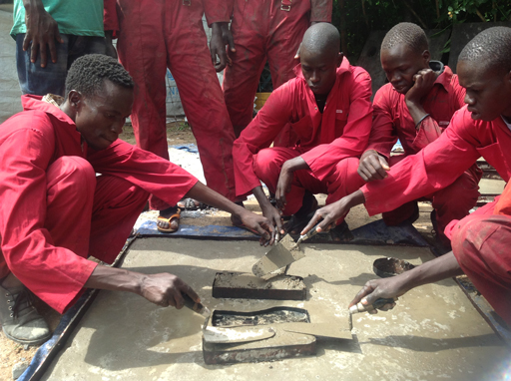 | 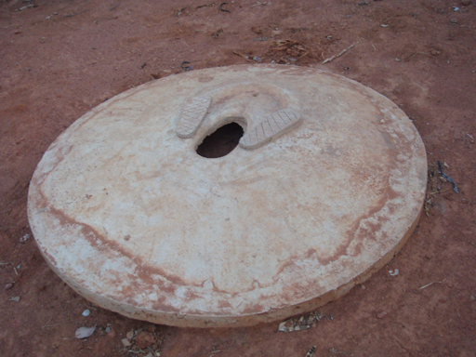
Figure 5.6 SanPlats may be square or circular.
The superstructure of the latrine provides privacy for the users and protection from the sun and the rain. The materials to be used for the superstructure will depend on what is available locally and will vary in urban and rural areas. Typically, wood, canvas sacks, thatch, bamboo, mud blocks, concrete blocks, bricks, stone with concrete, and corrugated iron sheets have been used (Figure 5.7).
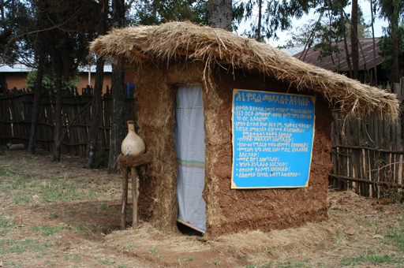 | 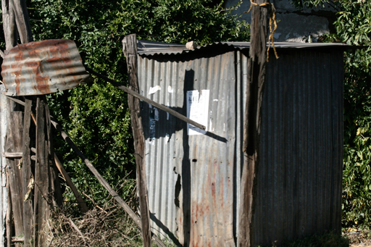
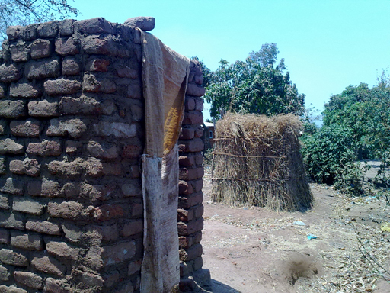 | 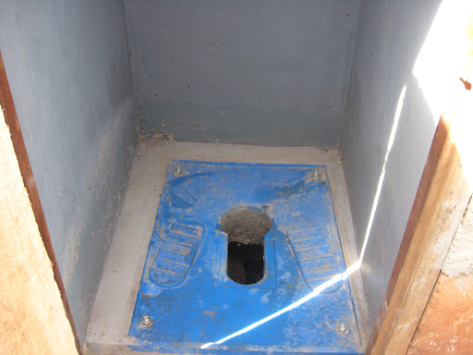
Figure 5.7 Pit latrine superstructures made of different materials.
There are also choices for the type of pit lining material (Figure 5.8).Typical lining materials include:
- perforated concrete rings
- rot-resistant timber
- bricks
- burnt mud blocks
- rocks or stones
- mortar plastered onto the soil
- other local materials such as bamboo, etc.
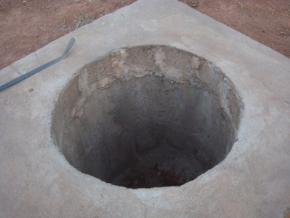 | 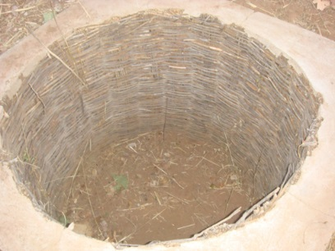 | 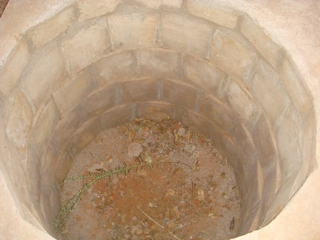
Figure 5.8 Pit linings made from stones, bamboo and blocks.

5.4.1 Ventilated improved pit latrine
The ventilated improved pit latrine or VIP latrine differs from a standard improved latrine due to the addition of a vent pipe (Figure 5.9). The VIP latrine was developed to overcome the problems of odour and fly breeding commonly found in unvented pit latrines.

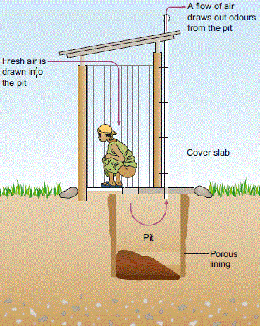
Figure 5.9 A ventilated improved pit (VIP) latrine.
Odour control is achieved by air coming in through the superstructure, entering the squat hole and pushing the hot, smelly air in the pit upward through the vent pipe. The pipe is typically 110–150 mm in diameter and reaches more than 300 mm above the highest point of the superstructure. Wind blowing across the top, open end of the vent pipe carry the odorous gases away. The thermal effect of the sun heating the vent pipe also draws odorous gases out of the pit; this effect can be improved by painting the pipe black, which makes the vent pipe warmer and creates an updraft that pulls air and odours up and out of the pit. Reducing the continuous air flow by obstructing either the squat hole or the vent pipe reduces the effectiveness of odour control.
Fly control is achieved by a screen at the top of the pipe. Flies outside the latrine attracted to the odour emitted by the vent pipe are unable to pass inwards through this screen. Flies emerging from the pit are attracted to the light at the top of the pipe; they become trapped under the screen, and eventually die. For effective fly control the inside of the latrine must be kept dark. The mesh size of the fly screen must be large enough to prevent clogging with dust and allow air to circulate freely. Aluminium screens with a hole size of 1.2–1.5 mm have proved to be the most effective (Tilley et al., 2014).

5.5 Ecological sanitation
Ecological sanitation, also known as ecosan, describes an approach to human waste management rather than a single method. In ecosan systems, human excreta is considered to be a resource, not waste. The principle is to make use of excreta by transforming it into an end product that can be used as a soil improver and fertiliser for agriculture. Ecosan systems require more space than conventional latrines, but they provide a more sustainable approach to waste management than other systems.
In the group of improved sanitation facilities in the sanitation ladder (see Figure 1.3 in Study Session 1), ecosan systems are represented by composting toilets. Composting toilets convert human waste into compost (soil-like material that can be safely used as fertiliser) by the action of aerobic bacteria. Aerobic means ‘with oxygen’ and is usually applied to microbial decomposition processes that take place where air is present. Composting toilets are just one of several latrine technologies that can be classified as ecosan systems.

5.5.1 Arborloo
A simple form of ecological sanitation is the Arborloo (Figure 5.10). Arborloos are mostly used in rural areas in Ethiopia because of their space requirements. An Arborloo is a single, unlined shallow pit with a portable ring beam (circular support), slab and superstructure. It is used like a normal latrine, but with the regular addition of soil, wood ash and leaves. When it is full, it is covered with leaves and soil and a small tree is planted on top to grow in the compost. (The tree gives the system its name; ‘arbor’ is Latin for ‘tree’.) Another pit is dug nearby and the whole structure is relocated over the new pit. No handling of the waste is required. If a fruit tree or other useful variety is grown, there is the added benefit of food or income.
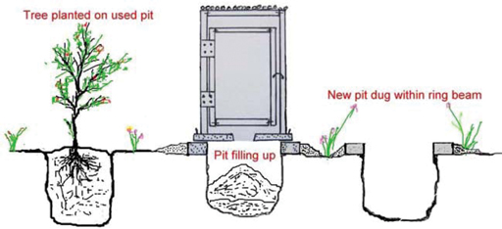
Figure 5.10 Arborloo – a simple ecological latrine that helps people to see human excreta as a resource, rather than as waste.

5.5.2 Urine-diverting latrine
The urine-diverting latrine (Figure 5.11), also known as a urine-diverting dry toilet (UDDT) is a latrine that separates urine and faeces. Both wastes are treated separately, without damaging the environment or endangering human health, and then used in agriculture. The urine and faeces go into different containers at the source (Figure 5.12). The urine is kept for 24 hours, after which it is mixed with three parts water to be used as a very effective fertiliser. Soil or ash is added to the latrine after each use and the faeces are composted. After approximately 12 months, pathogenic micro-organisms will have died off and the composted faeces can be used as a soil conditioner (helping the soil to retain moisture) for household gardening or urban agriculture.
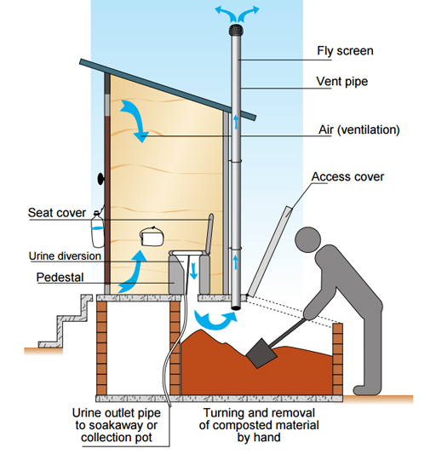
Figure 5.11 Basic components of a urine-diverting latrine.

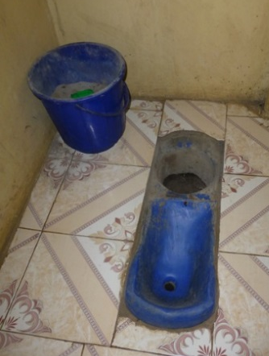 |  | 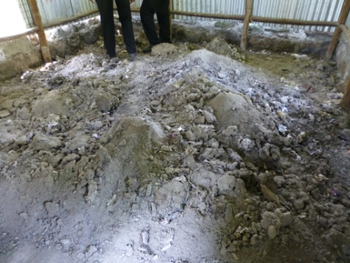
(a) | (b) | (c)
Figure 5.12 (a) Interior of a urine-diverting toilet. The small hole is for urine; the larger hole is for faeces, which are covered with a scoopful of ash from the bucket each time. (b) Faeces and ash collect in a container below the latrine that is emptied regularly. (c) Composting faeces with ash are stored under cover for at least 12 months; they do not smell.

5.5.3 Biogas latrines
In a biogas latrine or bio-latrine (Figure 5.13), the waste enters an airtight tank situated underground, and undergoes anaerobic digestion, resulting in the production of biogas and digested sludge. Biogas is a clean and convenient fuel that contains about 60% methane. Anaerobic digestion is the process whereby bacteria and other micro-organisms break down (decompose) organic material in the absence of air, yielding biogas. The digested sludge collects in a separate tank and can be used as a soil fertiliser.
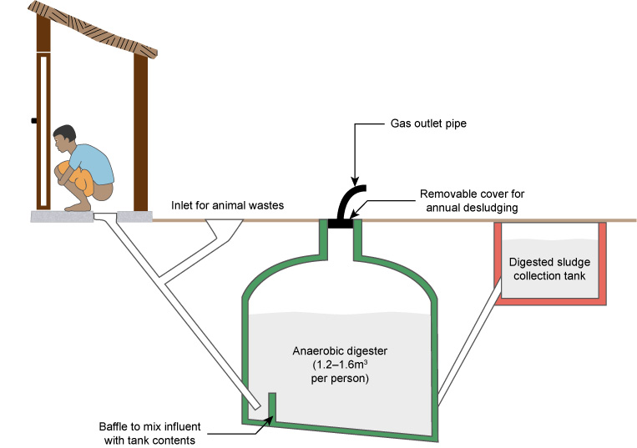
Figure 5.13 Basic components of a biogas latrine.
Biogas can be used for cooking and lighting, refrigeration, engine operation and electricity generation. Animal wastes can also be added to the digester. Being a relatively expensive system, this has been applied in Ethiopia only at public latrines (Figure 5.14) and institutions such as schools, colleges, universities, hotels and prisons, where large numbers of people use the latrine.
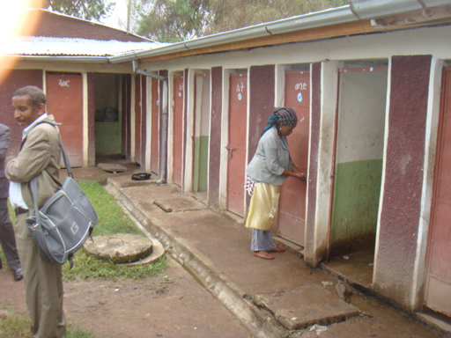 | 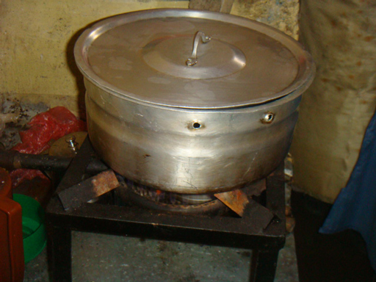
(a) | (b)
Figure 5.14 (a) Public biogas pit latrines in Addis Ababa, constructed by the Emmanuel Development Association and financed by WaterAid. (b) Biogas is piped from the anaerobic digester to a nearby cafeteria where is it used for cooking.

5.6 Water-flushed systems
All of the latrine technologies described so far are dry systems. These are the most appropriate systems for places where there is limited water supply. If water is piped into the premises or is otherwise easily available, then a water-flushed system can be used. Water-flushed toilets, also known as water carriage or water-borne toilets, can be connected to a pit, septic tank or sewer. A septic tank is an underground, watertight tank in which sewage is collected. Faecal solids accumulate in the tank and partially treated liquid is discharged into the ground. You will learn more about septic tanks in Study Session 6.

5.6.1 Pour-flush toilets
The problems of flies and smells in latrines can be overcome by using a toilet pan with a water seal (Figures 5.15 and 5.16). The shape of the toilet pan is designed with a bend in the outlet pipe. Water remains in the bend at all times and creates a ‘water seal’. Pour-flush toilets use this system. After defecation, 1.5–2 litres of water is poured (using a small container) into the toilet pan to move the wastes along. This system is popular where people traditionally use water for anal cleansing, and where water is readily available. Pour-flush toilets can be located inside the house, since the water seal prevents bad odours and insect nuisance.
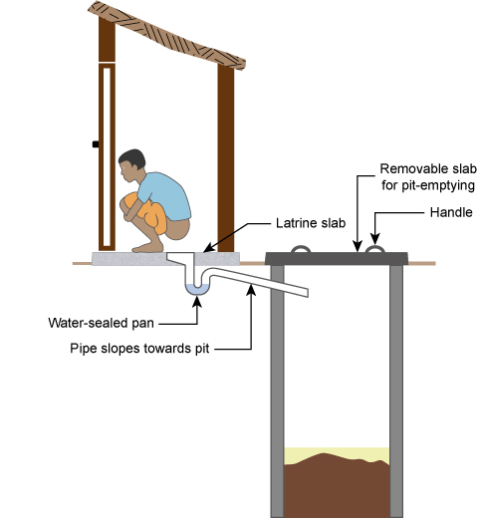
Figure 5.15 Basic components of a pour-flush toilet, showing the water seal.
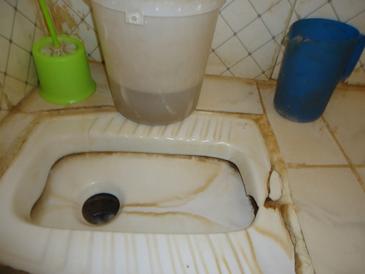
Figure 5.16 A pour-flush toilet. Water is stored in the white bucket and the blue jug is used for pouring water in after use.

5.6.2 Cistern-flush toilet
The cistern-flush toilet (Figure 5.17) also known as a water closet or WC, is usually made of ceramic material and consists of two parts: a bowl into which excreta are deposited and a tank (cistern) with volume of approximately 6-13 litres that supplies flush water for carrying away excreta. It needs a connection to constant running water for operation, and a discharge pipe to take the wastewater away to a sewer or septic tank. WCs are quite common in government offices, schools, hotels and health facilities. The attractive feature of the flush toilet is that it has a water seal to prevent odours from coming back up through the plumbing, but it is costly and requires a skilled plumber for installation.
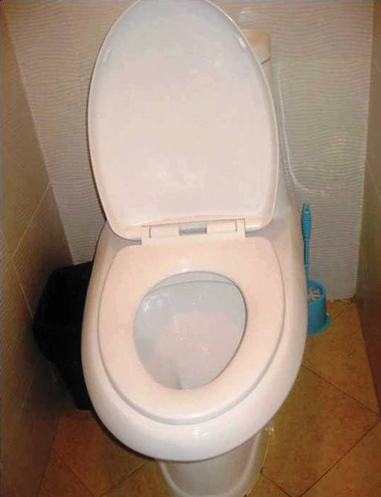
Figure 5.17 A cistern-flush toilet.

5.6.3 Urinals
Urinals, used by men and boys, are only used for collecting urine. Urinals are either wall-mounted units or a drainage channel constructed on the floor in connection with the wall. Most urinals use water to flush. In public places and schools, urinals for men and boys help to keep toilets cleaner and decrease the demand for toilet seats.

5.7 Choice of latrine technology
Several factors have to be considered when choosing the most appropriate latrine technology. This is a complex technical process so we can only cover some of the main issues here.

5.7.1 Location
You read earlier about the need to consider groundwater contamination. For any type of pit latrine, the location of the pit relative to water sources is of prime importance. Distance from houses and the users also needs to be considered.
The availability of water will determine whether or not a water-flushed system is possible. If an adequate water supply is available, pour-flush or cistern-flush toilets can be considered as an option. Otherwise, pit latrines have to be the system of choice. The space requirements (especially in urban areas) may limit the choice of systems that can be installed.

5.7.2 Construction materials
The type of construction materials and their availability will often dictate the type of latrine that is possible in a given area. To keep costs down, and for the latrines to be sustainable (i.e. to be able to be used for a long time), materials that are readily available locally should be used for construction. Added to this, a system that is easy to build and maintain using locally available skills is preferable.

5.7.3 Cost
Latrine systems have to be affordable to the users. The cost is made up of two components: construction cost and operating cost. The operating cost will include the cost of pit-emptying (in the case of pit latrines) and the cost of water (for water-flushed systems). The total cost should be kept low so that most people find it affordable.

5.7.4 Safety and accessibility
The latrines should be safe for both children and adults to use. For instance, the size of the squat hole should not pose a danger to children using the facility.
Accessibility for elderly people and people with disabilities is another important consideration. The chosen system should be easily accessible to them without causing discomfort or inconvenience. As examples of modifications, handrails may need to be installed to help the infirm and those who are blind, and the door of the latrine should be wide enough for wheelchair access (Figure 5.18).
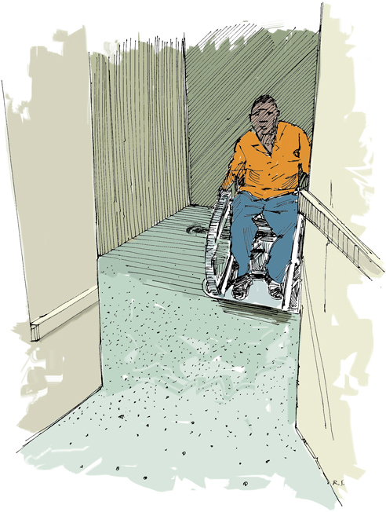
Figure 5.18 Consideration should be given to all users, particularly those with mobility problems.

5.7.5 User preferences
The people who will use the latrines should be consulted on their preference of latrine systems. There may be cultural and social reasons why some types are preferred over others. People will only use the system if they are happy with it. They should be given details of the options possible in their locality (e.g. design features, costs, maintenance details, etc.), so that they can make an informed choice. Now you have learned about the various latrine and toilet options, in Study Session 6 we will look at how the waste that is deposited in these latrines is managed.

Summary of Study Session 5
In Study Session 5, you have learned that:
- In Ethiopia the trend in latrine use since 1990 is positive, with a significant reduction in open defecation.
- Traditional pit latrines pose health and environmental risks and are frequently structurally unsafe.
- Shared latrines are used by two or more households; the term also applies to communal and public latrines.
- Improved latrines ensure the hygienic separation of human waste from people. They should be safe to use and easy to maintain.
- Pit latrines must be located and designed with care and constructed using appropriate techniques and locally available materials.
- The required depth of a proposed pit can be calculated from the number of users, the sludge accumulation rate, the required lifetime of the pit and the cross-sectional area of the proposed pit.
- Improved facilities include ventilated improved pit latrines, ecological sanitation systems such as the Arborloo, urine-diverting latrines and biogas latrines, and pour-flush or cistern-flush toilets which are appropriate if water is available.
- Selection of latrine technologies depends on location, the availability of materials and costs. Due consideration must be given to safety and accessibility and the needs and wishes of users.

Self-Assessment Questions (SAQs) for Study Session 5
Now that you have completed this study session, you can assess how well you have achieved its Learning Outcomes by answering these questions. You can check your answers with the Notes on the Self-Assessment Questions at the end of this Module.

SAQ 5.1 (tests Learning Outcome 5.1)
Write the following words next to their correct definitions in the table below.
anaerobic digestion; biogas latrine; cistern-flush toilet; ecosan latrine; improved latrine; pour-flush latrine; urine-diverting latrine; VIP latrine.
a type of latrine that separates urine and faeces
a type of latrine that generates a fuel gas
a latrine where there is no contact between the user and the excreta produced
a type of toilet where a water supply is needed for operation
a type of latrine where the faecal matter is composted
a modification of the simple pit latrine where the problems of odour and flies have been addressed
the process by which organic matter is decomposed by microorganisms in an environment where there is no air
a type of latrine where the user has to move the excreta along using water

SAQ 5.2 (tests Learning Outcome 5.2)
Ato Aschalew, a resident in the outskirts of your town, consults you about building a latrine in the compound of his house. He is an open-minded man who is keen to improve life for his family. He has a wife and three young children, and his elderly mother also lives with them. He doesn’t have a tap in his house and gets water from a nearby well. The area has heavy soil and the rock below is impermeable.
- Which types of latrine are possible choices for him?
- Which types of latrine would you recommend, and why?
- What other advice would you give him about the location, design and construction of the latrine?

SAQ 5.3 (tests Learning Outcome 5.3)
Galawdeyos and his family comprise a total of seven people. They plan to build a new VIP latrine with a pit with a diameter of 1 m in their back yard. Calculate the depth of pit required if they intend that it should last them three years. Take the sludge accumulation rate to be 40 litres per person per year.

SAQ 5.4 (tests Learning Outcome 5.4)
Which of the following statements are false? In each case explain why it is incorrect.
- For sustainability, it is best to use locally-available materials and skills when constructing latrines.
- The aim should always be to have water-borne toilets such as the WC.
- Constructing a pit latrine with a mound ensures that any water drains away.
- The raised footrests in a latrine help in the proper use of the facility in darkness.
- The cost of the latrine to the user is immaterial, since good health from proper sanitation is priceless.

Study Session 6 Liquid Waste Management and Treatment

Introduction
Dealing with liquid wastes is one of the biggest challenges of urban sanitation. Liquid waste management requires capital investment, skilled personnel, coordination between different government departments and organisations, and awareness of the issues by the public. Failure to manage liquid wastes, especially human excreta, leads to health and environmental problems.
In urban Ethiopia the vast majority of people (80%) use pit latrines for human waste disposal (Central Statistical Agency, 2014). In some parts of Addis Ababa, liquid waste from waterborne toilet systems is collected via a sewerage system and sent to the wastewater treatment facility at Kality. There are, however, many houses and institutions with waterborne toilet systems that are not connected to the sewerage system. In these places, the sewage is sent to septic tanks. These different sanitation technologies require different techniques for managing and disposing of the wastes.
This study session looks at what happens to human excreta and other liquid wastes after they are produced. You will learn about the methods used to remove sludge from pits and septic tanks and about some of the options for managing and treating liquid wastes, including human excreta, sullage and stormwater.

Learning Outcomes for Study Session 6
When you have studied this session, you should be able to:
6.1 Define and use correctly all of the key words printed in bold. (SAQ 6.1)
6.2 Describe some options for the collection and transport of faecal sludge. (SAQ 6.2)
6.3 List the sources of faecal sludge, and how it can be treated and reused. (SAQ 6.3)
6.4 Describe the main methods for wastewater treatment and explain the differences between them. (SAQ 6.4)
6.5 Suggest a suitable means for sullage disposal. (SAQ 6.5)
6.6 Suggest appropriate methods for stormwater management. (SAQ 6.6)

6.1 Faecal sludge management
When human excreta collects in a pit latrine, the solids settle at the bottom and form a slurry called faecal sludge. Over time the sludge accumulates and periodically needs to be removed and disposed of. This process presents several challenges because the sludge is offensive, a potential danger to human health and highly polluting if dumped indiscriminately into the environment. Faecal sludge management (FSM) is a set of processes designed to ensure that people and the environment are protected from these hazards. It includes the storage, collection, transport, treatment and safe end use or disposal of faecal sludge (Strande et al., 2014). FSM is a significant problem in towns and cities in many developing countries. Key issues are who is responsible for collecting sludge and where and how it is disposed of.
The next section describes some of the methods for removing faecal sludge from pit latrines. These methods also apply to sludge removal from septic tanks, which are described in detail in Section 6.3.

6.2 Pit emptying
The process of pit emptying is sometimes called desludging. There are manual and mechanical methods for desludging, but the manual removal of faecal sludge from pit latrines poses severe risks to those undertaking the task.
- What are the risks associated with manual emptying of pit latrines using buckets and shovels?
- Firstly, there is risk of contact with faeces which could contain pathogens and cause disease. There could also be a danger of the pit collapsing if someone has to get inside to dig out the sludge.
Whether using manual or mechanical methods, the personal safety of anyone employed in pit emptying should be of primary importance. Operatives should wear gloves, masks and protective clothing.

6.2.1 Vacuum trucks
Vacuum trucks are vehicles equipped with a storage tank and pump with a hose that is lowered into the pit to suck the sludge up and out into the storage tank (Figure 6.1). The sludge can then be easily transported to a suitable disposal site. Vacuum trucks are quick, powerful and efficient, but they are large vehicles and so access to the pits can be a problem. The size of the truck can limit their use in areas where roads are narrow and twisting. Truck operators will charge a fee for their services, which is another factor that needs to be considered.
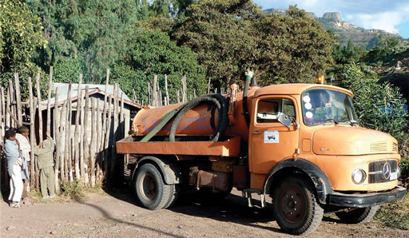
Figure 6.1 Vacuum trucks are used to empty pit latrines and septic tanks.

6.2.2 Vacutug
The Vacutug, shown in Figure 6.2, is basically a smaller version of the vacuum truck. It was devised by UN-Habitat as a system that could replace manual emptying. The Vacutug is a mechanical system that can be manufactured locally using readily available components. It is affordable, easily serviceable, able to operate in narrow passageways where vacuum trucks cannot go and is capable of sucking out waste sludge for transportation to a larger tanker vehicle (UN-Habitat, 2003). It can empty pits down to 2 m deep (Thye et al., 2009).
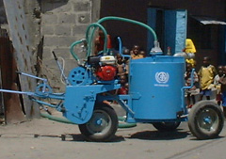
Figure 6.2 The Vacutug.

6.2.3 Hand-operated pumps
Even the Vacutug cannot get everywhere. The Sludge Gulper, like the one shown in Figure 6.3, is an example of a smaller hand-operated pump. These can be taken to pit latrines that are inaccessible to larger pumps. It is a simple design consisting of a PVC pipe containing two valves and can be built using locally available materials. The sludge is pumped up by hand, collected in a container and taken away for disposal. Care is needed to ensure that the operator and other helpers do not come into contact with the sludge and that it is not spilled.
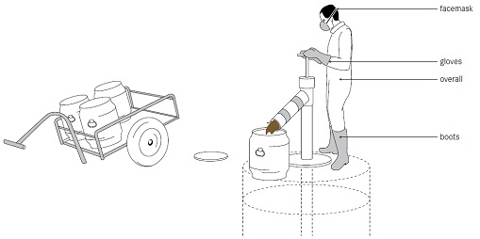
Figure 6.3 Hand-operated sludge pump. The pump is located over the pit and the operator (wearing suitable protective clothing) pumps the handle up and down. Sludge rises up the vertical pipe and is expelled into the container. (Tilley et al., 2014)

6.2.4 Disposal of the sludge
Several options are available for disposal of the collected sludge (Pickford and Shaw, 2005). It can be put directly onto land and used as a soil conditioner, but this is only possible if it has been left untouched for at least two years (Brikke and Bredero, 2003). Fresh, untreated wet sludge poses high risks for human health and so should not be put on land used to grow crops.
Drying the sludge will kill most pathogens. This can be achieved using drying beds (Figure 6.4), where sludge is put into shallow tanks to a depth of about 300 mm. The base of the tank is sloped and covered with a layer of sand (forming a ‘bed’) to allow liquid to drain out of the sludge. In the warm climate of Ethiopia and without rain, after about a week the sludge will be dry enough to be lifted by a shovel.
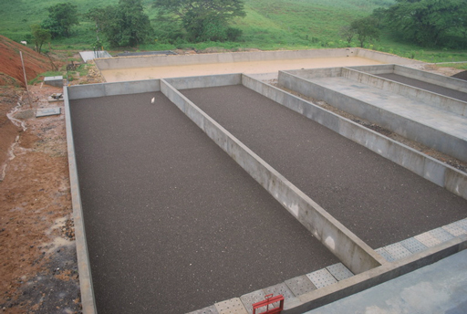
Figure 6.4 Sludge in drying beds.
The sludge can also be composted by mixing it with vegetable matter, or biogas can be obtained by anaerobic digestion. Whichever method is used, faecal sludge disposal must be carefully managed and operated in order to ensure that the associated risks to health and the environment are avoided.

6.3 Septic tanks
A septic tank (Figure 6.5) is an underground and watertight tank made of concrete, fibreglass or PVC in which sewage is collected and partially treated. These are used for water-flushed systems that are not connected to a sewer. Concrete septic tanks are commonly used in Ethiopia.
- What is sewage?
- Sewage is combined wastewater from all sources and includes blackwater (human excreta), greywater and stormwater.
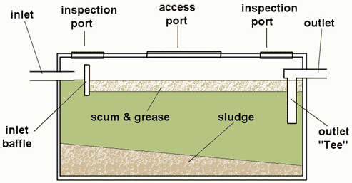
Figure 6.5 Diagram of a septic tank.
Wastewater enters the tank, remains there for a time, and is displaced out of the tank by new wastewater coming in. There are no pumps or mechanical parts. The time the wastewater remains in the tank is called the retention time and should be a minimum of 24 hours. In this period, the solid matter in the sewage settles to the bottom of the tank, where it is partially degraded by anaerobic micro-organisms.
The liquid above the sludge is relatively free of solids, but it does contain dissolved organic and inorganic chemicals that are not treated. Light substances such as oil and grease form a scum and float to the top. The position of the outlet (seen in Figure 6.5) ensures that only water from the middle of the tank is displaced outwards. This effluent is disposed of to a soakaway (also called a soak pit or seepage pit, Figure 6.6) or to a drainfield (Figure 6.7).
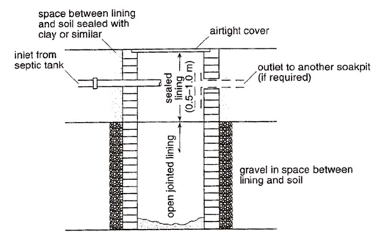
Figure 6.6 Diagram of a soakaway.
The soakaway is a covered, unsealed pit lined with bricks or stone. The wastewater from the septic tank seeps into the soil through the base of the pit and through the spaces in the lining material.
A drainfield (Figure 6.7) is a field where the effluent from a septic tank is disposed of. It can be constructed by laying a network of perforated pipes (pipes with tiny holes) in excavated soil which has a bed of gravel. Soil is placed over the top of the perforated pipe, and plants are grown on top of the drainfield. The wastewater is sent into the perforated pipe and percolates (seeps) through the gravel and goes into the ground, replenishing the groundwater.
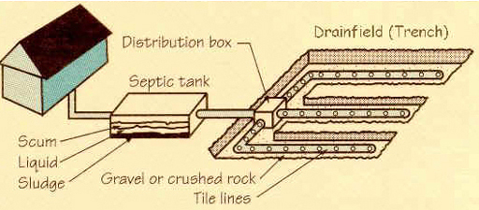
Figure 6.7 Diagram showing the location of a septic tank and a drainfield.
Septic tanks need to be desludged when the sludge depth is approximately two-thirds the depth of the tank. You can estimate this by putting a graduated stick into the tank. Depending on usage, this is typically once every 12 months. A vacuum truck is usually used to suck the sludge out for disposal (Figure 6.8).
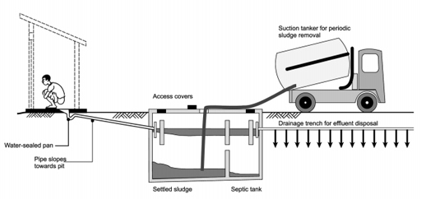
Figure 6.8 Diagram of a septic tank being desludged by vacuum truck.
If a sewer network is later installed in an area where there are septic tanks (as often happens in developing countries), the sewage flow can be connected directly to the sewer, thus bypassing the septic tank. This allows for better treatment (and possibly reuse) of the sewage, and of course eliminates the need for a septic tank.

6.4 Wastewater treatment options
Septic tanks remove solids from sewage, but treatment is minimal and the effluent contains high levels of dissolved organic matter and ammonia. Other options for better treatment are available.
The aim in wastewater treatment is to:
- reduce the amount of biodegradable material and solids
- remove toxic materials
- eliminate pathogenic micro-organisms.
There are several ways of treating sewage and other wastewaters with different costs and requirements. One that is particularly effective and economical in warm regions of the world is waste stabilisation ponds.

6.4.1 Waste stabilisation ponds
Waste stabilisation ponds are natural or constructed ponds used for treating sewage or other wastewaters biologically by harnessing the power of sunlight and wind. They are ideal for tropical countries like Ethiopia. The sewage collected by the sewerage network in Addis Ababa goes to waste stabilisation ponds at Kality.
In a typical waste stabilisation pond system, effluent that has passed through a screen is sent through a series of ponds (Figure 6.9) with a total retention time of between 10 and 50 days. Bacteria in the ponds degrade the organic waste and work symbiotically with algae, which provide oxygen through photosynthesis. (Symbiotically means in a relationship where two types of living organism live together for their mutual benefit.) Oxygenation also occurs through the action of wind and by diffusion from the air. No mechanical equipment is used in the ponds, so operation and maintenance costs are very low. Land requirement is, however, high.
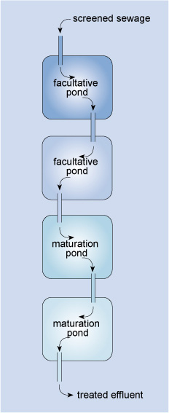
Figure 6.9 Layout of a waste stabilisation pond system treating domestic wastewater.
The major part of the biodegradation of the sewage takes place in the facultative ponds. Facultative ponds are 1–1.5 m deep, with a retention time of between 5 and 30 days. In these ponds the upper layers are aerobic and the lower layers of water are anaerobic. Solids settle to the bottom and are anaerobically digested, so sludge removal is rarely needed.
Maturation ponds are placed after facultative ponds for the purpose of pathogen reduction (Figure 6.10). These are usually 0.5–1.5 m deep with a retention time of between 15 and 20 days. These ponds serve to inactivate pathogenic bacteria and viruses through the action of UV radiation from sunlight and the greater algal activity in these shallow ponds, which raises the pH above 8.5. (pH is a measure of acidity and alkalinity. It has a scale from 0–14: pH 7 is neutral, less than 7 is acid and more than 7 is alkaline.) The long retention time in the maturation ponds also enhances the sedimentation of the eggs of intestinal parasitic worms.
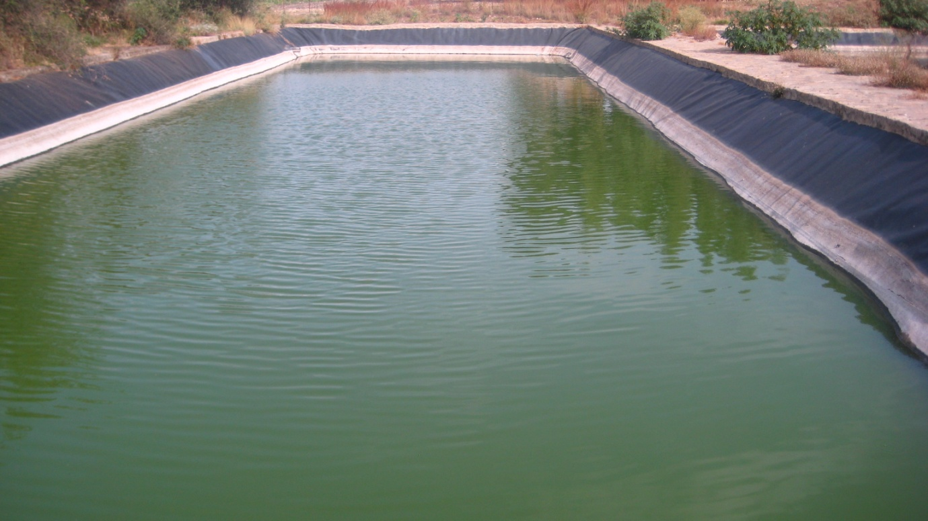
Figure 6.10 A waste stabilisation pond at Mekelle University – note the green colour of the pond due to algae.
If the wastewater has a very high level of pollutants, anaerobic ponds can be used ahead of the facultative ponds. Anaerobic ponds are 2–5 m deep and are nearly devoid of oxygen. Their retention time is one to seven days. Solids settle to the bottom, forming a sludge, and anaerobic digestion takes place, producing methane. Up to 60% of the organic material can be removed in this process (Tilley et al., 2014).
To prevent sewage from leaching away, and to preserve the effluent for reuse later, the ponds should have a liner. This can be made of clay, asphalt, compacted earth or any other impermeable material (material that does not let fluid pass through). To prevent run-off from entering the ponds and to prevent erosion, a protective raised earth barrier can be constructed around the ponds using the excavated material from their construction. Finally, a fence is needed to keep people and animals out (Tilley et al., 2014).
Any scum that builds up on the surface of the facultative and maturation ponds should be removed to allow sunlight to reach all the algae and also to increase surface aeration. Large plants that are present in the water should be removed.
Treated sewage can be reused in crop irrigation if safe limits of faecal bacteria and intestinal parasite eggs are achieved in the treatment process. At the same time as treating wastewater, pond systems have been used to increase protein production through the rearing of fish (such as Tilapia) and ducks in maturation ponds.

6.4.2 Reed beds
Reed beds, or artificially constructed wetlands with emergent plants, have been used to treat sewage in many parts of the world. In Ethiopia, studies have been carried out on this type of wastewater treatment system for domestic wastewaters in Addis Ababa (Genet, 2007) and Kombolcha (Sahu and Yimer, 2014), and brewery effluent in Addis Ababa (Angassa, 2011).
Reed beds are ideal for warm countries where plants grow rapidly. They have low operational costs but they do require a lot of land.

The plants (usually reed species Phragmites australis or Phragmites communis) are grown in rows in beds of soil or gravel lined with an impermeable clay or synthetic liner (Figure 6.11). The effluent requiring treatment is fed into the bed, which typically has a depth of 600 mm. The base of the reed bed has a slope to enable collection of the effluent after treatment.
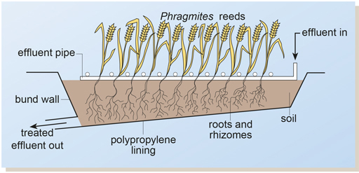
Figure 6.11 The reed bed system. When full-grown, the reeds are between 1.5 and 3.0 m high.
The effluent is distributed through pipes and nozzles onto the reed bed and then percolates down to the roots and rhizomes (horizontal underground stems) of the reeds. The root and rhizome system provides a mix of aerobic and anaerobic conditions that encourage a diversity of microbial species in the soil. As a result, the reed bed system has potential for treating a wide range of pollutants. For example, although micro-organisms that are capable of biodegrading many synthetic chemicals (such as some common pesticides) are found in soil, they not normally present in effluent treatment plants, so reed beds can be effective for treating effluents that contain these types of chemicals.
- Can you think of an additional advantage that reed beds offer?
- Reed beds are very attractive to birds and thus increase the diversity of wildlife where they are constructed.

6.4.3 Mechanical-biological wastewater treatment
Wastewater treatment can be undertaken using a sequence of processes in a mechanical-biological system (Figure 6.12). This treatment is faster than using natural systems such as waste stabilisation ponds or reed beds and requires less space. These factors make it desirable for sewage treatment in towns with large populations where there is not enough land for natural systems. However, mechanical-biological systems are more expensive because of the equipment required and the need for skilled personnel to operate them.
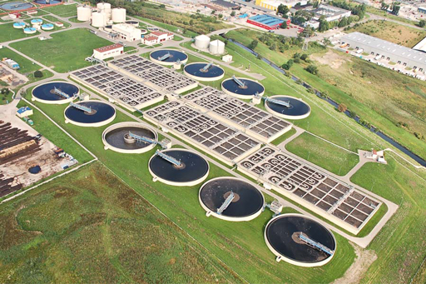
Figure 6.12 A mechanical-biological wastewater treatment plant.
These systems typically have three main stages: preliminary, primary and secondary treatment.

Preliminary treatment
In this first stage screens (Figure 6.13) remove large items such as pieces of wood, metal, rags, paper or plastic that have got into the sewerage system. Removing them protects the structures and equipment in the wastewater treatment plant. Paper and rags in the wastewater flow are sometimes shredded by comminutors, which are rotating, slotted drums equipped with cutting blades. The shredded material can then be returned to the flow further downstream without causing harm.
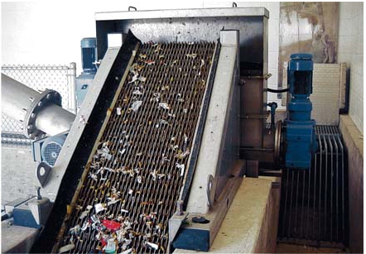
Figure 6.13 Screening of wastewater. Solid materials are retained on the screen while the liquid passes through.
Small stones and grit have to be removed from the flow. Grit is comprised of very small pieces of sand, stone and possibly also glass and metal. All these materials can increase the rate of wear of mechanical equipment and can also settle easily in pipes, causing blockages. The grit settles out in grit channels (Figure 6.14) and can be removed daily by manual or mechanical means and dumped at a landfill site.
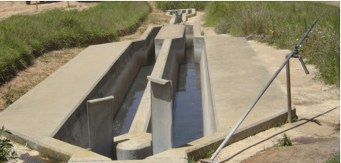
Figure 6.14 A grit channel that slows the rate of flow and allows grit to settle out by gravity.

Primary treatment
In the primary treatment stage, fine solids in the wastewater are removed by settlement in a sedimentation tank (Figure 6.15). A properly designed and well-operated primary sedimentation tank will reduce the suspended solids content of the wastewater by between 50 and 70%, and the biochemical oxygen demand (BOD) by between 25 and 40% (Crites and Tchobanoglous, 1998).
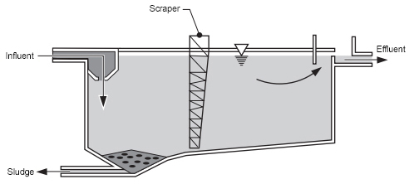
Figure 6.15 Diagram of a rectangular sedimentation tank.

Secondary treatment
This is the biological stage of treatment. In secondary treatment the organic matter in the sewage is biodegraded by micro-organisms using oxygen. Oxygen levels are increased artificially by various means to ensure removal of organic matter. Also in this stage, ammonia in the sewage is converted to nitrate. This is followed by a second sedimentation stage to remove solids produced by the microbial activity. The treated effluent should be clear, free of pathogens and safe to discharge into a river or possibly be reused for irrigation.

6.5 Sullage management
- What is ‘sullage’?
- Described in Study Session 4, sullage is water that doesn’t contain any faecal matter or urine. Typically, it is wastewater that is produced from washing ourselves, washing clothes and from food preparation.
Many people simply throw sullage onto the ground or into the street. In small quantities this may be acceptable, but in densely populated urban areas proper handling and disposal is required. Some of the disadvantages of improper disposal of sullage include the potential to contaminate the soil, pollute water sources and create favourable breeding conditions for disease vectors.
- Which vectors do you think might be encouraged by sullage collecting on the ground?
- Mosquitoes are likely to be attracted, as they use stagnant water as breeding sites. Flies and rats might also appear, because the sullage would be a source of drinking water for them.
Sullage can be discharged to sewers or septic tanks in areas where these facilities exist. Where they do not, it is necessary to construct a pit near the household to dispose of sullage properly (Figure 6.16). The pit should be filled with gravel or sand. A sullage pit keeps the wastewater in one place and encourages it to soak quickly into the ground.
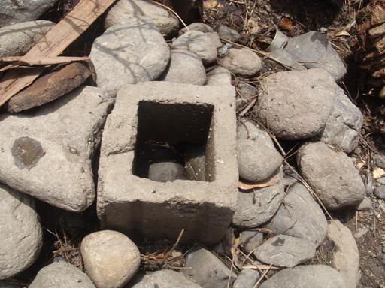
Figure 6.16 Pit for disposal of sullage

6.6 Stormwater management
- In Study Session 4 you learned about the pollutants likely to be present in surface water run-off. What were they?
- Faecal matter, soil, rubber from tyre wear, litter and oil from vehicles.
Stormwater has a polluting potential, as well as being a possible cause of flooding. In towns and cities, stormwater should be directed into stormwater drains (Figure 6.17). These should be kept clear of rubbish. Climate change means that many areas are experiencing heavy and prolonged rainfall, leading to flooding when the stormwater drains are unable to cope.
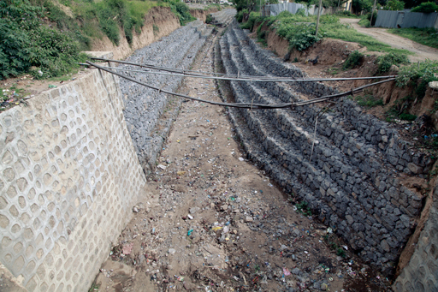
Figure 6.17 Stormwater drain designed to prevent flooding in Adama.
Sustainable drainage systems (SuDS) are an alternative to large storm drains. These systems include a range of techniques designed to reduce the speed of surface run-off, encourage infiltration into the ground and reduce the risk of flooding without the use of any mechanical equipment. Building ponds or holding areas in the drainage system so that storm water is temporarily stored and the speed of flow is reduced is one example. These storage ponds also make the water available for reuse. Another example is to encourage infiltration by using gravel or stones rather than solid concrete at the sides of roads (Figure 6.18). This reduces surface run-off and helps to replenish groundwater.
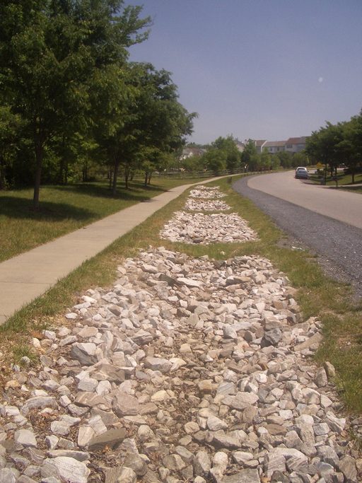
Figure 6.18 Infiltration trench with loose stone that encourages water to soak into the ground.

Summary of Study Session 6
In Study Session 6, you have learned that:
- Pit latrines are the most common method of disposing of human wastes in Ethiopia.
- Faecal sludge accumulates in pit latrines and septic tanks and must be regularly removed and disposed of safely.
- The sludge can be removed by various means, including vacuum truck, Vacutug or by manually operated pumps such as the Sludge Gulper.
- Sludge can be spread on land as a soil conditioner, but only after it has been treated to minimise health risks, for example by drying, composting or anaerobic digestion.
- Some water-borne toilet systems use septic tanks which hold wastewater for a minimum of 24 hours so that solids settle out. The effluent is discharged into the soil via a soakaway or drainfield. Septic tanks need to be desludged when approximately one-third full.
- The aims of wastewater treatment are to reduce the amount of biodegradable matter and solids in the effluent, remove toxic materials and eliminate pathogenic micro-organisms.
- Waste stabilisation ponds and reed beds use natural systems to treat wastewater and are suitable for warm countries. They do not need mechanical equipment and are thus low in operational costs but they both require a lot of land.
- Mechanical-biological wastewater treatment systems require less land than natural systems of wastewater treatment but they require equipment that makes them expensive to install and operate.
- Sullage should be discharged to sewers or septic tanks. If these are not available, it should be discharged into a pit filled with gravel or sand.
- Stormwater can be managed by sustainable drainage systems.

Self-Assessment Questions (SAQs) for Study Session 6
Now that you have completed this study session, you can assess how well you have achieved its Learning Outcomes by answering these questions. You can check your answers with the Notes on the Self-Assessment Questions at the end of this Module.

SAQ 6.1 (tests Learning Outcome 6.1)
Write the following words next to their correct definitions in the table below:
anaerobic ponds; comminutors; desludging; drainfield; facultative ponds; faecal sludge management; maturation ponds; retention time; septic tank; Sludge Gulper; soakaway; sustainable drainage systems; Vacutug.
a network of perforated pipes through which the outflow from a septic tank goes into the ground
a manually operated pump for desludging pit latrines
first stage of waste stabilisation pond system treating highly polluted wastewater
a watertight tank installed underground that collects sewage in areas where there are no sewers
ponds that have oxygen at the top and no oxygen at the bottom
an item of equipment that is used to cut up paper and rags in wastewater flowing into a treatment plant
a small vacuum truck designed for pit latrine emptying in crowded areas
a pit into which the wastewater from a septic tank goes for disposal
ponds that are used at the end of a waste stabilisation system to reduce the level of pathogens in the wastewater
the time that is spent in a given environment
the process of removing sludge from a place
drainage systems that encourage infiltration of rainwater without special equipment
combined processes for safely disposing of sludge from pit latrines and septic tanks

SAQ 6.2 (tests Learning Outcome 6.2)
Outline the main advantages and disadvantages of vacuum trucks, the Vacutug and the Sludge Gulper as options for pit emptying.

SAQ 6.3 (tests Learning Outcome 6.3)
- List the points where sludge is produced in the different treatment processes described in this study session.
- State briefly the options for treatment and reuse of the sludge.

SAQ 6.4 (tests Learning Outcome 6.4)
The table below has several statements applicable to different wastewater treatment systems. Allocate each of them to one of the following wastewater treatment options:
- Septic tank
- Waste stabilisation ponds
- Reed beds
- Mechanical-biological treatment.
Is expensive due to tanks and equipment involved
Can be used to treat wastewaters containing pesticides
Relies on sunlight and wind for treatment
Need a lot of space
Requires skilled personnel for operation
Used for houses with water-flushed toilets in areas without sewers
The area around the roots and rhizomes contains aerobic and anaerobic bacteria
A vacuum truck is used to suck sludge out of it
Consists of many different stages of treatment
Partially treated wastewater goes to a soakaway or drainfield
A symbiotic relationship exists between the bacteria and algae in this system
Use plants for treatment of sewage

SAQ 6.5 (tests Learning Outcome 6.5)
You are walking in an alley in an unsewered part of town when you are nearly drenched by washwaters from clothes washing thrown over a fence. What would you do to advise the householder about proper disposal of their wastewater?

SAQ 6.6 (tests Learning Outcome 6.6)
Name three ways in which the risk of flooding from stormwater can be reduced.

Study Session 7 Solid Waste: Sources, Composition and On-site Storage

Introduction
This is the first of five study sessions that focus on solid waste management. A solid waste management system consists of a chain of linked processes. The chain begins with the generation of the waste, which is the subject of this study session. In Study Session 8 we will look at waste reduction, reuse and recycling (the ‘3 Rs’) and Study Session 9 is about collecting the remaining wastes. Study Sessions 10 and 11 cover the ways of disposing of this remaining waste.
Good management of solid waste is one of the most important ways of protecting our health. Before we can design a waste management service and monitor its effectiveness we need detailed information on the waste itself. For each type of waste produced we need to know the quantities generated, where the waste is generated and its composition.
In this study session you will learn about the types of solid wastes generated from different sources (mainly domestic, industrial and commercial), and the amounts produced. This session will also enable you to advise householders on how to store solid wastes in such a way as to minimise the risk to people in their homes.

Learning Outcomes for Study Session 7
When you have studied this session, you should be able to:
7.1 Define and use correctly each of the terms printed in bold. (SAQ 7.1)
7.2 Describe the major sources of solid wastes in urban areas. (SAQ 7.2)
7.3 Use the results from waste surveys to calculate waste generation rates. (SAQ 7.3)
7.4 Describe the potential health effects of different wastes. (SAQ 7.4)
7.5 Explain the importance of proper on-site storage of solid waste at the household level. (SAQ 7.5)

7.1 Sources of solid waste in urban areas
- Thinking back to Study Session 1, how would you define ‘solid waste’? Using your general knowledge and previous experience, list the types of solid waste generated in the area where you live or work.
- Solid waste is anything that is not a liquid and which is thrown away because it is not wanted.
There are many possible answers to the second part of this question. You may have thought of wastes produced in domestic houses such as paper and plastic packaging, or peelings and other waste from food preparation. Other answers could include wastes from industry, commerce, schools, colleges and health facilities.
Solid wastes are all the wastes arising from human and animal activities that are normally solid and are discarded as useless or unwanted by the person or organisation that produces the waste.
You may recall from Study Session 1 that solid waste can be classified according to its source. The major sources of solid wastes in urban areas of Ethiopia are shown in Box 7.1.

Box 7.1 Major sources of solid wastes in urban areas of Ethiopia
- Residential sources: from households and residential areas. These are the major sources of solid waste in almost all cities and towns in Ethiopia.
- Commercial sources: from businesses such as food and drink establishments, shops, banks, etc.
- Institutional sources: from public and government institutions e.g. offices, religious institutions, prisons, schools, universities, etc.
- Open areas: waste from street sweepings, roadside dustbins, ditches and other public places.
- Industrial sources: from various types of industrial processes.
- Health facilities: from hospitals and other health facilities.
- Construction and demolition: from various types of construction and demolition activities in urban areas such as the construction of apartments, the demolition of urban slums, etc.
- Agricultural sources: from farming — more common in peri-urban areas of small and medium towns of Ethiopia and in rural areas.
- Electronic and electrical waste (e-wastes): waste electronic devices (computers, phones, radios, etc.) and household appliances (cookers, washing machines, etc.).
Residential solid wastes (sometimes called household waste) usually form the largest proportion of municipal waste (the combined solid wastes in an urban area). Let us take Bahir Dar as an example. Bahir Dar is a city on the southern shore of Lake Tana, about 600 km north-west of Addis Ababa, with a population of 320,000. In 2010 a waste survey was undertaken as the first stage of a programme to find better ways of treating the city’s waste. Figure 7.1 shows the survey results for the proportion of waste from different sources. You can see that the majority of the solid waste (55%) comes from residential areas (Forum for Environment/UNEP, 2010). In Bahir Dar, the household waste is collected by a private contractor and taken to an open dump for disposal. (You will learn more about waste disposal sites in Study Session 10.)
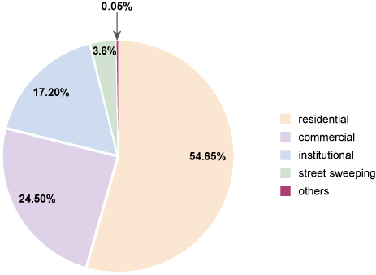
Figure 7.1 Major sources of solid wastes in Bahir Dar and their relative proportions by mass.
Types of solid waste generated in residential areas includes food wastes, packaging (bottles and cans), papers and miscellaneous items that have been used up or broken and are thrown out as waste (e.g. ashes, old shoes, worn out clothes, broken cooking pots, paper, baskets, bags, etc.). You should also note that, in areas where latrines are not available, bags of human faeces may be found among the waste.
Plastics in the form of bags and bottles make up a relatively small proportion of residential waste, but these present a major problem. Plastics do not degrade (or degrade at a very slow rate), and so they tend to accumulate in the streets and in watercourses. Plastic bags can also choke farm animals and wildlife if they are ingested (Figure 7.2).
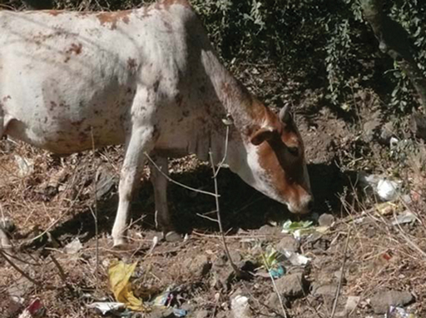
Figure 7.2 Waste plastic bags are a health hazard for grazing animals.

7.2 Classification of solid wastes
There are several different ways of classifying solid waste. As you have seen, one way is to classify it by where it is generated. Another way is based on whether the waste is biodegradable or not.
Biodegradable solid wastes are those that can be broken down (decomposed) into their constituent elements by bacteria and other micro-organisms. Food waste, manures and waste from producing crops are the main biodegradable wastes. If the decomposition process takes place in the absence of air (anaerobically), methane gas can form. Methane is a powerful greenhouse gas and can explode if enough of it accumulates and an ignition source (such as an electrical spark) is present. The decomposition may also produce offensive and irritating smells.
However, controlled anaerobic decomposition can produce biogas – a useful fuel for heating, cooking and even power generation that you learned about in Study Session 5 – as well as fertilisers and soil conditioners. Waste that decomposes in the presence of an adequate air supply (aerobically) under controlled conditions can produce compost, which can be used to improve the quality of soils.
Non-biodegradable (also sometimes called inorganic) solid wastes are those that do not decompose by microbial action. These wastes include plastic containers, scrap metal, food and drink cans and plastic bags.
Materials in solid wastes can also be classified as combustible or non-combustible, depending on whether they will burn or not.
Depending on the inherent dangers associated with its physical and chemical properties, solid waste can be classified as either hazardous or non-hazardous. Hazardous wastes pose substantial or potential threats to public health or the environment. For example, toxic, infectious and corrosive (acidic or alkaline) substances are all likely to be classed as hazardous. Non-hazardous wastes are those that do not possess hazardous characteristics, although they can still be harmful to people or the environment. (Hazardous waste is described in more detail in Study Session 10.)
- Can you think of any examples of non-hazardous wastes that could be harmful?
- Some materials in waste, such as metal cans and broken glass, can cause cuts from sharp edges, which may lead to infection. Large quantities of wastes can block watercourses, leading to flooding.

7.3 Composition of residential solid waste
The composition of solid waste means the different types of waste material that it consists of and their characteristics. As an urban WASH worker you may need to understand the factors that affect the composition of solid waste in your area. These factors include the season of the year, the habits or culture of the community, people’s educational or economic status and the geographical location.
- Why do you think that the composition of waste produced by households might change at different times of year?
- Some possible answers are:
- Different foods are available at different times of year, so the amount of waste from preparing food (vegetable trimmings and so on) and its composition will change.
- Wastes tend to be wetter during rainy seasons.
- There may be more food waste produced during festival times and less produced when people are fasting.
Returning to the Bahir Dar survey mentioned earlier, Table 7.1 shows the major components of municipal solid wastes generated in Bahir Dar according to the 2010 study.
Table 7.1 Composition of municipal solid waste in Bahir Dar. (Forum for Environment/UNEP, 2010)
Solid waste component | Percentage by mass
Food wastes | 43.5
Paper | 9.4
Plastics | 3.3
Textile | 1.3
Rubber | 0.7
Leather | 0.2
Garden waste | 11.9
Wood and charcoal | 1.7
Glass | 1.1
Metals | 1.3
Ash and soil | 20.2
Others | 5.6
Total | 100
- Figure 7.3 shows a bin containing solid waste from a kitchen. Using the types of wastes included in Table 7.1, list the types that you can identify in the bin in Figure 7.3.
- The waste in the bin includes paper, a plastic bag (which may contain other materials), a plastic food pot, metal foil (the yogurt pot lid) and food waste.
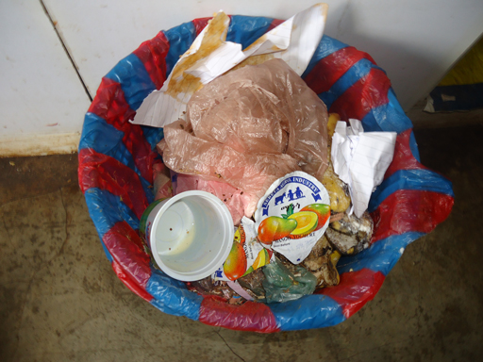
Figure 7.3 Waste from an Ethiopian kitchen.
The composition of solid waste affects the length of time that it can be safely stored before disposal. If kept uncovered for too long, some waste will become a health hazard or cause some other nuisance. The recommended time for storage is shown in Table 7.2 for typical Ethiopian conditions where the waste is stored at normal temperatures in a container that is not sealed.
Table 7.2 Length of storage in days for different types of solid wastes and the potential problems from storing the waste for too long. (Tadesse, 2004)
Waste type | Length of storage in days | Effects if stored for longer
Food wastes | 4 | Fly breeding
Residential waste | 7 | Flies, land pollution
Street sweepings | 7 | Unsightliness
Dead animals | 1 | Flies, animal diseases
Ashes | 14 | Air pollution from dust, unsightliness

7.3.1 Chemical composition of solid wastes
Knowing the chemical composition of solid waste is very important when planning for different waste management options. Key aspects of chemical composition are:
- moisture content – the percentage of water in the waste
- ash content – the amount of material remaining after burning the waste
- heat content – also known as calorific value, which is the amount of heat energy produced when the waste is burned.
Full analysis could also identify the different chemical elements present in the waste.
In practice, the composition of a mixture of wastes is found by separating the components and testing each different material to find out its moisture, ash content and chemical composition, and combining the values to get the overall composition of the waste.
The moisture content of municipal solid wastes varies depending on the season of the year, humidity and weather conditions, as well as on the composition of the waste. It is calculated by weighing an amount of waste, drying it in an oven which causes the moisture to evaporate, then weighing it again. The mass lost in the drying process is equivalent to the moisture content and is calculated as a percentage of the initial mass. Table 7.3 shows typical moisture content of the major solid waste components generated in Bahir Dar during the 2010 study. As you can see from the data, organic wastes such as food, paper and garden wastes have high moisture contents.
Table 7.3 Typical data for moisture content of residential solid waste in Bahir Dar, 2010. (Forum for Environment/UNEP, 2010)
Component | Moisture content (percent)
Food waste | 46
Paper | 34
Plastic | 12
Textile | 9
Rubber | <1
Leather | 3
Garden waste | 30
Wood | 13
Glass | <1
Metals | <1
Ash and soil | 16
Stone | <1
Other | <1
- A sample of food waste weighs 460g. After drying it weighs 275g. What is the moisture content of the sample?
- The moisture content is 460g – 275g = 185g.
In percentage terms, this is $\frac{\text{185}}{\text{460}}$ × 100 = 40%.
Analysing waste to determine its chemical composition and calorific value is highly specialised work that needs laboratory equipment to prepare the samples and then carry out the analyses. As an urban WASH worker you are unlikely do this type of work, but you should be aware that the results can be used to assess the suitability of a waste for composting, anaerobic digestion, recycling and energy recovery.
- Thinking back to Study Session 1, what do you understand by the term ‘recycling’?
- Recycling means taking materials from waste and transporting them to a factory where they are processed to make new raw materials that can be then be used.

7.4 Quantities of residential waste
The total quantity of waste generated by a town or city is obviously directly related to the size of population. The amount of solid waste produced in a given area is usually expressed in terms of tonnes per day (or tonnes per month or year) and sometimes as kilograms per person per day. (You may see this written as ‘per capita waste generation’.) For some purposes, the volume of waste, expressed in cubic metres (m³), produced in a given time period may be reported.
Countrywide average rates of waste generation in most industrialised countries lie between 0.8 and 1.4 kg per person per day. In developing countries, the average generation rate is more likely to be in the range of 0.3 to 0.5 kg per person per day. Reliable information is not widely available, but Table 7.4 shows the values of different solid waste generation rates in different towns and cities in Ethiopia based on separate studies.
Table 7.4 Summary of selected towns’ and cities’ solid waste generation rate from households. (Addis Continental Institute of Public Health, 2015)
Town/city | Generation rate (kg/person/day)
Addis Ababa | 0.25
Mekelle | 0.30
Debre Berhan | 0.55
Jimma | 0.55
Bahir Dar | 0.25
Dessie | 0.23
Aweday | 0.85
In areas where the waste is collected (perhaps by the kebele authorities) it is necessary to know how much is produced to make sure that the bins and skips for the waste are large enough. If the waste is then transported to a disposal site, the information on the amount of waste produced can be used to find out how many trips per week the transport vehicle will have to make.

Example
A small town produces an average of 1.5 m³ of waste per day and the accumulated waste is to be taken in a truck to a disposal site a few kilometres away once a week. If a storage container can hold 1.1 m³ of waste, how many containers will be needed?

Answer
The amount of waste produced each week is 1.5 × 7 = 10.5 m³
The number of containers required = $\frac{\text{10.5}}{\text{1.1}}$ = 9.5.
It only makes sense to have a whole number of containers, so the town would need ten containers.
The generation rate data allows current waste collection and treatment needs to be planned, and also helps to predict the amounts that may be seen in the future.

7.5 Handling and on-site storage of solid wastes
In some areas, residential waste is taken from a collection point to the disposal site by the kebele authority or by a contractor employed by the authority. In other places the householder either takes their waste to a communal disposal point or disposes of it in a pit in their yard. This is also true for commercial and industrial organisations.
Unless the waste is placed in a pit as soon as it is produced, there will be a need for some kind of storage. Storage is the first stage of the waste management process. It is important because poorly handled and stored waste can be sources of nuisance, flies, smells and other hazards. The other stages of the waste management process are covered in Study Sessions 8 to 11.

7.5.1 Types of storage containers
According to the Solid Waste Management Proclamation (FDRE, 2007), solid wastes should be stored indoors in a closed container that is animal-proof and insect-proof. The containers should also be washable and strong enough to withstand normal day-to-day treatment. The container should be emptied every day into an outdoor storage container or directly into a disposal pit.
However, a recent situation assessment of waste management in 28 Ethiopian cities and towns indicated that 88% of the households use sacks to collect solid waste in their household (Addis Continental Institute of Public Health, 2015). So clearly, the majority of households store their solid waste in a container that does not meet the standard (Figure 7.4).

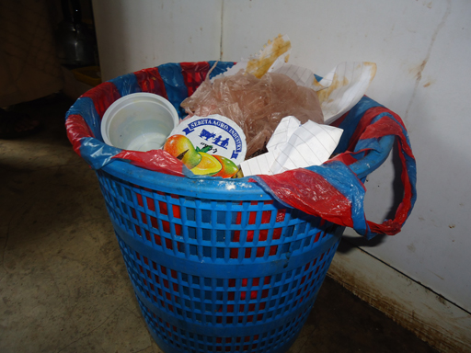 | 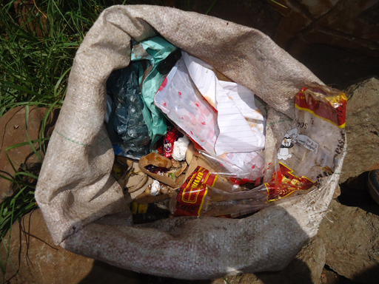
Figure 7.4 The most common types of containers used for on-site storage of solid wastes.
Where waste is collected for disposal, householders have to empty their waste containers into larger communal containers. These containers should also be fitted with lids to keep insects, other animals and rainfall out. An ideal container is shown in Figure 7.5, but open containers known as skips are often used (Figure 7.6).
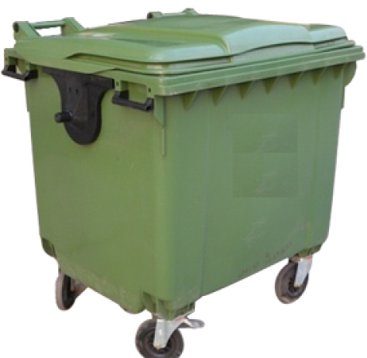 | 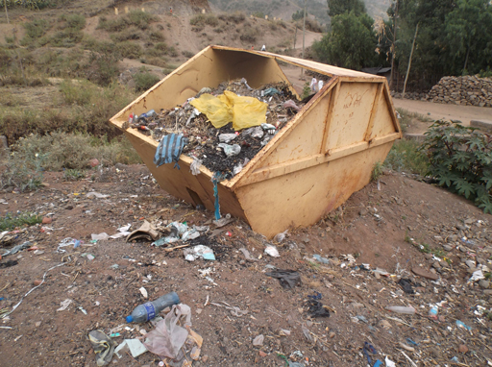
Figure 7.5 A communal waste storage container. | Figure 7.6 Communal waste skip awaiting collection to be emptied. Regular emptying is essential to avoid the situation shown here.

7.6 Commercial and industrial solid wastes
As explained in Section 7.1, commercial wastes are those produced from businesses such as food and drink establishments, shops, banks and by public administration offices. These wastes contain similar materials to residential waste, although the proportions may vary. For example, a restaurant will produce more food waste than a normal household and an insurance office will produce more paper and less food waste.
There are also many industrial facilities in Ethiopia that process agricultural products such as cotton, flour, hides and skins. Other important industries include plastic and resin manufacturing, textiles, cement, metallurgical, foods, general chemicals and pharmaceuticals. All these industries manufacture useful products and contribute to the country’s economy but, at the same time, they can also be a major contributor to the country’s solid waste and pollution problems.
The composition of the waste produced by industry depends very much on the nature of the industry concerned. For example, animal hide processing produces large amounts of biodegradable waste (animal parts), while the construction industry produces a lot of excavated soil, rock and demolition waste (bricks, stones, wood, glass, etc.). For this reason, industrial waste is usually processed and disposed of by the industry itself, often using specialised technologies. As explained in Section 7.2, these wastes can be classed as either hazardous or non-hazardous depending on the inherent dangers associated with their physical and chemical properties.
- Think about the industrial and commercial wastes produced in the area where you live and write down some of the wastes that these organisations might produce.
- Your answer will depend on the types of industry in your area. However, all commercial and industrial organisations are likely to produce waste paper, food wastes, plastics and packaging materials.
Industrial organisations also produce more specialised wastes, for example:
- stone masonry – rubble, dust
- food processing – vegetable peelings, animal skins, bones, etc.
- chemical manufacture – chemical containers, various solid chemical wastes.
As you have seen from Figure 7.1, industrial and commercial organisations only produce a small proportion of a city’s waste. Because of this, less attention is given to these wastes and the amounts produced are not known accurately. However, for urban WASH workers, it is useful to understand the characteristics of the solid waste generated from these sources in order to:
- advise workers on the potential health and environmental hazards of handling the solid waste
- give advice on the transportation, treatment, and disposal systems needed
- develop precautions and procedures to protect people during collection and disposal
- understand and determine which of the solid wastes generated in any particular industry can be managed along with the household and commercial wastes.

7.7 Healthcare wastes
Healthcare waste is any waste produced by healthcare activities. It is sometimes known as medical waste, hospital waste or infectious waste. The main sources of healthcare waste are hospitals, health posts, health centres and clinics. Dental surgeries, veterinary surgeries and cosmetic establishments (ear-piercing and tattoo parlours) also produce some healthcare waste. Healthcare waste consists of both hazardous and non-hazardous waste.
Around 75–90% of the waste produced by healthcare establishments is general commercial waste. This must be kept separate from the hazardous material at all times until it is finally disposed of. The remaining 10–25% is hazardous and can contain sharps (syringe needles, knives and other surgical instruments), blood, other body fluids, human organs and tissues, used dressings, drugs, other chemicals and possibly radioactive substances.
This waste is potentially hazardous to health in a number of ways. Sharps can cause physical harm and provide a way into the body for pathogenic micro-organisms. Much of the waste contains pathogens, which can cause many types of infections. Of particular concern is the risk of transmission of the human immunodeficiency virus (HIV), which causes AIDS, and the hepatitis A and C viruses.
Healthcare waste must be collected, transported and treated under carefully controlled conditions. If not, it will present a serious risk to everyone in the community. We will be looking at the disposal of healthcare waste in more detail in Study Session 12.

Summary of Study Session 7
In Study Session 7, you have learned that:
- The major sources of solid wastes in Ethiopia in urban areas are residential areas, commercial areas, institutions and street sweepings.
- Solid waste can be classified by source or by its characteristics including whether or not it is biodegradable, combustible or hazardous.
- The composition of municipal waste varies with location, season and the habits and economic status of the community.
- Food wastes, papers, plastics, textiles, street sweepings, wood and charcoal, glass and ashes are the major solid waste types generated in Ethiopian towns and cities.
- Waste, especially organic waste, can become a health hazard if stored for too long.
- Analysis of moisture content, ash content and heat content of wastes are important for planning waste management options.
- Assessment of the quantities of wastes generated are needed to plan for waste collection and disposal schemes.
- On-site waste storage requires closed containers that are emptied frequently.
- Commercial solid waste has a similar composition to residential waste. The nature of industrial waste depends on the type of industry.
- Healthcare wastes should be considered hazardous and need special handling and disposal procedures.

Self-Assessment Questions (SAQs) for Study Session 7
Now that you have completed this study session, you can assess how well you have achieved its Learning Outcomes by answering these questions. You can check your answers with the Notes on the Self-Assessment Questions at the end of this Module.

SAQ 7.1 (tests Learning Outcome 7.1)
Write the following words next to their correct definitions in the table below:
ash content; biodegradable; hazardous; moisture content; non-combustible.
waste that will not burn
proportion of solids left after waste is burned
waste that is decomposed by micro-organisms
proportion of water in waste
waste that is a risk to health

SAQ 7.2 (tests Learning Outcome 7.2)
List three main sources of solid waste in Ethiopian towns and briefly describe the typical composition of waste from each source.

SAQ 7.3 (tests Learning Outcome 7.3)
Suppose you are assigned as an urban WASH worker in a town where there is no information on the amount of residential waste produced. The WASH team did its own survey and, based on a sample of 34 households taken over a seven-day period, they came up with the data shown below.
- The total mass of solid waste produced by the 34 sample households over seven days was 480 kg.
- The average household size was 6.3 people.
- The population of the town was 75,000.
Based on these data, calculate:
- the generation rate of residential solid waste per person per day
- the total amount of domestic solid waste generated per day by the town’s people.

SAQ 7.4 (tests Learning Outcome 7.4)
What are the main health risks from healthcare waste?

SAQ 7.5 (tests Learning Outcome 7.5)
Imagine that you have been asked to advise a householder on the storage of kitchen waste in the home before taking it to a communal disposal pit. Give a brief summary of your advice.

Study Session 8 Solid Waste Reduction, Reuse and Recycling

Introduction
In every aspect of human life unwanted materials are generated and then discarded simply because they are considered to be wastes. Think about preparing a meal; there will be vegetable peelings and fruit cores, there may be skin and fat trimmed off fish and meat, and, if canned or bottled ingredients are used, there will be the empty bottles and cans. Households, businesses, industries, the healthcare system and public organisations all produce wastes that need to be processed. In Study Session 7 you learned about the different types of wastes, and in this study session you will learn how the waste hierarchy can be applied to help reduce, reuse or recycle the solid wastes that we produce.

Learning Outcomes for Study Session 8
When you have studied this session, you should be able to:
8.1 Define and use correctly each of the terms printed in bold. (SAQs 8.1 and 8.2)
8.2 Use the waste hierarchy to identify the best ways of dealing with different wastes. (SAQ 8.2)
8.3 Give examples of how people and organisations can reduce waste. (SAQ 8.3)
8.4 Explain the benefits of separating solid waste. (SAQ 8.4)
8.5 Explain the processes for composting and for producing biogas from organic wastes. (SAQ 8.5)

8.1 The waste hierarchy and the ‘3 Rs’
- Think back to Study Session1. What do you remember about the waste hierarchy?
- The waste hierarchy lists the different ways of dealing with wastes, starting with the most beneficial and working down to ‘disposal’, which is the worst way of getting rid of waste.
Many versions of the hierarchy have been published, but they all present the same message. The version of the hierarchy used in this module is shown in Figure 8.1. Reduction, reuse and recycling were first defined in Study Session 1 and are explained more fully in the following sections. The fourth option, recovery, is also explained here. The final option, disposal is about finding a place to get rid of wastes that cannot be treated by any of these alternatives. Waste disposal is the topic of Study Session 10.
Figure 8.1 The waste hierarchy.

8.2 Waste reduction
At the top of the hierarchy is waste reduction. This is the best option because the most effective way to limit the health effects and environmental impacts of a waste is not to create waste in the first place. Making any new product requires materials and energy. Raw materials must be extracted from the Earth and processed, and the product must be manufactured, packaged and transported to wherever it will be sold. Each of these stages may produce solid waste as well as liquid wastes and air pollutants. If we can find ways of making a particular item whilst producing less waste in the process, this is one of the most effective ways to reduce pollution, save natural resources, protect the environment and save money. Industry has a major part to play in waste reduction. If more efficient manufacturing processes were adopted, greater quantities of products could be made without increasing the use of raw materials. Industry can also work to incorporate less material into its products – so for example, an item could be packaged using less cardboard than before.
Waste reduction is also important at household level. In Ethiopia a number of waste reduction initiatives have been put in place in big cities like Addis Ababa and Mekelle by informal organisations and private sector enterprises. These initiatives frequently involve several different stakeholder groups including urban Health Extension Workers (HEWs), civil society, private sector enterprises and organised women’s development groups. The local kebele administration and appropriate experts from the Woreda Health Office and Greenery and Beautification Office are also likely to be involved. The Ministry of Health has produced some teaching aids and promotional materials aimed at educating communities on how to reduce and minimise waste at household level. Educational campaigns can raise awareness of the individual economic incentives, and can also be used to reduce the stigma attached to working with waste.
Part of your role as an urban WASH worker may be to help educate householders, through home visits and at community gatherings, about better ways to manage their domestic waste. This can result in behavioural change among the community members and increase their active participation in waste reduction (and reuse) at the household level.
There are many possible ways of reducing the amount of waste produced at home that could be suggested to householders. These include educating and encouraging them to:
- Buy products that use less packaging. Buying in bulk, for example, can reduce packaging and save money. Where households cannot afford to pay large sums of money up front, it may be possible for neighbours to club together and buy a large quantity of a basic foodstuff between them.
- Make use of reusable rather than disposable items. For example, use refillable containers where possible; washable rather than disposable nappies; cotton handkerchiefs rather than paper tissues; rechargeable batteries and refillable ink pens.
- Use their own shopping bags, preferably made of cloth or other recycled material rather than plastic bags.
- Minimise food scraps or feed these scraps to animals, if appropriate.
- Repair and maintain items such as clothing so that they last longer.

8.3 Waste reuse
Reuse can be defined as using a waste product without further transformation and without changing its shape or original nature. This is the second option in the waste hierarchy. Different types of solid wastes can be reused, such as bottles, old clothes, books and anything else that is used again for a similar purpose to that originally intended. Reuse means that less solid waste is produced. It brings other benefits by taking useful products discarded by those who no longer want them and passing them to those who do.
- Suppose you are attending a meeting of a women’s development group and one of the participants asked you to explain what is meant by reusing waste. How would you explain the concept?
- You could first explain that reuse means using something without changing its shape or original nature. You could then list some examples, such as bottles that can be refilled, old clothes that can be passed to neighbours and carrier bags that can be used more than once.
The informal waste management sector does a lot to promote reuse and recycling. Individuals (known as korales) buy reusable bottles and jars and recyclable materials from householders and sell them on to small shopkeepers and merchants (Figure 8.2). Bjerkli (2005) estimated that around 5000 korales were working in Addis Ababa.
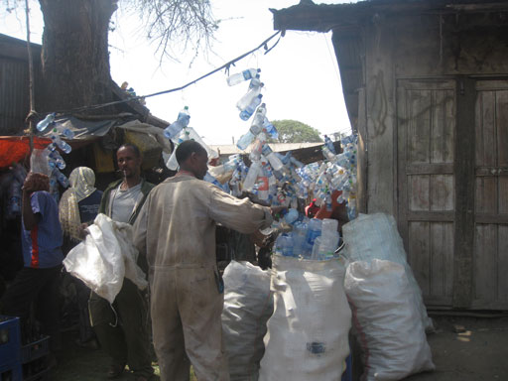
Figure 8.2 Collecting and selling reusable plastic bottles.

8.4 Benefits of reducing and reusing solid waste
Waste is becoming a bigger problem in urban areas each year. Households are producing more waste, so disposal sites are filling up and new sites are further away from residential areas. Where waste is collected and transported to a disposal site, this is becoming more expensive. Where householders have to dispose of waste themselves, they have to spend more time doing this. Anything that reduces the amount of waste that has to be disposed of helps to reduce these problems. Some other advantages of waste reduction and reuse are summarised below.

Community benefits
Reuse can be very helpful for disadvantaged people who cannot afford to buy new goods. These could include clothing, building materials, and business equipment. Reuse centres that collect and distribute reusable goods can also provide community benefits by engaging in job-training programmes and general training for the long-term unemployed, disabled people and young people.

Economic benefits
By reusing materials rather than creating new products from raw materials, there are fewer burdens on the economy as a whole – especially if reuse results in a reduction in raw material and product imports. Reuse is an economical way for many people to acquire the items they need. It is almost always less expensive to buy a used item than a new one.

Environmental benefits
Reusing something uses little or no water, energy or other resources and is unlikely to cause pollution. As well as these benefits, reuse eliminates the environmental damage that would have been caused if the item had been disposed of, rather than reused. In contrast, manufacturing a product from raw materials (and, to a lesser extent, recycling) consumes resources, causes pollution and generates wastes.

8.5 Waste recycling
Recycling waste means that the material is reprocessed before being used to make new products. The reprocessing activities can have an impact on people’s health and the environment, but these impacts are usually lower than those from making the product from new, raw materials. Recycling means treating the materials as valuable resources rather than as waste. It has many benefits but it is important to have a market for the end product, otherwise the process will not be economically sustainable.
The options for recycling depend on the type of waste. For example, waste paper can be broken down to its fibres in a process called pulping. The pulp is cleaned and then formed into new paper to be used for printing or packaging. Waste metals and glass can also be recycled by melting them down into new raw materials. Sheet metals can be beaten and reformed into new products (Figure 8.3). Plastic bottles can be ground down and used to make plastic rope or plastic coating for electric wires. For some wastes, recycling involves complex technical processes and requires specialised machinery, but others can be recycled more simply and on a small scale. All types of organic waste can be recycled by composting, which can be carried out at home or on a larger scale. Composting is described in Section 8.5.2.
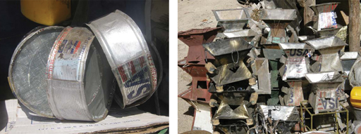
Figure 8.3 Large metal containers can be cut and reformed into new products like these sieves and stoves.

8.5.1 Waste separation
It is difficult to recycle materials once different wastes have been mixed together, so the first stage of the recycling process is to separate the materials into different categories. This is called waste segregation or separation at source and should be done by the householder when the waste items are finished with and discarded. Waste is separated by placing the different categories of waste into different bags or containers.
The degree of separation required will depend on the recycling opportunities that are available, but it is important to separate ‘dry’ and ‘wet’ materials. The simplest method of separation is to keep food waste separate from the remaining materials so that the food waste can be composted or used to make biogas (see Sections 8.5.2 and 8.6). If korales are active in the area, they may ask householders to keep all their recyclable materials (paper, metals, plastics and glass) together, or ask for just one or two materials to be separated.
If waste is not separated at the source, it ends up at a disposal site where all the waste is mixed up so separating the different types becomes much more difficult and hazardous. In many developing countries, including Ethiopia, collecting waste for recycling is often conducted by the informal sector. Such work can be done in a very labour-intensive, unsafe and polluting way, and for very low income. Often young children are employed as collectors. Part of a WASH team’s job is to help put the recycling industry on a more formal basis. This is another aspect of waste management that requires collaboration among stakeholders, including the informal sector and other concerned partners, to help improve the working conditions and provide protective equipment and training to the korales and other waste collectors.
It is possible to set up a more formal scheme to collect recyclable materials where the collectors provide separate receptacles for recyclable and non-recyclable wastes. Although separation has the advantage of promoting recycling, it also has the disadvantages of higher collection costs and needing special equipment and additional workers to collect each type of material. Therefore, in most urban and peri-urban areas, recycling collections are carried out by the informal sector.
Once separated materials have been collected from householders by the korales or by the more formal sector, they are passed on to merchants and eventually to the industrial operations that transform the wastes back into useful raw materials or products. Much of this part of the recycling chain falls outside the work of a local WASH team, but team members can still help people to become more aware of the importance of waste recycling and encourage them to separate materials for collection.

8.5.2 Composting
Composting is the process where biodegradable organic wastes (food and garden waste) are converted into compost in a natural biological process. Composting can be done by individual householders and community groups or on a commercial scale. On the larger scale, the waste from an entire town or city could be composted if sufficient land, labour and equipment is available. The benefits of composting are not only the reduction of waste, but also the production of compost which is a valuable soil improver. Soils treated with compost are better able to withstand droughts and are more fertile because plant nutrients are returned to the soil, which reduces the need for manufactured fertilisers. It is possible to add a certain amount of animal manure to residential waste for composting, which may help with other waste problems in the community and adds to the amount of useful soil improver that is made.
- Refer back to Table 7.1 in Study Session 7 and estimate what proportion of the municipal waste from urban areas can be composted.
- According to the data in Study Session 7, municipal waste contains 44% food waste and 12% garden waste making a total of 56%, so more than half of the waste can potentially be composted.
As an urban WASH worker you may be required to help individuals or communities set up and operate composting processes (Figure 8.4). The stages in the composting process are outlined below.
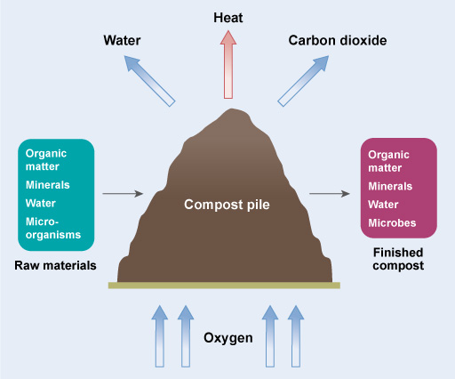
Figure 8.4 The composting process.
- Separation of compostable materials: It is important to begin with an uncontaminated input to the process. Nearly all organic wastes can be composted, but if a composting pile attracts rodents and other scavenging animals it may be better to exclude meat products and cooked food from the process and just collect garden waste and raw vegetable waste.
- Grinding or shredding: To speed up the composting process it may be necessary to shred the raw waste before placing it in the compost pile. Shredding is normally required if a significant proportion of the waste has particles greater than about 50 mm. On a domestic scale this can be achieved simply by cutting up the waste into smaller pieces.
- Blending or proportioning of materials: Composting works best with the right mixture of wastes so that the moisture content and the proportions of the chemical elements carbon and nitrogen are suitable. Generally, the ideal mix for composting is three parts (buckets, for example) of ‘brown’ waste (such as leaves, hay, straw, eggshells, shredded paper, card and woody material), with one part ‘green’ material (such as grass, food waste and animal manure). ‘Brown’ waste contains a higher proportion of carbon and ‘green’ waste, contains more nitrogen and has a higher moisture content. Thus the ratio of brown waste to green waste is 3:1.
Compost can still be made if the proportions are not in the ratio 3:1. If there is too much brown material, it will take more time to make the compost and water might need to be added. If there is too much green waste, the pile will need to be turned over more often (see below) and it may smell. Also, an unpleasant liquid may drain from the bottom of the pile.
- Composting: Composting is normally carried out in a pile. For larger scale composting processes, piles are in the shape of long rows of waste, normally with a triangular cross-section (Figure 8.5). The ideal pile is 1.5–2 m wide and about 1.5 m high. The length of the pile is determined by the space and the amount of waste available. On the domestic scale the pile will be much smaller, forming a rounded heap. The pile can be built up as waste becomes available, but it is important to have enough material present to allow the biological processes to take place reasonably quickly, so as a guide a domestic compost heap should be at least 1 cubic metre to start the process.
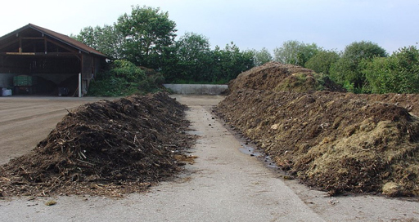
Figure 8.5 Composting process: mixed waste is piled in long rows.
Composting is an aerobic process, so the pile needs to be turned regularly to introduce air. This means dismantling it, mixing the waste to introduce air and then rebuilding the pile. The first turning-over of the heap should be done after two to three weeks and then every three weeks or so. The composting process will be complete within three to six months. The composting process generates heat, so it is normal to see steam coming out of the pile.
The process is complete once the pile no longer heats up after mixing and rebuilding. The final product should be brown and crumbly and look like a good soil. If it still contains identifiable items, the process is not complete.
- Summarise the advantages of composting.
- Composting provides an effective and safe way of disposing of a large proportion of a community’s waste that doesn’t involve specialised or costly equipment. It provides a valuable product that can be used by the community to improve the quality of its vegetables while reducing the need to buy fertilisers. Other wastes, such as animal manure, can also be added to the composting process.

8.5.3 Recycling and composting in Ethiopia
It is very difficult to assess how much of Ethiopia’s waste is recycled or composted. As explained above, much of the nation’s recycling is done by the informal sector and so information about it never enters the official statistics. Percentage recycling rates cannot be estimated because the total amount of waste produced is unknown. Much of the waste is never collected and disposal sites do not weigh the waste that does arrive there. Bjerkli (2005) quoted government figures for Addis Ababa which suggested that about 15% of the city’s waste was recyclable, but that the recycling rate was about 5%. Around 60% could have been used in compost production, but only 5% was composted. However, these figures should be viewed with caution because they depend on the reported quantities of waste and, as noted above, it is very difficult to obtain accurate data. In addition, some reusable and recyclable wastes such as metal scraps, old clothes and shoes are not considered as wastes in the first place. The actual recycling rates, if these materials were taken into account, would probably be higher.

8.6 Energy recovery
The fourth option in the waste hierarchy is recovery. Recovery is about finding other uses for wastes that enable some value to be extracted or recovered from them, usually by using them as a source of energy.
Recovering energy from waste on a large scale using an advanced incineration plant is a high-technology, high-cost option that is common in many developed countries. However, it needs a highly developed infrastructure (a reliable source of waste, good roads, a reliable waste collection service, a power distribution grid, etc.) and large amounts of waste. This technology is currently rarely used in low- and middle-income countries, but as cities develop there is great potential for energy-from-waste in the future in Ethiopia and many other countries (Scarlat et al., 2015).

8.6.1 Biogas production
In Study Session 5 you learned about the production of biogas from excreta by anaerobic digestion using the biogas latrine. The same technology can be used to treat food waste on its own or in combination with human excreta or animal manure.
Biogas recovery from organic waste (Figure 8.6) can be done at the kebele or household scale, where the biogas can be used for cooking and heating water. The sludge from the digester can be used as a fertiliser and soil improver. Another benefit of biogas production is the reduced use of fuel wood, which improves living conditions by reducing indoor air pollution. Additionally, biogas contributes to the reduction of greenhouse gases. The use of biogas as a cooking fuel will mainly benefit women because it will reduce their overall workload by providing energy for the household without requiring labour-intensive fuel collection.
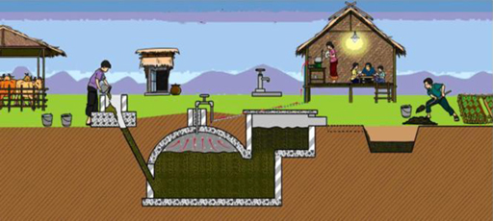
Figure 8.6 A biogas instructional poster from the Biogas Pilot Program (BPP).
Biogas production needs more equipment than composting, so it is more expensive to install. It also requires greater expertise than composting to operate and the equipment must be maintained. Small-scale biogas is well established in China and India, but this method is still relatively uncommon in Ethiopia (Rajendran et al., 2012).
To conclude this study session and provide an example of the various ways in which waste can be used, Box 8.1 describes the IGNIS programme, based in Addis Ababa. This programme included several pilot projects using many of the waste management options that you have been reading about.

Box 8.1 The IGNIS programme
The overall aim of IGNIS is to help people to generate income by recovering value from waste. This has involved the development and implementation of novel technologies and working to improve the social status and health of waste workers. Funding was provided by the German Federal Ministry of Education and Research, and the programme was run by a number of German and Ethiopian governmental agencies, academic institutions and non-governmental organisations (NGOs).
Some of the IGNIS projects include:
- Setting up a house-to-house collection of compostable waste and training people to make compost and to use it to grow vegetables.
- Collecting and composting waste from street markets and employing former street children and sex workers to collect the waste, as well as to make and sell the compost.
- Using the compost to fertilise and improve soil on deforested slopes around Addis Ababa which are prone to erosion. The land can then be planted with crops and brought back into use.
- Addressing the health issues (malnutrition and back problems) of the korales.
- Encouraging small-scale paper recycling factories.
- Supporting a women’s group in recycling charcoal dust and reconstituting it to make fuel briquettes.
- Installing pilot biogas plants that use food and kitchen waste to produce biogas for cooking.
- Making gloves from scraps of leather and textile wastes.
(IGNIS, 2012)
The IGNIS projects demonstrate that considering waste as a resource has many environmental, economic and social benefits. They also show how integrating different approaches to waste management can maximise the benefits.

Summary of Study Session 8
In Study Session 8, you have learned that:
- The waste hierarchy is a guide to selecting the most environmentally sound strategies for municipal solid waste, which ranks waste management interventions according to their environmental or energy benefits.
- Waste reduction involves industry in designing products to reduce the amount of waste that will later need to be thrown away. At the household level, waste reduction is about people making decisions to avoid generating waste.
- Recycling means reprocessing waste into new material. The first step is separation of waste into different types.
- Composting is the process of converting biodegradable waste into compost, a soil improver. This method has the advantage of providing a safe disposal route for organic waste while producing a useful end product.
- Composting requires organic wastes to be sorted, shredded, blended and placed in a pile for a few months. The pile must be turned every few weeks to introduce air.
- Recovery means extracting (recovering) value from waste, usually in the form of energy.
- Biogas recovery from organic waste has the potential to provide gas for heating at the kebele or household level. It can treat residential waste along with human excreta and animal manure.

Self-Assessment Questions (SAQs) for Study Session 8
Now that you have completed this study session, you can assess how well you have achieved its Learning Out comes by answering these questions. You can check your answers with the Notes on the Self-Assessment Questions at the end of this Module.

SAQ 8.1 (tests learning Outcome 8.1)
Composting is an example of waste recycling but it could also be described as an example of recovery from waste. Explain why this statement is true.

SAQ 8.2 (tests Learning Outcomes 8.1 and 8.2)
The waste management hierarchy is shown in Figure 8.7 below but without labels.
Add the correct terms to the five label lines on the right side of the diagram.
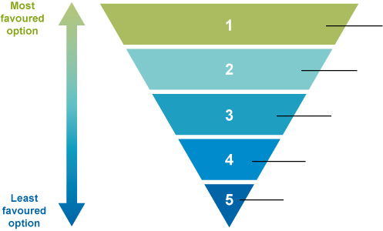
Figure 8.7 The waste hierarchy.

SAQ 8.3 (tests Learning Outcome 8.3)
Tigist is a mother of three children aged between 6 months and 5 years. Her husband has a good job and the family are well-off. Tigist does most of her shopping in the local supermarket where they give plastic carrier bags to all their customers.
Give three examples of ways Tigist could reduce the amount of waste produced by her household.

SAQ 8.4 (tests Learning Outcome 8.4)
In your job as a WASH worker, one of the korales has told you that they can’t collect much waste paper from a particular kebele because it is too dirty. How would you explain to the householders how and why they should separate their waste paper?

SAQ 8.5 (tests Learning Outcome 8.5)
Which of the following statements are false? In each case explain why it is incorrect.
- Biogas is produced from organic waste in an open tank called a digester.
- Removing plastic from waste is important for both composting and biogas production.
- Compost piles must be turned regularly because composting is an anaerobic process.
- Composting and anaerobic digestion both produce material that can be used to improve soil.
- Methane makes up about 60% of biogas.

Study Session 9 Storage, Collection, Transfer and Transport of Solid Waste

Introduction
Solid waste management can be thought of as a chain of linked stages, as shown in Figure 9.1. The chain begins with the generation of waste by individual households, institutions and workplaces. This is Stage 1, which you learned about in Study Session 7. Stage 2, covered in Study Session 8, is where the ‘3 Rs’ should be practised by separating the waste at source. This study session focuses on Stage 3. Waste treatment and disposal, the final stage, is covered in Study Session 10.
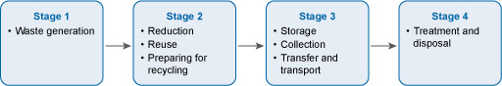
Figure 9.1 Four stages of the waste management chain.
In this study session you will be guided through the principles and strategies for storing, collecting, transferring and transporting solid waste.

Learning Outcomes for Study Session 9
When you have studied this session, you should be able to:
9.1 Define and use correctly each of the terms printed in bold. (SAQ 9.1)
9.2 Explain the difference between primary and secondary waste collection arrangements. (SAQ 9.1)
9.3 Explain the need for solid waste transfer stations. (SAQ 9.2)
9.4 List possible solid waste collection equipment needed for small- and medium-sized towns. (SAQ 9.3)
9.5 Identify ways of involving private collectors to increase the efficiency of solid waste collection. (SAQ 9.4)

9.1 Background
Solid waste is a major problem for cities in developing countries. It is considered to be a big challenge because it needs commitment, time and effort from businesses and householders to practise reduction, reuse and recycling. It also requires major financial investment as well as infrastructure development. A well-planned collection and transfer process can lead to significant reductions in the overall cost of waste management.
The national Solid Waste Management Proclamation sets out the regulations for waste management in Ethiopia. Its overall aim is to ‘… prevent the possible adverse impacts while creating economically and socially beneficial assets out of solid waste.’ (FDRE, 2007).
Among its clauses, the Proclamation makes urban administrations responsible for producing and implementing solid waste management plans. At the practical level, administrations are required to install waste bins in streets and public places, and to collect waste from these bins often enough to prevent them overflowing.
Ethiopia has a long way to go to achieve adequate waste collection systems in all its towns and cities. For example, in Addis Ababa, only 65% of the city’s solid waste was collected in 2003 (Regassa et al., 2011). More recent data indicates that this figure has since increased to 80% (Tessema, 2010; PPIAF, 2011). Even so, the city still has considerable progress to make. In other towns, the situation is worse. In Dessie, 48% of residents practise ‘open dumping’ of their waste (Sharma et al., 2012). In other words they deposit it on the roadside, on abandoned land, in open sewers or river banks, or around their yard. In Bahir Dar the collection rate was estimated in 2010 to be 67% and in Mekelle, until recently, only a third of total waste generated was collected by the municipality (Tefera and Negussie, 2015).
- You read about some of the negative effects of poor solid waste management in Study Session 2. Make a list of the benefits to everyone of having a good waste collection system.
- Your list will probably include the following. A good waste collection system can:
- reduce the number of flies, rodents and other scavenging animals that can spread diseases
- keep drains clear avoiding flooding and contamination of watercourses
- make the area more pleasant
- encourage people to look after their area
- encourage businesses to stay in the area or others to move there
- help to build a healthier society where people can earn more money and children can gain more from their schooling.
In Ethiopia and many other developing countries, collection is the most expensive stage of the waste management process chain – one estimate suggests that it demands 50–70% of the total budget (Tchobanogous and Kreith, 2002). So it is important that an effective collection system is in place.

9.2 Waste storage containers
The third stage of the waste management chain (Figure 9.1) begins when a householder or business employee puts their waste in a container. The choice of container will depend on several factors, including the wealth of the household and the amount of waste to be collected. It will also depend on the collection system – is it collected from outside the house or does the householder have to empty it into a communal container?
The simplest and cheapest storage containers for individual households are old lidded food containers, similar to Figure 9.2(a). You saw some other examples of simple domestic waste containers in Figure 7.4 in Study Session 7. It is easy for a householder to empty these containers into a communal bin for collection. At the other extreme are wheeled bins that can hold up to 240 litres of waste (Figure 9.2(c)). These need to be emptied into a vehicle fitted with lifting equipment. Any system using this type of bin needs well-maintained wide roads within 10 m or so of each property served.
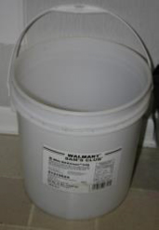 | 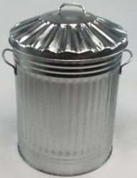 | 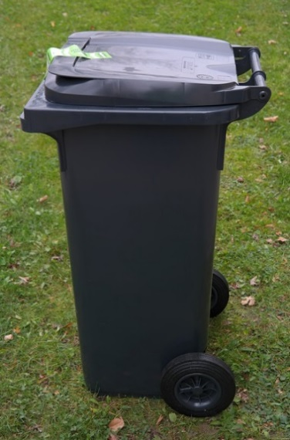
(a) | (b) | (c)
Figure 9.2 Household waste storage containers: (a) old ten-litre food container; (b) 60-litre metal bin; (c) 240-litre wheeled bin. (Cowing et al., 2014)
Communal bins need to be larger than domestic containers and they should also be more robust. Often they need to be emptied by a specialised vehicle fitted with lifting equipment (described in the next section). Some examples are shown in Figure 9.3.
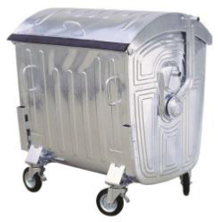 | 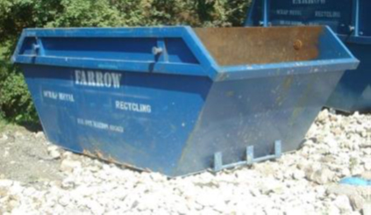
(a) | (b)
Figure 9.3 Communal waste containers: (a) Metal bin with 1 m³ capacity; (b) Waste skip – these can range from 3 to 15 m³. (Cowing et al., 2014)
Effective waste management in needs commitment from both the local people and the kebele authorities. The people should use the communal waste containers in the correct way and avoid littering. In return, the kebele or town administration (or its contractors) should empty the containers at regular, predetermined times (for example, every Tuesday and Thursday morning) and keep the containers and immediate area clean.

9.3 Primary and secondary collection
After on-site storage, the next step is collection. Primary collection is the collection of waste from the point where it is placed by the person or organisation that has produced it. These collection points could be located outside each individual household and business, communal containers serving a number of households, or waste skips taking waste from households and businesses in the surrounding area. Depending on the collection vehicle and the distance to the waste treatment/disposal site, the waste at this stage may be taken to the final disposal site or to a transfer station, as described in Section 9.4.
Primary collection can be done in many ways. Table 9.1 summarises the lower-technology options that are suitable for collecting waste from households and transporting it to a transfer station or local disposal site. These all have the benefit of being able to serve narrow streets in crowded areas.
Secondary collections are where the waste from a number of primary collections is taken from the transfer station to the final disposal site. Table 9.2 shows some options for secondary waste collection vehicles, but note that some of these are also used for primary collections in certain situations.
Table 9.1 Options for primary collection. (Cowing et al., 2014)
Vehicle | Comments
Wheelbarrow  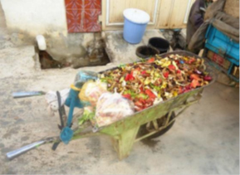 | Only suitable for taking waste from households to a communal collection point. Good for narrow streets, but needs a well-maintained street surface.
Hand-cart  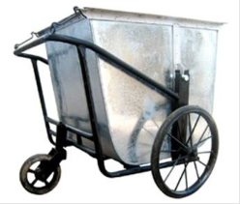 | The additional wheels mean that this is more stable than the wheelbarrow (especially on poor road surfaces) and it is easier to move over longer distances. It can also carry a larger volume (1–2 m³).  Suitable for door-to-door collections in crowded areas and for transporting waste to communal containers at the ends of streets or to local transfer stations.
Cycle cart  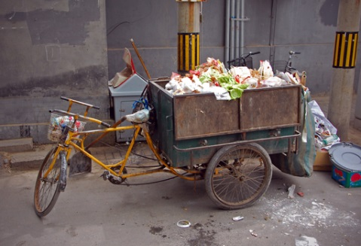 | Can collect up to 3 m³ and transport the waste to a communal bin or transfer station. The cart has drop-down sides to make loading and unloading easier.  It needs a reasonable road surface and is not suitable for steep hills.
Donkey cart  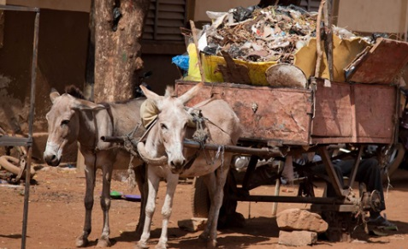 | Similar uses to the cycle cart. It has a drop-down end and, like the cycle cart, needs reasonable road surfaces and is not suitable for steep gradients.
Tractor  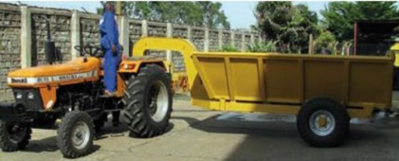 | A tractor has much higher costs than the above options, but can transport up to 4 m³ of waste for distances up to around 20 km to disposal sites or transfer stations.

Table 9.2 Secondary collection vehicles. (Cowing et al., 2014)
Vehicle | Comments
Truck fitted with bin lifter  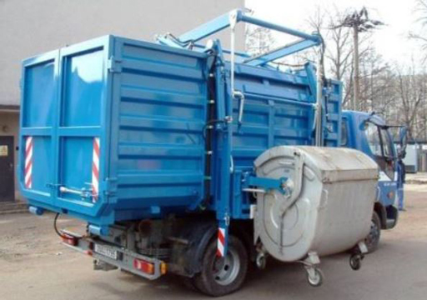 | A robust vehicle that can travel on rough roads. Suitable for transferring or collecting communal bins from residential and commercial areas.  Note that dump trucks without bin lifters are not recommended due to need for manual loading.
Enclosed light truck  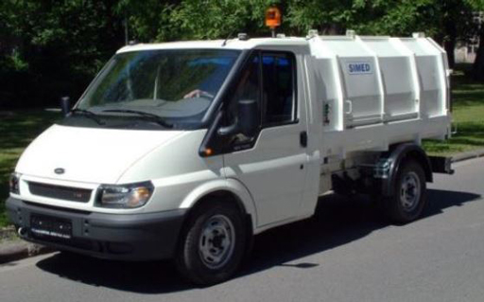 | A waste collection tipper box fitted to a conventional vehicle chassis. Useful for emptying street-side litter and communal residential waste bins. Can serve narrower streets than most motorised collection vehicles but needs better roads than truck-based vehicles.
Flatbed crane truck  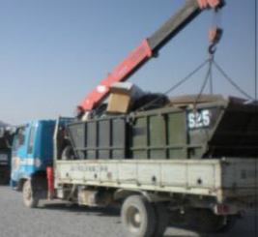 | Useful for collecting skips from transfer stations, markets and industrial areas.  Fitted with its own crane for loading and unloading.
Compactor  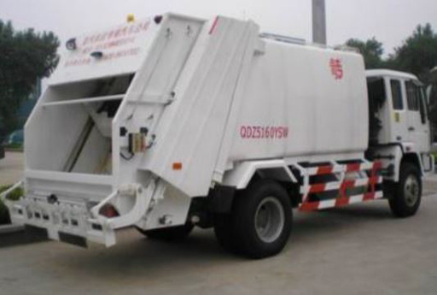 | The most expensive collection/transfer vehicle, costing around US$250,000. Hydraulic compaction equipment not suitable for residential waste (which already has a high density) and hydraulics need specialist maintenance.  Only suitable for collecting low-density waste in large quantities where road conditions are good.  Of little use outside major cities.

9.4 Transfer stations
Most of the collection vehicles shown in Table 9.1 can only really transport the waste a short distance – a few kilometres at most. On the other hand, most of those shown in Table 9.2 are too large to collect waste from crowded urban areas and/or too expensive for most of Ethiopia. So unless the disposal site is less than around 3 km from the urban centre, the waste needs to be taken off the primary collection vehicle and loaded onto secondary collection vehicles. This is done at a transfer station. Waste can also be stored at a transfer station for a short time period where, in some cases, recyclable material is extracted from the mixed waste.
Transfer stations should be located conveniently close to all the communities they serve, but not too close to people’s homes or factories, schools, hospitals, etc. so that they cause a nuisance. They should also have access to major roads leading to the treatment or disposal sites.
Transfer stations have many advantages:
- They reduce the overall traffic levels by using fewer but larger-capacity vehicles, which reduces traffic congestion and pollution.
- If primary collection vehicles have to drive longer distances to the disposal site they are more likely to be tempted to save time by illegally dumping the waste at the side of the road. Transfer stations prevent this happening.
- In areas with a low population density it is cheaper to have a transfer station that incorporates short-term storage of the waste. Small carts can deposit their waste here daily and a larger vehicle can transport the stored waste to the disposal site every few days.
- Consolidating the waste into fewer vehicles reduces vehicle wear, the need for maintenance and fuel consumption.
- Waste can be screened so that recyclable items or inappropriate waste (like tyres and vehicle batteries, which should not go to a landfill) can be taken out.
- Transfer stations reduce traffic at the disposal facility. Since fewer vehicles go to the final disposal site, traffic congestion can be avoided, the cost of operation can be minimised and public safety is improved.

9.4.1 Types of transfer station
The simplest transfer stations consist of an area of hardstanding where skips are situated. The contents of primary collection carts are transferred to the containers manually (Figure 9.4).
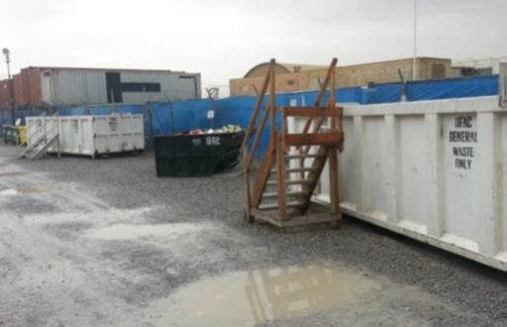
Figure 9.4 Simple transfer station.
In more complex transfer stations, the collection carts tip their waste onto a concrete floor and a mechanical loading shovel is used to transfer the waste to the skips (Figure 9.5). This allows the use of larger containers, so this type of station is more economical where distances to the waste disposal site are greater.
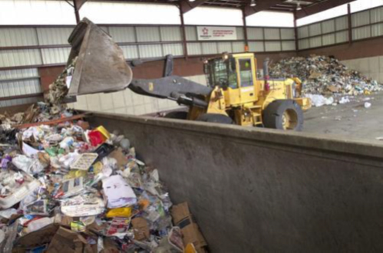
Figure 9.5 Mechanically loaded transfer station.
- Looking at Figure 9.5, what are the measures being taken to protect the health and safety of workers and the general public?
- The site is enclosed with walls, so only authorised people can gain entry to areas where machinery is being operated. Enclosure also keeps out scavenging animals and reduces wind-blown littering.
The site has a roof, so the rain is kept out and the waste cannot pollute surface run-off. The roof also reduces wind-blown litter.
Loading using a machine rather than people doing this work with shovels reduces human contact with the waste, which in turn lessens the risk of injury from sharp items (broken glass, metal edges) and the transmission of infections. (In areas with poor sanitation, the waste will contain human faeces.)

9.4.2 Health and environmental impacts of transfer stations
Transfer stations can be environmentally damaging, as shown in Figure 9.6. In contrast, a high-quality site with good fencing, hardstanding, lighting and an office/amenity building (Figure 9.7). will have little environmental impact. Of course, all waste transfer stations smell to some extent, but even this can be minimised by ensuring that waste is not stored for long periods.
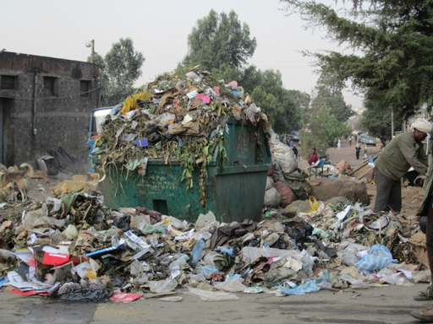 | 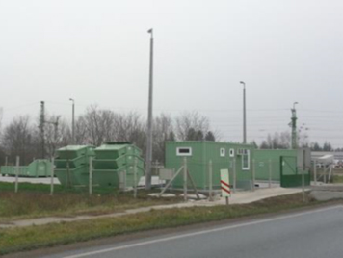
Figure 9.6 A badly equipped and poorly managed transfer station. | Figure 9.7 A well-designed transfer station.
Consideration also needs to be given to the transfer station staff, who will be exposed to all the waste hazards (including physical damage from sharp items, human faecal and other pathogens, heavy metals and dust and other chemicals). They should be provided with, and required to use, protective equipment (boots, gloves, hard hats, dust masks, high visibility jackets and safety glasses). An amenity room should also be provided for meal breaks and other breaks and handwashing facilities provided.

9.5 Planning the route for waste collection vehicles
For any urban location, there is likely to be a number of transfer stations distributed around the town. The waste will need collecting from all these stations as well as directly from businesses, institutions and some households. In most locations, there is only one site for final treatment and disposal, to which the waste must be transported, and this is usually situated at the edge of the town. It is important to plan the routes for the waste collection vehicle (or vehicles) to make the best use of the resources available. This keeps costs down and gives people the best-possible service. Route planning is a complex operation, but the basic process consists of three stages:
- Identifying the pickup points and the likely amounts of waste to be collected from each point.
- Grouping pickup points to form ‘collection rounds’ that can be served by a single collection vehicle.
- Planning the route of each collection round taking account of the distance travelled, traffic levels and safety to the public and the waste collectors.

9.6 Involving the private sector
One of the causes of a poor solid waste collection and treatment/disposal programme is a weak cost recovery system. This means there is no effective mechanism for collecting payments to cover the costs of the waste collection system. If the users of a service (the householders and businesses) do not pay for the waste collection and disposal service – either directly or through the kebele local authority – then there will be no funds available to pay wages, maintain the equipment or invest in new equipment and facilities. This leads to a decline in the service offered, which in turn leads to reduced income for the service providers, and so on. Private sector organisations can be better equipped than governmental organisations to collect payments and manage the finances. If they become involved in providing the waste management services, this spiral of declining services can be reversed.
Private companies may also have more experience of waste collection and access to better equipment than local government, resulting in better service provision. This arrangement, where the public and private sectors work together, is called a public–private partnership (PPP) or private sector participation (PSP). For example, a private sector company may be paid to collect a kebele’s waste and to collect payments from individual businesses and residents. If several companies are competing for the same PPP contract this should result in lower costs to the kebele.

9.6.1 Examples of waste management PPP schemes

Addis Ababa
Private sector operators became eligible to obtain permits to take part in waste collection, transport and treatment when the Solid Waste Management Proclamation was published in 2007 (FDRE, 2007). By April 2011, 524 firms in Addis Ababa had been permitted to collect solid wastes, employing 5800 people (PPIAF, 2011). Over the four years, the proportion of the city’s waste collected had risen from 60% to 80%, providing waste collection services to an additional 600,000 people.
Many of these private sector operators are ‘micro-enterprises’ (see Box 9.1). Under these PPP schemes, the planning and administration is the responsibility of the kebele authorities, who remain owners of the service (Tilaye and van Dijk, 2013). These micro-enterprises are responsible for operating the schemes. They collect waste from individual households, taking a fee from each household served and also receiving a fee from the kebele based on the amount of waste deposited at the central collection points/transfer stations. This helped to raise the proportion of waste collected, but the scheme was only semi-regulated, resulting in several collectors working in the same (well-off) areas and no collectors working in areas where residents could not afford to pay the collection fees.

Box 9.1 Terminology of micro- and small enterprises
You may come across several terms and abbreviations used to describe small businesses of different sizes. The various terms depend on the number of employees and the financial status of the firm. Precise definitions can vary, but one frequently used classification is:
- micro-enterprises: fewer than 10 employees
- small enterprises: 10 to 50 employees
- medium-sized enterprises: 50 to 250 employees.
Various abbreviations are used, of which SME, meaning small and medium-sized enterprises, and MSE are the most common. MSEs are micro- and small enterprises comprising businesses with fewer than 50 employees.

Bahir Dar
In 2008 the local government of Bahir Dar contracted a newly formed private company to collect, transport and dispose of the city’s waste. The company claimed that it could provide a better service at a lower cost. The scheme was assessed by Lohri et al. (2014). Waste is collected from outside houses and businesses by 270 collectors which carry or use hand-carts to take the waste to a network of around 100 collection points. At these collection points the collectors load the waste onto open trucks which are driven to an open dumpsite 7 km outside the city. The money to set up the scheme was provided by the government (56%), the United Nations (34%) and the company (10%), and the only income stream was from fees paid by the householders for the collections. The scheme was successful in that the proportion of waste collected rose from 50% to 67%. However, the fee income was only half the level expected, so the company had to use grants provided for capital equipment (vehicles, etc.) to pay staff wages. This meant that the scheme could not continue in the long term. According to Tefera and Negussie (2015), the municipality subsequently organised four additional MSEs to extend the system and improve waste collection rates across the city.
Solid waste management systems are developing in many Ethiopian towns and cities, but there is still considerable scope for improvement. Based on a study of Addis Ababa, Desta et al.(2014) identified several ways of increasing efficiency including:
- raising awareness of the public health implications of poor waste management
- improving planning decisions and the enforcement of regulations
- increasing the number of transfer stations at accessible sites
- increasing the number of trucks available for transportation
- promoting compost production from organic waste
- promoting the separation of waste at the source (household level)
- enhancing the collaboration and participation of the private sector and communities.
To make significant and sustainable progress in solid waste management, an integrated approach that used a combination of these methods.

Summary of Study Session 9
In Study Session 9, you have learned that:
- Waste collection means collecting waste from where it is generated. Before collection, the waste should be stored in appropriate containers with lids.
- Primary collection takes waste from where it is produced to a transfer station. Secondary collection is the stage when it is moved from the transfer station to the final treatment or disposal site.
- Many different containers and vehicles are used for waste collection and transfer. They are appropriate in different situations, depending mostly on size and cost.
- Transfer stations should ideally have fences and roofs. Waste should be removed frequently to prevent unsightly and unhygienic conditions developing.
- The routes for collection vehicles should be carefully planned so they are efficient and cover the shortest distances.
- Private sector involvement in waste collection can increase efficiency. However, all systems need effective planning, management and operation if they are to provide a successful waste collection service and be financially viable.

Self-Assessment Questions (SAQs) for Study Session 9
Now that you have completed this study session, you can assess how well you have achieved its Learning Outcomes by answering these questions. You can check your answers with the Notes on the Self-Assessment Questions at the end of this Module.

SAQ 9.1 (tests Learning Outcomes 9.1 and 9.2)
Explain whether the following waste collection vehicles would be better suited to primary or secondary collections:
- wheelbarrow
- donkey cart
- flatbed truck.

SAQ 9.2 (tests Learning Outcome 9.3)
Give four reasons why transfer stations are needed.

SAQ 9.3 (tests Learning Outcome 9.4)
Assume that you are a solid waste collection manager for a small town. What equipment would you need to run an effective solid waste management system?

SAQ 9.4 (tests Learning Outcome 9.5)
How could you encourage private sector waste collection enterprises to serve households that cannot afford to pay for the service?

Study Session 10 Disposal of Solid Wastes

Introduction
So far, in the series of study sessions focusing on solid waste management, you have studied sources and quantities of waste (Study Session 7), ways of reducing, re-using and recycling wastes (the ‘3 Rs’; Study Session 8), and ways of collecting the remaining waste (Study Session 9). Unfortunately, after practising the 3 Rs, we are often still left with a portion of waste to be disposed of. In this study session you will look at the different disposal options and how they can be used in urban areas in Ethiopia. You will also learn more about hazardous waste and how it should be managed.

Learning Outcomes for Study Session 10
When you have studied this session, you should be able to:
10.1 Define correctly all of the key words printed in bold. (SAQs 10.1, 10.2, 10.3 and 10.5)
10.2 List the main options available for solid waste disposal and describe their advantages and disadvantages. (SAQs 10.1, 10.2 and 10.3)
10.3 Describe the key factors to consider when planning a landfill for a small or medium-sized town. (SAQ 10.4)
10.4 Describe how toxic and other hazardous waste can be disposed of safely. (SAQ 10.5)

10.1 Options for waste disposal
Waste disposal processes aim to isolate the waste from people and the environment in a manner that causes no harm. The best option for dealing with any particular waste depends on the nature of the waste itself (its form, composition and quantity), the technologies available in the region, the availability of financial resources, and having enough skilled people to build, operate and maintain the facilities. In Ethiopia, two main waste disposal processes are widely used: landfill, including burial and dumping, and thermal processing, which includes burning and incineration. Different methods of landfill and thermal processing are described in the following sections.

10.2 Landfills
Landfill was defined in Study Session 1 as an area of land set aside for the final disposal of solid waste. Ideally the site is managed to prevent people and animals from entering and the deposited waste is covered with soil to isolate it from the environment. However many informal sites do not cover the waste or have any other control measures. We are using ‘landfill’ here as a general term that applies to any site where solid waste is deposited for final disposal.
There are many different types of landfill, some with greater environmental impact than others. In all of them the waste gradually decomposes by a combination of biological, chemical and physical processes. During these decomposition processes, two major emissions are of primary concern – leachate and landfill gas:
- Leachate is the polluted water that emerges at the base of the landfilled waste. It is formed in two ways. Rainwater landing on the waste slowly flows over and through the waste and soluble substances are dissolved in the water. Also, some of the decomposition reactions taking place in the waste produce liquid that can be acidic. Some substances, such as toxic metals, tend to dissolve more easily in acids, making the final leachate more harmful. If leachate enters a watercourse used to provide human or animal drinking water or for irrigation, people can be exposed to these pollutants.
- Landfill gas is formed in large landfills through degradation of the waste in anaerobic conditions. Landfill gas consists of a mixture of carbon dioxide and methane, which are both greenhouse gases that contribute to global climate change. It is also flammable and will burn if exposed to a flame or other source of ignition. In extreme cases, the gas can build up in a landfill and explode, with the risk of injury and death. Managed landfill sites have vent pipes that allow the gas to get out of the waste and be released to the air or burned in a controlled way.
The different types of landfill can be ranked according to their potential to cause environmental pollution. Starting with the worst, they are:
- Indiscriminate waste disposal
- Communal open dumping
- Burial in pits
- Controlled landfill
- Sanitary landfill.
These types of landfill are described in the following sections.

10.2.1 Indiscriminate waste disposal
This is the most unwanted and dangerous practice in solid waste management. It occurs when an individual leaves waste by the roadside, on a piece of disused land, in a field, by the side of a riverbank or in a river (Figure 10.1). This practice is very common in urban areas in Ethiopia and is also known as open dumping.
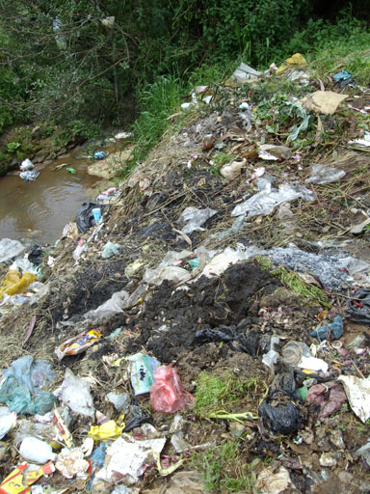
Figure 10.1 Open dumping on the banks of a river.
- Why do we discourage open dumping?
- Open dumping is discouraged for a number of reasons. It:
- attracts flies, rodents and birds
- flies contaminate our food, causing food-borne illnesses
- rodents can transmit a range of diseases and can damage property
- birds disperse pathogens in their faeces
- is unsightly and causes bad odours
- allows waste, especially paper and plastic bags, to be blown around by wind
- causes fire hazards
- is a hazard for grazing animals
- can block rivers and drains, causing flooding.

10.2.2 Communal open dumping
This method is practised in many small and medium-sized towns in Ethiopia. A convenient area of land near the town is identified, frequently in a valley or a natural depression in the ground. Waste is then deposited at the site and gradually accumulates over time. At their worst, these sites have no barrier to keep out animals, there is no equipment to move or compact the waste, no environmental control measures, and no site staff. (Compacting means reducing the volume occupied by landfilled waste by pressing down on it, usually by driving over it with a tractor or other heavy vehicle.)
Open dumping can be an effective way of isolating waste from people, but adverse effects can emerge in the long run, such as:
- There is no barrier between the waste and the ground below so leachate can contaminate groundwater and surface waters.
- The areas selected for such sites are often some distance from the community and not accessible to carts and other wheeled transport. This means that the waste must be carried to the site, which is time-consuming. Some people will be tempted to dispose of waste indiscriminately rather than walk all the way to the site.
- Unless the site is well looked after (which is unlikely), waste can be blown off the surface by the wind and the exposed waste may attract flies, rodents, dogs, hyenas and birds.
- Finally, if the waste is deposited in a normally dry valley, flooding can occur in the event of unexpected heavy rain. The rainwater will become contaminated with leachate and with waste items such as plastics.

10.2.3 Burial in a pit
This is practised mainly in the yards of individual households. It can be an effective way of dealing with waste, especially when the waste is covered by earth every day. But care must be taken in choosing where to position the pit so that there is no danger of leachate contaminating groundwater or surface water. Another disadvantage is that these pits cannot accommodate a huge volume of solid waste, so a household could run out of disposal space. An example of a burial pit, which is fenced to keep out animals and children, is shown in Figure 10.2.
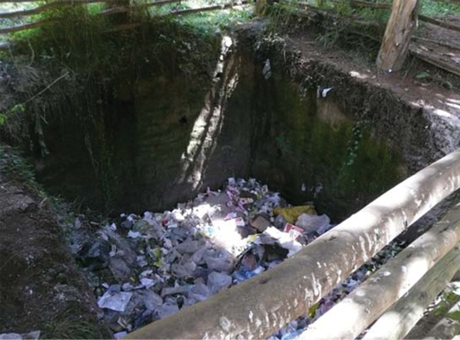
Figure 10.2 Waste pit for a small community.

10.2.4 Controlled landfill
For urban waste disposal, a controlled landfill is a significant improvement on the communal open dump. The area is fenced to control access and the waste is covered with soil at the end of each day. This prevents the waste being blown around, stops flies breeding on the waste, makes it less accessible to scavenging animals and prevents the waste catching fire. A controlled landfill site is staffed, and some machinery (such as a tractor) is available to spread, compact and cover the waste with soil.
The national Urban Solid Waste Handling and Disposal Strategy (MUDHC, 2015) includes standards for waste disposal areas of different categories of town and city. The standard for smaller cities and towns requires that the site should:
- accommodate up to 50 metric tons of waste daily
- have an inlet road, which is kept repaired
- make sure that dumped waste is covered with soil
- have procedures for controlling the waste coming to the site
- have light machinery, such as tractors, regularly on site
- have an additional 15% land area for operating space and site services
- forbid the disposal of rubber products, industrial wastes, medical and hazardous wastes, and keep construction waste separate from general waste.
Note that the standard specifically mentions the problem of rubber products, which generally refers to vehicle tyres. Tyres should not be added to landfill for several reasons: they cannot be compacted; they may collect water which creates a breeding site for mosquitoes; and, if they catch fire, they can burn for many weeks or even months.
Following these standards is good practice in small and medium-sized towns, but continuous staffing is needed to control how and where the waste is deposited and to prevent the site from becoming an open dump. Furthermore, there is no control of leachate being formed or contaminating ground and surface waters.

10.2.5 Sanitary landfill
A sanitary landfill is an engineered facility for the disposal of waste from larger towns and cities (Figure 10.3). To be cost-effective there needs to be more than around 150 metric tons of waste deposited in a day. The site is designed and operated to minimise public health and environmental impacts. The additional environmental control measures should include a system to collect and treat leachate, better gas venting systems and good amenities for site staff. In Figure 10.3 you can see the drainage channels for leachate that have been prepared before the waste is added to the area in the foreground. Larger sites should be divided into ‘cells’ separated by earth banks. Adding waste to one cell at a time allows each part of the site to be filled and covered more quickly.
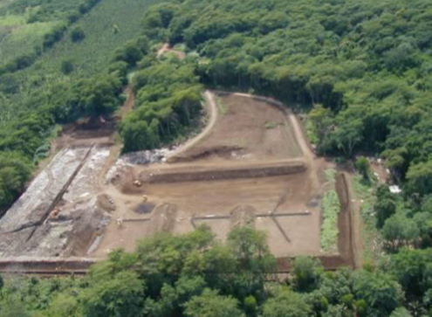
Figure 10.3 A sanitary landfill.
For the largest cities, the ideal sanitary landfill would also have:
- an active system to pump out landfill gas and burn it, ideally making use of the heat generated
- a liner made of compacted clay or a synthetic membrane sheet that separates the waste from the ground below and prevents leachate leaking from the site and into the surrounding ground.
These types of landfill sites are uncommon in African countries, but efforts are being made to convert the Repi landfill in Addis Ababa into a sanitary landfill.
- According to the data in Study Session 7, typical waste generation rates in Ethiopia are between 0.3 kg and 0.5 kg per person per day. If you assume a rate of 0.3 kg, how big a population would a city need for it to operate a sanitary landfill?
- To be cost-effective, a sanitary landfill needs to take at least 150 metric tons of waste a day, which is 150,000 kg. If all this waste came from residential sources, this would need:
$\frac{\text{150,000}}{\text{0.3}}$ = 500,000 people

10.3 Planning controlled landfills for small and medium-sized towns
If small and medium-sized towns wish to reduce open dumping, a dedicated controlled landfill site needs to be identified and developed. To plan for a new site, two key factors to consider are the area of land required and the choice of the best location.

10.3.1 Estimation of the required land area
As an example, think of a town with a population of 25,000 people that produces around 4000 metric tons of waste a year (residential, commercial and industrial). The town intends to construct a controlled landfill that will last for five years.
The first stage is to estimate the volume of space that this waste will occupy. From previous experience, it is known that one cubic metre (1 m³) of waste weighs about 600 kg when landfilled; in other words the density of waste is 600 kg per m³. So one year’s worth of waste (4,000,000 kg) will occupy:
$\frac{\text{4,000,000}}{\text{600}}$ = 6667 m³
Therefore five years’ waste will need 6667 × 5 = 33,333 m³.
But we also need to allow for the soil that is used to cover the waste. Again, from experience, it is known that this will add about 10% to the space required. In this case we will need:
33,333 × $\frac{\text{110}}{\text{100}}$ = 36,667 m³
We now need to calculate the land area. If we assume that the depth of the waste and soil cover in the site will be 3 m, the site area required will be:
$\frac{\text{36}\text{,}\text{667}}{\text{3}}$ = 12,222 m²
Although this is the requirement for the land used for disposal, additional land is required to give space for vehicles to move, for the cover soil to be stored and for an amenity building. From Section 10.2.4, this will account for a further 15%, so the site area becomes:
12,222 × $\frac{\text{115}}{\text{100}}$ = 14,055 m²
If the site were rectangular, a space of 100 m by 140 m would be suitable.

10.3.2 Finding a suitable location
Once the area of land is known, the next step would be to find a suitable location. The main factors in deciding if a site is suitable are as follows:
- How far is the site from the centre of the population? On the one hand, if the site is too close, the people may be bothered by odours. However, if the site is more than about 3 km from the town, a transfer station (see Study Session 9) will be needed to transfer the waste from the collection vehicles to a lorry that then takes the waste to the site.
- Is the site near a watercourse? Generally speaking it is better to avoid an area close to flowing water because there is always a risk that leachate will leak from the site. It may be tempting to use a dry valley but this may not be dry during the rainy season and running water could carry the landfilled waste over a large area. For this reason, valleys are best avoided.
- Is there any groundwater under the site? It is important to take specialist advice about this because of the risk of contamination.
- What is the local soil type? Water and leachate flows through different soils at different speeds. Sandy soils tend to be very permeable and leachate will flow through them quickly and for a long distance. Clay soils tend to be less permeable so leachate travels slowly and for shorter distances through them.
- What do the local community think about it? Some areas of land are considered to be sacred by one or more religious groups and should never be considered for landfill. Using such land would be deeply offensive to the people concerned.

10.4 Thermal processing methods
Thermal processing of waste means heating waste so that it burns. During the burning (also known as combustion) process, the combustible material is converted into gases (mainly carbon dioxide and water vapour) and an ash residue. Thermal processing leads to a large reduction in the volume of solid material left over for landfill disposal and destroys pathogens, so it may look like an attractive option. However, unless the combustion takes place under tightly controlled conditions using equipment designed to prevent and capture any pollutants produced, the process will emit a large amount of smoke and other invisible air pollutants that can cause serious health problems.
There are two main thermal processes you may come across: open burning; and incineration. There are other more advanced thermal processing methods but these are not currently used in Ethiopia.

10.4.1 Open burning
Many individual householders practise open burning in their yards, where waste is burned in a pile in the open air and the remaining ash is buried or spread on the ground. This may be easier for the householder than taking their waste to a collection point or a landfill, but the smoke is an annoyance to the neighbours and can be a health hazard (Figure 10.4). You should always discourage open burning unless it really is the only option for dealing with the waste.
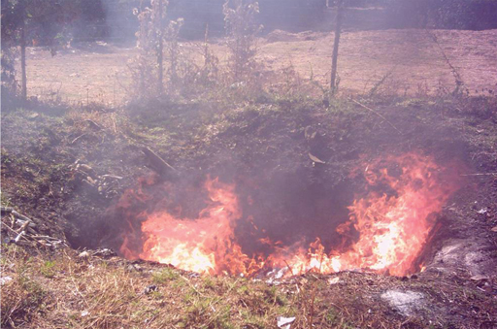
Figure 10.4 Open burning produces a lot of smoke and can be dangerous.

10.4.2 Incineration
Incineration, as opposed to open burning, is the combustion of waste material in an enclosed container with an air supply and ideally fitted with a chimney. The combustion process can be controlled to some extent so less pollution is produced and a chimney helps to reduce the impact by sending product gases upwards into the atmosphere. An incinerator of the type that may be used in large schools or hospitals is shown in Figure 10.5(a). Smaller, lower-cost incinerators may be built from bricks (Figure 10.5(b)). These can be built locally and are the type you are most likely to see.
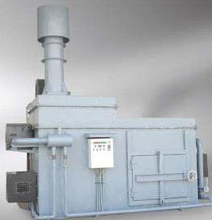 | 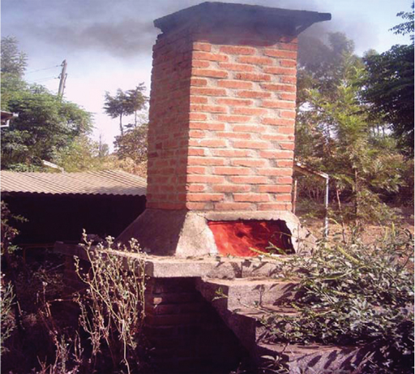
Figure 10.5 (a) A metal incinerator with a chimney. (b) A brick incinerator is simpler and cheaper to build.
Incinerators are mostly used in Ethiopia to treat healthcare waste or waste in other institutions such as schools. They are preferable to open burning but they still generate smoke and other pollutants. They need to be operated with care to make sure they function correctly and to minimise possible pollution. Good practices in managing small incinerators include the following:
- Make sure there is a sufficient air supply to the container where the burning takes place. Usually the air flows upwards through the chamber, so the bars that the burning waste sits on should not be blocked.
- Most pollution is formed when the incinerator is heating up, so use firewood or clean, dry waste at the start.
- Waste should be added to the incinerator regularly so that the temperature does not fall and cause smoke to be formed. Generally, wet waste should be added in small amounts and ideally mixed with dry waste.
- The ash should be removed when cold and then buried. Care must be taken to avoid light ash blowing away in the wind.
- The incinerator should be in a fenced-off area – when operating, the external surfaces will become very hot.
- The incinerator operators should be trained adequately. They should wear protective clothing (gloves, face masks, etc.), especially when burning healthcare waste. They should have access to and use handwashing facilities at the end of each shift and before meal breaks.

10.5 Types of hazardous waste
Hazardous waste was defined in Study Session 7 as any discarded material that may pose a substantial or potential threat to public health or the environment. Hazardous waste, whether liquid or solid, must be kept separate from non-hazardous waste and requires special handling and treatment. Hazardous wastes may be:
- Toxic – these are wastes that are capable of causing acute or chronic health problems. Examples include asbestos, arsenic, heavy metals and synthetic pesticides.
- Ignitable – ignitable wastes will catch alight very easily when exposed to a flame or spark. Ignitable wastes are also highly flammable meaning they burn easily. Examples are organic solvents, oils and paint wastes.
- Corrosive – corrosive substances that are strongly acidic (pH less than 2) or strongly alkaline (pH higher than 12.5), and can readily dissolve standard container materials or damage living tissue. Examples include acids, alkalis, cleaning agents and discarded batteries or battery manufacturing residues.
- Reactive – reactive wastes are dangerous because of their vigorous reaction with air and water, or because they can explode and generate toxic fumes. Examples are obsolete munitions, wastes from manufacturing dynamite or firecrackers, and some chemical wastes.
- Infectious – any waste that contains micro-organisms that can harm humans. Much of the waste produced by hospitals, health centres and dentists may well be infectious. This type of waste may also be referred to as a biohazard.
- Which of the following waste materials could be considered to be hazardous?
  - food waste
  - discarded mobile phones
  - used gas canisters
  - school laboratory waste
  - old medicines and drugs.
- All of these waste materials, apart from food waste, should be considered hazardous.
How do you know whether a waste is hazardous? Many hazardous products are found in Ethiopia but people do not always know how to identify them. It is important that anyone who comes in contact with hazardous materials understands their nature so they can protect themselves and handle the specific product or waste with care to avoid damage to skin, clothes or even property and life. There is an internationally agreed set of hazard symbols, shown in Figure 10.6.
 |  | 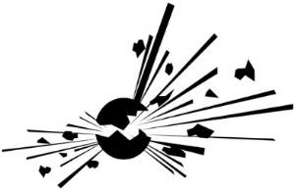
Poison or toxic. These materials, if ingested, can cause serious illness or death, in addition to cancer, birth defects or other chronic health problems. | Flammable. These materials will burn under certain conditions. | Explosive. These materials may react violently when exposed to heat or other substances.
 | 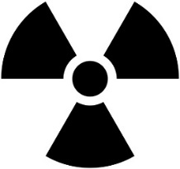 | 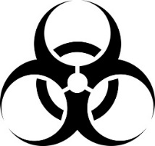
Corrosive. These materials can eat away other substances, including living tissue. | Radioactive. These materials may cause illness if not shielded properly or if their shield breaks down due to improper disposal. | Biohazardous/infectious. These materials may pass on disease. No household items should contain this symbol.
Figure 10.6 Hazardous waste symbols.

10.5.1 Household hazardous waste
You may think that hazardous waste is only produced in factories and hospitals, but you should be aware of household hazardous wastes. These are wastes produced in normal households that have any of the hazardous properties listed above. This could include bleaches and some cleaning products, batteries, paints, pesticides, and pharmaceuticals (Figure 10.7).
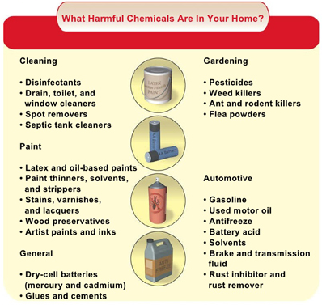
Figure 10.7 Some harmful chemicals that can be found in our homes.

10.6 Management of hazardous waste
When it comes to treating hazardous wastes, the principle of the 3 Rs should be followed where possible. Alongside reduction, replacement should also be practised as the first stage in the waste hierarchy. This means replacing hazardous substances with non-hazardous ones in manufacturing processes and avoiding processes that produce hazardous by-products. Applying the 3 Rs to hazardous waste is highly specialised and would normally be the responsibility of the industries concerned.
There are a number of options for treating hazardous waste, based on transforming it to a non-hazardous form or isolating it from people and the environment. The options are:
- Secure landfill, where the waste is completely isolated from the environment. This is generally the safest method, but sites that are designed to take hazardous waste are uncommon in Africa.
- Treating the hazardous waste chemically to transform it into a non-hazardous waste. For example, acid waste can be neutralised by the addition of the correct amount of an alkali.
- Treating organic hazardous wastes (oils, for example) with micro-organisms to break them down into non-hazardous materials.
- Controlled high-temperature incineration of flammable wastes (oils and chemicals) and medical wastes. However, the process needs to be very carefully controlled and carried out in a purpose-designed incinerator.
In reality, much of Ethiopia’s hazardous waste, along with other wastes, is disposed of in landfill sites. This does give some isolation from people and the environment in the short term, but you must be aware that this means that all landfills should be treated as containing hazardous waste and all possible steps should be taken to keep people away from these sites.

Summary of Study Session 10
In Study Session 10, you have learned that:
- Solid waste that cannot be recycled can be treated or disposed of by landfill or thermal processing.
- The two main environmental problems from landfill are leachate, which can contaminate water sources, and landfill gas, which is a greenhouse gas and is flammable.
- Landfills range from uncontrolled open dumps to sanitary landfills, where leachate and landfill gas are managed and controlled.
- Factors to be considered when selecting a new landfill site include the area of land required, distance from the town, potential for pollution of water sources, soil type and local culture and beliefs.
- The open burning and open dumping of solid waste, which is a common practice in many urban centres in Ethiopia, is dangerous to human health and safety and to the wider environment.
- Incineration reduces the volume of waste for disposal, but the remaining ash still needs to be landfilled.
- It is important to know the nature and characteristics of solid waste, to recognise hazardous waste, and to appreciate how it should be handled and treated.

Self-Assessment Questions (SAQs) for Study Session 10
Now that you have completed this study session, you can assess how well you have achieved its Learning Outcomes by answering these questions. You can check your answers with the Notes on the Self-Assessment Questions at the end of this Module.

SAQ 10.1 (tests Learning Outcomes 10.1 and 10.2)
Which of the following waste disposal methods would you consider to be the safest to public and environmental health? Explain the reasons for your choice and why the other two options are less desirable.
- Disposal into open field away from residential areas.
- Disposal into a river.
- Disposal in a sanitary landfill.

SAQ 10.2 (tests Learning Outcomes 10.1 and 10.2)
If a community wanted to transform its open dump site into a controlled landfill, what measures would it have to take?

SAQ 10.3 (tests Learning Outcomes 10.1 and 10.2)
Explain how incineration differs from open burning.

SAQ 10.4 (tests Learning Outcomes 10.3)
What are the key factors to be considered when planning a new landfill in small and medium-sized towns? List at least four factors.

SAQ 10.5 (tests Learning Outcomes 10.1 and 10.4)
- Identify the type of hazardous waste of each of the following:
  - old batteries from wrecked cars and lorries
  - firecrackers that were thrown away because they got damp
  - empty pesticide can
  - bloody bandages from a health centre
  - liquid waste from a factory with pH 13
  - used solvent from cleaning paint brushes.
- State four ways in which hazardous waste can be disposed of safely.

Study Session 11 Integrated Solid Waste Management

Introduction
In Study Sessions 7–10 you learned about the composition of solid waste and the options for treating or disposing of wastes. None of the techniques and technologies that we looked at can on their own treat every type of solid waste; they need to be used in combination. This study session introduces the idea of Integrated Solid Waste Management, where a combination of methods are used to manage solid waste in a way that is best for people, communities and the environment.

Learning Outcomes for Study Session 11
When you have studied this session, you should be able to:
11.1 Define and use correctly all of the key words printed in bold. (SAQ 11.1)
11.2 Explain what is meant by integrated solid waste management. (SAQ 11.2)
11.3 Outline the reasons for shifting from a traditional to an integrated solid waste management strategy. (SAQ 11.3)
11.4 Identify ways of encouraging and supporting an integrated waste management approach. (SAQ 11.4)

11.1 What is Integrated Solid Waste Management?
- Think back to previous study sessions and remind yourself what you understand by the following terms:
  - waste reduction
  - reuse of waste
  - waste recycling.
- Waste reduction means avoiding producing waste in the first place. In manufacturing industry, it is about using less raw materials to make a given product. In the home, waste reduction could include avoiding buying over-packaged products.
Reuse happens when something is used more than once for its original purpose – perhaps refilling a drinks bottle with water.
Recycling is the reprocessing of materials recovered from waste so that they can be used as raw materials in manufacturing processes, for example melting of glass bottles and forming them into new bottles. You may also have mentioned composting which is classed as a form of recycling.
By now you are familiar with the waste hierarchy, which is shown again in Figure 11.1. In the past few study sessions, we have discussed all the options in the hierarchy from the most desirable (reduction) to the least desirable (disposal).
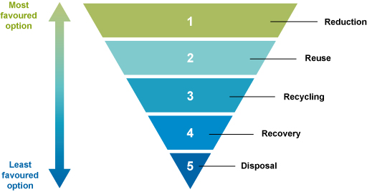
Figure 11.1 The waste hierarchy.
Unfortunately, many towns and cities are not able to follow the waste hierarchy and the only option used is disposal. Much of the waste is never collected (it is dumped or burned) and even where it is collected, most of the waste is taken to a landfill that has no means of controlling pollution from the site. Case Study 11.1 about the town of Jimma illustrates this situation.

Case Study 11.1 Waste management in Jimma: an example of current practice
In 2011, Jimma had a population of around 160,000; this had grown to 200,000 by 2014. Solid waste generation in 2011 was 88 metric tons per day with 87% of this being waste from households.
A total of 25% of households deposited their waste in communal containers that were then taken to landfill; 51% used disposal pits, their own back yards or open dumping of waste in public spaces; 22% burned their waste in public open spaces; and the remaining 2% of households had waste collected by private sector organisations. There is no formal system for collecting wastes for reuse or recycling.
Waste management is the responsibility of the municipality’s Social and Economic Department who employ 33 waste workers. The department has one tipper lorry for waste collection purposes and ten metal bins for commercial waste storage, each with capacity of 4 m³ that are placed randomly in residential and commercial areas. The budget for waste is less than 1% of the total municipal budget. Staff wages take up 90% and the remainder is spent on fuel, maintenance and other running costs.
(Getahun et al. 2012)
The situation in Jimma is typical of many towns in Ethiopia. This session looks at how towns like Jimma can adopt the principles of Integrated Solid Waste Management to move their waste management systems further up the hierarchy and reduce the risks of damaging people’s health and the environment.
Integrated Solid Waste Management (ISWM) can be defined in many ways but it is probably best to think of it as a way of using a combination of waste management techniques to treat the different types of waste in ways that are environmentally, financially and socially sustainable. ISWM should be based on the waste hierarchy and focus on using the 3 Rs while finding a suitable way of dealing with the remaining waste. It also depends on collaboration among all the organisations and individuals involved in waste management.
Van de Klundert and Anschütz (2001) explain that the ISWM concept is built upon four basic principles:
- Equity: the allocation of resources, services and opportunity to all segments of the population according to their needs. In waste management this means that everyone has a right to be served by a waste management system that protects their health and the environment. Pollution travels and doesn’t respect kebele or area boundaries, so if one area is neglected, a much larger area can suffer.
- Effectiveness: the waste management methods used must meet the overall aims of any waste plan and meet the needs of the people. At the very least, effectiveness means that all the waste is collected and disposed of in a safe way. Once this has been achieved, higher-level aims such as maximising waste recycling and composting should be addressed. Again, a scheme is only effective if it covers the whole of the kebele, city or district.
- Efficiency: in general, efficiency means increasing output for a given input, or minimising input for a given output. An efficient waste management system is one that is equal and effective while making the best use of the resources available (staff effort, use of equipment and cost).
- Sustainability: for a project, programme or other activity to be sustainable it must be effective and last a long time. To achieve sustainability social, environmental and economic factors must be considered. Sustainability of the waste management system can be achieved if it is appropriate to the local conditions and can continue in the long term by using the human, financial and material resources available in the area. It should also be environmentally sustainable in that it minimises the use of non-renewable natural resources (such as oil) and doesn’t lead to long-term environmental problems that will be left for later generations to address.
- Which of the following waste management systems meet the four conditions of ISWM?
- Waste is collected from households that can pay a weekly fee; those who can’t pay use informal methods of waste disposal.
- A network of korales coordinated by the kebele collect recyclable materials (glass, paper and metals), householders take the remaining waste to communal bins (one per 30 households) which are emptied by the kebele’s contractor who takes the waste to landfill.
- Waste is collected from households in well-off areas by charging a weekly fee; in poorer areas the waste is collected from communal bins by kebele employees.
- Under a grant from an aid agency that will run for two years, a kebele’s waste is collected, taken to a transfer station and then driven 20 km to a landfill site that is also funded by the grant.
- Options (b) and (c) do broadly meet these conditions (although we should find out more about the standard of the landfills).
Option (a) does not meet the criteria of equity or effectiveness.
Option (d) is good for the environment and people’s health but is not financially sustainable.

11.2 The advantages of ISWM
Introducing ISWM means adopting all of the beneficial practices that have been described in previous study sessions and ensuring that they all work together effectively. It has a number of advantages for the different sectors of society. Here are some examples:
- Reduction and reuse at source – reducing waste at the source and reusing wastes means that less waste has to be collected. This lowers costs for residents, businesses and the local authority. Also, the pollution generated in transporting the waste and at the disposal site is reduced. Waste reduction and reuse means that there is less pollution from manufacturing and a reduced need to import goods. Finally, society benefits because people have the use of items that they may not otherwise be able to afford.
- Waste separation at source – many ISWM schemes require householders and businesses to separate reusable and recyclable materials from the rest of the waste and sort them by type (Figure 11.2). This helps to make people more aware of what they throw away and means that the material separated for recycling is of a higher quality and has a higher selling price. In alternative schemes, where recyclable materials are extracted from mixed wastes at the transfer station, there is a greater health risk to those who do this work and also to those who work in the recycling industry.
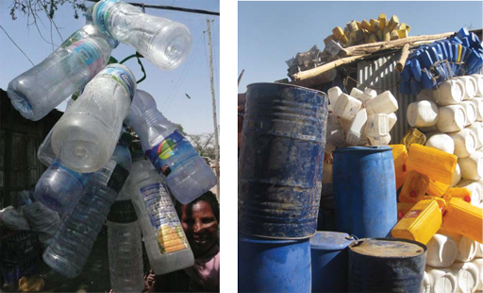
Figure 11.2 Separating wastes such as plastic bottles and containers at source increases opportunities to reuse or recycle.
- Recycling – like reduction and reuse, recycling has benefits outside the waste management system. Recycling reduces the need to extract raw materials from the ground or to import them. Producing metals, glass and paper from waste materials rather than raw materials consumes far less energy. Also in common with reduction and reuse, recycling means less waste is sent to landfill, giving further reductions in pollution.
- Organic waste recovery – composting organic waste is a form of recycling (see Study Session 9) and has similar benefits to other recycling processes. The amount of waste sent to landfill is reduced and the compost can be used locally to improve soils and the crops grown on them. Organic waste can also be used in anaerobic digesters to produce biogas for cooking and lighting.

11.3 The components of ISWM
An ISWM system is more than just the 3 Rs. It has three components: the waste system elements; the stakeholders; and the influencing factors. These three components are shown in Figure 11.3. The waste system elements are the stages in the waste management chain that have been discussed in previous study sessions. In ISWM, every stage in the chain should be guided by strategies to minimise the waste that reaches the disposal site, to protect the environment and where possible to generate income from waste. The stakeholders are the people and organisations involved and the influencing factors are other aspects that need to be considered when developing an ISWM system. Stakeholders and the influencing factors are described below.
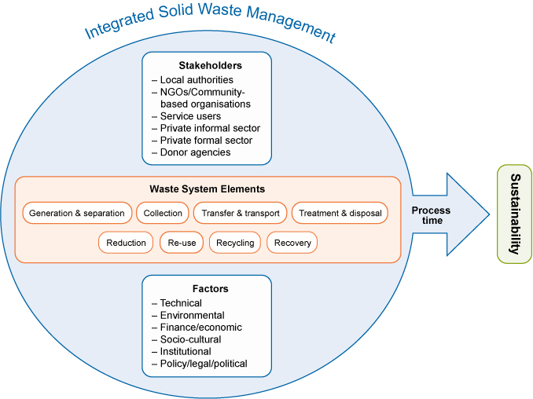
Figure 11.3 The integrated solid waste management model. (Adapted from Van de Klundert and Anschütz, 2001)

11.3.1 Stakeholders
The term stakeholder refers to any individual or organisation that has a stake or an interest in a programme or activity or is affected by the activity. When it comes to the management of a kebele’s waste, who are the stakeholders? Everybody who lives or works in the kebele is a stakeholder. So are people who visit the kebele for any reason (perhaps relations of residents). The organisations in the kebele are also stakeholders (businesses, commerce, government etc.). If a private sector organisation is involved in providing the service, it too is a stakeholder. The organisations that provide any funding for the ISWM (local and national government, NGOs, aid agencies) are also stakeholders. This is such a wide group because every person, institution, organisation and industry in the kebele generates waste and is affected by the way it is collected, treated and disposed of.
Waste management requires a concerted effort throughout the process of its management and the degree of involvement of stakeholders varies from place to place. So it is necessary to identify stakeholders and their areas of interest and degrees of involvement in waste management (e.g. funding, training, waste collection, recycling etc.).
- List the stakeholders in waste management in your home village, town or city.
- Your list will depend on where you live but could include:
- households, individuals, businesses and other waste producers
- kebeles and municipalities
- urban health bureaus
- micro- and small enterprises
- city greening, beautification and parks development agencies
- private sector organisations engaged in waste collection, transfer and transport
- korales
- waste pickers
- dealers who buy and trade in recyclable wastes
- end-user industries that buy recyclables
- NGOs.
One of the main challenges of ISWM is coordinating the stakeholders and getting them to work together for a common goal. So those working in waste management need to be able to work with the various stakeholders and help them to agree the way forward. Participation by the community members in planning and decision making is especially important because their cooperation and a positive attitude to recycling and reuse will be essential.

11.3.2 Influencing factors
Several factors will influence the selection, operation and effectiveness of any waste management scheme and need to be considered when planning a successful ISWM programme. They include:
- Technical factors – refer to the selection of technologies that are available and will function with the quantities and composition of the waste produced. For example, the technology designed to compost one ton of waste a day will not be suitable for processing 50 tons per day. The reliability of the technology needs to be taken into account; it must operate under Ethiopian climate conditions and be repairable using locally available materials and people.
- Financial factors – are aspects that deal with budgeting and costs of the waste management system. Some of the most important issues to consider are the effect of private sector involvement and recovering the cost of the system from residents, businesses and government. The impact of the market prices of recovered materials, the amount and source of any subsidy to cover collecting wastes from those who cannot pay, and any other income-generation schemes also need to be considered.
- Environmental factors – focus on the effects of waste management on land, water and air, the need for conservation of non-renewable resources, pollution control, and public health concerns (Figure 11.4).
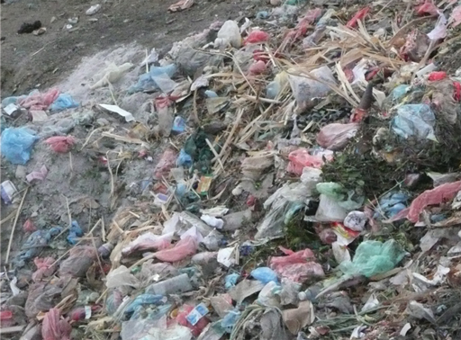
Figure 11.4 Open dumping causes environmental pollution and is a risk to health.
- Political and legal factors – refer to the administrative context in which the waste management system exists; the goals and priorities that have been set; the determination of roles and responsibilities; the existing or planned legal and regulatory framework and the decision-making processes.
- Socio-cultural factors – include the influence of culture on waste generation and management in the household and in businesses and institutions, the community and its involvement in waste management; the relations between people in the community of different age, sex and ethnicity; and the social conditions of waste workers.

11.4 Applicability of ISWM
Integrated solid waste management can be planned for big cities such as Addis Ababa, Dire Dawa, Bahir Dar, Hawassa, Mekelle and Adama or medium-sized cities such as Jimma, Nekemte, Dessie and Assela, or small towns like Wolkite, Wukro, Debre Birhan, Bedele and Maksegnit. Although the principles used are the same, some of the waste system elements are more applicable in particular sized communities as shown in Table 11.1.
Table 11.1 Applicability of waste management components in different sized cites in Ethiopia.
Waste management component | Big cities (population above 200,000) | Medium cities (population 100,000–200,000) | Small cities (population less than 100,000)
Reduction at source | Highly applicable | Highly applicable | Highly applicable
Sorting at household level | Applicable but not yet introduced as part of the formal waste system but could be done if sufficient start-up funding was available  Some segregation takes place through the korales | Applicable but not yet introduced as part of the formal waste system but could be done if sufficient start-up funding was available and if the cities are close enough to manufacturers willing to take the materials recovered  Some segregation takes place through the korales. | Applicable but not yet introduced, sorting would probably be limited to separating compostable wastes  Some segregation takes place through the korales
Reuse of items | Highly applicable | Highly applicable | Highly applicable
Recycling | Highly applicable | Applicable if linked to big cities  Can be promoted through small-scale recycling (paper for example) | Applicable and can be promoted through small-scale recycling (paper for example)
Composting | Applicable and can be scaled up at material-processing and energy-recovery facilities  Can be scaled up by using the private sector/small-scale enterprises with subsidy | Applicable and can be scaled up by using the private sector/ small-scale enterprises with subsidy | Applicable and can be scaled up by creating awareness and by organising small-scale enterprises

11.5 Encouraging ISWM
In the previous sections, we have explained the many benefits that ISWM brings to a community. ISWM helps to safeguard public health, improve the environment and gives a better image to the city. Hence improving waste services is a priority for many stakeholders – the government, NGOs, health and environment ministries and city councils.
However, developing and implementing ISWM needs start-up capital and an on-going revenue scheme. It needs investment in equipment and in the training and development of skilled staff. ISWM also requires effort from all the stakeholders. Therefore, it is sometimes necessary to encourage people to develop and implement ISWM by providing incentives. These incentives may be financial benefits or the offer of some other sort of reward for adopting an ISWM approach.
It is at the local level where encouragement and incentives need to be provided. This is a task for national or local government and can take a number of forms. For example:
- National government could allow municipalities that perform well in terms of waste collection and treatment the flexibility to spend more of their budget on waste services if it can be shown to achieve savings in other areas.
- Where good practice in waste management has been demonstrated, special funds could be allocated to allow this practice to be extended within an area or replicated in other areas.
- Local authorities could reward best performing individuals, institutions or environment clubs through various mechanisms including media coverage and awards.
- Financial support could be given to environmental groups and small-scale private sector enterprises that engage in waste collection, composting and recycling. This support could be provided through the savings achieved by the municipality in its collection, transport and disposal costs.
Even when incentives are provided, attempts to improve the waste management system are not always successful as shown in the following case study. Read the case study and then answer the questions below.

Case Study 11.2 Why do composting programmes fail? The case of Jimma
Jimma city administration organised a group of young people to become involved in waste composting through its job creation policy framework. The youth club members were identified by kebeles and sent to the Environment and Social Affairs Department of the municipality for training. The municipality ‘oriented’ them and provided them with land and basic tools to run the composting programme. These young people were very well motivated and started their job, hoping that they would earn sufficient money to sustain their livelihoods.
The task they were set was not simple. They had to collect compostable waste, separate and remove the waste components they did not need and send them back to the communal collection skips. Unfortunately, their training did not give them the information they needed to be sure about the mix of wastes for effective composting process (for example, whether it needed more leaves, more paper and or more food waste). They also did not know how to monitor the temperature and moisture content of the composting waste. Consequently, the compost took a long time to mature and even after six months they did not have good quality compost.
This youth group were very disappointed with their first batch of compost. They had hoped to sell the compost to local farmers but most of them had no interest in buying it because they had access to synthetic fertilisers distributed by the government. The farmers who did express an interest offered a small amount of money but this was not enough to cover the producers’ labour costs. The youths became frustrated and gave up the scheme.
- What are the lessons that can be learned from this case study?
- Several things could have been done much better:
- The initial training programme should have been expanded to cover the nature of waste, the types of waste needed to make compost and how to carry out the composting process (balancing the material mixes, how often to turn the compost heaps, how to measure the temperature and moisture content and how to know when the compost is ready for use).
- More equipment should have been provided (at the least, suitable thermometers should have been made available).
- The youths should have been supervised, assisted and guided through the process of making and selling compost for at least the first year to encourage them to keep on doing the job.
- A financial supporting mechanism should have been established for at least an initial period until markets for the compost had been established and money started to flow in.
- Markets for the compost should have been identified beforehand.
- From your study earlier in the Module, what specific information should the young people have been given about the required mix of brown and green waste for composting?
- They should have been told to mix three parts of brown waste (paper, woody material, dried vegetation) to one part of green waste (food waste, animal manure, fresh vegetation).
Developing and implementing an ISWM system is a significant task that requires commitment and the cooperation of many stakeholders as well as financial investment. Its success will depend on continuing support from the community. As someone involved in promoting improved sanitation, you may find yourself working with a team charged with introducing an ISWM system. The sort of tasks that you could be doing include:
- helping to educate the public on the advantages of introducing the 3 Rs and the basic principles of integrated solid waste management
- working closely with the health sector and labour and social department of the municipality to protect the health of korales and others in the informal waste management sector
- identifying potential stakeholders in the town
- assessing the situation in and around the town and deciding with other stakeholders whether it is possible to introduce ISWM.
In Ethiopian towns, there is increasing focus on solid waste management. Adopting an ISWM approach that brings together the most effective technologies and has the support of all stakeholders will ensure that sustainable improvements are made which will benefit the communities and the environment.

Summary of Study Session 11
In Study Session 11, you have learned that:
- Integrated waste management is built upon the 3 Rs –reduce, reuse and recycle – and on the waste hierarchy.
- ISWM involves using a combination of waste management methods to achieve the best waste management solution.
- ISWM builds on the four principles of equity, effectiveness, efficiency and sustainability.
- ISWM has three components: the waste system elements; stakeholders; and influencing factors.
- ISWM can be applied to towns and cities of all sizes but the details will vary depending on the population size and amount of waste produced.
- Implementing ISWM requires resources and investment in equipment and staff training. It may be necessary to offer incentives to encourage municipalities and others to develop an ISWM system.

Self-Assessment Questions (SAQs) for Study Session 11
Now that you have completed this study session, you can assess how well you have achieved its Learning Outcomes by answering these questions. You can check your answers with the Notes on the Self-Assessment Questions at the end of this Module.

SAQ 11.1 (tests Learning Outcome 11.1)
Rewrite the paragraph below using terms from the list provided to fill the gaps.
effective (more than once!), efficient, equity, sustainable.
The waste management system should ensure everyone in the community can benefit from the service provided. This is the principle of ……………… An ……………… system will function well and meet the needs of all the people. It will also be ………………, which means it will make the best use of available resources and ………………, meaning it will continue to be ……………… into the future.

SAQ 11.2 (tests Learning Outcome 11.2)
Explain why Integrated Solid Waste Management is described as ‘integrated’.

SAQ 11.3 (tests Learning Outcome 11.3)
Which of the following statements are false? In each case explain why it is incorrect.
- ISWM has benefits for public and environmental health.
- ISWM is a simple, inexpensive approach to waste management.
- ISWM reduces the amount of plastic and other waste dumped in the streets.
- ISWM reduces the lifespan of the local landfill site.
- ISWM provides opportunities for production of compost and other valuable materials.

SAQ 11.4 (tests Learning Outcome 11.4)
Give three examples of ways of encouraging or supporting an ISWM approach.

Study Session 12 Institutional Sanitation and Waste Management

Introduction
In this session you will learn about sanitation and waste management in institutions and its importance to public health. The scope of this session will be limited to schools, health institutions, prisons, public offices and religious institutions. We will consider the essential sanitation and waste management requirements for these institutions and enable you to relate this into your own locality. However, there are other public service provider institutions such as shopping centres, mill houses, slaughterhouses and market areas that may also need to be considered.

Learning Outcomes for Study Session 12
When you have studied this session, you should be able to:
12.1 Define and use correctly each of the terms printed in bold. (SAQs 12.1 and 12.3)
12.2 Identify the minimum requirements for school sanitation and waste management. (SAQs 12.1 and 12.2)
12.3 Identify the major hazardous waste components and management options for healthcare waste. (SAQ 12.3)
12.4 Describe the activities needed for planning improvements in sanitation and waste management in local institutions. (SAQ 12.4)

12.1 Sanitation and waste management in schools
- In Study Session 2, you learned about the effects of poor sanitation and waste management. List some of the potential impacts on schools.
- The possible answers include health problems, impacts on attendance (especially for girls) and achievement, and pollution of the school environment.
Poor school sanitation and waste management create many problems:
- Many school children, teachers and school administration staff are exposed to increased health risks.
- The children’s ability to learn may be affected by helminth infections which impair their physical and cognitive development. Diarrhoeal diseases and helminth infections force many school children to be absent from school.
- Girls are likely to be affected by lack of adequate facilities for menstrual hygiene which can contribute to them missing days at school or even to drop out.
- If school latrines are not accessible to girls and boys with disabilities, they may not eat or drink all day to avoid needing the latrine.
Conversely good sanitation and waste management in schools means that:
- The children are more able to integrate hygiene promotion into their daily lives and can be effective messengers and agents for change in their families and the wider community.
- The proper behaviours that children learn at school are skills that they are likely to maintain as adults and pass on to their own children.
- You have been a school student at some time in the past. What were the components of school health services in your time?
- You might have various memories of events. Your classroom teacher might have checked your personal hygiene. You might have learned about the common bacterial eye infection trachoma and face-washing in science class. You were probably reminded to use the latrine properly and to wash your hands afterwards.
In Ethiopia, many schools do not have water supply or latrines at all, or if they do, they may not have handwashing facilities. Even in schools that do have facilities, these are frequently not maintained or kept clean, or may be kept locked. To give guidance on how to improve this situation, a design manual has been published jointly by the Ministry of Health, Ministry of Education and Ministry of Water and Energy in collaboration with UNICEF (MoH et al, 2012). The manual gives recommendations for safe water supply in schools and the volume of water that should be available per person per day. It also establishes the principles for sanitation and hygiene provision in schools, which are outlined in the following sections.

12.1.1 Provision of improved latrines
The provision of improved latrines with attached urinals in schools is extremely important. Many of the design requirements are similar to those for domestic latrines that you learned about in Study Session 5. For example, latrines must be located a safe distance from water sources. The government guidance for schools includes the following additional requirements:
- There should be separate latrine blocks for boys and girls that are located away from each other in the school compound. They should be near enough to the classrooms to be convenient for use but not so close that odour is a problem. The location, design and construction must provide privacy and security. Hedges can be used as screens between girls’ and boys’ latrine blocks. Latrines for male and female teachers must be separated as well.
- Latrines must be easy to clean, well maintained and agreeable to use.
- The number of squat holes (cubicles) should be proportional to the number of students and take account of any future increase in school population. The recommended ratio is at least one cubicle per 100 students. All schools, regardless of size, should have a minimum of two cubicles for girls and two for boys. Using appropriately designed urinals for boys and men can reduce the total number of cubicles required.
- Facilities should be designed to be appropriate for the size of children in the school. For example, for young children door handles and wash basins need to be lower.
- Each latrine block should have one cubicle that is accessible to students with disabilities including those who use a wheelchair (Figure 12.1). This should have additional space inside, handrails, a raised seat and an access ramp.
- Handwashing facilities must be provided for boys and girls.
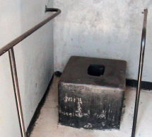
Figure 12.1 Latrine with handrails and raised position to support disabled students.
- In Study Session 5, you learned of the different types of latrine technologies. Which of them do you think could be used in schools?
- Schools could use improved pit latrines or VIP latrines (with lined pit, concrete slab and vent pipe). They could use composting toilets or urine-diverting toilets if they had the necessary equipment, staff and procedures in place. Pour-flush latrines or cistern-flush toilets are also possible if there was access to water and connection to a septic tank or sewer.

12.1.2 Handwashing facilities
Handwashing facilities need to be constructed very close to all latrines and urinal blocks for use by students and teachers. The minimum requirement is a basin, a way to pour or run water over the hands, and soap. In urban Ethiopia, there are many models for handwashing stations: water taps with basins or troughs (Figure 12.2); buckets of water; and tippy taps (Figure 12.3). Remember that soap should always be available.
The greywater that results from the handwashing must be drained to a soakaway pit or septic tank (or sewer, if available). If there is enough space, it is possible to use greywater in a school garden to irrigate the vegetables.
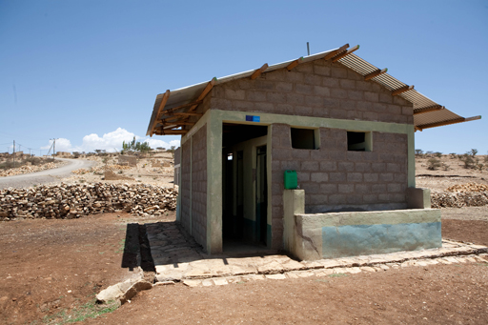 | 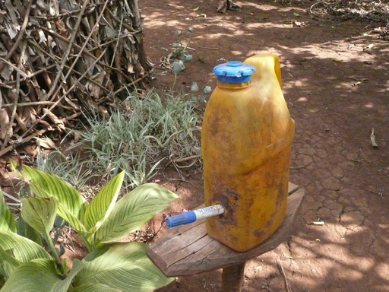
Figure 12.2 New school latrine block with handwashing facilities. | Figure 12.3 Tippy taps are easily and cheaply made from an old plastic container and the plastic tube from a used pen.

12.1.3 Menstrual hygiene management
Menstrual hygiene management (MHM) is the management of monthly menstrual periods by women and adolescent girls using a clean material to absorb or collect menstrual blood. It is essential that this material can be changed in privacy and as often as necessary for the duration of the menstrual period. MHM includes using soap and water for washing the body as required and having access to facilities to dispose of or wash used menstrual pads and towels.
In Ethiopia, as in many parts of the developing world, MHM is one of the critical challenges facing adolescent schoolgirls. Poor facilities for MHM in most schools of Ethiopia has been shown to cause worry and humiliation, contribute to monthly absenteeism and lead to poor performance (Sommer et al, 2013).
The following facilities should be provided for adequate MHM provision in schools:
- girls’ latrines should be in a separate location from boys’ latrines
- individual cubicles should be fitted with doors that close properly
- disposal facilities should be available for used disposable MHM products and washing facilities for reusable products
- handwashing facilities and soap should be provided adjacent to the latrines
- school offices should have MHM products available for emergency use.

12.1.4 Provision of solid waste management facilities
Schools should practise the 3 Rs of waste management. Since a large proportion of schools’ waste is paper, it may be possible to collect the paper for recycling by the paper industries. Ideally, each classroom should have separate bins for the waste that is collected for recycling and for the non-recyclable waste. Children should be encouraged to keep the classrooms and other areas clean and take pride in a clean and hygienic school environment. There should also be bins in teachers’ rooms and the playground. It is helpful to encourage a culture in schools that makes dropping litter unacceptable and helps children to develop the habit of putting waste in a bin.
If the school has its own waste disposal pit, this should be in an isolated area and fenced off to prevent access by the children. The waste should be covered with soil after placing it in the pit to reduce scavenging by rodents and birds. There could also be chemical wastes from school laboratories. These should be stored separately in a secure location for collection and disposal (the kebele authority or possibly a local hospital may be able to collect this waste).

12.2 Sanitation and waste management in health institutions
Health institutions include public and private hospitals, health centres, health posts and special clinics. All these institutions have responsibilities to ensure the safety of patients and staff which means provision of sanitation facilities and proper management of healthcare waste. Similar to the guidelines for schools, a design and construction manual for water supply and sanitation facilities in health institutions has been published by the government (MoH et al, 2013). This provides full details of the recommended provision according to the type of institution and the number of people who visit or work there; it also includes recommendations for solid waste management.

12.2.1 Sanitation
Latrines and urinals should be available in each health institution with separate and clearly signed facilities for men and women. Latrines should be clean, comfortable and pleasant to use. They should also be accessible to disabled people.
Handwashing facilities need to be constructed close to all latrines and urinal blocks for use by patients and staff. Additional handwashing facilities should be provided in any place where patients are likely to be examined so that staff can wash their hands before and after the examination.

12.2.2 Managing solid healthcare waste
- In Study Session 7 you learned about the classification of solid waste. What are the types of waste that can be generated in health institutions?
- Healthcare waste includes hazardous waste (approximately10-25%) and non-hazardous wastes (75–90%) which is similar in composition to commercial and residential waste.
The major concern in health institutions is proper management of hazardous wastes which include sharps (needles, etc.), pathological or anatomical waste (placentas, body parts, blood or body fluids), used gauze, bandages, gloves and plasters. It may also contain expired drugs, laboratory reagents and other chemicals.
Some of the key points in managing healthcare waste before final disposal are:
- Healthcare workers should try to reduce the amount of waste but reducing (or reusing) waste should never be carried out if it compromises patient care or creates any other risk of infection.
- Hazardous and non-hazardous waste must be separated and stored separately. Waste should be separated immediately by the person generating it. The different wastes should be placed in containers with the appropriate colour for that particular type of waste (FMHACA, 2013). The container for each waste type is:
- Black bins for all non-hazardous waste such as paper, packaging materials, office supplies, drink containers, hand towels, boxes, plastic bottles and food wastes.
- Yellow bins for infectious waste, which includes any material that has been in contact with blood or body fluids such as gauze, dressings and gloves.
- Red bins for highly infectious wastes such as anatomical wastes (e.g. teeth, placenta) and pathological wastes (e.g. sputum-containing materials, test tubes containing specimen fluids).
- A safety box (Figure 12.4) for sharps wastes that have the potential to cause injuries and spread disease, such as needles, scalpels, syringes, blades, and broken glass.
- Waste disposal facilities such as an incinerator and burial pits must be available, appropriate for the type of waste and health services provided. (Disposal is described further in the next section.)
- Water supply and handwashing facilities are very important for good personal hygiene practice among health workers and patients. In addition, all staff who handle or come in contact with the waste should be provided with appropriate protective clothing including gloves, aprons and face masks.
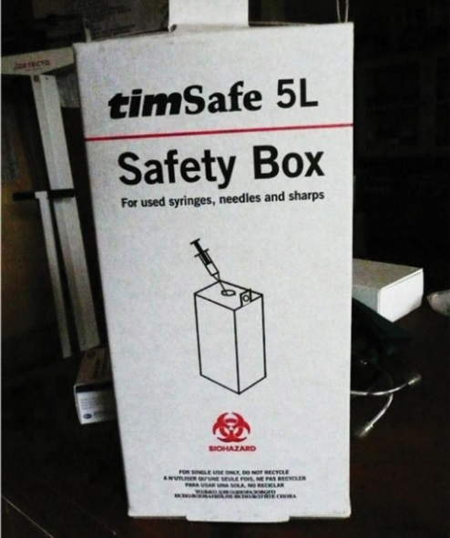
Figure 12.4 Safety box for collecting needles and other sharps.

12.2.3 Disposal of healthcare waste
In large cities, it may be possible for healthcare waste to be collected and taken for disposal off-site by a licensed disposal firm. However, in smaller towns and cities each healthcare facility will probably have to dispose of its own waste. The two main methods are burial or incineration (described in Study Session 10).
A number of separate pits will be needed for the different types of hazardous healthcare waste. For anatomical and pathological wastes, a placenta pit should be used. These should be sited inside the health facility compound and be at least 1 m deep. The pit should be fenced and have a locked gate. The waste should be collected in a plastic or galvanised metal container with a tight-fitting cover and immediately transported to the pit using dedicated trolleys or carts. The waste should be covered with a layer of soil immediately after disposal into the pit. Care needs to be taken over the disposal of anatomical waste that consists of identifiable body parts. Burial is the best way of disposing of these wastes, but local customs and cultures of the society must be taken into account.
Sharps and the remains of incinerated sharps safety boxes should be disposed of in a sharps pit. A properly constructed sharps pit should have a cover at the surface and be lined with concrete to make it watertight in order to avoid contamination of groundwater and soil.
Incinerators can be used to treat some hazardous healthcare wastes. If the incineration process takes place at a sufficiently high temperature, it can be an effective way of destroying pathogens and sterilising sharps, but should not be used for anatomical wastes for which a purpose-designed incinerator should be used. However, you should note that incinerators are only likely to be available in the larger health facilities in major cities and towns. The ash removed from an incinerator should be buried in an ash pit.
All burial pits for hazardous waste should be properly fenced to prevent access by people or animals. The bottom of the pit must be at least 1.5 m above the water table to prevent groundwater contamination.

12.3 Sanitation and waste management in other institutions
Other types of institution you may come across are prisons, religious institutions and public or government offices.

12.3.1 Prisons
Effective sanitation and waste management are also important in prisons, jails, and temporary arrest facilities. The transmission of communicable diseases such as diarrhoea, relapsing fever, scabies and typhus is made more likely by overcrowding and poor sanitation and hygiene. Access to safe water, showers, latrines and facilities for washing clothes are essential in a prison. There should also be appropriate solid waste disposal facilities. In addition, conditions in prisons can be improved by the following interventions:
- A sanitation committee can organise a regular cleaning schedule with the guidance of the prison authorities. Its duty is to plan and execute a cleaning and hygiene day at least once a week. Cleaning interior rooms and the prison compound, washing clothes and personal hygiene are among the priorities to maintain the health of detainees.
- Checking for the presence communicable diseases through regular prison inspection.
- An insanitary interior of the prison is attractive for insects such as cockroaches, ﬂeas, lice and bedbugs. New prisoners’ clothing and bodies must be inspected for the presence of these insects when they arrive. High standards of personal hygiene through frequent body washing, maintenance of clean premises and clean clothes should be enforced.
- The rooms for detention should have an adequate supply of indoor light and fresh air. The surface area of windows should be a minimum of 10% of the ﬂoor area in order to admit daylight and adequate air.
- Overcrowding must be controlled as much as possible because many people living in close proximity with each other in unhygienic conditions leads to the transmission of many communicable diseases.
- Periodical hygiene education on selected relevant topics.

12.3.2 Religious institutions
Churches and mosques areas are places where a lot of people gather. Both church servants and those attending need to have access to good environmental health services. The provision of a safe water supply and latrines with handwashing facilities in agreed sites should have priority. Proper solid waste management is also important.

12.3.3 Public offices
Various offices are organised to serve the population, such as city/town administration bureaus, municipalities, kebele administrative offices, etc. These all need a healthy office environment for the benefit of the health of the civil servants and their visitors. Particular requirements include well lit and ventilated offices/rooms, latrines and proper solid waste management facilities. The supply of safe water and handwashing facilities are important for personal hygiene.

12.4 Planning for improvements
To make improvements to the sanitation and waste management situation in any of the institutions we have described requires careful planning. If you were involved in a scheme to make improvements to institutions, there are a number of planning activities that should be done in a stepwise manner. Some of the key activities are brieﬂy described below.

Know the scope of your activity
This requires the identification of institutions by type and number in your working area.

Identify existing WASH-related problems
A survey to assess the conditions and gather data on any existing problems should be undertaken. This is similar to the assessments you learned about in Study Session 3. It will provide baseline data that is useful for analysing any problems and setting priorities based on the local situation. An example checklist for a school is shown in Table 12.1.
Table 12.1 School safety form.
No. | Question | Response
1.0 General information
1.1 | Date of inspection
1.2 | Name of the institution
1.3 | Number of students by sex | Male/female
1.4 | Address
1.5 | Ownership | Private/public
1.6 | Level of school | 1st cycle/2nd cycle
2.0 School compound
2.1 | Location of school, hazards such as noise, proximity to road
2.2 | Compound sanitation: free from solid waste, flowing liquid waste | Yes/no – indicate the subject
3.0 Classroom
3.1 | Window | Adequate/inadequate
3.2 | Ventilation | Adequate/inadequate
3.3 | Lighting | Adequate/inadequate
3.4 | Condition of classroom and its floor
4.0 Water supply
4.1 | Is water available in the school compound? | Yes/no
4.2 | Source | Piped/well/spring/river/other
4.3 | Supply of drinking water and handwashing facilities | Yes/no
4.4 | Number of water taps
4.5 | Cleanliness around the water point | Yes/no
5.0 Latrine provision
5.1 | Is latrine available in the school compound? | Yes/no
5.2 | Type of latrine | Pit latrine/VIP/other
5.3 | Floor of latrine (washable slab) | Concrete slab/earth
5.4 | Latrine available for: | Students/teachers
5.5 | Separate latrines for male and female students | Yes/no
5.6 | Latrine superstructure
5.7 | Excreta seen around the latrine | Yes/no
5.8 | Excreta inside the latrine | Yes/no
5.9 | Can a student use the latrine in its current condition? | Yes/no
5.10 | Doors that lock from the inside, not the outside | Yes/no
5.11 | Number of latrine holes
5.12 | Access to disabled children | Yes/no
5.13 | Access to menstrual hygiene management | Yes/no
6.0 Solid waste management
6.1 | Is there a refuse container in the compound? | Yes/no
6.2 | Is there a refuse container in each classroom? | Yes/no
6.3 | Is there a burial pit for refuse? | Yes/no
6.4 | Is there an incinerator? | Yes/no
6.5 | Is waste collected for disposal by a contractor? | Yes/no
7.0 Students’ personal hygiene (observe a few students)
7.1 | Clothing | Intact/torn/clean/unclean
7.2 | Hair | Clean/unclean
7.3 | Face | Clean/unclean
7.4 | Nits | Yes/no
7.5 | Feet | Clean/unclean
7.6 | Fingernails | Clean/unclean
7.7 | Eyes | Clean/unclean
7.8 | Lice | Yes/no
7.9 | Teeth | Clean/unclean
7.10 | Scabies | Yes/no
8.0 Handwashing facility
8.1 | Basin
8.2 | Source of running water for rinsing (tap, jug) | Tap/jug
8.3 | Soap or ash | Yes/no
8.4 | Soak pit to avoid standing water | Yes/no
9.0 Summary of main findings

10.0 Suggestions

Identify partners that you can work with
It is useful to identify partners in order to work together and bring improvements from mutual efforts. Depending on the type of institution, partners are likely to be government offices such as the kebele administration, health office, education office, water utility, school administration, school parents’ committees, school WASH clubs, traditional leaders or police and court desks. It is also important to include authorities of religious and other local institutions/organisations.

Identify and prioritise activities
In collaboration with partners and in consultation with potential beneficiaries, proposed activities can be identified and then plans developed. There will need to be careful assessment of the resources required. Improving sanitation, waste management and hygiene so that they meet recommended requirements is challenging. For example, if a school has no latrine and the school head is advised to install latrines for students, they cannot do it immediately. They need time and a budget.
If the school has latrines but they are in poor condition (Figure 12.5) then improvements can be made more easily and require fewer resources. Other activities that may not require many resources include establishing WASH clubs, hygiene education for students, and periodically conducting personal hygiene inspections.
Figure 12.5 A dirty school latrine cubicle and wash basin with a tap that is obviously not used.
- What improvements would you suggest for the school facilities shown in Figure 12.5?
- The priorities would be to:
- introduce a daily cleaning schedule to keep cubicles and the surrounding area clean
- fit doors to the cubicles for privacy
- provide water in a by the basin jerrycan if piped water supply is not possible
- provide soap.

Design the plan of action
This will depend on the number and type of institution. The plan should indicate the list of activities, the timescale for implementation, the frequency for regular events like inspections, and who is responsible. It should also include appropriate follow-up activities after improvements have been made.

12.5 Regular inspection and monitoring of facilities
Inspection is a tool to identify problems, to design strategies for improvement and to monitor behaviour and the impacts of interventions. Regular visits are needed to each local public institution, at least once a year, using a checklist or a questionnaire that enables you to collect data on sanitation and waste management, similar to the checklist for schools in Table 12.1. If you are taking part in an inspection, you should inform the owners or people responsible for the institution that you want to visit them at a speciﬁed date and time. It is important to be transparent and genuine when inspecting to show that you want to help the institution to attain proper hygiene and not to criticise or penalise them. You should give advice to the owners for improvement. If you do find any violations of sanitary requirements that require enforcement, these should be reported to the kebele administrator. Monitoring is an important part of any programme for improvement and is described in more detail in Study Session 15.

Summary of Study Session 12
In Study Session 12, you have learned that:
- Sanitation and waste management facilities are essential for all schools to ensure that students remain healthy, attend regularly and achieve educational success.
- All schools need separate latrines for boys and girls and handwashing facilities with soap. Latrines should be designed with the number of children, their size and needs of disable students in mind.
- It is essential to provide facilities in schools that enable girls to manage their monthly menstrual periods effectively and with privacy.
- Schools should have several bins available for waste paper and other types of solid waste.
- Healthcare institutions should have routine procedures for separating hazardous from non-hazardous solid waste and for the correct handling, storage and disposal of these wastes.
- Usual methods for disposing of hazardous healthcare waste are burial in pits or incineration. In larger towns and cities, licensed disposal firms may be available.
- Prisons, religious institutions and public offices should all have latrines and handwashing facilities sufficient for the number of people using them.
- Planning improvements for institutional WASH requires assessment of the situation to identify problems, consideration of available resources, collaboration with partners, and the development and implementation of activity plans.
- Regular inspection of sanitation and waste management facilities at all types of institution is important.

Self-Assessment Questions (SAQs) for Study Session 12
Now that you have completed this study session, you can assess how well you have achieved its Learning Outcomes by answering these questions. You can check your answers with the Notes on the Self-Assessment Questions at the end of this Module.

SAQ 12.1 (tests Learning Outcomes 12.1 and 12.2)
Imagine there is a local NGO working in the town you are assigned to that wants to develop a school WASH programme. While preparing the project documents, the delegates of the local NGO come to your office and ask you to support them. List the minimum requirements that you will advise them to include in the sanitation and hygiene part of their programme.

SAQ 12.2 (tests Learning Outcome 12.2)
If the same NGO wanted to extend their schools programme to include improvements to solid waste management, what further advice would you offer?

SAQ 12.3 (tests Learning Outcomes 12.1 and 12.3)
In many towns in Ethiopia, primary collection of solid waste is done by micro- and small enterprises (MSEs). Health centres and other health institutions in the town are customers of the MSEs. Imagine you were organising some technical training for the MSE employees. Describe the major hazardous waste components of healthcare wastes that you would address during the training and identify appropriate disposal methods for each of them. In particular explain how anatomical waste should be disposed of.

SAQ 12.4 (tests Learning Outcome 12.4)
Briefly describe the main activities needed for planning improvements in sanitation and waste management in local institutions.

Study Session 13 Commercial Opportunities in Urban Sanitation and Waste Management

Introduction
Commercial opportunities in urban sanitation and waste management depend on there being demand for the products and services provided and willingness among the people to adopt new practices and change their behaviour. Demand creation and behaviour change for improved sanitation and hygiene are central elements of the government of Ethiopia’s health strategy. People must also be willing to pay for the products and services. Profitability is essential if the provision of improved sanitation technologies and waste management services is to be sustained.
In this study session you will learn about ways of developing and strengthening commercial opportunities in the sector. In particular we focus on sanitation marketing as an approach that encourages and supports improvements in sanitation provision.

Learning Outcomes for Study Session 13
When you have studied this session, you should be able to:
13.1 Define and use correctly each of the terms printed in bold. (SAQ 13.1)
13.2 Outline the key factors affecting the development and sustainability of small businesses in urban sanitation and waste management. (SAQ 13.2)
13.3 Explain what is meant by sanitation marketing. (SAQs 13.2 and 13.3)
13.4 Describe the possible advantages and disadvantages of public–private partnerships for urban sanitation and waste management. (SAQ 13.4)

13.1 Opportunities for small-scale enterprise
Commercial opportunities are simply ways in which private sector organisations that provide goods and services can supply them on a commercial basis for profit. They can generate income by developing existing relations with households through supplying sanitation and waste management services or by extending these services to new clients, thereby increasing the company’s income and profits.
- Based on previous study sessions and your existing experience, what commercial opportunities for private sector organisations in this sector can you think of?
- You may have thought of any of the following possibilities:
- manufacture of latrine slabs
- digging latrine pits and building the superstructure
- emptying latrines
- operating public latrines
- setting up and operating handwashing facilities
- collecting recyclable materials from households and taking them to merchants
- composting organic wastes and latrine sludges and selling the compost.
These commercial opportunities range from product design and manufacture through to recovery and reuse of materials and all bring both economic and environmental benefits. In most of the urban and peri-urban areas of Ethiopia, these opportunities are increasingly being taken up by micro- and small enterprises (MSEs). MSEs were defined in Study Session 9 as organisations with fewer than 50 employees although many operating in this sector are at the smaller (micro) end of the scale.
Sanitation services provided by MSEs in urban and peri-urban areas include pit latrine emptying and the management and operation of public latrine and washing facilities. Public toilets in urban areas often need major improvements in terms of the quality of the services provided to the users. Operators frequently lack the required training, especially in hygiene requirements and in business skills needed for the operation of the facilities. Case Study 13.1 illustrates how a public latrine can be operated successfully as a commercial enterprise.

Case Study 13.1 Successful public latrine business in Mekelle
In Mekelle, the public latrine shown in Figure 13.1 provided an opportunity for commercial development and for improvement in sanitation and hygiene services available to the community.
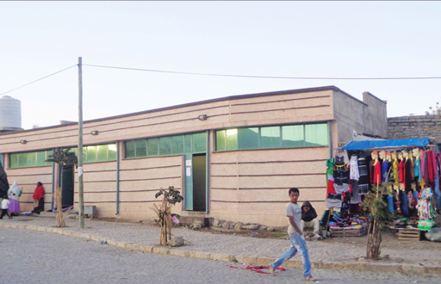
Figure 13.1 This public latrine was developed as a commercial opportunity for women in Mekelle town, Tigray region.
Five women were selected from the organised women’s development group of the kebele where the public latrine is located. The selected women were:
- from model households in terms of their sanitation activities and actively involved in a weekly sanitation campaign
- volunteers who were accepted by local people
- low in economic status.
The women operated and managed the latrine. They kept it in a hygienic condition and charged 50 cents to use the toilet and 5 ETB per person for showering. They also kept a mini-shop selling toilet paper, soaps and other sanitation-related products and services. Four years after establishing this public latrine, it remains clean, safe and comfortable to use and it has created a commercial opportunity for the women who operate the facility. It is a success story!
Other services provided by local small enterprises include the separation and composting of organic wastes. Faecal sludge and household wastes are collected by private individuals. Any inorganic material is removed and the organic wastes are composted to make an excellent soil improver. (You learned about composting in Study Session 9.) The production of high-quality organic fertiliser from waste and faecal sludge for sale to farmers is highly profitable and meets many needs in peri-urban areas.
In Study Session 8 you read about commercial opportunities in recycling and reuse of solid waste. There are simple and applicable methods for processing waste into useful products for urban markets. Recycling and reuse are providing raw materials for manufacturers as well as solving the municipal waste accumulation problems. The access to financing for these often small-scale initiatives is improving with the development of micro-finance institutions (MFIs). MFIs provide loans for people on low income and can be a source of start-up funds for new businesses. The main challenges in establishing a new commercial enterprise is achieving financial sustainability, and then further scaling-up. Not all of these businesses will prove to be financially sustainable in the long run, although they do fulfil a role in the development process.

13.2 Factors affecting commercial opportunities
The success of any commercial enterprise is dependent on a number of factors. Three key questions for any new business are: to find out if there is a demand for the product or service to be provided; whether it will be affordable; and why people might want to spend their money on it. We will look at these three factors with latrines and improved sanitation in mind.

13.2.1 Creating demand for improved sanitation
Demand is created when consumers’ have knowledge, motivation, opportunity and ability to purchase sanitation technology that suits their needs. People require motivation to pay for products and services. Creating demand for latrines can be helped by raising awareness of the health benefits but it needs to do more than this. Latrine adoption is rarely motivated by messages about preventing disease. Householders are more motivated by factors such as increased convenience, comfort, cleanliness, privacy, safety and prestige offered by home sanitation. But even if they want to install sanitation facilities, households also need the opportunity and be able to afford products or services that suit their needs.

13.2.2 Affordability of improved sanitation
Affordability in the context of sanitation refers to the ability to pay for a sanitation product or service. If you were involved in a sanitation improvement project in your woreda it would be very important to identify the number of households who cannot afford to buy sanitation facilities in a single payment. In most cases these will be people living in slum areas or the urban poor. Discussions with these households should be held to determine how much they can afford to pay every month and then help should be given to them to arrange a loan from their local micro-finance organisation.
- If the total cost (including any credit charges) for a circular latrine slab is 260 birr, how much will a household have to repay every month if the payment agreement with local micro-finance is to pay this off within 12 months?
- The repayment for this household is $\frac{260}{12}$ = 21.67 birr per month.
Affordability and payment schedules would be included in project planning and considered with other financial matters in negotiation with the Woreda WASH Steering Committee, private sector organisations and other stakeholders.

13.2.3 Willingness to pay for sanitation services
While affordability affects a household’s ability to pay for sanitation, willingness to pay is a motivational issue, i.e. whether individuals or households are motivated to pay for a product or service – or not. Willingness to pay for sanitation services can be influenced by numerous factors, including the following:
- Expectations of subsidies: if a community has heard of subsidies being offered or planned, households may not be as willing to pay to acquire a latrine.
- Perceived value for money: if a household has an unimproved latrine, it may not upgrade the facility if family members do not perceive much of a benefit, compared to the additional costs. Another example is where a household that does not perceive any value in hiring a mason to improve their latrine if they believe they can do it themselves.
- Explain the difference between affordability and willingness to pay.
- Something is affordable if a household has sufficient money to buy it (with cash or through a loan). If the household is willing to pay, it means that they think the price is reasonable for the product or service they will receive and there is nothing else they would rather do with the money such as spending it on something else or saving it.

13.3 Sanitation marketing
As noted above, creating demand for latrines and sanitation services is not a simple task. Sanitation marketing (sometimes referred to as SanMark) is an approach to household sanitation promotion that aims to improve standards by encouraging people’s demand for sanitation products and services. This helps companies supplying these products and services to develop and prosper because they have a growing market of customers. In this way sanitation marketing addresses both supply and demand for products and services, resulting in the development of a sustainable local sanitation industry.
A key principle of sanitation marketing is that it is demand-driven, which means that individuals and households must want to install sanitation for their own use. They choose what type of facility they want to build and pay for it themselves. In the past, sanitation development was often funded by charities or subsidies, but this created dependency and if households had a low sense of ownership they did not always use their sanitation facilities properly or maintain them.
The National Sanitation Marketing Guideline (NSMG) explains the principles and gives guidance on the process (MoH, 2013). Sanitation marketing starts with research to understand consumers’ motivations and preferences and to find out about any constraints to improved latrine adoption. If communities and individuals are practising open defecation and have limited knowledge of good hygiene behaviour then these problems will need to be addressed before the demand for new products can exist. One way to tackle this is the community-led total sanitation (CLTS) approach, also known in Ethiopia as community-led total sanitation and hygiene (CLTSH). CLTSH is an approach to changing community behaviour that aims to achieve open-defecation free (ODF) status and ensure everyone has access to and uses a latrine. CLTSH involves specially trained people, known as facilitators, working with the community to analyse the extent of open defecation in the area. The facilitators help the community to understand the implications for faecal-oral contamination, and trigger a feeling of disgust and shame in community members that motivates them to take action. The community is empowered and encouraged to build its own latrines and aim for ODF status.
The NSMG recommends that the process should also be supported with behaviour change communication (BCC). This has a focus on changing behaviour of individuals through education and raising awareness of good hygiene practice as a means to improve health. Both CLTSH and BCC help people to recognise the value of having their own latrine which creates the demand for sanitation products.
- What do you consider to be the main drivers for creating a demand towards improving sanitation facilities?
- The main drivers towards creating a demand are:
- Improving health – using improved sanitation facilities can reduce the incidence and prevalence of diarrhoeal diseases.
- Dignity and status – having and using improved sanitation facilities at home gives pride and is a sign of high status in the community and with visitors.

13.4 Strategies for sanitation marketing
To be successful, sanitation marketing must give attention to supply as well as demand. There is no point in creating demand if the right products are not available to meet that demand. On the supply side, strategies should be structured around the traditional ‘4 Ps’ of marketing, which are product, place, promotion and price. Knowing how these four factors interact in sanitation marketing will help build and promote sustainable commercial opportunities for sanitation services in your area.

13.4.1 Sanitation products
Slabs for latrines will be the core component of most sanitation packages. These may be made of concrete, plastic, ceramic or other appropriate materials (Figure 13.2). The product strategy will be to supply households with a slab that is durable, affordable, convenient and easy to clean and maintain. Sanitation marketing in your area could also involve products related to handwashing facilities, such as sinks, water pipes and taps. Sanitation-related services can also be thought of as products, for example solid waste collection, or construction of biogas digesters (Figure 13.3).
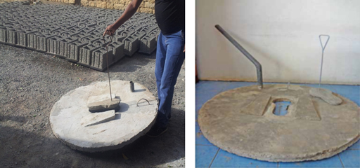
Figure 13.2 Circular slabs produced by a private sector company.
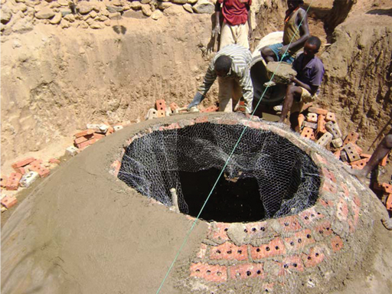
Figure 13.3 Biogas digester under construction.

13.4.2 Sanitation ‘place’
In this context, place means the site where sanitation facilities are produced and also where they are sold. They may be the same place or in different locations, but the important point is that must be easily accessible to customers (especially for heavy items such as a concrete slab). A major problem in peri-urban areas is that the place of production and sale of the slabs can be a long way from people’s homes.
- If the place where slabs or other products are sold is a long way from people’s homes, how could this affect motivation to improve sanitation at the household level?
- People are less likely to be motivated to buy the products if they have to travel long distances to view them.
This question illustrates how ‘place’ can affect demand and so reduce the sale of ‘products’. If you were faced with this problem, you should work in coordination with the Woreda WASH Team and private sector organisations to try to offer production and sales in more accessible places, ideally in the kebele rather than only at woreda level. The outlets that are most convenient for sales include:
- local selling centres established by MSEs
- personal selling by local artisans (e.g. masons, carpenters, plumbers)
- kebele administrators’ offices
- health centres.
Other possible outlets are:
- Farmers Training Centres in peri-urban areas
- local retailing shops or sanitation sales centres
- cooperatives (e.g. women’s associations, farmers’ associations in peri-urban areas).

13.4.3 Promotion of sanitation facilities
Promotion is the process of designing messages about sanitation products and services and communicating them to potential customers so as to create a demand for sanitation facilities. Communication strategies include printed materials like posters (Figure 13.4) leaflets and advertising messages on television and radio.
The promotion that you may be involved with is likely to have the general aim of encouraging householders to adopt better sanitation practices. Promotion by commercial firms will be more specific and aimed at selling a particular product or service. For example, the message they want to convey may be ‘buy our Sanplat’ or ‘use our latrine-emptying service’.
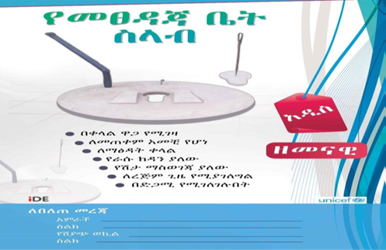
Figure 13.4 Typical poster used to raise awareness of sanitation products.

13.4.4 Pricing of sanitation products and services
The price is the amount of money that a consumer has to pay for a particular product or service. In the case of sanitation products, the price may also include the cost of installation and maintenance. Price is a key factor in making a product financially sustainable, meaning it can be manufactured and sold over a long period and cover its costs without the need for subsidies or grants. The consumer wants prices to be as low as possible while the manufacturer wants prices (and their profits) to be as high as possible. If these two demands can be balanced (a low enough price for the buyer that still generates enough profit for the seller), financial stability and sustainability can be achieved.

13.4.5 Business model for sanitation marketing
Giving due consideration to the 4 Ps can lead to the development of a successful business model, like the one shown in Figure 13.5. This model shows the steps in the supply process from manufacture to installation. Three main stakeholders are involved: the producer; the sales agent; and the customer.
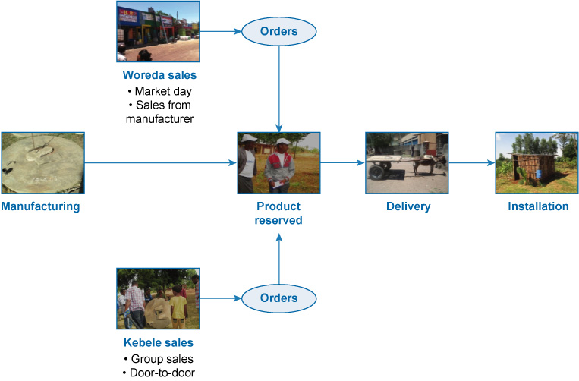
Figure 13.5 A summary of a basic business model for sanitation products. (Sani Mark ‘Zena’, 2014)
The producer is responsible for manufacturing the item (for example, a latrine slab) and giving information to customers on its installation. Some sales at woreda level are made directly from the manufacturer or by orders placed at a market.
At kebele level, sales agents are recruited from the local community. People who are respected are selected from each kebele and trained on the importance of sanitation products and how to communicate this to potential customers. The sales agents engage in sales activities at the community and household level with prior introduction by the local kebele head or Health Extension Worker. When they make a sale, the agents receive the initial deposit from customers and retain their commission from the deposit. They then deliver the order and give the balance of payment to the producers.
This model was used in a pilot study in two woredas in the Tigray Region and it was found that leaflets and posters (such as the one shown earlier in Figure 13.4) distributed to every block of kebeles and the main gates of condominiums were effective in promoting the scheme.

13.5 Public–private partnerships in the sanitation sector
Good sanitation benefits the government, individual people and businesses so all three groups have an interest in promoting improved sanitation. The government can facilitate development of the sanitation market through a number of activities:
- developing promotional materials to help create a demand for the products and services
- providing subsidies to customers, where appropriate
- working with the private sector to provide better financing to the customer – both by directly providing access to lower-cost funds and through policy changes that enable the private financial sector to offer more and lower-cost funds.
The government can also enter into direct public–private partnerships (PPPs). PPPs were introduced in Study Session 9 in the context of solid waste management. They can be defined as public services which are funded and operated through a partnership between national, regional or local government and one or more private sector companies. The private sector businesses are motivated to provide a good service by the potential profits they can make and the public sector offices are relieved of the responsibility to provide the service.
The Ethiopian government has highlighted the potential of PPPs as well as the willingness of entrepreneurs to develop sanitation businesses and fill the existing gaps in service delivery (for instance in schools). By working with the private sector, local government investment in sanitation marketing supports businesses to sell affordable, desirable products and services to low-income households which enable them to expand their businesses. Local government efforts also support scaling-up of sanitation services by encouraging greater household investment in improved sanitation and by working with local businesses to respond to increased demand (Pedi et al., n.d.).
Many economists say that the main advantage of involving the private sector is that it will be more efficient than the public sector in providing services at lower cost and with higher standards. This is because private sector organisations:
- can access capital (from loans or reserves) in order to purchase the most suitable equipment to manufacture sanitation products and they can buy raw materials in bulk, minimising their business expenditure
- often specialise in a small number of services and so have considerable expertise in these fields
- are motivated by profit and have greater freedom to use their finances in ways that promote competition with other providers.
However, it is very important to be familiar with the drawbacks if the interactions with private companies are not managed well. Potential drawbacks include:
- seeking higher profits can lead to lower standards
- private companies can ‘walk away’ from a contract if it proves less profitable than they expected, leaving householders without the service
- the risk of a monopoly situation developing, so that there is no alternative to one particular service provider – who can then increase prices and/or reduce standards without fear of losing the contract
- corruption (bribes paid to inspectors and officials to award contracts to a particular firm or to overlook shortcomings and associated penalties) can happen.
As you have seen in this study session, sanitation as a business goes beyond selling latrine slabs. It is crucial that private sector sanitation entrepreneurs develop business plans that will lead to viable businesses. Public–private partnerships must be very carefully designed, the roles of each partner clearly determined and spelled out, and the needs and expectations of each stakeholder addressed. This needs time and effort. Building partnerships is time-consuming and requires champions within participating organisations, but can result in improvements to people’s health and the environment while stimulating the local economy.

Summary of Study Session 13
In Study Session 13, you have learned that:
- There are commercial opportunities in providing a range of WASH services and in product design and manufacture, management, and recovery and reuse of materials. In all of these areas, economic and environmental benefits go together.
- There has to be a demand for a product or service for there to be an opportunity for a successful business. Other key factors are affordability and willingness to pay.
- Sanitation marketing is an approach to household sanitation promotion that aims to create sustained and effective sanitation by stimulating household demand for products and services. This supports the development of supply-side businesses to meet that demand.
- Strategies for the supply of products and services should consider the 4 Ps of marketing: product, place, promotion and price.
- One business model for sanitation products centres on a network of sales agents that act as the link between customers and producers and conduct sales activities at community and household levels.
- Public–private partnerships are an alternative to the traditional service delivery system that is fully controlled by the public sector.

Self-Assessment Questions (SAQs) for Study Session 13
Now that you have completed this study session, you can assess how well you have achieved its Learning Outcomes by answering these questions. You can check your answers with the Notes on the Self-Assessment Questions at the end of this Module.

SAQ 13.1 (tests Learning Outcome 13.1)
        - Write the following words next to their correct definitions in the table below:
affordability, CLTSH, commercial opportunity, willingness to pay.
how motivated people are to pay for improved sanitation and waste management
the ability of the local people to pay for a sanitation product or service
a strategy where communities take the lead in the process of eliminating open defecation
ways in which private sector organisations could provide products or services on a commercial basis for profit
        - What are the 4 Ps of marketing?

SAQ 13.2 (tests Learning Outcomes 13.2 and 13.3)
Two examples of commercial opportunities in urban sanitation are:
- a pit-emptying service
- a slab-manufacturing business.
For each of these possible businesses, suggest at least one way to create demand for the product or service and at least one possible constraint to a successful and sustainable business.

SAQ 13.3 (tests Learning Outcome13.3)
Which of the following statements is false? In each case explain why it is incorrect.
- Sanitation marketing is aimed at encouraging individuals and households to want to install their own latrine.
- Making good quality slabs that are durable, easy to clean and reasonably priced is all that is needed for a successful business.
- Sanitation marketing aims to improve public and environmental health by encouraging demand for sanitation products and services.
- Sanitation marketing can support communities in achieving the goal of open-defecation free (ODF) status.
- The only way to convince people to buy a latrine is to tell them about the health risks from open defecation.

SAQ 13.4 (tests Learning Outcome 13.4)
Give two examples of potential benefits and two examples of possible drawbacks from public–private partnerships in urban sanitation and waste management.

Study Session 14 Emergency Sanitation and Waste Management

Introduction
Ethiopia is affected by many different emergency situations and also the occasional disaster. In this study session you will learn about emergencies and an outline approach for rapid assessment of emergency situations. Management of emergency sanitation and waste can have a huge impact on ensuring the health of communities who are trying to cope with very difficult circumstances. You will also learn about the importance of effective sanitation, excreta disposal and solid waste management during emergencies and the recommended standards required for emergency responses according to international agreements.

Learning Outcomes for Study Session 14
When you have studied this session, you should be able to:
14.1 Define and use correctly each of the terms printed in bold. (SAQ 14.1)
14.2 Explain the purpose of rapid field assessment of emergencies. (SAQ 14.2)
14.3 Identify appropriate options for sanitation, excreta disposal and hygiene interventions needed during emergencies. (SAQ 14.3)
14.4 Identify minimum interventions for proper management of solid waste in emergency situations. (SAQ 14.4)

14.1 Emergencies and their impacts
An emergency is a sudden and unforeseen event that calls for immediate measures to minimise its adverse consequences. Emergencies may force the population to move away from their homes to avoid the impacts. Emergency situations are often caused by disasters such as droughts, floods, earthquakes, disease outbreaks, wars and other conflicts.
A disaster is a serious disruption of the functioning of society, causing widespread human, material or environmental losses which exceed the ability of the affected population to cope using only its own resources. A rapid-onset disaster could be defined as resulting from a unique, distinct and unforeseeable event such as a flood. A slow-onset disaster unfolds gradually over time and is often the result of a combination of events such as drought which leads to population movements and to widespread famine.
Displacement of people as a result of emergencies is not uncommon in Ethiopia. The European Community Humanitarian Office (ECHO, 2015) states that in 2015 there were around 440,000 internally displaced persons (IDPs) in Ethiopia mainly as a result of flooding and clashes over scarce resources. Additionally there were 720,000 refugees who had moved across national borders into Ethiopia. Displaced people may need temporary settlements, like the one shown in Figure 14.1. When they are first established, these settlements will probably lack the infrastructure to deal with the sanitation requirements for a large number of people.
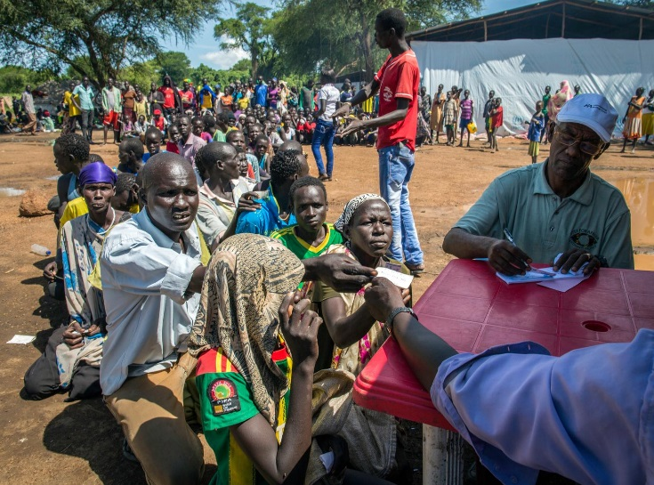
Figure 14.1 Newly arrived refugees from South Sudan registering at Kule camp, Gambella region, 2014.
It is important to understand that management of water, sanitation and hygiene arrangements are often critical for survival, particularly in the early stages of any emergency. People in emergency situations are generally much more susceptible to illness and death from diseases that are related to inadequate sanitation, waste management, water supplies and poor hygiene conditions. Vulnerable groups such as young children, the elderly and pregnant women are most at risk.
The most significant diseases in emergencies are the infectious diseases transmitted by the faecal-oral route. The main objective of any sanitation, waste management and hygiene promotion intervention in an emergency situation is to reduce the transmission of faecal-oral diseases and the exposure to disease-bearing vectors. This is achieved through management, control and promotion of good hygiene practices along with the provision of safe drinking water. Emergency management aims to reduce environmental health risks by establishing the conditions that allow people to live with good health, dignity, comfort and security.
Emergencies require an immediate response to minimise impacts and bring order to the situation.
In Ethiopia, the Disaster Prevention and Preparedness Agency (DPPA) has the responsibility of responding and making interventions in emergencies. However, many other agencies are involved in an emergency response including the national government, international organisations such as the United Nations, as well as international and local NGOs.

14.2 Phases of an emergency and initial response
Emergencies can happen at any time and, without rapid intervention, can spiral into an uncontrolled situation. Emergencies can be described as having three phases:
- Immediate emergency — typically this lasts from several weeks up to three months. This is the most important phase for any emergency response and will require instant action. This will include deployment of staff and resources to the emergency area.
- Stabilisation — this may last several months or several years depending on the type and severity of the emergency.
- Recovery — this phase it may take several years or even a decade for a community to recover from an emergency, which can impact on long-term development issues.
The first phase requires rapid intervention and response by the provision of basic facilities for sanitation and excreta disposal. Once these issues are under control, longer-term solutions to the problems can be developed and implemented.
Any intervention should address excreta disposal as a priority and minimise high-risk practices (such as open defecation) with the aim of reducing faecal disease transmission rates.
- Why is excreta disposal so important? (It may help if you look back to Study Session 2.)
- Excreta disposal is very important because human faeces carry many pathogens that cause a number of serious diseases such as cholera, typhoid, other diarrhoeal diseases and parasitic infections.
- Think back to the F diagram of pathways for faecal-oral transmission of disease. What are the steps that can be taken to prevent the contamination links from faeces to people?
- The links can be broken in several ways:
- by building and using latrines that reduce the risk of contact with faeces
- by ensuring that drinking water comes from a safe source and is treated if possible
- by washing foods in clean water before eating them
- by always washing hands with soap at critical times.

14.3 Rapid field assessment in an emergency
You may find yourself in a team providing support in an emergency situation. It is important for the team to understand the extent of the emergency and the priorities for their efforts. This is established through a rapid assessment, which is a key requirement of Phase 1 of the emergency. The assessment needs to address the main issues that can impact on health. It should quickly gather key relevant information which can be used to put the possible interventions in an order of priority. The assessment should also consider medium- and long-term interventions for Phases 2 and 3 of the emergency. The principles are very similar to the rapid assessment methods you read about in Study Session 3.
Harvey (2007) suggests 20 key questions to be applied when collecting baseline data for initial assessments. The questions are designed to find out what sanitation facilities are available, whether the current provision and practices represent a health threat, whether there is space for additional latrines, and whether there are facilities for dealing with menstruation. There are also questions about the environmental context such as the local ground and surface water situation (drainage patterns, soil types, height of the water table), etc.
From the rapid assessment, a programme of planning and implementation of the response needs to be drawn up. Harvey suggests the process has a number of stages. The first stage is to carry out any immediate actions necessary to deal with the initial problems. This would be followed by a more detailed assessment of the situation, consultation with the community and other stakeholders. This second phase would lead to the design and implementation of a programme to address the longer-term needs. For emergency WASH provision, the World Health Organization has published a set of brief technical guidance notes that provide practical recommendations for responses to immediate and medium-term water, sanitation and hygiene needs of populations affected by emergencies (WHO/WEDC, 2013a).

14.4 Standards for emergency response
There are various standards produced by different agencies that specify the minimum requirements for water supply, sanitation, hygiene, food, shelter and health in emergency situations. Two important ones are the United Nations High Commissioner for Refugees Standards (UNHCR, 2007) and the Sphere Handbook (Sphere Project, 2011). You may also come across other standards produced by different agencies. One thing they have in common is the importance of providing facilities that prevent the spread of disease, do not contaminate water supplies and give the people sufficient dignity and privacy. These standards can be useful in planning and designing an emergency response and act as a goal for achievement.
The Sphere standards describe the humanitarian actions that should be taken in the event of an emergency in order for ‘disaster-affected populations to survive and recover in stable conditions and with dignity’ (Sphere Project, 2011). In the section on water supply, sanitation and hygiene promotion, there are several standards in different categories, as shown in Figure 14.2.
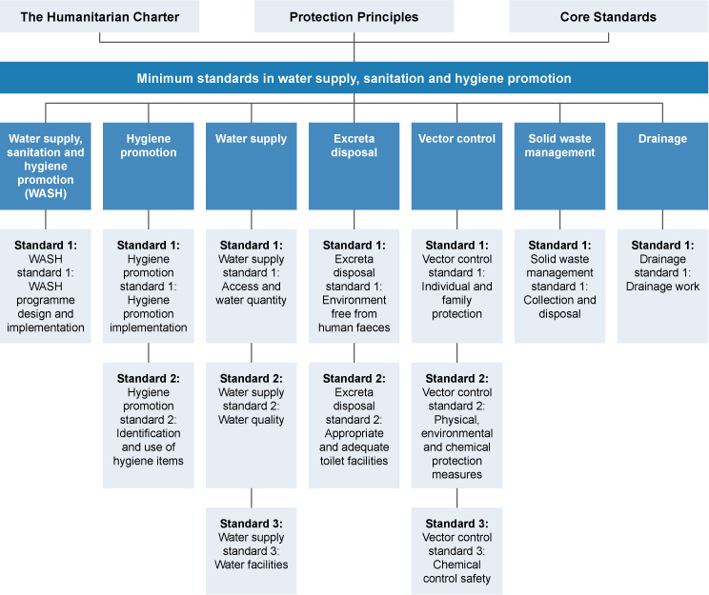
Figure 14.2 The Sphere Handbook: contents of the section ‘Minimum standards in water supply, sanitation and hygiene promotion’. (Sphere Project, 2011)

14.4.1 Water supply
Water supply is not the focus of this module but is obviously essential in an emergency situation. As you can imagine, there may not be sufficient water available to meet basic needs and in this situation supplying a survival level of safe drinking water is of critical importance. The Sphere Handbook sets standards for the minimum quantity and quality of water that should be available to people in emergencies, shown in Table 14.1. The recommended absolute minimum is 7.5 litres per person per day although this can vary depending on a number of different factors.
Table 14.1 Basic water needs during an emergency situation. (Sphere Project, 2011)
Water use | Volume per person per day | Comments
Survival needs: water intake (drinking and food) | 2.5–3 litres | Depends on the climate and individual physiology
Basic hygiene practices | 2–6 litres | Depends on social and cultural norms
Basic cooking needs | 3–6 litres | Depends on food type and social as well as cultural norms
Total basic water needs | 7.5–15 litres

14.4.2 Latrine provision and excreta disposal
The Sphere standards for excreta disposal state that the environment should be free of faeces and that people should have adequate and appropriate toilet facilities. It then goes on to list more specific requirements which include:
- a maximum of 20 people use each toilet
- toilets are no more than 50 m from dwellings
- they can be used safely by all sections of the population including children, older people, pregnant women and persons with disabilities
- they are sited in such a way as to minimise security threats to users, especially women and girls, throughout the day and the night
- they are sufficiently easy to use and keep clean and do not present a health hazard to the environment
- they allow for the disposal of women’s menstrual hygiene materials and provide women with the necessary privacy for washing and drying menstrual hygiene materials
- separate, internally lockable latrines/toilets for women and men.
The Sphere standards also lists the possible options for safe excreta disposal and when they would be used in an emergency situation (Table 14.2).
Table 14.2 Sphere guidance on possible alternatives for safe excreta disposal. (Sphere Project, 2011)
Excreta disposal type | Phase of use/comments
Demarcated open defecation area (e.g. with sheeted-off segments) | First phase (2–3 days) when there may be a huge number of people needing immediate facilities
Trench latrines (Figure 14.3) | First phase for up to two months
Simple pit latrines | From the start through to long-term use
Ventilated improved pit (VIP) latrines | For medium- to long-term use
Ecological sanitation (ecosan) with urine diversion | In situations where there is a high water table or flooding. May be required from the start and suitable for medium to long term use
Septic tanks | Mid- to long-term phases
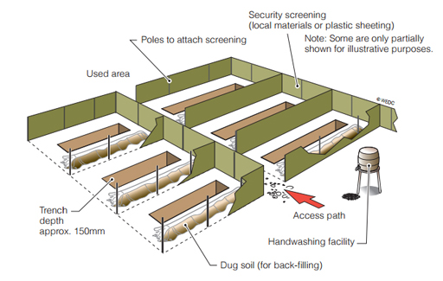
Figure 14.3 Shallow trench latrine, appropriate for the first phase of an emergency.
It is important to remember that successful excreta disposal programmes are based on an understanding of people’s varied needs as well as on the continuing participation of the users. It may not be possible to make all latrines acceptable to all groups and special latrines may need to be constructed for the vulnerable sectors of a community. These may include children, older people and disabled people. They may require potties or latrines with lower seats or supporting hand rails.
Keeping latrines clean is an important on-going task in an emergency situation. If latrines are not kept clean then people will prefer not to use them and find alternative uncontrolled areas to defecate in. Latrines will be more likely to be kept clean if users have a sense of ownership. This is encouraged by promotional activities, having latrines close to where people sleep and involving users in decisions about their design and construction and in the development of rules on proper operation, maintenance and use.
Inappropriate siting of latrines may also make women and girls more vulnerable to attack, especially during the night. Ways should be found to ensure that women feel, and are, safe using the latrines provided. Where possible, communal latrines should be provided with lighting or families provided with torches. The input of the community should be sought with regard to ways of enhancing the safety of all users.

14.4.3 Handwashing and hygiene
The Sphere Handbook also specifies standards for handwashing facilities close to latrines. The standard states: ‘Users should have the means to wash their hands with soap or an alternative (such as ash) after using toilets, after cleaning the bottom of a child who has been defecating, and before eating and preparing food. There should be a constant source of water near the toilet for this purpose.’ (Sphere Project, 2011).
- List at least five critical times for handwashing in an emergency?
- The critical times for handwashing in an emergency are mostly the same as they would be normally and include:
- after using the toilet (or disposing of human or animal faeces)
- after cleaning a child’s bottom and disposing of the faeces
- before preparing or handling food
- before eating
- before feeding a child
- after contact with contaminated surfaces.
There is an addition to this list which may arise in an emergency which is to always wash hands after touching dead bodies.
Sphere also sets a standard on the minimum hygiene items to be provided in an emergency (Table 14.3). Often, displaced people will have brought very little with them and only have what they can carry. Personal items such as hygiene materials may get left behind so people will be dependent on replacements being available.
Table 14.3 Sphere guidance on basic minimum hygiene items for emergencies. (Sphere Project, 2011)
Item | Quantity
10–20 litre capacity container for transporting water | One per household
10–20 litre capacity container for storing water | One per household
250 g bathing soap | One per person per month
200 g laundry soap | One per person per month
Suitable materials for menstrual hygiene (e.g. washable cotton cloth) | One per woman
- Outline in a sentence or two how the approach to sanitation differs in an emergency to a normal sanitation situation.
- Sanitation facilities will need to cope with a huge concentration of people in a small area with very limited or no resources. The people may not be used to community latrines. They will be stressed, possibly malnourished, and be more likely to be ill or injured than in normal conditions.

14.4.4 Solid waste management in emergencies
The safe disposal of solid waste is critical for public health, especially during an emergency. Not only will existing solid waste collection and disposal systems be disrupted but there will be extra waste caused by the emergency itself. Initially at temporary settlements for displaced people or refugees there will be no arrangements in place at all for solid waste management. If solid waste is not dealt with quickly, serious health risks will develop, which may further demoralise the displaced community already traumatised by the emergency.
If organic solid wastes (such as food waste) are not managed properly, there are major risks of fly and rodent infestation (particularly rats) and surface water pollution. Solid waste often blocks drainage channels and leads to environmental health problems associated with stagnant and polluted surface water that can lead to drinking water contamination. Uncollected and accumulating solid waste and the debris left after an emergency, natural disaster or conflict may also create a depressing and ugly environment, discouraging efforts to improve other aspects of environmental health.
The Sphere standard for solid waste management aims to ensure that ‘the affected population has an environment not littered by solid waste, including medical waste, and has the means to dispose of their domestic waste conveniently and effectively’ (Sphere Project, 2011). The key indicators in the Sphere standards include specific requirements such as ‘all households have access to refuse containers which are emptied twice a week at minimum and are no more than 100 m from a communal refuse pit’.
At a temporary settlement site, routines for the storage, collection and the disposal of solid waste or refuse need to be implemented and resourced. This is particularly important at high density sites. Engaging the community can be a vital aspect and any initial clean-up operation should be community based.
A common way to produce storage containers is to use 200-litre drums that can be cut in half to give two 100-litre drums. Drainage holes should be drilled in the bottom. UNHCR suggest that these drums should be placed throughout the site so that no household is more than 15 m away from one (UNHCR, 2007).
Collection from site containers should be done regularly (daily if possible). Lorry or tractor and trailer-based collections can be expensive. It may be more appropriate to use hand carts, wheelbarrows or donkey-pulled carts if available.
The options for treatment and disposal of solid waste in emergency situations are similar to the standard methods that you learned about in Study Session 10. Open dumping should be avoided because of the health risks for people and animals. Burning of solid waste is possible although it creates the problem of smoke and will not achieve a sufficiently high temperature unless a purpose-built incinerator is used. The most likely disposal method is burial. If it is possible to do so, existing waste disposal sites should continue to be used. For temporary settlements, areas should be designated for burying waste and they should be well away from households and fenced off. If waste is to be buried on-site in either household or communal pits, it should be covered daily with a thin layer of earth to prevent it attracting vectors such as flies and rodents. Figure 14.4 shows the main features of a solid waste burial pit.
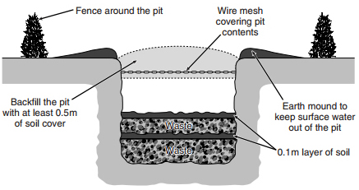
Figure 14.4 Solid waste burial pit. (Davis and Lambert, 2002)
- Briefly outline why standards are important in the management of emergencies.
- They set a benchmark of targets to achieve and maintain. They are universally accepted as good practice and can help the planning of resources and preparation for emergencies.

14.5 Disposal of human bodies
It is an unpleasant fact that in some disaster situations people may lose their lives. In the worst cases, this may result in many bodies needing to be disposed of quickly, safely and respectfully. This is inevitably very distressing for everyone concerned. The WHO Technical Note (WHO/WEDC, 2013b) includes the following recommendations:
- Bodies should be collected as quickly as possible, but without interrupting other activities aimed at helping survivors. Bodies should be placed in body bags and labelled with a unique reference number. If body bags are not available, plastic sheets, shrouds or other locally available materials should be used.
- Although collection of bodies should be done quickly, it is not necessary or advisable to hurry their disposal. It is important for bodies to be identified and relatives to be informed and allowed to make their own decisions about the next steps.
- If possible, bodies should be stored under refrigeration but if this is not available, then temporary burial is the next best option.
- The recovery teams who are collecting bodies may be made up of members of the surviving community, volunteers and specialist search and rescue teams. Recovery teams should wear protective equipment such as gloves and boots. They should also be encouraged to wash their hands with soap after handling dead bodies.
The people involved in body recovery and other aspects of dealing with the immediate problems of an emergency may need to be protected from other hazards. Depending on the type of emergency, there may be danger of physical injury, for example, from collapsing buildings. There are obvious health risks in the case of outbreaks of infectious disease which may need specialist protective clothing. There are also potential impacts on the mental health of survivors and recovery team members which may not become apparent until well after the event. Appropriate medical treatment and care should be available to all those affected by an emergency to ensure long-term recovery.

Summary of Study Session 14
In Study Session 14, you have learned that:
- An emergency is a sudden and unforeseen event that calls for immediate measures to minimise its adverse consequences. As a consequence of emergencies there are often mass migrations of people who need to use temporary settlements.
- It is essential, in the early stages of an emergency, to ensure affected people have access to safe water and sanitation. Planning and managing sanitation provision is therefore among the first priorities in any emergency. The provision of safe water and appropriate facilities for defecation are essential for people’s dignity, safety, health and well-being.
- The first two phases of an emergency are critical and a rapid site assessment will need to be carried out to evaluate the scale of the emergency and the resources needed.
- There are set standards for emergency provision and these can be used as targets for achievement. Two commonly used standards are from the Sphere Project and UNHCR, although others also exist.
- The Sphere standards specify minimum requirements for water supply, excreta disposal, hygiene, and solid waste management among other critical aspects of emergency response.
- The handling and disposal of the dead can be an important aspect of emergency sanitation. This carries a risk of physical and psychological harm to those concerned and must be done in a sensitive way.

Self-Assessment Questions (SAQs) for Study Session 14
Now that you have completed this study session, you can assess how well you have achieved its Learning Outcomes by answering these questions. You can check your answers with the Notes on the Self-Assessment Questions at the end of this Module.

SAQ 14.1 (tests Learning Outcome 14.1)
Rewrite the paragraph below using terms from the list provided to fill the gaps:
disasters, emergency, IDPs, rapid-onset disasters, slow-onset disasters.
Floods, droughts, famines and earthquakes are examples of ……………… that can cause ……………… situations requiring immediate intervention to help the people affected. In these situations, many people leave their homes and become ……………… when they move to other places within their own country.
Floods and earthquakes happen unexpectedly and are examples of ……………… Drought and famine are ……………… because they develop gradually over time.

SAQ 14.2 (tests Learning Outcome 14.2)
What are the most important questions you would need to address in a rapid assessment of an emergency?

SAQ 14.3 (tests Learning Outcome 14.3)
Imagine that in the area where you are working a flood emergency happened and nearly 5,000 people, the majority of them children, women and old people, were displaced from their area. Your office assigned you to be a member of the emergency response team. The team conducted a quick assessment on the existing situation and identified that there is an urgent need for more latrines. What latrine options would you suggest in the immediate and longer term to cope with this particular population?

SAQ 14.4 (tests Learning Outcome 14.4)
What are the possible interventions to manage the solid waste in an emergency situation? List at least three actions that could be taken.

Study Session 15 Monitoring and Evaluation

Introduction
Monitoring and evaluation (M&E) is a project management technique that is an integral part of any programme cycle. It includes the gathering and analysis of information, and the reporting of processes and outputs. In this study session, you will learn how M&E can be used to assess progress made in sanitation and waste management.
Any M&E system needs to ensure that the programme implementation is carried out as planned and is achieving the aims and objectives to an acceptable quality, and in the planned time period. The system should also provide assurance that sustainability and management issues are being addressed and that supporting organisations such as local community groups are in place and functioning.
The World Bank (2004) summarises the advantages of M&E as ‘better means for learning from past experience, improving service delivery, planning and allocating resources and demonstrating results as part of accountability to key stakeholders’.

Learning Outcomes for Study Session 15
When you have studied this session, you should be able to:
15.1 Define and use correctly each of the terms printed in bold. (SAQs 15.1, 15.2 and 15.4)
15.2 Explain the difference between monitoring and evaluation. (SAQ 15.2)
15.3 Describe the purpose of M&E and explain why it is important. (SAQ 15.3)
15.4 Identify the data and methods that can be used to monitor and evaluate the performance of urban sanitation and waste management schemes. (SAQ 15.4)

15.1 Introduction to monitoring and evaluation
Monitoring and evaluation are critically important aspects of planning and management of any programme. Monitoring is the systematic and continuous assessment of the progress of a piece of work over time, in order to check that things are going to plan. Evaluation is an assessment of the value or worth of a programme or intervention and the extent to which the stated objectives have been achieved. Evaluation is not continuous and usually takes place periodically through the course of the programme or after completion. Together, monitoring and evaluation are a set of processes designed to measure the achievements and progress of a programme. The two terms are closely connected and are frequently combined with the result that the abbreviation M&E is widely used.
- A town health office is interested in finding out how many families practise solid waste sorting and reuse at household level. Is this monitoring or evaluation?
- This is monitoring because it is an on-going activity concerned only with counting the number of something, in this case how many families were sorting their waste.

15.1.1 What is M&E?
Programmes, projects and other interventions can be described in five stages, as shown in Figure 15.1. The inputs, on the left, are the resources (funding, equipment, personnel) and activities that are undertaken. The results, on the right, are the outputs, outcomes and impacts (see Box 15.1).
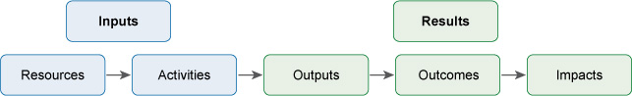
Figure 15.1 Five-stage model of a programme.
An effective M&E system measures the inputs, outputs, outcomes and impacts resulting from implementation of a programme. To provide useful knowledge these results need to be compared with the situation before the programme started, which requires baseline data. Baseline data gives information about the situation at the start of an intervention (the baseline position) and provides a point of comparison against which future data, collected as part of a monitoring process, can be compared. Progress can be evaluated by comparing the two.

Box 15.1 Outputs, outcomes and impacts
There are several words used in M&E that can be confused. They sound similar but have important differences in their meaning.
- Outputs – the things produced by the project/programme/intervention. In sanitation and waste management, examples could include tangible products like new latrines or waste transfer stations or could be events and activities like running a training workshop for composting workers.
- Outcomes – the effects of the intervention, usually in the short to medium term. Some examples, following those above, could be the number of people in a kebele who now have access to improved sanitation or the number of people attending the training workshop.
- Impacts – long-term effects and consequences. Examples could be a fall in the incidence of diarrhoeal disease or a reduction in the amount of waste sent to landfill.
It’s very important to plan monitoring activities during the earliest stages of project development — they should be integrated into project activities and not be added on as an afterthought. Monitoring requires regular and timely feedback in the form of reports from implementers to project managers so they can keep track of progress. These reports provide information about activities and what has been achieved in terms of outputs. They also include financial reports that give information on budgets and expenditure. With this information, managers can assess progress and plan the next steps for their project.

15.1.2 Why is M&E so important?
A well-managed M&E system will allow stakeholders to:
- Track progress: M&E assesses inputs (expenditure), outputs and outcomes, which enables managers to track progress towards achieving specific objectives.
- Measure impact: M&E reduces guesswork and possible bias in reporting results by asking questions such as: What is the impact of the programme? Are the expected benefits being realised? Is sanitation improving? Are waste recovery rates increasing?
- Increase accountability: M&E can provide the basis for accountability if the information gathered by the M&E process is reported and shared with users and other stakeholders at all levels.
- Inform decision making: M&E provides evidence about the successes and failures of current and past projects that planners and managers need to make decisions about future projects. It should also encourage reflection on lessons learned in which managers ask themselves questions like ‘what worked well in this project?’ and ‘what can we do better next time?’.
- Encourage investment: a credible M&E system builds trust and confidence from government and donors which will increase possibilities of further investment.
- Build capacity: a sound M&E system supports community participation and responsibility. It encourages the user communities to look regularly at how well their sanitation and waste schemes are working, what changes need to take place in sanitation and waste behaviours, what health benefits are resulting and what more needs to be done. It enables a community to build its own capacity, recognise its own successes and record them regularly.
Reporting on monitoring activity is essential because otherwise the information cannot be used. It is no use collecting data and then filing it away without sharing it. As noted above, one of the reasons for undertaking M&E is to inform decision makers and enable lessons to be learned and therefore they need to be provided with the information in a timely way for that benefit to be realised.

15.2 Monitoring in practice
As you have seen, a key part of monitoring is the gathering of data.

15.2.1 Data types
Data can be classified into two types. Factual information based on measurement is called quantitative data. Information collected about opinions and views is called qualitative data.
- Suggest examples of quantitative and qualitative data that could be collected about open defecation in a kebele.
- Collecting data about the change in the proportion of people practising open defecation is an example of quantitative data. An example of qualitative data could be assessing people’s views about the reduction of open defecation. You may have thought of other examples.
If you look back to Figure 5.1 in Study Session 5, you will find an example of quantitative monitoring data. The WHO/UNICEF Joint Monitoring Party data for sanitation coverage is compiled from monitoring programmes in countries all over the world.

15.2.2 Key features of monitoring
Monitoring is a continuous or periodic review of project implementation focusing on inputs, activity work schedules and outputs. It should be designed to provide constant feedback to ensure effective (the extent to which the purpose has been achieved or is expected to be achieved) and efficient (to what degree the outputs achieved are derived from well organised use of resources) project performance. Monitoring should allow the timely identification and correction of deviations in a programme. It should provide early warning or the opportunity to remedy undesirable situations before damage occurs or gets worse.
Monitoring consists of three related activities, which are:
- Collection of data and information: for example, to monitor the proper use of sanitation facilities, data can be collected from various different sources such as regular household visits and observation of the amount and frequency of faecal matter outside the latrine. Information can be gathered from community questionnaires and reports from focus groups.
- Information analysis: data should be analysed in terms of place, time and who was surveyed in order to summarise the results. If the data suggests there are problems, appropriate management action needs to be taken.
- Action based on monitoring feedback: if, for example, after analysing monitoring data on household waste management, you find most households do not separate their wastes into organic and non-organic types, there are three types of action you can take:
- Corrective actions – you could provide practical demonstrations to show the people how to separate household wastes and how to store it properly.
- Positive reinforcement – if some households practise the required behaviour and are separating their waste they can be used as a good example to others.
- Preventive actions that will stop the problem arising in future – for example, arranging an education and promotion programme for the community. This could encourage behaviour change by showing the impact of non-compliance and the benefits to the wider community and the environment if wastes are separated at source. Peer pressure can be an important factor in communities. Highlighting the negative impact of non-compliance to individuals or communities can be a useful approach.
Monitoring should be a continuous process of regularly and systematically reviewing achievements, performance and progress towards the planned objectives of a programme. This will require a schedule for monitoring activities that should be prepared at the start and reviewed regularly. For example, a typical schedule for monitoring at the Woreda Health Office level would be part of an annual plan and might include:
- monthly field visits
- monthly, quarterly, annual and biannual reports
- annual and biannual review meetings.

15.3 Indicators
An effective monitoring programme needs precise and specific measures that can be used to assess progress towards achieving the intended goals. These are called indicators. An indicator is something that can be seen, measured or counted and that provides evidence of progress towards a target. Some examples of basic monitoring indicators for urban sanitation and waste management are:
- number of households with unimproved latrines
- number of schools with improved latrines
- number of people using communal latrines
- number of people using public latrines
- number of public toilets constructed
- number of Health Extension Workers trained in solid waste recycling and reuse
- number of institutions with improved VIP latrines and handwashing facilities
- number of households with access to improved sanitation facilities
- number of schools with access to adequate sanitation
- number of community members who received education and information on the safe handling and disposal of wastes
- number of community members trained on safe handling and disposal of wastes
- number of community meetings held on safe handling and disposal of wastes.
These are all examples of indicators that could be used to monitor progress towards specific programme targets.

15.3.1 Key performance indicators
The terms ‘performance indicator’ or key performance indicator (KPI) are often used by organisations to describe measures of their performance, especially in relation to the service they provide, and how well they have met their strategic and operational goals. KPIs can be measures of inputs, processes, outputs, outcomes or impacts for programmes or strategies. When supported with good data collection, analysis and reporting, they enable progress tracking, demonstration of achievement and allow corrective action for improvement. Participation of key stakeholders in defining KPIs is important because they are then more likely to understand and use them for informing management decisions.
KPIs can be used for:
- setting performance targets and assessing progress toward achieving them
- identifying problems to allow corrective action to be taken
- indicating whether an in-depth evaluation is really needed.
Sometimes too many indicators may be defined without accessible and reliable data sources. This can make the evaluation costly and impractical. There is often a trade-off between picking the optimal or desired indicators and having to accept indicators which can be measured using existing data.
The Ethiopian WaSH M&E Framework and Manual (FDRE, n.d.) uses the following KPIs for sanitation and hygiene:
- number and percentage of health facilities with water and latrines with water
- percentage of households with a functioning latrine meeting minimum standards
- percentage of households with a functioning handwashing facility.
- percentage of people washing hands after defecation.
The percentages are calculated from the data collected during monitoring surveys. For example:
Percentage of households with a functioning latrine =
$\frac{\text{Number of households who have a functioning latrine}}{\text{Total number of households}}$ × 100
The advantage of KPIs is that they provide an effective means to measure progress toward objectives. They can also make it easier to make comparisons. For example, different approaches to a common problem can be compared to find out which approach works best, or results from the same intervention in a number of districts can be compared to find out what other factors affected the outcomes. It is important for KPIs to be carefully defined so they can be applied consistently by different organisations (Jones, 2015). For example, the definition of ‘functioning latrine meeting minimum standards’ in the KPIs listed above, should specify exactly what the minimum standards are. Without precise definitions, survey data could be collected and interpreted by different people in different ways which would make comparisons meaningless and useful analysis and evaluation impossible.

15.4 Evaluation
Evaluation should answer why and how programmes have succeeded or failed and allow desired changes to be planned for improvements in implementation. It is an activity that should allow space to reflect upon and judge the worth (value) of what is or has been done. Evaluation can be seen as a cyclical process as shown in Figure 15.2. You should read this diagram by starting at the top and then following the arrows down the middle. From the top, data are collected, then analysed and then evaluated. If the aims of the programme are being achieved (the arrow to the right), no action is required but results should be reviewed and feed into the next evaluation if there is one. However, if the aims were not achieved (the arrow pointing down), action is required in the form of review of the management plan and changes to the way the programme is implemented. This will then require further evaluation in due course (the arrow going back up to the top) to assess the success of the revised programme.
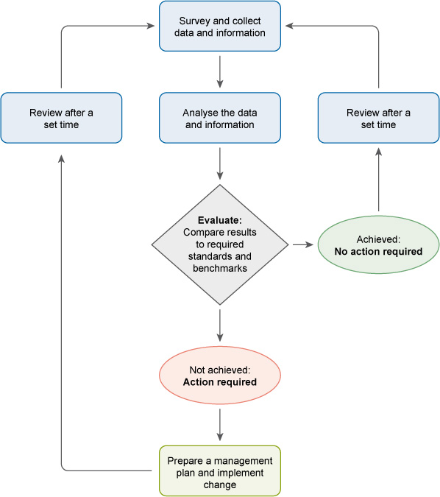
Figure 15.2 Data collection, evaluation and management intervention cycle.
Unlike monitoring which is a regular activity, evaluation will be conducted only when there are evaluation questions that need to be answered. There is no fixed schedule for this but it may happen:
- mid-term
- at the end of a project
- three to five years after the project is completed (to assess the total impact).
Evaluation questions may arise from monitoring data or any other observations that lack in-depth information to explain observed levels of performance or effectiveness. In such cases, evaluation provides useful data on how and why programmes succeed or fail.
Evaluation as an activity may be related to processes, outcomes or impacts of a programme.
Process evaluation, as the name suggests, looks at process questions and can give insight into whether the project is on track or not, and why. At the end of a project, it would involve a review of all the project processes, from start to finish. Process evaluation aims to explain why things have happened in the way they have and answers questions such as:
- Was the intervention implemented according to expectations and the agreed management plan?
- Did the intervention meet the required standards of quantity and quality?
- Can the reasons for the success or failure of the intervention be assessed?
Outcome evaluation is the assessment of what the intervention has achieved. For example, if the intended outcome was to reduce open defecation in a target population, evaluation questions could be:
- Is there a change in the level of open defecation by the target population? And to what extent?
- What contribution did the project make to the observed level of change?
- Was the change that was attributable to the project adequate to meet project goals?
In most cases, outcomes or impacts are influenced by more than one factor and by other changes in a situation. For this reason, an outcome evaluation needs to be designed so that it is possible to estimate the difference between the current outcome level and that expected if the intervention was not in place.
Impact evaluation is the systematic identification of the effects (positive or negative and intended or not) on individuals, households or communities caused through implementation of a programme or project (The World Bank, 2004). Impact evaluations can vary in scale. They may be large surveys of target populations that use baseline data and then a follow-up survey to compare before and after. They could also be small-scale rapid assessments where estimates of impact could be obtained from a combination of group interviews, focus groups, case studies and available secondary data.
Impact evaluation can be used to:
- measure impacts of a programme and distinguish these from the influence of other external factors
- inform management decisions on whether to modify, expand or abolish programmes
- learn lessons for improving the design and management of future activities
- compare the effectiveness of alternative interventions
- help to clarify whether costs for a programme or activity are justified.
The advantages of impact evaluation are that it provides estimates of the magnitude of outcomes and analyses the impacts for different demographic groups, households or communities over time. It should show the extent of the difference that a programme is making and allow plans for improvement to be made. However, it needs competent managers and some approaches can be very expensive and time-consuming.
- One year after a hygiene promotion programme has ended, the Regional Health Bureau is interested to see if child health has improved in the woredas where the programme was implemented. Is this monitoring or evaluation?
- This is evaluation because it is concerned with the impacts of a particular programme. However, monitoring is also involved because the data collection required for the evaluation would probably have come from regular monitoring reports.

15.5 Tools for monitoring and evaluation
There is a wide range of tools available which can be used to generate information for monitoring and evaluation purposes.
- Think back to Study Session 3 and list the main methods that can be used to gather data from communities and individuals about their access and use of sanitation and waste management services.
- The main methods are:
- interviews with individuals and households
- observation in public places and in homes
- community discussions (Figure 15.3)
- focus groups (Figure 15.4)
- questionnaires that can be completed by large numbers of people or used to structure interviews.
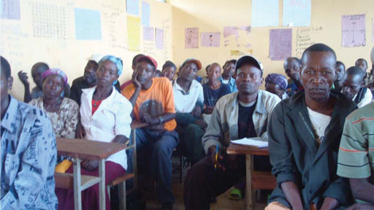
Figure 15.3 Community meetings can allow people to participate in M&E planning.
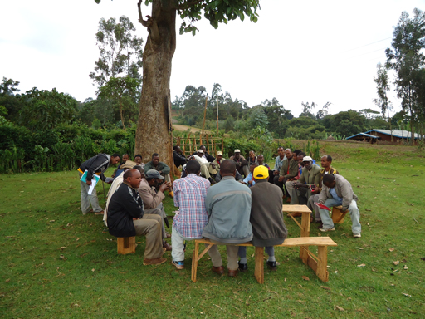
Figure 15.4 A focus group considering an issue.
Large-scale monitoring programmes can generate enormous amounts of data. Collating the data and organising it in a way that is meaningful for evaluation or other purposes is a significant task. This is the purpose of a management information system (MIS). An MIS is a computer-based system that provides tools for collecting, organising and presenting information so that is useful for managers and other stakeholders.
In Ethiopia, there are two national monitoring systems that are relevant to urban sanitation and waste management. The Health Management Information System/Monitoring and Evaluation (HMIS/M&E) is used to record data from routine services and administrative records across all woredas and all health facilities throughout the country (MoH, 2008; Hirpa et al., 2010).
In the WASH sector, the National WASH Inventory (NWI) is a country-wide monitoring programme that was initiated in 2010/2011. Its purpose is to provide a single comprehensive set of baseline data about water, sanitation and hygiene provision for the whole country. The early phases of data collection used paper-based surveys and questionnaires but later phases have moved to a system of collecting data using smart phones (as long as there is service) which is much quicker and more efficient. The WASH MIS has been developed to collect monitoring data and to enable production of reports from national to woreda levels.
There is a lack of coordination between the HMIS and WASH MIS and this is recognised as a problem. In addition, at present, there is greater emphasis on water supply than there is on sanitation and hygiene, and currently there is no national monitoring of solid waste management. Recent developments such as the One WASH National Programme, which you read about in Study Session 1, are signs of the move towards more collaborative and integrated working in the sector which will bring many benefits.

Summary of Study Session 15
In Study Session 15, you have learned that:
- Monitoring and evaluation (M&E) activities are a key management component of interventions and programmes. Monitoring is systematic and continuous assessment. Evaluation is an assessment of the value of a programme and the extent to which its objectives have been achieved.
- Baseline data should be collected at the start of a programme so that it can be compared with data collected later.
- M&E is intended to track progress, measure impact, increase accountability, inform decision making, encourage investment and build capacity.
- The main features of monitoring activities are collecting data, analysing information and acting on that information.
- Effective monitoring needs careful identification and definition of an appropriate number of measureable indicators.
- Evaluation is a cyclical process that should be regularly reviewed and repeated. It can be undertaken with respect to processes, outcomes or impacts.
- There are several tools for data collection for monitoring including surveys, observation, interviews, community discussions and focus groups.

Self-Assessment Questions (SAQs) for Study Session 15
Now that you have completed this study session, you can assess how well you have achieved the Learning Outcomes by answering these questions. You can check your answers with Notes on the Self-Assessment Questions at the end of this Module.

SAQ 15.1 (tests Learning Outcome 15.1)
Write the following words next to their correct definitions in the table below:
baseline data; impact evaluation; impacts; indicator; outcomes; outputs; process evaluation; qualitative data; quantitative data.
measureable factual data
the long-term effects of a project or programme
a way of determining if a programme is on track to meet its aims
data collected at the start of an intervention to provide a point of comparison against which future data can be compared
information collected about views and opinions
effects of an intervention, usually in the short to medium term
something that can be seen, measured or counted, providing evidence of progress towards a target.
identifying the effects on individuals, households or communities caused through implementation of a programme or project
the things produced or objectives achieved by a project or programme

SAQ 15.2 (tests Learning Outcomes 15.1 and 15.2)
Which of the following statements are false? In each case explain why it is incorrect.
- Collecting data is an important part of monitoring.
- Monitoring is an activity that should be done occasionally during a project’s lifetime.
- Monitoring will help you decide if any corrective action is needed.
- Evaluation can answer questions about project process, outcomes and impacts.
- Evaluation should always be left to the end of a project so that final outcomes are known.

SAQ 15.3 (tests Learning Outcome 15.3)
Give three reasons for incorporating plans for M&E during the early stages of a project’s development.

SAQ 15.4 (tests Learning Outcomes 15.1 and 15.4)
Explain why an indicator based on quantitative data will be more useful than an indicator based on qualitative data. Use examples of indicators in your answer and describe how you might measure them.

Notes on the Self-Assessment Questions (SAQs) for Urban Sanitation and Solid Waste Management

Study Session 1

SAQ 1.1
This game is intended to familiarise you with the terms you will meet again in subsequent study sessions. To find the right answer, you can check the definition written in your own words with that in the study session.

SAQ 1.2
Sanitation | Waste management | Both sanitation and waste management
Mainly concerned with liquid waste | Mainly concerned with solid waste | Aims to protect people from disease
Options are described as a ladder | Options described as a hierarchy | Aims to prevent pollution
Management of human excreta | Management of e-waste | Management of industrial wastes

SAQ 1.3
The sequence for the sanitation ladder is:
- pour flush toilet (improved latrine)
- simple pit latrine with no ventilation or slab (unimproved latrine)
- defecating on waste ground (open defecation).
The sequence for the waste hierarchy is:
- refill plastic bottle with cooking oil (reuse)
- old cardboard box, flattened out, used as door mat (recycling)
- broken wooden box used for firewood (recovery – if the fire is used to keep warm or to cook food. If just burned without benefit then this is classed as disposal).

SAQ 1.4
There are several possible answers to this question, but the main challenges from urbanisation are caused by many people living very close together which puts pressure on all urban services. The rate of increase in population is very fast and the development of infrastructure for water supply and sanitation services cannot maintain the same pace of change. People arriving in cities often live in informal settlements which are developed without planning or control and lack essential facilities for the people who live there.

SAQ 1.5
There are several possible reasons, but you may have thought of the following:
- There is a well-known and direct link between poor sanitation, a lack of safe water, poor hygiene and human health. The impacts from poor solid waste management, however, are more environmental, social and economic and less directly linked to health so corrective actions are not always considered urgent.
- There is limited data available about current solid waste production which makes it more difficult to manage.
- There are many different policies and laws that relate to sanitation that have been in place for many years. Legislation about solid waste management is more recent and enforcement is not yet complete.

Study Session 2

SAQ 2.1
Pathogen type | What it is | One disease caused
Bacteria | Simple micro-organisms | Typhoid
Viruses | Infectious agents that invade cells | Polio
Protozoa | Single-celled animals that live inside humans | Malaria
Parasitic worms | Animals that live inside humans, usually in the intestines | Ascariasis

SAQ 2.2
As well as ensuring the family is using water that is safe to drink, the focus should be on reducing the potential for the child to come into contact with faeces directly and indirectly. These barriers could include:
- ensuring all family members use a latrine. If the child is not old enough to use the latrine themselves, the mother or other carer should dispose of the child’s faeces in a latrine.
- ensuring all family members wash their hands at the appropriate times, especially before feeding the child. Teach the child to wash their own hands.
- not giving the child access to raw foods
- keeping food and wastes covered to reduce the problem of flies
- discouraging the child from picking things up in the street or off the floor
- discouraging the child from putting their fingers in their mouth.

SAQ 2.3
- Effects on health: Good sanitation and waste management help to keep people separate from potential sources of pathogens. They reduce the risk of contaminating water supplies with pathogens and discourage the transmission of disease.
- Effects on education: Healthy children have fewer days off school through illness. When they are at school, healthy children learn better than sick children. Providing good sanitation facilities encourages children to attend school, particularly girls during their menstrual periods.
- Effects on economic conditions: The health benefits promoted by good sanitation and waste make for a more productive community. Less money is spent on healthcare and people lose fewer days off work through caring for the sick.
- Effects on the environment: Good sanitation and waste management means that there will be less faeces and waste deposited in public places and less pollution of the water and soil.

Study Session 3

SAQ 3.1
Interviews are frequently part of a rapid assessment process. Structured interviews involve asking a set of questions that are decided in advance. These are usually closed questions that have a limited number of possible answers. This type of question is also often used in questionnaires. Questions that allow people to answer more freely are called open questions. They are used in in-depth interviews. Both types of question are used in semi-structured interviews.

SAQ 3.2
An overall aim could be: ‘To find out why there is a low use of latrine use in the kebele’. Possible objectives are:
- to determine the state of the local latrines
- to find out people’s attitudes to using the latrines
- to produce a set of recommendations to encourage greater use of the latrines.

SAQ 3.3
The best way to find out more information about the state of the latrines would be through observation and interview or discussion groups.
One-to-one interviews would be a good way of finding out people’s attitudes to the latrines, as some people may be unwilling to speak out about this subject in a public event.
Reviewing existing reports and research may provide typical reasons for not using latrines and suggest ways of overcoming this. This could be useful when devising possible recommendations.

SAQ 3.4
The purpose of the report is to summarise the results from the assessment and indicate how well its aims have been achieved. After permission from the funders has been obtained, it should be sent to all those who had an interest in its findings. Apart from the funders, recipients could include:
- the kebele administration
- community representatives
- the local Health Extension Workers team
- any non-governmental organisations (NGOs) or funding organisations who might be willing to finance or support a follow-on programme
- any local WASH programmes.

Study Session 4

SAQ 4.1
When we use water for any purpose and it becomes unclean after we used it, we refer to it as wastewater or effluent. In our homes we generate two types of liquid waste. The type from toilets which contains excreta is called blackwater, while other wastewaters (e.g. from clothes washing) that are not contaminated by excreta are referred to as greywater. Another word for the latter type of wastewater is sullage. Domestic wastewater is sometimes referred to as sewage. In many towns and cities around the world domestic wastewater goes into underground pipes called sewers that take the wastewater to treatment works.
The solids in a wastewater that are carried along in flowing water are called suspended solids. Organic matter in water may cause odours due to biodegradation. It also creates oxygen demand, which can be measured by its biochemical oxygen demand or chemical oxygen demand. If faecal matter is in the water, there may be pathogenic micro-organisms present. Inorganic chemicals in wastewaters are likely to include nitrates and phosphates. Industrial wastewaters may have significant polluting potential, for example, tannery waste frequently contains persistent hazardous pollutants that contain heavy metals.

SAQ 4.2
- Residential wastewater will probably only contain domestic liquid wastewater but in commercial areas there will also be wastes from businesses such as shops, cafes and restaurants. This may increase the proportion of fats and oils in the effluent.
The volume of wastewater generated per person will be greater in residential areas because it will include water from washing activities.
- Both residential and industrial wastewater will contain organic wastes but domestic waste is unlikely to include toxic chemicals, which will be found in many types of industrial waste.
The volume of wastewater produced by industrial processes is more likely to vary with the seasons than the volume of wastewater from residential areas.

SAQ 4.3
- To assess the physical characteristics, Worknesh could perform a suspended solids test. She could also measure the temperature of the sample and assess the odour. (Note that if she was measuring temperature she would have to do this at the point of origin because the temperature could change within a short time.)
- A high BOD test result would tell Worknesh that there was a lot of organic matter in the sample. If this was discharged into the river it would remove oxygen from the water, which would harm fish and other organisms living in the river.

SAQ 4.4
A is false. Effluent from food processing factories is not toxic but it will probably contain organic matter, which should be treated before the waste is discharged.
C is false. Tannery waste may contain suspended solids but the reason why it is highly polluting is because it contains toxic chemicals.

Study Session 5

SAQ 5.1
urine-diverting latrine | a type of latrine that separates urine and faeces
biogas latrine | a type of latrine that generates a fuel gas
improved latrine | a latrine where there is no contact between the user and the excreta produced
cistern-flush latrine | a type of toilet where a water supply is needed for operation
ecosan latrine | a type of latrine where the faecal matter is composted
VIP latrine | a modification of the simple pit latrine where the problems of odour and flies have been addressed
anaerobic digestion | the process by which organic matter is decomposed by microorganisms in an environment where there is no air
pour-flush latrine | a type of latrine where the user has to move the excreta along using water

SAQ 5.2
  - Since he doesn’t have a piped supply of water, Aschalew cannot install a water carriage system; instead, he has to install a dry latrine system. The possible choices are a ventilated improved pit latrine, an Arborloo, a urine-diverting latrine or a biogas latrine.
  - The ventilated improved pit latrine would be suitable, but if he has space and farms near him (since he is at the outskirts of town) a composting system is recommended, such as the Arborloo or urine-diverting latrine. This would produce a useful organic compost and so protect the environment. In the urine-diverting latrine, a fertiliser from urine is also produced. Aschalew could sell these products to the farmers. The biogas latrine is not recommended because it is suitable only where there are a large number of users.
  - The pit must be at least 30 m away from his well, and it must also be at a lower level according to the slope of the land. He should also consider the wind direction and place the latrine downwind and at a convenient distance from the house. For the safety of the children, he should choose a SanPlat for the slab. He should seek advice about possible materials to be used for the superstructure. The materials should be available locally, so that the system is sustainable. He should install a handwashing facility next to the latrine.

SAQ 5.3
Depth of pit = $\frac{\text{P} \text{×} \text{S} \text{×} \text{N}}{\text{A}}$ + 0.5 m
P = 7
S = 40 litres per person per year = 0.04 m³ per person per year
N = 3 years
A is $\frac{\text{π ×} {\text{d}}^{\text{2}}}{\text{4}}$ or $\frac{\text{3.142 × }{\text{1}}^{\text{2}}}{\text{4}}$ = 0.79 m²
depth = $\frac{\text{7 × 0.04 × 3}}{\text{0.79}}$ + 0.5 = 1.6 m

SAQ 5.4
B is false. Water-flushed toilet systems should only be considered if a continuous supply of water is available.
E is false. Latrines need to be affordable for people to adopt them.

Study Session 6

SAQ 6.1
drainfield | a network of perforated pipes through which the outflow from a septic tank goes into the ground
Sludge Gulper | a manually operated pump for desludging pit latrines
anaerobic ponds | first stage of waste stabilisation pond system treating highly polluted wastewater
septic tank | a watertight tank installed underground that collects sewage in areas where there are no sewers
facultative ponds | ponds that have oxygen at the top and no oxygen at the bottom
comminutors | an item of equipment that is used to cut up paper and rags in wastewater flowing into a treatment plant
Vacutug | a small vacuum truck designed for pit latrine emptying in crowded areas
soakaway | a pit into which the wastewater from a septic tank goes for disposal
maturation ponds | ponds that are used at the end of a waste stabilisation system to reduce the level of pathogens in the wastewater
retention time | the time that is spent in a given environment
desludging | the process of removing sludge from a place
sustainable drainage systems | drainage systems that encourage infiltration of rainwater without special equipment
faecal sludge management | combined processes for safely disposing of sludge from pit latrines and septic tanks

SAQ 6.2
Vacuum trucks are quick and efficient, but because they are large vehicles are not suitable in some urban areas where roads and passageways are too narrow for them. Vacutugs are smaller and therefore can access places that trucks cannot reach. In places with very limited space a Sludge Gulper or similar hand-operated pump may be a better option. These are very simple tools, but it may be difficult to ensure the safety of the operator and effective containment of sludge throughout the process.

SAQ 6.3
- Sludge is found in pit latrines, septic tanks, anaerobic ponds in waste stabilisation pond systems, and in primary and secondary sedimentation tanks in mechanical-biological treatment plants.
- Some options for treatment and reuse are:
- direct application onto land as a soil conditioner after two years of storage
- drying out the sludge
- composting the sludge with vegetable matter
- anaerobically digesting the sludge to produce biogas.

SAQ 6.4
Is expensive due to tanks and equipment involved | Mechanical-biological treatment
Can be used to treat wastewaters containing pesticides | Reed beds
Relies on sunlight and wind for treatment | Waste stabilisation ponds
Need a lot of space | Waste stabilisation ponds
Requires skilled personnel for operation | Mechanical-biological treatment
Used for houses with water-flushed toilets in areas without sewers | Septic tank
The area around the roots and rhizomes contains aerobic and anaerobic bacteria | Reed beds
A vacuum truck is used to suck sludge out of it | Septic tank
Consists of many different stages of treatment | Mechanical-biological treatment
Partially treated wastewater goes to a soakaway or drainfield | Septic tank
A symbiotic relationship exists between the bacteria and algae in this system | Waste stabilisation ponds
Use plants for treatment of sewage | Reed beds

SAQ 6.5
After recovering from my shock, I would approach the house where the water came from and gently explain to the person who threw the water that it is not advisable to dispose of such waters (sullage) by throwing it away as they did because:
- an innocent person could get soaked with dirty water
- the washwaters on the ground could become a breeding place for mosquitoes, and flies and rats could also be attracted to it as a water source
- the washwaters would make the alleyway wet and unpleasant.
I would suggest that the best way to dispose of the sullage would be to pour it into a hole that has had gravel or sand put into it.

SAQ 6.6
Flood risk can be reduced by
- building storm drains that are large enough to cope with large volumes of water
- constructing ponds that will temporarily hold the stormwater
- using broken stones and gravel rather than solid concrete in roadside ditches and other places where rainwater builds up so that water can infiltrate into the ground.

Study Session 7

SAQ 7.1
non-combustible | waste that will not burn
ash content | proportion of solids left after waste is burned
biodegradable | waste that is decomposed by micro-organisms
moisture content | proportion of water in waste
hazardous | waste that is a risk to health

SAQ 7.2
The main sources are:
- residential waste, which consists mostly of food wastes, plastics, paper, ash, textiles etc.
- commercial waste, which is generally similar to residential waste but may vary with the type of business, for example, restaurants and cafes will have a higher proportion of food waste.
- institutional waste from schools and government offices which is likely to contain more paper and less food waste.

SAQ 7.3
- We know that 34 households (or 34 × 6.3 = 214.2 people) produced 480 kg of waste in seven days. So the total amount produced per person is:
$\frac{\text{480}}{\text{214.2}}$ = 2.24 kg per person over seven days
The daily amount produced per person is, therefore:
$\frac{\text{2.24}}{\text{7}}$= 0.32 kg per person per day
- The total amount of domestic solid waste generated by the town’s people is:
0.32 × 75,000 = 24,000 kg or 24 metric tons per day.

SAQ 7.4
Healthcare waste poses risks from physical injury (such as cuts) from needles and broken glass. Injuries of this nature also provide a route into the body for pathogens.
Healthcare waste contains many pathogens from blood, other fluids, faeces or used dressings. Of major concern are the HIV virus and the hepatitis B and C viruses.
If ingested without proper guidance (for example, if a child eats them), drugs and medicines can be toxic. Many healthcare unit chemicals are also harmful.

SAQ 7.5
Your advice should include the following points: The waste should be stored in a container made of plastic or metal, and should not leak. It should be fitted with a lid so that small children cannot open it and insects cannot get into it. You should take the container to the disposal pit every day and empty it. After emptying, it should be rinsed with water and wiped out if necessary.

Study Session 8

SAQ 8.1
Composting is an example of recycling because the waste is reformed into a new material, compost, which is different from the original waste. It is also an example of recovery because the compost has value as a soil improver and has been recovered from the waste.

SAQ 8.2
Figure 8.8 The waste hierarchy.

SAQ 8.3
There are several possible answers but you may have thought of the following:
- When she is shopping, Tigist could look for products with less packaging. She could buy fresh food bought loose in a market rather than packaged food from the supermarket.
- She could take her own bags to the supermarket so that she didn’t have to use theirs and get new ones on each visit.
- For the baby, she could use washable nappies instead of disposables.
- She could use the clothes that the older children have outgrown for the younger children.

SAQ 8.4
You could explain that separating wastes into different types makes it easier to reuse and recycle. Separation should be done in the home so that the different types do not get mixed up together. If householders sorted out their waste paper and ensured it was not made dirty by food and other wet waste, this would make it more usable. If it was clean, the korales could take it away so the householders would not have to dispose of it themselves. You could also explain about the social benefits to the korales and the wider environmental benefits of reducing waste.

SAQ 8.5
A is false. Biogas is produced in a digester but the tank must be sealed, not open because it is an anaerobic process.
C is false. Compost piles must be turned regularly but this is because it is an aerobic, not anaerobic, process.

Study Session 9

SAQ 9.1
- The wheelbarrow would only be suitable for primary collections. While it can work in the most crowded areas, it is not suitable for transporting waste more than around 100 metres.
- The donkey cart would mainly be used for primary collections. In situations where the waste disposal site is close to the town (1 km or so) and road conditions are good, it might be possible to use the donkey cart for secondary transport.
- The flatbed truck would mainly be used for secondary collections from transfer stations and communal bins – it is too large to use in many areas. However, it may be used for primary collections from markets and business premises.

SAQ 9.2
There are a number of reasons. The main ones are to:
- allow waste to be deposited close to where it is produced and then be taken to disposal sites more than a few kilometres away
- reduce illegal dumping
- make the collection and transport system more efficient and cost-effective
- allow the waste to be screened to remove recyclable materials.

SAQ 9.3
This system would need:
- primary collection vehicles (mainly carts and barrows)
- communal waste storage bins for individuals and primary collectors to deposit wastes in
- transfer stations to collect and store the waste from primary collections and communal bins. The transfer stations should be built on hardstanding and be fenced-off. They will need sufficient containers, a tractor (or other loading device), a covered storage area and staff amenity building
- secondary collection vehicles to take the waste from the transfer stations to the final disposal site.

SAQ 9.4
The private sector waste collection enterprises could be paid a fee directly from the kebele based on the total volume of waste that they deliver to the transfer station.

Study Session 10

SAQ 10.1
Option (c), sanitary landfill, is the safest option.
  - The open field is away from residential areas so odour may not be a problem but it would attract flies, rats and other scavengers. The waste is not covered so it could be blown around by wind or burn uncontrollably. Leachate from the waste could pollute water sources and there would be no control of landfill gas.
  - Discarding waste into a river could cause all the above problems and would certainly pollute the river water which could affect people using the river as a water source for themselves, their animals or for irrigation. Pollution would also affect wildlife both in and around the river.
  - A well-managed sanitary landfill is the safest option because this would ensure leachate was collected and treated and would contain and control landfill gas. The waste would be covered every day with soil to stop it blowing around, prevent fly breeding, discourage scavenging animals and prevent the waste from catching fire.

SAQ 10.2
Measures to transform an open dump site into a controlled landfill should include:
- surrounding the site with a child-proof and animal-proof fence
- employing a person to staff the site
- providing a tractor to spread and compact the waste
- covering the freshly deposited waste with a layer of soil each day.

SAQ 10.3
Incineration is burning that is enclosed and controlled. Open burning is uncontrolled. Incineration produces less smoke; the ash is contained and can be removed for burial; it is safer because the burning waste cannot be blown around and spread fire. A higher temperature can be maintained in an incinerator which ensures more of the waste is consumed, leaving little residue.

SAQ 10.4
Key factors to consider when planning a landfill in small and medium-sized towns include:
- available land
- required land area based on population size, both current and future, and estimated waste production rate
- distance from the site to the town to be served
- location of rivers that could be polluted
- presence of groundwater below the site
- soil type and geology
- local opinions and beliefs about the site.

SAQ 10.5
        - The types of waste and their corresponding hazards are:
Type of waste | Type of hazard
Old batteries from wrecked cars and lorries | Corrosive
Firecrackers that were thrown away because they got damp | Explosive or flammable
Empty pesticide can | Toxic
Bloody bandages from a health centre | Infectious
Liquid waste from a factory with pH 13 | Corrosive
Used solvent from cleaning paint brushes | Ignitable and flammable
        - Depending on the type of hazard, safe disposal methods of hazardous waste include:
- disposing of the waste in a secure landfill where the waste is kept completely isolated from the general environment
- subjecting it to various chemical treatment methods
- controlled incineration at a high temperature
- biological treatment using specific micro-organisms.

Study Session 11

SAQ 11.1
The waste management system should ensure everyone in the community can benefit from the service provided. This is the principle of equity. An effective system will function well and meet the needs of all the people. It will also be efficient, which means it will make the best use of available resources and sustainable, meaning it will continue to be effective into the future.

SAQ 11.2
ISWM is described as integrated because it is a combination of different approaches. Rather than just recycling, for example, or any other single approach, ISWM depends on using many of the methods of waste management together. It is also integrated in the sense that it requires all stakeholders to work together in a collaborative way to achieve the goals of improved solid waste management.

SAQ 11.3
B is false. ISWM has many advantages but it is a complex long-term approach that needs financial and other resources.
D is false. ISWM will reduce the quantity of waste that goes to the landfill site because some will have been removed for reuse or recycling. Less waste means that the landfill site will take longer to fill up so its lifespan will be extended, not reduced.

SAQ 11.4
You may have mentioned any three of the following possible ways of encouraging and supporting ISWM:
- the national government can allow greater flexibility in budget spending by municipalities
- extra funds may be allocated to adopt or extend ISWM
- start-up funding can be provided for new initiatives such as waste collection, composting and recycling schemes
- special awards could be given to individuals and organisations to celebrate successful projects
- providing effective training for people who wish to start new schemes and supporting them in the early stages of development
- organising promotional campaigns to raise awareness of the 3 Rs among all members of the community.

Study Session 12

SAQ 12.1
Your advice to the NGO needs to suggest that:
- Separate latrines for boys and girls should be provided that are located in a convenient place in the school compound, give privacy to users, are easy to clean and agreeable to use.
- The number of latrines should be calculated based on the number of students (one cubicle per 100 students) with a minimum of two cubicles for girls and two for boys, with urinals as well.
- Latrines should be designed and constructed to be appropriate for children of the age at the school; small children will need facilities they can reach and feel comfortable using.
- There should be appropriate latrine and handwashing facilities for students with disabilities.
- Handwashing facilities with soap should be provided very close to the latrines with separate facilities for boys and girls. The supply of water for handwashing must be maintained at all times.
- There should be appropriate provision of menstrual hygiene management facilities that ensure privacy for girls and allow them to dispose of or wash used menstrual pads hygienically.

SAQ 12.2
To improve management of solid waste in schools you could advise that there should be:
- waste bins in all classrooms and teachers rooms, with separate bins for recyclable and non-recyclable waste
- a regular cleaning schedule to keep classrooms and all other parts of the school including latrines and the outside areas, clean and tidy
- efforts made to discourage students from dropping litter anywhere in the school and to take pride in a clean school environment
- a disposal pit in the grounds that is fenced off, if the school has to dispose of its own waste. Waste deposited in the pit should be covered immediately with soil.

SAQ 12.3
Firstly, you should explain to the MSE employees that they should only collect the non-hazardous waste which should be in black bins. They should not collect waste in yellow or red bins unless authorised, because this contains hazardous material and should be kept separate. Hazardous waste needs proper management starting from generation to disposal.
However, they need to be made aware of the possible hazardous wastes and appropriate disposal methods as follows:
- Sharps (needles, syringes etc.) should be put immediately in a sharps box and then incinerated and/or burned in a sharps pit.
- Materials contaminated with blood or body fluids such as bandages and used gloves could be infectious so should be stored in a yellow bin and incinerated and/or buried.
- Anatomical waste including placentas, body parts, blood etc. is also infectious and should be stored in a red bin, or yellow bin if red is not available. These wastes should not be handled by the MSE employees but should be buried in a placenta pit. A placenta pit is a burial pit specifically for placentas and other anatomical waste. It should be at least 1 m deep and be surrounded by a fence with a lockable gate. Waste should be transported on a dedicated trolley or cart, deposited in the pit as soon as it is produced and covered immediately with soil.
You should also advise the MSE employees to wear gloves and other protective clothing when carrying out their duties.

SAQ 12.4
The following step-by-step actions are important when developing a plan for an improvement programme:
- Know the scope of activity by identifying the institutions to be included.
- Assess the existing sanitation and waste management situation and identify the main problems.
- Identify the possible partners that you can work with.
- Identify and prioritise activities taking account of available resources.
- Develop and implement the plan of action.

Study Session 13

SAQ 13.1
(a)
willingness to pay | how motivated people are to pay for improved sanitation and waste management
affordability | the ability of the local people to pay for a sanitation product or service
CLTSH | a strategy where communities take the lead in the process of eliminating open defecation
commercial opportunities | ways in which private sector organisations could provide products or services on a commercial basis for profit
        - The 4 Ps are: product, place, promotion and price.

SAQ 13.2
- To create demand for a pit-emptying service you would have to raise awareness among the people who owned or were responsible for the pits of the need for regular emptying and the potential dangers of the pit overflowing if it was not emptied. Constraints include:
- the start-up costs of buying the pit-emptying machinery (e.g. Sludge Gulper, Vacutug)
- employing and training responsible staff
- operational difficulties such as access to the pits
- costs of effective advertising and promotion of the service to potential customers
- price of the service - if the price was too high people would not be willing to pay or it may not be affordable.
- Demand for latrine slabs could be created by the CLTSH strategy or promoting the advantages of latrines by behaviour change communication – or both. Promotional leaflets and advertisements could help to convince people of the benefits or having their own improved latrine (health benefits, impressing their neighbours etc.). Constraints are similar to those above in some respects and include:
- the costs of buying raw materials and equipment for slab manufacture
- employing and training staff to make and sell the slabs
- transporting the slabs from the place of manufacture to the customers
- costs of effective advertising and promotion of the slabs to potential customers
- price of the slabs – if the price was too high people would not be willing to pay or it may not be affordable.
This is not a complete list and you may have thought of other ways of creating demand and possible constraints.

SAQ 13.3
B is false. Even the best quality slabs will not sell unless there is demand for them.
E is false. Telling people about health risks is important but they may be more convinced by arguments that emphasise the increased status and sense of pride they may gain from having a latrine.

SAQ 13.4
Benefits from public–private partnerships include:
- they can be more efficient and provide a better service because private companies are motivated by the potential profits
- private companies can be specialists in the service area and have access to expert knowledge and special equipment
- they may be able to access funds that are not available to government offices.
Drawbacks include:
- private companies may be greedy and more interested in profit than in providing a good service
- they may not be committed to providing the service over a long period of time and may leave or close down unexpectedly
- if a single company provides a service with no competition they may take advantage of their monopoly by raising prices.

Study Session 14

SAQ 14.1
Floods, droughts, famines and earthquakes are examples of disasters that can cause emergency situations requiring immediate intervention to help the people affected. In these situations, many people leave their homes and become IDPs when they move to other places within their own country.
Floods and earthquakes happen unexpectedly and are examples of rapid-onset disasters. Drought and famine are slow-onset disasters because they develop gradually over time.

SAQ 14.2
Some of the important questions to include for rapid assessment of an emergency would be:
- What sanitation facilities are already available?
- Does the current position have the potential to cause a threat to people’s health?
- Is there space for additional latrine provision?
- What are the local conditions in terms of groundwater, surface water and soil type?
You may have thought of other possible questions.

SAQ 14.3
The immediate response would be to allocate an area for open defecation and provide sheeting and materials necessary to build temporary walls for privacy. This should soon be followed by more organised facilities such as a trench latrine with the intention of starting work to provide pit latrines. Handwashing facilities should also be provided near the latrines as a matter of urgency.
The longer-term needs of the population to be taken into account include:
- providing sufficient numbers of latrines for the population that are conveniently located relative to the dwellings
- providing segregated women’s and men’s latrines that are safe for women (in particular) to use at night
- providing some latrines that are appropriately sized for young children
- providing sufficient latrines that are accessible and can be used by the elderly and disabled
- provision for menstrual care.

SAQ 14.4
Possible activities to manage solid waste in emergencies are:
- mobilising the community for an initial clean up
- making sure that all households have access to on-site containers for their waste
- in the longer term, arrange a regular solid waste collection service
- make sure waste is taken to a managed disposal site for burial and ensure the waste pit is covered with soil.

Study Session 15

SAQ 15.1
quantitative data | measureable factual data
impacts | the long-term effects of a project or programme
process evaluation | a way of determining if a programme is on track to meet its aims
baseline data | data collected at the start of an intervention to provide a point of comparison against which future data can be compared
qualitative data | information collected about views and opinions
outcomes | effects of an intervention, usually in the short to medium term
indicator | something that can be seen, measured or counted, providing evidence of progress towards a target.
impact evaluation | identifying the effects on individuals, households or communities caused through implementation of a programme or project
outputs | the things produced or objectives achieved by a project or programme

SAQ 15.2
B is false. Monitoring should be a continuous process, not just an occasional one.
E is false. Evaluation could, and probably should, be done at the end of a project but it also important to evaluate at other times.

SAQ 15.3
Three possible reasons for incorporating plans for M&E during the early stages of a project’s development are:
- so that progress can be checked at key stages of the project to ensure that plans are being followed, budgets spent appropriately and targets on track to be met
- so that the impacts of the project can be assessed to find out if the project has been effective and provided value for money
- to identify any problems or failures and learn from them so that the next project does not make the same mistakes.
You may have thought of other reasons.

SAQ 15.4
For an indicator to be a useful tool for assessing a situation, it has to be something that can be seen, counted or measured. It also should be precisely defined. Quantitative data is factual information based on measurement so that would meet the requirements for an indicator. For example, the number of people using a latrine could be counted by observation on a small scale or, on a larger scale, could be measured by asking people about their habits using a questionnaire or in interviews. For the survey method, it would be important to specify exactly what type of latrine was being used.
Qualitative data would be much harder to use as an indicator because it is not so easy to measure. For example, you could gather qualitative data about the reasons why people did or did not use the latrine. This could be useful information but would not be a helpful indicator because it would not produce simple numerical answers.

Key terms

Key term | Study session
3 R method | 2
4 Ps | 13
aerobic | 5
affordability | 13
agricultural waste | 1
anaerobic | 5
anaerobic digestion | 5
anaerobic pond | 6
Arborloo | 5
ash content | 7
bacteria | 2
baseline data | 15
baseline position | 3
biochemical oxygen demand (BOD) | 4
biodegradable | 7
biodegradation | 4
biogas | 5
biogas latrine | 5
blackwater | 1
calorific value | 7
chemical oxygen demand (COD) | 4
cistern-flush toilet | 5
closed question | 3
combustible | 7
commercial opportunities | 13
commercial waste | 1
comminutors | 6
community-led total sanitation and hygiene (CLTSH) | 13
compact (solid waste) | 10
compost | 5
composting | 8
construction and demolition waste | 1
controlled landfill | 10
corrosive | 10
desludging | 6
disaster | 14
disposal | 8
drainfield | 6
ecological sanitation (ecosan) | 5
effectiveness | 11
efficiency | 11
effluent | 4
electronic and electrical waste  (e-waste) | 1
emergency | 14
equity | 11
evaluation | 15
excreta | 1
F diagram | 2
facilities (sanitation) | 1
facultative ponds | 6
faecal sludge management | 6
faecal-oral route | 2
focus group | 3
grease trap | 4
greenhouse gases | 2
greywater | 1
grit | 6
hazardous | 1
hazardous wastes | 7
healthcare waste | 1
heavy metals | 4
helminths | 2
household hazardous waste | 10
household waste | 1
hygiene | 2
ignitable (waste) | 10
impact evaluation | 15
impacts | 15
impermeable | 6
improved facilities | 1
incineration | 10
in-depth interview | 3
indicator | 15
industrial waste | 1
inorganic | 4
institutional waste | 1
Integrated Solid Waste Management (ISWM) | 11
internally displaced people (IDP) | 14
key performance indicators (KPIs) | 15
korales | 8
landfill | 1
landfill gas | 10
leachate | 10
liquid waste | 1
management information system (MIS) | 15
maturation pond | 6
mechanical biological system | 6
menstrual hygiene management (MHM) | 12
methane | 7
moisture content | 7
monitoring | 15
morbidity | 2
mortality | 2
MSEs (micro- and small enterprises) | 9
municipal waste (municipal solid waste) | 1
non-biodegradable | 7
non-combustible | 7
non-hazardous wastes | 7
objective (assessment) | 3
observation | 3
open burning | 10
open defecation | 1
open dumping | 10
open question | 3
organic | 4
outcomes | 15
outputs | 15
parasitic worms | 2
pathogen | 1
peri-urban areas | 2
pH | 6
placenta pit | 12
polluting potential | 4
pollution | 1
pour-flush toilet | 5
primary collection | 9
primary treatment | 6
private sector participation | 9
process evaluation | 15
protozoa | 2
public–private partnership | 9
qualitative data | 15
quantitative data | 15
questionnaire | 3
rapid-onset disaster | 14
reactive (waste) | 10
recovery | 8
recycle | 1
reduction (of waste)
reed bed | 6
replacement (of hazardous waste) | 10
residential waste | 1
retention time | 6
reuse | 1
sanitary landfill | 10
sanitation | 1
sanitation ladder | 1
sanitation marketing | 13
sanitation platform | 5
secondary collection | 9
secondary treatment | 6
semi-structured interview | 3
septic tank | 5
services (sanitation) | 1
settleable solids | 4
sewage | 1
sewer | 4
sewerage | 4
shared sanitation facilities | 1
slow-onset disaster | 14
Sludge Gulper | 6
soakaway | 6
soil improver | 8
solid waste | 1
stakeholder | 11
stormwater | 1
structured interview | 3
subjective (assessment) | 3
sullage | 1
suspended solids | 4
sustainability | 11
sustainable drainage systems (SuDS) | 6
transfer station | 9
unimproved facilities | 1
urbanisation | 1
urine diverting latrine | 5
Vacutug | 6
vectors | 2
ventilated improved pit (VIP) latrine | 5
viruses | 2
waste | 1
waste hierarchy | 1
waste management | 1
waste stabilisation ponds | 6
willingness to pay | 13

References

Addis Continental Institute of Public Health (2015) Situational Analysis of Urban Sanitation and Waste Management, Strengthening Ethiopia’s Urban Health Program, John Snow, Inc., Addis Ababa, Ethiopia [Online]. Available at http://www.jsi.com/JSIInternet/Inc/Common/_download_pub.cfm?id=15883&lid=3 (Accessed 30 November 2015).
Angassa, K. (2012) Evaluation of the Performane of Constructed Wetland for the Treatment of Brewery Wastewater, MSc thesis, Addis Ababa University [Online]. Available at http://etd.aau.edu.et/bitstream/123456789/3974/2/101596329358534457905517962239458231263 (Accessed 5 January 2016).
Asefa, M. and Tessema, F. (2000) ‘Supplementary reading for research undertaking’, Jimma University, Ethiopia.
Bai, X., Nath, I., Capon, A., Hasan, N. and Jaron, D. (2012) ‘Health and wellbeing in the changing urban environment: complex challenges, scientific responses, and way forward’, Current Opinion in Environmental Sustainability, vol. 4, no. 4, pp. 465–72 [Online]. Available at: http://dx.doi.org/10.1016/j.cosust.2012.09.009 (Accessed 13 July 2015).
Basha, T. (2007) ‘Is privatization an option for a better municipal solid waste management of Addis Ababa?’, Municipal Solid Waste Management in Addis Ababa [Online]. Available at http://www.academia.edu/3319471/Municipal_solid_waste_management_in_Addis_Ababa (Accessed 13 July 2015).
Bjerkli C. L. (2005) ‘The cycle of plastic waste: an analysis of the informal plastic recovery system in Addis Ababa, Ethiopia’, MSc thesis, Department of Geography, Norwegian University of Science and Technology. Available at http://wiego.org/sites/wiego.org/files/publications/files/Bjerkli-Cycle-of-Plastic-Waste-Addis-Ethiopia.pdf (Accessed 21 July 2015).
Brandberg, B. (1997) Latrine Building: A Handbook for Implementing the SanPlat System, London, Intermediate Technology.
Brikke, F. and Bredero, M. (2003) Linking Technology Choice with Operation and Maintenance in the Context of Community Water Supply and Sanitation: A Reference Document for Planners and Project Staff, Geneva, World Health Organization and IRC Water and Sanitation Centre [Online]. Available at http://www.who.int/water_sanitation_health/hygiene/om/wsh9241562153.pdf (Accessed 16 July 2015).
Central Statistical Agency [Ethiopia] (2014) Ethiopia Mini Demographic and Health Survey, Addis Ababa, Ethiopia [Online]. Available at http://www.unicef.org/ethiopia/Mini_DHS_2014__Final_Report.pdf (Accessed 15 July 2015).
Cowing, M.J., Whiteman, A. and McCarthy, B. (2014) National Urban Solid Waste Management Standards: Part 2: Solid Waste Management Handbook, Urban Governance and Decentralization Programme, Addis Ababa, Ethiopia, Ministry of Urban Development and Construction, February [Online]. Available at http://ethiopiancities.org/index.php/en/what-we-do/international-and-local-best-practices-2/doc_download/15-solid-waste-management (Accessed 23 July 2015).
Crites, R. and Tchobanoglous, G. (1998) Small and Decentralized Wastewater Management Systems, Singapore, McGraw Hill.
Davis, J. and Lambert, R. (2002) Engineering in Emergencies, 2nd edn, ITDG Publishing, London [Online]. Available at http://www.missions-acf.org/kitemergency/EN/5.%20ACF-Paris%20Toolbox/5.5%20Wash/01%20-%20Analysis/00%20-%20Reference%20books/02%20-%20Engineering%20in%20Emergencies.pdf (Accessed 27 July 2015).
Desta, H., Worku, H. and Fetene, A. (2014) ‘Assessment of the contemporary municipal solid waste management in urban environment: the case of Addis Ababa, Ethiopia’, Journal of Environmental Science and Technology, vol. 7, pp. 107–22, [Online]. Available at http://www.scialert.net/fulltext/?doi=jest.2014.107.122&org=11 (Accessed 5 December 2015).
Dufera, M., Petros, B., Erko, B., Berhe, N. and Gundersen, S.V. (2014) ‘Schistosoma mansoni infection in finchaa sugar estate: public health problem assessment based on clinical records and parasitological surveys, western Ethiopia’, Science, Technology and Arts Research Journal, vol. 3, no. 2, pp. 155–61 [Online]. Available at http://dx.doi.org/10.4314/star.v3i2.20 (Accessed 28 November 2015).
European Commission (2008) ‘Directive 2008/98/EC on waste and repealing certain Directives’, Official Journal of the European Union, L312, 22 November, pp. 3–30 [Online]. Available at http://eur-lex.europa.eu/legal-content/EN/TXT/?uri=CELEX:32008L0098 (Accessed 13 July 2015).
European Community Humanitarian Office (ECHO) (2015) Echo Factsheet: Ethiopia, European Commission, Brussels [Online]. Available at http://ec.europa.eu/echo/files/aid/countries/factsheets/ethiopia_en.pdf (Accessed 27 July 2015).
Faris, K., Alemayehu, T., Wubshet, M. and Hailu, D. (2002) Human and Other Liquid Waste Management: Lecture Notes for Environmental Health Students, Jimma University, in collaboration with the Ethiopia Public Health Training Initiative, The Carter Center, the Ethiopia Ministry of Health, and the Ethiopia Ministry of Education [Online]. Available at http://www.cartercenter.org/resources/pdfs/health/ephti/library/lecture_notes/env_health_science_students/ln_human_waste_final.pdf (Accessed 15 July 2015).
Federal Democratic Republic of Ethiopia (FDRE) (2007) Solid Waste Management Proclamation No.513/2007 [Online]. Available at http://www.epa.gov.et/Download/Proclamations/Proc%20No.%20513-2007%20Solid%20Wast%20Management.pdf (Accessed 21 July 2015).
Federal Democratic Republic of Ethiopia (FDRE) (2014) One WaSH National Program: Program Operational Manual (POM) for the Consolidated WaSH Account, September [Online]. Available at http://www.cmpethiopia.org/page/884 (Accessed 13 July 2015).
Federal Democratic Republic of Ethiopia (FDRE) (n.d.) WaSH M&E Framework and Manual [Online]. Available at http://www.cmpethiopia.org/media/national_wash_m_e_manual_draft/(language)/eng-GB (Accessed 12 December 2015).
Feleke, A., Ashagrie, G. and Drewett, A. (2003) ‘Introduction to qualitative research’, Gondar University, Ethiopia.
Food, Medicine and Healthcare Administration and Control Authority (FMHACA) (2013) Healthcare Waste Management Directive No. 16 / 2013 [Online]. Available at http://www.fmhaca.gov.et/documents/Healtcare%20Waste%20management.pdf (Accessed 22 December 2015).
Forum for Environment/UNEP (2010) Solid Waste Characterization and Quantification of Bahir Dar City for the Development of an ISWM Plan [Online]. Available at http://www.fmhaca.gov.et/documents/Healtcare%20Waste%20management.pdf (Accessed 31 July 2015).
Genet, B. (2011) Constructed Wetland System for Domestic Wastewater Treatment: A Case Study in Addis Ababa, Ethiopia, MSc Thesis, Addis Ababa University [Online]. Available at http://etd.aau.edu.et/bitstream/123456789/1171/2/Birhanu%20Genet.pdf (Accessed 5 January 2016).
Getahun, T., Mengistie, E., Haddis, A., Wasie, F., Alemayehu, E., Dadi, D., Van Gerven, T. and Van der Bruggen B. (2012) ‘Municipal solid waste generation in growing urban areas in Africa: current practices and relation to socioeconomic factors in Jimma, Ethiopia’, Environmental Monitoring and Assessment, vol. 184, no. 10, pp. 6337–45, Department of Environmental Health, Jimma University [Online]. Available from http://link.springer.com/article/10.1007%2Fs10661-011-2423-x (Accessed 6 December 2015).
Graham J.P. and Polizzotto, M.L. (2013) ‘Pit latrines and their impacts on groundwater quality: a systematic review’, Environmental Health Perspectives, vol. 121, no. 5, May [Online]. Available at http://ehp.niehs.nih.gov/wp-content/uploads/121/5/ehp.1206028.pdf (Accessed 18 August 2015).
Haddis, A., Getahun, T., Mengistie, E., Jemal, A., Smets, I. and Van der Bruggen, B. (2013) ‘Challenges to surface water quality in mid‐sized African cities: conclusions from Awetu‐Kito Rivers in Jimma, south‐west Ethiopia’, Water and Environment Journal, vol. 28, no. 2.
Harvey, P. (2007) Excreta Disposal in Emergencies: A Field Manual, Water, Engineering and Development Centre (WEDC), Loughborough University, Loughborough [Online]. Available at http://wedc.lboro.ac.uk/resources/books/Excreta_Disposal_in_Emergencies_-_Complete.pdf (Accessed 27 July 2015).
Health Extension and Education Center (2007) Health Extension Program in Ethiopia, Addis Ababa, Ethiopia, Federal Ministry of Health [Online]. Available at http://tinyurl.com/px4xjrm (Accessed 13 July 2015).
Hirpa, W., Tesfaye, H., Nigussie, F. and Argaw H. (2010) ‘Implementation of an intergrated management information system and monitoring and evaluation system in Ethiopia: progress and lessons from poineering regions’ in World Health Organisation (WHO) Quarterly Health Bulletin, January, vol. 3, no. 1, Federal Ministry of Health, Addis Ababa, Ethiopia/WHO [Online]. Available at http://www.who.int/healthmetrics/library/countries/ETH_HIS_LessonsLearned.pdf (Accessed 21 July 2015).
IGNIS (2012) Realization of Pilot Projects [Online]. Available at http://www.ignis.p-42.net/index.php?page=pilot-projects (Accessed 22 July 2015).
Joint Monitoring Programme (JMP) (2014) Ethiopia: Estimates on the Use of Water Sources and Sanitation Facilities (1980–2015), Joint Monitoring Programme for Water Supply and Sanitation, WHO/UNICEF [Online]. The 2015 update of the resource used for this Module is available at http://www.wssinfo.org/documents/?tx_displaycontroller[type]=country_files (Accessed 25 May 2015).
Jones, O. (2015) Monitoring Sanitation and Hygiene in Rural Ethiopia: A Diagnostic Analysis of Systems, Tools and Capacity, WSP/World Bank Group [Online]. Available at http://wsp.org/sites/wsp.org/files/publications/WSP-Monitoring-Sanitation-and-Hygiene-in-Rural-Ethiopia.pdf (Accessed 13 December 2015).
Lohri, C.R., Camenzind, E.J. and Zurbrügg, C. (2014) ‘Financial sustainability in municipal solid waste management--costs and revenues in Bahir Dar, Ethiopia’, Waste Management, vol. 34, no. 2, pp. 542–52 [Online]. Available at http://ac.els-cdn.com.libezproxy.open.ac.uk/S0956053X1300500X/1-s2.0-S0956053X1300500X-main.pdf?_tid=cc564b48-b4c1-11e5-9bcf-00000aab0f01&acdnat=1452118195_347272fc22103bd098ecf146e0103caf (Accessed 23 July 2015)
Mahmud, M.A., Spigt, M., Bezabih, A.M., Pavon, I.L., Dinart, G.-J. and Velasco, R.B. (2015) ‘Efficacy of handwashing with soap and nail clipping on intestinal parasitic infections in school-aged children: a factorial cluster randomized controlled trial’, PLOS Medicine, 9 June [Online]. Available at http://journals.plos.org/plosmedicine/article?id=10.1371/journal.pmed.1001837 (Accessed 13 July 2015).
Ministry of Health (MoH) (2004) Construction Usage and Maintenance of Sanitary Latrine Extension Package [Online]. Available at http://cnhde.ei.columbia.edu/training/documents/Sanitary_Latrine.pdf (Accessed 8 June 2015).
Ministry of Health (MoH) (2005) National Hygiene and Sanitation Strategy (NHSS), Federal Democratic Republic of Ethiopia, Addis Ababa [Online]. Available at http://www.wsp.org/sites/wsp.org/files/publications/622200751450_EthiopiaNationalHygieneAndSanitationStrategyAF.pdf (Accessed 13 July 2015).
Ministry of Health (MoH) (2008) Health Management Information System (HMIS)/Monitoring and Evaluation (M&E): Strategic Plan for Ethiopian Health Sector [Online]. Available at http://phe-ethiopia.org/resadmin/uploads/attachment-58-Health_Managment_Information_System_(HMIS).pdf (Accessed 13 December 2015).
Ministry of Health (MoH) (2013) National Sanitation Marketing Guideline [Online]. Available at http://www.cmpethiopia.org/media/national_sanitation_marketing_guideline_20132 (Accessed 9 December 2015).
Ministry of Health (MoH), Ministry of Education, Ministry of Water and Energy, and UNICEF (2012) Design and Construction Manual for Water Supply and Sanitation Facilities in Primary Schools [Online]. Available at www.unicef.org/wash/schools/files/WASH_in_Schools_Design_Manual.pdf (Accessed 31 July 2015).
Ministry of Health (MoH), Ministry of Education, Ministry of Water and Energy, and UNICEF (2013) Design and Construction Manual for Water Supply and Sanitation Facilities in Health Institutions [Online]. Available at www.unicef.org/wash/schools/files/WASH_in_Health_Facilities_-_Design_Manual.pdf (Accessed 31 July 2015).
Ministry of Urban Development, Housing and Construction (MUDHC) (2015) Urban Solid Waste Handling and Disposal Strategy, Addis Ababa.
Ministry of Water and Energy (MoWE) (2011) Urban Sanitation Universal Access Plan (USANUAP). Addis Ababa, Ethiopia [Online]. Available at http://www.cmpethiopia.org/content/download/368/2247/file/Urban-Sanitation-Universal-Access-Plan.pdf (Accessed 15 July 2015).
Morgan, P. (2007) Toilets that Make Compost: Low-cost, Sanitary Toilets that Produce Valuable Compost for Crops in an African Context, Stockholm, EcoSanRes Programme [Online]. Available at http://www.ecosanres.org/pdf_files/ToiletsThatMakeCompost.pdf (Accessed 16 July 2015).
Pedi, D., Jenkins, M. and Chapin, J. (n.d.) ‘Private sector development: how do we improve capacity of local sanitation businesses?’, UNICEF Sanitation Marketing Learning Series, Guidance Note 4 [Online]. Available at http://www.unicef.org/wash/files/Guidance_Note_4_-_Business_Development.pdf (Accessed 18 December 2015).
Pickford, J. and Shaw, R. (2005) ‘Emptying pit latrines’, Technical Brief No. 54, Waterlines, vol. 23, no.3, pp.15–18 [Online]. Available at http://www.ircwash.org/sites/default/files/Pickford-2005-Technical.pdf (Accessed 20 July 2015).
Public–Private Infrastructure Advisory Facility (PPIAF) (2011) ‘PPIAF supports private sector participation in the solid waste sector in Ethiopia’, May [Online]. Available at http://www.ppiaf.org/sites/ppiaf.org/files/publication/PPIAF-Impact-Stories-PSP-in-Ethiopia-Solid-Waste-Sector.pdf (Accessed 23 July 2015).
Rajendran, K., Aslanzadeh, S. and Taherzadeh, M.J. (2012) ‘Household biogas digesters – a review’, Energies, vol. 5, pp. 2911–42 [Online]. Available at http://www.mdpi.com/1996-1073/5/8/2911/pdf (Accessed 22 July 2015).
Ranganathan, S. (2010) ‘Pour-flush latrine – types of toilet’, 25 January [Online]. Available at https://sargunan7.wordpress.com/2010/01/25/pour-flush-latrine-types-of-toilet/ (Accessed 16 July 2015).
Reed, B. (2014) ‘Latrine pit design’, WEDC Guide 023, Water, Engineering and Development Centre, Loughborough University [Online]. Available at http://wedc.lboro.ac.uk/resources/booklets/G023-Latrine-pit-design-on-line.pdf (Accessed 4 June 2015).
Regassa, N., Sundaraa, R.D. and Seboka, B.B. (2011) ‘Challenges and opportunities in municipal solid waste management: the case of Addis Ababa City, central Ethiopia’, Journal of Human Ecology, vol. 33, no. 3, pp. 179–90 [Online]. Available at http://www.krepublishers.com/02-Journals/JHE/JHE-33-0-000-11-Web/JHE-33-3-000-11-Abst-PDF/JHE-33-3-179-11-2145-Regassa-N/JHE-33-3-179-11-2145-Regassa-N-Tt.pdf (Accessed 23 July 2015).
Sahu, O. and Yimer, S. (2014) ‘Treatment of municipal waste water by wetland’, Journal of Environmental Microbiology, vol. 2, no.2, pp. 145–51 [Online]. Available at http://globalscienceresearchjournals.org/full-articles/treatment-of-municipal-waste-water-by-wetland.pdf?view=inline (Accessed 20 July 2015).
Sani Mark ‘Zena’ (2014) ‘UNICEF–iDE deep dive market assessment and improved latrine product prototyping’, no. 1, p. 4 [Online]. Available at http://www.cmpethiopia.org/media/zena_issue_1_oct_2014/(language)/eng-GB (Accessed 22 December 2015).
Scarlat, N., Motola V, Dallemand J.F., Monforti-Ferrario, F. and Mofor L (2015) ‘Evaluation of energy potential of municipal solid waste from African urban areas’, Renewable and Sustainable Energy Reviews, vol. 50, pp. 1269–86 [Online]. Available at http://www.sciencedirect.com/science/article/pii/S1364032115005389 (Accessed 30 November 2015).
Sharma, H.R., Destaw, B., Negash, T., Negussie, L., Endris, Y., Meserte, G., Fentaw, B. and Ibrahime, A. (2012) ‘Municipal solid waste management in Dessie City, Ethiopia’, Management of Environmental Quality, vol. 24, no. 2, pp. 154–64 [Online]. Available at http://www.emeraldinsight.com.libezproxy.open.ac.uk/doi/pdfplus/10.1108/14777831311303056 (Accessed 5 December 2015).
Sommer, M., Vasquez E., Worthington N. and Sahin M. (2013) WASH in Schools Empowers Girls’ Education: Proceedings of the Menstrual Hygiene Management in Schools Virtual Conference 2012, United Nations Children’s Fund and Columbia University, New York [Online]. Available at http://www.unicef.org/wash/schools/files/WASH_in_Schools_Empowers_Girls_Education_Proceedings_of_Virtual_MHM_conference.pdf (Accessed 31 July 2015).
Sphere Project (2011), Sphere Handbook: Humanitarian Charter and Minimum Standards in Disaster Response, 2011 [Online]. Online version available at http://www.spherehandbook.org/en/ (Accessed 22 December 2015); PDF version available at http://www.ifrc.org/PageFiles/95530/The-Sphere-Project-Handbook-20111.pdf (Accessed 2 November 2015).
Strande, L., Ronteltap, M. and Brdjanovic, D (eds) (2014) Faecal Sludge Management, ‘Systems approach for implementation and operation’, IWA Publishing, London [Online]. Available at http://www.unesco-ihe.org/sites/default/files/fsm_book_lr.pdf (Accessed 24 August 2015).
Tadesse, T. (2004) Solid and Hazardous Waste Management: Lecture Notes for Environmental Sciences Students, Gonder University in collaboration with the Ethiopia Public Health Training Initiative, The Carter Center, the Ethiopia Ministry of Health, and the Ethiopia Ministry of Education [Online]. Available at http://www.cartercenter.org/resources/pdfs/health/ephti/library/lecture_notes/env_health_science_students/LN_Solid_Haz_Waste_final.pdf (Accessed 21 July 2015).
TAM Consult (2008) Study On Dairy Investment Opportunities in Ethiopia, SNV, Addis Ababa [Online]. Available at http://www.snvworld.org/es/publications/dairy-investment-opportunities-in-ethiopia (Accessed 13 August 2015).
Tchobanoglous, G. and Kreith, F. (2002) Handbook of Solid Waste Management, 2nd edn, McGraw-Hill.
Tefera Damtew, Y. and Negussie Desta, B. (2015) ‘Micro and small enterprises in solid waste management: experience of selected cities and towns in Ethiopia: a review’, Pollution, vol. 1, no. 4, pp. 461–72, Autumn [Online] Available at https://jpoll.ut.ac.ir/issue_7052_7386_Volume+1%2C+Issue+4%2C+Autumn+2015%2C+Page+347-472.html (Accessed 5 December 2015).
Teller, C.H., Gebreselassie, T. and Hailemariam, A. (2007) ‘The lagging demographic and health transitions in rural Ethiopia: socio-economic, agro-ecological and health survice factors affecting fertility, mortality and nutrition trends’, paper presented at Session 104, ‘Population growth and poverty linkages in Africa’, Fifth African Population Conference, 10–14 December, Arusha, Tanzania [Online]. Available at http://uaps2007.princeton.edu/papers/70214 (Accessed 13 July 2015).
Tessema, H. (2010) ‘Overview of Addis Ababa city solid waste management system’, Division for Sustainable Development, Department of Economic and Social Affairs, United Nations, Addis Ababa, Ethiopia [Online]. Available at https://sustainabledevelopment.un.org/content/dsd/susdevtopics/sdt_wasthaza_icm0310_presentations.shtml (Accessed 12 January 2016).
Thye, Y.P., Templeton, M.R. and Ali, M. (2009) ‘Pit latrine emptying: technologies, challenges and solutions’, EWB-UK Research Conference hosted by The Royal Academy of Engineering, 20 February [Online]. Available at http://www.pseau.org/outils/ouvrages/ewk_uk_pit_latrine_emptying_technologies_challenges_and_solutions_2009.pdf (Accessed 16 July 2015).
Tilaye, M. and van Dijk, M.P. (2013) ‘Private sector participation in solid waste collection in Addis Ababa (Ethiopia) by involving micro-enterprises’, Waste Management and Research, vol. 32, no. 1, pp. 79–87 [Online]. Available at http://wmr.sagepub.com.libezproxy.open.ac.uk/content/32/1/79.full.pdf+html (Accessed 5 December 2015).
Tilley, E., Ulrich, L., Lüthi, C., Reymond, Ph. and Zurbrügg, C. (2014) Compendium of Sanitation Systems and Technologies, 2nd revised edn, Swiss Federal Institute of Aquatic Science and Technology (Eawag), Dübendorf, Switzerland [Online]. Available at http://www.susana.org/en/resources/library/details/454 (Accessed 24 August 2015).
UNICEF (2014) ‘Water, sanitation and hygiene in Wukro, Tigray: baseline survey factsheet’ [Online]. Available at http://www.unicef.org/ethiopia/ETH_Water_sanitation_and_hygiene_in_wukro.pdf (Accessed 14 July 2015).
United Nations Department of Economic and Social Affairs (2014) World Urbanization Prospects: The 2014 Revision, Highlights (ST/ESA/SER.A/352), United Nations [Online]. Available at http://esa.un.org/unpd/wup/Highlights/WUP2014-Highlights.pdf (Accessed 13 July 2015).
United Nations Environment Programme (UNEP) (2011) Protocol on Liability and Compensation for Damage Resulting from Transboundary Movements of Hazardous Wastes and Their Disposal, Geneva, Basel Convention [Online]. Available at http://www.basel.int/Portals/4/Basel%20Convention/docs/text/BaselConventionText-e.pdf (Accessed 13 July 2015).
United Nations High Commissioner for Refugees (UNHCR) (2007) Handbook for Emergencies, 3rd edn, UNHCR, Geneva [Online]. Available at http://www.ifrc.org/PageFiles/95884/D.01.03.%20Handbook%20for%20Emergencies_UNHCR.pdf (Accessed 27 July 2015).
United Nations Human Settlements Programme (UN-Habitat) (2008) ‘Ethiopia: Addis Ababa Urban Profile’, Nairobi, Kenya, UN-Habitat [Online]. Available at http://unhabitat.org/books/ethiopia-addis-ababa-urban-profile/ (Accessed 13 July 2015).
United Nations Industrial Development Organization (UNIDO) (2012) ‘Technical assistance project for the upgrading of the Ethiopian leather and leather products industry’, Independent Evaluation Report. [Online]. Available at https://www.unido.org/fileadmin/user_media_upgrade/Resources/Evaluation/Ethiopia_leather_evaluation_FINAL_report_130208.pdf (Accessed 4 January 2016)
Van de Klundert, A. and Anschütz, J. (2001) Integrated Sustainable Waste Management: The Concept [Online]. Available at http://www.rainfoundation.org/tools/downloads/tools_ISWMconcept.pdf (Accessed 31 July 2015).
Visscher, J.T., Adank, M., Tucker, J. and Butterworth, J. (2014) Learning about Community Water and Sanitation Assessments and Action Plans in Ethiopia, June, Addis Ababa, GLoWS [Online]. Available at http://www.cmpethiopia.org/media/glows_manual (Accessed 13 July 2015).
Water, Engineering and Development Centre (WEDC) (n.d.) Poster 25: Shallow Trench Latrines in Emergencies [Online]. Available at http://wedc.lboro.ac.uk/resources/posters/P025_Shallow_trench_latrines_for_emergencies.pdf (Accessed 18 December 2015).
Water, Engineering and Development Centre (WEDC)/Loughborough University (2011) Inclusive Design of School Latrines: How Much Does it Cost and Who Benefits? [Online]. Available at http://wedc.lboro.ac.uk/resources/briefnotes/BN001_School_Latrines.pdf (Accessed 31 July 2015).
The World Bank (2004) Monitoring & Evaluation: Some Tools, Methods and Approaches, World Bank, Washington, USA [Online]. Available at http://lnweb90.worldbank.org/oed/oeddoclib.nsf/24cc3bb1f94ae11c85256808006a0046/a5efbb5d776b67d285256b1e0079c9a3/$FILE/MandE_tools_methods_approaches.pdf (Accessed 21 July 2015).
World Health Organization (WHO) (n.d.) ‘Health topics: sanitation’ [Online]. Available at http://www.who.int/topics/sanitation/en/ (Accessed 13 July 2015).
World Health Organization/Water, Engineering and Development Centre (WHO/WEDC) (2013a) Updated WHO/WEDC Technical Notes on WASH in Emergencies [Online]. Available at http://apps.who.int/water_sanitation_health/publications/technotes/en/index.html (Accessed 11 December 2015).
World Health Organization/Water, Engineering and Development Centre (WHO/WEDC) (2013b) ‘Technical Note 8: Disposal of dead bodies in emergency conditions’, Updated WHO/WEDC Technical Notes on WASH in Emergencies [Online]. Available at http://apps.who.int/water_sanitation_health/publications/2011/tech_note8/en/index1.html (Accessed 11 December 2015).
Young Lives (2014) ‘Nutrition and health: round 4 preliminary findings – preliminary findings from the 2013 Young Lives Survey (Round 4): Ethiopia’ [Online]. Available at http://www.younglives.org.uk/files/country-reports/round-4/ethiopia_r4_nutrition (Accessed 13 July 2015).

Acknowledgements

Except for third party materials and otherwise stated below, this content is made available under a Creative Commons Attribution-ShareAlike licence (http://creativecommons.org/licenses/by-nc-sa/4.0/). The material acknowledged below is Proprietary and used under licence for this project, and not subject to the Creative Commons Licence. This means that this material may only be used unadapted within the OpenWASH project and not in any subsequent OER versions.
We have used some images of products for illustrative purposes only. The Open University is not endorsing or recommending such branded products but illustrating what may be available and what they achieve. There are other brands available other than those illustrated.
Grateful acknowledgement is made to the following sources for permission to reproduce the material in this unit:
Cover image: © David Stanley in Flickr, https://creativecommons.org/licenses/by/2.0/.
Figure 1.1: Pam Furniss; Figure 1.2: Janet Haresnape; Figures 1.3 and 1.7: © WHO/UNICEF; Figure 1.4: © The Open University; Figure 1.5: Haddis, A., Getahun, T., Mengistie, E., Jemal, A., Smets, I. and Van der Bruggen, B. (2013) ‘Challenges to surface water quality in mid‐sized African cities: conclusions from Awetu‐Kito Rivers in Jimma, south‐west Ethiopia’, Water and Environment Journal, vol. 28, no. 2; Figure 1.6: © Peter Haden in Flickr, https://creativecommons.org/licenses/by-nc/2.0/; Figure 1.8: Marta H. Wisniewska.
Figure 2.1: http://www.facmed.unam.mx/; Figure 2.2: S.J. Upton, http://www.k-state.edu/parasitology/546tutorials/ProtQuery40; Figure 2.3: http://www.nhs.uk/conditions/roundworm/Pages/Introduction.aspx, http://www.nationalarchives.gov.uk/doc/open-government-licence/version/3/; Figure 2.4: http://globalnetwork.org; Figure 2.5: http://water.worldbank.org (redrawn); Figure 2.6: Pam Furniss; Table 2.1: Mulugeta Chernet.
Figure 3.1: UNICEF Ethiopia in Flickr, http://www.unicef.org/ethiopia/in, https://creativecommons.org/licenses/by-nc-nd/2.0/; Figure 3.2: Janet Haresnape; Tables 3.1–3.4: Mulugeta Chernet; Table 3.5: UNICEF (2014) ‘Water, sanitation and hygiene in Wukro, Tigray: baseline survey factsheet’, http://www.unicef.org/ethiopia/.
Figure 4.1: © The Naked Scientists, http://www.thenakedscientists.com/HTML/interviews/interview/1277/; Figure 4.2: Richard Adam; Figure 4.3: Go Green Environmental Services LLC, http://www.gogreenli.com/grease.html; Figure 4.4: Basiro Davey; Figure 4.5: © Lucian Coman/Shutterstock; Figure 4.6: Carmen in Flickr, https://creativecommons.org/licenses/by-nc-nd/2.0/.
Figure 5.1: adapted from Joint Monitoring Programme (JMP) (2014) Ethiopia: Estimates on the Use of Water Sources and Sanitation Facilities (1980–2015), Joint Monitoring Programme for Water Supply and Sanitation, WHO/UNICEF, http://www.wssinfo.org/; Figures 5.2, 5.9 and 5.15: © The Open University; Figure 5.3: Mesfin Getachew; Figure 5.4: redrawn from WHO and IRC Water Sanitation Centre, http://apps.who.int/iris/bitstream/10665/42538/1/9241562153.pdf; Figures 5.5, 5.6 (top right), 5.8, 5.14 and 5.16: Birhanu Genet; Figures 5.6 (left) and 5.7 (top left): UNICEF Ethiopia in Flickr, http://www.unicef.org/ethiopia/, https://creativecommons.org/licenses/by-nc-nd/2.0/; Figure 5.7: (top right) Dr Carrie Teicher, (bottom left) Rahul Ingle in Flickr, https://creativecommons.org/licenses/by-nc-nd/2.0/, (bottom right) SuSanA Secretariat, Wikimedia Commons, https://creativecommons.org/licenses/by/2.0/deed.en; Figure 5.10: Stockholm Environment Institute (2007) in http://www.open.ac.uk/africa/heat/heat-resources, http://creativecommons.org/licenses/by-nc-sa/3.0/; Figure 5.11: National Sanitation Task Team of Pretoria, http://www.susana.org/_resources/documents/default/2-931-sani-tech-options-2010.pdf; Figure 5.12: Pam Furniss; Figure 5.13: http://www.lboro.ac.uk/well/resources/technical-briefs/63-using-human-waste.pdf; Figure 5.17: Worku Tefera, http://www.open.ac.uk/africa/heat/heat-resources, http://creativecommons.org/licenses/by-nc-sa/2.0/uk/; Figure 5.18: (left) © Rod Shaw, WEDC, Loughborough University, (right) WaterAid/Guilhem Alandry, http://www.wateraid.org/uk.
Figure 6.1: Nicholas Watson; Figure 6.2: http://cn.unhabitat.org/; Figure 6.3: Tilley, E., Ulrich, L., Lüthi, C., Reymond, Ph. and Zurbrügg, C. (2014) Compendium of Sanitation Systems and Technologies, 2nd revised edn, Swiss Federal Institute of Aquatic Science and Technology (Eawag), Dübendorf, Switzerland, http://www.susana.org/; Figure 6.4: © The Open University; Figure 6.5: http://www.emptymyseptictank.co.uk; Figure 6.6: The Open University, http://www.open.ac.uk/africa/heat/heat-resources, http://creativecommons.org/licenses/by-nc-sa/3.0/; Figure 6.7: http://www.septicare.com; Figure 6.8: http://www.ircwash.org; Figures 6.9 and 6.11: © The Open University; Figure 6.10: Alemayehu Haddis; Figure 6.12: http://www.arup.com/; Figure 6.13: Schreiber Water, http://www.schreiberwater.com/; Figure 6.14: http://www.ewisa.co.za/; Figure 6.15: © WEDC, Loughborough University; Figure 6.16: Birhanu Genet; Figure 6.17: World Bank Photo Collection in Flickr, https://creativecommons.org/licenses/by-nc-nd/2.0/; Figure 6.18: Theodore E. Scott, http://www.swmaintenance.com/.
Figure 7.1: Forum for Environment/UNEP (2010) Solid Waste Characterization and Quantification of Bahir Dar City for the Development of an ISWM Plan, http://www.fmhaca.gov.et/; Figure 7.2: Pam Furniss; Figures 7.3 and 7.4: Birhanu Genet; Figure 7.5: © unknown; Figure 7.6: Janet Haresnape; Tables 7.1 and 7.3: Forum for Environment/UNEP (2010) Solid Waste Characterization and Quantification of Bahir Dar City for the Development of an ISWM Plan, http://www.fmhaca.gov.et/; Table 7.2: Tadesse, T. (2004) Solid and Hazardous Waste Management: Lecture Notes for Environmental Sciences Students, Gonder University in collaboration with the Ethiopia Public Health Training Initiative, The Carter Center, the Ethiopia Ministry of Health, and the Ethiopia Ministry of Education, http://www.cartercenter.org/; Table 7.4: adapted from http://www.jsi.com/JSIInternet/Inc/Common/_download_pub.cfm?id=15883&lid=3.
Figures 8.1 and 8.7: © The Open University; Figure 8.2: Janet Haresnape; Figure 8.3: Janet Haresnape, Basiro Davey; Figure 8.4: Relief Society of Tigray; Figure 8.5: Chrystalclear, Wikimedia Commons, http://creativecommons.org/licenses/by-sa/3.0/; Figure 8.6: Biogas Pilot Program, © unknown.
Figure 9.1: Stephen Burnley; Figure 9.2(a), 9.2(b), 9.3(a), 9.3(b), 9.4, 9.5 and 9.7: Cowing, M.J., Whiteman, A. and McCarthy, B. (2014) National Urban Solid Waste Management Standards: Part 2: Solid Waste Management Handbook, Urban Governance and Decentralization Programme, Addis Ababa, Ethiopia, Ministry of Urban Development and Construction, February, http://ethiopiancities.org/; Figure 9.2(c): https://creativecommons.org/publicdomain/zero/1.0/deed.en; Figure 9.6: Abera Kumie; Table 9.1: (wheelbarrow, hand cart, tractor) Cowing, M.J., Whiteman, A. and McCarthy, B. (2014) National Urban Solid Waste Management Standards: Part 2: Solid Waste Management Handbook, Urban Governance and Decentralization Programme, Addis Ababa, Ethiopia, Ministry of Urban Development and Construction, February, http://ethiopiancities.org/, (cycle cart) timquijano in Flickr, https://creativecommons.org/licenses/by/2.0/, (donkey cart) © Alexis von Mende in Flickr; Table 9.2: Cowing, M.J., Whiteman, A. and McCarthy, B. (2014) National Urban Solid Waste Management Standards: Part 2: Solid Waste Management Handbook, Urban Governance and Decentralization Programme, Addis Ababa, Ethiopia, Ministry of Urban Development and Construction, February, http://ethiopiancities.org/.
Figure 10.1: Magnus Franklin in Flickr, https://creativecommons.org/licenses/by-nc-nd/2.0/; Figure 10.2: Pam Furniss; Figures 10.3 and 10.5(a): Cowing, M.J., Whiteman, A. and McCarthy, B. (2014) National Urban Solid Waste Management Standards: Part 2: Solid Waste Management Handbook, Urban Governance and Decentralization Programme, Addis Ababa, Ethiopia, Ministry of Urban Development and Construction, February, http://ethiopiancities.org/; Figures 10.4 and 10.5(b): Muluken Azage, http://www.open.ac.uk/africa/heat/heat-resources, http://creativecommons.org/licenses/by-nc-sa/2.0/uk/; Figure 10.6: © The Open University; Figure 10.7: © BrooksCole Thomson, http://www.slideshare.net/dwillard/hazardous-wastes.
Figure 11.1: © The Open University; Figure 11.2: Pam Furniss, Janet Haresnape; Figure 11.3: adapted from Van de Klundert, A. and Anschütz, J. (2001) Integrated Sustainable Waste Management: The Concept, http://www.rainfoundation.org/; Figure 11.4: Pam Furniss; Table 11.1: Alemayehu Haddis.
Figure 12.1: © WEDC 2011, Loughborough University, Figure 12.2: UNICEF Ethiopia in Flickr, http://www.unicef.org/ethiopia/, http://creativecommons.org/licenses/by-nc-nd/2.0/; Figures 12.3 and 12.4: Pam Furniss; Figure 12.5: Lauren Lucretia Elliott; Table 12.1: Birhanu Genet, adapted from http://www.open.ac.uk/africa/heat/heat-resources, http://creativecommons.org/licenses/by-nc-sa/2.0/uk/.
Figures 13.1 and 13.2: Mulugeta Chernet; Figure 13.3: WaterAid Ethiopia, http://www.wateraid.org/uk/, http://www.open.ac.uk/africa/heat/heat-resources, http://creativecommons.org/licenses/by-nc-sa/2.0/uk/; Figures 13.4 and 13.5: iDE Ethiopia, http://www.ide-ethiopia.com/.
Figure 14.1: UNICEF Ethiopia in Flickr, http://www.unicef.org/ethiopia/, https://creativecommons.org/licenses/by-nc-nd/2.0/; Figure 14.2: http://www.spherehandbook.org/; Figure 14.3: © WEDC 2011, Loughborough University; Figure 14.4: adapted from Davis, J. and Lambert, R. (2002) Engineering in Emergencies, 2nd edn, ITDG Publishing, London, http://www.missions-acf.org/; Tables 14.1–14.3: http://www.spherehandbook.org/.
Figures 15.1 and 15.2: © The Open University; Figure 15.3: AMREF, http://amref.org/, http://www.open.ac.uk/africa/heat/heat-resources, https://creativecommons.org/licenses/by-nc-sa/2.0/uk/; Figure 15.4: http://www.ilri.org/, Flickr, https://creativecommons.org/licenses/by-nc-sa/2.0/.
Every effort has been made to contact copyright owners. If any have been inadvertently overlooked the publishers will be pleased to make the necessary arrangements at the first opportunity.

