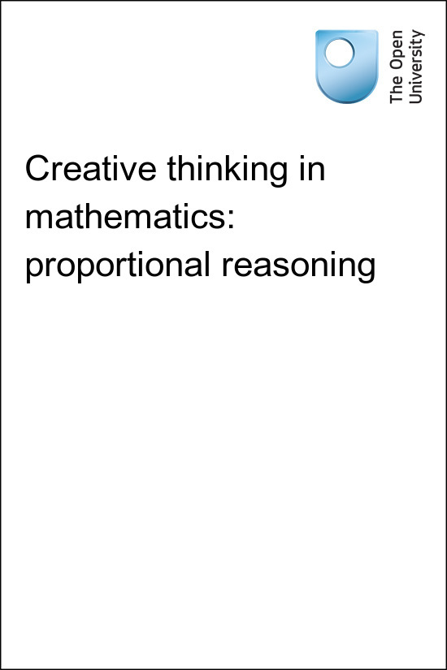

TI-AIE Teacher Education through School-based Support in India

TI-AIE
Creative thinking in mathematics: proportional reasoning
Copyright © 2016 The Open University
All rights reserved. No part of this publication may be reproduced, stored in a retrieval system, transmitted or utilised in any form or by any means, electronic, mechanical, photocopying, recording or otherwise, without written permission from the publisher.

Contents
- What this unit is about
- What you can learn in this unit
- 1 Common misconceptions about proportional reasoning
- 2 Creativity in learning mathematics
- 3 The role of playfulness in supporting creativity in mathematics
- 4 What happens if …?
- 5 Reflecting on possibility thinking
- 6 Summary
- Resources
  - Resource 1: NCF/NCFTE teaching requirements
- Additional resources
- References
- Acknowledgements

What this unit is about
Life without a sense of proportion is difficult to imagine – it is present in all actions of enlargement and reduction. It is used in the home when thinking about the ingredients for cooking for ten people instead of six. It is used in urban planning when thinking about building plans. It is used by policymakers when considering issues of taxation. It is even used by young children, perhaps implicitly, in working out how many sweets to get for several people or how to share a bag of marbles amongst friends.
Students therefore come to school with some intuitive understanding and knowledge of proportional reasoning, but they also come with misunderstandings and different levels of understanding.
This unit will explore ways to teach proportional reasoning, including inverse and direct proportion in a playful and creative way.

What you can learn in this unit
- How to help your students understand that proportional reasoning describes the multiplicative relationship between quantities.
- Some ideas to support your students to become more creative in their thinking about mathematics.
- Some suggestions on how to design activities that allow for possibility thinking.
This unit links to the teaching requirements of the NCF (2005) and NCFTE (2009) outlined in Resource 1.

1 Common misconceptions about proportional reasoning

Pause for thought
To start thinking about the presence of proportional reasoning in everyday life, make a note of all the situations you come across where you use proportional reasoning over the period of a day. For example: ‘I made a smaller amount of chapattis – about half of normal. I adjusted the amount of flour I needed to halve the quantity as well.’
You could ask your students to do the same and bring their examples to the next lesson.
The core idea in proportional reasoning is that it uses multiplication and division to compare quantities and to describe how these quantities relate to each other. So the width of one leaf can be four times as big as the width of another; the height of a picture one-third of another one, the age of a child one-and-a-half times that of another child, etc.
Researchers suggest that the main issue with learning about proportional reasoning is that students’ understanding of multiplication is often based on the repeated addition of integers, which is limiting when learning to engage in proportional reasoning (Watson et al., 2013). When students are comparing, for example, the age of Child A who is eight years old with another Child B who is 12 years old they can find it easier to compare by using the difference in age (four years) than by describing the relationship in a multiplicative way (Child B is therefore 1.5 times as old as Child A).
The teaching challenge is thus to provide students with an understanding of multiplicative reasoning that does not use repeated addition.

2 Creativity in learning mathematics
Creativity in learning is partly about allowing students to enjoy learning more and to think for themselves. Creative thinking in mathematics also importantly prepares students for their jobs in the future. In the future, jobs will rely less and less on doing things mechanistically, as this can be done by computers, and more on problem solving, and coming up with creative solutions.
It is not always easy to see how school mathematics and textbook practice can be turned into creative learning approaches. This unit aims to give some ideas for creative approaches. It builds on the perspective of creativity as ‘possibility thinking’. When you and your students can think of possibilities, or ‘what if’ scenarios, then this process will lead you to be creative in your thinking (Aristeidou, 2011).
Researchers have identified a list of teaching and learning features that are involved in possibility thinking in the classroom (Grainger et al., 2007; Craft et al., 2012). These features can be effectively addressed through the design of activities and by asking open questions and include:
- question posing and responding
- being imaginative
- play/playfulness
- risk taking.
The tasks in this unit work by developing learning activities that use these features.
Before attempting to use the activities in this unit with your students, it would be a good idea to complete all, or at least part, of the activities yourself. It would be even better if you could try them out with a colleague as that will help you when you reflect on the experience. Trying for yourself will mean you get insights into a learner’s experiences that can in turn influence your teaching and your experiences as a teacher. When you are ready, use the activities with your students and reflect again on how the activity went and the learning that happened. This will help you to develop a more learner-focused teaching environment.

Activity 1: Thinking about the physical effects of multiplication

Preparation
On the day before you have planned to conduct this activity, tell your students that they have to bring a thin dry stick of any length to the next lesson. It is important that they can break the stick easily.
This activity works best when the sticks are clearly of different lengths. If you feel that most students have sticks of approximately the same length, ask some of them to cut off a portion of their stick to shorten the length. Spare pieces could then be given to students who have not brought a stick.
At the start of the lesson, ask each student to hold the stick they have got in their hands and to raise their hands. If some students forgot to bring a stick, ask other students if they would be kind enough to share a part of their stick with these students.
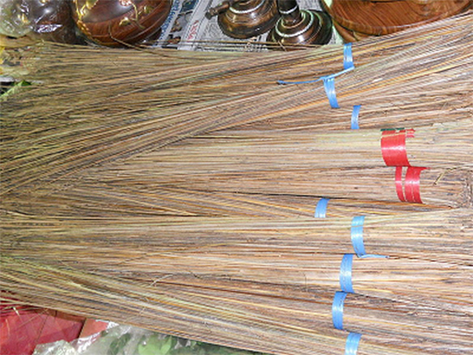
Figure 1 Coconut stick brooms. (Source: Fotokannan)

The activity
Put the students into pairs or small groups.
Ask your students to answer the following questions in their groups or pairs:
- Who has the shorter stick?
- What is the difference between the lengths of shorter and longer sticks?
- How many times does the smaller stick fit into the larger stick?
- In previous questions you compared the lengths of the shorter and longer sticks in two ways. What is the difference between these two ways of comparison?
Let some groups present their findings to the class to initiate a discussion, guided to students discovering the physical effects of multiplication.

Case Study 1: Mrs Rawool reflects on using Activity 1
This is the account of a teacher who tried Activity 1 with her elementary students.
The students loved the idea of bringing thin sticks and the majority of them did get them, but again as usual there were those who forgot. They were feeling bad so they welcomed the suggestion that they could get sticks from their classmates. I put the students in groups of four. I could organise that easily by just asking two students in each group to turn around and face the other two students.
Once all of them had the sticks and were seated in their groups, they did the comparison both ways as suggested in the activity. I also asked them to note down their observations so that they could contribute to the discussions that we would be having later.
Some of them had a problem, saying that they could find the difference easily but could not tell the multiplication bit very easily. But all of them tried, and the discussions were interesting. Some of them were very quiet and had to be coaxed into giving some input. Most of them were, as usual, worried about the fact that what they said might not make sense and then they would be laughed at. So I had to convince them that there was no problem in saying the wrong things because no one is an expert and that making mistakes would help them in their learning. I had not realised how hard it is for the students to feel confident to have a go and to take risks as they might get the answer wrong.
Mona, one of the students, remarked that they were estimating. They did not have any standardised measuring equipment such as rulers or tape measures to use which meant the measurements were not accurate in any way and so they were all just guessing. It seemed the students were more willing and confident in using their imaginations and coming up with their own ideas and answers afterwards. That made me think that perhaps if I want my students to take more risks in their learning of mathematics, I should give them more activities where there are no wrong answers, but many right answers.
Pause for thought
Mrs Rawool commented on how she had to work hard to convince some of her students that it was better to give a wrong answer than no answer at all, because making mistakes would help them in their learning. How do you feel about this approach? What strategies might Mrs Rawool adopt over the longer term to create an atmosphere in her classroom in which all students feel comfortable taking risks to help them in their learning?

Reflecting on your teaching practice
When you do such an exercise with your class, reflect afterwards on what went well and what went less well. Consider the questions that led to the students being interested and being able to progress, and those you needed to clarify. Such reflection always helps with finding a ‘script’ that helps you engage the students to find mathematics interesting and enjoyable. If they do not understand and cannot do something, they are less likely to become involved. Use this reflective exercise every time you undertake the activities, noting as Mrs Rawool did some quite small things that made a difference.
Pause for thought
Good questions to trigger such reflection are:
- How did it go with your class?
- What responses from students were unexpected? Why?
- What questions did you use to probe your students’ understanding?
- Did you feel you had to intervene at any point?
- What points did you feel you had to reinforce?
- Did you modify the task in any way? If so, what was your reasoning for this?

3 The role of playfulness in supporting creativity in mathematics
Playfulness is considered important to support creativity because in play you explore many possible solutions in a spontaneous way. The word playfulness is often associated with young children, but it should not be restricted to them. Play is about exploring and experimenting which anyone, at any age, can and should do. Simply watching children play can be a good reminder of children’s creativity.
In the process of exploring and experimenting it is important that students have choices – the choice to approach a problem in different ways, the option to make mistakes, the choice to come up with their own conjectures and test whether they are valid or not. In order to encourage students to adopt a playful way of thinking in the mathematics lesson it helps to use examples that are light-hearted, and even funny.
The next activity presents the students with an image of an extremely large shoe and asks them to imagine how big they would be if the shoe fitted them. By exploring possibilities, making their own choices about how to go about working out the mathematics and no doubt getting things wrong in the process, the students will develop their proportional reasoning skills.

Activity 2: Make it BIG

Preparation
This task works well for students working in pairs. However, make sure they also have some opportunity to work through the sums and do some thinking on their own. You may want to have a look at the key resource ‘Involving all’ to help you prepare for this activity.

The activity
Tell your students that Figure 2 shows the world's largest pair of shoes. The shoe is 5.29 metres (17.4 ft) long and 2.37 metres (7 ft 9 in) wide. It is said to be equivalent to a French shoe size of 753. The French shoe size of 34 is equivalent to the Indian shoe size of 6.
If your students have access to the internet, they could use a search engine to find more photographs and information about this pair of shoes. This might arouse their curiosity even further! If you have access to a printer, you could print out some larger photographs to share around the class or to help create an exciting wall display of the students’ work after the activity.
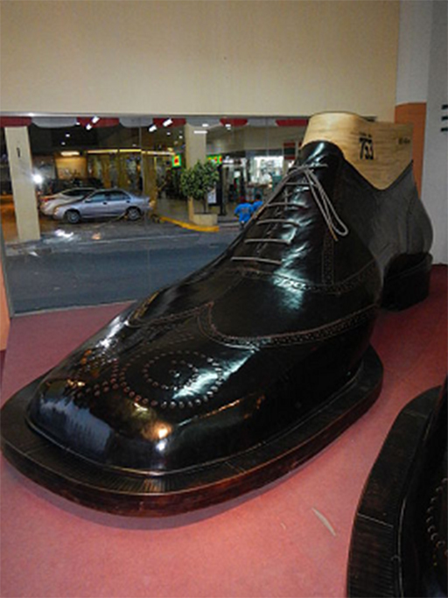
Figure 2 One of the world’s largest pair of shoes, on display in Marikina,
‘the shoe capital of the Philippines’, as certified by the Guinness
Book of World Records in 2002. (Source: Ramon F. Velasquez)
If this was your shoe, how tall would you be? Tell your students to talk about how they would solve the problem. After a few minutes, share ideas with the whole class and agree which ideas should be explained further.
Did all your students participate? If not, how can you encourage more participation next time?

Video: Involving all

Case Study 2: Mrs Mohanty reflects on using Activity 2
I did this activity with my Class VIII students. I thought it would be nice to start with an open discussion with the whole class so I decided to show them the picture and then passed it around the classroom so all the students could have a close look. They all laughed when they saw the shoe and I could feel they got curious about what this shoe was doing in their mathematics lesson!
I wrote down the measurements of the shoe on the blackboard and asked them the question: ‘If this was your shoe, what would be your height?’ Then Ranu shouted out (shouting out is normally not allowed in my lessons but I let him get away with it this time) with heartfelt emotion: ‘How on earth would they know what the height would be?’ Manisha raised her hand and then said that they could try by comparing their own shoe size and height.
Bharat wondered if that would always be true, as he argued that sometimes people with the same height have different shoe sizes. So he wanted to ask each student what their shoe size and height was. I thought that was a lovely idea but thought having my 86 students measuring their height and the length of their feet, and sharing that data there and then in the classroom, would result in chaos!
I shared this fear with the students and they came up with the suggestion to get some measuring sticks and rulers ready at lunchtime and then everyone could find out their measurements then and write them on the blackboard. Two students volunteered to oversee this happened in a good manner.
We continued with the activity after lunch. I asked them first to work in groups of four to see whether heights always matched the same feet length. Then work out individually what the proportional relationship was between their height and the length of their feet and to check with each other that they had done their calculations right. This way they would already get a lot of practice in working out proportions and ratios and they would get to know about different ways of working it out.
I then asked the whole class about that big shoe and the question ‘If this was your shoe, what would be your height?’ Different suggestions were made on how to work this out such as:
- comparing their own shoe size with the big shoe and then using that ratio to multiply their height
- using the ratio they had worked out earlier of feet length to their height and multiplying this with the big shoe length.
I told them they could use any of the suggested methods and it would be interesting to see whether different methods gave different results – in which case I wanted them to start thinking about why this would be, and discuss this with each other in their groups. Not many students thought about this in the end, but even so, I was pleased I asked the question because it might have planted a little seed for them to think about. We ended the lesson with a discussion about the various things in life that you could observe in nature that are in proportion and those that are not.
Pause for thought
- What responses from students were unexpected in your lesson? Why?
- What questions did you use to probe your students’ understanding?
- Did you modify the task in any way? If so, what was your reasoning for this?
Activity 2 used the question starting ‘If this …’ to trigger students to play, explore and investigate the proportional relation between shoe size or length of feet and the students’ height.
Having the choice of how to go about this – to work out a method themselves and make mistakes – together with the funny example of the huge shoe, enthused the students and encouraged them to engage with the task.

4 What happens if …?
Playfulness involves thinking about changes in situations – sometimes referred to as ‘what if …?’ thinking. This works very well with thinking about variables in mathematics: ‘What if I change this variable? What will happen to the other variables then?’ In this process of thinking of possibilities, the role of and proportional connection between variables and constants can also be discovered.
The next activity asks students to think about ‘What happens if I change …?’ They can get a sense of ownership and feeling valued for their thinking powers from coming up with their own conjectures. To increase that ownership further, students are asked to imagine they are doing the mathematics as part of setting up their own sweet shop.

Activity 3: Gulab jamuns and direct and inverse variations

Part 1: Planning to stock your sweet shop
Introduce your class to the following scenario.
Sant Sweets Shop prepares gulab jamuns that are spheres of diameter 1.5 inches. The cost of each gulab jamun is Rs. 12. In each 1 kg box, Sant Sweets can pack 24 gulab jamuns.
- Do you think all sweet shops in India prepare gulab jamuns with the same diameter of 1.5 inches?
- Do you think all sweet shops in India sell gulab jamun for Rs. 12?
Now, imagine you are opening a sweet shop and you are thinking of selling gulab jamuns (Figure 3), but you want to make yours a little bit different from Sant Sweets Shop.
- If you increase the diameter of the gulab jamun, do you expect the price of the gulab jamun to increase or decrease?
- If you increase the diameter of the gulab jamun, will the number of gulab jamuns that can be packed into one box increase or decrease?
- In business it is always important to foresee what will happen when you change something. Based on your responses so far, fill in a copy of Table 1 below. In the table plus (+) denotes increase in value and minus (–) indicates a decrease in value. For each row, you are given one variation. You have to find the other two.
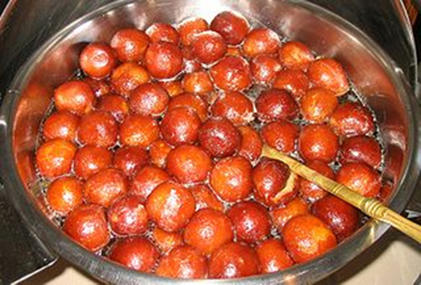
Figure 3 Making gulab jamuns.
This part of the activity is suitable for developing into a role play. For example, you might want to organise your class into groups, with each group making up a name for their sweet shop and assigning roles to group members. The key resource ‘Storytelling, songs, role play and drama’ will help you if you decide to use this approach.
Table 1 Planning to stock your sweet shop.
Size of gulab jamun | Price of gulab jamun | No. of gulab jamuns  in 1 kg box
 | +
 |  | +
+
–
 | –
 |  | –

Part 2: Exploring direct and inverse variation
- Ask each student, on their own or in pairs, to think of their sweet shop and to write as many pairs of quantities they can think of whose values are related to each other.
- Ask the students to classify each pair of quantities as:
  - Direct variation – if one quantity increases, the other does too.
  - Inverse variation – if one quantity increases, the other decreases.
  - No variation – a change in one of the quantities does not mean a change in the other quantity.

Part 3: Ending the lesson
In Case Study 3 below, Mrs Rawool ends this activity by giving descriptions of direct, indirect and no proportion, as well as some examples. How will you end your lesson and summarise the learning?
Video: Storytelling, songs, role play and drama

Case Study 3: Mrs Rawool reflects on using Activity 3
I thought this activity would be done better in groups, so that there could be a greater participation of each student. They had a great time discussing the different parts of the activity. I had also asked each group to keep a written note of their discussions. The level of noise was at a maximum, but the talk was mainly using mathematics terminology like: ‘As the price will include the cost of material, then obviously I will increase the price if I increase its radius’; ‘See if the box is of the same size. How can we put more in that box? Obviously the number will decrease’.
After they had filled in the table, I asked the most confident group to write their table on the blackboard and then I asked the others whether they agreed or not; if not, then I asked them to give their opinion on that statement. It worked very well and soon I had a lot of confident students saying why they felt that the quantities varied directly or why they varied inversely. More importantly, they could articulate what they meant by direct or inverse variation. I gave them the next part of the activity as homework so we could have the discussion the next day.
The next day I wrote the descriptions of direct, inverse and no proportional variation on the blackboard and I asked the students to discuss with their classmates the pairs of quantities of objects in ‘their’ shop that they thought related to each other. I asked them to think about: (a) was there a relationship; and (b) what kind of relationship was it: direct, inverse or none at all. In a whole-class discussion I then asked first for examples of quantities that were in direct proportion, then examples of inverse proportion, then examples where there was no proportional relationship. Lots of examples were given and although it did mean the descriptions were repeated over and over again, I am pretty sure they knew the difference by the end of the lesson!
Pause for thought
- What responses from students were unexpected? Why?
- What did their responses tell you about their understanding of direct and inverse proportion variation?
- How will you use this evaluation in your next lesson? Did you feel you had to intervene at any point?
- Did you modify the task in any way? If so, what was your reasoning for this?

5 Reflecting on possibility thinking
Think back about the features of possibility thinking that can be effectively addressed through designing activities and asking open questions. They are relisted here:
- question posing and responding
- being imaginative
- play and playfulness
- risk taking.
Pause for thought
- Which of these have your students displayed when working on the activities in this unit?
- Can you give examples of what they did that made you think they were engaged in doing these features?
- What was it in these activities that enabled possibility thinking?

6 Summary
In studying this unit you have thought about how to enable your students to develop proportional reasoning by using activities that stimulate creative possibility thinking.
Possibility thinking asks students to be creative, to try things out and to make their own decisions and therefore their own mistakes. Teachers sometimes think it is their job to prevent their students making mistakes; this unit demonstrates that it is the teacher’s job to allow the students to make mistakes and to learn from them. Asking the students to ‘play with ideas’ means that they exercise their creative side, try out lots of ideas and end up really knowing and understanding ideas.
Asking your students to be creative and playful and make choices for themselves also means that they are better prepared when asked about something in an unfamiliar context, as often happens in examinations. They know that if they think around an idea and try some things out, they can solve a problem that looks difficult to begin with, just as they have done before.
Pause for thought
Identify three techniques or strategies you have learned in this unit that you might use in your classroom, and two ideas that you want to explore further.

Resources

Resource 1: NCF/NCFTE teaching requirements
This unit links to the following teaching requirements of the NCF (2005) and NCFTE (2009) and will help you to meet those requirements:
- View students as active participants in their own learning and not as mere recipients of knowledge; how to encourage their capacity to construct knowledge; how to shift learning away from rote methods.
- View learning as a search for meaning out of personal experiences and knowledge generation as a continuously evolving process of reflective learning.
- Support students to learn to enjoy mathematics rather than fear it.

Additional resources
- A newly developed maths portal by the Karnataka government: http://karnatakaeducation.org.in/KOER/en/index.php/Portal:Mathematics
- National Centre for Excellence in the Teaching of Mathematics: https://www.ncetm.org.uk/
- National STEM Centre: http://www.nationalstemcentre.org.uk/
- National Numeracy: http://www.nationalnumeracy.org.uk/home/index.html
- BBC Bitesize: http://www.bbc.co.uk/bitesize/
- Khan Academy’s math section: https://www.khanacademy.org/math
- NRICH: http://nrich.maths.org/frontpage
- Art of Problem Solving’s resources page: http://www.artofproblemsolving.com/Resources/index.php
- Teachnology: http://www.teach-nology.com/worksheets/math/
- Math Playground’s logic games: http://www.mathplayground.com/logicgames.html
- Maths is Fun: http://www.mathsisfun.com/
- Coolmath4kids.com: http://www.coolmath4kids.com/
- National Council of Educational Research and Training’s textbooks for teaching mathematics and for teacher training of mathematics: http://www.ncert.nic.in/ncerts/textbook/textbook.htm
- AMT-01 Aspects of Teaching Primary School Mathematics, Block 1 (‘Aspects of Teaching Mathematics’), Block 2 (‘Numbers (I)’), Block 3 (‘Numbers (II)’): http://www.ignou4ublog.com/2013/06/ignou-amt-01-study-materialbooks.html
- LMT-01 Learning Mathematics, Block 1 (‘Approaches to Learning’) Block 2 (‘Encouraging Learning in the Classroom’), Block 4 (‘On Spatial Learning’), Block 6 (‘Thinking Mathematically’): http://www.ignou4ublog.com/2013/06/ignou-lmt-01-study-materialbooks.html
- Manual of Mathematics Teaching Aids for Primary Schools, published by NCERT: http://www.arvindguptatoys.com/arvindgupta/pks-primarymanual.pdf
- Learning Curve and At Right Angles, periodicals about mathematics and its teaching: http://azimpremjifoundation.org/Foundation_Publications
- Textbooks developed by the Eklavya Foundation with activity-based teaching mathematics at the primary level: http://www.eklavya.in/pdfs/Catalouge/Eklavya_Catalogue_2012.pdf
- Central Board of Secondary Education’s books and support material (also including List of Hands-on Activities in Mathematics for Classes III to VIII) – select ‘CBSE publications’, then ‘Books and support material’: http://cbse.nic.in/welcome.htm

References
Aristeidou, V. (2011) ‘Exploring the characteristics of students’ possibility thinking and teacher pedagogy in the drama game method in Cypriot primary education’, paper presented at ICSEI 2011 conference (online). Available from: http://www.icsei.net/icsei2011/Full%20Papers/0174.pdf (accessed 25 July 2014).
Bell, A. (1987) ‘Diagnostic teaching 3: provoking discussion’, Mathematics Teaching, vol. 118, pp. 21–3.
Bouvier, A. (1987) ‘The right to make mistakes’, For the Learning of Mathematics, vol. 7, no. 3, pp. 17–25.
Craft, A., Cremin, T., Burnard, P., Dragovic, T. and Chappell, K. (2012) ‘Possibility thinking: culminative [sic] studies of an evidence-based concept driving creativity?’, Education, 3–13: International Journal of Primary, Elementary and Early Years Education, pp. 1–19.
Grainger, T., Craft, A. and Burnard, P. (2007) ‘Examining possibility thinking in action in early years settings’, In: Imaginative Education Research Symposium, 12–15 July 2006, Vancouver, BC, Canada.
National Council for Teacher Education (2009) National Curriculum Framework for Teacher Education (online). New Delhi: NCTE. Available from: http://www.ncte-india.org/publicnotice/NCFTE_2010.pdf (accessed 24 March 2014).
National Council of Educational Research and Training (2005) National Curriculum Framework (NCF). New Delhi: NCERT.
National Council of Educational Research and Training (2012a) Mathematics Textbook for Class IX. New Delhi: NCERT.
National Council of Educational Research and Training (2012b) Mathematics Textbook for Class X. New Delhi: NCERT.
Watson, A., Jones, K. and Pratt, D. (2013) Key Ideas in Teaching Mathematics. Oxford: Oxford University Press.

Acknowledgements
Except for third party materials and otherwise stated below, this content is made available under a Creative Commons Attribution-ShareAlike licence (http://creativecommons.org/licenses/by-sa/3.0/). The material acknowledged below is Proprietary and used under licence for this project, and not subject to the Creative Commons Licence. This means that this material may only be used unadapted within the TESS-India project and not in any subsequent OER versions. This includes the use of the TESS-India, OU and UKAID logos.
Grateful acknowledgement is made to the following sources for permission to reproduce the material in this unit:
Figure 1: (c) Fotokannan, http://commons.wikimedia.org/wiki/File:Coconut_stick_broom_d.jpg made available under http://creativecommons.org/licenses/by-sa/3.0/deed.en.
Figure 2: © Ramon FVelasquez, http://commons.wikimedia.org/wiki/File:MarikinaRiverBankShoesjf9425_34.JPG made available under http://creativecommons.org/licenses/by-sa/3.0/deed.en.
Figure 3: http://commons.wikimedia.org/wiki/File:Gulab_Jamun.jpg, made available under http://creativecommons.org/licenses/by-sa/3.0/deed.en.
Every effort has been made to contact copyright owners. If any have been inadvertently overlooked the publishers will be pleased to make the necessary arrangements at the first opportunity.
Video (including video stills): thanks are extended to the teacher educators, headteachers, teachers and students across India who worked with The Open University in the productions.

