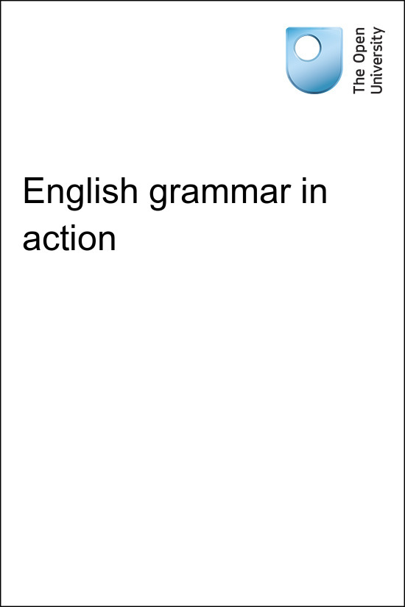

TI-AIE Teacher Education through School-based Support in India

TI-AIE
English grammar in action
Copyright © 2015 The Open University
All rights reserved. No part of this publication may be reproduced, stored in a retrieval system, transmitted or utilised in any form or by any means, electronic, mechanical, photocopying, recording or otherwise, without written permission from the publisher.

Contents
- What this unit is about
- What you can learn in this unit
- Why this approach is important
- 1 Different approaches to teaching grammar
- 2 Using the textbook to practise English grammar
- 3 Using other resources to practise English grammar
- 4 Summary
- Resources
  - Resource 1: Other approaches to teaching English grammar
  - Resource 2: Extract from a textbook
  - Resource 3: Develop your own English
  - Resource 4: Using local resources
  - Resource 5: Planning lessons
- Additional resources
- References
- Acknowledgements

What this unit is about
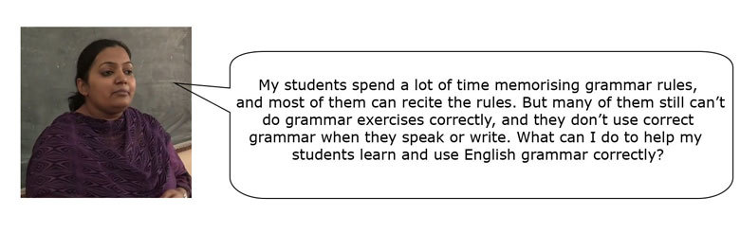
Your students may be able to recite grammar rules, but this does not necessarily mean that they are able to complete grammar exercises in the textbooks or exams. Being aware of grammar rules does not always mean that students can use language effectively when they speak or write. Memorising rules can be helpful when learning a language, but there are other techniques that you can use to help your students to understand English grammar and use it more effectively in their writing and speaking.
These techniques include:
- giving students activities that help them to notice how grammar is used in passages in their textbooks or in other texts
- helping students to guess grammar rules by looking at examples.
The purpose of these techniques is for students to do activities that allow them to notice patterns of English grammar and practise grammar through writing and speaking. Doing this will enhance your students’ ability to communicate in English (Lee and VanPatten, 2003).

What you can learn in this unit
- How to help students use grammar to communicate.
- How to use the textbook and other resources to teach English grammar.
- How to help students notice patterns in English language use and guess grammar rules.

Why this approach is important
Grammar is an integral part of a language. If you can help your students to improve their knowledge and use of English grammar, whatever their level, you will not only help them with their school studies and exams, you will help them to understand written and spoken English better. In real life, students do not usually carry a grammar book around to help them communicate their thoughts and feelings. Teaching grammar, therefore, includes preparing students to use grammar effectively in their daily lives.

1 Different approaches to teaching grammar
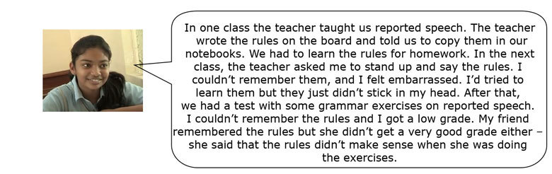

Pause for thought
If you can, discuss the following questions with a colleague.
- Do you have students in your classes who find it difficult to remember the grammar rules?
- Do you have students who remember the rules but still achieve only low grades?
Some students will not spend time or effort learning the grammar rules, but other students will be like the student above: they will try to learn the rules but will find it difficult to remember them Even if they can remember them, they still need time to think of and apply the rules.
A language cannot be learned through rules alone. Language learners need to use the language to become fluent, and not just learn about it. They need to see and hear lots of examples of language being used, in order to understand how it is used.
Now read about the experiences of a Class X student.
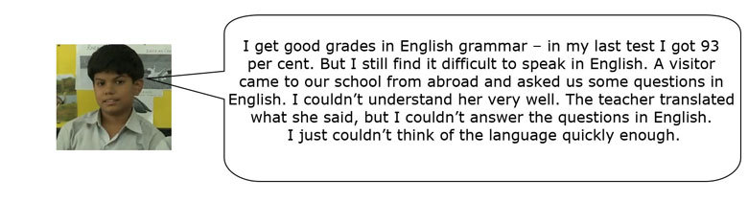
Pause for thought
If you can, discuss these questions with a colleague:
- Do you have students like this in your classes?
- Why do you think they have problems speaking in English, even though they may get good grades for grammar?
Some students may be able to do written grammar exercises very well, but that does not always mean that they are able to use it well when they are writing or speaking English. To use grammar effectively, students need to be able to practise it in different kinds of speaking and writing situations – not just grammar exercises or tests.

Activity 1: Approaches to teaching English grammar
There is no ‘right’ way to teach English grammar. However, if you vary your approach to teaching grammar, you will help more students to understand and use it, both in exams and in real-life situations. Using examples and having students guess grammar rules can help them learn and use the rules successfully. Seeing how the language works in context can have more impact than just memorising a grammar rule.
Here are three different ways to teach a grammar point. The examples here are about reported speech, which is commonly taught in secondary English textbooks, but you could use any grammar point:
- This approach focuses mostly on the grammar rule. Mrs Aparajeeta writes the grammar point on the board (‘Reported Speech’) and gives them the following rule:
  - ‘If the verb in the original sentence is in the present tense in direct speech, it shifts to past tense in reported speech.’
- After that, she tells students to do the exercises on reported speech in the textbook individually. She then asks them to memorise the rule for homework.
- This approach is more interactive, as the teachers asks students to come up with examples. Mr Kapur writes the grammar point on the board (‘Reported Speech’) and explains the rule (as above). As he explains, he writes some examples of changing direct speech to indirect speech on the board, as shown in Table 1.
Table 1 Examples of direct and reported speech.
 | Introduction | Direct speech | Reported speech
Example | Kemal said: | ‘I want a samosa.’ | Kemal said that he wanted a samosa.
Tense | Simple past | Simple present | Simple past
- Then he organises students into groups and asks them to write some sentences in direct speech. He asks groups to exchange their sentences and change them from direct speech to indirect speech.
- In this approach, the teacher gets the students to try to guess what the rule is from examples. Mrs Agarwal writes a sentence using reported speech on the board:
  - ‘Sachin Tendulkar said he had never tried to compare himself to anyone else.’
- She writes Sachin’s original sentence on the board:
  - ‘I have never tried to compare myself to anyone else.’
She then asks students to tell her the differences between the sentences. She does this with a few more examples, and asks students if they can say what the rules of reported speech are. Once the students say their ideas, the teacher explains the rules, and asks her students to practise with some other sentences.
Over the next few lessons, try each of these approaches with your classes. After each lesson, think about what your students learnt with each approach: which students have learnt the grammar point and which students need more help to become confident with the grammar point? How will you help these students? Can they help each other?
Then compare your experiences with Resource 1, which gives the benefits and challenges of each approach listed above.

Case Study 1: Mr Talwar’s different approach to teaching English grammar
Mr Talwar teaches English to Class IX in a government school. He explained reported speech to his students, and wrote the rules and some examples on the board. Most of his students could recite the rules and examples, but then they did not get very good grades in their exam.
I wondered how I could help my students understand reported speech better. I could see that memorising the rules wasn’t helping them to understand the grammar point, and it wasn’t helping them to use it. They needed to see more examples of the structure, and they needed more practice in using reported speech. I wrote examples of some direct speech on the board, including a variety of tenses. To make it more interesting and more relevant to the students’ lives, I made up some sentences about a famous person and wrote these on the board in direct speech.
- ‘I live in Mumbai with my wife and children.’
- ‘My mother always believed I would be an actor.’
- ‘I’ve just won an award.’
- ‘I’m going to star in a new film next month.’
On the other side of the board, I wrote ‘Shah Rukh Khan said:’.
I asked the class, ‘What would these sentences be in reported speech?’ I didn’t think that they would know, but one student raised her hand and she gave me the answer for the first sentence:
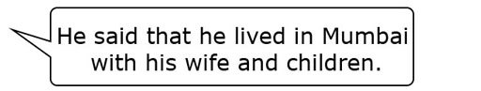
I praised her, and wrote the sentence on the board. I asked her: ‘How did you know the correct answer?’ She said she wasn’t sure. I asked about the other sentences, and sometimes students knew how to put them in reported speech and sometimes they didn’t. As we did the activity, I explained the rules of how to form indirect speech.
Once I explained the rules and students had seen several examples, I thought that students would need more practice. After all, only a few students had participated so far. So I organised my students into pairs, and told them to write down some sentences in direct speech. I told them that they should imagine that the sentences were spoken by a famous person. I asked for some examples from the room:
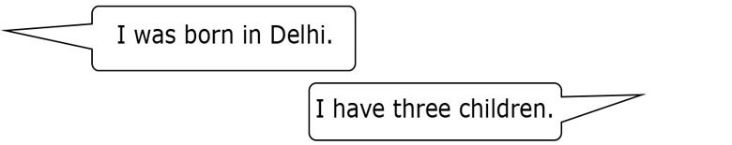
I gave the class five minutes to write some sentences in direct speech. As they wrote, I walked around the room and checked some of the pairs. I kept checking to make sure that all of the students were busy writing! After five minutes, I told the students to stop and to exchange their sentences with the pair next to them. Once each pair had another pair’s sentences, I asked them to turn the sentences – the direct speech – into indirect speech. Again, I gave the class a time limit of ten minutes to change the sentences into indirect speech.
It would be good to be able to spend more time doing these activities, but I already have so much to fit into the classes – I couldn’t spend too much time on this. Anyway, giving a time limit makes sure that the students stay focused.
As the class worked, I walked around again and tried to check as many sentences as I could. I could see that some of the students were having problems, so I showed those pairs how to make the sentences. Of course, it was impossible to check and help every pair, but at least they all had a chance to think about the grammar point. And I’ve realised that students need to have some time to think and try to use grammar structures. When the ten minutes were up, I asked some students to give some examples, which gave me a chance to see if they understood, and it gave the class an opportunity to discuss the rules again.

2 Using the textbook to practise English grammar
Grammar is not an isolated part of language. You can use the lessons in your textbook to help students understand how English is structured and to teach how the language is actually used.
Pause for thought
Read this extract of a lesson from NCERT Class X textbook, First Flight. As you read it, think about the following questions:
- What kinds of grammatical structures are regularly used in the passage?
- How could you use this passage to help students with English grammar?
Early in the New Year of 1956 I travelled to Southern Iraq. By then it had crossed my mind that I should like to keep an otter instead of a dog, and that Camusfeàrna, ringed by water a stone’s throw from its door, would be an eminently suitable spot for this experiment.
When I casually mentioned this to a friend, he casually replied that I had better get one in the Tigris marshes, for there they were as common as mosquitoes, and were often tamed by the Arabs. We were going to Basra to the Consulate-General to collect and answer our mail from Europe. At the Consulate-General we found that my friend’s mail had arrived but that mine had not.
I cabled to England, and when, three days later, nothing had happened, I tried to telephone. The call had to be booked twenty-four hours in advance. On the first day the line was out of order; on the second the exchange was closed for a religious holiday. On the third day there was another breakdown. My friend left, and I arranged to meet him in a week’s time. Five days later, my mail arrived. I carried it to my bedroom to read, and there, squatting on the floor, were two Arabs; beside them lay a sack that squirmed from time to time. They handed me a note from my friend: ‘Here is your otter…’
This extract has examples of several grammar points. Here are some, but you may have others to add to the list:
- past tenses (‘travelled’, ‘had crossed my mind’)
- reported speech (‘he casually replied that I had better’)
- passive voice (‘were often tamed’).
Passages such as these provide examples of how grammar is used, and you can point these out to your students. You can also ask your students to read the extract and look for – or underline – examples of a certain grammar task. For example, they could underline all the examples of the past simple tense. This is a good way to help students review grammar points that they have already learned, or should know at this level.

Case Study 2: Mr Banerjee reviews present tenses
Mr Banerjee was recently transferred to a government school in a rural district. He had previously taught in the capital city.
When I began teaching the students of Class IX, I was shocked to see how quiet students were during their lessons: they did not laugh at my jokes, or respond to my questions, or enjoy writing on the board. They seemed to be afraid that I would punish them for making grammatical mistakes in their speaking and writing. I realised that I would have to make my students relax in the class and develop the confidence to speak and write in English.
I looked for an appropriate lesson in the English textbook to illustrate this. Unit 3, of their English textbook (CBSE’s Interact in English), called ‘Environment’, had a description of the Indian rhinoceros [see Resource 2]. I felt this would be a good way of showing how the present simple tense is used to describe people or things.
Before I began, I divided the class into groups of five and asked them the following:
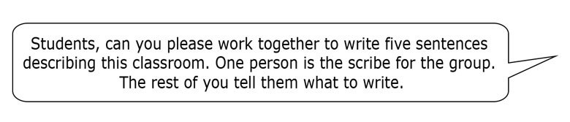
Two groups managed to write accurate descriptions in simple English, but most others wrote descriptions that were not grammatically correct. Some wrote sentences without the verb. Others used a mixture of tenses.
I then asked students to put their texts aside and told them we would come back to them.
I told students to open their book at Unit 3 and to read the passage on the Indian rhinoceros. While they were reading, I wrote sentences with verbs in the present simple tense and asked students to complete them with information from the passage:

After they completed the sentences, I drew their attention to the parts of the text that described the features of the rhino, and then to the verbs used in these sentences. I pointed out how the present simple tense is used to describe something that is true generally.
I then reminded them of subject/verb agreement rules for the present simple (‘It lives’ and ‘They live’; ‘It has’ and ‘Rhinos have’). At that point I felt that students had noticed how present simple is used in passages, and I had reminded them of the rules of forming it. I then wanted to see whether they could correct their own writing.
So I asked my students to look back at their own descriptions of the classroom and to see if they could make them better. I was pleased that the students were eager to edit and then read out their passages to the class. This time, the students structured their sentences far more accurately.

Activity 2: Using the textbook readings to teach grammar
This is an activity for you to do with your students.
In Case Study 2, the teacher used the textbook to help students notice how the present tense is used and to use it more accurately in their writing. The textbook is a useful resource for teaching and reviewing English grammar, especially if you don’t have a specific grammar book. Follow the steps below to use this technique in your classroom:
- Identify an area of grammar that you feel your students are having problems with (for example, using past tenses).
- Choose a lesson that has some examples of this grammar point.
- Organise students into pairs and ask them to find – or underline – examples of the grammar point in the lesson reading. Before they begin, do an example with the whole class so that everyone understands what they need to do. Set a time limit, e.g. three minutes.
- After several minutes, ask students to give you the examples, and write them on the blackboard. Try to ask students from different parts of the classroom to make sure everyone feels involved.
- For each example, ask students to explain why that grammar point is used. If students can’t explain, help them by asking more questions. Try not to give the explanation yourself.
- Ask questions about the form or spelling.
- To find out how much your students have understood, give them an error-correction exercise. Take a few more sentences from the lesson and copy them out onto the board, inserting a few mistakes.
Ask students to copy down the sentences and correct the mistakes in pairs. Give them a time limit for this and then review the corrections with the class.
Pause for thought
Here are some questions for you to think about after trying this activity. If possible, discuss these questions with a colleague.
- Were your students able to identify the examples in the lesson from the textbook? If not, how could you help them?
- What did this exercise tell you about your students’ skills? Which students found it difficult to correct the mistakes? How can you help them to correct their own mistakes?
You could help your students find examples by discussing the grammar point before they look, and giving them some examples. You could give them clues such as: ‘There is an example in the third paragraph.’ For examples of the language you could use in this kind of activity, see Resource 3.
If your students can’t identify their own mistakes, you could mark them so that students know where the mistakes are. Don’t tell them what the mistake is – just tell them what sentence it is in. Or you can ask questions about the mistake: for example, ‘The person here is “my mother”, so what form of the verb “have” do you need?’
When doing this kind of activity, make a note of which students seem to grasp the language easily, as well as ones who find it difficult. Some students may be ready to learn more, while others need more practice. If you notice that many of the students in your class need more practice, then you can do a grammar activity like this every day. If only one or two students seem to be struggling, you can work with them individually or assign them special homework so that they can improve over time.

3 Using other resources to practise English grammar
You can find examples of grammar structures that students need to learn in English textbooks. You can also find them in texts that you encounter in your daily life, such as newspapers, magazines, advertisements – even wedding invitations. There are many advantages of using real texts to illustrate a grammar point. They:
- help students understand that grammar is more than a set of rules to memorise
- prepare them to use such structures themselves in speech and writing
- encourage them to see grammar and English as being a relevant subject in their lives.
(See the unit Local resources for teaching English for further examples of everyday texts that you could use in your English classes, as well as Resource 4, ‘Using local resources’.)

Video: Using local resources

Case Study 3: Mrs Chakrakodi uses a food wrapper to review the imperative
Mrs Chakrakodi teaches English in a secondary school. Many of her students have problems with grammar structures that she thinks they should know by now. For instance, her students had problems using the imperative in a textbook exercise. She decided to try something which would help them to remember and use it.
I noticed that instant noodle packets carry quick and simple recipes that even teenagers can try at home. I decided to use recipes to teach my students the imperative.
One day I asked my Class IX students to bring empty instant noodle wrappers to the class. Before talking about making noodles, I started a conversation about what they could cook, and whether they knew how to make tea. We had a whole-class discussion and I elicited from them the steps to make tea, which I put on the board. There were sentences like ‘We boil water’, ‘I put in sugar’, ‘I put in milk’, ‘I add one spoon of milk power’, etc.
Amid a lot of laughter, we argued about whether to put sugar in the cup first, or tea leaves in the water itself, and I finally wrote the steps on the board, making a point to use imperative sentences (‘Pour a cup of water in a kettle and boil …’, ‘Add a spoonful of sugar …’). Without my students necessarily realising it, I was reviewing the use of the imperative and its structure. I pointed out that the first word of each sentence was a verb, and that these sentences give instructions.
With the students ready to use the structure, I divided them into groups and asked them to look at the recipes on the instant noodle wrappers that they had brought from home. Their task was to discuss all the recipes, and to make a new and more interesting one using tips from all of them, using the imperative.
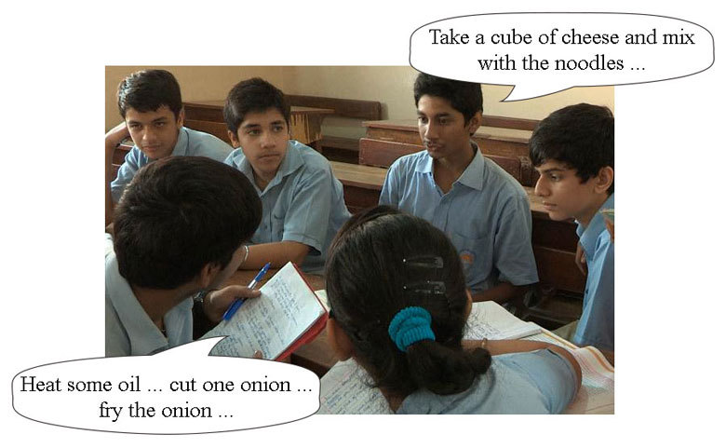
Figure 1 Students discuss the recipes on instant noodle wrappers.
As the students worked I walked around the groups, helping where necessary. After fifteen minutes, I started taking feedback. I asked a student from one of the groups to read out their recipe, which I wrote down on the board. We then discussed the recipe together, trying to add or change details where necessary. We also corrected any mistakes with the imperative.

Activity 3: Using other resources to practise English grammar
This is an activity for you to do with your students.
Here are some everyday objects and texts from real life that have English text. Consider how you could use them to teach grammar:
- An empty food wrapper (Figure 2).

Figure 2 An instant noodle wrapper.
- Newspaper headlines:
  - ‘World Cup: defending champions Spain defeated 5–0 by the Netherlands’
  - ‘Man caught with 6 gold bars in Goa airport
- Wedding invitations (Figure 3).

Figure 3 Two wedding invitations.
There are many ways that you could use these objects to teach grammar. Here are some suggestions, although you may have more ideas that you could share with your colleagues:
- Food packets sometimes have recipes on them. You could use these recipes to teach or review the language of instructions, for example the imperative (‘Heat some oil…’). Students could write recipes using the imperative. The packets could lead to a discussion of how instant noodles are made, or about students' opinions on the best way to cook instant noodles (with cheese, egg, tuna, etc.…)
- The headlines use the passive voice. The full sentences would be ‘The defending champions Spain were defeated 5–0 by the Netherlands’ and ‘A man has been/was caught with six gold bars in Goa airport’. Students could write headlines about local events using the passive voice, or transfer them into the active voice.
- The invitations in Figure 3 highlight the passive and active voice. You could also use them to review adverbs (‘cordially’) or prepositions (‘on Sunday’; ‘at Hotel Park Continental’).
What objects can you collect to teach and review English grammar to your classes? You could even take photos of any examples of English that you see used around you. See Resource 5, ‘Planning lessons’, for more on this.
Plan a lesson to teach and review a grammar point using one of these ideas and resources from food packets, adverts, newspapers or magazines.
Video: Planning lessons
Pause for thought
Here are some questions for you to think about after trying this activity. If possible, discuss these questions with a colleague.
- Do you think that this activity helped your students to remember the grammar point, and to use it more accurately?
- If so, why? If not, why not?
Using resources besides the textbook can make a change for students. Using resources like instant noodle packages can help students notice how English is used around them and how they might use the language for their own purposes.

4 Summary
In this unit you explored teaching techniques that help your students to move away from memorising grammar rules to noticing how grammar is used in order to use language correctly in their speech and writing. These techniques include giving your students activities that help them to notice how grammar is used in passages in their textbooks or in other texts, and helping students to guess grammar rules by looking at examples. These techniques will help you support your students in learning to use English for communicative purposes and can be used regularly with your students.
If you would like to practise and improve your own grammar, see Resource 3. If you would like to read more about integrating grammar into your lessons and students discovering the rules, look at the additional resources.

Resources

Resource 1: Other approaches to teaching English grammar
Table R1.1 Other approaches to teaching English grammar.
Teacher | Benefits | Problems
A | It’s quick. Students practise with an exercise  Can be effective with lower levels | Memorising rules has some problems: some students can’t remember; and it can be difficult to apply the rules  Students don’t get a lot of practice (one exercise); what about the students who don’t understand?
B | Students see more examples of the grammar point, and get more practice than the approach of Teacher A  In groups, students can help each other (especially if someone didn’t understand the explanation)  When students write their own sentences, they remember them more | It takes longer than the approach of Teacher A  Students might write incorrect sentences  Some students in a group might do all of the work, and others may not work  The sentences are all different so the teacher can’t check all of the work
C | Students see several examples; they work the rules out for themselves – this helps them to remember more | Can be difficult for students who are not used to it; takes more time than the approaches of Teachers A and B

Resource 2: Extract from a textbook
This prehistoric-looking rhinoceros has thick, silver-brown skin which becomes pinkish near the large skin folds that cover its body. The male develops thick neckfolds. It has very little body hair aside from eyelashes, ear-fringes and tail-brush. These rhinos live in tall grasslands and riverine forests, but due to habitat loss they have been forced into more cultivated land. They are mostly solitary creatures, with the exception of mothers and calves and breeding pairs, although they sometimes congregate at bathing areas. The Indian rhinoceros makes a wide variety of vocalizations. At least ten distinct vocalizations have been identified: snorting, honking, bleating, roaring, squeakpanting, moo-grunting, shrieking, groaning, rumbling and humphing. In addition to noises, the rhino uses olfactory communication.

Resource 3: Develop your own English
Here is some language you could use in your classroom when teaching grammar:
- This sentence is in direct speech. Can you tell me how to put it in reported speech?
- Yes, that’s a good start. Can anyone help?
- OK, very good. Now let’s look at the next example. Can another student tell me how to put this sentence in reported speech?
- Can you find an example of the past tense in this passage?
- There is an example of simple past in the third paragraph.
- The person in this sentence is ‘my mother’. What form of the verb ‘have’ do you need’ to use in this sentence?
- We use past tense when we are writing about something that happened at a specific time in the past. It is finished now.
- Which letters do we usually add to a verb to talk about the past?
- Why does the word ‘replied’ have the letter ‘i’ in it?
- ‘We was going to Basra.’ Is that correct?
Here are some tips for developing your own knowledge and use of grammar:
- Identify the mistakes you often make, or the grammar points that you want to improve. Make a plan of how and when you are going to work on these points.
- Obtain or arrange access to a grammar reference book (or find an online resource). Refer to it whenever you have a question about grammar.
- Read as much as possible in English and pay close attention to the grammar. This is also very useful for developing your vocabulary.
- Discuss grammar points with colleagues.
- Try grammar practice exercises, either in a grammar book or online. See below for some useful links.
Here are some links to websites where you can learn about and practise grammar:
- English grammar: http://learnenglish.britishcouncil.org/en/english-grammar
- Quick grammar reference: http://learnenglish.britishcouncil.org/en/quick-grammar
- Grammar exercises: http://learnenglish.britishcouncil.org/en/grammar-exercises
- The internet grammar of English: http://www.ucl.ac.uk/internet-grammar/
- Grammar, vocabulary and pronunciation: http://www.bbc.co.uk/worldservice/learningenglish/language/

Resource 4: Using local resources
Many learning resources can be used in teaching – not just textbooks. If you offer ways to learn that use different senses (visual, auditory, touch, smell, taste), you will appeal to the different ways that students learn. There are resources all around you that you might use in your classroom, and that could support your students’ learning. Any school can generate its own learning resources at little or no cost. By sourcing these materials locally, connections are made between the curriculum and your students’ lives.
You will find people in your immediate environment who have expertise in a wide range of topics; you will also find a range of natural resources. This can help you to create links with the local community, demonstrate its value, stimulate students to see the richness and diversity of their environment, and perhaps most importantly work towards a holistic approach to student learning – that is, learning inside and outside the school.

Making the most of your classroom
People work hard at making their homes as attractive as possible. It is worth thinking about the environment that you expect your students to learn in. Anything you can do to make your classroom and school an attractive place to learn will have a positive impact on your students. There is plenty that you can do to make your classroom interesting and attractive for students – for example, you can:
- make posters from old magazines and brochures
- bring in objects and artefacts related to the current topic
- display your students’ work
- change the classroom displays to keep students curious and prompt new learning.

Using local experts in your classroom
If you are doing work on money or quantities in mathematics, you could invite market traders or dressmakers into the classroom to come to explain how they use maths in their work. Alternatively, if you are exploring patterns and shapes in art, you could invite maindi [wedding henna] designers to the school to explain the different shapes, designs, traditions and techniques. Inviting guests works best when the link with educational aims is clear to everyone and there are shared expectations of timing.
You may also have experts within the school community (such as the cook or the caretaker) who can be shadowed or interviewed by students related to their learning; for example, to find out about quantities used in cooking, or how weather conditions impact on the school grounds and buildings.

Using the outside environment
Outside your classroom there is a whole range of resources that you can use in your lessons. You could collect (or ask your class to collect) objects such as leaves, spiders, plants, insects, rocks or wood. Bringing these resources in can lead to interesting classroom displays that can be referred to in lessons. They can provide objects for discussion or experimentation such as an activity in classification, or living or not-living objects. There are also resources such as bus timetables or advertisements that might be readily available and relevant to your local community – these can be turned into learning resources by setting tasks to identify words, compare qualities or calculate journey times.
Objects from outside can be brought into the classroom – but the outside can also be an extension of your classroom. There is usually more room to move outside and for all students to see more easily. When you take your class outside to learn, they can do activities such as:
- estimating and measuring distances
- demonstrating that every point on a circle is the same distance from the central point
- recording the length of shadows at different times of the day
- reading signs and instructions
- conducting interviews and surveys
- locating solar panels
- monitoring crop growth and rainfall.
Outside, their learning is based on realities and their own experiences, and may be more transferable to other contexts.
If your work outside involves leaving the school premises, before you go you need to obtain the school leader’s permission, plan timings, check for safety and make rules clear to the students. You and your students should be clear about what is to be learnt before you depart.

Adapting resources
You may want to adapt existing resources to make them more appropriate to your students. These changes may be small but could make a big difference, especially if you are trying to make the learning relevant to all the students in the class. You might, for example, change place and people names if they relate to another state, or change the gender of a person in a song, or introduce a child with a disability into a story. In this way you can make the resources more inclusive and appropriate to your class and their learning.
Work with your colleagues to be resourceful: you will have a range of skills between you to generate and adapt resources. One colleague might have skills in music, another in puppet making or organising outdoor science. You can share the resources you use in your classroom with your colleagues to help you all generate a rich learning environment in all areas of your school.

Resource 5: Planning lessons

Why planning and preparing are important
Good lessons have to be planned. Planning helps to make your lessons clear and well-timed, meaning that students can be active and interested. Effective planning also includes some in-built flexibility so that teachers can respond to what they find out about their students’ learning as they teach. Working on a plan for a series of lessons involves knowing the students and their prior learning, what it means to progress through the curriculum, and finding the best resources and activities to help students learn.
Planning is a continual process to help you prepare both individual lessons as well as series of lessons, each one building on the last. The stages of lesson planning are:
- being clear about what your students need in order to make progress
- deciding how you are going to teach in a way that students will understand and how to maintain flexibility to respond to what you find
- looking back on how well the lesson went and what your students have learnt in order to plan for the future.

Planning a series of lessons
When you are following a curriculum, the first part of planning is working out how best to break up subjects and topics in the curriculum into sections or chunks. You need to consider the time available as well as ways for students to make progress and build up skills and knowledge gradually. Your experience or discussions with colleagues may tell you that one topic will take up four lessons, but another topic will only take two. You may be aware that you will want to return to that learning in different ways and at different times in future lessons, when other topics are covered or the subject is extended.
In all lesson plans you will need to be clear about:
- what you want the students to learn
- how you will introduce that learning
- what students will have to do and why.
You will want to make learning active and interesting so that students feel comfortable and curious. Consider what the students will be asked to do across the series of lessons so that you build in variety and interest, but also flexibility. Plan how you can check your students’ understanding as they progress through the series of lessons. Be prepared to be flexible if some areas take longer or are grasped quickly.

Preparing individual lessons
After you have planned the series of lessons, each individual lesson will have to be planned based on the progress that students have made up to that point. You know what the students should have learnt or should be able to do at the end of the series of lessons, but you may have needed to re-cap something unexpected or move on more quickly. Therefore each individual lesson must be planned so that all your students make progress and feel successful and included.
Within the lesson plan you should make sure that there is enough time for each of the activities and that any resources are ready, such as those for practical work or active groupwork. As part of planning materials for large classes you may need to plan different questions and activities for different groups.
When you are teaching new topics, you may need to make time to practise and talk through the ideas with other teachers so that you are confident.
Think of preparing your lessons in three parts. These parts are discussed below.

1 The introduction
At the start of a lesson, explain to the students what they will learn and do, so that everyone knows what is expected of them. Get the students interested in what they are about to learn by allowing them to share what they know already.

2 The main part of the lesson
Outline the content based on what students already know. You may decide to use local resources, new information or active methods including groupwork or problem solving. Identify the resources to use and the way that you will make use of your classroom space. Using a variety of activities, resources, and timings is an important part of lesson planning. If you use various methods and activities, you will reach more students, because they will learn in different ways.

3 The end of the lesson to check on learning
Always allow time (either during or at the end of the lesson) to find out how much progress has been made. Checking does not always mean a test. Usually it will be quick and on the spot – such as planned questions or observing students presenting what they have learnt – but you must plan to be flexible and to make changes according to what you find out from the students’ responses.
A good way to end the lesson can be to return to the goals at the start and allowing time for the students to tell each other and you about their progress with that learning. Listening to the students will make sure you know what to plan for the next lesson.

Reviewing lessons
Look back over each lesson and keep a record of what you did, what your students learnt, what resources were used and how well it went so that you can make improvements or adjustments to your plans for subsequent lessons. For example, you may decide to:
- change or vary the activities
- prepare a range of open and closed questions
- have a follow-up session with students who need extra support.
Think about what you could have planned or done even better to help students learn.
Your lesson plans will inevitably change as you go through each lesson, because you cannot predict everything that will happen. Good planning will mean that you know what learning you want to happen and therefore you will be ready to respond flexibly to what you find out about your students’ actual learning.

Additional resources
Here are some links to articles and tips about teaching grammar:
- Exploiting texts: http://www.onestopenglish.com/grammar/grammar-teaching/exploiting-texts/
- The discovery technique: http://www.onestopenglish.com/grammar/grammar-teaching/the-discovery-technique/
- Grammar reference: http://www.onestopenglish.com/grammar/grammar-reference/
- Grammar teaching: http://www.onestopenglish.com/grammar/grammar-teaching/
- What matters in grammar teaching: http://www.teachingenglish.org.uk/article/what-matters-grammar-teaching
- Teaching grammar inductively: http://www.teachingenglish.org.uk/article/teaching-grammar-inductively-catherine-walter
- ‘Communicative grammar’: http://orelt.col.org/module/6-communicative-grammar

References
Lee, J.F. and VanPatten, B. (2003) Making Communicative Language Teaching Happen, 2nd edn. Boston, MA: McGraw-Hill.

Acknowledgements
Except for third party materials and otherwise stated below, this content is made available under a Creative Commons Attribution-ShareAlike licence (http://creativecommons.org/licenses/by-sa/3.0/). The material acknowledged below is Proprietary and used under licence for this project, and not subject to the Creative Commons Licence. This means that this material may only be used unadapted within the TESS-India project and not in any subsequent OER versions. This includes the use of the TESS-India, OU and UKAID logos.
Grateful acknowledgement is made to the following sources for permission to reproduce the material in this unit:
Figure 2: https://www.nissinfoods.com/.
Every effort has been made to contact copyright owners. If any have been inadvertently overlooked the publishers will be pleased to make the necessary arrangements at the first opportunity.
Video (including video stills): thanks are extended to the teacher educators, headteachers, teachers and students across India who worked with The Open University in the productions.

