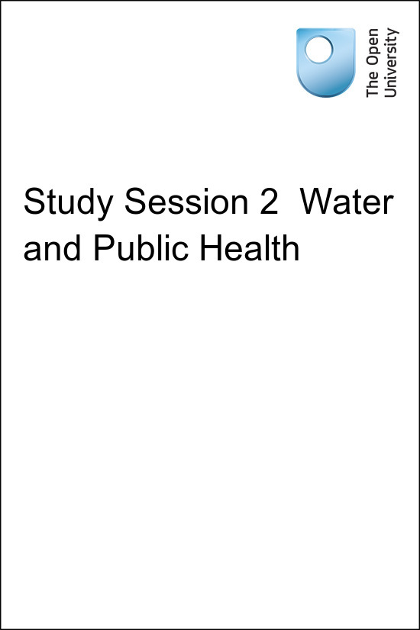

UrbanWS_1.0 OpenWASH

Study Session 2 Water and Public Health
Copyright © 2016 The Open University
All rights reserved. No part of this publication may be reproduced, stored in a retrieval system, transmitted or utilised in any form or by any means, electronic, mechanical, photocopying, recording or otherwise, without written permission from the publisher.

Contents
- Introduction
- Learning Outcomes for Study Session 2
- 2.1 Water for human consumption
  - 2.1.1 Importance of water for human health
- 2.2 Diseases associated with water
  - 2.2.1 Waterborne diseases
  - 2.2.2 Water-washed diseases
  - 2.2.3 Water-based diseases
  - 2.2.4 Water-related diseases
- 2.3 Common diseases associated with water in Ethiopia
  - 2.3.1 Diarrhoeal diseases
  - 2.3.2 Malaria
  - 2.3.3 Parasitic worm infections
  - 2.3.4 Trachoma
  - 2.3.5 Amoebic dysentery
- 2.4 Water quality assessment
  - 2.4.1 Microbiological tests
  - 2.4.2 Chemical tests
  - 2.4.3 Physical tests
- Summary of Study Session 2
- Self-Assessment Questions (SAQs) for Study Session 2

Introduction
In Study Session 1 you read about the need for an adequate, safe and accessible water supply. If there is an insufficient quantity of water, or if the water is contaminated, this can have serious effects on people’s health and can be the cause of many different illnesses – even death. This, of course, impacts on the economic well-being of the community. In this study session you will look more closely at what is meant by safe and unsafe water, and you will learn why water is important for human health. You will consider the various classifications of diseases associated with water and examine the situation in Ethiopia in relation to these diseases.

Learning Outcomes for Study Session 2
When you have studied this session, you should be able to:
2.1 Define and use correctly all of the key words printed in bold. (SAQ 2.1)
2.2 List the ways in which water is used in the human body. (SAQ 2.2)
2.3 Understand the different ways in which water is involved in the transmission of human diseases. (SAQs 2.3 and 2.4)
2.4 Describe the situation in Ethiopia in relation to diseases from unsafe water. (SAQ 2.4)
2.5 Briefly outline the tests that are carried out in water quality assessment. (SAQ 2.5)

2.1 Water for human consumption
Water for human consumption must be palatable and safe. Palatable water is pleasant to drink, meaning it is completely clear and free from tastes, odours and colours. Safe drinking water, also known as potable water, is defined as water that does not contain harmful or potentially harmful substances and does not present any risk to human health. Harmful substances can be in the form of micro-organisms or chemicals. Unsafe water is a cause of bad health for people of all age groups. There are, however, some groups of people who are at greater risk. These include infants and young children, older people and people who are debilitated by diseases (such as HIV/AIDS).

2.1.1 Importance of water for human health
Water makes up about 70% of an adult human being’s weight. In the human body, blood contains about 82% water and our brain is made up of about 95% water. Losing just 2% of our water content can result in signs of dehydration, fuzzy short-term memory and difficulty in focusing on smaller print or words displayed on a computer screen.
Water has several roles in relation to human health:
- Water plays an important part in keeping us and our environment clean. It is essential for good personal hygiene. We use water to wash our hands and bodies, and also to wash places in our homes that could possibly harbour harmful micro-organisms (such as toilets).
- Many of our foods are prepared with water and others naturally contain large amounts of water (e.g. milk is made up of approximately 88% water; eggs 66%; fish 80%; potatoes 75%; and beef 77%).
- Inside the body, water serves as a lubricant during digestion of our food. Water in saliva facilitates chewing and swallowing, and the food goes down into the stomach with the help of water. The functions of all the body’s cells and organs depend on water.
- Water is involved in transporting valuable nutrients around the body in the bloodstream. Nutrients are broken down in the digestive system and transported to where they are needed in the body.
- Water is used by the body to remove harmful toxins and wastes through urination and perspiration. Water also helps to reduce constipation. Drinking enough water helps body organs such as the kidneys and the liver to get rid of waste products.
- Water helps to regulate body temperature. The body controls over-heating through perspiration. When sweat evaporates from the surface of the skin, it takes heat from the body and produces a cooling effect.

2.2 Diseases associated with water
The majority of water-related health problems are caused by infectious agents that can invade the body and cause disease. They include pathogenic (disease-causing) bacteria, viruses, protozoa and parasites. Infectious agents can cause disease when they are ingested (eaten or swallowed) or otherwise come into contact with the human body. The different ways in which water is involved in this contact can be used to classify the diseases into four main groups: waterborne, water-washed, water-based and water-related diseases.

2.2.1 Waterborne diseases
Waterborne diseases are caused by people ingesting water contaminated by human or animal faeces containing pathogens. Such diseases can also be caused by food that has been prepared using water contaminated with pathogens. The diseases are caused only when the infectious agent enters the body. Waterborne diseases include most of the enteric (related to the intestine) and diarrhoeal diseases caused by bacteria and viruses. Bacteria are unicellular organisms (made of one cell) and are very small, ranging from 0.5 to 5.0 micrometres (µm) in size. When seen under a microscope, they have different shapes, such as spheres, rods, or spirals. Viruses are microscopic infectious particles, much smaller than bacteria, that can only reproduce when inside the living cells of organisms. Waterborne diseases also include some caused by protozoa (single-celled micro-organisms that are much larger than bacteria, usually between 10 and 50 µm) and helminths. Helminths is a general term for worms, usually applied to those that are parasites on humans and other animals. Table 2.1 shows examples of waterborne diseases and their causes.
Table 2.1 Examples of waterborne diseases.
Category of infectious agent | Disease | Infectious agent
Bacterial | Cholera | Vibrio cholerae
Bacterial | Bacterial dysentery | Campylobacter jejuni
Bacterial | (Acute) gastroenteritis | Various
Bacterial | Shigellosis | Shigella species
Bacterial | Typhoid fever | Salmonella typhi
Viral | Viral gastroenteritis | Rotavirus and others
Viral | Viral hepatitis | Hepatitis A and E viruses
Viral | Poliomyelitis | Polio virus
Protozoal | Amoebic dysentery | Entamoeba histolytica
Protozoal | Cryptosporidiosis | Cryptosporidium
Protozoal | Giardiasis | Giardia lamblia
Helminths | Ascariasis (roundworm) | Ascaris lumbricoides
Helminths | Dracunculiasis (Guinea worm) | Dracunculus medinensis
Helminths | Trichuriasis (whipworm) | Trichuris trichiura
Although drinking contaminated water is a very significant route of transmission for many of the diseases listed above, they may also be transmitted by other means such as by eating contaminated food. Food can become contaminated by poor hygiene during preparation. Flies are also important transmitters of contamination from faeces to food. There are other possible routes of transmission, including through droplets and aerosols, if these are ingested. We use our fingers for eating and frequently put our hands to our mouths; touching contaminated surfaces can also be a route for disease transmission.
- How could poor personal hygiene by people preparing food cause disease?
- If cooks do not thoroughly wash their hands before touching food, they could easily transfer contamination by infectious agents. When the contaminated food is eaten, this could transmit disease to the consumers.
In all these cases, the origin of the contamination is faeces of people who are already infected by the disease. Some diseases may be transmitted via the faeces of infected animals. In places without adequate sanitation and where people defecate in the open, waterborne disease is far more likely to occur. By sanitation, we mean the prevention of human contact with wastes. If faeces are effectively separated from people then the transmission routes of waterborne diseases are cut off.

2.2.2 Water-washed diseases
Water-washed diseases are those that occur as a result of inadequate quantities of water being available for good personal hygiene. Good personal hygiene habits include:
- washing hands with soap, or using an alternative such as ash, after using the latrine
- washing hands before preparing and/or eating food
- washing the body frequently
- cleaning the teeth at least once a day
- washing the hair with soap or shampoo at least once a week.
Figure 2.1 shows the steps in a thorough technique for handwashing.
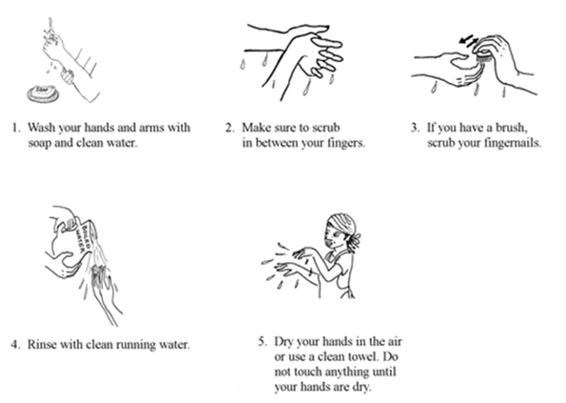
Figure 2.1 Handwashing technique.
Water-washed diseases are sometimes called ‘water-scarce’ diseases because they are a problem if water supply is limited. They include fungal skin diseases such as ringworm, ophthalmic diseases (diseases of the eye) such as trachoma and conjunctivitis, and infections caused or carried by lice, mites, fleas or ticks. Two examples of these diseases are scabies (caused by mites) and louse-borne epidemic typhus (caused by Rickettsia prowazekii bacteria and transmitted largely by body lice).
- Adequate quantities of clean water can prevent such diseases affecting a population. Why do you think this is so?
- Because if plenty of water is available, people are able to wash frequently and the disease-causing organisms will be washed away.

2.2.3 Water-based diseases
Water-based diseases are caused by parasites that spend part of their life cycle in water. Water-based diseases such as bilharzia (also known as schistosomiasis – this will be described in Section 2.3.3), and dracunculiasis are caused by helminths. Dracunculiasis, or Guinea worm disease, is transmitted by drinking water that is contaminated with copepods that contain the larvae of the Guinea worm (Figure 2.2). Copepods are very small crustaceans, sometimes known as water fleas, that are found in the sea and in fresh water. The Guinea worm larvae get into the water by emerging through the skin of an infected person while they are washing or bathing. To prevent dracunculiasis infection, effective water treatment is needed. A global campaign to eradicate Guinea worm has made great progress in reducing the incidence of the disease and it is now found in only a few countries in the world. Ethiopia is one of them, but the disease is now rare; only three cases were reported during 2014 (WHO, 2015). (Note that transmission of dracunculiasis requires drinking of contaminated water and it can, therefore, be classified as both a waterborne and a water-based disease.)
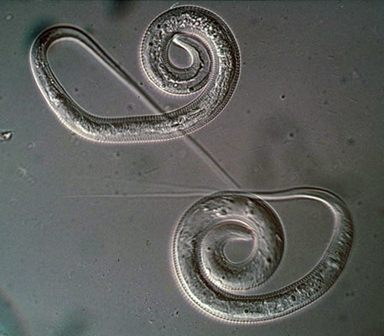
Figure 2.2 Guinea worm: the parasite that causes the disease dracunculiasis. The worm is 1–2 mm wide and can grow up to 100 cm long.

2.2.4 Water-related diseases
Water-related diseases are transmitted by insects that breed or feed in or near water bodies. The best-known example is malaria, which is spread by the Anopheles mosquito (this disease will be described in Section 2.3.2). Water-related diseases are not associated with lack of access to clean drinking water or to hygiene and sanitation services. The significant factor is the presence of standing water, which provides a habitat for the insects to breed. Other water-related diseases include onchocerciasis (spread by blackfly), dengue fever and yellow fever (both spread by mosquitoes).

2.3 Common diseases associated with water in Ethiopia
The government of Ethiopia is taking steps to improve the quality of water supply in urban areas of the country, but many people suffer from communicable diseases associated with water. Data from Harari Region are used here as an example. Table 2.2 shows the diseases that were most prevalent in Harari Region in 2013/2014.
Table 2.2 The prevalence of diseases associated with water in Harari Region in 2013/2014. (Harari Regional Health Bureau, 2014)
Disease | Number of people affected
Diarrhoeal diseases (e.g. rotavirus infection, cholera) | 6345
Malaria | 3861
Infection by intestinal parasites | 462
Trachoma | 432
Amoebic dysentery | 365
The sections that follow describe these diseases in more detail.

2.3.1 Diarrhoeal diseases
Diarrhoea is a symptom of many waterborne diseases and is the cause of 11% of deaths among children aged under 5 across the world, with a reported total of 2195 deaths each day (Liu et al., 2012). The global major causes of death in children under 5 are shown in Figure 2.3.
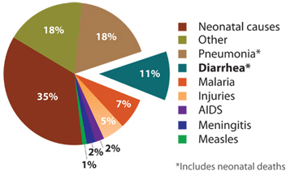
Figure 2.3 Diarrhoea kills more children under 5 years of age across the world than malaria, measles and AIDS combined. (Liu et al., 2012)
Worldwide, 88% of diarrhoeal disease is attributable to unsafe water, poor hygiene and inadequate sanitation. In Ethiopia, 15% of all deaths are from diarrhoea, with the highest death rate among young children (World Life Expectancy, n.d.). Children, especially those under 5 years of age, are vulnerable to infection because they frequently put their unwashed fingers in their mouths.
One important example of a diarrhoeal disease is cholera. Cholera is an acute bacterial infection of the intestinal tract that produces watery diarrhoea. It is caused by the bacterium Vibrio cholerae (Figure 2.4) and causes severe loss of body fluids through diarrhoea, with the stool looking like rice-water. Without treatment, the disease can quickly lead to acute dehydration and death. Cholera is a worldwide problem, common in areas that lack basic sanitation. It can also be a problem in emergency situations (as you will learn in Study Session 14). It can be prevented by the provision of safe drinking water, effective sanitation and good hygiene behaviour, including food hygiene.
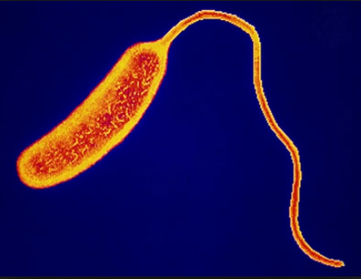
Figure 2.4 Vibrio cholerae (0.5–0.8 µm wide, and 1.4–2.6 µm long).

2.3.2 Malaria
Malaria is a parasitic disease transmitted by the female Anopheles mosquito and caused by the pathogenic protozoa Plasmodium. When a mosquito bites an infected individual it sucks up blood containing the parasite. If it then bites a healthy person, the protozoa is transferred into their blood and they can become ill. The mosquitoes breed in standing water such as swamps, lakes, pools and open channels dug for crop irrigation; even a puddle can provide enough water for mosquitoes to breed. Only the female mosquitoes take human blood, which is needed to develop their eggs. The most likely time for mosquitoes to bite is in the early evening or at night.
- Can you think of ways to avoid being bitten by mosquitoes?
- Wearing long-sleeved clothing and using insect repellents helps to keep people from being bitten. At night, mosquito nets (preferably impregnated with permethrin, which is toxic to mosquitoes) or various sprays or vapours can be used to keep them away.

2.3.3 Parasitic worm infections
People become infected with intestinal parasitic worms (helminths) through water or food that has been contaminated with faecal matter from an infected person. Infection occurs when these parasites get into the intestinal tract of a new host. Even though there are numerous parasites that infect humans, those most common in Ethiopia are the roundworms that cause ascariasis (Figure 2.5) and trichuriasis (Figure 2.6). Both of these diseases are spread through ingestion of contaminated food and water, and also poor hygiene behaviour. Children are more likely to be affected because their immune systems are not fully developed; they constitute important reservoirs of the infections.
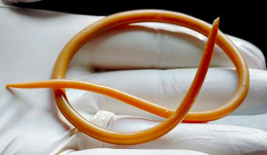
Figure 2.5 Ascaris lumbricoides roundworm: these intestinal parasites can be very large – up to 35 cm long.
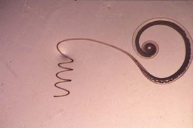
Figure 2.6 Trichuris trichiura roundworm: these parasites can reach 4 cm in length.
Schistosomiasis, also known as bilharzia, was mentioned earlier in this study session. It is also a disease caused by parasitic worms but in this case they do not get into the body from ingesting contaminated water or food. This is a water-based, not a waterborne disease. The Schistosoma parasitic worm enters the body by penetrating through the skin. It has a complicated life cycle and spends part of its life in a human body and part in a particular species of water snail, as shown in Figure 2.7.
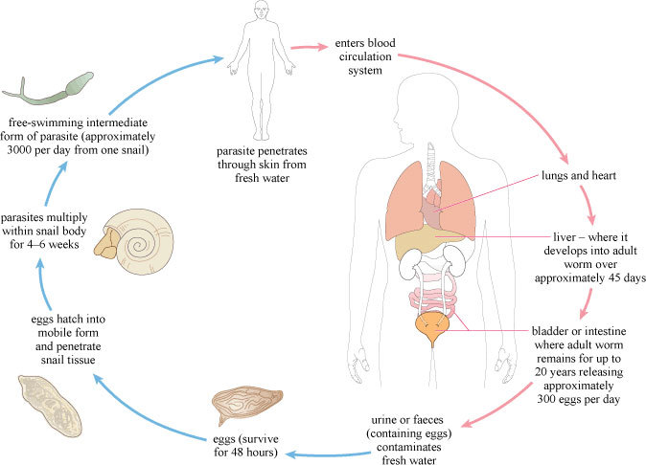
Figure 2.7 Life cycle of the Schistosoma parasite.
The eggs of the worm are released into water bodies through the urine or faeces of an infected person and they then infect the snails, the intermediate host. Snails are more often found in slow-flowing or standing water where water plants are growing, rather than in rapidly flowing water. If the environmental conditions are not suitable for the snails, they will not survive and the disease cycle can be broken. In preventing water-based diseases like schistosomiasis, it is important to focus interventions on still waters of lakes and ponds and water channels used for irrigation, where vegetation is growing.

2.3.4 Trachoma
Trachoma is a bacterial eye infection that is made worse by poor hygiene due to lack of adequate water for washing. Repeated infections can lead to blindness if left untreated. Trachoma affects women and children more than adult men (WHO, 2002). It spreads easily from child to child or from child to mother, either directly by hand contact or indirectly on clothing, or by flies that land on the face of an infected child. A 2007 study found that 40% of Ethiopian children in the age group 1–9 years were suffering from active trachoma infection (Berhane et al., 2007). Good personal hygiene and encouraging children to wash their faces can significantly reduce incidence of the disease.

2.3.5 Amoebic dysentery
Amoebic dysentery, also called amoebiasis, is a disease caused by the protozoa Entamoeba histolytica (Figure 2.8). It is acquired by ingesting infectious cysts (a dormant form of the organism that helps it survive in unfavourable environments) through water or food items that are contaminated.
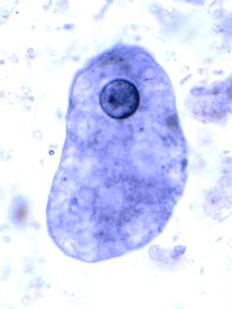
Figure 2.8 Entamoeba histolytica, up to 60 µm in size.

2.4 Water quality assessment
Many analytical methods are used to test for the presence and concentration of possible contaminants in water. Concentration is the measure of the quantity of a substance dissolved in a known volume of water. For water quality assessment, the units used are usually milligrams per litre, which is written as mg/l, or mg l^{–1}.

2.4.1 Microbiological tests
As you have been reading, there are many different types of pathogenic micro-organisms that may be present in water but it would be very difficult and time-consuming to test for all of them. The source of the pathogens is usually human faeces; therefore, tests have been devised that detect the presence of faecal contamination. If faecal contamination is found, this indicates that pathogenic organisms may be present. The most widely used tests for faecal contamination are for total coliforms, faecal coliforms and Escherichia coli (E. coli). Coliforms are a group of bacteria found in human and animal faeces and also in soil. ‘Total coliforms’ includes all bacteria in this group. The presence of ‘total coliforms’ indicates contamination of some sort but, because of their relatively wide distribution, they cannot be used to confirm if the contamination is from faeces. Faecal coliforms are a sub-set of total coliforms and, as the name suggests, are typically found in faeces. E. coli is a type of faecal coliform bacterium that is commonly found in the faeces of humans and other warm-blooded animals. If E. coli is present in a water sample this indicates faecal pollution and the possible presence of pathogenic organisms; the absence of E. coli from a sample shows that the chances of faecal contamination of the water, and therefore of pathogens being present, are negligible. Thus the presence of E. coli in a water sample provides an important indicator of pollution. An indicator in this context is a biological species that tells us something about the environment.
It is important to realise that E. coli is only an indicator and its absence cannot give complete assurance that the water is safe. Some pathogens – such as Giardia, Entamoeba histolytica and some viruses – can survive in waters long after E. coli has died; therefore, the absence of E. coli will not necessarily mean that water is totally free from other organisms.

2.4.2 Chemical tests
Although the great majority of health-related water quality problems are the result of biological contamination, chemical contamination of water sources can also cause serious health problems.
Fluoride in low concentrations (less than 1.5 mg l^{–1}) in drinking water has beneficial effects on teeth, but exposure to excessive fluoride can give rise to a number of adverse effects (WHO, 2004). Fluorosis (an abnormal condition caused by excessive intake of fluorides) is a common problem in children living in the Rift Valley region of Ethiopia where the level of fluoride, especially in groundwater, can be high. Levels of fluoride above 1.5 mg l^{–1} can lead to mottling of children’s teeth (the appearance of spots or blotches of different shades of colour – Figure 2.9). Higher levels can lead to severe skeletal fluorosis, where fluoride accumulates in the bones over many years causing stiffness and pain in the joints and bones (WHO, 2004). Consuming water that has levels in excess of 10 mg l^{–1} leads to crippling skeletal fluorosis where the extremities become weak and moving the joints is difficult. The vertebrae partially fuse together, crippling the patient (WHO, 2004).
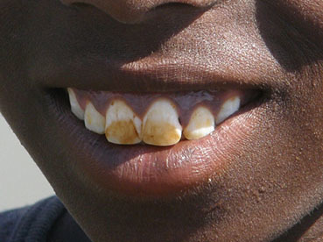
Figure 2.9 Fluorosis causes mottling of children’s teeth.
Alternatively, some health effects occur as a result of specific chemical deficiencies in the diet, of which water forms a part. Examples include goitre, caused by iodine deficiency, and dental caries resulting from low fluoride intake.

2.4.3 Physical tests
Turbidity (cloudiness due to a large number of very tiny particles), colour, taste and odour (smell), whether of natural or other origin, affect people’s perceptions of water. As you know water should be free of tastes and odours that would be unpleasant to the majority of people. In extreme cases, people may avoid water that does not look or taste good – even if it is otherwise safe – in favour of more pleasant-looking and tasting water that may actually be contaminated.
Colour in drinking water occurs due to the presence of dissolved organic matter and metals such as iron and manganese. Colour can come from industrial pollution such as from dyes used in textile manufacture. Odour in water is due mainly to the presence of organic substances. Taste is the combined perception of substances detected by the senses of taste and smell. Changes in the normal taste of a piped water supply can be important as they may signal changes in the quality of the raw water source or deficiencies in the treatment process.

Summary of Study Session 2
In Study Session 2, you have learned that:
- Water is essential to life. People can live for many days without food but for very few days without water.
- Water for public consumption must be palatable and safe.
- Unsafe water can seriously harm human health. Infants, young children, older people and people debilitated by disease are the most vulnerable.
- Water in the human body is essential for several bodily functions.
- The diseases associated with water can be classified as waterborne, water-washed, water-based and water-related.
- The causative agents of disease in unsafe water include bacteria, viruses, protozoa and helminths (worms).
- The main illnesses in Ethiopia include diarrhoeal diseases and malaria.
- Detection of faecal coliform bacteria including E. coli is used to test for the presence of faecal contamination and to indicate the likelihood of the presence of pathogenic organisms in drinking water.
- Chemical contamination of water can cause health problems.
- Turbidity, colour, taste and odour are important factors in water being acceptable to people.

Self-Assessment Questions (SAQs) for Study Session 2
Now that you have completed this study session, you can assess how well you have achieved its Learning Outcomes by answering these questions.

SAQ 2.1 (tests Learning Outcome 2.1)
Match the following words to their correct definitions.
the prevention of human contact with waste
another way of saying ‘safe drinking water’
the total number of coliform bacteria (which come from faecal matter and other sources)
water that does not have any components that can harm people
the amount of a substance in a given volume of water
worms that live as parasites in humans and animals
an abnormal condition that results from an excess of fluoride in the body
water that is pleasant to drink
diseases transmitted by insects that breed or feed in or near water
single-celled organisms ranging in size from 0.5 to 5.0 µm
micro-organisms and viruses that can invade the human body and cause disease
cloudiness caused by a large number of tiny particles in a liquid
coliform bacteria that originate from faeces
diseases caused by parasites that spend part of their life cycle in water
concerned with the intestine
a biological species that gives information about the environment
diseases that are caused through the ingestion of water contaminated by human or animal faeces containing pathogens
single-celled micro-organisms that are much larger than bacteria
diseases that occur due to inadequate water being available for good personal hygiene
small infectious particles that are much smaller than bacteria
waterborne diseases
water-washed diseases
water-related diseases
water-based diseases
viruses
turbidity
total coliforms
sanitation
safe drinking water
protozoa
potable water
palatable water
infectious agents
indicator
helminths
fluorosis
faecal coliforms
enteric
concentration
bacteria

SAQ 2.2 (tests Learning Outcome 2.2)
- Briefly describe the important roles that water plays in the human body.
- List the types of people who are most vulnerable to waterborne diseases.
View answer - SAQ 2.2 (tests Learning Outcome 2.2)

SAQ 2.3 (tests Learning Outcome 2.3)
For which of the following diseases will the construction and appropriate utilisation of latrines (instead of open defecation) reduce transmission? Give reasons for your choice.
- amoebiasis
- dracunculiasis
- schistosomiasis
- malaria
- giardiasis.
View answer - SAQ 2.3 (tests Learning Outcome 2.3)

SAQ 2.4 (tests Learning Outcomes 2.3 and 2.4)
Read Case Study 2.1 and answer the questions that follow.

Case Study 2.1
Abebe is a 25-year-old man originally from Zegie, Lake Tana. He lives on the outskirts of the city of Bahir Dar in a single room together with his two friends. He is a daily labourer. In the compound of the house where they live, there is no space to construct a latrine. Thus, all the people in the compound defecate in the open area nearby.
Because of the long journey home from Bahir Dar to Zegie, he seldom visits his family. The family grows and sells coffee and khat for their living. Abebe’s family does not have a latrine either and uses an open field. During a recent visit to his family, he swam in Lake Tana and washed his clothes there. Upon returning to Bahir Dar, Abebe became sick, having severe abdominal pain, diarrhoea, joint pain, headache, and fever. The next morning, his friends took him to the nearest health centre and he got some medication.
- What is the most important public health issue you see in this case study?
- What specific water-associated diseases do you expect Abebe might have?
- What do you think are the causes of these problems?
View answer - Untitled SAQ

SAQ 2.5 (tests Learning Outcome 2.5)
Which of the following statements is false? In each case explain why it is incorrect.
- E. coli is a type of virus found in faeces.
- Faecal coliforms are typically found in human and animal faeces.
- The presence of E. coli in a water sample means the water is safe to drink.
- The absence of E. coli in a water sample means the water is safe to drink.
View answer - SAQ 2.5 (tests Learning Outcome 2.5)

SAQ 2.2 (tests Learning Outcome 2.2)

Answer
- Water plays the following roles in the human body:
  - aids swallowing and digestion of the food that we eat
  - is used to remove toxins and waste products from the body
  - transports nutrients to where they are needed in the body
  - helps to maintain the body at the right temperature.
- The people who are most vulnerable to waterborne diseases are:
  - infants
  - young children
  - older people
  - people who are weak due to suffering from other diseases.
Back

SAQ 2.3 (tests Learning Outcome 2.3)

Answer
a. amoebiasis, c. schistosomiasis and e. giardiasis can be transmitted through faecal matter from infected persons entering water sources, hence the construction and use of latrines would help to reduce their transmission.
b. dracunculiasis is caused by consuming water that contains copepods and is not related to human faecal contamination; d. malaria is transmitted by the Anopheles mosquito, which breeds in stagnant water. Latrines would not have any impact on these two diseases.
Back

Untitled SAQ

Answer
- The issue of open defecation is the most important public health issue as this leads to disease.
- Abebe may have caught a waterborne disease (e.g. diarrhoeal disease such as cholera or typhoid), a water-based disease (e.g. bilharzia), or a water-related disease (e.g. malaria).
- Open defecation may have contaminated the water in Lake Tana, making anyone using the water vulnerable to disease. The lake could also be a breeding ground for mosquitoes that cause malaria, or snails that carry bilharzia.
Back

SAQ 2.5 (tests Learning Outcome 2.5)

Answer
A is false. E. coli is a type of bacterium, not a type of virus.
C is false. If a water sample is positive for E. coli this indicates faecal contamination, which means it is likely that pathogens are present in the water.
D is also false. The absence of E. coli indicates the water is not contaminated with bacteria of faecal origin but it does not mean the water is necessarily safe to drink because it may still contain pathogens.
Back

