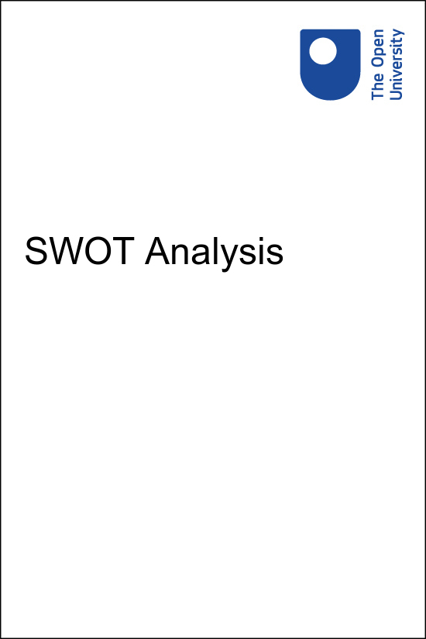

DIY-Learn-SWOT-analysis-tool DIYLearn

SWOT Analysis

Copyright © 2016 The Open University
All rights reserved. No part of this publication may be reproduced, stored in a retrieval system, transmitted or utilised in any form or by any means, electronic, mechanical, photocopying, recording or otherwise, without written permission from the publisher.

Contents
- SWOT Analysis
- 1 When to use a SWOT analysis
- 2 Exploring the environment of a project
- 3 The four components of SWOT analysis
  - 3.1 Strengths and weaknesses
  - 3.2 Opportunities and threats
- 4 Completing the SWOT analysis
- 5 Using the SWOT analysis for decision making
  - 5.1 SWOT analysis: a case study
- Summary
- Self Assessment Questions
- End of Module Quiz
- References and acknowledgements
- Solutions

SWOT Analysis
This module will support your understanding and use of the SWOT Analysis Tool from the DIY Toolkit. You should look at the SWOT Analysis Template before working through the module. You will find it helpful to have a print out of the SWOT Analysis Template which can be found on page 17 of the DIY Toolkit with you while you work through this module.

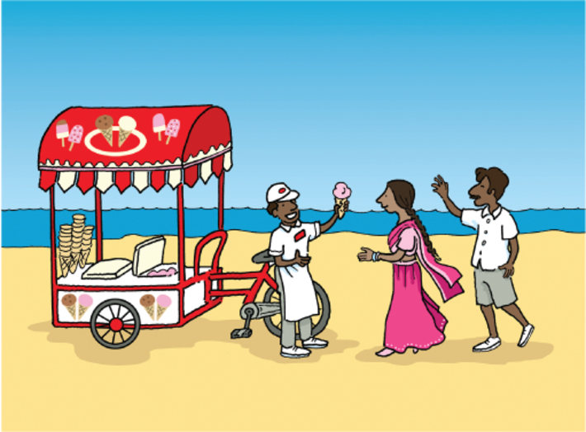
Understanding your strengths can put you in the right place at the right time
View alternative description - Understanding your strengths can put you in the right place at the right time

Knowledge of the internal strengths and weaknesses, along with the opportunities and threats – SWOT – facing a business, project or programme can paint a broad picture of its current status. This proactive analysis leads to a richer understanding and avoids relying on habit or instinct, helping leaders and managers to make informed decisions about the actions available to them.
Conducting a SWOT analysis can be useful for lots of contexts, including:
- problem solving
- planning
- competitor evaluation
- personal-development planning
- strategic decision making, such as entering a new sector or launching a new product
- a potential partnership
- an investment opportunity
- outsourcing a service, activity or resource
- staff-development planning
- developing contingency plans.
This module explains how to use SWOT analysis as a tool. As with many of the DIY tools, it is a subjective activity that would probably be completed quite differently by two people working on the same issue for the same organisation. Asking colleagues and partners to help with a SWOT analysis will always give a richer result than working in isolation.

Learning outcomes
After studying this module, you should be able to:
- describe what a SWOT analysis is and where you would use it (SAQ 1)
- explain the terms strength, weakness, opportunity and threat in the context of a SWOT analysis (SAQs 2 and 3)
- distinguish between the internal and external issues in a project and its environment using a SWOT analysis (SAQ 2)
- conduct and interpret a simple SWOT analysis (SAQ 3)

1 When to use a SWOT analysis
SWOT analyses are popular because of their ease of use and flexibility in highlighting where project or business ideas are strong and/or vulnerable, and where there are opportunities to explore.
The SWOT Analysis Tool helps you to analyse and explore your position through both internal and external lenses. While it could be applied at any stage of a planning process, it is most suitable at the start, or at a significant point of review. This is because it is important to assess and understand the current situation before committing to a sensible and sustainable course of action.
A SWOT analysis can be performed on a project, service or product, a sector, an organisation or even on an individual in the form of personal development planning. When done properly, a SWOT analysis will give you a clear picture of the most important factors that can influence the survival and sustainability of your activity.
For convenience – to save you reading sentences like ‘the strengths of your service/product/project/sector/activity’ – within this module we will use ‘project’ as a general term to cover all the activities to which a SWOT analysis might be applied.

Activity 1
Allow around 5 minutes for this activity

Which one of the three statements below is correct?

Statement 1: A SWOT analysis is a complex long-term planning tool for understanding the external environment of a project.
Statement 2: A SWOT analysis is a method of conducting a general and quick examination of a project’s current position, which will inform the actions to be taken to reach a favourable future position.
Statement 3: A SWOT analysis is a process that focuses on identifying where a project or programme is vulnerable.
View answer - Activity 1
View discussion - Activity 1

2 Exploring the environment of a project
Every project or development activity operates within a context of internal and external influences.
Most interactions with a project or development activity take place within the internal environment. Internal factors are generally within your control, and can be altered to suit the needs/influences coming from the external environment.
Factors in the external environment around a project are generally outside of your direct control.

Activity 2
Allow around 10 minutes for this activity

Below is a list of factors that could affect a project. Imagine this is your own project and, for each factor, indicate whether you think it is internal (something you can control or manage), or if it is more likely to be external (something outside of your influence).

a. Society, culture and politics

Internal
External
View answer - Part

b. Pricing

Internal
External
View answer - Part

c. Knowledge (of team members)

Internal
External
View answer - Part

d. Competitor activity

Internal
External
View answer - Part

e. Value for money

Internal
External
View answer - Part

f. Economic climate

Internal
External
View answer - Part

g. Legislation

Internal
External
View answer - Part

h. Product quality

Internal
External
View answer - Part

i. Technology

Internal
External
View answer - Part

j. People and skills (team members)

Internal
External
View answer - Part

k. Reputation

Internal
External
View answer - Part
View discussion - Part

3 The four components of SWOT analysis
So far, we’ve established that SWOT stands for:
- Strengths
- Weaknesses
- Opportunities
- Threats
These components could be described as providing different perspectives through which to explore an issue. We’ll now look at each of these in more detail.

3.1 Strengths and weaknesses
Strengths and weaknesses refer to factors in the internal environment of the project.

Table 1 Strengths
Such as | Example | Typical questions
Competences and skills | Outstanding expertise in basic healthcare training | What do you do better than anyone else?  What makes you unique?  What unique or lowest-cost resources can you draw upon that others can’t?  What do people in your market see as your strengths?  What makes you agile and/or flexible?
Resources | Highly skilled and motivated workforce
Attributes | Good brand image and reputation
Knowledge | Established community network with excellent understanding of local context
Data | Facts and figures about customers/beneficiaries and their behaviour or preferences

Table 2 Weaknesses
Such as lack of | Typical questions
Competences and skills  Resources  Attributes  Knowledge  Data | What could you update or improve?  What should you avoid?  What are things that users/clients/beneficiaries/partners might see as weaknesses or cause for complaint?  What critical resources can’t you provide – do you have sufficient cash flow?  Are the timescales achievable?

3.2 Opportunities and threats
Opportunities and threats refer to factors in the external environment around the project.

Table 3 Opportunities
Such as | Example | Typical questions
Changes in technology | Increasing availability of internet access | Do people have a need?  Do people prefer something else?  Are there any new technologies?  Are there changes in government policy?  What tools or routes can you use to engage with your target audience?  Who could you partner with?  What events can you align your message with?
Changes in government policy or regulation | New rules that give you greater freedom in an environment
Local and global events | World AIDS day as a global focus for activities and resources
New products and/or services | A new local supplier of a product that was previously difficult to access
Use of marketing or promotion | A local radio station that might be persuaded to run community-service advertising
Social or population structures | A strong local women’s group that could help provide support access to vulnerable individuals
Lifestyle fluctuations | Increasing rates of non-communicable disease (NCD)*.
* This is a deliberate example to illustrate that something negative can be an opportunity in certain contexts – if you provide healthcare training, then this unfortunate trend could be an opportunity to develop much-needed new training materials on NCD.

Table 4 Threats
Such as negative impact of | Typical questions
Changes in technology  Changes in government policy or regulation  Local and global events  New products and/or services  Use of marketing or promotion  Social or population structures  Lifestyle fluctuations | This section has been left deliberately blank. See Activity 3, below.

Key point
It is important that the four components of the SWOT analysis are considered together and not in isolation. This is because a factor can be both a threat or an opportunity, depending on the context and how you are able to respond to it

Activity 3
Allow around 15 minutes for this activity

What do you think some of the typical questions might be when considering the threats to a project from its external environment? Try and think of at least five threats and note them down in the text box below.

1.
2.
3.
4.
5.
View discussion - Activity 3

4 Completing the SWOT analysis
Now that you understand the sections in the SWOT Analysis Template, it’s time to go ahead and complete it! It is important to have a clear objective for developing your SWOT analysis, and its content will vary significantly according to the question(s) you want to answer. Use the tips below to help you construct an effective SWOT analysis.
- Do not overestimate the strengths or underestimate the weaknesses of your project. Be realistic in your analysis.
- Be prepared with all the relevant facts and figures.
- Get input from other people.
- Focus on the current situation and what you know rather than what you want the project to become.
- Prioritise facts over opinions.
- Only include information that is relevant to your decision making.
- Use your competitors or similar organisations in your sector as a benchmark to assess your internal factors against.
- Keep your SWOT analysis short and simple – avoid unnecessary complexities.
- Use no more than ten factors for each section.

5 Using the SWOT analysis for decision making
The act of completing your SWOT analysis template may bring some revelations in itself, but you’ll also need to work with the completed tool to get the most value from the whole SWOT analysis process.
Consider the obvious natural priorities:
- Are you doing everything you can to make the most of your strengths?
- What ‘quick wins’ can you implement straight away?
- Within your weaknesses, what could you start or stop doing straight away that would make a positive change?
- Are there any weakness so urgent that you need to remedy them before considering any other actions?
Consider how your strengths align with the opportunities:
- Are there any surprises that you need to explore in more detail?
- How are you going to prioritise the right opportunities for you, for example, ‘quick wins’ or long-term gain?
- What are the opportunities that don’t involve your weaknesses?
Consider how your weaknesses align with the threats:
- Does this highlight any vulnerabilities you weren’t aware of?
- Can anything be turned into an opportunity, for example, is it time to stop pursuing something you’re not very good at and focus resources elsewhere?
- Will your colleagues agree with this analysis or are they in denial about the weaknesses and threats?
Consider any other potential matches:
- Are any threats balanced by opportunities, for example, as one supplier closes is another opening?
Reflect on the overall message of your SWOT analysis. It should give you a deeper understanding of an issue that can then contribute to your decision-making process. Sometimes it will raise more questions than it answers, and you might need to go around the loop several times to deal with what is raised before you can focus on the original issue.
Depending on the context in which you are working, it can sometimes be helpful to return to a SWOT analysis after a break and compare the situation then and now according to the actions you have taken.

5.1 SWOT analysis: a case study
Read through the case study and SWOT Analysis Template, then try to complete the activity below.

Case study 1: Syed’s business opportunity
Syed runs his own enterprise in an area on the outskirts of Dhaka, Bangladesh. He manages a collective of people with disabilities who make Bangladeshi puppets in a traditional style, mainly selling to tourists through local shops, and pays them a basic salary as well as a profit share. The puppets are all made to Syed’s own designs, and are quite different to the standard items in most tourist stores. His quirky designs and their popularity with shoppers have come to the attention of Muhammad, who runs a relatively large factory producing puppets and other tourist-friendly wares. Muhammad approaches Syed to suggest that he buy his enterprise, including his designs, and that Syed and his employees all come and work at Muhammad’s factory. He is offering a lot of money, and Syed doesn’t know whether he wants to maintain his independence or go for the security offered by a lump cash sum and guaranteed employment. He uses a SWOT analysis to take a snapshot of his current situation and help him consider the decision:

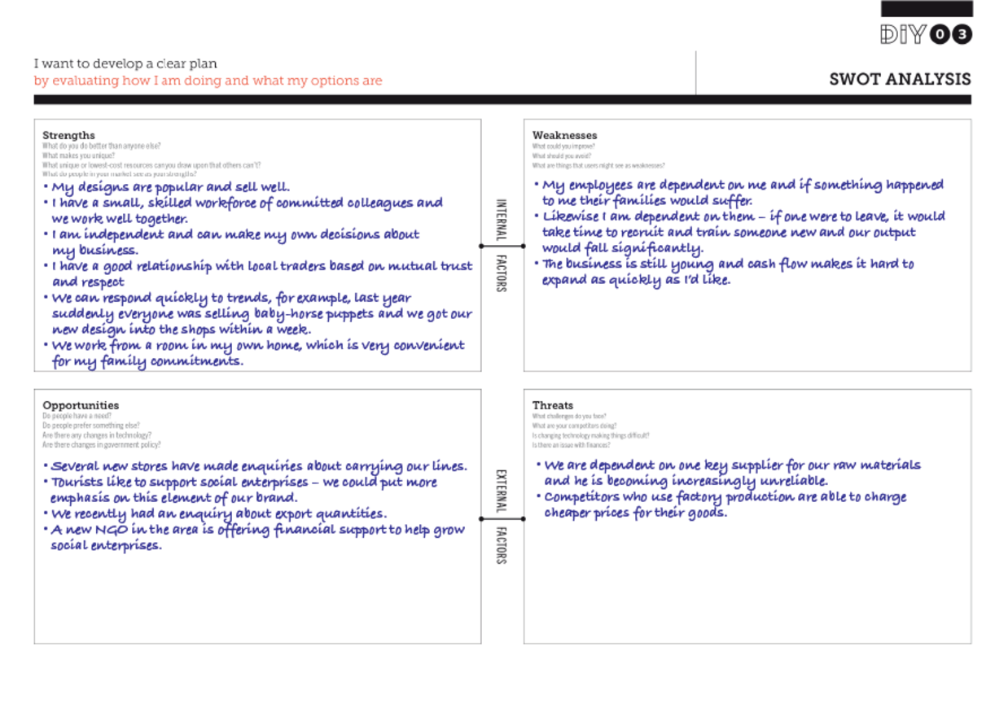
View alternative description - Uncaptioned Figure

Activity 4
Allow around 20 minutes for this activity

Looking at the case study above, including Syed’s SWOT analysis, imagine you are helping Syed make his decision. What points would you highlight? Would you recommend him to sell to Muhammad? Make some notes in answer to this question in the text box below.

Provide your answer...
View discussion - Activity 4

Summary
In this module, we have explored how a SWOT analysis can be useful in taking a snapshot to assess and understand elements of the internal and external environments of a project in order to make a decision. We have seen that it is useful as a guide to help consider further actions or the development of an idea.

Self Assessment Questions

SAQ 1

Which two of the statements below are true?

SWOT stands for Securities, Weaknesses, Opportunities, Threats.
A SWOT analysis is a good tool for taking a snapshot of a situation in order to inform a decision-making process.
A SWOT analysis should include as much information as you can find about all elements of your business.
Although often used for business decisions, a SWOT analysis can also be used for personal-development planning.
SWOT is always best when completed by just one individual.
View answer - SAQ 1

SAQ 2

Drag and drop the words below into the missing gaps in the sentences.

Interactive content is not available in this format.

SAQ 3

In the feedback to Activity 4, it was suggested that Syed could do another SWOT analysis to consider the idea of a partnership with Muhammad. Below is an example of what points this SWOT analysis might raise. For each of the points below, indicate whether they are a strength, weakness, opportunity or threat.

a. The new designs might prove to be more popular than Syed’s existing lines.

Strength
Weakness
Opportunity
Threat
View answer - Part

b. Syed and Muhammad create limited-edition line of products to test their relationship. This was then featured in the local newspaper, generating publicity and significant demand.

Strength
Weakness
Opportunity
Threat
View answer - Part

c. Both partners have good brand reputation; Muhammad’s is much more widely known than Syed’s.

Strength
Weakness
Opportunity
Threat
View answer - Part

d. A local businessman has started importing Bangladeshi-style puppets made in China that retail at lower prices than even Muhammad can offer.

Strength
Weakness
Opportunity
Threat
View answer - Part

e. Muhammad is considering renting a new factory space, near Syed’s home, as the production base for their potential collaboration.

Strength
Weakness
Opportunity
Threat
View answer - Part

f. Syed’s workers are worried about their job security with the expansion, damaging the usually positive atmosphere in their workroom.

Strength
Weakness
Opportunity
Threat
View answer - Part

g. Muhammad is investing in a new website, designed to attract export orders.

Strength
Weakness
Opportunity
Threat
View answer - Part

End of Module Quiz
Congratulations, you have now reached the end of this module! We hope that you have enjoyed it, and have learned useful skills.
End of Module Quiz
This quiz allows you to work towards your badge for DIY Learn: SWOT Analysis. To achieve your badge, you must answer six out of eight questions correctly.
- You can try each question three times.
- There is no limit to the number of attempts you can have to take the whole quiz.
- If you answer fewer than six questions correctly, you will need to start again if you want to earn your badge.
Don’t worry if you are not successful first time, as you will be able to attempt the quiz again in 24 hours.
You need to enrol in this course before you can attempt this quiz which you can do by clicking on the Sign up / Sign in button at the top of this page.
End of module quiz
When you have finished the quiz, click on ‘Next’ to review your ‘Summary of attempt’. Once you are happy with your answers, click ‘Submit all and finish’. Once you have finished this quiz you will be redirected back to this page.
Don’t forget there are another nine modules to choose from which you can find on the DIY Learn home page.

References and acknowledgements
Inspired by: MindTools (1996) SWOT Analysis.
This Module should be cited as follows:
DIY Learn (2016) SWOT Analysis, Copyright © The Open University and Nesta
Except for third party materials and otherwise stated below, this content is made available under a Creative Commons Attribution-ShareAlike licence (http://creativecommons.org/licenses/by-nc-sa/4.0/). The material acknowledged below is Proprietary and used under licence for this project, and not subject to the Creative Commons Licence. This means that this material may only be used un-adapted within the DIY Learn project and not in any subsequent OER versions.
Return to the DIY Learn home page

Solutions

Activity 1

Answer
Right:
Statement 2: A SWOT analysis is a method of conducting a general and quick examination of a project’s current position, which will inform the actions to be taken to reach a favourable future position.
Wrong:
Statement 1: A SWOT analysis is a complex long-term planning tool for understanding the external environment of a project.
Statement 3: A SWOT analysis is a process that focuses on identifying where a project or programme is vulnerable.
Back to - Activity 1

Discussion
Statement 2 most accurately captures what a SWOT analysis is: a simple diagnostic tool for assessing the present and desired state of a business. The other two statements provide only a limited view of what a SWOT analysis can do.
A SWOT analysis will help you to analyse both the internal and external environment of a project. It will also show what a project should reinforce and what it should revise and adapt to ensure the survival and continuity of the project.
Back to - Activity 1

Activity 2

Part

Answer
Right:
External
Wrong:
Internal
Back to - Part

Part

Answer
Right:
Internal
Wrong:
External
Back to - Part

Part

Answer
Right:
Internal
Wrong:
External
Back to - Part

Part

Answer
Right:
External
Wrong:
Internal
Back to - Part

Part

Answer
Right:
Internal
Wrong:
External
Back to - Part

Part

Answer
Right:
External
Wrong:
Internal
Back to - Part

Part

Answer
Right:
External
Wrong:
Internal
Back to - Part

Part

Answer
Right:
Internal
Wrong:
External
Back to - Part

Part

Answer
Right:
External
Wrong:
Internal
Back to - Part

Part

Answer
Right:
Internal
Wrong:
External
Back to - Part

Part

Answer
Right:
Internal
Wrong:
External
Back to - Part

Discussion
If you got more than three or four wrong, you might want to come back to this activity and try it again later. It might be helpful to think of the words ‘Change in …’ before each term, so that you can ask yourself if this is something you could have direct influence over.
Back to - Part

Activity 3

Discussion
One approach to this activity is to turn around the questions in the opportunities box, for example:
- Are people’s needs/preferences being met elsewhere?
- Are new technologies overtaking us?
- Is our activity restricted by changes in government policy?
Other questions I thought of were:
- Are we under threat from the economic climate?
- Does the employment market allow us to recruit the people we need?
- Are our partners looking for new opportunities without us?
Your questions are probably influenced by the specific context in which you work. For example, if your geographic location is heavily influenced by the weather, then this could be a key consideration in your questions around threat. The important thing is that you capture all the potential obstacles in your own external environment.
Back to - Activity 3

Activity 4

Discussion
Syed has provided some interesting information in his SWOT analysis. By taking a realistic look at his business as it is, he can decide what is most likely to make sense for its future. There’s no absolute right or wrong here (there rarely is in this sort of decision-making), but based on the information given I would advise Syed not to sell. These are the key points I would highlight:
- Syed has a lot of strengths, mainly based on the very fact that the organisation is small and under his management.
- Being dependent on one supplier is always a risk, especially now they are becoming unreliable. However, there’s no reason he couldn’t identify other suppliers and shop around to get a good deal and spread the risk by regularly using two or three.
- Syed has said that cash flow is a weakness that stops him from expanding. It sounds like now would be a great time to explore the financial support from the new NGO, as this would enable him to respond to some of the other opportunities (new shops and the potential for export) at his own pace and under his control.
- If he expands, perhaps he could take on some new employees part time? If he has, say, four employees who work half time rather than two who work full time, he has spread the risk of his dependency – if someone is ill or leaves, one or more of the others might be able to increase their hours.
- If he agrees to Muhammad’s offer, he will lose his independence and have to commute to a different workplace. Will the people he works with be able to commute, or in practical terms will this mean they become unemployed (and how might he feel about that)? More people will see and buy his designs, but will his name or mark be on them?
- What if he explores the opportunities for expansion that the SWOT analysis has highlighted, and then considers whether the offer looks tempting?
Finally, I would perhaps suggest that this isn’t a yes or no decision, and there might be a way that Syed could maintain all his strengths but still work in partnership with Muhammad. He could create some designs especially for Muhammad’s factory, and/or draw on some of his resources in exchange for design expertise. At this point, a SWOT analysis of the potential partnership could be a useful decision-making tool.
Back to - Activity 4

SAQ 1

Answer
Right:
A SWOT analysis is a good tool for taking a snapshot of a situation in order to inform a decision-making process.
Although often used for business decisions, a SWOT analysis can also be used for personal-development planning.
Wrong:
SWOT stands for Securities, Weaknesses, Opportunities, Threats.
A SWOT analysis should include as much information as you can find about all elements of your business.
SWOT is always best when completed by just one individual.
Back to - SAQ 1

SAQ 3

Part

Answer
Right:
Weakness
Wrong:
Strength
Opportunity
Threat
Back to - Part

Part

Answer
Right:
Opportunity
Wrong:
Strength
Weakness
Threat
Back to - Part

Part

Answer
Right:
Strength
Wrong:
Weakness
Opportunity
Threat
Back to - Part

Part

Answer
Right:
Threat
Wrong:
Strength
Weakness
Opportunity
Back to - Part

Part

Answer
Right:
Opportunity
Wrong:
Strength
Weakness
Threat
Back to - Part

Part

Answer
Right:
Weakness
Wrong:
Strength
Opportunity
Threat
Back to - Part

Part

Answer
Right:
Strength
Wrong:
Weakness
Opportunity
Threat
Back to - Part

Understanding your strengths can put you in the right place at the right time

Alternative description
Cartoon of ice cream seller standing in front of his cart on a beach holding up an ice cream cornet and two people approaching him
Back to - Understanding your strengths can put you in the right place at the right time

Uncaptioned Figure

Alternative description
Diagram of a SWOT analysis tool with 4 boxes with hand written bullet points in each section. Box 1: Strengths, Box 2: Weaknesses (with Internal Factors text in between connecting both boxes), Box 3: Opportunities, Box 4: Threats (with External Factors text in between connecting both boxes).
Back to - Uncaptioned Figure

