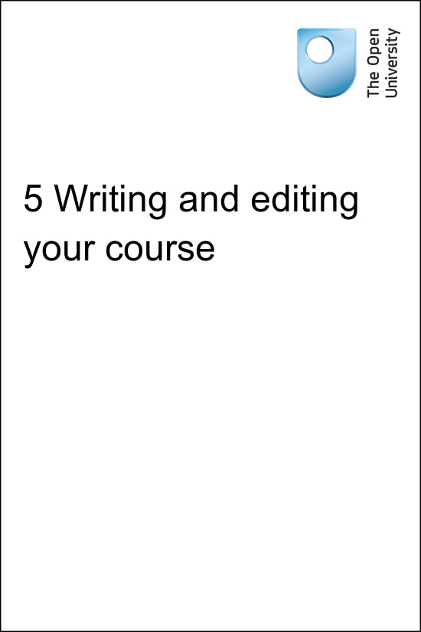

onlinecourse_1.0

5 Writing and editing your course
Copyright © 2016 The Open University
All rights reserved. No part of this publication may be reproduced, stored in a retrieval system, transmitted or utilised in any form or by any means, electronic, mechanical, photocopying, recording or otherwise, without written permission from the publisher.

Contents
- Introduction
- 5.1 Early planning: learning design activities
- 5.2 Structure
- 5.3 Writing and drafting
- 5.4 Editing
- 5.5 Best practice for writing an online course
- 5.6 Video and audio
- 5.7 This week’s quiz
- 5.8 Summary
- Acknowledgements

Introduction
After deciding that you want to create an open online course and carefully considering the purpose, intended audience and type of course you want to produce, it is time to put pen to paper and begin to write. You may intend for your course to depend heavily on third-party resources or you may be creating a course containing only entirely new content. Whatever your type of course, there is likely to be writing involved and editing required.


Figure 1 Starting a course from scratch.
View description - Figure 1 Starting a course from scratch.

This session of the course builds on earlier sessions by looking in more depth at the types of activities you might like to include. You will then go on to consider how best to structure your course and make the content as clear as possible for the learner. You will also look at the process of writing content and then getting that content reviewed, possibly by an editor.
Listen to the following audio recording in which Jane Roberts introduces the session.

Audio content is not available in this format.
5 Writing and editing your course.
View transcript - 5 Writing and editing your course.

5.1 Early planning: learning design activities

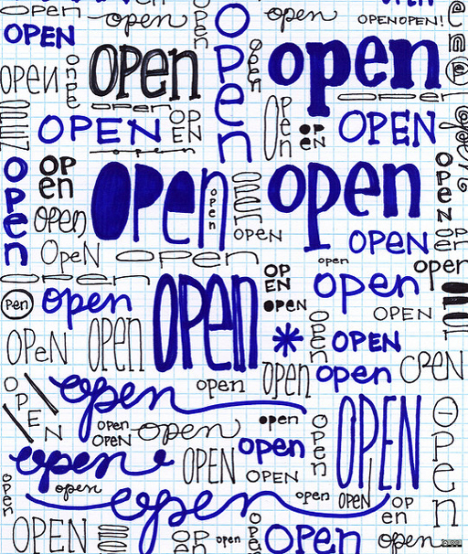
Figure 2 Use the principles of open educational resources while planning your course.
View description - Figure 2 Use the principles of open educational resources while planning your co ...

Before you start to write it is important to plan the content and structure of your course. There are various learning design activities we recommend you take part in before you start to write the content.
As discussed in Session 2 on planning your course, one of the best places to start once you have an idea about the sort of course you’d like to produce is to create a list of learning outcomes. This doesn’t need to be an exhaustive list; it should be manageable, attainable and not put off learners before they’ve even started to read the course. Depending on the length and structure of your course, you may want a list of learning outcomes that covers the entire course, or you may want more specific learning outcomes for each section. Creating learning outcomes early on in your planning will help to give you a grounding on what you want learners on your course to come away with. It also gives you something to use as a check that your writing is focused on what you want learners to learn about.
The next step is to think about the types of activities you would like to include and how long you would expect learners to spend on them. You should ensure that these relate clearly to the learning outcomes. Types of activities include:
- assimilative: reading text; watching video; listening to audio
- finding and handling information: finding information and then dealing with it
- communicative: interacting with other people, possibly other learners
- productive: producing something tangible, for instance a spreadsheet or a toolkit
- experiential: applying learning into a work or formal setting; reflection
- interactive/adaptive: for example, role play.
As discussed in Session 2, activities, especially those with feedback against which learners can check their answers, are particularly popular on open online courses. Forced social interaction is favoured considerably less.
While planning your course, you may find it useful to consider how you are going to assess your course. This is covered in depth in the next session.

5.2 Structure
Do not underestimate the importance of the structure of your course.
Structure is especially important for open online courses. On OpenLearn, approximately two-thirds of the learners on our free online courses arrive via a search engine, rather than a direct link to the first page of the course. This means that they can come in to the course on any web page or section. Therefore, it is important that when the learner arrives on this page not only are they excited by the specific content on that page but they can also see where it fits into the course as a whole. If learners arrive on a page which only contains one line of text, perhaps they will feel uninspired to explore the rest of the course.

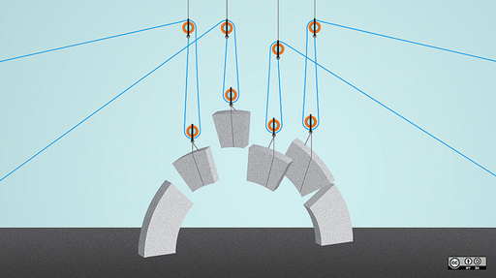
Figure 3 Building the structure of your course.

Introductions and summaries are vital to the learner’s understanding of the course and its content. Consistent use of structural elements such as introductions, summaries and conclusions, especially in a multi-authored course, will improve its coherence. Furthermore, it is useful to communicate clearly what you course is aiming to do, so that learners can read it with the right frame of reference.
Use headings to aid navigation through the course. Thinking about your headings and subheadings while in the early drafting stages will help you to write the final course. Creating a list of contents will help you to assess the structure of your materials.

Example of a clear internal structure: What is strategy?
This illustrates a course which has two main study blocks, each consisting of a number of different sub-sections. The headings contain useful titles which give a good indication of the content and are not too long so are not distracting.

If you are producing a course in distinct sections, for example weekly units, learners may find it useful for there to be some consistency across these. For example, consistent use of structural elements, such as introductions, summaries and conclusions, especially in a multi-authored course, will improve its coherence. Furthermore, try and make these sections of equal length. For example, the Open University’s badged open courses are structured so that each weekly section is three hours long.

Example of a consistent overall structure: Introducing the voluntary sector
Each week begins with an Introduction, which includes a video, ends with a summary and is of roughly equal length.

Consistent use of audio and video (a-v) is also useful. Why don’t you start each weekly section with an introductory video presented by the author or authors of the course?

Example of consistent use of a-v: Returning to STEM
Each week begins with a video presented by a person relevant to the course’s content.

You will look at audio and video in more detail at the end of this session of the course.

5.3 Writing and drafting
When you have an idea of the structure of your course, it’s time to start writing the content. As you write, regularly check that what you are writing relates to the learning outcomes and the general purpose of the course. It’s important that you ensure that the course is doing what you intend it to do.
Rather than simply writing long sections of prose, try and include activities in early drafts. Think about what you want learners to take from the different sections of your materials.
Your course will go through a number of iterations. It is useful at each major drafting stage to have your work reviewed by someone else. This role of an editor/reviewer is covered in the next section.

5.4 Editing
You will inevitably find that having your content reviewed by an editor at various stages will be useful.
An editor can:
- check the text carefully with an eye to pedagogic and structural clarity, looking at it from the perspective of a learner
- provide a fresh eye on content you have probably read and revised multiple times
- check that material is presented in a logical way and that the structure and journey through the course is clear and appropriate
- question any content that they find difficult to understand
- check for consistency of terminology, punctuation and spelling
- provide close and detailed editing, checking spelling, punctuation and grammar
- ensure that the content adheres to any house style guides you may have.

5.5 Best practice for writing an online course
Below are some general tips on best practice for writing an online course. We are fortunate at OpenLearn to receive a considerable amount of feedback from learners, from which we have been able to ascertain what makes an online course successful.
- Clear structure/learning journey through the materials. Good use of headings to indicate the structure.
- Clear and enticing introductory text. Avoid making sentences too long as this reduces their readability and accessibility, especially in an online setting when long sentences and paragraphs need to be broken into more manageable lengths.
- Use of imagery - photographs, figures and illustrations.
- Use of interactive content – quizzes, with feedback so that learners can test their learning and see their progress.
- Use of audio and video (especially video) – but best in small chunks.
- Keeping learners within the course as far as possible. For instance, if using third-party material, such as a-v or extracts, embedding these within the course (while bearing in mind that this has copyright implications) is preferable to linking out so that students leave the course/platform. If you do require learners to leave the platform to access content, then it is advisable to suggest learners open the link in a new tab or window so that they can return to the course easily.

5.6 Video and audio
You may find it beneficial to include some video and audio assets in your course, to provide some variety in the overall balance of content and activities. You might want to add videos for guidance, providing learners with a sense of what to expect on the course and to spark their interest, or to present your learners with a ‘human face’ or ‘teacher’ of the course, which would otherwise be lacking in an online learning environment. You might also wish to provide opportunities for learners to hear from colleagues who are experts in the field or people with different perspectives on a particular subject.
One of the key things to remember, whether video or audio, is to keep things brief. Learners in an online environment will rarely tolerate media assets of more than around five minutes, and often prefer them to be much shorter, so the key message you want to deliver needs to be focused and succinct.
Video production can be one of the more expensive and time-consuming elements of course production so you need to ensure video assets add sufficient value to your course. However, not everyone has access to professional camera and sound operators, or editors, or the budget to buy in such expertise. Learners no longer expect all video and audio to be broadcast quality – we’re now all used to seeing and hearing self-filmed content, or Skype interviews, recorded using smartphones or low-cost cameras. One important thing to consider is that learners will be more tolerant of lower quality video as long as the sound is clear and audible – without good sound your asset will be unusable – and of course the content itself needs to engaging and relevant.
If you are going to be the ‘face’ of your course, you will need to be able to present yourself in a friendly and engaging way and you are unlikely to achieve this simply by reading from a script. One option is to write a script that lasts, say, 2–3 minutes and then simply to learn by heart what you have written. If you are more experienced at presenting you could list the key points you need to make and then build your video round these, or (if budget and resources allow) use an autocue. Either way you will need to practise in advance of the filming to be sure about your timing and ensure you’ve covered everything you want to say to get your message across.
Recording audio sequences is much easier, as you can have a script in front of you and simply read from it. However, you still need to imagine you are speaking to your learner, and ensure you come across in an engaging way.
For accessibility, it is advisable to provide transcripts of all video or audio assets, so that the content can be accessed by as many learners as possible. If resources and budget allow, you may also wish to consider providing closed captions for videos.

5.7 This week’s quiz
Test your learning on the course so far by taking this practice quiz.
Open the quiz in a new tab or window and come back to the course when you are done.

5.8 Summary
In this session of the course, you were introduced to some ideas to help you start writing your course, how to ensure that the structure and content is suitable and effective and how to include audio and video into your course successfully.
Next, you will start to think about assessing your course.
You can go now to Session 6.

Acknowledgements
This session of the course was written by Hannah Parish and Jane Roberts on behalf of the Free Learning team at The Open University.
Except for third party materials and otherwise stated (see terms and conditions), this content is made available under a Creative Commons Attribution-NonCommercial-ShareAlike 4.0 Licence.
Images
Figure 1: Photo: Anonymous Account on Flickr: https://www.flickr.com/photos/anonymouscollective/4263193267/
Figure 2: By Opensource.com CC BY SA https://www.flickr.com/photos/opensourceway/5535034664/
Figure 3: By Opensource.com CC BY SA https://www.flickr.com/photos/opensourceway/7496799718/
Every effort has been made to contact copyright owners. If any have been inadvertently overlooked, the publishers will be pleased to make the necessary arrangements at the first opportunity.

Figure 1 Starting a course from scratch.

Description
A close up of a laptop keyboard with fingers on the mousepad. The keyboard keys are on the left, the mousepad on the right with the right hand on it and the left-hand fingers hovering on the edge of the laptop. The image is in black and white.
Back to Session 1 Figure 1

Figure 2 Use the principles of open educational resources while planning your course.

Description
The image shows the word ‘open’ in many different handwriting styles on graph paper.
Back to Session 2 Figure 1

5 Writing and editing your course.

Transcript
Jane Roberts
This session provides practical advice on how to start writing your course content, including some useful information on using learning design principles to help make your course as engaging, relevant and successful as possible.
At OpenLearn, we’re fortunate to receive extensive feedback on our courses and so we’re able to share with you examples of existing courses to provide tangible evidence of what makes a good course.
Whether you’re writing a course alone or as part of a team, you’ll probably need someone to look at the content from an editorial perspective at some stage during the writing and production of the course. This session gives some advice on the type of editorial involvement you may want to seek and the types of tasks you might want an editor to undertake.
The session ends with the exciting topic of adding audio and video to your course. It covers practical information on planning, recording and delivering audio and video assets, as well as advice on how to make these assets as engaging as possible.
Back to Session 1 MediaContent 1

