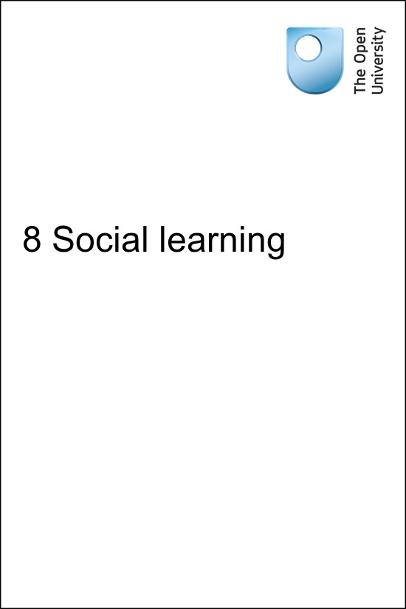

onlinecourse_1.0

8 Social learning
Copyright © 2016 The Open University
All rights reserved. No part of this publication may be reproduced, stored in a retrieval system, transmitted or utilised in any form or by any means, electronic, mechanical, photocopying, recording or otherwise, without written permission from the publisher.

Contents
- Introduction
- 8.1 Social learning in education
- 8.2 Potential problems with social learning
- 8.3 Resourcing social learning
- 8.4 Summary
- References
- Acknowledgements

Introduction
In this part of the course you will look at what social learning is and how it can be included in an open course. You will also explore the benefits of using social learning methods in an open course and also consider the potential problems than can come from learning in a social environment.
Listen to the following audio recording in which Simon Hull introduces the session.

Audio content is not available in this format.
8 Social learning
View transcript - 8 Social learning

8.1 Social learning in education
The last ten years has seen the way in which we communicate with each other change hugely. Social media now exists, for many, as the primary way in which they communicate and from this we have found that it is possible to interact with others and learn from each other at the same time.


Figure 1 Social media in higher education: here to stay.
View description - Figure 1 Social media in higher education: here to stay.

From interacting with others around us about topics that have a common interest, participants join together to learn, engaging with each other in a social context in what is sometimes referred to as a community of practice (Lave and Wenger, 1991). In this context, we learn from each other, transferring knowledge in a wide range of locations and times. Social learning occurs when we learn from others around us, watching their behaviours and actions and replicating them.
For example, watching another person demonstrate performing a simple task such as making a cup of tea is more effective than reading about performing the same task in a book or a teacher simply telling a learner about it without reference to additional teaching aids. Watching someone perform the task may happen in any number of differing locations and could be discussed between many different people who have observed the same actions.
If you had not made a cup of tea before, how would you find out quickly how to do this? Many people will use a search engine to find a short video and copy how the person on the video makes a cup of tea, listening to their ideas and experiences as they demonstrate the skills.

Activity 1

Think about what you would do if you could not follow the video. How would you find out more about the subject?

View discussion - Activity 1

But social learning is not only about learning behaviours. The attitudes of others and the way they react to a situation can also be passed on easily, as we see every day when a child copies the way a parent, teacher or friend reacts to an everyday situation. Children often talk or move their bodies in a similar way to their parents, copying the actions that they have witnessed at home.
Social learning is therefore found in many different situations, but the widespread use of information technology has allowed learning designers to use social learning theory to create exciting and informative learning environments that move away from the traditional teacher/pupil approach to learning.


Figure 2 ‘Open’ educational resources
View description - Figure 2 ‘Open’ educational resources

Social learning can only occur if the tools to communicate are available to your learners and, importantly, if they know how to use them. If learners will not engage with social learning then it is worthless, so designers must consider which tools can best be used on their course.
There are a wide range of applications that could be used in an open course. Some, such as Twitter, Instagram and Facebook, are free, widely used and understood globally.
You may choose to use a tool that is included as part of the open course platform that you are developing the course on, such as the Wiki tool that is available on Moodle. Try to avoid being overly reliant on one particular tool and make attempts in advance to understand how your learners feel about using them. Forced social learning is often not well received on open courses, so you should seek to avoid alienating potential learners by over reliance on it or making it a requirement for assessment.
So which tools are you going to use in your open course?
Forums can be integrated into a course to allow learners to communicate with each other regarding the topic that they are learning. These can be set up using a tool provided in your course platform or you may choose to use a social media platform such as Facebook. Twitter can be used in numerous ways in an open course, for example, learners could send questions to the tutor or facilitator and other learners using predefined hash-tags. However, it can be time consuming to monitor a high turnover of tweets. Forums may be used in differing ways within a course. For example, you may choose to assign a task to a section of your course in which learners are asked to make meaningful contributions to a forum. You may choose to have a general forum activity within your course in which learners can ask questions of each other and share experiences.
Blogging is popular throughout the world as a way of individuals expressing themselves and sharing their thoughts and ideas. Learners on your open course could be encouraged to write a regular blog of their experiences and reflections on the subject that they share with other learners and on which others can comment.Wikis can also be used to allow social learners to contribute to and compile ideas, such as a glossary that relates to the subject that you are teaching.
Live streaming software is becoming increasingly popular as a social learning tool, adding an extra social dimension to courses. Applications such as Periscope can be used to allow learners to view a task being demonstrated by the tutor or other learners and then discussions can be held on forums to draw further learning from the experience of the group and to summarise what has been demonstrated.
A potential drawback of open learning is that learners often do not get back any feedback or recognition regarding their learning, primarily because open courses are often not facilitated. This may be addressed during learning design by including quizzes or even by issuing statements of participation or open-badges. Another way is to allow for peer review or peer assessment in your design. Peer review is essentially a mechanism that allows for learners to complete a piece of work and then hand it to another learner to review and, if required, assess. Assessment is also covered in Section 6 of this course. This can act as a way of providing support and encouragement amongst learners and allow the opportunity to learn from each other. As with any form of social learning activity, the extent to which learners are required to carry out this activity needs to be carefully considered as forcing them to participate may mean they do not complete the course if it is something that they do not want to do.

8.2 Potential problems with social learning
Social learning has been widely adopted by learning designers who are seeking to create engaging online courses. However, whilst encouraging learners to engage in social learning activity is often found to be a positive learning environment and experience for individuals, there can also be drawbacks, particularly for open courses.
Open courses are usually designed to run without a facilitator who will be moderating forums and they are also usually designed without a set start and finish date, making engagement with others on a discussion difficult as it cannot carried out at a specific time. Also, open courses will not usually have a defined cohort of learners. Defined cohorts are much easier to facilitate and manage than learners who are engaged on an open course. For social learning to be a success, there is a requirement for a critical mass of learners to be engaged with the course during a similar timeframe so that they can interact with each other. OpenLearn courses are not usually designed with social learning activities for this reason, although they will be found in FutureLearn MOOCs, which do have specific start and finish dates and are therefore less problematic to manage.
As we have found, discussion forums can be used for learners to exchange ideas and findings based around the subject that they are studying. Some people enjoy contributing to such discussions and others do not. If a requirement of your course is that a learner must engage in a discussion activity, maybe as part of a formative or summative assessment, they may feel pressured and uncomfortable by this. If a learner enjoys the activities that they are being asked to carry out, there is far more chance of them completing the activity and the course.
Experience gained at The Open University has shown that when learners are forced to engage in social activity within a course that drop-out rates significantly increase. Learners do not always see what is to be gained from contributing to a social learning activity and may choose to ignore it. An open course that was designed with an activity where learners were asked to create a video diary and share it with other learners was not well received and resulted in many of the learners prematurely leaving the course.
In order to avoid the inclusion of social learning elements becoming a weakness in a course, the designer should first consider how important it is to include an element of social learning and, if used, the reason for including it and how it will aid the learner needs to be clearly indicated.

8.3 Resourcing social learning
Facilitating this process should be considered at an early stage. There is often a requirement for social learning to be monitored and the design of your open course will be dependent on who is going to oversee it and how this will be implemented. The commitment required by the educator when running a course with a social learning element cannot be over-stated.
Considerations should be given to the ground rules associated with conduct of learners on the course - what kind of topics can be discussed, can learners expect a response from a teacher or other person associated with the course, what kind of language and behaviour is acceptable in discussion posts, how long should posts be? If general guidance is not given around these issues then then a well-meaning inclusion of a discussion forum can quickly deteriorate and remove credibility from the course. It may help to have closed discussion groups in which a facilitator suggests topics, but is this truly embracing the concept of social learning?
Should learners decide to set up their own forum using social media but that is directly related to their experiences on the course, it may be harder for the tutor to manage this. It is up to each course manager to decide if this should be encouraged and it may be prudent to establish ground rules with learners and also consider adding a disclaimer to the course stating that the authors of the course are not responsible for content not directly managed by them.
Course leaders who are interested in becoming facilitators may benefit from some training around the topic, helping them to gain a greater understanding of facilitation of social learning. You may be interested in studying the OpenLearn badged open course How to become an online facilitator which explores the principles and best practices underpinning mentorship.



8.4 Summary
In this session of the course you have learned about the use of social learning within open courses.
In the next session you will think about the ways you can test your course.
You can now go to Session 9.

References
Lave, J. and Wenger, E. (1991) Situated Learning. Legitimate Peripheral Participation, Cambridge: University of Cambridge Press.

Acknowledgements
This session of the course was written by Simon Hull on behalf of the Free Learning team at The Open University.
Except for third party materials and otherwise stated (see terms and conditions), this content is made available under a Creative Commons Attribution-NonCommercial-ShareAlike 4.0 Licence.
Images
Figure 1 By mkhmarketing. Issued under Creative Commons licence.
Figure 2 opensource.com via flickr. https://www.flickr.com/photos/opensourceway/6555466069/, CC BY SA
Every effort has been made to contact copyright owners. If any have been inadvertently overlooked, the publishers will be pleased to make the necessary arrangements at the first opportunity.

Activity 1

Discussion
You might have thought of activities such as:
- use a forum to ask a question about how to carry out the task
- use Facebook or Twitter to ask friends for advice and guidance.
Back to Session 2 Activity 1

Figure 1 Social media in higher education: here to stay.

Description
Four social media buttons are shown wearing graduation mortar boards - the boards are black, with yellow tassles hanging from each. The social media buttons are, from left to right: Facebook, Twitter, Pinterest and RSS feed.
Back to Session 2 Figure 1

Figure 2 ‘Open’ educational resources

Description
Four books showing the word ‘open’ spelled across them. The books are closed and each has one letter of the word on its cover. They are laid out in an uneven row. The left book with the letter ‘O’ in brown is orange, the next book with letter ‘P’ in white has a cover of pink and orange with a large red spot under the letter, the next book is aquamarine with the letter ‘E’ in darker blue. The book on the right is a lighter navy blue with the letter ‘N’ in turquoise printed on the cover with two rows of lined circles just below the letter.
Back to Session 2 Figure 2

8 Social learning

Transcript
Simon Hull
In this session, we’ll explore a subject which has changed the way we think about learning in recent years, social learning.
The use of Facebook, Twitter, Yammer and Linkedin, to name but a few, has become ubiquitous in our daily lives, often being the primary way in which we communicate with each other for our social and working lives. But can these methods of communication transfer into an open learning environment?
The actual concept of social learning is nothing new. After all, learning from others through discussion and sharing has formed the way we have learned for many years. But the rapid development of social media and the way in which it’s been adopted by people of all ages, backgrounds and learning abilities across the world has given new meaning to social learning and its application as a learning method.
In this part of the course we’ll look at what social learning is and how it can be included in an open course. We’ll also explore the benefits of using social learning methods in an open course and consider the potential problems than can come from learning in a social environment.
Back to Session 1 MediaContent 1

