Continuing collaborative relationships to reduce social exclusion for disabled and older people
Structures
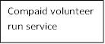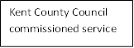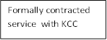
Expanded Service including disabled schoolchildren

Policy
Use of charities to deliver council services
Council safety net for those without access
Achieve cost savings in Transport budget
None in place

Time Change of Compaid CEO New Compaid Transport Manager Restructure of KCC
People
KCC Head of Public Transport
KCC Integrated Transport Manager
KCC Transport Manager
Current CEO
KCC Schools Transport Manager
Previous CEO

Processes
KCC Select Committee hearing
Total Transport Pilot
Membership of Kent Community Transport Forum
Six monthly Contract review meetings
Light touch funding arrangement

