Making Sense of Open Education – Day 5
Irene Stewart

Link to copyright information for my jurisdiction:

Canadian Intellectual Property Rights Office http://www.ic.gc.ca/eic/site/cipointernet-internetopic.nsf/eng/h_wr00003.html

Government of Canada, a Guide to Copyright https://www.ic.gc.ca/eic/site/cipointernet-internetopic.nsf/eng/h_wr02281.html

Government of Ontario, Trademarks, copyright and other intellectual property https://www.ontario.ca/page/trademarks-copyright-other-intellectual-property

Government of Ontario, Open Government License – Ontario https://www.ontario.ca/page/open-government-licence-ontario

Notes on Videos

Copyright, CC & Fair Use
https://www.youtube.com/watch?v=sbQMxI310iQ&feature=youtu.be

- Online images & other works, you can’t just use anything
- Single C icon ©
- Creative commons licenses – can be free to use, reproduce and remix
- Fair Use – small amount of a work – 5-10% of a book
- Classroom – a good place to teach creative commons

A shared culture
https://www.youtube.com/watch?v=1DKm96Ftfko&feature=youtu.be

- Creative commons in response to failed sharing
- Creators can make a choice
- Exercise your rights in the way you want to
- About building community

Wanna work together {Creative Commons}
https://www.youtube.com/watch?v=TokJ48dZLLI&feature=youtu.be

- Sharing creative wealth, around the world
- © all rights reserved
- CC is free to apply license where you don’t give up your license, you refine it

Attribution

Title | Author | Source | License
“cats” | David Howard | https://www.youtube.com/watch?v=TokJ48dZLLI&feature=youtu.be | CC-BY 2.0
Vượt sóng | H. Đức | https://www.flickr.com/photos/33845213@N00/41683169805/ | CC Attribution-NonCommerical License
Wake Up Now | Agenda23 | http://freemusicarchive.org/music/AGENDA_23/AGENDA_23_-_Singles/AGENDA_23_-_WAKE_UP_NOW | CC Attribution-ShareAlike License.

The flickr cc attribution helper may be ready to use, but I neither understand how to use is or what it is for.

Create your own license

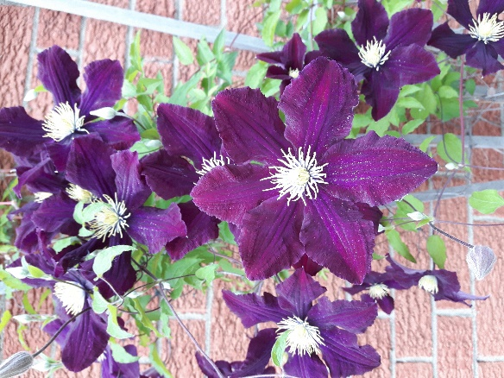
Purple Climber by Irene Stewart
This work is licensed under a Creative Commons Attribution 4.0 International License.

