Day 5 OER

Task 1
TASK: Take a look for copyright information for your geographic location that is specific to your context - i.e. education, industry, work related, etc. Do a general search and collect links to 4-5 sources of credible information for future reference. Be ready to share these in your discussion post
https://www.copyright.gov/fair-use/
https://www.copyright.gov/timeline/
https://www.copyright.gov/timeline/timeline_2013-beyond.html
https://www.copyright.gov/legislation/past-legislation.html
http://www.loc.gov/teachers/copyrightmystery/#/copyright/
http://www.loc.gov/teachers/usingprimarysources/copyright.html
https://www.wikihow.com/Copyright-Material-(US)

Task 2
TASK: Capture some jot notes from these videos into your work processing work space.
Copyright, CC & Fair Use
Copy write materials are protected from creation of the material and cannot be used in its entirety without permission.
Using Creative commons allows a creator to permit use of their material (under specified conditions) to be used by others.
Fair Use law permits parts of the material to be used under certain circumstances without permission. This is typically only a small portion of the work not more than 5% to 10% of the work.
Copyright Basics for Teachers
Use of internet materials required balance. It is not a use everything or use nothing world.
There are three types of materials: Copy Write, Public Domain, and Creative Commons
Copy Write: Everything as it is created has a copy write. This means that it can only be used with permission of creator. Except material under the Fair Use law. The Fair Use law requires four criteria be considered:
- Purpose – is it transformative or different?
- Nature – was the work creative or information?
- Size – Is a small portion being used or the whole thing?
- Impact on market.
Public Domain has no copy write and can be used without permission. A search for example of this is LibriVox for audiobooks.
Creative commons allows creators to choose how the work will be used. www.ck-12.org was a new resource to me that has a book that could be helpful to me for College Algebra and Trigonometry.
Wanna Work Together
Creative commons allows creativity to be shared.

Task 3
TASK: Create a chart (with columns Title, Author, Source, License) to provide attribution information for ONE creative work from each of the suggested open, searchable repositories.

Repository | Citation (Title, Author, Source, License)
Creative Commons Search | “A mathematician seated at a table, working on mathematical equations, from a portfolio of prints of the Imperial Gallery of Paintings in Vienna; plate 34 of series” by Anton Joseph von Pernner, After Jusepe de Ribera, Original source via Metropolitan Museum of Art licensed CC0 1.0
Flickr.com | “Destiny (Explored)” by Sapna Reddy on Sapna Reddy Photography, Copy write lincense all rights reserved
Legal Music for Videos | “Murmuration” from “sector” by Silicon Transmitter on Free Music Archive, License CC BY NC SA

Task 4
TASK: Using this link to the Creative Commons License Chooser, try creating a CC license for yourself. Save an image of the license using a screen-capture and save the html code in a word processing document. Embed the image into the same document and keep the image and code together for future use.

Selected License
Attribution-NonCommercial-NoDerivatives 4.0 International

This work is licensed under a Creative Commons Attribution-NonCommercial-NoDerivatives 4.0 International License.

<a rel="license" href="http://creativecommons.org/licenses/by-nc-nd/4.0/"><img alt="Creative Commons License" style="border-width:0" src="https://i.creativecommons.org/l/by-nc-nd/4.0/88x31.png" /></a><br />This work is licensed under a <a rel="license" href="http://creativecommons.org/licenses/by-nc-nd/4.0/">Creative Commons Attribution-NonCommercial-NoDerivatives 4.0 International License</a>.

Day 5 Activity
OPTION ONE:
Create a digital image of your choice – it could be a picture from your garden, pet, shoe, hand or any other item of your choice. Add a Creative Commons license to your creative work.
You can choose to share you work in the Day 5 discussion forum in the course shell, in a social media space (blog, tweet, Instagram, Flickr), with family, friends, and colleagues, or just save it for your own reflection.

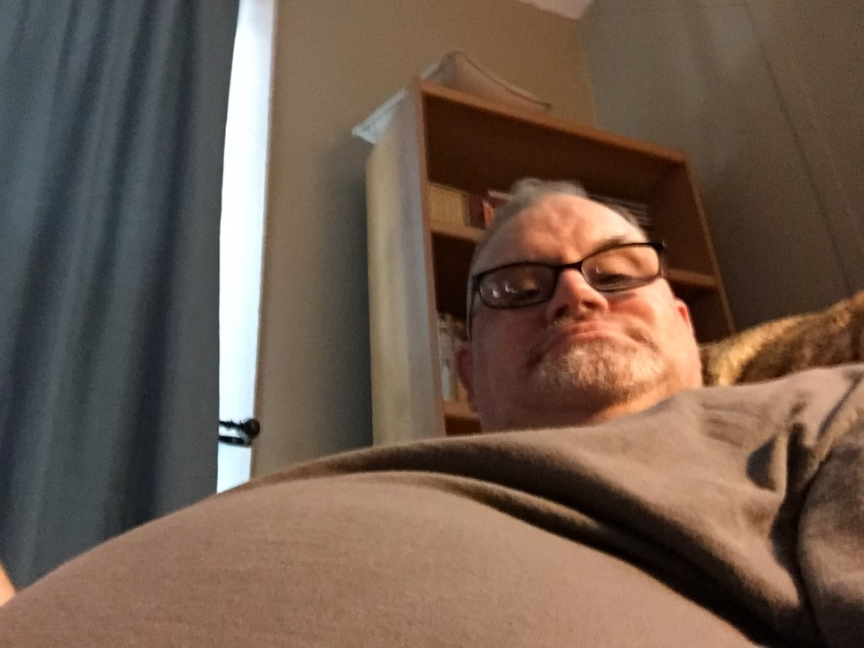
“Dallas posing for OER” by Carol L. White
This work is licensed under a Creative Commons Attribution-NonCommercial-NoDerivatives 4.0 International License.

