Title | Author | Source | License | Image of Resource
Technical Writing Essentials: A Guide to Professional Communications in the Technical Fields | Suzan Last | https://pressbooks.bccampus.ca/technicalwriting/ | CC-BY | 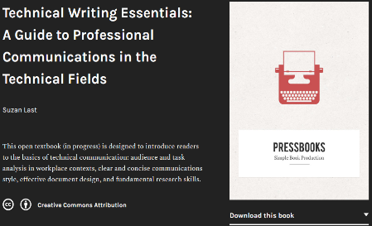
106. The Toulmin Method of Argumentation | THUNK | https://www.youtube.com/watch?v=1vArfwlX04I | CC | 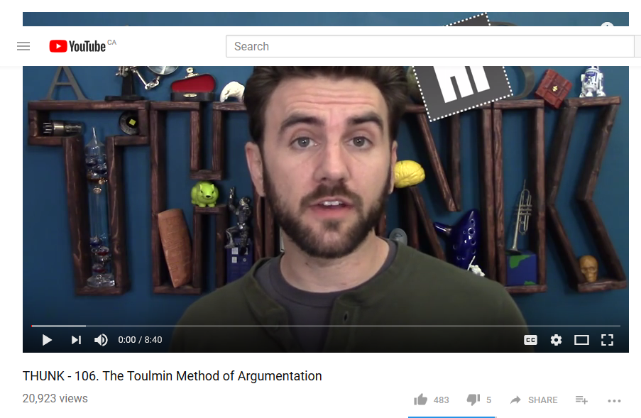
How to Argue – Philosophical Reasoning: Crash Course Philosophy #2 | CrashCourse | https://www.youtube.com/watch?v=NKEhdsnKKHs | CC4.0 | 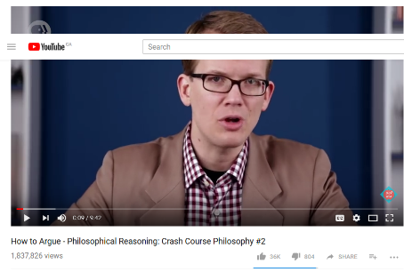
Online Technical Writing: Examples, Cases, & Models | David McMurrey | https://www.prismnet.com/~hcexres/textbook/models.html | CC-BY | 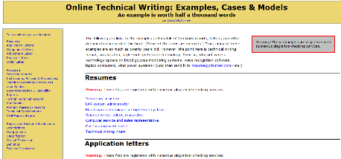
RESEARCH BRIEF: Furniture Engineering Process Analysis | Chao Wang, MS Candidate  Virginia Tech | http://sim.sbio.vt.edu/?p=543 | CC-BY
32. Teaching Writing Skills That Enhance Student Success in Future Employment | James P. Coyle | https://celt.uwindsor.ca/ojs/leddy/index.php/CELT/article/view/3262 | CC-BY | 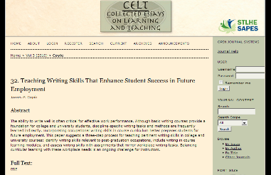
Writing in College: From Competence to Excellence | Amy Guptill | https://textbooks.opensuny.org/writing-in-college-from-competence-to-excellence/ | CC-BY-NC-SA | 