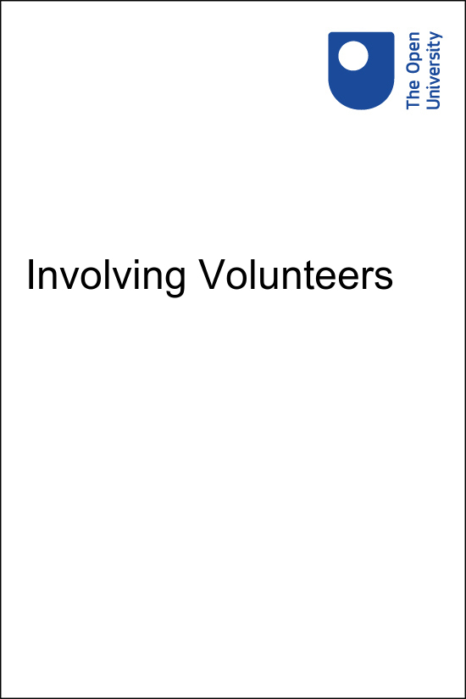

Involving Volunteers Involving Volunteers

Involving Volunteers

Copyright © 2021 The Open University
All rights reserved. No part of this publication may be reproduced, stored in a retrieval system, transmitted or utilised in any form or by any means, electronic, mechanical, photocopying, recording or otherwise, without written permission from the publisher.

Contents
- 1 Introduction
  - 1.1 Who is this course for?
  - 1.2 What you will learn
  - 1.3 How you will learn
  - 1.4 Introducing the case studies
  - 1.5 What is volunteering?
- 2 Thinking about volunteering
  - 2.1 ‘Be ready’
  - 2.2 ‘Is this right for me?’
  - 2.3 Take action and be ready for volunteers
  - 2.4 Further resources
- 3 Getting started
  - 3.1 ‘Be interested in me’
  - 3.2 ‘I want to feel welcomed and encouraged’
  - 3.3 Take action and be ready to get started
  - 3.4 Further resources
- 4 Making a difference
  - 4.1 ‘How am I supported?’
  - 4.2 ‘What have I achieved?’
  - 4.3 Take action and be ready to make a difference
  - 4.4 Further resources
- 5 Building on success
  - 5.1 ‘Enjoy it, love it, be happy!’
  - 5.2 ‘Don’t make me feel guilty, let me go!’
  - 5.3 Take action to be ready to build on success
  - 5.4 Further resources
- 6 Developing your practice
  - 6.1 Volunteering in Scotland
  - 6.2 Developing your reflective practice
  - 6.3 About Volunteer Scotland and CVSL
  - 6.4 Acknowledgements
  - 6.5 Further resources
- 7 Evaluation and thanks
- Solutions

1 Introduction

All rights reserved.
View description - All rights reserved.

This course is about the essential things you need to consider to ensure a positive experience for individuals engaging in volunteering. The overall aim is to help you build upon and improve your practice. It was developed with input from volunteers, volunteer-involving groups and organisations, volunteer practitioners and trainers. This input has given us the volunteers’ perspective and the volunteers’ ‘voice’ that we hope you will find helpful throughout the course.

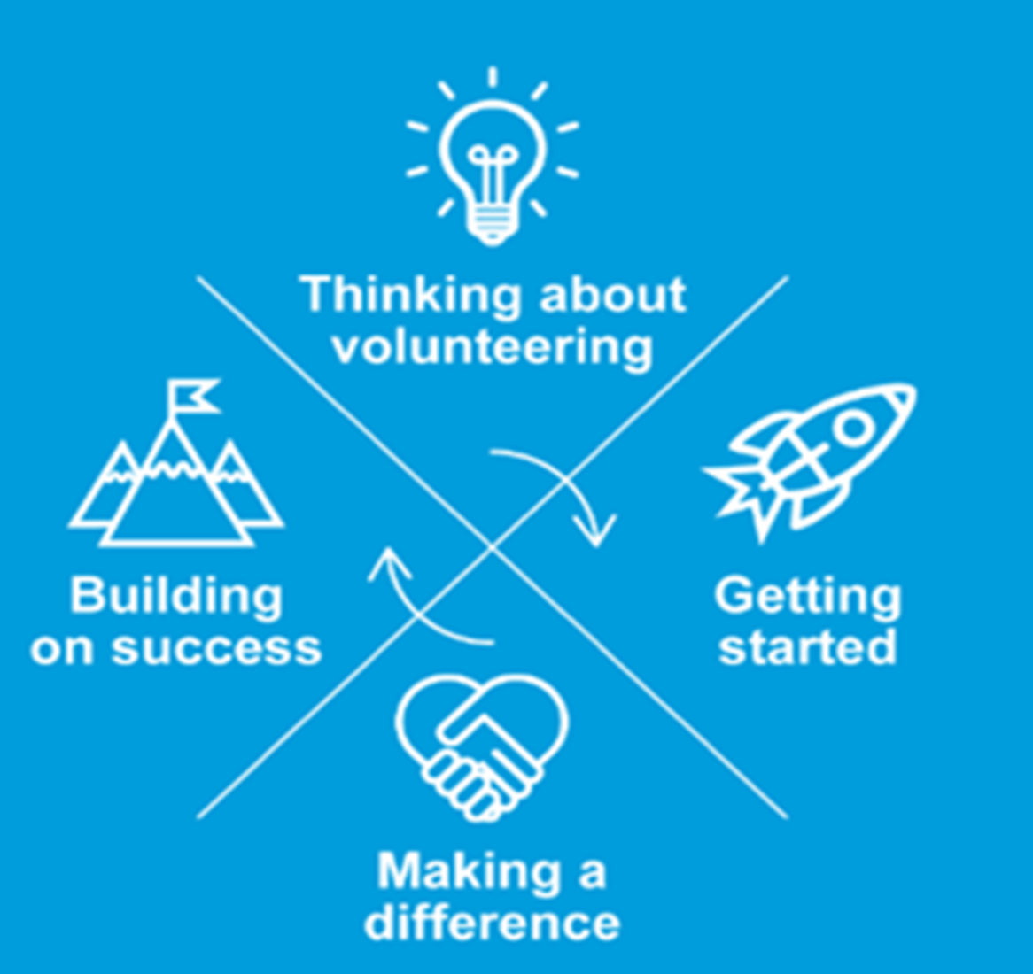
Figure 1 Volunteer management model. All rights reserved.
View description - Figure 1 Volunteer management model. All rights reserved.

The course approaches the four stages of the volunteer management model (above) from the perspective of a volunteer as they pass through different phases of their volunteering ‘journey’.
This model was developed by Volunteer Scotland with volunteers and those who support volunteers. It is a four-stage model that takes the volunteer and group or organisation through their journey from thinking about volunteering, to getting started, and then on to making a difference and building on success. In each of the four sections we ask you to consider some key issues. You will explore and reflect on these in your context and then develop an appropriate action plan for your situation.
Throughout the course you will encounter the phrase ‘appropriate to your context’. This course recommends that at every stage, how you involve, manage or support volunteers needs to be proportionate. Where formality is required it should be provided; where it is not required, then formal procedures and structures are not appropriate. For example, a four-page application form is not appropriate for a one-day event volunteering opportunity, but it might be appropriate for a volunteer who is going to be working with a vulnerable client group over a long period of time.

1.1 Who is this course for?
This course is for individuals who support volunteers, whether they do so in a group, in an organisation or in an informal community-based setting. It reflects the spirit of volunteer management and community engagement. It is aimed at a broad range of people, from volunteers who support other volunteers, to community workers that involve community members, to paid volunteer managers. Or perhaps you have never supported volunteers and want to know where to start.

1.2 What you will learn
We understand that not everyone who supports volunteers is a paid member of staff, and that not all volunteer practice happens in big organisations. This course has been developed to support the functions related to creating a positive volunteer experience regardless of where the volunteering takes place.
By the end of the course you will:
- be clear about how volunteering fits into your context and the opportunities it provides
- be able to develop an appropriate way of getting to know volunteers and for volunteers to get to know you
- understand the importance of supporting volunteers and communicating the difference their contribution makes
- be able to identify the volunteers’ voice in order to learn from volunteers’ experiences and ensure that they have a positive volunteering journey.
Underlying this course is a set of values developed from Volunteer Scotland’s own experience and extensive engagement with volunteers and those supporting volunteers and volunteer activity. These values are focused around a community ethos, inclusiveness and providing solutions. They are outlined in the Volunteer Scotland Annual Report 2018.

1.3 How you will learn
The course aims to be accessible, appropriate and adaptable to your situation. To help with this, the course uses a ‘reflective practice’ approach to learning, which encourages participants to observe, reflect and act.
‘Reflective practice’ is becoming increasingly common in a range of contexts. At its core is the sense that reflecting on what you do makes you better at what you do. As volunteering takes place in so many different settings and takes many different forms, this is not a course that shares the right answer but encourages you to ask the right questions. Several different models of reflective practice exist, and you can learn more about these in the OpenLearn course Learning to teach: becoming a reflective practitioner.
To support reflective practice the course contains a series of activities. You will get the most out of the course if you work through the activities and record your responses in this learning journal. Once you click on the link, you can download the template and use it to help you structure your reflections on the activities and build them into an action plan for your work.
Although the learning materials are online, this does not mean that all learning will take place online. You will learn through applying ideas and asking questions within your context. The activities are written from the perspective of an individual working their way through the material. However, it is worth exploring how you might involve others in this learning and how to apply this reflective practice in a group setting.
The course will also signpost you to further resources at the end of each section. Where relevant, reference materials have been included throughout the course to act as a gateway to further reading and learning if you wish to explore this.

1.4 Introducing the case studies
Throughout the course there are videos and quotes from groups, organisations and volunteers, all talking about their experiences of improving volunteering practice. These reflections will help to support your own critical reflection. They are introduced below and you can read more about them in Section 6: (Ctrl + Click to open in new tab)
- Kilmaurs Gala Committee is a small, volunteer-run community group that organises an annual community gala, and you will find quotes from the group throughout the course.
- Polbeth and West Calder Community Garden is entirely run by volunteers in West Lothian and you will see video contributions from Lisa, the Co-convenor.
- Gairloch and Loch Ewe Action Forum (GALE) is a multi-faceted community organisation. There are 20 members of staff, 30 regular volunteers and another 40 who volunteer at least once a year. Tania, the Volunteer Co-ordinator, and a volunteer, Rebecca, filmed their own video contributions.
- LGBT Youth Scotland is a national charity with 50 full-time, part-time and sessional staff and over 100 volunteers. Videos feature Randi and Jordan, who are volunteers, and James the Volunteering Manager.

1.5 What is volunteering?
It is worth considering this question before we go any further as, as we each have our own understanding of what volunteering is, The UN General Assembly definition describes volunteering as ‘Three basic criteria can be identified to distinguish volunteering from other types of human activity:
It is not undertaken primarily for financial gain. Because voluntary action is not rewarded with a wage or salary, it is generally cost-effective, although not cost-free.
It is undertaken of one’s own free will. The decision to volunteer may be influenced by peer pressure or personal feelings of obligation to society but, in essence, the individual must be in a position to choose whether or not to volunteer.
It benefits a third party or society at large. Actions that benefit only the person who volunteers or that cause harm to society do not meet this criterion.’
The Scottish Government’s Volunteering for All – A National Framework, states that

“Volunteering is a choice. A choice to give time or energy, a choice undertaken of one’s own free will and a choice not motivated for financial gain or for a wage or salary”.

Informal volunteering can include individual activities such as helping a neighbour, or group activities such as taking a friend’s children to school, without involving a group. Then there are forms of community action or social participation that can include residents’ committees or a community centre, where groups and group or organisations will often be involved to enable the voluntary activity. There is also formal volunteering, where you commit to giving your time to a group, such as fundraising in a local charity shop (see Figure 2).

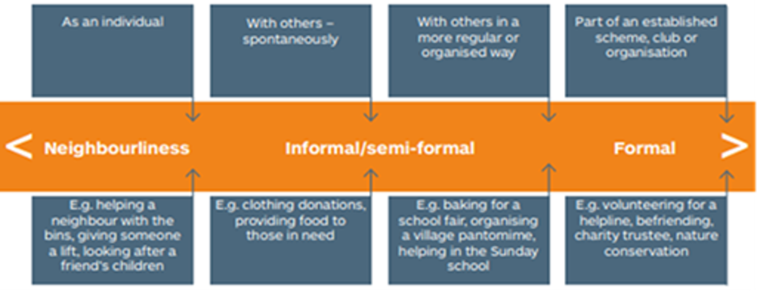
Figure 2 The Scottish Government’s Volunteering for All – A National Framework

There are a wide variety of volunteering roles, opportunities and contexts. This course is principally focussed at formal volunteering and those managing formal volunteer opportunities, although the reflective practice would be suitable for all to use who involve volunteers. For more information on informal volunteering, follow the link and read Volunteering ‘below the radar’?.

2 Thinking about volunteering

All rights reserved.
View description - All rights reserved.

In this section you are asked to consider the start of an individual’s journey into volunteering. This begins with an individual looking for an appropriate place or activity to ‘help out’, participate or get involved with. For an individual to make an informed choice, they need to have a clear sense of what is on offer – or what they as an individual can offer – so this is all about communication.
However, you will only be able to communicate effectively if you have a clear understanding of what your offer is. This means being clear about what you want individuals to do, and asking what individuals would like to do and how they would like to contribute.
From the volunteers’ perspective there are two essential areas that this section will cover:
- ‘Be ready’ – volunteers say that they want a group or an organisation to have fully considered the involvement of volunteers and to be clear about why volunteers are needed and what they will be asked to do.
- ‘Is this right for me?’ – volunteers also say that they need the right information to decide if the opportunity is right for them. This is all about sharing and understanding each other’s expectations.
These key areas are explored in more detail in this section.

2.1 ‘Be ready’
If you have 20 volunteers in a room and ask them why they volunteer, you will probably get 20 different responses, as a person’s decision to volunteer will be unique to them. This is because a person’s motivation to volunteer is influenced by their own personal values and experiences.
For example, if a family member with cancer received support from a charity this might lead to the individual wanting to give something back to this charity. Or perhaps someone just wants to take action to improve their local community. They might then have considered what they can personally contribute by volunteering and what they hope to gain from the experience.
People’s reasons to volunteer can be as simple as a desire to keep active or to give structure to their day, through to wanting to share or gain a skill or spend time doing something with friends or family.
In the following videos you can hear from volunteers about why they decided to volunteer.

Video content is not available in this format.
Randi, Volunteer, LGBT Youth Scotland. All rights reserved.
View transcript - Randi, Volunteer, LGBT Youth Scotland. All rights reserved.

Video content is not available in this format.
Jordan, Volunteer, LGBT Youth Scotland. All rights reserved.
View transcript - Jordan, Volunteer, LGBT Youth Scotland. All rights reserved.

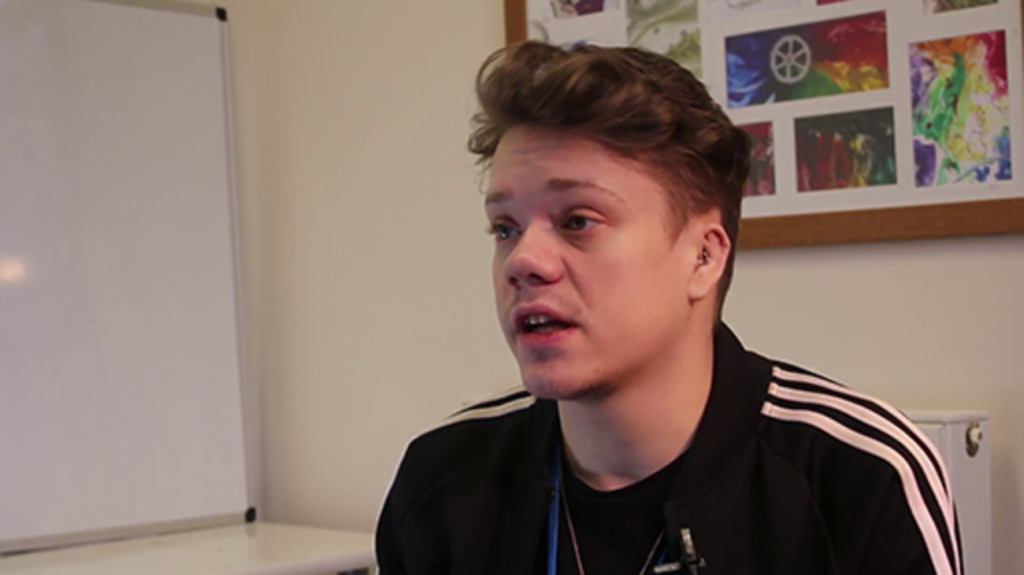

Video content is not available in this format.
Rebecca, Volunteer, GALE. All rights reserved.
View transcript - Rebecca, Volunteer, GALE. All rights reserved.

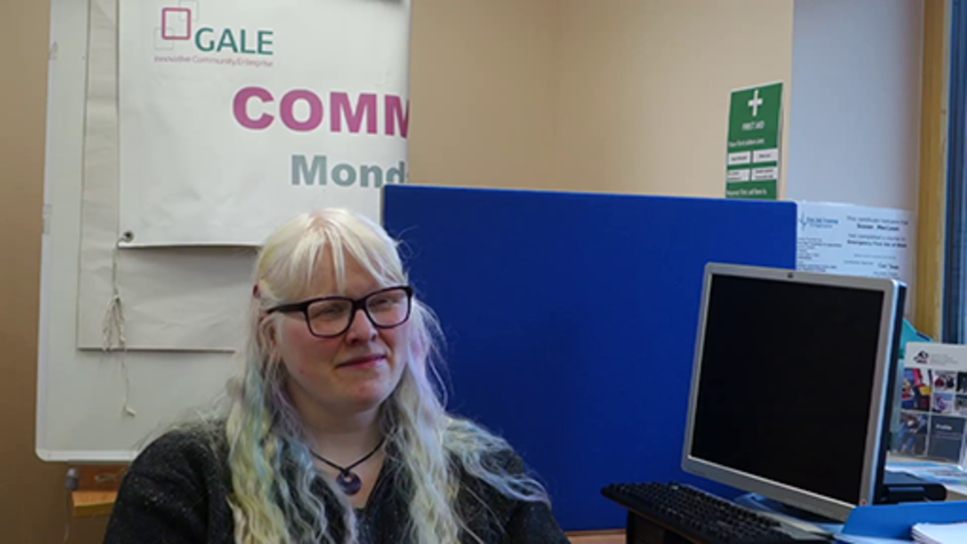

Everyone has a set of values, and one of the ways potential volunteers might assess whether a volunteer activity is right for them is whether it complements their values. For example, an elderly person who values friendship may seek out a volunteer activity that provides this. So, it is vital to acknowledge how important it is for volunteers to connect with the group or organisation’s values and for them to become shared values.

‘Be ready’ continued
Groups and organisations typically have a purpose that derives from a set of values, and these values will influence the involvement of volunteers. While the individual is considering why they want to volunteer, a group or an organisation must also consider why they want to involve volunteers in an activity and be ready to share this.
Some groups and organisations might involve volunteers because it is part of their ‘business model’ and they can only achieve aspects of their mission by involving volunteers; for example, charity shops or social enterprises.
Other groups and organisations might involve volunteers because the contribution of volunteers will directly help them to achieve their mission, such as befriending charities. Still others might involve volunteers because of the difference that it will make to the volunteers themselves, for example community support projects or employability programmes.
Polbeth and West Calder Community Garden is run by volunteers, and in this video Lisa the Co-convenor talks about why volunteers are involved.

Video content is not available in this format.
Lisa, Co-convenor, Polbeth and West Calder Community Garden. All rights reserved.
View transcript - Lisa, Co-convenor, Polbeth and West Calder Community Garden. All rights reserved ...

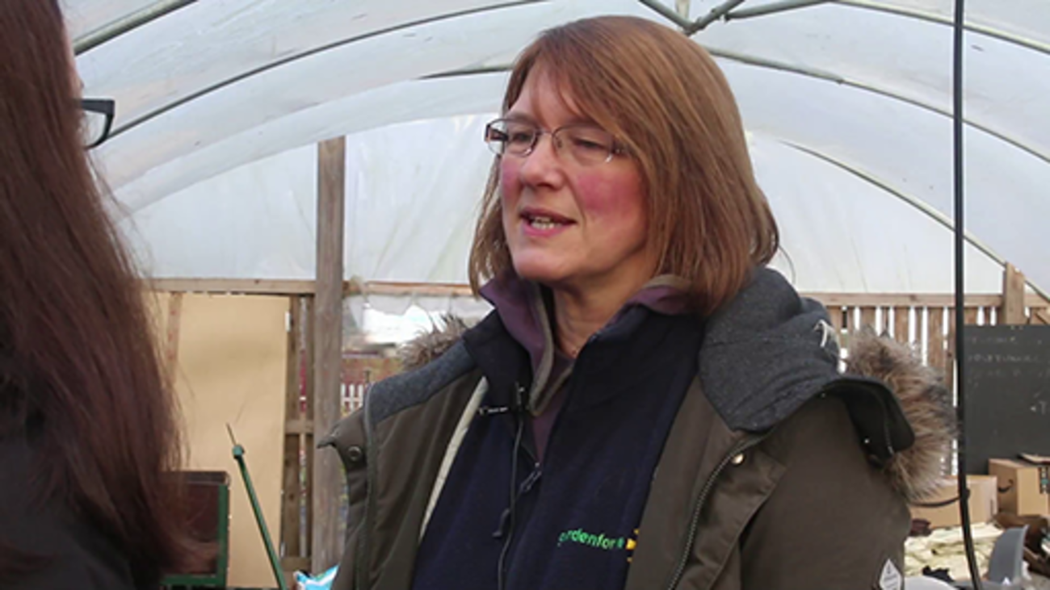

James, the Volunteering Manager at LGBT Youth Scotland, talks about why they involve volunteers and the values that inform the volunteering programme.

Video content is not available in this format.
James, Volunteering Manager, LGBT Youth Scotland. All rights reserved.
View transcript - James, Volunteering Manager, LGBT Youth Scotland. All rights reserved.

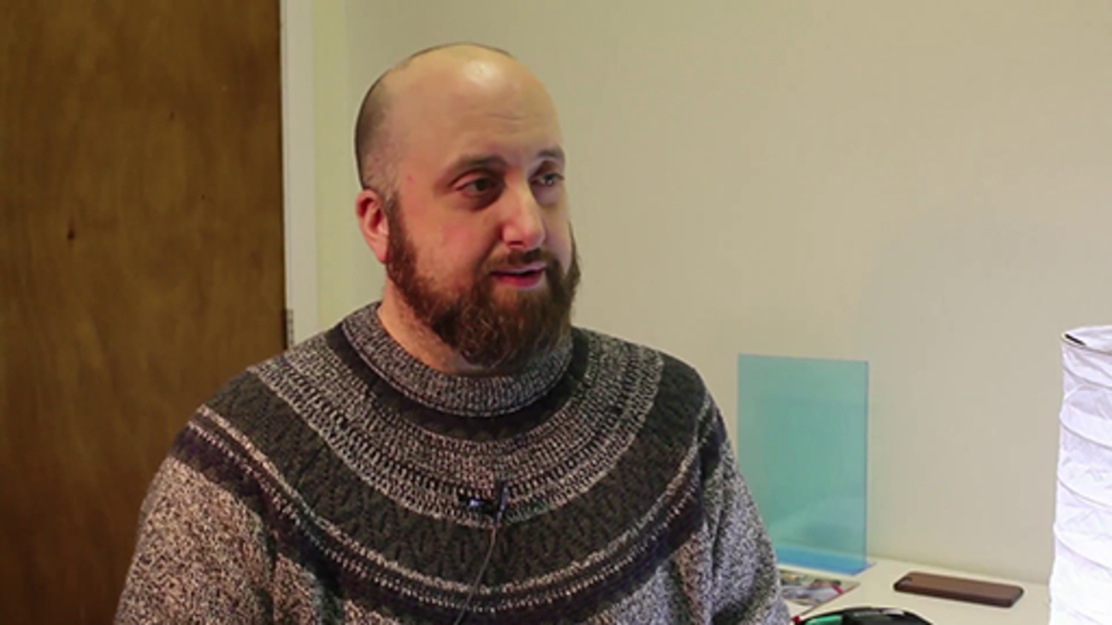

‘Be ready’ activity
Having listened to and reflected on what you heard in the videos, we’d like you to capture your reflections in your learning journal. The activity below provides a way to structure your thoughts.

Activity 1

Please take some time to consider the following points in relation to your context and record your reflection in your learning journal[link to word document, Learning journal] (download a copy if you haven’t done so already):
- Why do you think people choose to volunteer with your group or organisation, or why might they want to, if you don’t involve volunteers yet?
- Why did you decide to involve volunteers?
- How does the involvement of volunteers fit with the values of your group or organisation?
- What are the benefits that involving volunteers will bring to both the volunteer and the group or organisation?
- What tasks or activities do you need volunteers to help with?

View discussion - Activity 1

2.2 ‘Is this right for me?’
Individuals who are considering volunteering need to decide whether an opportunity or an activity is going to be right for them, which is about choice. Choices are often based on a complex mix of practical concerns and more complex personal choices associated with our beliefs and values (as discussed in Section 2.1).
For potential volunteers, practical expectations might include understanding what is expected of them in terms of a time commitment and whether an opportunity is flexible, or it could be about the provision of expenses. For others, who might see volunteering as a progression route, the expectations might relate to the opportunities for training and progression.
You can make real choices if you have a clear understanding of what is expected of you, and what you can expect in return. Imagine you are thinking about volunteering – how would you find out what is expected of you? You would probably look for information, perhaps online, or you could talk to someone who is connected to the group or organisation.
What we know about volunteering is that, while the information that organisations and groups produce is important in raising awareness, most people learn about opportunities from others through word of mouth.
In this video, Randi at LGBT Youth Scotland outlines how he found out about the organisation and reflects on his own expectations.

Video content is not available in this format.
Randi, Volunteer, LGBT Youth Scotland. All rights reserved.
View transcript - Randi, Volunteer, LGBT Youth Scotland. All rights reserved.

Rebecca’s experience was a little more informal, as she heard about GALE through word of mouth and didn’t have clear expectations.

Video content is not available in this format.
Rebecca, Volunteer, GALE. All rights reserved.
View transcript - Rebecca, Volunteer, GALE. All rights reserved.

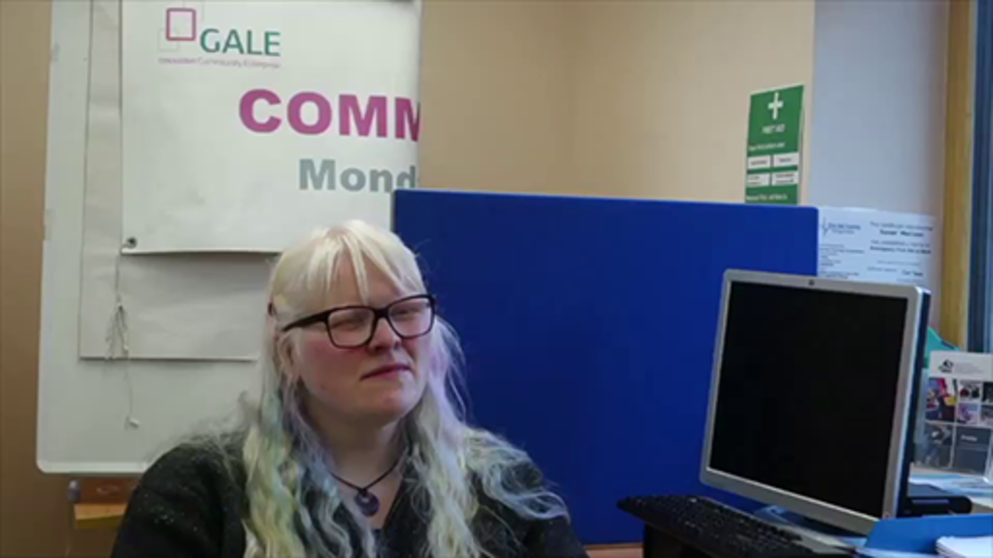

So, while you will need to understand what potential volunteers might expect from you, it is also important to be clear about the opportunities or activities on offer and what you expect from volunteers once they start. In the previous activity you were asked to consider your reasons for involving volunteers and what roles volunteers might carry out, which was the start of defining your expectations of volunteers.
Lisa at the Community Garden talks about what they do to help people decide if their group is the right choice for individuals considering volunteering. This work includes involving the local volunteer coordinator in promoting the Community Garden’s opportunities.

Video content is not available in this format.
Lisa, Co-convenor, Polbeth and West Calder Community Garden. All rights reserved.
View transcript - Lisa, Co-convenor, Polbeth and West Calder Community Garden. All rights reserved ...

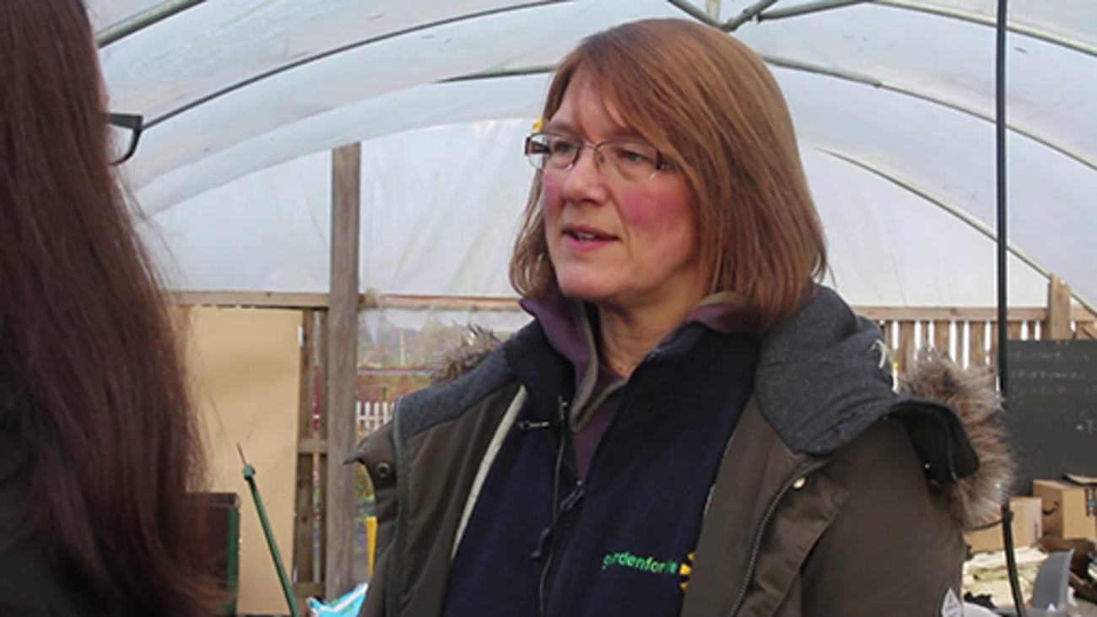

‘Is this right for me?’ activity
In the next activity, the focus is on what you can do to help a person decide if your group or organisation, and the potential volunteering roles on offer, will be right for them.

Activity 2

Potential volunteers rely on how clearly you can communicate what volunteers can expect so they are able to decide whether this might fit with their own expectations. It’s the step that gets them from the idea of volunteering to the decision to contact your group or organisation.
Some things to consider might be:
- How would a potential volunteer find out what to expect from you?
- How would they ask questions if they had specific needs?
- Are there written policies and procedures about volunteering?
You might want to discuss these questions with others. Don’t forget to record your reflections in your learning journal.

View discussion - Activity 2

2.3 Take action and be ready for volunteers
So far you have considered two key areas related to ‘thinking about volunteering’: ‘Be ready’ and ‘Is this right for me?’ The next step, having reflected on what is proportionate for your context, is to develop an action plan to help you make positive changes.
Actions you might want to take could include:
- ensuring you can communicate why your organisation or group involves volunteers
- being able to communicate what the benefits of involving volunteers will be, for both the individual and the organisation
- having identified how volunteers will be involved, drafting role descriptions that will help to make expectations clear
- being ready to share the group’s or the organisation’s expectations of volunteers, so potential volunteers can make an informed choice about whether to get started
- understanding what volunteers will be considering when deciding if your opportunities and group or organisation are right for them
- making a decision on which structures are needed to support the involvement of volunteers, such as a volunteer policy or volunteer agreement.

Activity 3

In your learning journal, note three actions that you want to take from the learning in this section. Prioritise these and write the most important one into your final action plan at the end of the journal.
You might have thought of something that wasn’t significant enough to write in your action plan, which you could do easily and would improve the experience for volunteers. Just do it now.

2.4 Further resources
You may find some of the following resources useful.
- There is lots of information available on the Volunteer Scotland website:
  - what volunteers can expect, including lots of volunteer’s stories
  - a wide range of volunteering opportunities in their opportunities database, which is searchable
  - if you want to write role descriptions
  - if you want to develop a volunteering culture in your organisation
  - if you want to define a volunteering strategy for volunteering
  - good practice guides, if you want to review other policies or procedures related to the involvement of volunteers.
- You can also access wider reading at the Volunteer Plain Talk and VolunteerWiki! sites.

3 Getting started

All rights reserved.
View description - All rights reserved.

This section is about getting a person started in a volunteering role with your group or organisation, and at Volunteer Scotland and CVSL (Centre for Voluntary Sector Leadership) we have found volunteers want you to ‘make it easy to get involved’.
Volunteers want to feel that your group or organisation is interested in them, so getting to know individuals who want to get involved is a critical stage. It is where people are matched with opportunities or activities, and where each party comes to know what the other expects and what they can each offer one another.
This is the point at which the question raised in Section 2.3, ‘Is this right for me?’, is realised. It is also about supporting new volunteers through the process of getting started so that they feel part of the team and ready to start their role.
From the volunteers’ perspective there are two essential areas that this section will cover:
- 'Be interested in me’ – volunteers say that when they are deciding if your organisation is right for them, they also want you to be interested in them and to ‘get to know the person’. This is important as it will help to ensure the right match between volunteer, role and the group or organisation.
- ‘I want to feel welcomed and encouraged’ – volunteers also say that they need the right information to carry out their role and to feel comfortable in your group or organisation, but for volunteers the top priority was a broad one of being made welcome.
These key areas are explored in more detail in this section.

3.1 ‘Be interested in me’
For the potential volunteer, this stage helps the person to reflect on whether this is the right place for them and decide if they want to get involved. They will want to:
- learn more about the group or organisation
- know what roles are available
- discuss what they can potentially bring to a role
- share what they hope to get out of it and understand if that can be met
- ask questions to help them decide if the opportunity is right for them.
At this stage the person is investing in the process, so they will expect detailed information in return, including a clear sense of the level of commitment, or what kinds of skills and training they will receive.
This is also when you will decide if the person is the right fit for your group or organisation. Bear in mind that some people lack confidence and might feel like they don’t have any skills to bring, so you may need to help draw this out. Others might be quite clear that they want to develop new skills, and you’ll need to consider how you can support them to do that in the role, if possible.

‘Be interested in me’ continued
Outlined below are some methods that might help you get to know potential volunteers and for them to better understand your group or organisation and the roles available.

Provide information at the point of enquiry
It can be useful to have some introductory information that you can send to someone who wants to know more. It could be your current role descriptions and information on how to get started, explaining what the volunteer can expect and how they’ll be supported, or just a quick chat over the phone.

‘Open’ sessions
Holding an open session is a chance for people to come along and find out more. Potential volunteers can be invited to meet current volunteers and have an opportunity to ask questions about their experience and get to know others. Organising these social events can be very effective in communities where you are trying to encourage people to become more involved in local initiatives or activities.

Taster sessions
A ‘taster’ session is where people have an opportunity to experience what it might be like to volunteer. This also allows others in the group to meet potential volunteers, and the individual will get a sense of where they might fit in. After all, there’s no point in taking someone right through the getting started process only for them to come along on the first day and decide it’s not for them.

Application process
Having a form that is appropriate for your context is a useful way to gather all sorts of information that you might need from a potential volunteer: from basics like contact details and availability to more detail on why they want to volunteer, what they could bring to the role or if they have any support needs.
The application process needs to be accessible and proportionate. In some cases, it might be an application form followed by an interview; in others, a set of questions you use in a chat to capture the essentials and complete on their behalf.
When capturing any personal information about individuals, it is important to ensure this is done in compliance with the Data Protection Act 2018. More information and guidance on this can be found on the Information Commissioner’s Office website.

Informal chat
No matter what other matching techniques you use, the most popular way of getting to know a potential volunteer is to meet with them for an informal chat or interview. However, it might not always be appropriate or even possible to do this for all contexts, such as large-scale volunteer involvement in events.
In addition, depending on the size of your group or organisation and the variety of roles, it could be good to involve others in meeting potential volunteers. Staff or volunteers that are ‘on the ground’ and will be working alongside a new volunteer are sometimes better placed to decide if someone will be right for a role.
In this video, James talks about why he feels it’s so important to ask a potential volunteer why they want to volunteer.

Video content is not available in this format.
James, Volunteering Manager, LGBT Youth Scotland. All rights reserved.
View transcript - James, Volunteering Manager, LGBT Youth Scotland. All rights reserved.

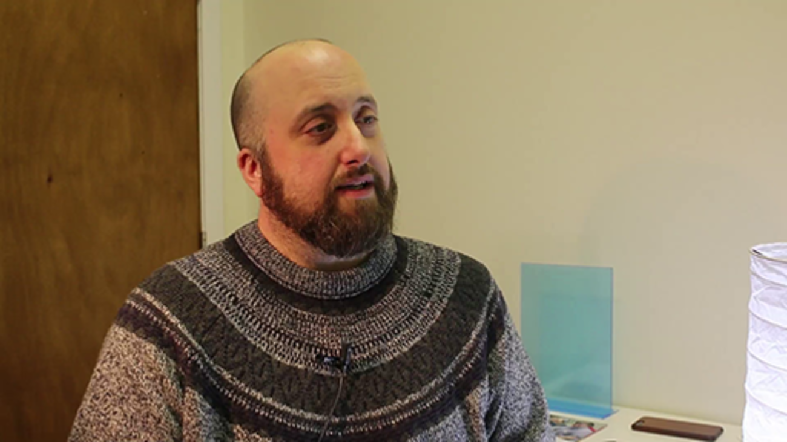

References
Having to provide a reference to volunteer can feel overly formal for some people. Indeed, for some people they might not have references to give and gaining a reference might be part of their motivation to volunteer. Due to this, insisting on two references might be a barrier for some individuals. It’s important to consider why you’re taking up references, what you hope to get out of it and make sure you explain this.

Protection of Vulnerable Groups (PVG) check or Disclosure
You will need to identify whether a role requires you to obtain a Disclosure or PVG check. You might consider having a recruitment of ex-offenders policy or a risk assessment procedure to help you respond appropriately to any disclosure returns. Where appropriate, evaluating this information along with any other information you have gathered is another way to help decide whether the potential volunteer is right for the role.
You can find out more about disclosure requirements in Scotland at mygov.scot. Volunteer Scotland has produced useful information on PVG for voluntary sector organisations.
In this video, Lisa from the Community Garden talks about their experience of matching people to roles, which is quite informal and based on interests and availability.

Video content is not available in this format.
Lisa, Co-convenor, Polbeth and West Calder Community Garden. All rights reserved.
View transcript - Lisa, Co-convenor, Polbeth and West Calder Community Garden. All rights reserved ...

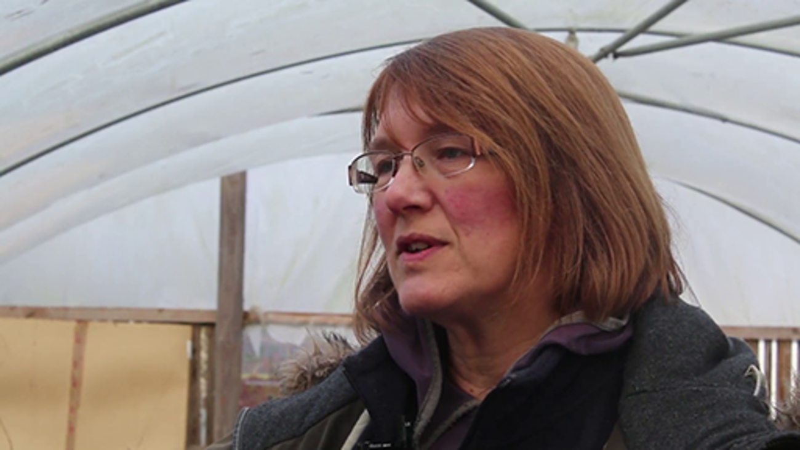

‘Be interested in me’ activity
In the next activity you are asked to reflect on your context and how you get to know potential volunteers and they get to know you.

Activity 4

- In your learning journal, write down five things you will need to know about a volunteer.
- Consider the methods that have been previously outlined and identify how you will find out this information about the potential volunteer.
- Write down five things that an individual might need to know about your group or organisation.
- Again, using the methods outlined, when and how will the potential volunteer be able to find out this information?
You might want to ask your current volunteers to help with these questions.
Don’t forget to record all this in your learning journal.

View discussion - Activity 4

3.2 ‘I want to feel welcomed and encouraged’
At this stage, a new volunteer has decided to take the next step and commit to volunteering with your group or organisation. They now need to be made to feel welcome and supported through the process of getting started.
We’ve all experienced being the new person somewhere and it can take a while to understand everything you need to know. So, creating an effective induction for new volunteers is crucial to make sure people know the group or organisation, feel part of the team, and get all the information and training they need for their role. Ultimately, you want to ensure that new volunteers are ready to ‘get started’ in their role so that they can go on to help make a difference.
While induction will sound like an appropriate word to some, to others it might sound unnecessarily formal. Volunteer Scotland has found many volunteers welcome the term induction as it provides clarity and, if done well, gives a sense of a group or an organisation being serious about involving volunteers in a meaningful way.
In this course the term induction is simply used to refer to the process you have that makes sure people feel ready to start in their role. For example, the Kilmaurs Gala Committee refer to this period as the ‘welcome’. Whatever the degree of formality, it ought to be proportionate to the context in which you operate, so you ensure it is easy for the volunteer to understand and get involved.
Lisa, from the Community Garden, talks about how induction differs depending on the role at the Community Garden.

Video content is not available in this format.
Lisa, Co-convenor, Polbeth and West Calder Community Garden. All rights reserved.
View transcript - Lisa, Co-convenor, Polbeth and West Calder Community Garden. All rights reserved ...

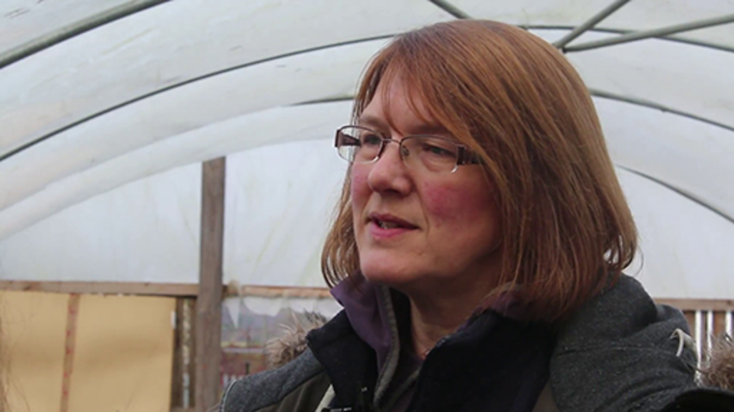

Depending on your context, some organisations also use the completion of an induction period, which includes relevant training, as another way of helping a volunteer decide whether they are right for the role. This time allows the volunteer to build confidence, understand the potential demands of the role, how they will be supported and start to build relationships with staff and volunteers.
If it is decided that the volunteer will not be suitable, they will need to be supported as it might be hard for an enthusiastic volunteer to realise they cannot fulfil the requirements of the role. This should include supporting them to find an alternative, more suitable role, either within your group or organisation or elsewhere.
In this video, James talks about learning more about volunteers during the training process and how this is managed if someone is not suitable.

Video content is not available in this format.
James, Volunteering Manager, LGBT Youth Scotland. All rights reserved.
View transcript - James, Volunteering Manager, LGBT Youth Scotland. All rights reserved.

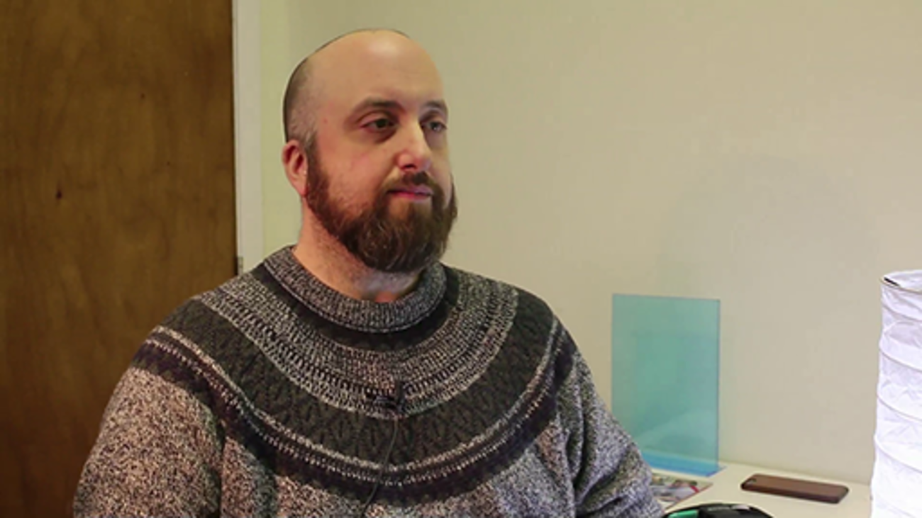

And here, Randi talks about the value of the training for him.

Video content is not available in this format.
Randi, Volunteer, LGBT Youth Scotland. All rights reserved.
View transcript - Randi, Volunteer, LGBT Youth Scotland. All rights reserved.

‘I want to feel welcomed and encouraged’ activity
When planning an induction process, the main thing you want to avoid is overwhelming a new volunteer with too much information. There are some key areas to consider and prioritise, which you will consider in the next activity.

Activity 5

Listed below are key questions to help you plan your induction process. Reflect on these and make notes in your learning journal.
- What? Write on post-it notes all the things you think a volunteer needs to know as they get started. Make sure you cover both information on the group or organisation and details for them to be effective in their role. Think about how you will also create space for people to express their own interests and get to know others in the group or organisation.
- When (priority)? Re-order your post-it notes to prioritise when on the volunteers’ ‘getting started’ journey you will share the information. Consider what is important enough that you want to make sure you cover it on day one, and what is less urgent.
- How? Induction is a process rather than an event. So, are you going to bring everyone together face to face to cover the top priority information? Or could some aspects be undertaken online or even read in a volunteering handbook? Does specific training need to be undertaken before starting, or could it be picked up ‘on the job’? You could also consider involving a longer-term volunteer as a buddy or mentor for people starting out. Considering these questions will also tell you the length of your induction period.
- When (delivery)? You also need to consider when the induction will be delivered. If you have asked a volunteer to make a monthly commitment on a Saturday, you can’t expect them to be available on a Monday and a Tuesday for two full days of induction.
- Where? For some groups or organisations you will also need to consider where you hold your induction to make it accessible for volunteers.

View discussion - Activity 5

3.3 Take action and be ready to get started
In this section you have considered two key areas related to getting started: ‘Be interested in me’ and ‘I want to feel welcomed and encouraged’. The next step, having reflected on what is proportionate for your context, is to develop an action plan to help you make positive changes.
Actions you might want to take could include:
- deciding on the methods that will help both the potential volunteer and your group or organisation to decide if you’re right for each other
- identifying how you will get to know new volunteers and show that you’re interested in them
- preparing what you want to cover during an induction process for volunteers
- deciding how and when you will share information with volunteers, so they are not overwhelmed
- designing an ‘induction’ process to make sure volunteers feel ready to start.

Activity 6

In your learning journal, note three actions that you want to take from the learning in this section. Prioritise these and write the most important one into your final action plan at the end of the journal.
You might have thought of something that wasn’t significant enough to write in your action plan, which you could do easily and would improve the experience for volunteers. Just do it now.

3.4 Further resources
You may find some of the following resources useful.
- Visit the Volunteer Scotland website:
  - if you want to think further about how to attract new volunteers
  - if you want to attend the Volunteer Scotland’s Supporting Volunteers course and learn more about supporting volunteers from their first enquiry right through their getting started stage
  - If you would like direction on the induction process, please read these guidance notes
  - for other relevant good practice guides.
- You can also access wider reading at the Volunteer Plain Talk and VolunteerWiki! sites.

4 Making a difference

All rights reserved.
View description - All rights reserved.

In this section we will explore making a difference, the third stage in the volunteer management model. People get involved in volunteering or community activities for a variety of reasons but often because they want to make a difference. Ensuring volunteers can see this difference means supporting them so they can make a difference and being clear about what difference they are making.
From the volunteers’ perspective there are two essential areas that this section will cover:
- ‘How am I supported?’ – volunteers say that they want to be supported to effectively undertake their role and make a difference. They want to be able to carry out their role in an environment that enhances and protects their wellbeing. It is also about effective communication that ensures the group or organisation knows how the volunteer is getting on in their role.
- ‘What have I achieved?’ – volunteers also say that they need to be able to see the bigger picture and the contribution that they have made, as this helps provide them with a sense of achievement, belonging and value.
These key areas are explored in more detail in this section.

4.1 ‘How am I supported?’
Volunteers need to be well supported to effectively undertake their roles and make a difference. This involves ensuring they can carry out their role in a safe and supportive environment. The practice of keeping volunteers safe goes beyond the legal health and safety requirements and is concerned with a broader sense of ‘wellbeing’.
In a recent paper on volunteering and wellbeing, personal wellbeing was defined as:

‘a particularly important dimension which we define as how satisfied we are with our lives, our sense that what we do in life is worthwhile, our day-to-day emotional experiences (happiness and anxiety) and our wider mental wellbeing.’

(Linning and Jackson, 2018)
In relation to health and safety, groups and organisations have a duty of care towards their people (including volunteers) so there is a need to assess potential risks and ensure the safety of volunteers. There is a section for voluntary organisations on the Health and Safety Executive website that outlines how the law applies when involving volunteers and contains useful checklists and guidance.
In this video, Tania at GALE talks about how they consider volunteers’ health and safety and wellbeing. She then goes on to talk about the value of support being provided in a relaxed and friendly environment as a way of building a positive relationship with volunteers.

Video content is not available in this format.
Tania, Volunteer Co-ordinator, GALE. All rights reserved.
View transcript - Tania, Volunteer Co-ordinator, GALE. All rights reserved.

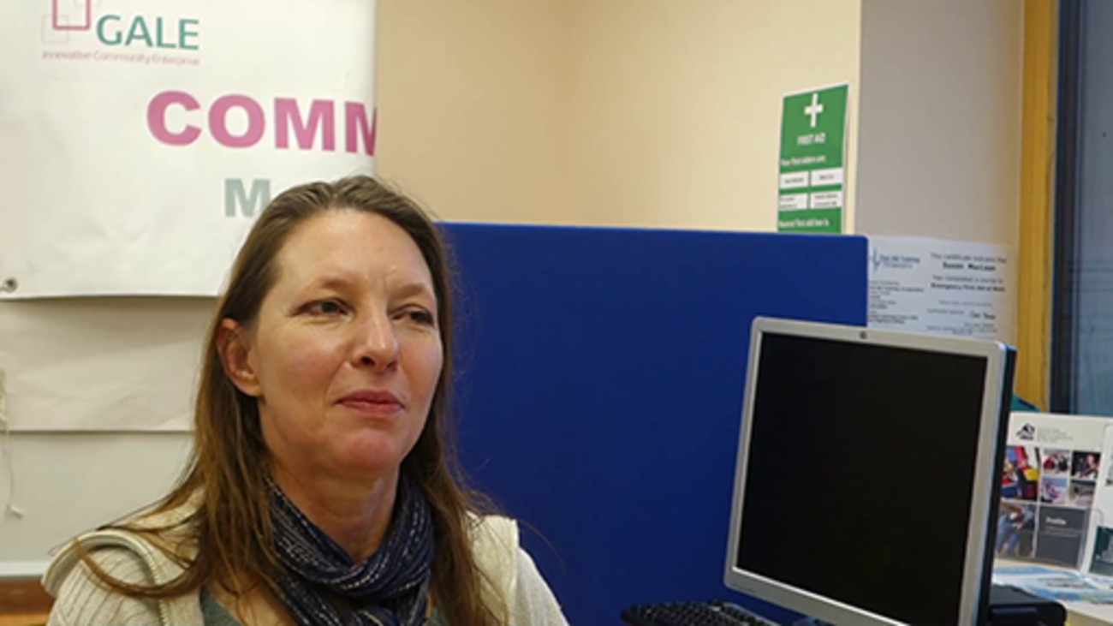

Considering that support needs to be proportionate to the context, for the Kilmaurs Gala Committee support is informal and often focused on wellbeing. Volunteers said, ‘We look out for each other’, and ‘We support each other and work as a team. We help each other and if someone can’t do a role or task we divvy it up and all take a role.’
Support can be both emotional and practical and it is important that volunteers know whom to go to for support, and that they feel able to raise any concerns should they arise. As Tania mentioned in the video, role-related support will involve catching up with volunteers to find out how they are getting on. Depending on the size of your group or organisation, it might also be necessary to communicate with other relevant staff members to find out how volunteers are getting on.
Jordan talks about his support for personal circumstances while volunteering, and how safeguarding training ensures he is not at risk.

Video content is not available in this format.
Jordan, Volunteer, LGBT Youth Scotland. All rights reserved.
View transcript - Jordan, Volunteer, LGBT Youth Scotland. All rights reserved.

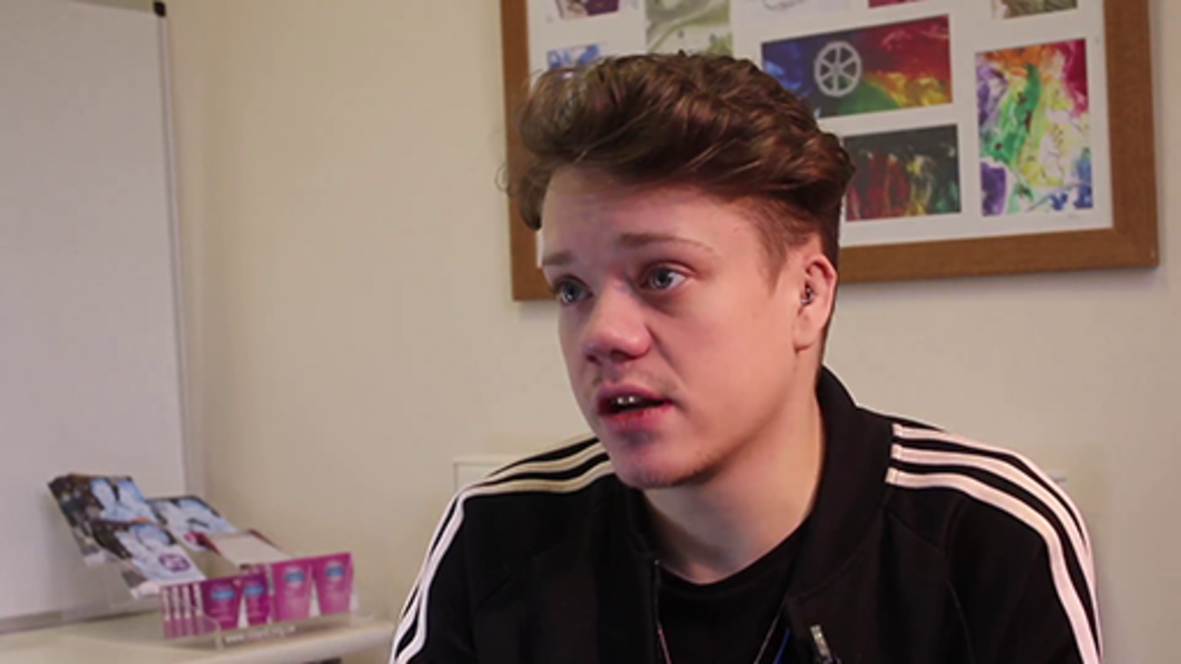

‘How am I supported?’ activity
In the next activity you are asked to think about the support your organisation offers their volunteers.

Activity 7

Thinking about what support is appropriate in your context, you may want to reflect on:
- Risks and ‘health and safety’ factors and how these are addressed.
- What kinds of support are available on a day-to-day basis to promote volunteers’ individual wellbeing?
- What are the long-term plans to support volunteers, including developing knowledge and skills?
- How are any specific support needs that relate to a person, their role or their individual circumstances addressed?
As you reflect, also think about when and where the opportunities present themselves to address any of these issues with volunteers. Have you asked volunteers how they would like to be supported? Remember it has to be proportionate for your context and right for the volunteers.
Don’t forget to note your thoughts in your learning journal.

View discussion - Activity 7

4.2 ‘What have I achieved?’
Volunteers have told us that they want to have a sense of satisfaction that they have achieved something; that their contribution of time and effort has been of value. Earlier, the course highlighted the importance of the link between an individual volunteer’s values and the values of a group or an organisation. These values are only meaningful if they are put into practice. For volunteers to understand what they have achieved you need to know what difference is being made by their contribution and then share this with volunteers.
To know what difference is being made you need to consider what you want to know. It is important to recognise the difference between the impact of volunteers, and the impact on volunteers. Often the impact on volunteers is positive and relates to the development of new skills, a growth in confidence or a feeling of personal satisfaction. Sometimes, though, the impact on volunteers can be negative, such as being put in a difficult situation without support or feeling stuck in a role and unable to change.
The impact of volunteers refers to the impact volunteers themselves have on the service delivered; for instance, the difference their contribution has made to service users. You might need to know this to demonstrate the added value that involving volunteers brings to your organisation.
Once you’ve decided what you want to know, you will have to decide how you will find this out. You will be able to get lots of useful information to demonstrate your impact by monitoring certain aspects of your delivery. Remember to collect and document this information as you go along. There is more information on the Volunteer Scotland website.
In this video, Lisa talks about the value of knowing how often the Community Garden is used and how many volunteers have contributed.

Video content is not available in this format.
Lisa, Co-convenor, Polbeth and West Calder Community Garden. All rights reserved.
View transcript - Lisa, Co-convenor, Polbeth and West Calder Community Garden. All rights reserved ...

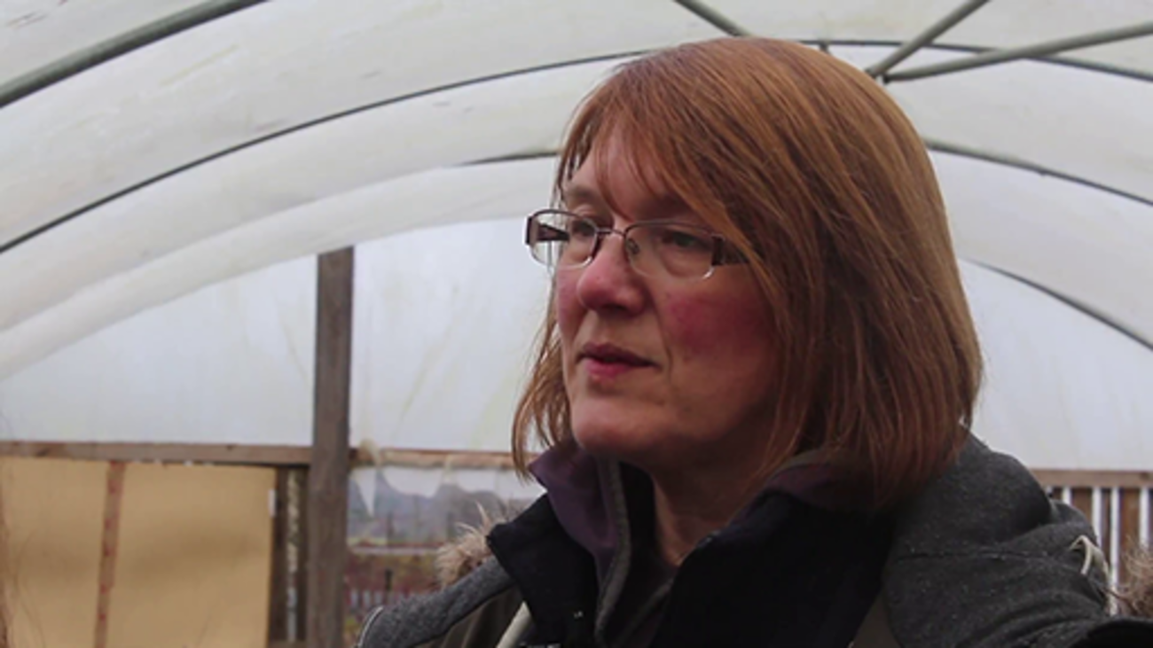

You might also want to speak to volunteers, staff and service users about their experience. As well as finding out about the impact on or of volunteers, it is also an opportunity to find out what is going well or what could be done differently. You could do this via a survey or by getting people together for a focus group.
James talks about triangulating data from volunteers, staff and young people to gain a complete picture of the difference made by volunteers.

Video content is not available in this format.
James, Volunteering Manager, LGBT Youth Scotland. All rights reserved.
View transcript - James, Volunteering Manager, LGBT Youth Scotland. All rights reserved.

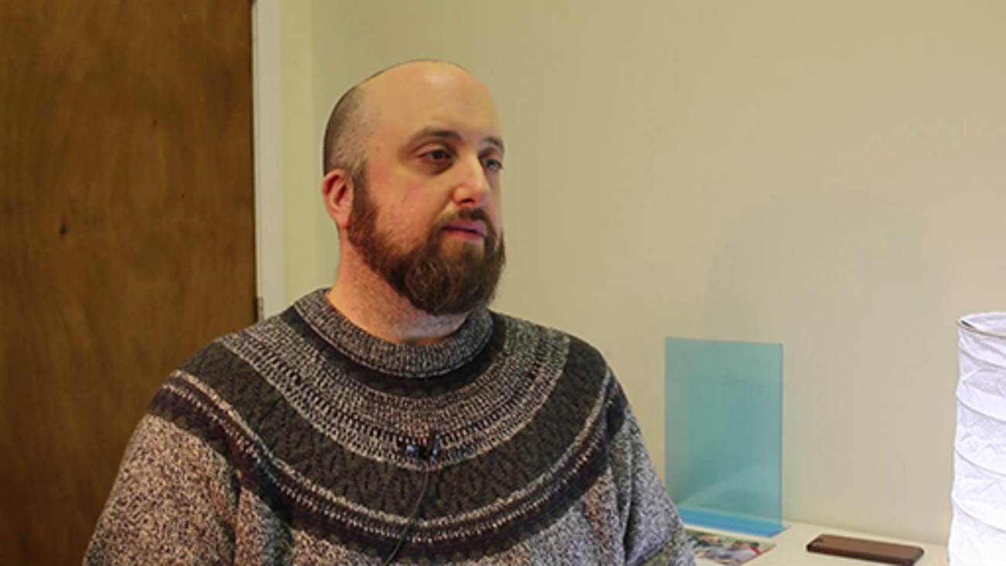

‘What have I achieved?’ continued
You also need to consider how you will share what you’ve found out with volunteers and celebrate their achievements. Letting volunteers know about the difference they have made is a great motivator.
The Kilmaurs Gala Committee said, ‘We share stories through Facebook and the local paper.’ They went on to say that they ‘give a vote of thanks at the AGM and we always tell people the amount of money that we raised for the village’.
For many volunteers, their sense of making a difference comes from the beneficiaries. A volunteer said, ‘We know we’ve made a difference because the people in the village tell us.’
Here Randi talks about what difference he thinks he makes, and the difference volunteering makes to him.

Video content is not available in this format.
Randi, Volunteer, LGBT Youth Scotland. All rights reserved.
View transcript - Randi, Volunteer, LGBT Youth Scotland. All rights reserved.

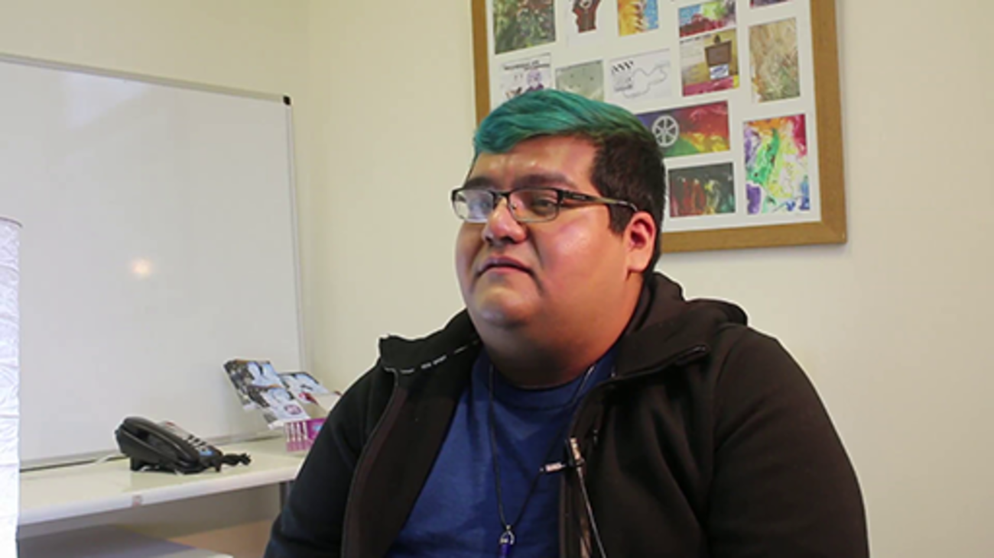

‘What have I achieved?’ activity
In this activity we’d like you to think about how your organisation monitors volunteers’ contributions and how you feedback to them about the difference they make.

Activity 8

Reflecting on what you have read, ask yourself:
- What do you want to know more about: the impact on volunteers or the impact of volunteers?
- What is the contribution that volunteers make on a day-to-day basis?
- How do you monitor volunteers’ contributions?
- What other methods might you use to evaluate what’s going well or what could be improved?
- Is the difference that their contribution makes clear to the volunteer?
- How do you communicate and celebrate this difference, both internally and externally, in a way that is proportionate for the context?
Don’t forget to record your reflections in your learning journal.

View discussion - Activity 8

4.3 Take action and be ready to make a difference
In this section you have considered two key areas related to making a difference: ‘How am I supported?’ and ‘What have I achieved?’ The next step, having reflected on what is proportionate for your context, is to develop an action plan to help you make positive changes.
Actions you might want to take could include:
- defining how volunteers will be supported in the day-to-day delivery of their role to ensure they feel valued
- identifying how you will support volunteers, both in terms of health and safety and their wider wellbeing
- deciding what support you can provide formally and what you can promote informally
- deciding what you want to find out about the impact of volunteering
- planning how you will find out what difference has been made by volunteers
- preparing how you will communicate this information to volunteers.

Activity 9

In your learning journal, note three actions that you want to take from the learning in this section. Prioritise these and write the most important one into your final action plan at the end of the journal.
You might have thought of something that wasn’t significant enough to write in your action plan, which you could do easily and would improve the experience for volunteers. Just do it now.

4.4 Further resources
You may find some of the following resources useful.
- Visit the Volunteer Scotland website:
  - if you want to know more about the link between volunteering and wellbeing
  - to read a case study about supporting volunteers in emotionally demanding roles
  - if you want to know more about having difficult conversations with volunteers, come on Volunteer Scotland’s ‘Supporting volunteers’ course
  - if you want to read more about inclusive volunteering
  - if you want to measure the impact of volunteers, email the team at volunteerpractice@volunteerscotland.org.uk
  - for other relevant good practice guides on the Volunteer Scotland website.
- Health and Safety in Voluntary Sector Scotland
- If you want to consider how you will resource volunteering, read VIVA – The Volunteer Investment and Value Audit.
- You can also access wider reading at the Volunteer Plain Talk and VolunteerWiki! sites.

5 Building on success

All rights reserved.
View description - All rights reserved.

This section explores how listening to volunteers is a vital part of ensuring a positive volunteering experience and offers an opportunity to improve service delivery as volunteers are often the welcoming face of a group or an organisation. Inviting volunteers to contribute to improving service delivery and the volunteer experience reinforces that their contribution is valued. Providing opportunities to grow and develop in a role is also important to ensure volunteers continue to have an enjoyable experience, although not all volunteers will want to ‘progress’.
At some point volunteers will want to ‘move on’, perhaps to a different role within a group or an organisation or perhaps to somewhere new. You also need to support volunteers when they choose to move on and plan for this. Everyone’s circumstances can change and it’s important to celebrate the time someone has given, rather than make them feel bad for needing to leave or to take a break from volunteering.
From the volunteers’ perspective there are two essential areas that this section will cover:
- ‘Enjoy it, love it, be happy!’ – volunteers say that they want their volunteering experience to meet their expectations. This might be opportunities to develop (in the role or into a new role), to have their views taken on board and to contribute more to the group or organisation, or continue to be supported in their role so they don’t ‘burn out’.
- ‘Don’t make me feel guilty, let me go!’ – volunteers also say that they want to have a positive ending to their volunteering, where they are encouraged to progress personally even if this is on to new things.
These key areas are explored in more detail in this section.

5.1 ‘Enjoy it, love it, be happy!’
Listening to and learning from volunteers will help you to identify where an individual’s expectations are not being met, and if they need any additional support to ensure that they continue to be happy. Pro viding appropriate opportunities for volunteers to express their views, including listening to and valuing their experience, lets volunteers know how important they are, while improving the effectiveness of your group or organisation.
Volunteers are often the face of a group or an organisation, interacting with people on a day-to-day basis, dealing with requests or complaints, raising revenue, providing information, care or support. This means volunteers have a special insight into what a group or an organisation does, how well it is performing and what it could do better.
In this video, James talks about getting feedback from volunteers during a national roadshow, which led to improvements in how volunteers can share ideas and learn from each other.

Video content is not available in this format.
James, Volunteering Manger, LGBT Youth Scotland. All rights reserved.
View transcript - James, Volunteering Manger, LGBT Youth Scotland. All rights reserved.

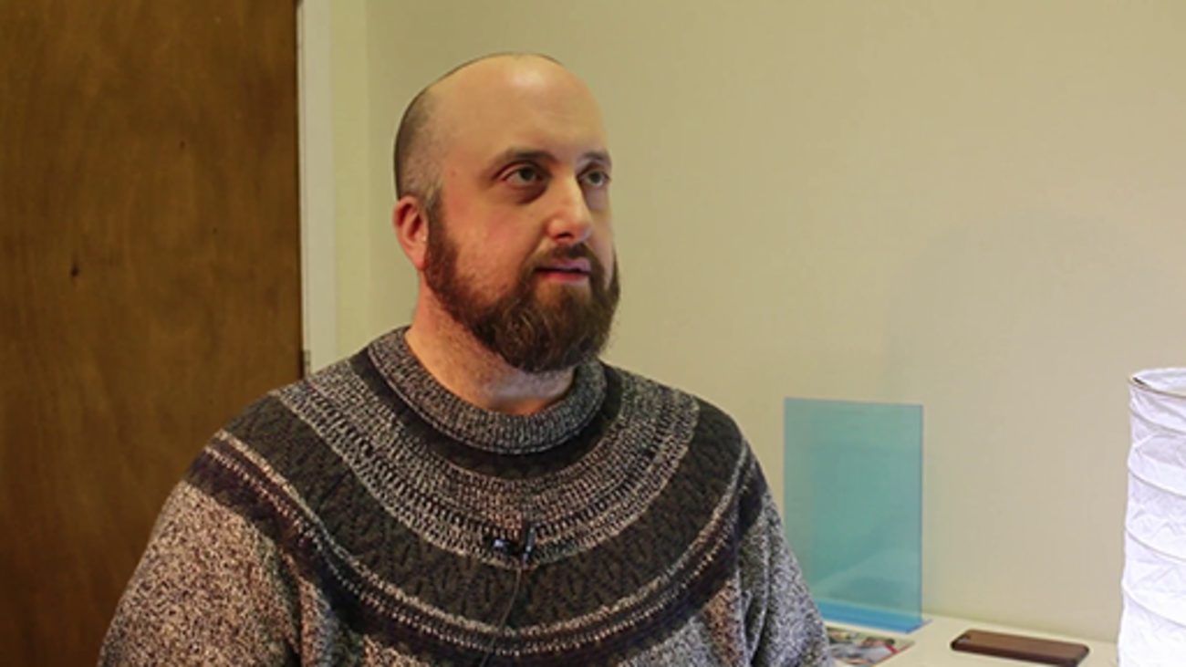

For some volunteers, a sense of enjoyment and satisfaction in their role can also come from interaction with service users rather than from their own progression. In this video, Randi talks about gaining a great deal from both the communications he has with LGBT Youth Scotland, and the young people that attend the groups.

Video content is not available in this format.
Randi, Volunteer, LGBT Youth Scotland. All rights reserved.
View transcript - Randi, Volunteer, LGBT Youth Scotland. All rights reserved.

Rebecca highlights that new opportunities are often offered, and she feels able to suggest ideas.

Video content is not available in this format.
Rebecca, Volunteer, GALE. All rights reserved.
View transcript - Rebecca, Volunteer, GALE. All rights reserved.

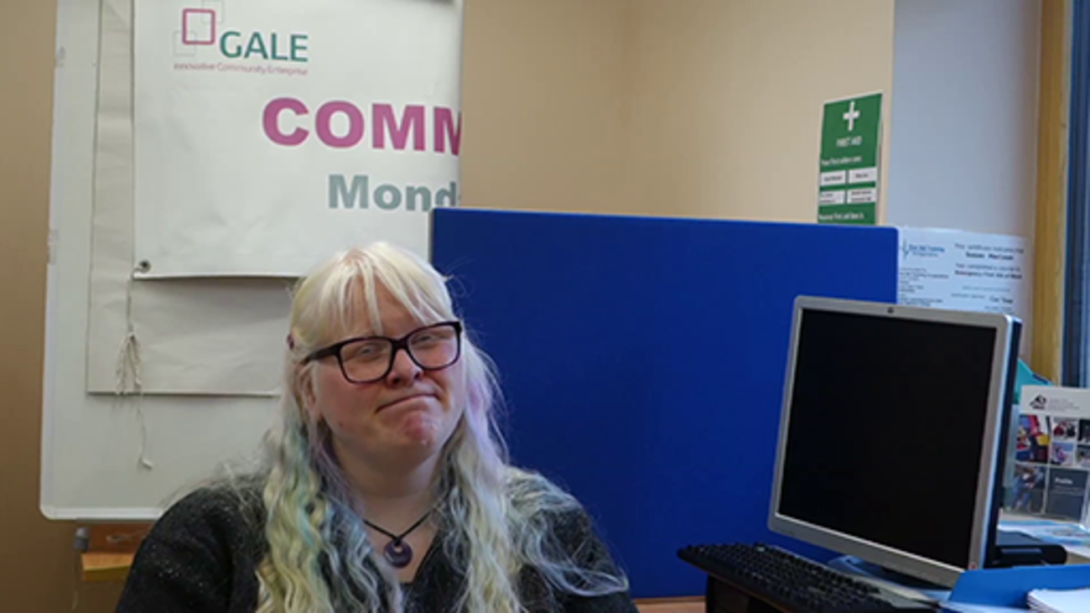

An important aspect of ensuring people are happy whilst volunteering is to be aware that, as much as you want to offer opportunities for further engagement to volunteers, you don’t want to ask too much of them either. It is detrimental to a volunteer’s health and wellbeing if they take on too much, so you need to support volunteers to ensure this doesn’t happen.
You also need to check in with volunteers to ensure that their experience continues to meet their expectations. For instance, the Kilmaurs Gala Committee said, ‘If people are struggling with the role we will change it, or we will all help them achieve it. We all get to know each other’s job because we have to step in and help each other out.’
In this video, Lisa talks about how they all need to look out for each other as they are all volunteers.

Video content is not available in this format.
Lisa, Co-convenor, Polbeth and West Calder Community Garden. All rights reserved.
View transcript - Lisa, Co-convenor, Polbeth and West Calder Community Garden. All rights reserved ...

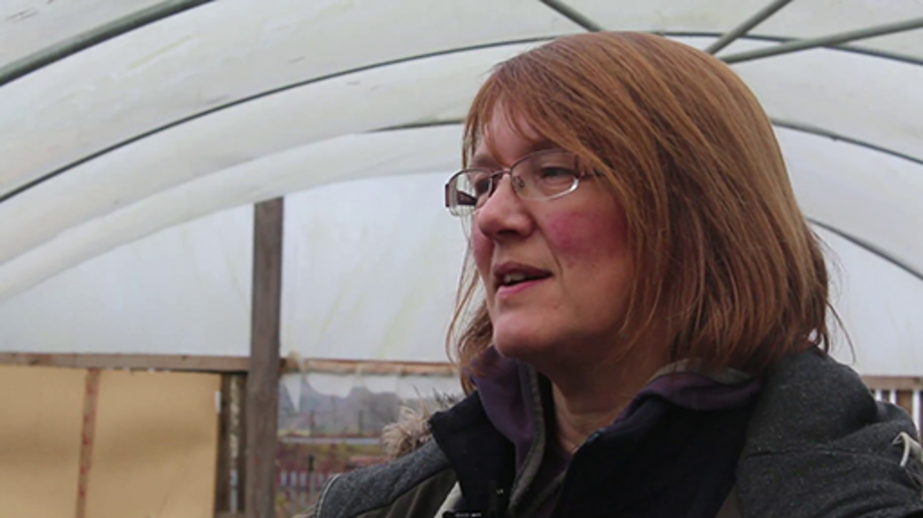

‘Enjoy it, love it, be happy!’ activity
In this activity you are asked to think about how you listen to and learn from volunteers, to ensure an individual’s expectations are met and they continue to love their volunteering.

Activity 10

Thinking about the opportunities to listen to and learn from volunteers that are appropriate in your context:
- What kinds of opportunities exist at present for volunteers to share their reflections and learning?
- What happens to any insights, recommendations or offers from volunteers? How are they acted on? How are volunteers involved in the process?
- Can volunteers see evidence that their views matter and the group or organisation learns from them?
- How do you continue to support volunteers to ensure that their volunteering is meeting their expectations and they are not taking on too much?
Don’t forget to record your reflections in your learning journal.

View discussion - Activity 10

5.2 ‘Don’t make me feel guilty, let me go!’
People’s circumstances change, and you can’t expect volunteers to stay with you forever. For example, if volunteers say at the beginning of their volunteering that their main motivation is to gain experience in a particular field, then, they might want to be supported to move on through the provision of a reference. Or, volunteers might want support to develop into a new role within your group or organisation, or elsewhere.
Volunteers might simply have a change in wider personal circumstances and find that they no longer have the same time available to offer, or that they’ve achieved what they wanted to through their volunteering. On occasion, volunteers leave because they have decided the role, or the group or organisation is not right for them.
Whatever the reason, it’s useful to try and get feedback from volunteers as they leave, which can then inform future service delivery, volunteers’ activities or roles. And again, whatever the reason, it’s important to acknowledge the contribution that the volunteer has given.
Here, James talks about managing volunteers leaving and how he seeks feedback.

Video content is not available in this format.
James, Volunteering Manger, LGBT Youth Scotland. All rights reserved.
View transcript - James, Volunteering Manger, LGBT Youth Scotland. All rights reserved.

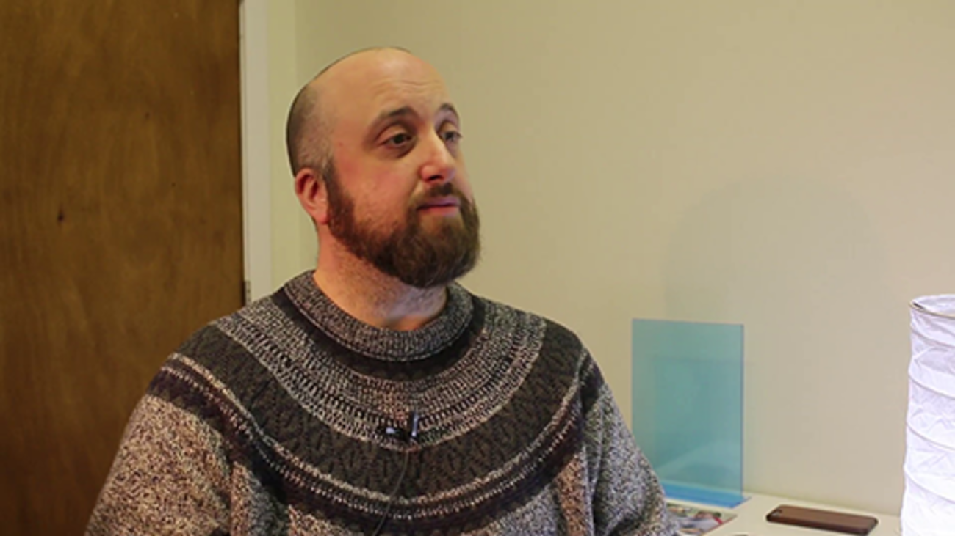

Accepting volunteers will leave means accepting the need to consider succession planning, which can be particularly important for small groups where everyone is a volunteer. Volunteers have said that some of the guilt that can be felt when wanting to leave comes from knowing a group has not really thought about how to replace them.
Some groups or organisations can become very reliant on the skills of certain individuals; sometimes it is the specialist knowledge they bring with them, sometimes it is the expertise they have developed through their volunteering. However, this is not just a problem for small groups. Groups or organisations of any size can become reliant on a particular volunteer, perhaps even taking their contribution for granted.
In this video, Tania talks about the challenge of finding new volunteers in a rural community.

Video content is not available in this format.
Tania, Volunteer Co-ordinator, GALE. All rights reserved.
View transcript - Tania, Volunteer Co-ordinator, GALE. All rights reserved.

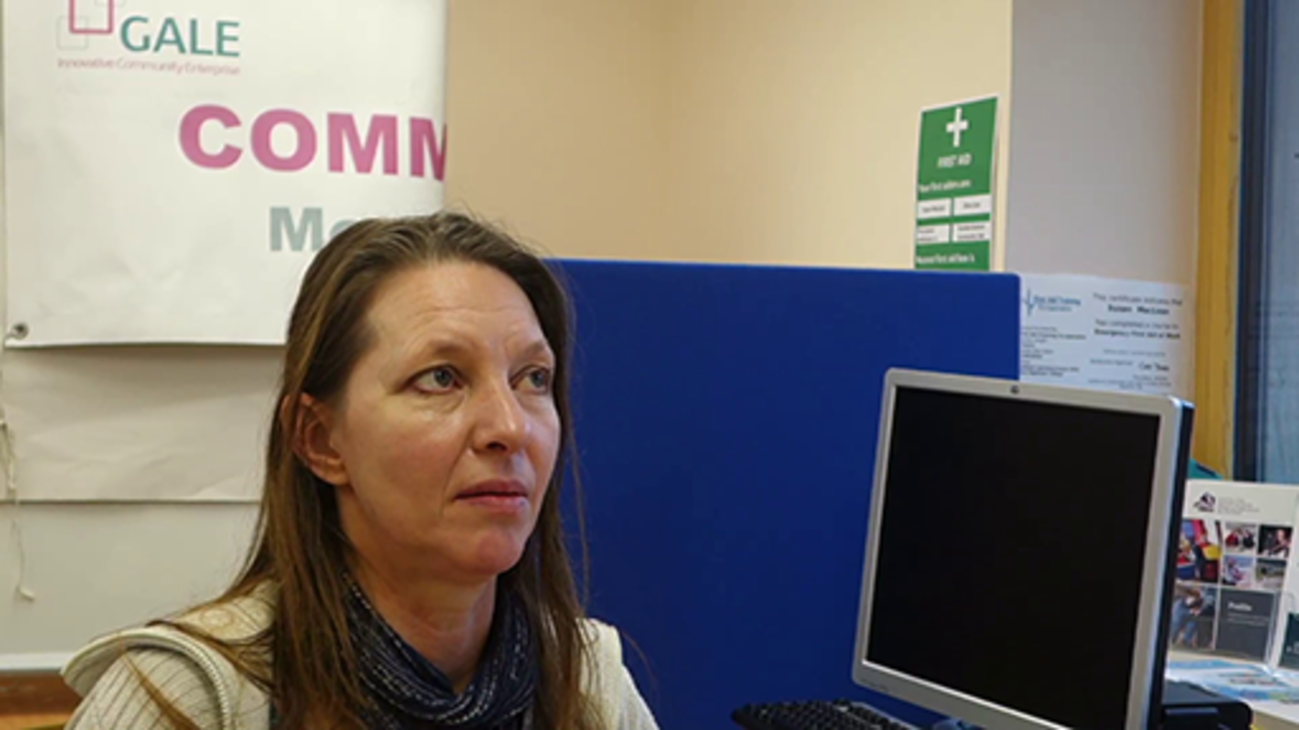

‘Don’t make me feel guilty, let me go!’ activity
We’d now like you to think about how your organisation supports volunteers when they wish to leave.

Activity 11

Thinking about what is appropriate in your own context consider:
- How can you support volunteers in their personal development that would allow them to grow into a new role in your organisation or elsewhere?
- Are there appropriate mechanisms in place to learn from volunteers before they move on?
- When volunteers do move on, how is their contribution recognised?
- How are you planning to ensure you will continue to involve more volunteers in the future?
Don’t forget to record your reflections in your learning journal.

View discussion - Activity 11

5.3 Take action to be ready to build on success
In this section you have considered two key areas related to building on success: ‘Enjoy it, love it, be happy!’ and ‘Don’t make me feel guilty, let me go!’ The next step, having reflected on what is proportionate for your context, is to develop an action plan to help you make positive changes.
Actions you might want to take could include:
- planning how you will make sure you listen to volunteers and learn from their experience
- being prepared to act on suggestions for development made by volunteers
- planning how you will support volunteers to ensure that their volunteering meets their expectations
- identifying how you can support volunteers in their personal development, either within the role, or when they decide to move on
- deciding how you will celebrate the contributions made by volunteers when they decide to move on
- planning to ensure that you continue to have enough volunteers in the future.

Activity 12

In your learning journal, note three actions that you want to take from the learning in this section. Prioritise these and write the most important one into your final action plan at the end of the journal.
You might have thought of something that wasn’t significant enough to write in your action plan, which you could do easily and would improve the experience for volunteers. Just do it now.

5.4 Further resources
You may find some of the following resources useful.
- Energize Inc. website:
  - if you want to think more about ongoing recognition of volunteers
  - if you want to recognise volunteers by offering them personal development
- Volunteer Plain Talk website:
  - if you have questions about the retention of volunteers
- Volunteer Scotland website:
  - for other relevant good practice guides
- You can also access wider reading at the Volunteer Plain Talk and VolunteerWiki! sites.

6 Developing your practice

All rights reserved.
View description - All rights reserved.

This course asks you to reflect on the essential elements that volunteers and those supporting them consider to be key to ensuring a positive volunteer experience. The focus is on practical things: asking you to consider what may already be familiar issues and encouraging you to create the space to explore the relevance of these.
The course does not attempt to provide all the answers, instead it asks you to consider some key questions and helps to point you to some relevant sources of information that will enable you to explore these themes in more detail.
While you may be focused on improving your practice, it is also worth considering the wider context of volunteering where you are, as this will influence your volunteer involvement.
This section begins by outlining the landscape of volunteering in Scotland. It then goes on to highlight sources of support you might want to access.

6.1 Volunteering in Scotland
Having thought about volunteer engagement in your setting, it is worth considering how the wider landscape of volunteering in Scotland might impact on how you intend to involve people.
In Scotland, the annual Scottish Household Survey (SHS) asks participants about volunteering. From this, we know that 27% of adults aged 16 and over had volunteered at least once in the last 12 months (2017). And those people who say that they volunteer weekly make up only 12% of the adult population.
So, those groups and organisations that need a weekly contribution are reliant on a small proportion of the population. Volunteer Scotland has carried out further analysis of the SHS survey findings, which can be found on their website.
Volunteer Scotland has also undertaken research into youth volunteering (11–18 years) and the volunteer rate has increased dramatically from 33% in 2009 to 52% in 2016. This paper, Young People and Volunteering in Scotland 2016, provides information on the different ‘push’ and ‘pull’ factors that encourage young people to volunteer.
The National Council for Voluntary Organisations (NCVO) has published a report on the volunteering experience called Time Well Spent. It explores how volunteering fits into people’s lives, what a quality volunteer experience looks like and how to better engage potential volunteers.
Investing in Volunteers (IiV) is the UK’s quality standard for volunteering. There are six quality areas and organisations are supported to develop in these areas to achieve the award. This course reflects the IiV standard and you can find out more on the Investing in Volunteers website.
Volunteer Friendly is a Scotland wide quality standard, to support, develop, reward and recognise volunteer programmes. It is designed for small groups/organisations who may not be ready to undertake IiV. Find out more on the Volunteer Friendly website.

6.2 Developing your reflective practice
This course encourages you to reflect on your practice. Being a reflective practitioner is about the cycles of observation, reflection and action. It is worth revisiting the reflective practice link that was shared earlier and, if you have not done so already, looking at the next section of this OpenLearn course, which considers how one’s practice is transformed through reflection.
Part of developing your practice is seeking opportunities to grow and develop. Some of these might be learning needs you identified through this course. As well as learning for and from your practice, you may want to access further learning materials.
The Open University offers a range of free learning resources, including Introducing the Voluntary Sector. In addition, there are more courses from the Centre for Voluntary Sector Leadership, such as Leadership in Voluntary Organisations and Collaborative Leadership in Voluntary Organisations.

6.3 About Volunteer Scotland and CVSL
Volunteer Scotland is the national body for volunteering in Scotland and exists to help you make a difference through volunteering. Scotland, more than ever, needs us all to share in the nation’s common good. The potential to bring out the best in us has never been better and we’re supporting you by:
- recognising the need for volunteers and demonstrating how this makes a difference
- understanding what volunteers and volunteer-involving organisations want to do
- making volunteering easy for everyone, so that more people volunteer and have a great time.
The Centre for Voluntary Sector Leadership (CVSL) is hosted by The Open University Business School. It builds on The Open University Business School’s expertise in leadership in the voluntary and public sectors and in open and distance learning, engaging in a range of academic research, policy work, and working in partnership with practitioners. You can learn more by visiting the CVSL website.

6.4 Acknowledgements
The course was developed in partnership by Volunteer Scotland and The Centre for Voluntary Sector Leadership. At Volunteer Scotland the writing was led by Zoe MacGregor with contributions from Adrian Murtagh and Gemma Jackson. And at The Centre for Voluntary Sector Leadership, invaluable development support was provided by Ronald Macintyre, Carol Jarvis, and James Rees.
We would like to thank all the volunteers and staff who contributed to the initial workshops and pilot that gave us invaluable feedback that was vital to shaping our understanding of how to ensure a positive experience for volunteers. The volunteers and staff that contributed come from a wide variety of groups and organisations and we have tried to reflect their breadth of experience in this course and through the selection of the case studies. We are especially grateful for the time given by the organisations involved in developing the case studies. You can find details on each of them, starting with Kilmaurs Gala Committee, on the following pages.
This course is licensed under Creative Commons CC BY SA NC which allows non-commercial sharing, revising, remixing of the content as long as it is shared again under the same licence. All the images and video were created by Volunteer Scotland and all rights are reserved, if you want to use any of the images or videos for anything other than private study then please contact Volunteer Scotland.

Kilmaurs Gala Committee
Kilmaurs Gala Day started in 1922, and the current Gala Committee and a group of local community members re-started the event in 2006, after a period of inactivity. They are a constituted group supported by the local community, businesses, Kilmaurs Primary School and East Ayrshire Council.
All 30 event volunteers are co-ordinated by a voluntary committee of seven. They uphold a local tradition by organising a week of activities around the village, including a fun run, a car treasure hunt, a bowling competition, a village quiz night and a local business fundraising event. The week of events end with the celebration of a village gala day at the local park, which includes stalls, fun events and the crowning of the gala queen.
In the course, there are quotes from committee members and other active volunteers.

Polbeth and West Calder Community Garden
Polbeth and West Calder Community Garden was started in 2011 by a group of local interested people. By 2013 they had moved through being a constituted group to being a Scottish Charitable Incorporated Organisation (SCIO) and had signed a five-year lease for the site they currently use.
Everyone is a volunteer and they have a Board of Trustees representing the groups who use the site, with bimonthly volunteer meetings. In 2017/18 the Community Garden had 80 individual volunteers giving their time, not including school and nursery visits.
On site there are 3–5 Green Gyms per week, 5 Open Days per year, various workdays, and local schools and nurseries visit for sessions. The Community Garden also runs specific meetings to which all volunteers are welcome. The site is open to the public 24 hours a day, every day of the year, and hosts the first, and as of 2019, the only Stickman Trail in Scotland.
In the course there are contributions from Lisa, the voluntary Co-convenor of the board.

Video content is not available in this format.
All rights reserved.
View transcript - All rights reserved.

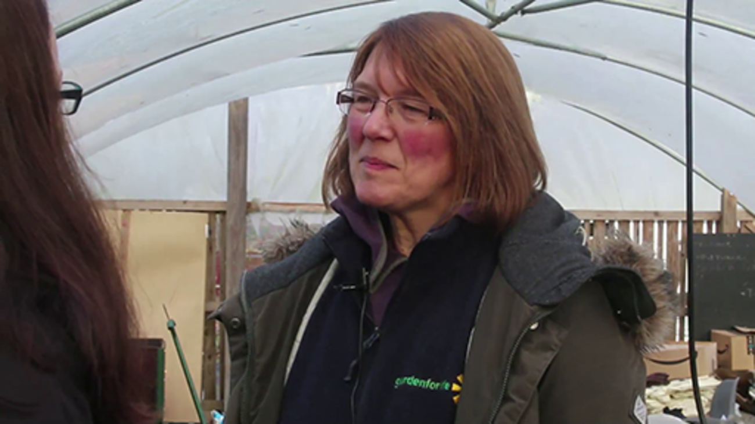

Gairloch and Loch Ewe Action Forum
Gairloch and Loch Ewe Action Forum (GALE) is a self-financing, community-owned and managed, development trust, social enterprise and charity. GALE believes that volunteers are literally their roots and branches, for they were started by volunteers and the areas of growth are largely volunteer driven.
GALE was established in 1997 by a group of volunteers who were concerned by the loss of key services in the area, which is a remote, economically fragile, rural location. Their ethos is to develop a sustainable economy, one that empowers the community to make decisions for itself and focus on what is important for its residents.
The projects are volunteer driven, which reflects where the desire of the community lays. The enthusiasm and engagement of volunteers enabled GALE to then consider employing someone to manage a project and drive it forward. This is an organic process and one that has made GALE the successful organisation that it is today.
The GALE Centre was built about seven years ago. The Centre contains a community café, local craft retail outlet, independent tourist information, and units that are currently rented to West Highland College, part of the University of the Highlands and Islands. GALE has also achieved the Investing in Volunteers quality standard.
In the course, there are contributions from Tania MacKenzie, the Volunteer Co-ordinator, and a volunteer, Rebecca.

Video content is not available in this format.
All rights reserved.
View transcript - All rights reserved.

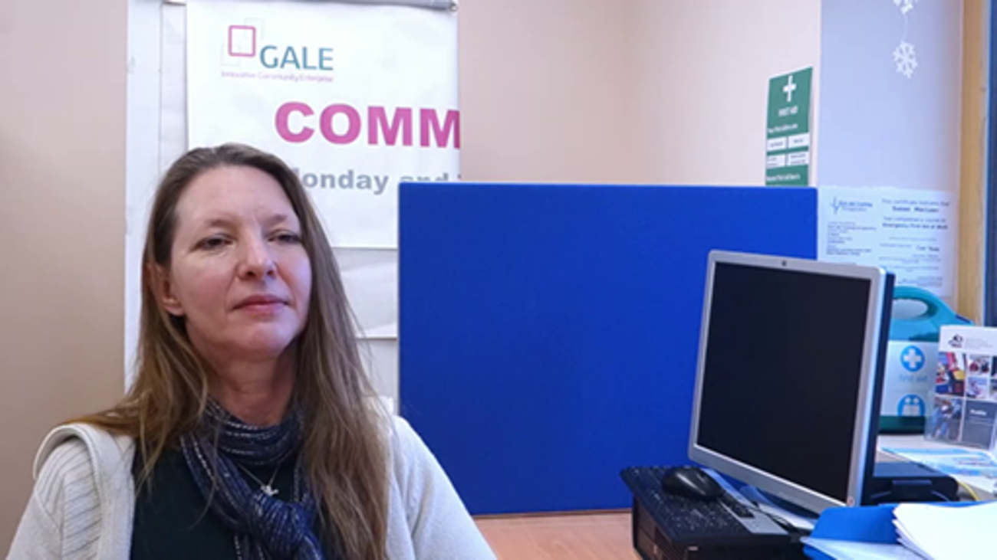

Video content is not available in this format.
All rights reserved.
View transcript - All rights reserved.

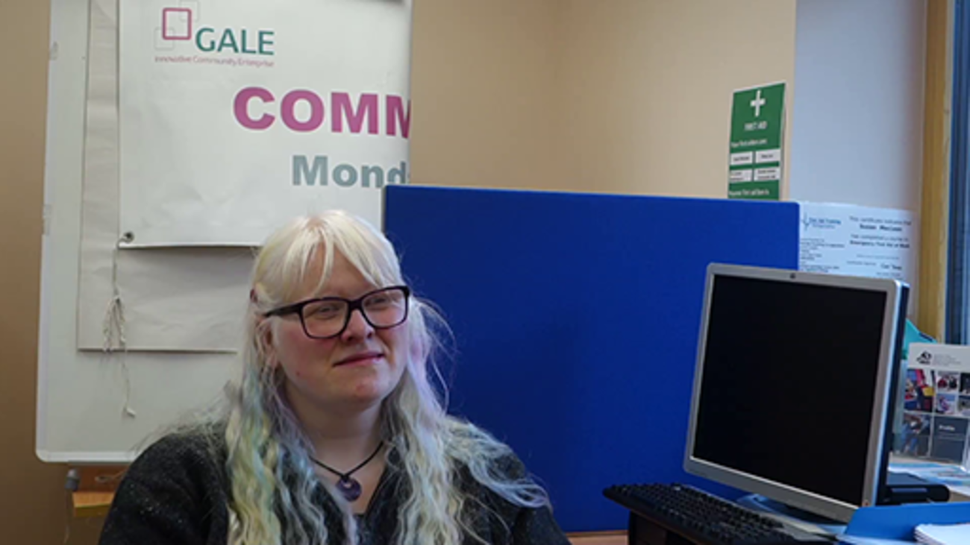

LGBT Youth Scotland
LGBT Youth Scotland is Scotland's only national youth and community-based organisation leading on the inclusion of lesbian, gay, bisexual and transgender (LGBT) young people. They work across Scotland supporting the development of local sustainable services. Their work includes specialist youth group provision as well as training and outreach, often in partnership with other local youth services. There are over 100 volunteers across Scotland who carry out direct youth work in groups and online, fundraise, run events and much more.
LGBT Youth Scotland’s vision is that Scotland is the best place to grow up for lesbian, gay, bisexual, transgender and intersex (LGBTI) young people. Their mission is to play a leading role in the provision of quality youth work to LGBTI young people that promotes their health and wellbeing, and to be a valued and influential partner in LGBTI equality and human rights.
In the course, there are contributions from James Whyte, the Volunteering Manager, and two volunteers, Jordan and Randi.

Video content is not available in this format.
All rights reserved.
View transcript - All rights reserved.

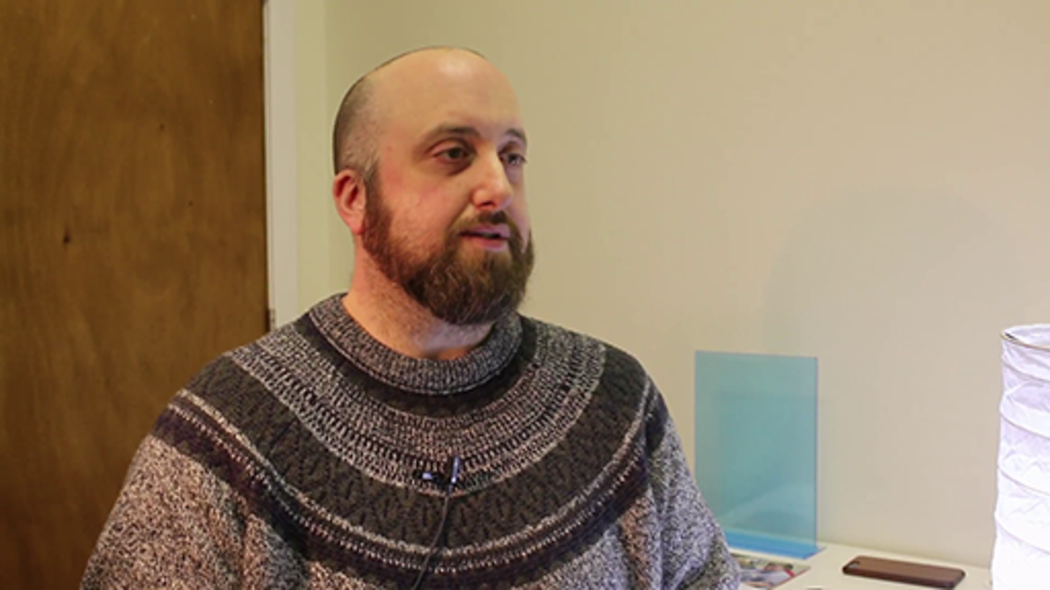

Video content is not available in this format.
All rights reserved.
View transcript - All rights reserved.

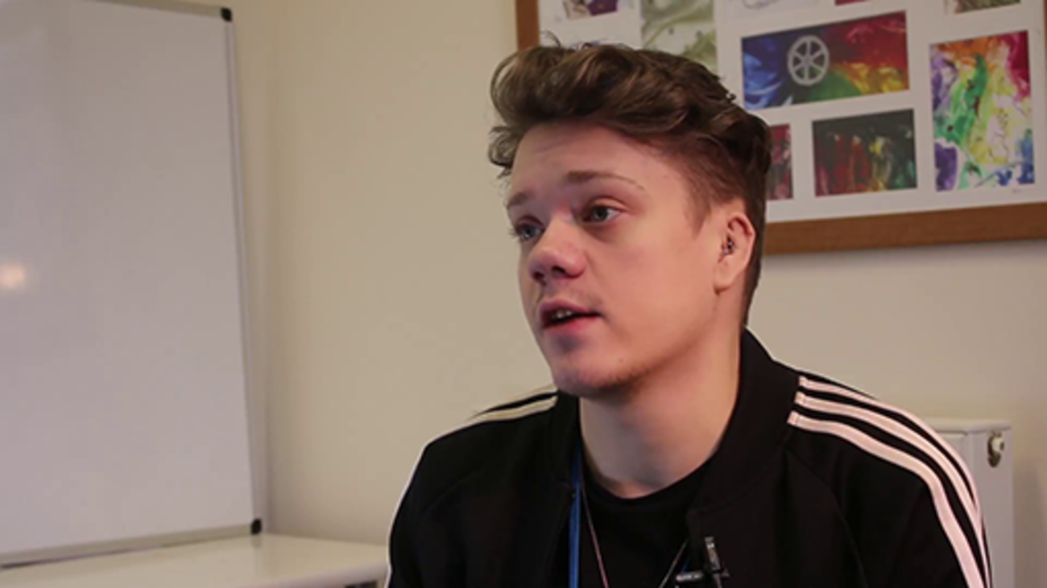

Video content is not available in this format.
All rights reserved.
View transcript - All rights reserved.

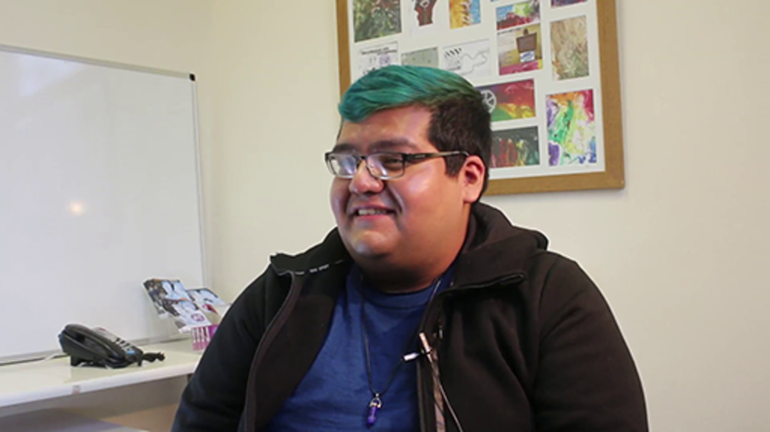

6.5 Further resources
You may find some of the following resources useful.
- Scottish Council for Voluntary Organisations (SCVO)
- National Council for Voluntary Organisations (NCVO)
- Association of Volunteer Managers
- Voluntary Sector Studies Network (VSSN)
- Third Sector Research Forum
- Third Sector Research Centre
- Energize Inc. website
- E-Volunteerism

7 Evaluation and thanks
Thank you for taking the time to complete this course and we hope that you have found it useful for your practice. Throughout the course we have tried to represent the scale of volunteer practice from small community groups to large national organisations, as we believe that the core of best practice can and is seen within these volunteer programmes. Please remember to always relate your learning to your current situation and share your volunteer practice with others.
We would really like to hear from you about your experience of undertaking this course. Please complete this online survey to tell us more. Evaluation feedback is anonymous and will be collated and reviewed to inform course updates.

Solutions

Activity 1

Discussion
In 2016, Historic Environment Scotland undertook a survey of volunteering across the historic environment sector. The top two reasons for involving volunteers were given as: ‘volunteers improve community engagement’ and ‘volunteers increase capacity of the organisation’. You can find out more in their report, Volunteering and the historic environment.

Role descriptions
Something that you might want to consider when thinking about involving volunteers is producing a role description. It’s worth bearing in mind that role descriptions don’t necessarily have to be written. If you’re involved in an informal group, you might find that there is a shared understanding of the different volunteer roles and expectations, and that this can be shared with potential volunteers.
Volunteer Scotland has found that people often like to have an idea of what they’re signing up to before they get in touch, and not providing this picture might put a few people off. So, it is worth asking yourself whether even a brief role description is appropriate in your context.
In this video, James at LGBT Youth Scotland briefly outlines the roles that volunteers are involved in.

Video content is not available in this format.
James, Volunteering Manager, LGBT Youth Scotland. All rights reserved.
View transcript - James, Volunteering Manager, LGBT Youth Scotland. All rights reserved.

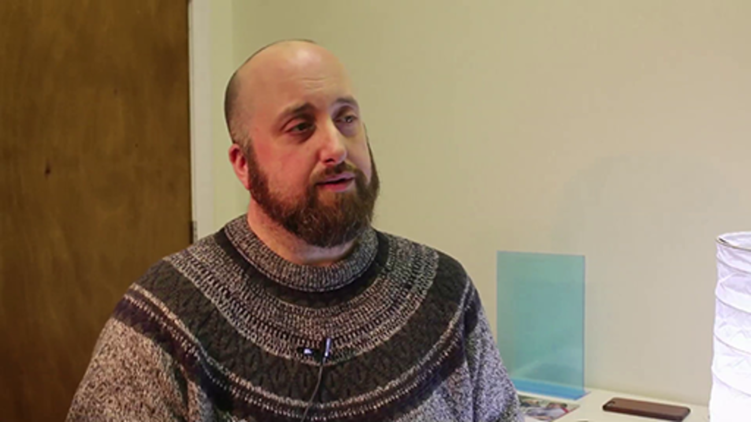

Here is an example of a role description to give you an idea of the kinds of things it might contain. It’s taken from the environmental charity Trees for Life. It is worth noting the description is:
- written from the volunteers’ perspective, using key questions they might want to know the answer to
- not for a very ‘glamorous’ role, but the charity is honest about it; this helps clarify the expectations of the role
- written in a friendly and approachable way
- concerned with the practicalities of engaging volunteers, such as the provision of accommodation and making sure volunteers are not out alone at night.
There are no details on how long the opportunity is for and this might leave the reader unclear if they are able to commit. However, this might be due to the opportunity being closed at the time of writing this course.
Back to - Activity 1

Activity 2

Discussion
Many groups and organisations make use of a Volunteer Policy and Volunteer Agreement, which set out the organisation’s approach to involving volunteers and what both the volunteer and the group or organisation can expect.
In the Prince’s Trust’s Volunteer Policy (available on their website), you can see that they’ve introduced why they involve volunteers (discussed in Activity 1) and then gone on to outline under key headings what a volunteer can expect.
You can see some further examples of volunteer policies on these websites:
- Whizz-Kidz
- National Autistic Society .
At its simplest, the volunteer agreement could be a conversation between the volunteer and the person supporting their involvement. Ideally, each agreement will be unique for each volunteer. You can find out more about writing a Volunteer Agreement in the Good Practice Guide on the Volunteer Scotland website.
As you speak to more potential volunteers you will begin to build a picture of what expectations are typical and you can then make sure that you communicate these to potential volunteers. This will help them make that important decision about choosing to contact your group or organisation.
Back to - Activity 2

Activity 4

Discussion
To ensure new volunteers have a good experience when getting started with their chosen group or organisation, you need to think about making this process as streamlined and as easy as possible. Volunteers are going to be put off by a process that takes too long or has seemingly unnecessary hurdles.
In some cases, getting to know new volunteers will be informal – perhaps a conversation at an event or over a cup of tea. Other situations will require a degree of formality proportionate to the context.
The volunteers for the Kilmaurs Gala Committee said, ‘I went to the meeting and got an idea of what they did’ and ‘I was asked to do things and then I started to suggest things to do’. As a volunteer-led organisation, this level of flexibility seems to work well for all involved, with the volunteers on the committee reflecting on how this informal approach allows them to ‘get to know [the volunteer] and find a role that is suitable for them’.
In this video, Tania at GALE talks about their relatively informal process of getting started and how they support people to go on to other opportunities if what’s on offer is not right for them.

Video content is not available in this format.
Tania, Volunteer Co-ordinator, GALE. All rights reserved.
View transcript - Tania, Volunteer Co-ordinator, GALE. All rights reserved.

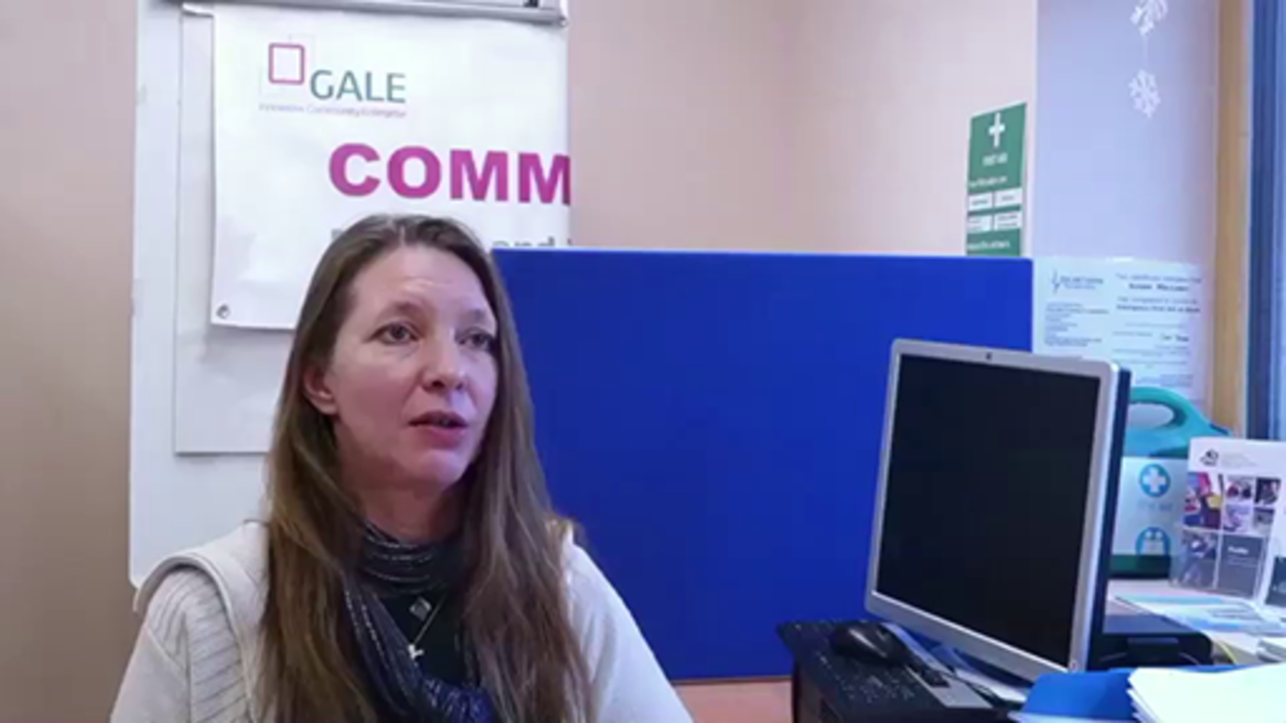

Back to - Activity 4

Activity 5

Discussion
The Kilmaurs Gala Committee favour an informal induction process where ‘volunteers shadow each other to learn the role, so the more experienced volunteer will show the new volunteer what to do’. The volunteers endorsed this approach saying, ‘I was greeted at the door; everyone is very supportive and welcoming’ and ‘I learned from others and they showed me what to do’.
In this video, Tania describes the process of getting started at GALE, including an informal chat, organisation induction and role-specific tasters and induction.

Video content is not available in this format.
Tania, Volunteer Co-ordinator, GALE. All rights reserved.
View transcript - Tania, Volunteer Co-ordinator, GALE. All rights reserved.

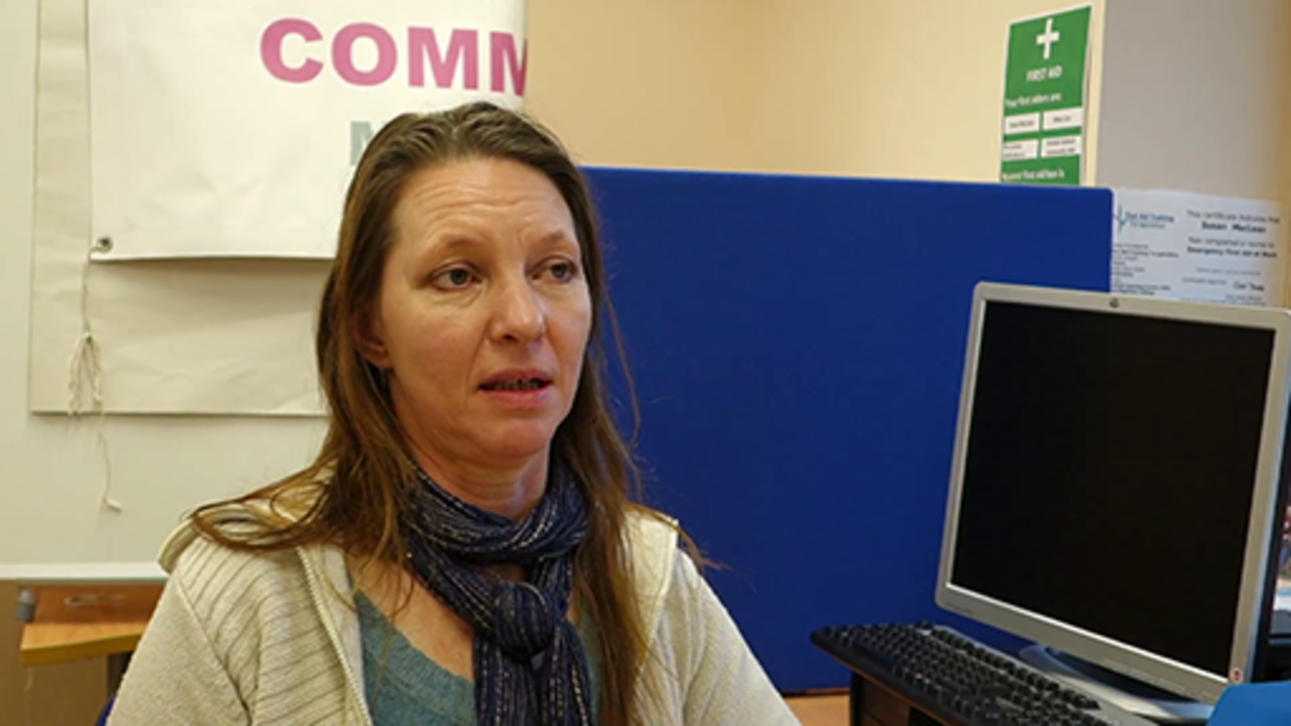

Here, James talks about his collaborative approach to developing induction at LGBT Youth Scotland, including using post-it notes to help prioritise what to include.

Video content is not available in this format.
James, Volunteering Manager, LGBT Youth Scotland. All rights reserved.
View transcript - James, Volunteering Manager, LGBT Youth Scotland. All rights reserved.

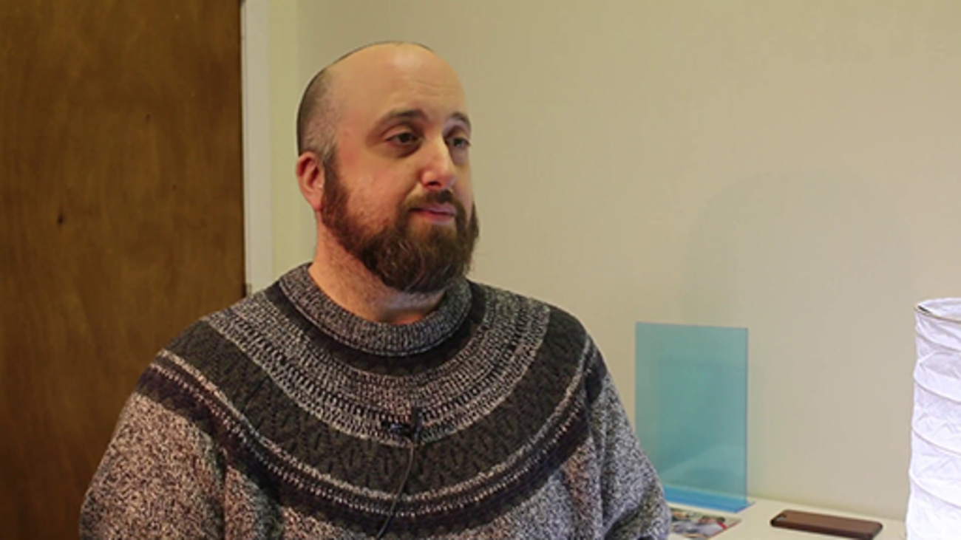

In this video, James talks about how they designed their induction as a national organisation.

Video content is not available in this format.
James, Volunteering Manager, LGBT Youth Scotland. All rights reserved.
View transcript - James, Volunteering Manager, LGBT Youth Scotland. All rights reserved.

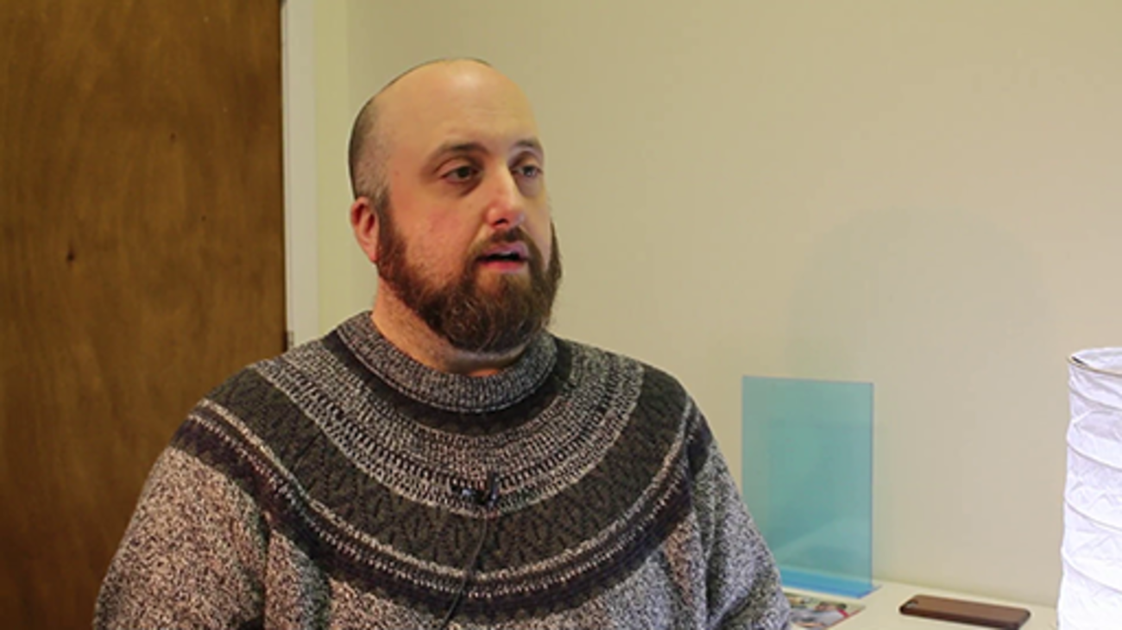

Back to - Activity 5

Activity 7

Discussion
Support might seem like an unnecessarily formal approach, more suited to large organisations with structured volunteer programmes. However, promoting wellbeing and creating a safe and supportive environment is important in all volunteering situations as it helps to ensure a positive volunteering experience, which in turn will help individuals feel valued and motivated.
For volunteers, having a good understanding of where and when support is available will help promote wellbeing and it can also help if things are not going well. James talks about volunteers having a key contact for delivery and support from a person higher up in the organisation if needed.

Video content is not available in this format.
James, Volunteering Manager, LGBT Youth Scotland. All rights reserved.
View transcript - James, Volunteering Manager, LGBT Youth Scotland. All rights reserved.

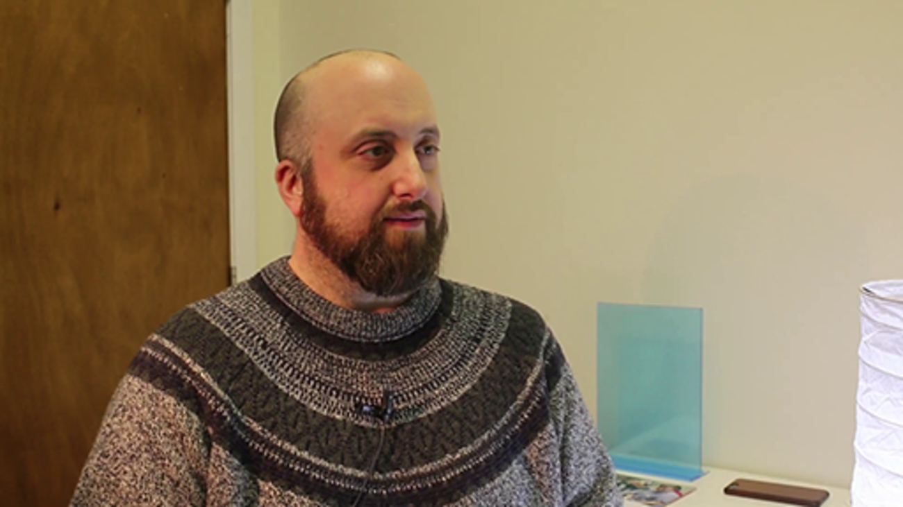

It is also worth considering how flexible and inclusive you can be to adapt roles to support individual volunteers and enable them to find the best role for them. In this clip, Tania at GALE describes finding a role for someone who lacked confidence interacting with members of the public.

Video content is not available in this format.
Tania, Volunteer Co-ordinator, GALE. All rights reserved.
View transcript - Tania, Volunteer Co-ordinator, GALE. All rights reserved.

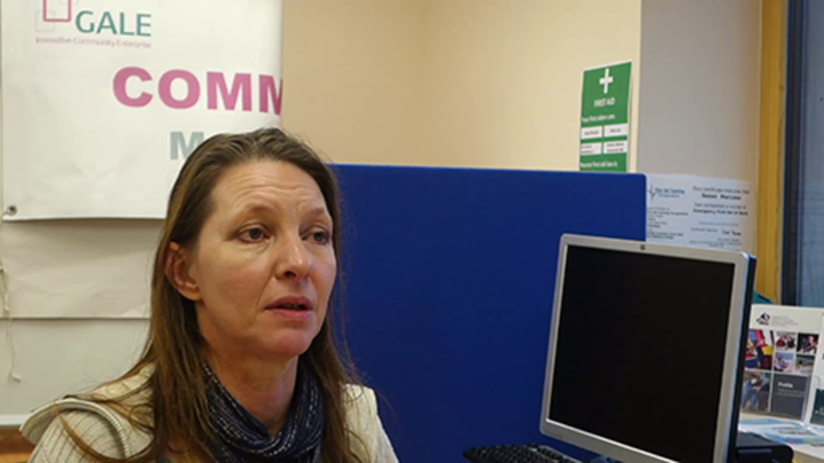

Back to - Activity 7

Activity 8

Discussion
It doesn’t have to be a daunting task to find out more about the difference that volunteers make. Collecting and sharing some basic monitoring information can help you do this. For example:
- Volunteers filled 20 bags of litter at the community clean up.
- Last month volunteers coached 50 kids at the football club.
- Volunteers welcomed and assisted over 200 people attending an annual event.
Volunteers might be having a great time and be happy to go out and chat to members of the public, but they do need some evidence that while they are enjoying themselves they are also having an impact. By linking these achievements back to your group or organisation’s aims and objectives, volunteers can see how their contribution fits into the bigger picture.
You could also take it a little further than this and survey your service users and share some of the findings with volunteers. For example:
- Ninety-nine per cent of our customers enjoyed the opportunity to spend time with their volunteer befriender.
- The youth club fulfilled its aim to engage 50 young people a year.
- Last year volunteers contributed 600 hours to delivering activities that the young people rated as ‘excellent’ and ‘great fun’.
In this video James from LGBT Youth Scotland talks about how they share what they find out about the difference that volunteers make.

Video content is not available in this format.
James, Volunteering Manager, LGBT Youth Scotland. All rights reserved.
View transcript - James, Volunteering Manager, LGBT Youth Scotland. All rights reserved.

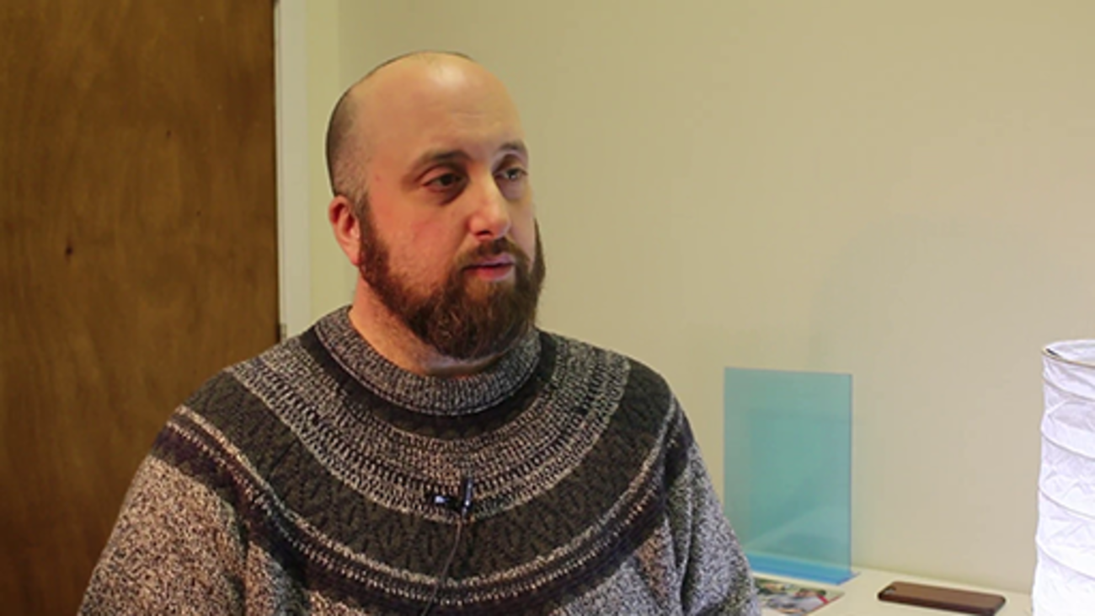

For volunteers at the Community Gala Group, knowing that they have made a difference can be gained on Gala day. One volunteer said, ‘People in the village tell us and you can see it in their faces.’ Another said, ‘You see the park set up with all its stalls, rides, food tents and stage in a few hours. And the amount of money that we raise for the village.’
Knowing the difference you make as a volunteer also relates to roles and communication. If volunteers are clear from the start about why the organisation needs voluntary contribution, and what they’re expected to do, then it will be easier for them to see the difference they are making.
Back to - Activity 8

Activity 10

Discussion
Listening to volunteers and learning from them is not simply a matter of having regular meetings or a consultation, or asking them to fill in an evaluation or feedback form. These forms can sometimes appear tokenistic, or even become a chance for people to moan about things they don’t like. This is less likely to happen if volunteers have regular opportunities to engage in conversations about their contribution to making a difference. And, as a result, volunteers will feel a sense of ownership over the process.
Tania gives an example of responding to a volunteer’s feedback, showing that the positive culture of engagement in the organisation meant the volunteer felt able to voice their thoughts.

Video content is not available in this format.
Tania, Volunteer Co-ordinator, GALE. All rights reserved.
View transcript - Tania, Volunteer Co-ordinator, GALE. All rights reserved.

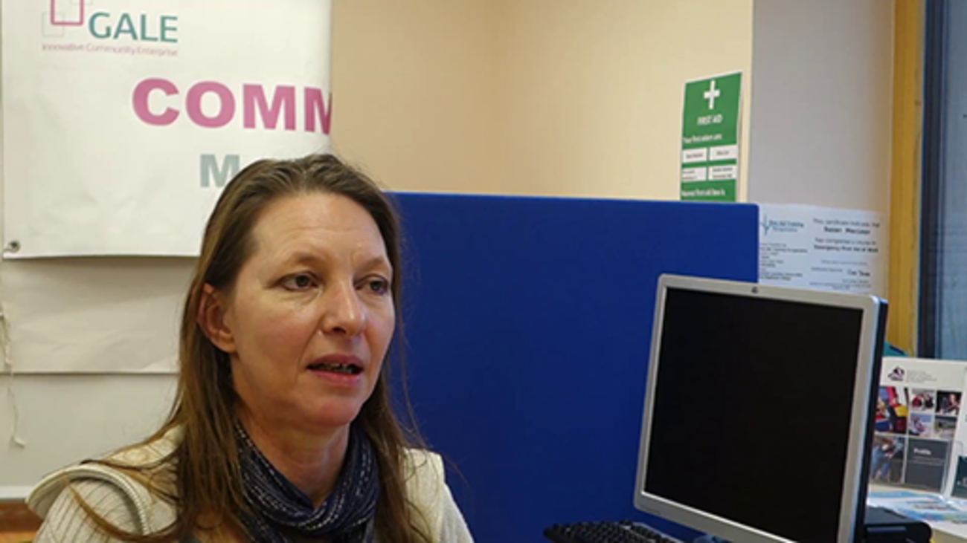

It is important to develop an appropriate process by which volunteers feel that they have a real say in how a group or an organisation works. This means active involvement goes beyond opportunities to be listened to and engages volunteers in the design and development of practice.
The community gala group volunteers talk about what happens once the event is finished: ‘We have a meeting after the gala day and talk about what worked well and how we could improve things.’
There have been positive changes as a result of this: ‘A volunteer suggested that we change the layout of the stalls and events on the gala day. We did this, and it worked better as it was more organised.’ And, ‘We stopped the parking on the grass at the park as it was pointed out that it was damaging the grass.’
Back to - Activity 10

Activity 11

Discussion
You might have recognised the feelings of guilt expressed earlier, either as a volunteer who feels it is time to ‘move on’ but cannot as there is no clear replacement, or because you have asked someone to stay on when you know they want to go.
One thing you ought not to feel bad about is engaging in appropriate succession planning. As noted earlier in section 4, volunteering has an impact on volunteers, and wanting to move on, either to a new role in the organisation or elsewhere, or simply to take a break, is to be expected and should be supported.
The most important thing to try and do at this stage is to end things amicably. A volunteer, whether current or retired, can be an ambassador for your group or organisation.
Lisa talks about volunteers leaving after deciding that it’s not right for them, and the importance of that being sensitively resolved.

Video content is not available in this format.
Lisa, Co-convenor, Polbeth and West Calder Community Garden. All rights reserved.
View transcript - Lisa, Co-convenor, Polbeth and West Calder Community Garden. All rights reserved ...

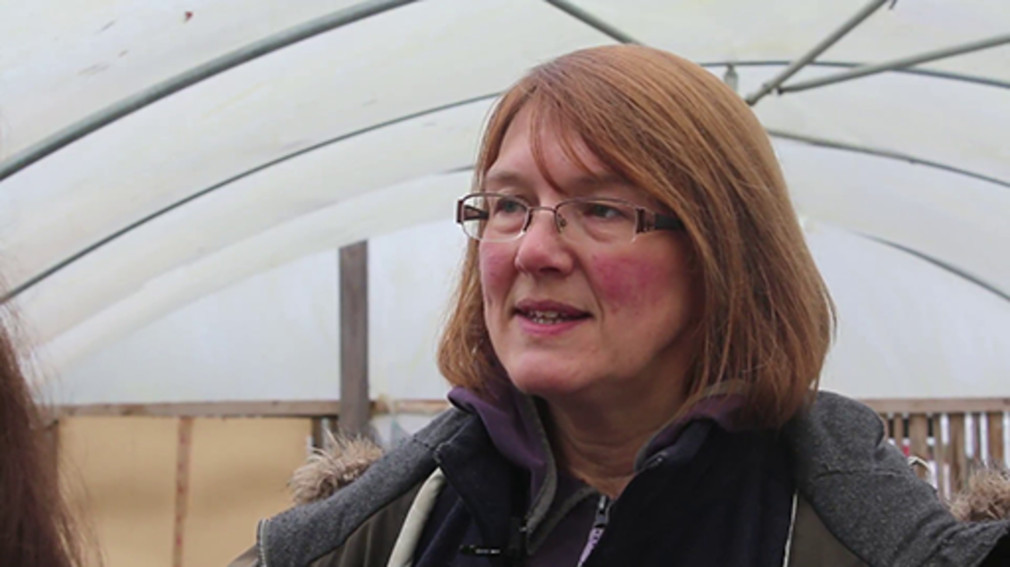

Back to - Activity 11

All rights reserved.

Description
Green heart on pale green background
Back to - All rights reserved.

Figure 1 Volunteer management model. All rights reserved.

Description
There is a circle divided into 4 quarters, the first is called 'thinking about volunteering', the second is 'getting started', the first is 'making a difference' and the fourth is 'building on success'. There is an arrow showing a cyclical progression round the four quarters of the whole circle.
Back to - Figure 1 Volunteer management model. All rights reserved.

All rights reserved.

Description
Graphic image of a head with cogs in it, on a pale blue background
Back to - All rights reserved.

All rights reserved.

Description
Graphic image of a stopwatch on a red background
Back to - All rights reserved.

All rights reserved.

Description
Graphic image of a smiley face on a pale green background
Back to - All rights reserved.

All rights reserved.

Description
Graphic image of a hand laying bricks on a purple background
Back to - All rights reserved.

All rights reserved.

Description
Graphic image of signpost on pale green background
Back to - All rights reserved.

Randi, Volunteer, LGBT Youth Scotland. All rights reserved.

Transcript
Randi
Volunteering is about giving back to the community. I think it’s something that I’ve found rooted within my grandmother’s work and with her being an inspiration, I’ve learned to be a volunteer and really helping those around me. And especially within this context and in this community I really want to make a positive impact, especially on LGBT youth and also just being there for people who may need it.
Back to - Randi, Volunteer, LGBT Youth Scotland. All rights reserved.

Jordan, Volunteer, LGBT Youth Scotland. All rights reserved.

Transcript
Jordan
I think volunteering to me specifically has been about building my own confidence on working with individuals and groups of people as well. I particularly, when I went into volunteering, wanted to build on my confidence, I wanted to give back to people like myself who are from an LGBT community specifically. And I wanted to help those and gain more experience from others older than me, from a mature perspective on things. I currently volunteer for LGBT Youth Scotland to help other kids from ages 13-16 gain more confidence working in groups. I also volunteer to give back a bit more of my free time to help those from an LGBT background specifically because when I was younger I didn’t have the opportunity to get that.
Back to - Jordan, Volunteer, LGBT Youth Scotland. All rights reserved.

Rebecca, Volunteer, GALE. All rights reserved.

Transcript
Rebecca
I volunteer because I do have some finite and precious time but it makes me feel so good to be able to put back to the community and it enriches me socially and with learning new skills so it’s totally a give and take.
Back to - Rebecca, Volunteer, GALE. All rights reserved.

Lisa, Co-convenor, Polbeth and West Calder Community Garden. All rights reserved.

Transcript
Lisa
We involve volunteers because it’s really strongly connected with our ethos. It’s a community garden, it’s run by the community for the community. The community benefits but the community also involves themselves, it’s their ideas and aspirations that inform what we do. But it’s also their energy and enthusiasm and skills and knowledge that take the project forward.
Back to - Lisa, Co-convenor, Polbeth and West Calder Community Garden. All rights reserved.

James, Volunteering Manager, LGBT Youth Scotland. All rights reserved.

Transcript
James
So, there are lots of reasons why we involve volunteers at LGBT Youth Scotland. One of them is to ensure that our services are able to meet the needs of LGBT young people. We also find that volunteers bring a really diverse range of skills and knowledge and experiences that we might and often don’t have in our staff time. So volunteering is a great way to bring all those extra talents, those pieces of knowledge, into the organization. Another reason why we involve volunteers is that it’s a really good way to increase our contact with the communities that we serve. So, in terms of the values that inform our volunteering programme, we have a strong sense that volunteering benefits the volunteers themselves, it also benefits the organization and most of all it benefits our young people. We believe very strongly that volunteers should not replace paid staff roles and we keep a very clear distinction between the two about what we ask of volunteers and what we ask of our staff members. We also think it’s really important to try as much as we can to make sure that the costs of volunteering are met by the organization so that volunteers should never be out of pocket for their volunteering. Another thing that’s really important to us is to make sure that our volunteers come from a wide range of backgrounds and abilities because we really want to make sure that volunteering is as accessible as possible and is open to everyone. That we get the benefits that different people bring regardless of their backgrounds or their abilities.
Back to - James, Volunteering Manager, LGBT Youth Scotland. All rights reserved.

James, Volunteering Manager, LGBT Youth Scotland. All rights reserved.

Transcript
James
We have for the most part, about 75% of our volunteers help us run youth groups, so they’re youth workers within youth groups but we’ve got a range of other roles as well. We’ve got a digital youth work service so young people can get advice and support online. We’ve got a live chat facility on our website so they can also text us and email us. We’ve got volunteers that help us with research. We’ve got volunteers involved in our policy work. We’ve got admin volunteers. We’ve got a talent pool so volunteers are able to dip in to ad hoc activities.
Back to - James, Volunteering Manager, LGBT Youth Scotland. All rights reserved.

Randi, Volunteer, LGBT Youth Scotland. All rights reserved.

Transcript
Randi
So, I guess it’s not really a funny story, but I was actually at the Regent Bar here and there was a flyer for LGBT Youth Scotland and I was like, ‘Oh, this looks like a fascinating organization’ and so I looked it up and decided to send an email and learn more about the volunteering opportunity and how I could get involved. I figured it would be something enriching for my experience here in Edinburgh besides going to university and yeah, just sending a simple email lead me to here.I don’t know if I really had any expectations. I think I was driven by wanting the experience of actually being involved with an LGBT organization because I didn’t have much experience in the States. I was maybe involved in student organizations but never really volunteer work. And it was just something exciting for me and I guess maybe the expectation was learning how to work with this population and engaging with people who are LGBT that are younger than me. And wondering you know, what are the issues that they face and what are some of the circumstances that that they go through. And kind of like learning about, you know, the differences between their experiences and my experiences of being an LGBT youth.
Back to - Randi, Volunteer, LGBT Youth Scotland. All rights reserved.

Rebecca, Volunteer, GALE. All rights reserved.

Transcript
Rebecca
I found out through word of mouth really, through friends and I saw an opportunity where I could help. I didn’t really have expectations because it’s all about learning and working within the group and just seeing what comes out of it and whether you’re a good match. So I just joined and became part of the wee community and learned from that and hoped that what I could do was as valuable as what I got from it.
Back to - Rebecca, Volunteer, GALE. All rights reserved.

Lisa, Co-convenor, Polbeth and West Calder Community Garden. All rights reserved.

Transcript
Lisa
So we let volunteers know what opportunities there are at the garden, what is available for them to do, what is on offer by opening up the garden numerous times through the year. We have events, we encourage people to come and see the garden, to visit. We then will get talking to people about the kind of people that are involved already, the kind of groups that operate, the kind of skills and knowledge that those groups have or need. We also have access to a volunteer coordinator for 4 hours a week. She is out in the community promoting what the garden is about, promoting volunteering opportunities, and meeting with people and finding out what they’re interested in and matching them to a range of organizations, one of which is ourselves.
Back to - Lisa, Co-convenor, Polbeth and West Calder Community Garden. All rights reserved.

James, Volunteering Manager, LGBT Youth Scotland. All rights reserved.

Transcript
James
So, a big reason a lot of people get involved in volunteering is personal development. When I do the initial conversation with new volunteers, what you might call the informal interview, I always make a point of asking, ‘why do you want to get involved with this organization, why do you want to start volunteering’. It’s really important to find out what a volunteer’s motivation is for getting involved because if you can help deliver that to some extent, then you’re giving them what some people call the motivational pay cheque. They don’t get paid by money, but they are getting involved for some reason and if they can get that, that’s what makes it worth them keep coming back. So I always like to ask that question about what’s your motivation for volunteering.
Back to - James, Volunteering Manager, LGBT Youth Scotland. All rights reserved.

Lisa, Co-convenor, Polbeth and West Calder Community Garden. All rights reserved.

Transcript
Lisa
So we find out if we would be a good fit for prospective volunteers by meeting them on site, doing a walk round, talking about the groups that use the garden, the kind of projects that are ongoing in the garden, some of the history, some of the background, some of our future plans and trying to find out what interests they have that match what we are already doing or what skills and knowledge they bring that we could actually start something new with. We talk to them about how they see themselves getting involved, what their particular interests are, what brought them here and get them to start maybe looking at one group they might like to join but not trying to overwhelm them cause there are so many opportunities, there are so many fun exciting interesting things to get involved with, as well as some of the other stuff like minute taking and the governance that not everyone wants to do but we try to show people a whole range of things because there are so many tasks that need done. And some people volunteer for us and yet are never on site, they’re never at the garden. They do other things behind the scenes, they type up minutes, they make fudge. These people are really valuable to the organization but they don’t have to come on site, they don’t have to garden and I think that’s important to get that message across. So how we help them to decide where they would fit is to look at their availability for one thing. We have groups that come down every week and so some people that fits in really nicely, they are looking to get out the house, they’re looking to escape isolation, they’re looking to meet other people and they’re looking to do outdoor activities. So, they are a perfect fit for any of our green gyms, so they are coming to do gardening, they’re coming to help manage the woodland, they are coming to plant flowers for the in-bloom project. There is lots of opportunities for them to come to during the week, meet other likeminded people and be outdoors. Other people we find are really interested and have come on the back of visiting an event. And so, some of those people are not available during the week they have maybe limited availability but they are really keen to get involved in the events side of things and so we would encourage them to come to one our open meetings for our event planning and just kind of find themselves the best role or the role that they are most interested in doing.
Back to - Lisa, Co-convenor, Polbeth and West Calder Community Garden. All rights reserved.

Tania, Volunteer Co-ordinator, GALE. All rights reserved.

Transcript
Tania
So our procedure to find out about our volunteers is relatively informal. Most either approach us either face-to-face by coming into our center and speaking to staff there or by email or telephone. We often ask them to fill out a registration form but that’s often done over a cup of coffee and quite informally together. And through that we get to know what a volunteer is expecting or wanting from volunteering. And from then on we then go on and have a slightly more formal induction if they want to continue and we can then tailor roles quite easily in our organization to fit each individual. At that recruitment procedure we get to know the volunteer really well and we have sort of key questions and what volunteer is looking for in their volunteering and if we can meet that need. All of our roles are really quite flexible and we can tailor them quite easily but we also work with other organizations so if necessary we can signpost volunteers to another organization if we feel it meets their needs better.
Back to - Tania, Volunteer Co-ordinator, GALE. All rights reserved.

Lisa, Co-convenor, Polbeth and West Calder Community Garden. All rights reserved.

Transcript
Lisa
We do have various different types of induction depending on the different role. So, trustee inductions are quite formal, there’s access to our google drive, there’s access to all the documents, there’s access to specialist training. That’s quite specifically tailored for the trustees. For the green gym volunteers the induction is much more coming down, watching the health and safety video, and actually just shadowing or spending time with the green gym leader or meeting the green gym group and just having a sort of tryout with them, seeing if it’s the kind of thing they enjoy doing. And some people also come with a support worker so they can help in that role. Help the meeting people and bedding down into a group and kind of finding out the tasks there are to do. In terms of our events we just really invite people to come along to our meetings so there isn’t a particular induction as such. But there are materials such as our annual report that people can get a flavor of what it is we do and how we work. But it tends to be much more informal and people will dip in and out of events depending on other things going on in their life. Like if they become a student or if they’ve gone into employment so we’ll see them and then we’ll not see them for a while and then they’ll come back. So it’s much more fluid and loose.
Back to - Lisa, Co-convenor, Polbeth and West Calder Community Garden. All rights reserved.

James, Volunteering Manager, LGBT Youth Scotland. All rights reserved.

Transcript
James
So, one of the important ways that we look at whether a volunteer is a good fit for the organization is how they perform in the training. So, they might be at a stage where they’ve passed the informal chat interview stage and we then want to involve them in the training and that can be a chance to see how volunteers perform in different exercises, what attitudes and values they have. The stuff that might not have come out in a 15-minute telephone call for example. So, another thing we like to do to make sure a volunteer is a good fit is to just check in with them after they’ve started. We usually wait about 3 months after they’ve started volunteering in their role. So, this is after the point that they’ve where they’ve completed all their training, they’re then into a youth group or they’re working in our research team or they’re helping with admin. But we’ll try and check in at roughly 2 to 3 months see how things are going. And that should be a two-way decision so that the volunteer is able to say themselves whether they feel it’s going well, are they settled into the role, was it what they expected, are they enjoying it, is it challenging enough, is it too challenging. It’s also a chance for staff to talk about how the performance is going up to that stage. And what we usually try and do at the end of that is make a joint decision about whether the volunteer might want some more training, they might be fine just to carry on with the role or we might want to look at a different role as there are several different roles within the organization that volunteers can do.
Back to - James, Volunteering Manager, LGBT Youth Scotland. All rights reserved.

Randi, Volunteer, LGBT Youth Scotland. All rights reserved.

Transcript
Randi
So yeah, there’s an online application form which I found very informative and the site was also very informative. And I think I got a call from James about like coming to, like you know, meet him and, you know, talk about some things. And there were quite a few trainings to go to and I think those trainings really enlightened me to this volunteer experience and what was expected from me. And I found those trainings to be very helpful in knowing what this organization stood for and how volunteers are supposed to interact with the youth and you know just the basic interactions and communications of being a volunteer representing LGBT Youth Scotland.
Back to - Randi, Volunteer, LGBT Youth Scotland. All rights reserved.

Tania, Volunteer Co-ordinator, GALE. All rights reserved.

Transcript
Tania
So we started off by sort of looking at the other organizations and how they developed their inductions. We do an induction into the organization and all the details of that to start off with as part of the initial informal meeting. And then the different members of staff from the different departments then looked at what they needed from volunteers. And we looked at as well, you know to make sure, the differences between volunteers and staff, so volunteers aren’t taking on responsibilities that really should be for staff. And so, we developed those inductions that way. So, when a volunteer comes with us, after they’ve had their registration of interest, followed by an informal chat and they have a more formal induction to the organization as part of that. And then when we’ve worked out what role they would be interested in they then go and have a taster session which is also an induction into that area of the organization.
Back to - Tania, Volunteer Co-ordinator, GALE. All rights reserved.

James, Volunteering Manager, LGBT Youth Scotland. All rights reserved.

Transcript
James
When we developed our induction training, our starting point was to look at what would our volunteers need from us in order to get the best possible start in volunteering. And we also thought about what skills and what knowledge do we need our volunteers to have in order to ensure that they can do the role they’ve chosen as well as possible. And actually, I was there when we did that and I ran an exercise with our management team, there were post it notes everywhere there was lots of discussion in small groups. They came back with a huge big list and then we kind of together just whittled it down to some essentials. So, the Induction training that we have for volunteers, the kind of compulsory training tat volunteers have to do before they can start is in 5 parts and it’s a modular exercise. All volunteers have to attend part one which is the organizational induction so information about LGBT Youth Scotland and also some background information about what’s it like to be a young person living in Scotland, some of those facts and figures. For volunteers that are going to be involved in youth work or working with young people there are other parts. So, we have a half day group work training, we have a half day one-to-one skills training. There’s a half day session on trans, intersex and non-binary young people. That’s often the part that a lot of volunteers identify for themselves they have the biggest knowledge gap around. And the final part of our five part induction training is the protection of children, young people and vulnerable adults, so what most people would refer to as child protection training. There’s a lot of other training that we make available to our volunteers, we’ve got an annual training calendar and it just rolls throughout the year and staff and volunteers can sign up to whichever sessions they feel are important. So, things like mental health, sexual health I mean there’s all kinds of things there that people can learn about. But our five-point induction training is compulsory for all volunteers working with young people and the introduction session is compulsory for all of our volunteers if that’s admin, or policy work, research work, if they’re ad hoc volunteering.
Back to - James, Volunteering Manager, LGBT Youth Scotland. All rights reserved.

James, Volunteering Manager, LGBT Youth Scotland. All rights reserved.

Transcript
James
So the way that we deliver the training is across different weekend days. They’re usually delivered on the weekend. So our next session for example is in February, we’ve got two Saturdays in February and then two Saturdays in March and one of those is a full day and that’s how we fit the 5 half day modules into that. Training is provided by different staff. So often I provide the child protection training. Our youthwork staff are heavily involved in the training as well, it’s really great to get their skills because these are the people that work day in day out with young people. So, they’re great people to deliver our group work training and our one to one training. The working with trans, intersex, and non-binary young people, the youth work staff bring a lot of their own expertise into that as well. And we hold the training around the country so typically one of the sessions would be in Edinburgh, one would be in Glasgow, one in our Dumfries office and one might be in Dundee or Stirling so we try and do a bit of north, south, east, west, around Scotland that means that everybody has to do a bit of travel and hopefully everybody has one session that’s quite near to them as well.
Back to - James, Volunteering Manager, LGBT Youth Scotland. All rights reserved.

Tania, Volunteer Co-ordinator, GALE. All rights reserved.

Transcript
Tania
Volunteer’s wellbeing and safety is really important to us. We have standard policies and procedures, we do risk assessments for all of the roles, and health and safety. Insurance is all kept up to date and includes volunteers, as well as, volunteers are also included in the fire drills. For their wellbeing we make sure that they have regular reviews, which are usually very informal, and when volunteers first start, they tend to quiet frequent to make sure that they’re settling in, that everything is ok, that the role is suitable for them, and then over time we will gradually space them out a bit more. So initially they might be weekly and then monthly. And then we aim to have regular reviews every six to three months, depending on the individual volunteer’s needs. The staff also feedback to us regularly, to let us know how they are getting on and raise any concerns. If it’s too formal it can create a bit of a barrier between us and volunteers, and that’s not what we want, we want them to understand that we are there to support them, if their having issues with staff that we will address them and that they are being listened to. So very often we will all sit down and just have a cup of tea, maybe some cake, and just have a sort of general chat. It just might be about their lives, what’s going on for them. And through that we can learn a lot about what their needs are, and we can develop that relationship and trust.
Back to - Tania, Volunteer Co-ordinator, GALE. All rights reserved.

Jordan, Volunteer, LGBT Youth Scotland. All rights reserved.

Transcript
Jordan
I’ve been supported brilliantly by the organisation just because I’ve had to be quite flexible with uni, cause I am currently studding but I wanted to volunteer so that I can help use that volunteer practice in what am doing workwise and what am doing in my studies. I’ve also found the organisation have been brilliant because I have some health-related issues physically, so if I’ve had to take weeks off for health related issues they have been really supportive, they have found great ways at dealing with that and not made me feel any pressure in the slightest. During my training there was a great deal of how to safeguard yourself in a position, making sure that you didn’t put yourself at any risk. So if a conversation was to arise between you and one child and you could see the situation becoming uncomfortable, you got another member of staff. These were things I hadn’t actually leant in my other job, so I found that training really a benefit because I felt like I was safeguarding a position that I wouldn’t be put at risk should a situation arise.
Back to - Jordan, Volunteer, LGBT Youth Scotland. All rights reserved.

James, Volunteering Manager, LGBT Youth Scotland. All rights reserved.

Transcript
James
Also, in terms of how we support our volunteers, every volunteer will be given a named member of staff that’s their key contact, that’s typically the personal that they interact the most with throughout their volunteering. So if you are volunteering with a youth group it would be the youth worker that runs that group that will be your key contact. That persons there as a kinda day-to-day contact if you’ve got any questions, but also the key worker will check in with you every once and while, maybe have a one to one every now and then, or just get a sense of how you are doing. All our volunteers also have a named line manager, so that’s a member of the management team and it would be probably the head of department or the manager responsible for each area of work that the volunteer is involved in. So that’s somebody who has kind of an overview of the volunteer’s progress, how well are they being supported, how they are getting on with their day-to-day activities. And then finally there’s me, so as the national volunteers manager, am available to all volunteers. I am that person, if they want to just pick up the phone, have a chat, if there is anything they want to suggest as an improvement, if there’s anything that doesn’t feel quite right for them or that they are worried about or anxious about, I try to be there and help guide that process as well.
Back to - James, Volunteering Manager, LGBT Youth Scotland. All rights reserved.

Tania, Volunteer Co-ordinator, GALE. All rights reserved.

Transcript
Tania
I have several examples of responding to individual needs. Because we are a small organisation, we tend to tailor all of the roles to volunteers. So we had one woman who came to volunteer with us, she lived on a boat for about 9 years. She become use to her solitude and wasn’t really very use to being around people, so had some anxiety about that, and really did not want to be doing anything where she’s directly working with the public. So we were able to work with a member of staff responsible for different jobs like in the stock room and office base work, so we could development enough work for her to come and do some on a volunteer level.
Back to - Tania, Volunteer Co-ordinator, GALE. All rights reserved.

Lisa, Co-convenor, Polbeth and West Calder Community Garden. All rights reserved.

Transcript
Lisa
So we have to produce an annual report every year and one of the reasons that that’s so important is the council has given us this site rent free, for our lease, the duration of our 25 years lease, but one of our provisos is that we must demonstrate community benefits to the tune of £4,000 per year. So we do quite detailed analysis of the number of volunteers that are accessing the site and kinda improving the site and also the kinda of hours they are putting in, hours that other groups are putting in, so for example, Royal Bank of Scotland staff come down on corporate work days with the conservation volunteers. So that’s a huge impact as well and just opening the site up and making it available including building. So we are now hosting meetings, other groups are using it for meeting space as well. So there is a range of uses which benefit the wider community and we know from the stats that the building has been opened and in use for 250 days out of the last year. So that’s really important to us that it isn’t just used by a small group of volunteers on a sporadic basis, it’s being used most days and sometimes it’s being used for several sessions morning, afternoon and evening of those days, so that’s really valuable as a resource. Everyone knows that we are a voluntary organisation. I think what people don’t realise is just the shear number of volunteers that are involved. And I must admit I got a shocked myself when I counted up who were the individuals for the last year, and there were 80 different individuals who had given their time, maybe only once for a couple of hours, but had given their time to this project, to an event or to a work day. And that was just our own volunteers, that didn’t include cooperate work days. That was just people that are known to us, and 20 of those 80 were under 18’s. And that’s really hearting to know that the young people really embrace what’s been done here and they can make a fantastic contribution.
Back to - Lisa, Co-convenor, Polbeth and West Calder Community Garden. All rights reserved.

James, Volunteering Manager, LGBT Youth Scotland. All rights reserved.

Transcript
James
So in terms of how we measure the difference that volunteers make, I think really all of our works as an organisation is evaluated, and volunteers typically play a part in more or less everything that we do. When it comes to working with young people and the volunteers that work with young people, we try and kind of triangulate information about volunteers, so we want to hear about volunteers themselves and about what’s the difference volunteering is making for you, how are you are enjoying it, how things are going for you. We’ll also talk to staff, we’ll hear from youth worker and managers about how people are getting on, how they are progressing as a volunteer. And really importantly what we also do, we try and listen to young people, cause young people will tells us. They are not shy about telling us about their favourite volunteer or a volunteer who really helped them out in a difficult time they were having. So it’s great to capture that, can be really powerful to feed that back to the volunteer, that such and such a young person has told us this, so well done.
Back to - James, Volunteering Manager, LGBT Youth Scotland. All rights reserved.

Randi, Volunteer, LGBT Youth Scotland. All rights reserved.

Transcript
Randi
I think it’s just, you know by being present and there, I feel like I make a difference, in just knowing that I can be reliable enough to show up and engage with these children, get to know them, talk to them about their experiences. I don’t know how much of a difference I’ve made to them but I know that they have made a difference to me, being more comfortable and open with who I am and what I want to be.
Back to - Randi, Volunteer, LGBT Youth Scotland. All rights reserved.

James, Volunteering Manager, LGBT Youth Scotland. All rights reserved.

Transcript
James
So volunteers that makes a difference, it’s really important that we tell them, because that could be what keeps them, that how they maybe know they are doing a good job. So we will let volunteers know, we can do that formally and informally. One of the things we do, dependent on funding of course, we will try at least once a year to have a staff and volunteer conference, where we can bring everyone together internally. And that’s a really good opportunity to share good news stories across the whole organisation. So that’s certainty one way we can let volunteers know how they are doing well. We also write to them, sometimes I might be asked by a youth worker, sometimes a youth work might write to a volunteer themselves, and maybe send an email to say thanks very much; I overheard you having that conversation with Jamie and it was really well handled. Sometimes the youth workers will get in touch with their manager or me, and quite often I am asked to send a letter or something that just kind of, without a huge fuss, but just writing to say we have heard some great things about you, here’s some of the things we heard about you. And sometimes as well our chief executive likes to write to volunteers themselves or to give them a phone call and have a chat with them. I think that’s really nice as well and volunteers have told us that its really quite meaningful to hear from someone at the top of the organisation, that they have heard and understood the difference that they have made in their volunteering.
Back to - James, Volunteering Manager, LGBT Youth Scotland. All rights reserved.

James, Volunteering Manger, LGBT Youth Scotland. All rights reserved.

Transcript
James
So we often ask volunteers for feedback or volunteers will give feedback, and it’s important when we can that we act on that feedback and we are seen to act on that feedback. A really nice memory I had was that recently we had a volunteering Roadshow where we went around the country with a few of the managers, just talking to volunteers, brining volunteers together. And a bit of feedback we got from a few of our volunteers was, it is great when we get these opportunities to bring all us together form different parts of the country, and so much happens when ideas come up, when we share ideas, we learn from each other and we learn about best practice and we find out about the skills that people have. But it just seems that we do this once or twice a year, wouldn’t it be great that we could do this throughout the year. So we thought about that, what we introduced was an online portal where our volunteers can share information, they can stay in touch with each other, even if they are in geographical areas. So for example if a particular volunteer, maybe, develops a works shop that they run with young people, and it’s being really successful, they might be able to share that with somebody hundreds of miles away, they can upload there materials and say here is the workshop, here is what I have developed, here’s instructions on how to run it, see how you get on. It’s a really nice way of volunteers to stay in touch as well and we encourage that informal chat, just to stay in touch with people that you have maybe met at a training event or a conference.
Back to - James, Volunteering Manger, LGBT Youth Scotland. All rights reserved.

Randi, Volunteer, LGBT Youth Scotland. All rights reserved.

Transcript
Randi
The development comes with the training and the communication that I have kept with staff, even when being back home and the state’s still checking in on the centre and see how it is going. But I guess that before, all the original development comes with interacting with the kids and certain groups have really inspired me to be more of myself and you know, it pushed me into coming out more of my own coming out process.
Back to - Randi, Volunteer, LGBT Youth Scotland. All rights reserved.

Rebecca, Volunteer, GALE. All rights reserved.

Transcript
Rebecca
It’s like anything, you just work up, you build up confidence and you ask if you can maybe have a go at something else, or more often or not you are given the opportunities which is even better. You’re offered to do this or that, and that’s what’s so brilliant, that there are so many opportunities to do different things.
Back to - Rebecca, Volunteer, GALE. All rights reserved.

Lisa, Co-convenor, Polbeth and West Calder Community Garden. All rights reserved.

Transcript
Lisa
Because we are quite an unusual organisation in that we have volunteers at every level, running the organisation in a kind of governance, the day-to-day, the kinda work on the ground. Absolutely everything is done by volunteers and sometimes a lot of that is the same volunteers working at lots of different levels in the organisation, and there is an opportunity to pile on too much pressure or people to take on more than a lot that they can manage. You know, there is a lot of enthusiasm, there is a lot of passion for the project and for the things that are happening but sometimes people forget that they also need to have a life or sometimes their circumstances change, they’re dealing with illness. And so we’ve always really been aware of that and we have always tried to support each other through difficult periods and stressful periods, and so you know, invariably someone will say to you “you know I think you are doing too much” or “do you want to have a break” or “can we rearrange our work schedule”. I think we have to be aware of that because we rely on our volunteers to keep going as an organisation, and we are providing all these opportunities for other people to be outdoors and be healthy and we are sometimes we think, we’re not really thinking about ourselves. We need to protect ourselves so that we are able to still deliver this valuable resource to the community and so that we are trying to do more, having events, bringing volunteers together socially, it’s not all work based, it’s not all task based and planning, it’s actually coming together because we actually like each other’s company.
Back to - Lisa, Co-convenor, Polbeth and West Calder Community Garden. All rights reserved.

Tania, Volunteer Co-ordinator, GALE. All rights reserved.

Transcript
Tania
Volunteers can share their experiences and give their feedback easily. We are very approachable in our organisation and many of our volunteers are quite content with sharing their opinions and how they feel, things could be ran differently or ran better or maybe some sort of new idea. Many of our volunteers have got skill sets that maybe members of our staff don’t have. So often it’ll be through an informal chat with me. Somebody might bring something up or a member of staff might feedback that a volunteer has suggested something and they think it is a good idea. In which case I will approach the volunteer and let them know that it seems to be a good idea and that I will be investigating it and bringing it to other people in the organisation, who might be able to consider it and put it into action.
Back to - Tania, Volunteer Co-ordinator, GALE. All rights reserved.

James, Volunteering Manger, LGBT Youth Scotland. All rights reserved.

Transcript
James
So I guess with every volunteer there comes that point where they have to move on. I think it’s really important we don’t look at a volunteer moving on as a failure. Often it just means that they have got to the place where they want to be or volunteering has filled a purpose for them. So I’m generally quite happy when that happens. When volunteers move on, it can happen in many different ways, it can be lots of different reasons, behind that. Commonly what I find is that a volunteer might ask if they can take a break because they’re really busy and then we agree a time limit for that break and then I will check in with them and they maybe want a bit longer. And that might be a time for me to then start saying, well should we have a chat about this, things have changed for you, you’ve got more responsibilities of work, you have a young family now, or whatever it might be. But we can gently explore if the volunteer wants to leave. And they don’t always, but there are times when they’re quite grateful that I have asked them that question, so we can look at a way on how that is done. What’s important for us, particularly if a volunteer is working with young people, is to plan how they exit the youth group, so they might want to think about when they are going to tell the young people that they’re planning to move on, and sometimes the young people want to throw some kind of a leaving party for the volunteer, so that can be really nice. I’ll always try and do an exit interview with volunteers when they leave, wherever I possibly can. Just go through how were things, is there anything we can learn. And I always send an anonymous online questionnaire that the volunteer can fill out as well, just in case there is anything they didn’t feel comfortable talking about. But it is really important to hear back from volunteers about, not just what we did well, but also what we maybe could have improved upon, that helps us get it right next time.
Back to - James, Volunteering Manger, LGBT Youth Scotland. All rights reserved.

Tania, Volunteer Co-ordinator, GALE. All rights reserved.

Transcript
Tania
Trying to ensure that we have enough volunteers as other volunteers leave is a really difficult thing to do in this community. There is quite an established pool of volunteers that are shared by all the organisations locally. So we do sort of rely on people moving into the area. And we’re fortunate in that way is because of the nature of our organisation, that people moving into the area often come in here to try and find out more about the area. So immediately, very often the volunteers or potential volunteers, we can address them that way. Members of staff are aware and they’ll always mention to somebody who’s coming in or has just moved or is planning to move to the area, will always say ‘well you can always volunteer’. And we advertise, we have posters and we have a Facebook page. There is lots of different ways, but the main one, that’s our main way, we rely on recruiting new volunteers.
Back to - Tania, Volunteer Co-ordinator, GALE. All rights reserved.

Lisa, Co-convenor, Polbeth and West Calder Community Garden. All rights reserved.

Transcript
Lisa
Because it is a very wide-ranging project and we are always looking for volunteers, we don’t always get volunteers who find that we are the right fit for them. Sometimes it can be because they have been told to come by a referring agency or a parent even and we have had to have a conversation with parents to say this might not be the right place for this young person and I think they’re so desperate for it to be a successful. But we have had situations, one particular young person was just not engaged when he came down and it just really wasn’t working out, to such an extent that he would pretend to come and be picked up by his parent. And this is someone who was over 18 but would pretend to come and we did have to put an end to that I suppose to stop that happening. And we have to, we also have to help people move on, if this isn’t the right thing for them, if this isn’t really what it is they want then there are other opportunities out there. Again we are fortunate with the volunteer coordinator locally, that she now has a massive range of volunteering activities. So if things don’t really work out for people here, if it isn’t really what they are looking for, if they actually don’t enjoy particularly being outside and there is not an indoor role they’re looking for, there are other volunteering opportunities in the local area. And the people groups and organisations are crying out for volunteers, so people shouldn’t feel that well if they tried it out and it wasn’t really for them that they couldn’t go somewhere else which is a better fit for them. And certainly one of our volunteers who left because they didn’t feel that we were managing the site in the way that they would have managed it, but have now found themselves volunteering for the community development trust so that they’re able to use their skills and offer their knowledge in a different role and in a different organisation and that seems to be working out for them. And it is still very amicable between us and them, so that is a huge relief because it’s important that people don’t leave feeling that they didn’t get what they wanted and bare a grudge. We wouldn’t be happy for that to happen. And I have to say it’s not always easy and sometimes there are personal dynamics, but the vast majority of people who have left actually come back on the open days or come back to visit and that is really good to know that they still see this place to even be a part of as a visitor.
Back to - Lisa, Co-convenor, Polbeth and West Calder Community Garden. All rights reserved.

All rights reserved.

Transcript
Lisa
So we are Polbeth and West Calder community Garden SCIO and we are a small local charity and we are entirely volunteer led and volunteer run, and have been operating on the Garden for life site for 5 ½ years and prior to that spent 2 years negotiating, lobbying the council, getting community support together and basically reaching a group of people who wanted to come together and run a community garden for the first time in West Lothian.
Back to - All rights reserved.

All rights reserved.

Transcript
Tanya
I’m Tanya McKenzie. I’m a Volunteer Coordinator for Gairloch and Loch Ewe action forum or GALE for short. When I was first in post I was employed to establish the volunteer programme to replace the policies and procedures. GALE is a volunteer driven organisation, it’s community owned, it’s a development trust, a charity and social enterprise. It was established about 20 years ago by a group of volunteers who got together because we were losing resources and services in our area which is rural and economically quite fragile. They were then able, with the work they were doing, to employ a project manager and that has been a pattern of GALE ever since. Projects are volunteer driven and if they are successful then they are able to create employment which is an important core ethos of GALE to create a stable and sustainable economy for this community.
Back to - All rights reserved.

All rights reserved.

Transcript
Rebecca
Hello I’m Rebecca Duville and I do a numeral amount of volunteering in the Gairloch area including the GALE but also for the cubs and the community car scheme and other bits and pieces.
Back to - All rights reserved.

All rights reserved.

Transcript
James
I’m James White I’m the national volunteering manager for LGBT Youth Scotland. So that’s a paid position, I’m employed full-time to oversee the volunteering of LGBT Scotland. And I think my role is about making sure that volunteering at LGBT Scotland is as good as it possibly can be in many different ways that you can do that. We have got volunteers all over the country at the moment. We’ve got over 100 volunteers, typically at any one time it’s somewhere between 100 – 120 volunteers and has been that level for the last 2 years. So we’ve got volunteers all the way up from Inverness, all the way down to Dumfries and the borders. We have, for the most part, about 75% of our volunteers help us run youth groups, so there are youth workers within youth groups. We have got a range of other roles as well. We’ve got a digital youth work service so young people can get advice and support online. We have a live chat facility on our website; they can also text us and email us. We’ve got volunteers that help us with research. We’ve got volunteers involved in our policy work. We’ve got admin volunteers. We’ve got a talent pool so that volunteers are able to dip in to ad hock activities. If there’s an event coming up, if we’re doing some fundraising and we need some people to hold collecting tins, if we’re doing a fundraising ceilidh, or something like that, we can send out a message to our talent pool and invite people to get involved. And it’s very much a ‘on this day we’re planning to do this kind of activity and we need somebody that’s able to do this for us, can you help us?’ And we’ll send that out to our huge talent pool. And volunteers can then say ‘yeah I’m available to help with that’ or they might say ‘I’m not free for that day but let me know of the next thing’.
Back to - All rights reserved.

All rights reserved.

Transcript
Jordan
My name is Jordan I volunteer for LGBT Youth Scotland and I currently assist a Wednesday group.
Back to - All rights reserved.

All rights reserved.

Transcript
Randy
My name is Randy Lopez, I am from the States, Texas specifically, and I volunteer here at LGBT Youth Scotland in Edinburgh. I have been a volunteer on and off for about 1 year, just got back from the States and going to be a volunteer again.
Back to - All rights reserved.

