CLASSROOM MANAGEMENT
AND ORGANIZATION

03
CONTENT
1 INTRODUCTION TO CLASSROOM MANAGEMENT AND ORGANIZATION 3
1.1 Defining classroom management 3
1.2 The role of the teacher 3
1.3 Defining classroom organization 4
1.3.1 Classroom seating arrangement 5
1.3.2 Overview of classroom seating arrangement styles 6
1.4 Benefits of effective classroom management and organization 7
2 Strategies for effective classroom management 8
2.1 The teacher as a model 8
2.2 Desired learner behaviour 8
2.2.1 Rewarding learners 10
2.2.2 Types of rewards 10
2.2.3 Reinforcing learners 11
2.2.4 Delivering a reinforcer 12
3 Lesson planning 13
3.1 Definition of a lesson plan 13
3.2 Components of a lesson plan 14
3.3 Lesson plan template 14

INTRODUCTION TO CLASSROOM MANAGEMENT AND ORGANIZATION
Get ready for an introduction to classroom management and organization. This first subtopic will give you everything you need to get comfortable with the concepts 'classroom management'/'classroom organization' and its underlying principles.

Defining classroom management

Classroom management refers the collection of techniques that teachers use to encourage effective learning by minimizing distractions and disruptions. It includes all of the things that a teacher does toward fostering learner involvement, cooperation, and a productive working environment. When classroom management strategies are executed effectively, teachers minimize the behaviours that impede on learning and by so doing reinforce the practices that foster learning.

A teacher can have great lesson plans and materials. However, if a teacher cannot manage her/his class, effective learning will not happen. So, what are the essential elements of good classroom management? It is important for a teacher to have good classroom management skills. Both technical and personal relationship skills are important in classroom management. Below are management skills required of a teacher:
- Planning a programme of learning and teaching for your class
- Decision making concerning resources, teaching strategies and discipline
- Organizing learning activities
- Attending to learner diversity
- Coordinating learning in the classroom with learning from other sources
- Communicating with learners and parents
- Establish good relationship with the learners
- Establish class expectations, consequences and goals

The role of the teacher

Classroom management is one of the core responsibilities of the teacher. It is an important function and concerns the co-ordination and co-operation necessary for learning. A teacher has the authority to direct and facilitate what goes on in the classroom. However, the teacher’s authority does not mean being autocratic, domineering or an overt use of power. Instead, a positive teacher’s authority is a quality that facilitates a smooth operating classroom and is at the heart of successful group management.
The role of the teacher in classroom management include:
- setting the tone and culture for learning in the classroom
- building a warm and friendly learning environment
- mentoring and nurturing the learners’ behaviour
- being a role model

Defining classroom organization

Classroom management and organization are intertwined. While rules and routines influence learner behaviour, classroom organization affects the physical elements of the classroom, making it a more productive environment for learners. How the classroom environment is organized influences the behaviour in it. For example, actions as simple as establishing fixed locations for laboratory supplies and designating specific places for other classroom supplies can have a dramatic effect on classroom organization and, consequently, on learning.
Classroom organization is evident in a room even if no one is present. Furniture arrangements, location of materials, displays, and fixed elements are all part of organization. Effective teachers decorate the room with learner's work, they arrange the furniture to promote interaction as appropriate, and they have comfortable areas for working. They also consider learners' needs in arranging the room by leaving space for wheelchairs to manoeuvre, having walkways so learners can access what they need with minimal disturbance to others and organizing in such a way as to allow the teacher to freely move around the room to monitor progress. Effective teachers think about the little details that enhance the use of available space in the classroom including different types of classroom settings for different teaching activities.
Considerations for effective classroom organisation
In order to organize a classroom effectively, it is important to create a positive and safe environment for your learners that will maximize learning and will minimize the frequency of behaviour problems. The following actions can be taken into consideration:
Floor space
- Count the number of desks and chairs needed
- Try to ask for furniture or needed items well ahead of time
- Place the desks where learners can easily see the teacher
- Keep high-traffic areas clear

Learner area
- Plan areas for learner's belongings.
- Provide space for learner's binders, back-packs, lunch boxes, umbrellas, shoes, etc.
- Plan for learners to hang up/store jackets or coats.
Wall space
- Cover one or more bulletin boards with coloured paper and leave bare for learner work.
- Display classroom ground rules
- Post procedures, assigned duties, calendar, clock, emergency information, schedules,menus, charts, maps, etc.
- Have a consistent place for listing the day’s or week’s assignments

Classroom seating arrangement

Classroom organization can significantly influence learning. The physical setup of chairs, tables, and presentation in a classroom can impact how the teachers communicates with learners and how the learners interact with each other. Furthermore, this can impact engagement, motivation and focus. Therefore, it is important that teachers consider ways to modify seating arrangements and match them with the demands of classroom activities in order to help maximize learning.
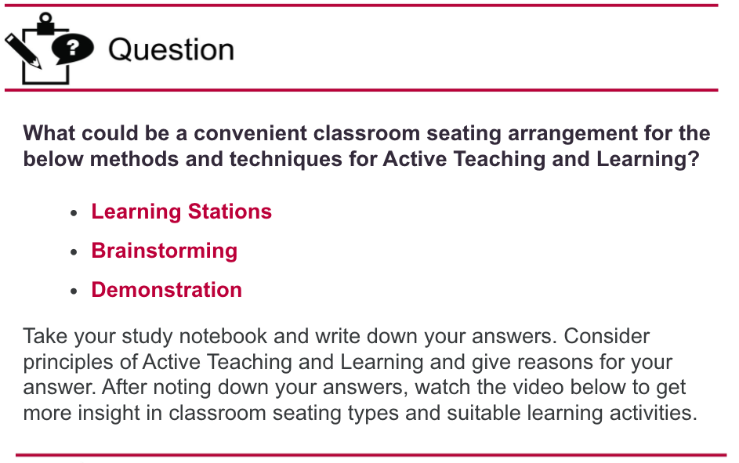
Link to the video: https://bit.ly/3gb7mxt

Overview of classroom seating arrangement styles

Traditional
The traditional lecture setup typically consists of rows of fixed seating where learners face the teacher with their backs to one another. The highest communication interactions between teachers and learners typically occurs with learners in the first row or along the middle of the classroom.
Roundtable
A classroom seating arrangements may consist of learners sitting in a circle or around a single large table. This seating arrangement can also be formed using individual desks. Learners and teachers all face one another in this setup, which can support whole-class as well as pair-wise dialogue.
Horseshoe or Semicircle
The horseshoe or semi-circle offers a modified roundtable setup, where all learners face each other while the instructor can move around the classroom. The horseshoe encourages discussion between learners and with the teachers
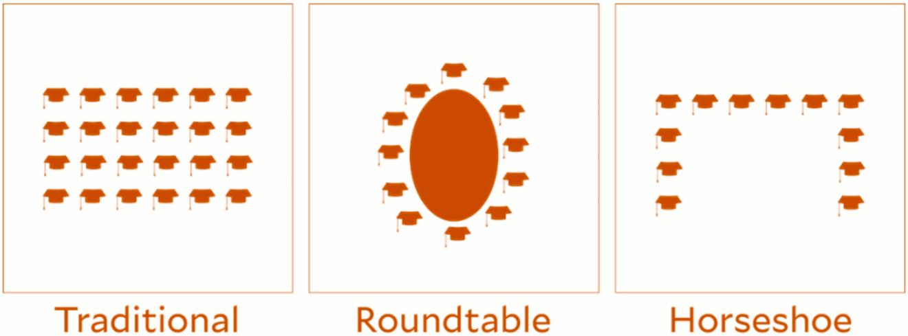

Double Horseshoe
This seating arrangement involves an inner and outer horseshoe, and similar to the conventional horseshoe, invites greater discussion than the traditional format. It is more limited by the backs of learners within the inner circle facing learners in the outer circle. However, learners may also more easily interact with those nearest to them or turn around and face learners behind them for group work.
Pods (Groups, Pairs)
The pod or pair arrangement can be designed with learners’ individual desks. With regards to stations, teachers can place several tables together to form learners groups (e.g. 3 - 4 learners), or pairs. This arrangement is useful when learners will work in groups or pairs for a large portion of class time.

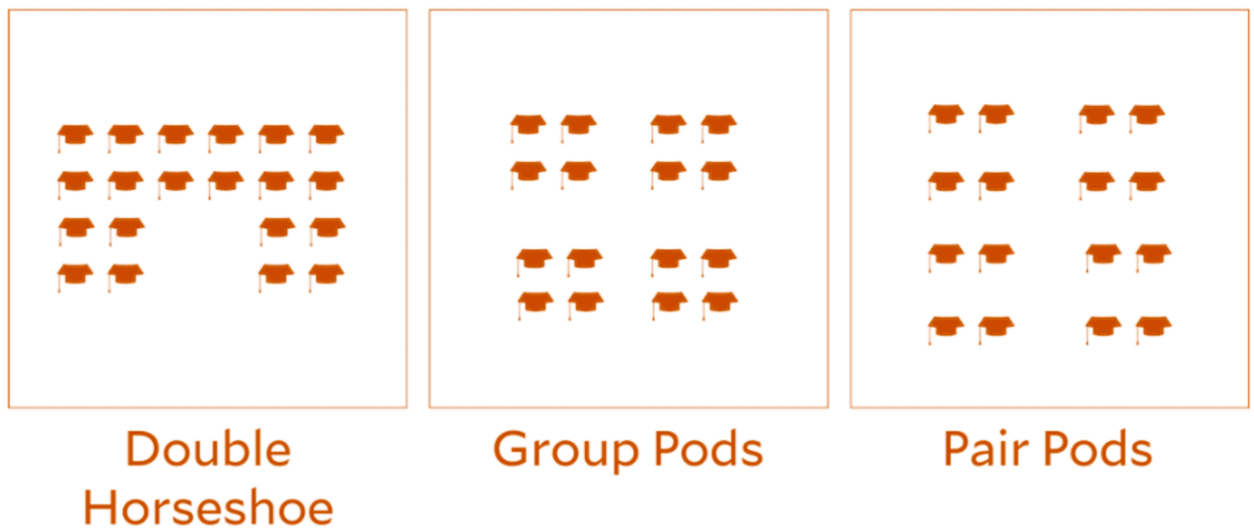

Benefits of effective classroom management and organization
Learner benefits

The prime benefits of a well-organized classroom will accrue to the learners. The organization and procedures of the teachers (or lack thereof) are, after all, ever present reminders to the learners of how to behave, how to conduct tasks, and how best to be effective without discord in a group. Respect for others, consideration, efficiency, pride of accomplishment, security in knowing what, how, when, and where to do something - all these positive elements are the hallmarks and characteristics of learners who learn in well-organized classrooms. Learners like a predictable, safe, and orderly environment and they like going to a school that provides that environment. For these reasons alone, it is important for teachers to pay close attention to good classroom management and organization.
Teacher benefits
Aside from the benefits to learners, good organization brings powerful help to the teacher. In fact, it can be truthfully said that the first “aide” any teacher has is his or her ability to organize the classroom well. The immediate benefits of a well-organized classroom to the teacher are clear; less wasted time and therefore more efficiency. Not so immediately apparent, perhaps, are the following very significant elements:
- improved learner-teacher relations
- improved parent-teacher relations
- increased job satisfaction
- increased enthusiasm for professional growth
- increased academic progres

Strategies for effective classroom management
In a well-managed classroom there is a strong sense of classroom management where learners feel safe and respected and have the desire to learn. In a well-managed classroom, learners also know what is expected of them, learners can make the choice to follow those expectations or not. It is always possible that learners do not behave the way a teacher expects them to. This subtopic puts light on strategies for effective classroom management in order to give you more insights in achieving desired learner behaviour.

The teacher as a model

Teachers have an important role in instilling desired behaviour of learners. as they should be models/exemplary in behaviour. This is possible by attending school regularly and punctually, having knowledge of and enforcing school rules and regulations without fear or favour. Knowing each learner as an individual and keeping learners busy by giving them meaningful work to do and involving them in school/class activities to avoid idleness and redundancy.
Teachers should also involve learners in making class rules; practice democracy and involve learners in problem solving, observe and assess their learners carefully, make learners feel loved and that their time at school is put to good use, make the learners to understand and enjoy what they are doing at school, be firm, unbiased and objective, refrain from using harsh word and unfair punishment, and be consistent in the way learners are handled.

Desired learner behaviour

If learners do not behave the way a teacher expects them to, punishment is commonly used to achieve desired behaviour. Learners are commonly punished for giving wrong answers, failures, coming late, truancy, vulgar language, etc. Most forms of punishment hurt, embarrass and frustrate learners rather than discipline them. Therefore, punishment is not the best way of inculcating discipline because discipline backed by punishment leads to hostility and depending on adult authority to behave.
However, where punishment cannot be avoided, it should be equitable to the offence committed with a genuine desire to teach the learner self-control and good behaviour. It should be appropriate to the age and character of the learner as well as the change of behaviour desired. A teacher who uses consistent discipline strategies exhibits more effective classroom management than an inconsistent teacher. This is because classroom discipline refers to the strategies a teacher uses to manage learner behaviour and attitude during instructional time.
Alternative for desired behaviour of learners
As most forms of punishment embarrass and frustrate learners rather than discipline them, teachers must look at alternative means to achieve desired behaviour of learners.
Guidance and counselling will make the learner feel cared for, valued and loved; isolation will cause sense of embarrassment and guilt leading to behaviour reform; changing position in class to minimize bad influence and peer pressure; assigning leadership roles to stubborn learners will lead to create a sense of responsibility. Depriving interest, while others engage in something interesting or are set free will make the learner think through their misconduct.
Discipline is essential and cannot be separated from teaching. For the most part, how you teach will determine behaviour, for instance:
- A flexible, classroom set up
- Discipline as feedback and as learning
- Peer involvement in rules and enforcement
- Class meetings emphasizing the affective dimension of the classroom
- Pairing, partners, and cooperation
- Adding movement, music, humour, and "chance" elements to the lessons

Rewarding learners

Motivating your learners to learn and to participate can be very hard. Some teachers have their hands full with class management and they don’t even get to teaching. In order to stimulate learning and to motivate good behavior, lots of teachers use rewards for learners. Rewarding is a type of behavior management that focuses on rewarding what is done well by learners. Teachers focus less on reprimanding learners for misbehavior and more on rewarding good behavior and accomplishments.
Learners are motivated to achieve and conform to appropriate behaviours when either intrinsically or extrinsically rewarded. Those Learners who prefer intrinsic motivation enjoy, personally challenging projects and accomplishing educational tasks just for the love of learning. On the other hand, learners who prefer extrinsic motivation look for fame, grades, and praise. The type of reward given to learners must be fair and consistent for all learners but also must vary for each task. Advantages of rewards are the following:
- Promote appropriate behaviour
- Increased motivation for full effort on classroom tasks
- Positive leaner welfare
- Boosted self-esteem
- Higher learner achievement

Types of rewards

Teachers can offer many types of rewards to learners, but they all fall into the categories of compliments, symbols, tokens and prizes.

Praise
Verbal praise is the most common form of rewards that teachers offer learners. It consists of complimenting learners when they behave in a way that is positive. When offering praise, make sure to offer it promptly, so the emotional impact of the action is still present. Furthermore, be specific with praise. Let the learner know exactly why what she/he did was admirable, and that your words aren't empty and automatic.
Symbolic rewards
Symbolic rewards are rewards in the form of objects that represent exemplary performance of character or achievement. Perhaps the most common form of symbolic reward is the gold star. Others could be the inclusion of the learner's name or photograph on a bulletin board or poster. Symbolic rewards operate similarly to praise in that they are public demonstrations of favour toward a learners. Symbolic rewards, unlike praise, have the ability to last longer than a single spoken statement, and can serve as reminders for learners to maintain their good standing.
Token rewards
Tokens are physical rewards that represent value, or a form of currency that can be redeemed for a prize such as a voucher, extra free time or outings.
Tangible and activity rewards
Tangible rewards and activity rewards are awards you supply directly to the learner, without the step of symbols or tokens in between. A tangible reward is a prize for positive behaviour or achievement, and includes items such as school supplies or other physical objects. Activity rewards are intangible prizes, such as getting to be line leader or being the teacher's helper, being a team captain during activities.

Reinforcing learners
A reinforcer is an event that occurs after a behaviour, and due to the reinforcer the behaviour is likely to occur again in the future. Basically, if something is expected or enjoyed after engaging in a behaviour, one is likely to do the behaviour again.
By reinforcing the desired behavior with praise, the child will be more likely to perform the same actions again in the future. But positive reinforcement can also increase the probability of not only desirable behaviour but also undesirable behaviour. For example, if a learner screams to get attention and is successful in getting it, the attention serves as positive reinforcement, which increases the likelihood that the learner will continue to scream when looking for attention.
Types of reinforcers
Natural and direct reinforcers
This type of reinforcement results directly from the appropriate behaviour. For example, interacting appropriately with peers in group activities will lead to more invitations to join such activities. The natural reinforcement for appropriate bids for attention, help, participation, etc. is providing the attention, help and opportunity to participate. The goal should always be to move the learner to natural and intrinsic reinforcement.
Social reinforcers
These are reinforcers that are socially mediated by teachers, parents, other adults and peers which express approval and praise for appropriate behaviour. Comments (“Good job,” “I can tell you are working really hard,” “You’re nice”), written approval (“Super”), and expressions of approval (nodding your head, smiling, clapping, a pat on the back) are all very effective reinforcers.
Activity reinforcers
Activity reinforcers are very effective and positive for learners. Allowing learners to participate in preferred activities (such as games, computer time, etc.) is very powerful, especially if part of the reinforcement is being allowed to choose a classmate with whom to participate in the activity. This also provides social reinforcement from the partner.
Tangible reinforcers
This category includes edibles and other awards. Awards can be in the form of certificates, displaying work and letters home to parents commending the learners’s progress. These are powerfully motivating reinforcers.

Delivering a reinforcer

How should reinforcement be delivered? In order to make positive reinforcement an effective intervention, the following guidelines can help:
Reinforcement should be consistently delivered
Use a planned reinforcement schedule. If it is not, no connection will develop between appropriate behaviour and the reinforcement and the behaviour will not change.
Reinforcement should be delivered immediately
Learners should know when they can expect reinforcement. If the teacher waits until the end of the day to reinforce a learners for remaining in her seat during second period, the effect of reinforcement is reduced if not lost.
Improvement should be reinforced
Do not wait until the learner’s behaviour is perfect to deliver reinforcement. A teachers should recognize improvement and let the learner know that the effort is recognized.
Pair any reinforcement with social reinforcement
If your reinforcement plan is letting learners participate in preferred activities, make sure to give some sort of social reinforcement, such as telling the learner, “You really did an excellent job today. You should be really proud of yourself” or let the learner choose another leaners for the activity.

Lesson planning
A well-managed classroom starts with a good preparation prior to teaching. As classroom management and classroom organization are part of lesson planning, many problems related to classroom management occur due to lack of adequate planning. Lesson planning is also the only way to ensure that your educational objectives are achieved. Therefore, it is important to think about how you would like your learners to behave in order to achieve educational objectives. Planning begins with thinking about how you would like your learners to approach their learning in your subject, and what you would like them to understand, know or be able to do by the end of the session.
This subtopic provides insight in how teachers can design a lesson plan and apply appropriate procedures that support learning of target concepts.

Definition of a lesson plan

An order to understand what a lesson plan is, it is important to fully understand the concept of a lesson. A lesson is a single activity or a series of activities designed by the teacher so as to achieve one or more instructional objectives determined, or desired in promoting positive change in the learner. A lesson is thus a period of instruction or contact between the teacher and the learners which is totally devoted to a prior identified, specified and single limited title, skill, content or idea.
Lesson planning is the activity which the teacher performs before the actual lesson takes place. A lesson plan is a detailed description of the instructional strategies and learning activities to be performed during the teaching/learning process. This important preparation involves the following:
- Identification of learning as well as teaching objectives, activities and tasks to be undertaken by both the learners and the instructor.
- Sequencing of these activities and tasks.
- Determining appropriate instruction aids, methods and references.
- Deciding the proper organisation and or management of the learning resource available, environment and activities.
- Determining evaluation process i.e. how the learner shall be deemed to have acquired the desired chance of behaviour or mastery of content and/or skills.
The importance of a lesson plan is that it enables the teacher to read ahead in order to enrich the content area and skill to be taught, to have confidence during the actual teaching/learning process and to logically present the content standards for effective learning.

Components of a lesson plan

A lesson plan is a step-by-step guide on what students need to learn and how it will be done effectively during the class time. A teacher’s lesson plan includes many components, watch this video to discover the key components of a lesson plan:
Link to the video: https://bit.ly/3oqpGFM
Overview of key components:
General information
The course subject, class and the topic.
Learning outcomes
What should be achieved at the end of the lesson.
Learning materials
The materials needed to deliver the lesson.
Lesson phases
A lesson has a middle, beginning and end.
Learning activities
Types of activities learners will need to engage in.
Active Teaching and Learning
Methods, techniques and tools to make learning meaningful and interactive.
Timeline
Estimation of how much time each of the activities will take.
Differentiation
Differentiation in instruction to address different learning styles.

Lesson plan template
View the lesson plan template for lower secondary education and get an overview of all its necessary components to be considered prior to teaching. Note that the structure of a lesson plan is determined by the demands of the curriculum of a specific context. It is therefore necessary to observe that this lesson plan can be modified to suit a context.

