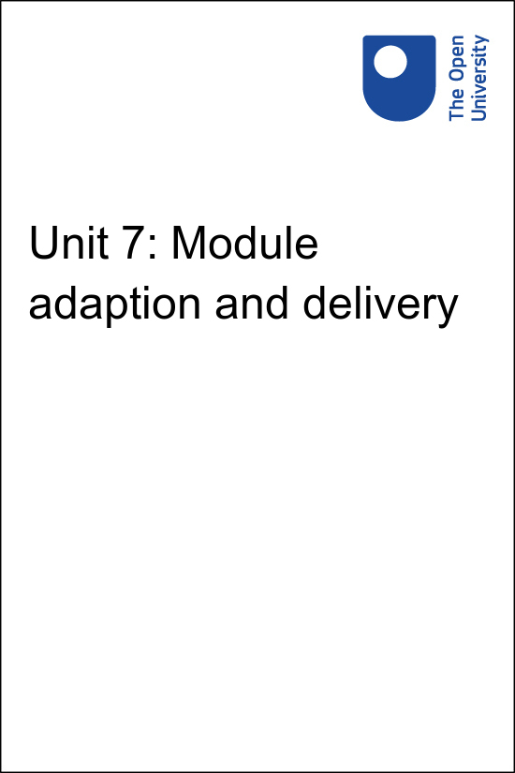

Implementing Education 4 Justice in your University Implementing the United Nations Education for Justice (E4J) initiative in your university

Unit 7: Module adaption and delivery
Copyright © 2020 The Open University
All rights reserved. No part of this publication may be reproduced, stored in a retrieval system, transmitted or utilised in any form or by any means, electronic, mechanical, photocopying, recording or otherwise, without written permission from the publisher.

Contents
- Unit 7: Module adaption and delivery
- 7.1 Integration with existing courses or using as a standalone programme
- 7.2 Localizing the content and adapting time frames
- 7.3 Making the most of the E4J resources
- 7.4 Conclusion and Module overview

Unit 7: Module adaption and delivery
The University Modules on Anti-Corruption, Integrity and Ethics have deliberately been designed to be adapted to your particular teaching context so you are able to design and deliver sessions that will engage your students.
Each Module provides an outline for a three-hour class but can be used for shorter or longer sessions. The following sections provide examples of the kind of adaptation that can take place. It is not an exhaustive list and can be expanded where required.
To be able to support lecturers even further, UNODC would appreciate receiving any adapted versions of the E4J Modules (messages should be sent to unodc-e4j@un.org and e4j.ethics@un.org). UNODC will then share these with its network lecturers as examples of how the Modules can be adapted to different regions, contexts and disciplines.
You can join the network by clicking on the network tab on the E4J website or sending a request to e4j.ethics@un.org.

Adapting modules for a local context
Lecturers around the world are already adapting the E4J Integrity and Ethics Modules for use in their own contexts.Here are three examples from lecturers teaching in Nigeria and South Africa.
Gender dimensions of Ethics – Module 9 – Nigeria
Media integrity and Ethics – Module 10 – South Africa
Professional Ethics – Module 14 – South Africa

To understand the impact that using these E4J Modules can have on a wider scale take a moment to watch this short summary video

Video content is not available in this format.
View transcript - Uncaptioned interactive content



7.1 Integration with existing courses or using as a standalone programme
All the E4J Modules have been designed in a way that they could either be offered as a stand-alone Module or integrated within an existing course. As mentioned before, the modular structure allows you to select only those that are relevant within a specific context. You may also create a complete course on anti-corruption, integrity and ethics by using all 14 E4J Ethics Modules and all 14 E4J Anti-Corruption Modules, or mix and match with the E4J Modules on Crime Prevention & Criminal Justice for example.
As a stand-alone programme, the E4J anti-corruption, integrity and ethics material could be offered as either a voluntary or mandatory addition to a course, e.g. as a workshop offered outside the normal scheduled sessions. It could also be offered as part of summer or interim sessions or as public sessions with broader participation than simply the registered students.
Integration within an existing course requires advanced planning, because a specific session would have to be scheduled in a course outline, which may have to go through internal approval processes. You probably have substantial flexibility to introduce new, but related, content in a course outline.
For example, in a media and communications studies course there is likely to be an existing focus on ethics and possibly corruption awareness. In such a case, you can either replace the existing content with the E4J Module or adapt/merge the existing content with the E4J content. If there is no existing ethics content, you will have to rearrange the current content to create space in the course outline for the E4J material.
It remains your responsibility to familiarize yourself with the academic requirements of your specific institution. The process described above might not always be possible. Below is an example of how E4J Ethics Module 1 could be adapted as a stand-alone course.

Session | Topic | Brief description
1 | Introduction | Dealing with ethical dilemmas and introducing the concept of integrity
2 | Substantive versus meta-ethics | Distinction between substantive and meta-ethics
3 | Cultural relativism | Dealing with the issue of different cultures and different moral codes
4 | Subjectivism and egoism | Subjectivism, emotivism and reason
5 | Social contract theory | Hobbes, the prisoner’s dilemma
6 | Utilitarianism | Overview of theory and main philosophers, with examples of application to specific cases
7 | Deontology | Overview of theory and main philosophers, with examples of application to specific cases
8 | Virtue ethics | Overview of theory and main philosophers, with examples of application to specific cases

7.2 Localizing the content and adapting time frames
You can take the following steps to localize the content:
- Determine if there is any content that might be deemed offensive in a local cultural context and remove or adapt that part
- Provide a customized introduction that refers to relevant legal frameworks and case studies, perhaps recent examples that appeared in the local media
- If required, replace or complement the existing readings, case studies and exercises with examples that reflect the local context
- If appropriate, merge the E4J content with an existing Module
- If required, translate the content into a local language
- Adapt content to better relate to a certain discipline, sector or industry.
The three-hour time slot is offered as a guideline. Depending on your lecturing style and the class size, a typical E4J Module, with all exercises, could probably be offered in a timeframe that ranges between one and four hours. These requirements vary between institutions and programmes.
Undergraduate contact sessions are usually shorter, and one E4J Module might have to be spread over two or more sessions. By contrast, postgraduate sessions could last two or three hours, which might be sufficient to cover the content of an entire Module.
However, you may still wish to spread the Module over two sessions, as the break in between the two sessions could allow students to process and internalize the materials better. In some cases, you might wish to introduce additional content to offer a half-day or even a full-day workshop.
There are no rigid guidelines in this regard and you need to make adjustments to fit your circumstances. Given their highly interactive nature, the exercises in the Modules are most appropriate for relatively small classes of up to 50 students, where students can be easily organized into small groups in which they discuss cases or conduct activities before group representatives provide feedback to the entire class.
In larger classes comprising a few hundred students, it is more challenging to have the same small group structure and you might wish to adapt the facilitation techniques to ensure sufficient time for group discussions as well as providing feedback to the entire class.
The easiest way to deal with the requirement for small group discussion in a large class is to ask students to discuss the issues with the four or five students sitting close to them. Given time limitations, not all groups will be able to provide feedback in each exercise.
It is recommended that you try to ensure that all groups get the opportunity to provide feedback at least once during the session. If time permits, you could facilitate a discussion in plenary after each group has provided feedback.

7.3 Making the most of the E4J resources
The E4J Modules are the product of an international collaboration of 600 academics from over 500 Universities drawn from all over the world. They have worked hard to provide what we think is a valuable resource to support you in your teaching.
In particular, they have included a number of specific features that aim to make it easier for you to adapt the material to your teaching context. The following infographic highlights some of the features of the Module design that you may find particularly helpful.

Interactive content is not available in this format.

Figure 15 The E4J Module components
The E4J Anti-Corruption, Integrity and Ethics Modules are part of a wider set of resources that make up the E4J initiative. Depending on your teaching context, you may find it useful to combine elements of the Integrity and Ethics materials with resources from other topic areas. So it is well worth spending some time familiarising yourself with the E4J website.
This web tour provides a useful summary of some of the key things to look out for.

Video content is not available in this format.
View transcript - Uncaptioned interactive content

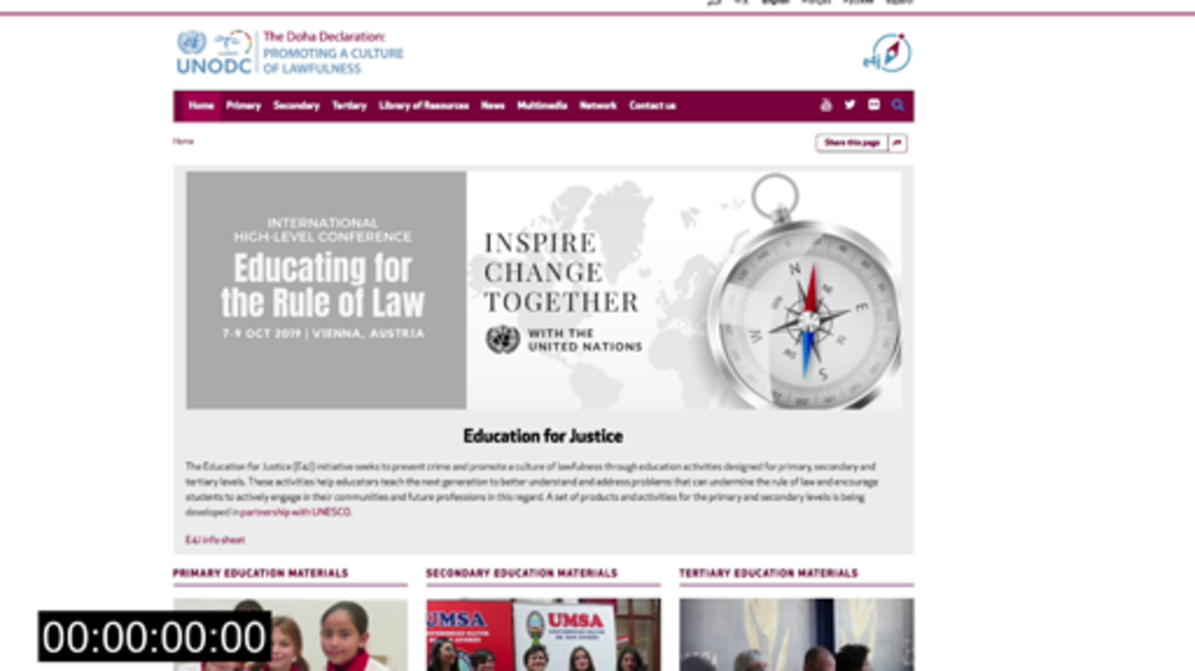

7.4 Conclusion and Module overview
In this unit you have explored how the E4J Anti-Corruption, Integrity, Ethics Modules have deliberately been designed to be adapted to fit your particular teaching context and engage your students.
You have explored how you can contextualise the materials and integrate the integrity and ethics content with other course material available on the E4J website and considered how you can benefit from the global E4J network.

The E4J Integrity and Ethics Modules
The interactive below gives you a summary of the 14 E4J Integrity and Ethics Modules. Clicking on each circle gives you a direct link to the Introduction and learning outcomes page of the corresponding Module website.
Please note: the Module links open in a new tab and your E4J course tab remains open in your browser.

Interactive content is not available in this format.

Figure 16 Links to the E4J Integrity and Ethics Modules

The E4J Anti-Corruption Modules
The interactive below gives you a summary of the 13 E4J Anti-Corruption Modules. Clicking on each circle gives you a direct link to the Introduction and learning outcomes page of the corresponding Module website.
Please note: only Modules 1–6 are currently available. The other Modules will be added as they are published by UNODC.

Interactive content is not available in this format.

Figure 17 Links to the E4J Anti-Corruption Modules
Go to Course conclusion and further reading now.

Uncaptioned interactive content

Transcript
DIMITRI VLASSIS
What we're looking forward to is you're using the Modules that are being developed, and inspiring your peers to use these Modules also in education. Just think that if you and the others who are participating in this smaller version of the network teach one course, the numbers of people who would benefit, of students who would benefit from it, can easily reach thousands.
Back to - Uncaptioned interactive content

Uncaptioned interactive content

Transcript
FRANCINE RYAN
To access the integrity and ethics Modules, go to the tertiary site. And if you click over and hover over Integrity and Ethics, you will see the teaching guide and 14 Modules. If we look at the teaching guide first of all, it has an introduction, has a section on helping people learn, it has a section on fostering ethical learning environments, it has an overview of the Modules and the learning outcomes, and it talks about how you can adapt these Modules for your own purposes.
And it also includes a table of exercises that you might want to use in your teaching. The teaching guide is covered in the online taught course. But here you have access to all the information that's contained in the teaching guide, so you may wish to review that at another point when you are thinking about developing these courses in your own universities.
If we take an example of a course, for example, Module 10, Media, Integrity, and Ethics, you will see that each Module is set up in the same way. Each Module contains instruction and learning outcomes, has the key issues, the exercises that you will use, has examples of class structure, has core readings for the course, the advanced readings that you may wish to use with your students. It contains student assessment, additional teaching tools and guidelines to develop a standalone course. So let's take each of those elements and have a look at them.
So the introduction starts off with what this course is all about. So it gives you the guidance to tell you what the course is going to cover, and then each course has a set of learning outcomes that your students will achieve through studying this course. If we then look at the key issues, the key issues are then explained in the course. So in this one, we have the key issues relating to journalism, we have the terms and concepts, we have the ethical principles for journalists and other media providers. We have the ethical principles for citizen journalists and media consumers. And then we have the references for where you can source this material from.
So each course will have a section, setting out the key principles of that particular course. Each course has a set of exercises. The exercises have a series of lecture guidelines, which gives you some information about how you could use these exercises in your own teaching. And then you will see that each of the exercises is explained, so you have the information to assist your students in completing these exercises.
Each Module will have a variety of different types of exercises. The Module will then have some information about the possible class structure. So in this Module, we're looking at an introduction that's 10 minutes long. Then we have an exercise on how to choose your news. We have a second exercise on the rise of fake news. And then we have another exercise on does the media have a duty of care, followed by an exercise on the Potter Box method, an exercise on AstroTurf and manipulation of media messages, and finally, one on citizen journalism and conclusion.
And each of those has guidelines to help you in terms of the timings for these particular exercises. But obviously, you can adapt them for what's right for your circumstances. So you may want to take longer or shorter depending on your students and the context within which you are delivering this Module.
There are then core readings that you can ask your students to read before a class based on this particular Module. So here, we have a list of core readings that you may wish to use with your students. And you can see that list is comprehensive. In addition, there's a set of advance readings. So these are readings that you might find useful for your students or students who want to find out a bit more about that particular topic.
And again, you'll see that's an extensive list of advanced readings that you can use, or your students can use in studying this Module. Each Module has a series of student assessments, so there's some guidance about preparing a post-class assignment for the purpose of assessing your students on the understanding of this particular Module. So you'll see an example here, and each Module has an example of a student assessment. Each Module also provides additional teaching tools.
So in this Module, there's a PowerPoint presentation, which you can use in your teaching, and then there are a series of video materials that you might wish to use and a blog that you will use to refer your students to. And these additional teaching tools form part of the exercises that the students will complete in class. And finally, there are guidelines to developing a standalone course.
This Module provides an outline for a three-hour class, but there is potential to develop it further or make it into a standalone course. So each Module gives you some guidance at the end to how to do that and how to create a standalone course. So you will see an example of here on how that you may wish to do this, so that you can incorporate this into your own teaching.
This is very useful. It shows the flexibility of these materials, and you can repurpose them to suit your students and your context in your university.
HUGH MCFAUL
When you land on the home page of the Education for Justice website, you'll be aware that the project relates not just to university level resources, but also to primary schools and secondary schools. The purpose of this web tour though, is to make you aware of the full range of facilities and resources designed for tertiary level education. So if you click onto this part of the website, you'll see that in addition to the integrity and ethics Modules, there are a range of resources on topics, including anti-corruption, organised crime, firearms, and counter-terrorism.
And these Modules, if you wish, can be combined with the integrity and ethics Modules to build a bespoke course. To help you do that, there is a Build Your Own Course application that you can see here that can help you organise the different aspects of the Modules, from, for example, cybercrime or firearms that you might want to combine with integrity and ethics. This way it will help you adapt the resources for the use for your own students in your own context.
In addition, it's worth knowing about the network of educators that the platform provides for. If you click on the Network tab, you'll be able to register your interests, your name and address, and this will allow you to keep in touch with other educators, who are using this resource elsewhere around the world. And you'll be able to share how you've adapted the materials in your own context and learn from your colleagues for how they've done that in their context.
In addition, it's worth knowing about the library of resources that provide a list of additional materials that help you or your students engage in the topics in a deeper level. So for example, on the integrity and ethics topic, there's a range of textbooks, journal articles, and other resources to help you and your students explore this area in more detail. We hope you find this web tour useful and have a better understanding of the resources available to you to support you in your teaching.
Back to - Uncaptioned interactive content

