Becoming an OU Tutor in STEM Being an OU Tutor in STEM: Computing and Communications

Part 4 Teaching in Computing and Communications

This version of the content may include video, images and interactive content that may not be optimised for your device.
Copyright © 2020 The Open University
Intellectual property
Unless otherwise stated, this resource is released under the terms of the Creative Commons Licence v4.0 http://creativecommons.org/licenses/by-nc-sa/4.0/deed.en_GB. Within that The Open University interprets this licence in the following way: www.open.edu/openlearn/about-openlearn/frequently-asked-questions-on-openlearn. Copyright and rights falling outside the terms of the Creative Commons Licence are retained or controlled by The Open University. Please read the full text before using any of the content.
We believe the primary barrier to accessing high-quality educational experiences is cost, which is why we aim to publish as much free content as possible under an open licence. If it proves difficult to release content under our preferred Creative Commons licence (e.g. because we can’t afford or gain the clearances or find suitable alternatives), we will still release the materials for free under a personal end-user licence.
This is because the learning experience will always be the same high quality offering and that should always be seen as positive – even if at times the licensing is different to Creative Commons.
When using the content you must attribute us (The Open University) (the OU) and any identified author in accordance with the terms of the Creative Commons Licence.
The Acknowledgements section is used to list, amongst other things, third party (Proprietary), licensed content which is not subject to Creative Commons licensing. Proprietary content must be used (retained) intact and in context to the content at all times.
The Acknowledgements section is also used to bring to your attention any other Special Restrictions which may apply to the content. For example there may be times when the Creative Commons Non-Commercial Sharealike licence does not apply to any of the content even if owned by us (The Open University). In these instances, unless stated otherwise, the content may be used for personal and non-commercial use.
We have also identified as Proprietary other material included in the content which is not subject to Creative Commons Licence. These are OU logos, trading names and may extend to certain photographic and video images and sound recordings and any other material as may be brought to your attention.
Unauthorised use of any of the content may constitute a breach of the terms and conditions and/or intellectual property laws.
We reserve the right to alter, amend or bring to an end any terms and conditions provided here without notice.
All rights falling outside the terms of the Creative Commons licence are retained or controlled by The Open University.
Head of Intellectual Property, The Open University

Contents
- 4.1 Introduction
- 4.2 Welcome to the School of Computing and Communications
- 4.3 What could you teach?
- 4.4 What are the roles that our tutors play?
- 4.5 Teaching in computing and communications
- 4.6 The teaching and technology challenges tutors help us solve
  - 4.6.1 Introduction to Computing and IT (TM112) – facilitating understanding
  - 4.6.2 Cisco Networking CCNA (TM257/TM357) – Packet Tracer
  - 4.6.3 IT Systems: Planning for Success (TM353) – exploring security vs. privacy
  - 4.6.4 The Computing and IT Project (TM470) – helping to shape a dissertation
- 4.7 How C&C supports the professional development of tutors
- 4.8 Summary
- Acknowledgements
- Solutions

4.1 Introduction
By Chris Douce and Chris Thomson

View description - Uncaptioned Figure

Tutors in the School of Computing and Communications help students to grow in confidence and step forward in their understanding of the subject. Whilst all STEM tutors share their knowledge and experience with students, this is especially important in computing and communications due to the breadth of the subject area and its fast-changing nature. Students especially value tutors that share their own experience to add depth and context to the student's learning.
On most modules, students have the opportunity to attend tutorials with several tutors, so multiple experiences are combined to give students a broad picture of the profession.
The breadth and fast-moving nature of computing and communications also impacts tutors' professional development, both at the Open University and in any external appointments. You are already aware of, and used to keeping up to date with, changes in technology in your field of work. We support tutors in this through our research seminars, taking part in research and making use of the fee waiver available to tutors to study any of our modules.
Here in Part 4, we introduce you to the school, our modules, the role of a tutor in computing and communications, and give you the opportunity to reflect on how your skills and experience relate to the role.

4.2 Welcome to the School of Computing and Communications

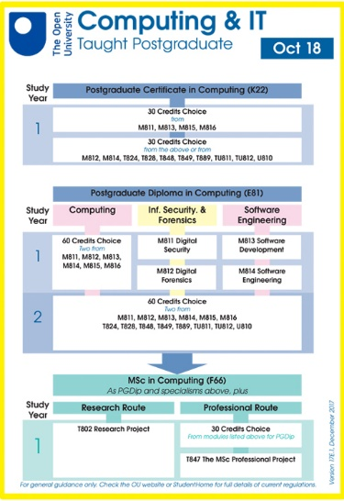
View description - Uncaptioned Figure

The School of Computing and Communications offers broad-based computing undergraduate and postgraduate degrees covering software engineering, data science, cyber security and networking. Most modules award 30 credits, requiring a student to complete four modules or 120 credits for each undergraduate stage. Our postgraduate degrees require 180 credits in total and are all taught at a single stage.
The undergraduate degrees, which follow a traditional three-year degree format, allow students to study computing and another subject or top up previous study. Most of our students study part-time and can study as little as 30 credits a year, often alongside a full-time job and family responsibilities. We also offer degree apprenticeships in computing subjects in England, Scotland and Wales.
Our postgraduate study options allow students to study subjects at greater depth and normally require students to have completed an undergraduate degree in computing or have equivalent practical experience of the subject. We offer a range of study options including an MSc and a level 7 apprenticeship in Cyber Security in Scotland.
All of our modules are taught at a distance, primarily though our online virtual learning environment, although some modules also provide printed books containing the module material. Many modules have the option of some face-to-face tutorials, which take place in locations around the country.
For example, TM129 (Technologies in practice) offers students 8 hours of online tutorials and 6 hours of either online or face-to-face tutorials across 27 locations in the UK. However, most tutorials are delivered online through Adobe Connect.
Details of the degrees and the pathways within them can be found on the OU website for undergraduates and post graduates. We also summarise them in this downloadable PDF.

4.3 What could you teach?

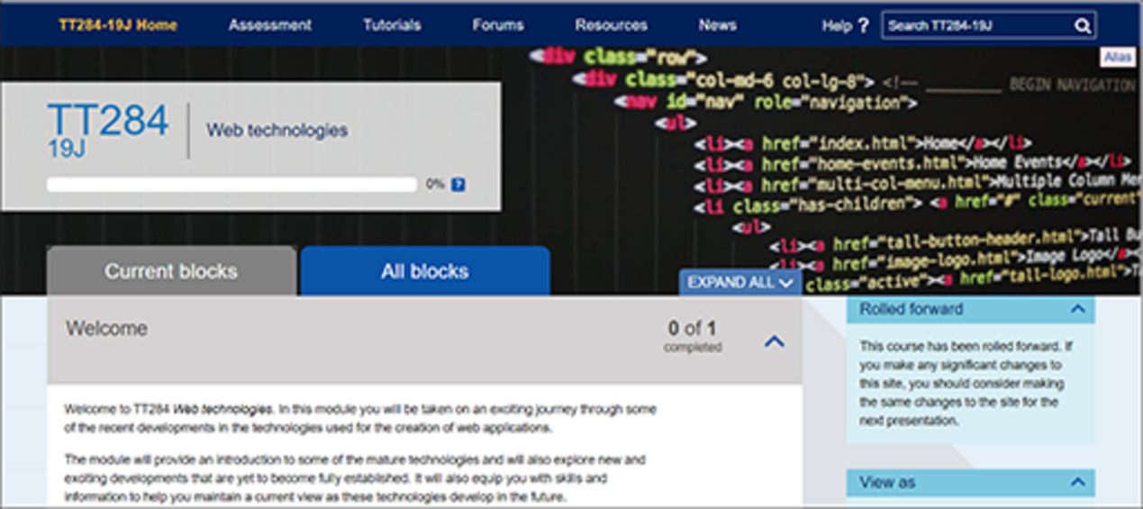
View description - Uncaptioned Figure

Several of our modules have extracts of materials included on OpenLearn. You will find this useful to understand what our modules cover, the style of teaching presented to students, and consider how your experience may be able to help students studying in these contexts.

Activity 1

Investigate a module
Select a module from the list below and work through the study material yourself. What did you find engaging in the material? What did you think a student who is new to the subject may need more help with?
- Web Technologies (TT284) – an undergraduate stage 2 module (equivalent to year 2 in a full-time degree).
- IT Systems: Planning for Success (TM353) – an undergraduate stage 3 module.
- Software Engineering (M814) – a postgraduate module.
Post your thoughts to the discussion forum and comment on some other posts. Do you agree with the other posters?

Find out more
If you would like to explore further study material, you can find the links on this page.

4.4 What are the roles that our tutors play?

View description - Uncaptioned Figure

Given the broad curriculum, most of the computing and communication tutors are specialised in part of the curriculum, but many teach across several modules and stages. In this section, we explore some of the main roles that tutors fall into within the curriculum and explore the skills and knowledge needed in these roles:
- Stage 1 tutors typically need a broad subject base as each of the modules cover broad subject areas integrating elements of computing, maths and technology at an introductory stage. These tutors are typically skilled in pastoral support helping students to start their study and develop appropriate study skills. They are confident in bringing the subject alive to inspire students and help them understand how the subject is studied academically.
- At stage 2, our tutors help to develop the core skills of computing and communications technologies, this includes developing programming, teamworking, analysis, design, networking and algorithms. These tutors are skilled in helping the students develop new skills and ways of thinking.
- Students' specialist skills are developed in the third stage of study. Our tutors at this stage have in-depth knowledge of the area in which they teach. Students at this stage are encouraged to use a range of sources, so tutors support their study in the subject outside of the module material by drawing on their own experience and professional development.
- Some tutors are experts in helping students develop programming skills. Learning how to program is an essential part of any computing degree, but also something many students struggle with. At stages 1 and 2 there is a focus on developing these skills starting with computational thinking, and then applying this in software design using Java, and data structures and algorithms using Python. The skill is further developed in web design to develop simple applications.
- We work with Cisco to deliver courses in networking and cybersecurity across all stages. Some of our tutors are Cisco accredited and support students on these modules using a mix of Cisco and Open University materials online, as well as Cisco day schools where students make use of physical hardware.
- Modules in computing and communications can be very technical in nature (such as teaching programming or networking) but can also focus on people and society. These themes look at ethics, how software is designed for human use, and the effective use of software within organisational change. Tutors who specialise in this are able to explain the big issues in computing and set them in context. They help our students grow in their understanding that humans define technology rather than vice versa.
- Postgraduate tutors are typically experts in their field and able to provide students with support that builds on their academic and practical experience. Most students at this stage are able to study independently, so the tutors focus on building and developing knowledge and skills primarily through feedback on assignments.
- Tutors who can act as a project tutor in undergraduate and postgraduate modules are always in high demand. These tutors would typically have the knowledge and skills to teach at least one of the other stage 3 undergraduate modules or postgraduate modules, respectively. The project would be based on the material in the other module and build upon it by seeking to apply other appropriate academic and professional sources relevant to the stage of study. The tutors help guide the students through the project, developing project management and research skills alongside applying technical knowledge in a real project.
- Practice tutors work with our apprentices in England, Scotland and Wales. They regularly visit the apprentice in their place of employment to discuss progress with the apprentice and their line manager. They help to relate study to the student’s workplace to develop high quality applied skills and knowledge.
Our tutors are typically given a lot of freedom in how to manage their time best to support their students. This allows for the fact that students studying in the school often have different expectations and needs from their education.

Activity 2

Part 1 Identify the modules that fit your practice

Explore our modules available for undergraduate and postgraduate study.
Identify which modules relate to your experience and interests, then select one or two that feel the most relevant based on the role profiles above.

Part 2 Mapping your experience

In the discussion forum, make a post to map out what you could offer our students.
Then comment on a couple of posts, highlighting what you see as being an important part of their contribution.
Do any of the highlighted skills or experience fit well with other modules you have looked at?

4.5 Teaching in computing and communications
Our tutors typically come with a range of academic and professional experience, but an essential element of tutoring is experience in teaching and supporting students. In this section, we have interviewed some existing tutors to explore how they support their students.

Activity 3

What is appealing about the tutor role?
Teaching in computing and communications remotely is different from classroom instruction. In this activity, you should consider the tools that you have experience with to work remotely. How might you use these in teaching?
Activities you could consider are using online tools to debug code, screen sharing, use of development tools, asking questions, or using the phone.
Select an idea and post it to the discussion forum. Add comments to two other posts, how could the effectiveness of the idea be increased?

Activity 4

What does teaching mean to you?
In this video, our tutors Prince, Kate, Colin, Tammy and Charly discuss various aspects of being an OU tutor, including contact with students, the challenges of supporting students, developing student skills, and the additional support required for some students.
Watch the video and make notes about how the tutor fulfils their role. How does the tutor support students? How do they demonstrate this skill to you?

Video content is not available in this format.
View transcript - Uncaptioned interactive content

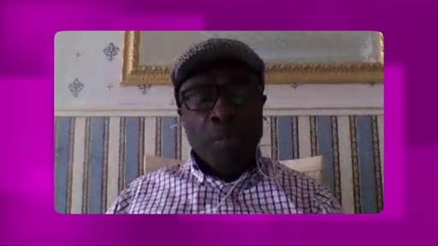

Correspondence tuition (supporting students through your marking feedback, emails, and tutorials) is a different skill to many other forms of teaching – so you may like to think about how you can apply your transferable skills to this new situation.
Reflecting on your own experience, how do you support people, learners or students with similar issues? Draw on all of your experience, both within work, academia and in informal settings.
Write a post to the discussion forum that demonstrates your experience. Comment on some of the other posts, is it clear what they do?

4.6 The teaching and technology challenges tutors help us solve
In this section, we explore a few of the teaching challenges we have, the innovative technology we use, and how tutors can help us close the gap to deliver an integrated learning experience for students.
The material by itself may feel to some students like studying from a book, so tutor interaction is an essential part of the OU experience.
The tutor’s expertise and experience customise the learning for the student, helping them when they get stuck and directing them to the most relevant materials for their learning context.

4.6.1 Introduction to Computing and IT (TM112) – facilitating understanding
Some subjects, such as cyber security, are fast moving. To enable students to appreciate some of the current issues in cyber security, the TM112 module team have created what is called a ‘guest lecture’.
The guest lecture is presented in two parts. The first part is a pre-recorded lecture (typically given by a member of the TM112 module team) which students can view, and the second part is an interactive question and answer panel discussion which is open to all students. Before the panel discussion takes place, students are invited to submit any questions they may have.
These two parts enable students to interact with the members of the module team who have written the module and to gain an awareness of an important subject that students may wish to study later.
An important role of the tutor is to signpost students towards different events and resources such as the guest lecture. Tutors can also make use of OU teaching resources in their tutorials and can refer to different parts of OU modules in their correspondence teaching.

Activity 5

Watch this short video clip from the lecture.

Video content is not available in this format.
View transcript - Uncaptioned interactive content

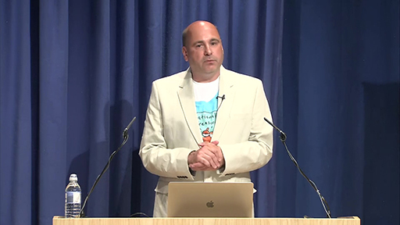

Think about how you might use some of the topics featured in the lecture in a tutorial. What questions might you ask students about the video to gauge their understanding of the material?

Provide your answer...
View answer - Activity 5

4.6.2 Cisco Networking CCNA (TM257/TM357) – Packet Tracer
Sometimes tutors are required to use additional third-party software and resources to support their teaching. Some tutors may need to be familiar with Cisco networking materials. TM129: Technologies in Practice, a stage 1 OU course, makes use of Cisco materials, as does level 2 and 3 modules from the OU Cisco Networking programmes; for example, TM257 (Cisco Networking Pt 1) and TM357 (Cisco Networking Pt 2).
The challenge here is helping the students relate material between Cisco, the OU, Assessment and the real world.
These courses are based on the Cisco Network Academy programme, where students are required to access their course materials as well as complete exams, all through the Cisco Netacad site. This is over and above accessing their own module course page through the OU VLE/TutorHome.
Additionally, students are also required to download and install network simulation software called Packet Tracer. This software allows the completion of lab-based activities as well as tutor-marked assignments (TMAs). The Packet Tracer software offers a fully functional environment where tutors and students have access to a variety of network hardware, media and cabling, smart devices and IoT technology as well as popular end devices such as PCs, tablets, printers and IP phones.
Packet Tracer also offers programming features such as interfaces for block-based visual programming (e.g. Scratch) as well as Python and HTML/CSS. Packet Tracer is also able to be used alongside networking hardware, where users are able to export configurations into real routers and switches.

Activity 6

Explore Packet Tracer on OpenLearn
You can experience this kind of learning on OpenLearn, why not have a quick go?

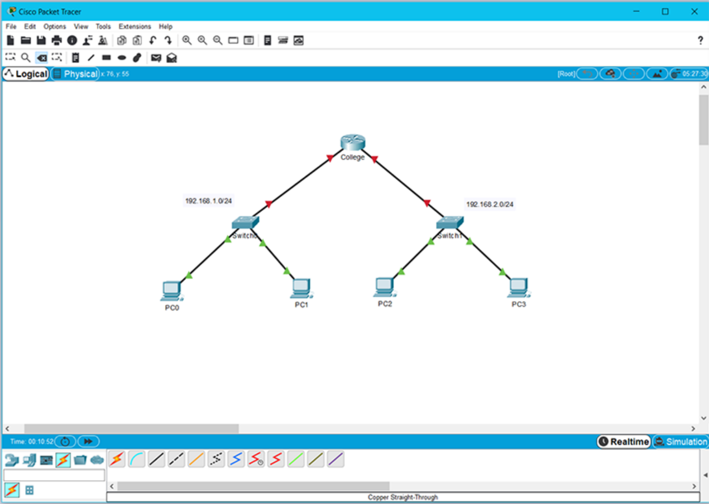
An example of Packet Tracer in use
View description - An example of Packet Tracer in use

4.6.3 IT Systems: Planning for Success (TM353) – exploring security vs. privacy
A significant part of TM353 explores the ethics of computing most of which students engage with and find interesting, but the security vs. privacy debate always raises some eyebrows.
Many students find it hard to engage with this due to pre-established, strongly held opinions. This module has three specialist tutorials, one of which explores issues around this debate.
Tutors typically select interesting examples that have recently come up in the news and design a tutorial around this that results in a lively debate around the issues. Below is an example tutorial for you to explore.

Interactive content is not available in this format.

4.6.4 The Computing and IT Project (TM470) – helping to shape a dissertation
Towards the end of their degree studies, many students complete what is known as a project module. A project module allows a student to demonstrate the skills and knowledge that they have acquired through earlier OU study. A project module differs from other OU modules in the sense that the project is defined by the student, rather than the module team. The module materials exist to guide the student through the process of choosing a project, how to organise and run their project, and also how to write the final project report (which is the equivalent of a dissertation).
The type of project that a student chooses is important. A project might be a research project where a student caries out an in-depth analysis of a technical problem. A project might also be an implementation problem, where a student solves a problem by creating a design of a system, perhaps drawing on technical knowledge they have gained by earlier level 3 study. A project could also be an evaluation project: a comprehensive comparison of different systems, products or solutions.
A project tutor will help a student to choose an appropriate project. The tutor will also provide a set number of hours of one to one tuition for each student.
Since the project module meets the accreditation requirements of the BCS, the British Computer Society, The Chartered Institute for IT and the Engineering Council, tutors must also encourage students to consider the social, ethical and professional issues that their project raises.
Towards the beginning of the module, a tutor may choose to run tutorials to help students to understand how best to plan and run their project. Towards the end of the project, a tutor might be providing very targeted one to one support.
Not only must a tutor provide some practical guidance about how to run a project, a project tutor must also be willing and able to offer some practical guidance about how to write and structure their project reports. For some students, the project report may be the biggest piece of assessed work they have ever completed for the university.

Activity 7

What challenges motivate you to help our students?
Pick one of the modules discussed briefly over the last few pages and consider how you would address the challenges described.
Select one example and post it to the discussion forum.
Comment on some other ideas posted. How do you think the students would respond to the proposed help?

4.7 How C&C supports the professional development of tutors
As explored in the previous sections, an important part of the tutor role is to interpret the module material in the light of recent developments and appropriate contexts for the student such as their workplace.
The school runs regular seminars on Thursday afternoon that highlight research the school has undertaken or where invited speakers present on interesting subjects. These are available to join online live and are recorded to watch later.
Tutors have access to the OU library, which provides a wide variety of books, professional and academic journals online. This includes the excellent Safari Books Online with access to a wide variety of books and videos on computing and communications subjects.
Tutors have the opportunity to get involved in Scholarship through eSTEeM. This is the faculty’s programme to develop our understanding of the most effective teaching methods. By taking part in projects, tutors can not only steer how we develop our teaching, but also attend conferences to present their research and see what others in the field are doing.

Investigating the perceived benefits to computing students of remote pair programming
A lot of published literature has confirmed that there are benefits to be gained from pair programming, whereby two people work side by side at the same computer to solve programming problems. A current Computing and Communications eSTEeM project is investigating whether pair programming can help OU students who are learning to program remotely and whether there are employability and social/community benefits to OU students who perform pair programming online. We are running this project with the (very welcome) support of two tutors.
In the first phase volunteer students watch a video of our two tutors pair programming. The students can watch or listen to the tutor pair attempting to solve the problem – and that includes coming up against issues, talking aloud about how to solve these, discussing different approaches, watching how they tackle debugging when there are e.g. compilation errors and so on.
In the second phase volunteer students watch the tutors pair programming “live”, using Adobe Connect. Students can ask questions of the programmers either during the programming or at the end.
In the third phase students to do pair programming work themselves, using Adobe Connect.
The project explores if our students benefit from watching and/or interacting with pair programmers solving problems, and/or pair programming themselves.
(Source: An example of an eSTEeM project linked to TM112 our Introduction to Computing module)

Activity 8

What continual professional development (CPD) activities have you participated in recently?
Reflect briefly on the professional development activities that you have completed in the last year. They may be formal events organised by your employer, training, volunteering or a book you have read.
How have these helped you keep up to date with the field of computing and communications? Have you put any of the things you learned into practice?
Write a short reflection that you could share with a student based on what you have learnt and post it to the discussion forum.
Review two other posts, and consider how might you take the reflection of the other poster and integrate it into a tutorial? Put your ideas up as a reply.
Part 6.3 of this course explores continual professional development (CPD) in more detail.

4.8 Summary
In Part 4 you have explored how tutors in the School of Computing and Communications support our students. You have seen some of our module material, the kind of different roles our tutors fill, and you have considered how you might fit into this role.
Go to Part 5 of the course, Correspondence tuition, where you learn in more detail about the role of the tutor in supplying tuition and feedback.

Acknowledgements
Grateful acknowledgement is made to the following sources:
Every effort has been made to contact copyright holders. If any have been inadvertently overlooked the publishers will be pleased to make the necessary arrangements at the first opportunity.
Important: *** against any of the acknowledgements below means that the wording has been dictated by the rights holder/publisher, and cannot be changed.
Except for third party materials and otherwise stated (see terms and conditions), this content is made available under a Creative Commons Attribution-NonCommercial-ShareAlike 4.0 Licence.
The material acknowledged below is Proprietary and used under licence (not subject to Creative Commons Licence). Grateful acknowledgement is made to the following sources for permission to reproduce material in this free course:
Acknowledgements for Part 4
Lady on laptop: © dolgachov / 123 Royalty Free
Self_examination: © Comaniciu Dan Dumitru / 123 Royalty Free
Cisco_PT: Image produced using Cisco Packet Tracer
Don't miss out
If reading this text has inspired you to learn more, you may be interested in joining the millions of people who discover our free learning resources and qualifications by visiting The Open University – www.open.edu/openlearn/free-courses.

Solutions

Activity 5

Answer
You might check their understanding by asking them to explain some of the scenarios to you. You might also ask whether they have heard of any recent or other cyber security stories. Asking questions that enable students to relate existing knowledge to new ideas and concepts is a very good way to facilitate student learning.
Back to - Activity 5

Uncaptioned Figure

Description
A young woman sitting at a table with a bowl of food and a cup of coffee on it. The woman is looking at her laptop computer and has headphones in her ears. She is smiling and giving a thumbs up gesticulation indicating she is pleased with something.
Back to - Uncaptioned Figure

Uncaptioned Figure

Description
This is an image of one of the pages of the downloadable PDF available further down this webpage.
Back to - Uncaptioned Figure

Uncaptioned Figure

Description
A screenshot of a webpage for module TT284 web technologies which is detailed in the content below.
Back to - Uncaptioned Figure

Uncaptioned Figure

Description
An image of a man's head with several question marks floating above it.
Back to - Uncaptioned Figure

An example of Packet Tracer in use

Description
A screenshot of a packet tracer diagram being created on a computer screen.
Back to - An example of Packet Tracer in use

Uncaptioned interactive content

Transcript
PRINCE BOATENG
One of the main responsibilities of a tutor, especially at level one, is to help develop our students' study skills which they would then need further along the line in their studies. Study skills like English, language skills, mathematical skills, and in our line of the IT department, we also try to help them to develop their problem-solving skills.
JOAN JACKSON
The usual role of a tutor, which is to provide academic support and also some welfare support, as well. Making sure that students are happy studying the module and sorting out any problems.
COLIN EVERISS
So you're very much engaged as a person with the student themselves, talking to them, discussing with them, verbally answering their questions in a very diverse way, much more than they are getting from a textual book or a video.
TAMMY BROWN
I think an important point to pick up is that a lot of what we do is we help reduce the sense of isolation by being that friendly face, by being the face of the university. We add that point of contact, that reliable point of contact. We help reduce that sense of isolation, which helps maintain the engagement of the students.
PRINCE BOATENG
I send them all a welcome email, setting up their expectations when they can get in touch with me and a little bit about myself. And then just make them feel comfortable and just let them know that you can contact me at any time. So I do that.
I also contact students to remind them of impending tutorials. So whenever we're going to have face-to-face tutorials or online tutorials, I would normally send an email around saying, don't forget that we have a tutorial on such-and-such a time.
CHARLY LOWNDES
One of the things I do is to make little videos at the start of each academic year saying, hi, I'm me, trying to get across the idea that I am a friendly face. I'll send very short emails, just to establish a line of communication.
Once that's going, I suppose I'm trying to do three things. One is to give them some factual information. This is what you need to do and where to find it and how to do it. One is if you like just pragmatic, have I got the right email? Reply so that I know. All you need to say is, hi. If I don't get a reply, then I'm going to keep following up, possibly through another channel like the telephone.
But the third and the most important thing is the emotional rapport, a tricky thing to do with somebody you've never met, may never meet face-to face. So I try to put myself across as being approachable because I want to be approached. That's what a large chunk of what a tutor is for.
TAMMY BROWN
I make sure that they know when they can contact me. And I try to set up a realistic sense, because I think it's important. Students will study for 15 hours, say, per course in a week. But we may not be employed to teach for that 15 hours specifically, and not 24 hours a day. So I think it's quite realistic to set the goals and then stand by them.
So I say that they can contact me by telephone between specific times. And I do my best to make sure that I am available during those times. They can contact me at other times, but we would then arrange that between ourselves. But most of the contact is through forum support and email, which makes it a little bit more convenient because it's asynchronous. So we don't have to be using the same means of communication at the same time.
COLIN EVERISS
Initially, I'll be spending a lot of my time talking to them about what it is or what it means to be a student with the Open University. And a lot of my time initially is talking to them about how it's organised and how they should be organised. And as I mentioned, some of that discussion also takes place with the employers as well.
TAMMY BROWN
Often students, they'll come to you. They're having a problem, say, with an assignment question. And it's kind of unravelling what it is they think their problem is to actually get to the core of it to know where to sign post them to.
PRINCE BOATENG
You have a TMA deadline. And then on the last day or just the day before, somebody comes to you and wants to request for an extension. And the story they are telling you, you don't think it's genuine. They just want to buy a bit of time. And trying to really read through the whole thing and try and help them. You want to help them as much as possible.
JOAN JACKSON
The main challenge is making the contacts. Yeah, making the contact personal and relevant for the individual student. I guess with postgraduate students, they can have a range of development issues. And it's like being a detective, really. You've got to identify what those issues are and tailor your feedback and support to address those.
CHARLY LOWNDES
There's a lot of interpretation of what it is that they ought to be doing. So that's straightforward, factual teaching, if you like. But there's also the underlying emotional and intellectual confidence to set about doing something where the pathway is not as clear as it might have been in earlier modules. And I think empathy with students is one of the things that I try most to get going.
COLIN EVERISS
The other thing that's quite challenging is that it's challenging for students themselves to find the right balance between study and work. And quite often, you're talking to students, often becoming a problem solver. You're finding them different - you're trying to encourage them to find different approaches to their study.
PRINCE BOATENG
I try and help develop their skills through the comments that I put on my TMA script, TMA scripts.
TAMMY BROWN
The relationship that you have with the individual student is absolutely crucial because the way you develop them has to be tailored for their particular needs. As we've said before, the one cap fits all just doesn't work. So you have to get to know your students.
And you tailor the feedback in the assignments, for example, the correspondence tuition, putting in place strategies, finding other resources, signposting them to other activities where they can actually do things to develop their skills.
COLIN EVERISS
One way of helping them is obviously to probably record. We do this through the quarterly review meetings that we behold, we record what they do. We are able to easily pick up these skills which they develop through the workplace, identifying and relating not only the academic work to the work that they're doing, but perhaps behavioural skills as well, looking at things as to how they work with different people and in a team, working under pressure, for example, working to deadlines, for example, which may not necessarily be picked up on an academic piece of work.
CHARLY LOWNDES
I think there's so many different skills to think about. There's obviously the pragmatic, technical stuff, the content of the module that they're studying. But in order to get to grips with that, they have to be able to absorb material. Then they've got to communicate it back out again. So it's reading and it's writing.
But it's also - in the middle of that, there's the reflection skill, which is a difficult one to get used to, particularly important in the project module I tutor on because a large part of the assessment of that is, how the student has reflected on what went well, what was frustrating, what got in the way. And that's a really interesting higher order thinking skill, if you like.
JOAN JACKSON
Obviously for me, I'm attempting to develop some of these higher order skills beyond the module academic material. So what I'm really looking to do is to get the students to think for themselves. So I have various ways to try and encourage them to do that by asking questions in my feedback as opposed to giving them answers. So I'm asking questions. I'm looking at things like giving them references, which they might like to explore other academic material. And generally, really encouraging them to search for additional material themselves.
CHARLY LOWNDES
So all of those come in. I try to distill some of these things down into short slogans and things that I can make a 1-minute hints and tips type video about. For example, I don't really claim any originality whatsoever. I'm sure all tutors have used this thought. But I call it Charly's Law for easy memory. Charly's Law is read the question and then answer it. Subtext, not the question you'd like to have been asked or the one you happen to know the answer to. My claim is that Charly's Law works with every level of assessment on any topic. So read the question and then answer it.
Other slogans would include, have a go. Try it. You might like it. It helps to study the material before you try to write an essay or answer a question or whatever. It always interests me how sometimes students think, well, I'll just answer this. And you think, well, have you not actually read this chapter or have you not tried that practical activity? I think you really would find it helps.
So it comes down to some pretty basic study skills. Have a go, read the stuff, think about it, reflect on it, all those things.
INTERVIEWER
Next question is, how do you help the students engage with their learning?
PRINCE BOATENG
We try and engage the students. I don't just rattle alone and just keep going. We try and cooperate. For instance, at the beginning of a tutorial, I'll try and introduce some icebreakers just to get students engaged, just to get students talking to each other, for instance, and engaging with each other.
And also, we try and incorporate activities into their lessons. So activities, for instance, pairing up people and asking them to do certain things and then feedback to their group.
TAMMY BROWN
Trying to make things as interactive and relevant, to not just their studies but to them. And sometimes that can involve re-educating them as to what is relevant and with a view to development beyond the module. So it's not just a, yes, you've done fantastic. Brilliant, excellent. You got your 85%. You got your distinction. Where can you lead it on to? They've always got to have something to be able to go on. And that then encourages them to dig that little bit deeper and to stretch themselves.
CHARLY LOWNDES
I make a point of, my standard emails sign off to any messages, have fun. Sometimes students, I can hear them groaning as they open up, oh, Charly's trying to be cheerful again and I still haven't got my head around question 3.
But I enjoy learning. I'm still an OU student. I'm now onto I think my fifth qualification with the Open University. And that's a good thing for me. Because I remember regularly and currently what it's like to get not quite the mark I hoped for. So I have to think, well, OK. What is going to get me motivated to attack TMA 3 having got disappointed with TMA 2?
JOAN JACKSON
It's very much trying to get students to think about the module concepts in relation to their own experience. And I think if you can get them to think about how those module concepts are going to be practically of use in their own organisations, then students automatically do engage more effectively with the material.
COLIN EVERISS
My approach with them is very much what I call the helicopter approach. Because I'm looking over all of what's happening and what they're doing. And it's very much about providing that additional voice of encouragement along the way, giving them that springboard, somebody to bounce ideas off, particularly when they're having difficulties or issues or problems. And very much, it's maybe even applying some form of alternative ways that they may actually tackle particular topics or particular subjects.
PROFESSOR
What kind of additional support do some students need?
TAMMY BROWN
One of the things that attracted me to the Open University in the first place is this word open. We are open. And we make available this amazing academic pathway that is not available to people through other means. And it doesn't matter what you come to the table with in terms of any difficulties, disabilities, anything. It doesn't even have to be as formal as a disability. We are open and we adapt. And we do our best to make the whole thing available. And we help develop your skills.
We're a great wealth, I find, as tutors, of additional support. And we're all very keen to assist each other, which I think is really, really lovely. Which again, feeds into this ethos of openness. But also, there is a massive wealth of support toolkits, different departments that will help to develop students skills with this additional support they need.
CHARLY LOWNDES
There's every possible point on that neurodiversity spectrum of people who come to us for study, because our kind of learning suits them. So in extreme cases, we've got a really well-organised and very skilled and very experienced student support team. So I know how to refer students who need specialist help to get the help that they need.
JOAN JACKSON
I mean, some students with difficulties would prefer teaching, using the spoken word. So we will extend our tutorials.
PRINCE BOATENG
A student who needs a bit more in terms of programming. It was about TMA 2 or something like that. And he needed extra support. So the SSD approached me and arranged extra time for me to actually call the student and take him through the various scenarios in the programme in a sense, and actually helped him.
JOAN JACKSON
But also organising yourself to study. These modules have an awful lot of reading. And you really have to be very good at organising all of your sources and organising your module material and how you're going to interact with that. So we do find that particularly, new students and students when they reach the end of the road, the capstone module, then we do sometimes have to provide additional support, things like using bibliographic management tools and also thinking about how you use combinations of online material, epubs, studying on mobile devices so you can get through all the reading that you need to do.
COLIN EVERISS
You have to remember that this is a partnership. It's a three way partnership between employers, the Open University, and the apprentice. And additional support can work both for the employer and for the apprentice. A good example of that is that student apprentices undertake a whole range of modules. And probably one of the important ones there is the work-based module. And because it's a partnership, it's very important to see that there's a relationship there, not only between the academic work that's been undertaken by the module. But it does relate to the actual work
Being undertaken by the student. So it's important to get the additional support to the employer such that they realise this so that they can identify aspects of work and components of work that match up with the module itself, rather than being fragmented and separate.
Back to - Uncaptioned interactive content

Uncaptioned interactive content

Transcript
MIKE RICHARDS
Who Turned Out the Lights? With the lights going out, something we take for granted is pretty much one of the scariest things we can think about. But it's more of a bigger picture than that. It's not just lights that are being turned off all around the world. It's other things we rely on for our everyday life.
So I just pulled a few random headlines from around the world. A schoolboy found a remote control for his television could be repurposed, and he could use it to trigger the points on the city's tram network. 2008, a pipeline carrying oil from the Caspian Sea region to the Mediterranean Coast exploded without any warning. And the one thing that goes in common with all of these is that people were attacking computer-based systems not for money, but to cause damage.
23rd of December, 2015, we're looking at Ukraine. And people were going about their everyday lives in Ivano-Frankivsk. And all of a sudden, 30 electrical circuit breakers providing grid power to the area all switched off. The power went, and it wasn't an accident. It wasn't bad weather. It wasn't a power station going down, or anything like that. The switches had opened deliberately.
The power went for between one and six hours across the region. It took more than six months to bring power back on a reliable basis. A year later, one fifth of Kiev lost its power for one hour. The ironic part of this was the part of the power grid in Kiev that suffered was the most modern. It was a post-Soviet installation, modern technology, modern supervising computers.
The things that's shared with both of these attacks in Ukraine is they were completely deliberate, and they'd been in planning for more than six months. Over a period of time, security engineers, mostly from the United States, Australia, and the UK, have been able to work out what happened before both of these attacks. And the first thing is something we all deal with on a daily case.
We call it phishing. This is the mail that arrives in your mailbox or in your social media feed that you didn't request. The reason we have phishing is because it's easy to send emails. It costs nothing. There is no real security on an email, so you can send a million, a billion emails out to the world, and a small number of people will respond.
Spearphishing is where you choose an individual who you think is vulnerable. And that's what happened in Ukraine. A couple of employees were spearphished. We don't know the messages that were sent, but it certainly ended with them receiving a Microsoft Word document that they opened. And by doing that, they allowed the attackers onto their computers.
This nasty software we call malware, malicious software. The Ukraine attack actually contained two different pieces of malware. The most important thing both of these do is they open what's called a backdoor on the victim's computer. Now, a backdoor is exactly what it says. It's a connection that computer has to the internet that the user doesn't know anything about.
So the attacker can sneak onto that computer at any time, do what they want, and they aren't known to the official users. So when they were ready, the attackers could log on through their backdoor onto the supervisory computer, and then they could use a whole collection of software tools. And they could find out what devices are on this network.
And over time, they were able to map the whole of the Ukrainian power grid. When the attackers were ready, they had enough information about how they could attack, what devices they were going to attack. And the reason hacking attacks are used is because they're relatively simple and they're deniable.
And there's this sobering statistic that came from Verizon last year, which is an American telecoms company. They investigated 53,000 cybersecurity incidents in the United States and found that 93% of these attacks began with phishing or spearphishing, these unsolicited messages that people were responding to. Of that 53,000, about 4% actually went on to become a serious breach in which data was lost or the operators lost control of their systems.
MAN 1
It's important to understand once this malware is deployed, the people behind it don't have direct control of it anymore, and they can get out into the wild as stuxnet did and infected something like an estimated 200,000 computers around the world, a large proportion of them in Europe, the US, and Japan.
WOMAN
I believe that there needs to be a paradigm shift in which we really address cybersecurity as a problem, as a social technical problem, moving away from being heavy technology-centric and moving more towards being human-centric. Interesting the human in the loop is going to be the key.
MAN 2
The security services always say at every event I've ever been to, always say that they have to be lucky all the time, where the bad guys only have to be lucky once. That really is true.
Back to - Uncaptioned interactive content

