Key Resource: Using mind maps and brainstorming to explore ideas

What is brainstorming?
Brainstorming is a group activity that generates as many ideas as possible on a specific issue or problem then decides which idea(s) offers the best solution. It involves creative thinking by the group to think of new ideas to address the issue or problem they are faced with.
Brainstorming helps pupils to:

- understand a new topic;
- generate different ways to solve a problem;
- be excited by a new concept or idea;
- feel involved in a group activity that reaches agreement.

How to set up a brainstorming session
Before starting a session, you need to identify a clear issue or problem. This can range from a simple word like ‘energy’ and what it means to the group, or something like ‘How can we develop our school environment?’ To set up a good brainstorm, it is essential to have a word, question or problem that the group is likely to respond to. In very large classes, questions can be different for different groups. Groups themselves should be as varied as possible in terms of gender and ability.

There needs to be a large sheet of paper that all can see in a group of between six and eight pupils. The ideas of the group need to be recorded as the session progresses so that everyone knows what has been said and can build on or add to earlier ideas. Every idea must be written down, however unusual. Before the session begins, the following rules are made clear:

- Everyone in the group must be involved.
- No one criticises anyone else’s ideas or suggestions.
- Unusual and innovative ideas are welcomed.
- Lots of different ideas are needed.
- Everyone needs to work quickly. Brainstorming is a fast and furious activity.

Running the session
The teacher’s role initially is to encourage discussion, involvement and the recording of ideas. When pupils begin to struggle for ideas, or time is up, get the group (or groups) to select their best three ideas and say why they have chosen these.

Finally:

- summarise for the class what they have done well;
- ask them what they found useful about their activity. What did they discover in the brainstorming that they didn’t realise before?

What is mind mapping?
Mind mapping is a way of representing key aspects of a central topic. Mind maps are visual tools to help pupils structure and organise their own thinking about a concept or topic. A mind map reduces large amounts of information into an easy-to-understand diagram that shows the relationships and patterns between different aspects of the topic.

When to use a mind map
A mind map is useful when you want to encourage creativity as its structure encourages free thinking.

When trying to solve a problem, a mind map helps to highlight the aspects of the problem and how they relate to one another.

A mind map can help to revise previous work with a class – quickly and in an organised way.

Use mind maps when you want to encourage discussion, variety, experimentation and thinking in class groups

How to make a mind map
- Begin by drawing a box in the centre of a piece of paper. Write in it the main theme, topic or idea you are going to represent.
- Make branches from the main box that have sub-themes associated with the main theme.
- Be creative with your basic map, adding in ideas around your sub-themes.
- Try a mind map out on your own before trying it with your class. You could use it as a demonstration.

Below there is a mind map of all the information teachers thought of at a workshop on the topic ‘all we know about water’:

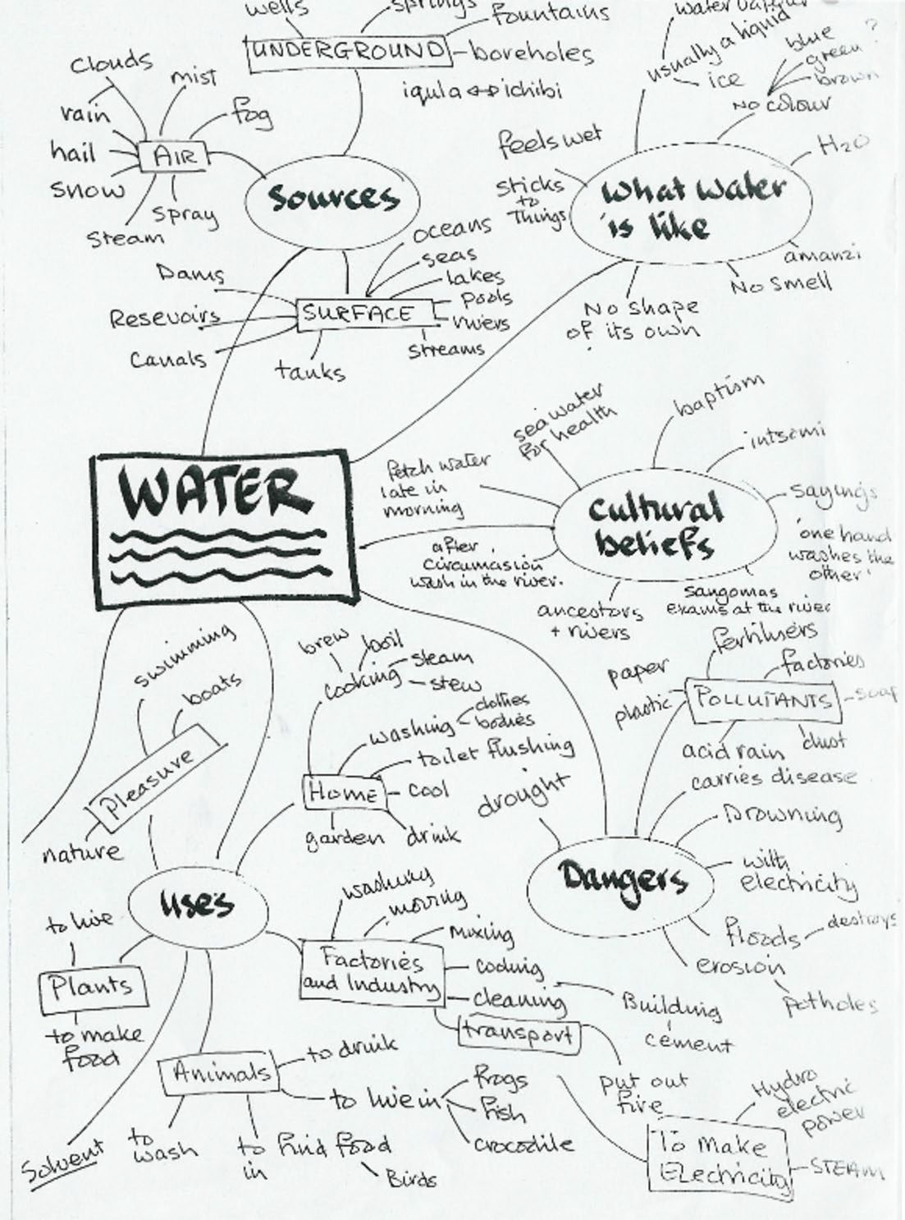

TESSA (Teacher Education in Sub-Saharan Africa) aims to improve the classroom practices of primary teachers and secondary science teachers in Africa through the provision of Open Educational Resources (OERs) to support teachers in developing student-centred, participatory approaches. The TESSA OERs provide teachers with a companion to the school
textbook. They offer activities for teachers to try out in their classrooms with their students, together with case studies showing how other teachers have taught the topic, and linked resources to support teachers in developing their lesson plans and subject knowledge.

TESSA OERs have been collaboratively written by African and international authors to address the curriculum and contexts. They are available for online and print use (http://www.tessafrica.net). The Primary OERs are available in several versions and languages (English, French, Arabic and Swahili). Initially, the OER were produced in English and made relevant across Africa. These OER have been versioned by TESSA partners for Ghana, Nigeria, Zambia, Rwanda, Uganda, Kenya, Tanzania and South Africa, and translated by partners in Sudan (Arabic), Togo (French) and Tanzania (Swahili) Secondary Science OER are available in English and have been versioned for Zambia, Kenya, Uganda and Tanzania. We welcome feedback from those who read and make use of these resources. The Creative Commons License enables users to adapt and localise the OERs further to meet local needs and contexts.

TESSA is led by The Open University, UK, and currently funded by charitable grants from The Allan and Nesta Ferguson Foundation, The William and Flora Hewlett Foundation and Open University Alumni. A complete list of funders is available on the TESSA website (http://www.tessafrica.net).

As well as the main body of pedagogic resources to support teaching in particular subject areas, there are a selection of additional resources including audio, key resources which describe specific practices, handbooks and toolkits.

TESSA Programme The Open University Walton Hall
Milton Keynes, MK7 6AA United Kingdom
tessa@open.ac.uk

Except for third party materials and otherwise stated, this content is made available under a Creative Commons Attribution-Share Alike 4.0 licence: http://creativecommons.org/licenses/by-sa/4.0/. Every effort has been made to contact copyright holders. We will be pleased to include any necessary acknowledgement at the first opportunity.
TESSA_EnPA_KR_all May 2016

This work is licensed under a Creative Commons Attribution-Share Alike 4.0 License

