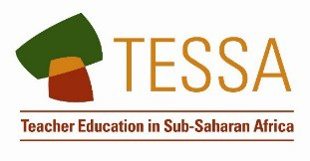

Key Resource: Being a resourceful teacher in challenging circumstances
Many teachers work in difficult contexts. They may have large classes. They may have few resources. The pupils in these contexts are not likely to have resources at home to compensate for limited school resources.

A group of teachers working in such circumstances recently brainstormed suggestions about how to be resourceful despite such difficult conditions. They came up with many ideas and decided that the following seven were most useful:

- Make maximum use of the local environment as a teaching aid. All schools have an environment that can be exploited for discussion, investigations and sources of classroom data.
- Make maximum use of the local community as a teaching aid. Parents and others are an important source for stories, for remembering what things were like in the past, and for having opinions on everyday issues.
- Exploit the communication systems currently in place. Nearly all communities now have access to radio, often with many channels available. Use the systems available to stimulate debate and discussion.
- Make teaching aids from materials around the school. Old boxes, magazines, newspapers and even plastic bottles can be turned into teaching aids (one of the teachers in the discussion group described how she had built a model of a volcano using such materials, the model could be opened out to show the ‘inner workings’ of the volcano).
- Cooperate with other schools, directly or by exchange of letters. This can be highly motivating for pupils and it opens up all sorts of possible exchanges of information (for example, exchanges of information between urban and rural schools can lead to interesting comparisons).
- Let the school become a resource for the local community: one teacher described how mothers joined in the reading classes and thus improved their own literacy.
- Set up a school garden: plants can be grown in even a small area. Pupils of all ages can benefit from participating in the planning, planting, growing and use stages in the development of a garden.

The TESSA programme would like to receive letters or emails about ideas for teaching in challenging conditions.

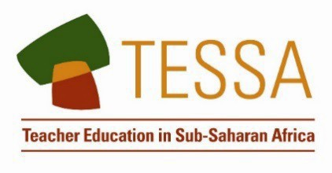
TESSA (Teacher Education in Sub-Saharan Africa) aims to improve the classroom practices of primary teachers and secondary science teachers in Africa through the provision of Open Educational Resources (OERs) to support teachers in developing student-centred, participatory approaches. The TESSA OERs provide teachers with a companion to the school
textbook. They offer activities for teachers to try out in their classrooms with their students, together with case studies showing how other teachers have taught the topic, and linked resources to support teachers in developing their lesson plans and subject knowledge.

TESSA OERs have been collaboratively written by African and international authors to address the curriculum and contexts. They are available for online and print use (http://www.tessafrica.net). The Primary OERs are available in several versions and languages (English, French, Arabic and Swahili). Initially, the OER were produced in English and made relevant across Africa. These OER have been versioned by TESSA partners for Ghana, Nigeria, Zambia, Rwanda, Uganda, Kenya, Tanzania and South Africa, and translated by partners in Sudan (Arabic), Togo (French) and Tanzania (Swahili) Secondary Science OER are available in English and have been versioned for Zambia, Kenya, Uganda and Tanzania. We welcome feedback from those who read and make use of these resources. The Creative Commons License enables users to adapt and localise the OERs further to meet local needs and contexts.

TESSA is led by The Open University, UK, and currently funded by charitable grants from The Allan and Nesta Ferguson Foundation, The William and Flora Hewlett Foundation and Open University Alumni. A complete list of funders is available on the TESSA website (http://www.tessafrica.net).

As well as the main body of pedagogic resources to support teaching in particular subject areas, there are a selection of additional resources including audio, key resources which describe specific practices, handbooks and toolkits.

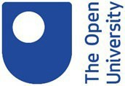

TESSA Programme The Open University Walton Hall
Milton Keynes, MK7 6AA United Kingdom
tessa@open.ac.uk

Except for third party materials and otherwise stated, this content is made available under a Creative Commons Attribution-Share Alike 4.0 licence: http://creativecommons.org/licenses/by-sa/4.0/. Every effort has been made to contact copyright holders. We will be pleased to include any necessary acknowledgement at the first opportunity.
TESSA_EnPA_KR_all May 2016

This work is licensed under a Creative Commons Attribution-Share Alike 4.0 License

