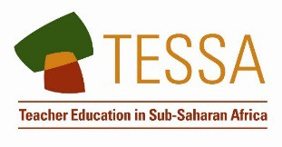
Key Resource: Researching in the classroom
Good teachers like to find out as much as they can about their classes and the teaching approaches that work best. This is often a very informal process. For example, it is very common to discuss the best way to teach a certain topic with other teachers. These same discussions might extend to other topics. Why is the attendance of boys in the school much poorer than the attendance of girls? In what ways can parents or guardians be encouraged to come and talk to us about their children’s progress?
This can become a more thorough process if you adopt the sorts of approaches and methods that researchers use. You can use what is often termed ‘action research’ to help improve your teaching and your school generally. The word ‘action’ is used to signify that you expect to gain information upon which you can ‘act’ fairly quickly.
Many books and publications now describe the ‘action research’ approach. Here we set out a very straightforward approach in just four stages.

Stage 1 – Defining the research question
Take the problem or issues you want to examine and formulate it in terms of a research question. For example, you may have become worried that some girls in the class seem to have problems doing homework. This worry becomes a question:
‘Why do some girls have problems doing schoolwork, especially homework, at home?’

Stage 2 – Deciding on methods to help answer the research question
You then have to think about the methods you use to explore this problem. For example, you could give the girls a short questionnaire asking them about working at home and the reasons why they experience difficulties. This assumes the pupils have reasonably good written skills. You could carry out individual interviews with the girls. In some situations, you might be able to visit the homes and interview the parents or guardians.

Stage 3 – Carrying out the research and recording findings
Find time to carry out interviews, observations or surveys. This is your research.
When you have carried out the research, it is a good idea to write up the findings. Sometimes teachers do this as part of a course (an upgrading course for example) and have to write things up in a formal way. Even if you are doing this for your own benefit, it is useful to note down your findings.

Stage 4 – Make changes
Interpret and reflect on your findings. Once you have the data, you need to think about what it means and what the implications are. For example, if the interviews with the girls revealed that some of them are expected to take over ‘childcare’ at home and find doing homework a problem, then you need to think about how you deal with this. Do you talk to the parents or guardians to stress the importance of the girls being able to do their homework? Or do you provide, for example, lunchtime opportunities for the girls to carry out their homework?
The research process then carries on as you evaluate the impact of the changes you have made.
Action research can be built into the general strategies for improving teaching and improving schools. It can be done individually but it is also very effective when groups of teachers work cooperatively to try to solve particular problems.

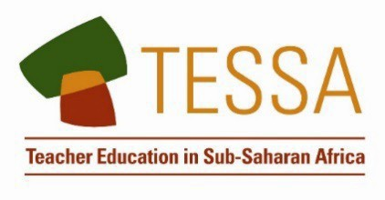
TESSA (Teacher Education in Sub-Saharan Africa) aims to improve the classroom practices of primary teachers and secondary science teachers in Africa through the provision of Open Educational Resources (OERs) to support teachers in developing student-centred, participatory approaches. The TESSA OERs provide teachers with a companion to the school
textbook. They offer activities for teachers to try out in their classrooms with their students, together with case studies showing how other teachers have taught the topic, and linked resources to support teachers in developing their lesson plans and subject knowledge.

TESSA OERs have been collaboratively written by African and international authors to address the curriculum and contexts. They are available for online and print use (http://www.tessafrica.net). The Primary OERs are available in several versions and languages (English, French, Arabic and Swahili). Initially, the OER were produced in English and made relevant across Africa. These OER have been versioned by TESSA partners for Ghana, Nigeria, Zambia, Rwanda, Uganda, Kenya, Tanzania and South Africa, and translated by partners in Sudan (Arabic), Togo (French) and Tanzania (Swahili) Secondary Science OER are available in English and have been versioned for Zambia, Kenya, Uganda and Tanzania. We welcome feedback from those who read and make use of these resources. The Creative Commons License enables users to adapt and localise the OERs further to meet local needs and contexts.

TESSA is led by The Open University, UK, and currently funded by charitable grants from The Allan and Nesta Ferguson Foundation, The William and Flora Hewlett Foundation and Open University Alumni. A complete list of funders is available on the TESSA website (http://www.tessafrica.net).

As well as the main body of pedagogic resources to support teaching in particular subject areas, there are a selection of additional resources including audio, key resources which describe specific practices, handbooks and toolkits.

TESSA Programme The Open University Walton Hall
Milton Keynes, MK7 6AA United Kingdom
tessa@open.ac.uk

Except for third party materials and otherwise stated, this content is made available under a Creative Commons Attribution-Share Alike 4.0 licence: http://creativecommons.org/licenses/by-sa/4.0/. Every effort has been made to contact copyright holders. We will be pleased to include any necessary acknowledgement at the first opportunity.
TESSA_EnPA_KR_all May 2016

This work is licensed under a Creative Commons Attribution-Share Alike 4.0 License

