

Primary Subject Resources
Literacy

Module 3 Promoting Communication in an Additional Language

Section 1 Providing natural contexts for language practice
Section 2 Ways towards fluency and accuracy
Section 3 Creating opportunities for communication
Section 4 Ways to build on home language knowledge
Section 5 Supporting additional language learning
ENGLISH

TESSA (Teacher Education in Sub-Saharan Africa) aims to improve the classroom practices of primary teachers and secondary science teachers in Africa through the provision of Open Educational Resources (OERs) to support teachers in developing student-centred, participatory approaches. The TESSA OERs provide teachers with a companion to the school textbook. They offer activities for teachers to try out in their classrooms with their students, together with case studies showing how other teachers have taught the topic, and linked resources to support teachers in developing their lesson plans and subject knowledge.
TESSA OERs have been collaboratively written by African and international authors to address the curriculum and contexts. They are available for online and print use (http://www.tessafrica.net). The Primary OERs are available in several versions and languages (English, French, Arabic and Swahili). Initially, the OER were produced in English and made relevant across Africa. These OER have been versioned by TESSA partners for Ghana, Nigeria, Zambia, Rwanda, Uganda, Kenya, Tanzania and South Africa, and translated by partners in Sudan (Arabic), Togo (French) and Tanzania (Swahili) Secondary Science OER are available in English and have been versioned for Zambia, Kenya, Uganda and Tanzania. We welcome feedback from those who read and make use of these resources. The Creative Commons License enables users to adapt and localise the OERs further to meet local needs and contexts.
TESSA is led by The Open University, UK, and currently funded by charitable grants from The Allan and Nesta Ferguson Foundation, The William and Flora Hewlett Foundation and Open University Alumni. A complete list of funders is available on the TESSA website (http://www.tessafrica.net).
As well as the main body of pedagogic resources to support teaching in particular subject areas, there are a selection of additional resources including audio, key resources which describe specific practices, handbooks and toolkits.

TESSA Programme
The Open University
Walton Hall
Milton Keynes, MK7 6AA
United Kingdom
tessa@open.ac.uk

Except for third party materials and otherwise stated, this content is made available under a Creative Commons Attribution-Share Alike 4.0 licence: http://creativecommons.org/licenses/by-sa/4.0/. Every effort has been made to contact copyright holders. We will be pleased to include any necessary acknowledgement at the first opportunity.

TESSA_EnPA_LIT_M3 May 2016


This work is licensed under a Creative Commons Attribution-Share Alike 4.0 License

Contents
- Section 1: Providing natural contexts for language practice
  - 1. Encouraging the use of English
  - 2. Learning a new language through everyday tasks
  - 3. Writing recipes in a new language
  - Resource 1: Total physical response ideas
  - Resource 2: Recipes
  - Resource 3: Mango drink and Fried Bananas
  - Acknowledgements
- Section 2: Ways towards fluency and accuracy
  - 1. Using real contexts to learn language structures
  - 2. Being a word detective
  - 3. Using peer assessment
  - Resource 1: Alternative lesson structures – used by Mr Gasana
  - Resource 2: Sale advertisement
  - Resource 3: Verb tense charts
  - Resource 4: A praise poem
  - Resource 5: Verbs and adverbs in the poem My Drum by Francis Faller
  - Resource 6: Writing frame to support planning a story
  - Acknowledgements
- Section 3: Creating opportunities for communication
  - 1. Creating opportunities for ‘real’ communication
  - 2. Describe and draw
  - 3. Making meaning: sequencing
  - Resource 1: More information gap activities
  - Resource 2: Ideas for pictures
  - Resource 3: Words and meanings – bones in the body
  - Resource 4: Describe and arrange
  - Resource 5: Making meaning
  - Acknowledgements
- Section 4: Ways to build on home language knowledge
  - 1. Using home language to stimulate creativity
  - 2. Bilingual approaches
  - 3. Code-switching to promote thinking skills
  - Resource 1: Poem
  - Resource 2: Lesson transcript
  - Resource 3: Safety
  - Resource 4: Who is my father?
  - Resource 5: Vision and mission statements – some examples
  - Acknowledgements
- Section 5: Supporting additional language learning
  - 1. Focus on everyday language
  - 2. Writing letters
  - 3. Creating books
  - Resource 1: Pen-pals
  - Resource 2: Writing letters
  - Resource 3: Assessing pen-pal letters
  - Resource 4: Songs and stories about processes
  - Acknowledgements

Section 1: Providing natural contexts for language practice
Key Focus Question: How can you help pupils to practise language structures in a natural context?
Keywords: classroom management; games; recipes; instructions; processes

Learning Outcomes
By the end of this section, you will have:
- used classroom management to help pupils learn an additional language;
- used games and everyday activities to develop pupils’ language skills and vocabulary.

Introduction
How much natural exposure – through radio, books, magazines, speakers and TV – do your pupils have to an additional language to that used at home?
The answer might be, ‘Very little. They only hear and use it in their daily class at school.’ This means that you are responsible for providing the kind of exposure to the language that will help pupils:
- use and become fluent in new vocabulary and grammatical structures;
- communicate using oral language in social situations;
- develop their reading and writing skills.
All of this requires a great deal of thought, planning and skill. This section will provide some approaches and techniques to help you.

1. Encouraging the use of English
As a teacher, you will often give instructions of various kinds to your pupils. You can use these everyday instructions to develop new vocabulary and listening skills in the additional language. Instructions use the imperative form of the verb. If you use the imperative form consistently, in meaningful contexts, pupils will begin to understand and learn it.
When pupils learn a new language, listening develops more quickly than speaking. They need lots of opportunities to listen and respond to new language. In the early stages of language learning (and later as well), you can use activities that require them to respond with actions but that do not need them to reply until they feel more confident. (This is often called ‘total physical response’ – see Resource 1: Total physical response ideas.)

Case Study 1: Classroom management in English
Mrs Mujawayo teaches a Grade 1 class in Kigali, Rwanda. She uses English for all her classroom management.
In the morning, she greets individuals in their home language, and asks for home news. After assembly, she says to the class (in English), ‘Line up, children,’ and gestures towards the veranda, where they should line up. ‘Walk in,’ she says, gesturing again. ‘Stand by your desks.’
Teacher and class greet one another in English. ‘Sit down,’ she says.
She then switches back to the home language to introduce story work, and continues in their home language until she puts them into groups, for different activities.
Each group has a letter. ‘A and B raise your hands,’ she says in English, raising her hand. ‘Take books from the box,’ she says, pointing to the book box. ‘Sit down, and read to your partner.’ If they seem uncertain, she mimes what they have to do.
She later gives further instructions to each group in English, without translation. Two groups are to illustrate their story, and one group will read with her in their home language from a big book.
Mrs Mujawayo finds that her pupils quickly become familiar with the English instructions, and soon start trying to say the words.

Activity 1: Simple Simon says
In this well-known game, pupils respond physically to commands. You can use it to extend vocabulary and listening skills in a range of subject areas.
The leader gives the command and carries out the actions at the same time. Pupils are only to obey commands that come from Simple Simon. (You could change this name to that of a well-known local person.)
The game goes like this:
Leader: Simple Simon says, ‘Jump!’ (Leader jumps.)
The pupils jump.
Leader: Simple Simon says, ‘Touch your toes!’ (Leader touches her toes.)
The pupils touch their toes.
Leader: ‘Scratch your nose!’ (Leader scratches her nose.)
Some scratch their noses. Others do not. Those who scratch their noses are out (because the instruction did not come from Simple Simon).
And so on...
Use simple instructions for new language pupils, more complex ones for more competent pupils. Start fairly slowly, but build up to a quicker pace. The winner is the last person left in.

2. Learning a new language through everyday tasks
Providing natural opportunities for developing your pupils’ skills in the additional language is important. Here we suggest ways that you can involve the community and use local skills and wisdom as a resource for classroom activities.
You have seen, in Case Study 1 and Activity 1, how everyday instructions can provide a useful natural context for language learning. Pupils listened and showed understanding through actions. In this part, we suggest you use local recipes and processes as contexts for instructions, giving pupils the opportunity to speak (and write) as well as listen.
The activities used here will be carried forward to Section 5, where your class begins to compile a book of recipes.

Case Study 2: Adult learners learn through doing
Some adult learners of ciNyanja were spending a day in the townships as part of their course at the local college. Each learner was accompanied by a language helper who was a ciNyanja speaker. The helpers supported the learners as they tried out the language they had learned; buying vegetables from hawkers on the streets and chatting with the families that were hosting them.
An important part of the day was cooking a meal. The learner was supposed to do the cooking, instructed by the language helper. The cooking had been practised and mimed, and often written down or recorded on tape, in classes the week before. In Zambian tradition, the men were given a list of things to go to the market to buy, while women were asked to stay at home and cook foods like impwa, cikanda, cibwabwa and tomato and onion gravy. They also talked of how they might swap roles around to help them learn the language.
When the meal was over, some Zambian songs were sung, and learners learned traditional Ngoni children’s games. Once the dishes were washed up, a happy and exhausted group of language learners boarded taxis to go home.

Activity 2: Learning through doing local activities
- Tell your pupils they are going find out how certain household tasks are done and explain the steps of the process in the additional language. Ask pupils to bring the information from home or invite community members to school to demonstrate the skills.
- Divide pupils into pairs or groups (these could be mixed-ability groups), to work out and, if possible, write down the steps of one of these processes in the additional language. Go round and help them with new vocabulary they may need.
- Give the groups time to memorise and rehearse the steps, in preparation for instructing others. They could collect from home items that are needed for the process.
- The next day, let one pupil use the additional language to instruct a member of another group, while the class watches e.g. sweeping the house.
How well did the pupils respond to this kind of activity?
Could you use it with other processes to extend their vocabulary?
If so, how would you plan this?

3. Writing recipes in a new language
Language is used for communication, and it is important that you create real reasons for pupils to speak, listen, read and write in the additional language. This is not always easy when your school is in an area where the additional language is not commonly spoken. However, the additional language may well be the language of books and written communication.
Around the world people exchange information on ‘how to do’ things; for example they give each other recipes or patterns for dressmaking. You have already done this orally; now pupils can do it in writing. Show your pupils conventional written formats for recipes, in the additional language. A recipe is often presented as a series of instructions.
When we write a recipe, or describe a process, we are not concerned about who does the action, but are concerned that the action is done.

Case Study 3: Drawing and writing recipes
In a school near Kabwe, in Central Zambia, pupils had been sharing recipes. They wanted to draw their recipes in diagrams and exchange them with their friends. Mrs Malambo, their teacher, thought it would be good for them to know different ways of presenting information. She showed them how to draw flow charts. Once they had drawn and labelled the flow chart, they wrote the process as a description as well (see Resource 2: Recipes for examples).
Mrs Malambo discussed with the pupils which they found easiest to do, and why. Over two-thirds of the class found the flow charts more fun and easier to do because they were able to break the recipes down into steps and the drawings helped them remember and understand the words.
Mrs Malambo used this idea of flow charts in other lessons, as this seemed to help her pupils to remember more. For example, in a geography lesson, she used a flow chart to write out directions from one place to another, and the pupils drew pictures of landmarks to make it easier to remember the words.
See Resource 3: Mango drink and fried bananas for an example of a flow chart.

Key Activity: Writing recipes and process descriptions
- Ask your pupils to find out how to make their favourite meals from home and share these with the class.
- Introduce your pupils to the format for a recipe before they do their own examples (see Resource 2).
- Ask your pupils to write out their recipes neatly, each making one version for themselves, and another to go into a class book of recipes. The second version could use a different format to the first (see Resource 2 for models).
- Ask pupils to exchange and discuss their recipes.

Resource 1: Total physical response ideas
 Background information / subject knowledge for teacher
http://www.tpr-world.com/
This website gives information about total physical response (TPR) as a way of working in language learning. There are also other discussions you might want to explore.
You can introduce your pupils to many new language structures through game-like activities that involve them responding to instructions with actions (total physical response). Here are some examples of the kinds of instructions that you can give. Focus on one type of instruction at a time, so that the pupils get used to the way the language works.
- Body movements
Stand up.
Laugh.
Cough.
Cry.
Kick the table.
- Activities and objects
Point to the door.
Pick up the pen.
Close the window.
Smell the flower.
Point to the mountain.
Point to the woman who is baking a cake.
- Activities, objects and people
Take the pen and give it to Pamela.
Fetch the book and give it to me.
Pick up the paper and hand it to Rose.
- Add possessives
Give Rose’s book to Sibeso.
Bring Pamela’s pen to me.
Give Songiso his book.
Give Lufwendo her glasses.
- This and that; here and there
Give this to Sibeso.
Fetch that from her.
Take the pen and put it here.
Fetch the book and put it there.
- Space relations
Put the pen between the two books.
Put the pen close to the ruler.
Put the eraser into the box.
Put the ruler on top of the box.
- Add number, colour and size
Put two pens into the box.
Take three stones out of the box.
Pick up the red pen and give it to Rose.
Put the green book on the table.
Take the small book and give it to Pamela.
Put the big book into the box.
- Instructions and descriptions, with some speaking
Do and listen
Pupil does the action. Teacher (or another pupil) says what they are doing (e.g. ‘You are standing.’)
Listen and do
Teacher (or another pupil) instructs the pupil (e.g. ‘Stand.’) Pupil obeys, doing the action.
True or false
Pupil learns to say ‘true’ and ‘false’. Teacher (or another pupil) does an action, and makes a true or false statement about what he or she is doing (e.g. ‘I am sitting.’) Pupil says, ‘true’ or ‘false’.
Listen, mimic and do
Teacher (or another pupil) instructs pupil. Pupil repeats what is said then obeys the instruction.
Tell, listen and mimic
Pupil does the action and describes what they are doing (e.g. ‘I am standing.’) Teacher (or another pupil) restates what the pupil has said and copies the action.
- Going outside or using pictures to extend vocabulary
At the beginning, you need to use known words with new instructions. Once the vocabulary of the classroom is known, you can move to outdoor vocabulary, e.g.:
Touch the leaf.
Point to the sky.
You can also extend vocabulary by making cards with words or pictures on them, e.g. pictures of types of food:
Take the meat and give it to Pamela.
Fetch Jamu’s bread and give it to me.
Adapted from: http://www.tpr-world.com/

Resource 2: Recipes
 Teacher resource for planning or adapting to use with pupils
Here are three different ways of presenting the same recipe.
Making Curried Peaches

Curried peaches (flow chart)
Peel 4 peaches  ↓  Slice the peaches  ↓  Boil 100 ml vinegar  ↓  Add the peaches, curry powder, and salt  ↓  Simmer the peaches until tender  ↓  Leave them to cool  ↓  Bottle them  ↓  Seal the bottles | 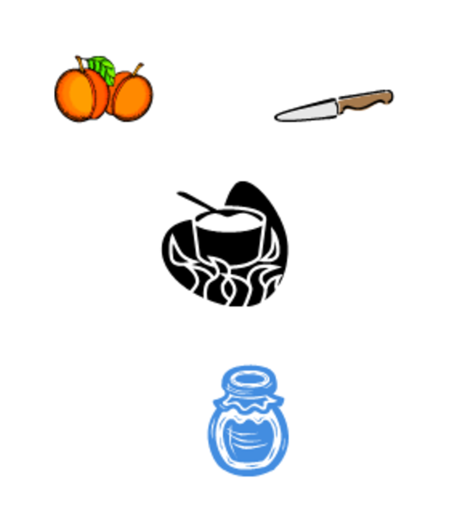
Curried Peaches (process description)
When peaches are curried, 4 peaches are peeled and sliced. 100 ml of vinegar is boiled, and the peaches, curry powder and salt are added. The peaches are simmered until they are tender, then they are left to cool. They are bottled and the bottles are sealed.
Curried peaches (ingredients and method)
Ingredients:
- 4 peaches
- 100 ml vinegar
- 1 tablespoon curry powder
- Salt (to taste)
Method
- Peel and then slice the 4 peaches.
- Boil 100 ml vinegar.
- Add the peaches, curry powder and salt to the boiling vinegar.
- Simmer the peaches until tender.
- Remove from the heat and leave the peaches and curry liquid to cool.
- Bottle the peaches covering with curry liquid.
- Seal the bottles.

Resource 3: Mango drink and Fried Bananas
Teacher resource for planning or adapting to use with pupils

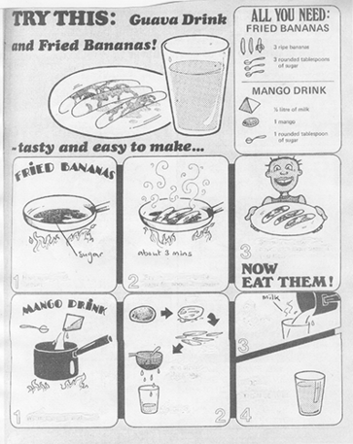

Acknowledgements
Grateful acknowledgement is made to the following sources:
Other
Resource 1 : Total physical response ideas : Original source(s):
http://www.tpr-world.com/ (Accessed 2008)
Fetch Jamu’s bread and give it to me.
Adapted from: http://www.tpr-world.com/ (Accessed 2008)
Every effort has been made to contact copyright holders. If any have been inadvertently overlooked the publishers will be pleased to make the necessary arrangements at the first opportunity.
Return to Literacy (primary) page

Section 2: Ways towards fluency and accuracy
Key Focus Question: How can you help pupils gain confidence in using specific language structures?
Keywords: verbs; adverbs; drills; poems; songs; edits

Learning Outcomes
By the end of this section, you will have:
- guided your pupils towards control of the structures of the additional language;
- used drills, songs, poems and stories to teach language structures;
- helped your pupils to monitor their own work as they look for meaning and correct use of verbs.

Introduction
As a teacher of the additional language, you need to be always looking for new ways to give your pupils experience of that language. If they are given opportunities to practise it, their use of the language will become more fluent and accurate.
This section introduces you to useful exercises that focus on particular tenses or structures.
Remember that the activities you choose need to have meaning for the pupils, either within the activity, or within their lives (preferably both).

1. Using real contexts to learn language structures
Providing your pupils with opportunities to use specific language structures over and over again, in order that they absorb them, needs to be enjoyable.
There is a theory that people learn language through imitation and repetition. In the past, many language courses made extensive use of drilling (repeating exercises). It is now thought that activities that involve pupils in ‘real’ communication are more helpful than meaningless drilling. However, drills can still be very useful if pupils can attach real meaning to the sentences. It also helps if they are set to music.
Try the ideas in Case Study 1 and Activity 1 to test these theories.

Case Study 1: A language drill about a newspaper story
Mr Gasana teaches English to Grade 4 in Butare, Rwanda. A murder had taken place in their city, at 8 o’clock, two nights before. He showed his pupils a newspaper report of the murder. He talked with his pupils (in the home language) about how detectives question people when they are trying to find a criminal. Then he put up a question and answer pattern on the board, in English:
Q: What were you doing at eight o’clock on Tuesday night, Kigeri?
A: I was watching television.
He asked a few pupils the question, making sure they gave their own answer in the right form. Then he put pupils into groups of six. Each pupil was to ask the question to the other five group members, who would provide their own answers. Mr Gasana encouraged the pupils to correct one another, and walked around, listening to and monitoring the groups.
He asked each pupil to write a ‘detective’s report’ about their group. Each of the six sentences was to be in the following form:
Muteteli was playing with her brother at 8 p.m.
Erisa was dishing out food at 8 p.m.
Resource 1: Alternative lesson structures gives the patterns Mr Gasana used with his older pupils in Grade 5.

Activity 1: Drilling about prices
Find or make a sale advertisement or a price list of local vegetables, showing price reductions (see Resource 2: Sale advertisement for examples). Before the lesson, make a big copy of the advertisement or price list on the board, or prepare one advertisement or price list per group in your class.
Write the following question and answer sequences on the board.
Q: How much is that .... ?
A. It was .... before, but now it’s only ....
Q: How much are those .... ?
A: They were .... before, but now they’re only ....
During the lesson, point to a few of the items, asking the appropriate question, and ask a few pupils to answer. Then put them in groups, to question and answer one another in the same format.
Let each group make up and perform a song, with verses in the form:
That .... was .... before, but now it’s only ....
What did your pupils learn from these activities? How do you know?
Will you use this kind of exercise again? Why, or why not?

2. Being a word detective
It is important in language teaching to focus on the meaning of the language, stressing the importance of communication, but at the same time working to develop pupils’ competence in grammar. Activity 2 gives an example of how to use a praise poem written in English to do some work with pupils on verbs and adverbs. This kind of work can be done with a wide range of texts, focusing on a wide range of structures. Make sure that you also focus on the meaning of the piece of writing, and don’t simply use it as a device for teaching grammar. With younger children, the focus will be on the meaning and enjoyment.
Stories usually use the past tense, while descriptions are usually in the present tense. These are good contexts in which to give your pupils practice in tenses.
If you do not teach English, think about what pupils find difficult about the grammar of the language that you do teach, and adapt Activity 2 to suit this language.

Case Study 2: Discussing grammar at a teacher workshop
At a workshop in Kampala, teachers had a lively discussion about grammar. Henry Woneka said he had read that grammar is the bones or skeleton of a language and other words are the flesh. Both bones and flesh contribute to meaning. The teachers agreed that pupils need to develop understanding of how the structures of a language work, but they also complained about pupils’ lack of interest in grammar lessons.
Ruth Kagaba teaches in a rural area and lessons for her pupils had been in the local language for their first four years of school but they are now in English. She tries to include activities that focus on language structures when her Primary 6 pupils are reading interesting stories or poems. For example, after reviewing the main verb tenses in English, she asked pupils to suggest why the writer of the story or poem had used past, present or future tense. Then she asked them to decide which verb tense or tenses they needed to use to write their own story or poem to make it more interesting for their readers.
To help with their English grammar, Ruth makes big charts on the backs of old calendars. These give pupils information about the present, past and future tenses of different verbs. (See Resource 3: Verb tense charts for a simple example that you could adapt for your pupils.) She encourages pupils to consult these charts when they are writing.

Activity 2: A verb and adverb detective game
- Make copies of Resource 4: A praise poem. Where photocopiers are not available, copy it on the chalkboard or the back of an old calendar.
- Once pupils have read the poem and understood it, let them work in groups to find all the verbs in the poem. Remind them that most verbs are ‘doing’ words. Let each group report back the verbs in one verse (see Resource 5: Verbs and adverbs in the poem).
- Ask them which tense the verbs are in. In verses 1 and 2, verbs are in the present tense; some in verse 3 are in the future and some in verse 4 in the past tense. With more advanced pupils, discuss why these tenses were used. Ask them what difference does the use of different tenses make to the meaning and effect of the poem?
- You can use other poems and stories in similar ways.

3. Using peer assessment
You will probably have found that it is difficult, at times, to mark pupils’ written work, because there are so many language errors in it. You do not want to discourage your pupils by making too many corrections. But you also don’t want them to get into bad habits. How can we solve this problem?
One way is to connect meaning with language structures. Set a writing task that has meaning for the pupils. Encourage them to edit their work before they hand it in. You could ask them to write in pairs so that they support each other. They can then receive their work back without having lots of marks on it.
When you do mark their work, focus on meaning and interest. As a secondary focus, concentrate on one aspect of language structure – spelling or perhaps verb tenses or prepositions. In this way, the feedback is limited and focused, and the pupils are more likely to take notice of it.

Case Study 3: Sharing experiences in a ‘Writers’ Circle’
A group of teachers on an in-service course in Kampala were trying to improve their own writing. Tutors encouraged them to form ‘Writers’ Circles’, where they read one another’s writing and gave feedback. They wrote about their own experiences – early childhood memories, memorable characters and places, unforgettable experiences.
Tutors guided them in giving feedback, using different criteria depending on what had been written. Here are examples:
- Does the writer make it clear what they are saying? Are there parts that need to be clarified?
- Which parts are interesting? What makes them interesting? Which parts are dull? How could these be improved?
- Does each paragraph have a main idea? Do some need to be more fully developed? Do paragraphs need to be reordered?
- Are sentences complete? Are they too long or too short? Are they correctly punctuated? Are words spelled correctly?
- In what tense is the piece written? Check that every verb is in the relevant tense or that there is a good reason for using another tense.
A book was compiled of the writing of these teachers that was shared with family and friends. The teachers decided that some of these ideas could be used in class, adapted for the age and ability of their pupils.

Key Activity: Self and peer editing to improve writing
Ask your pupils to write something based on their own experiences. Discuss ideas to stimulate their imaginations. For example, they could describe something they own or an interesting person they know. (As these pieces are descriptive they would probably use the present tense.) They could tell the story of a frightening or exciting experience, or a community event. (As these pieces are stories or narratives, they would probably use the past tense.) Some pupils may find it more helpful to work in pairs.
Next, ask them to work in small groups, to read their pieces to one another. Ask them to use one or both of the following sets of questions to provide feedback to each other:
- Which parts are interesting?
- What makes them interesting?
- Which parts are dull?
- How could these be improved?
- In what tense is the piece written?
Check that every verb is in the relevant tense OR make sure there is a good reason for using another tense.
Having received group feedback, each rewrites their piece. Take the pieces in, and use the same criteria to mark them.
How successful was this approach? Will you repeat it?
Did the quality of pupils’ writing improve? How do you know this?

Resource 1: Alternative lesson structures – used by Mr Gasana
Background information / subject knowledge for teacher

Question and answer sequences
Q: Did you hear the shot, Mrs Yuhi?
A: Yes, we were eating supper at the time.
or
Q: Did you hear the shot, Mr Mulifi?
A: No, I was travelling to Nyanza at the time.

Detective’s report structures
Mrs Yuhi heard the shot when they were eating supper.
or
Mr Mulifi didn’t hear the shot because he was travelling to Nyanza.

Resource 2: Sale advertisement
Teacher resource for planning or adapting to use with pupils
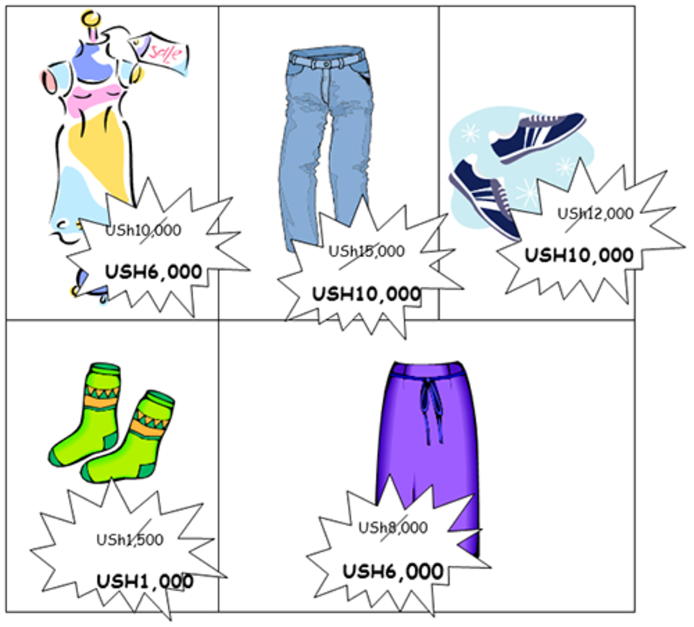
For older pupils, you can use more advanced sequences, such as:
Q: Look at that skirt! That’s a bargain.
A: Yes, they were charging USh….............for it last week!
or
Q: What a pity you bought those jeans last week!
A: Yes, I wish I’d waited for the sale. I’ve wasted USh ................

Vegetable price list
This scene may be more useful if you work in a rural area to provide a context for Activity 1.
You could fill in suitable prices depending on your area and the season.
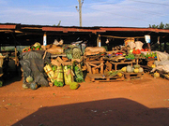

Original source: http://www.religionomics.com/carrie/images/marketonEntebbeRoad (Accessed 2008)
TODAY’S BEST PRICES – COME AND BUY!
YAM not USh…..... NOW USh….......!
PUMPKIN not USh…...... NOW USh….......!
ONIONS not USh…...... NOW USh….....!
MATOOKE not USh ...... NOW USh ........!

Resource 3: Verb tense charts
Teacher resource for planning or adapting to use with pupils
Present | Past | Future
I walk | I walked | I will walk
I bite | I bit | I will bite
I choose | I chose | I will choose
I dig | I dug | I will dig
I draw | I drew | I will draw
I eat | I ate | I will eat
I forget | I forgot | I will forget
I know | I knew | I will know
I see | I saw | I will see
I sleep | I slept | I will sleep
I swim | I swam | I will swim

Resource 4: A praise poem
 Pupil use
My Drum by Francis Faller
It beats
patiently
like water
dripping
on
a gutter
pipe
or proudly
as the pounding of the sea.
My drum. My drum.
It summons love.
It hammers anger out.
It calls for freedom.
It never stops
even when nobody
hears my drum
but me.
My drum greets
everything
that passes by:
the rising sun
the rain battering
the wind that blows
a family of cranes
home across the sky.
It greets the cricket
chirping out its glee.
It greets the workers
whose drills and picks
are digging holes
monotonously.
I follow it
into laughter
I lead it through
throbbing pain.
It’s a sparrow pecking seed
it’s a stick along the fence
it’s a rapid fire gun.
My drum. My drum.
Nervously it beats
a welcome
just for you.
Will you hear it
with delight?
Will you run away in fright?
A drum is only
skin and wood
so will you come?
You should.
You should.
My little drum
was yesterday so weak.
Today it’s beating
Strong.
Surely it wasn’t stretched
across this world
to play for nothing.
Though it never
gets reply
I think
I could not live
if the song
of my drum
should die.
Original source: My Drum – Meyerowitz, B., Copans, J. & Welch, T. (compilers)

Resource 5: Verbs and adverbs in the poem My Drum by Francis Faller
Background information / subject knowledge for teacher
In this version of the poem the verbs have been underlined and the adverbs are in bold type.
It beats
patiently | Note 1: patiently is an adverb of manner, which describes how the drum beats: calmly, over and over again without getting upset or angry.
like water
dripping | Note 2: dripping is part of the full verb ‘is dripping’: like water [that is] dripping – the poet decided to leave out ‘that is’.
on
a gutter
pipe
or proudly | Note 3: proudly is also an adverb that describes how the drum beats: with pride, as though it is very pleased with itself.
as the pounding of the sea
My drum. My drum.
It summons love.
It hammers anger out.
It calls for freedom.
It never stops | Note 4: never is an adverb of time that adds information to the verb ‘stops’: the drum does not ever stop.
even when nobody
hears my drum
but me.
My drum greets
everything
that passes by:
the rising sun
the rain battering | Note 5: battering is part of the full verb ‘is battering’: the rain [that is] battering.
the wind that blows
a family of cranes
home across the sky.
It greets the cricket
chirping out its glee.
It greets the workers
whose drills and picks
are digging holes
monotonously. | Note 6: monotonously is an adverb of manner which describes how the digging goes on and on in a boring, repeated way.
I follow it
into laughter
I lead it through
throbbing pain.
It’s a sparrow pecking seed | Note 7: It’s is the short form of It is and ‘is’ is a verb, though not an action verb.
it’s a stick along the fence
it’s a rapid fire gun.
My drum. My drum.
Nervously it beats | Note 8: Nervously is an adverb of manner that describes how the drum beats: as though the drum is anxious or a little afraid.
a welcome
just for you.
Will you hear it
with delight?
Will you run away in fright?
A drum is only
skin and wood
so will you come? | Note 9: ‘will come’ is in the future tense but it is in the question form ‘will you come?’
You should. | You should is a shortened form of You should come – also action in the future.
You should.
My little drum
was yesterday so weak. | Note 10: was is the past tense of ‘is’.
Today it’s beating
Strong. | Note 11: Strong would usually be written ‘strongly’: it is an adverb which describes how the drum is beating.
Surely it wasn’t stretched | Note 12: wasn’t stretched is a verb in the past tense.
across this world
to play for nothing.
Though it never | Note 13: never is an adverb of time (see Note 4).
gets reply
I think
I could not live | Note 14: could not live and should die are verbs that refer to the future because the suggestion is that the poet would not be able to live in the future without the drum.
if the song
of my drum
should die. | Note 15: Pupils may be puzzled by words ending in ‘ing’. Sometimes these words are part of a verb: I am singing. Sometimes they are nouns: The singing of the choir was excellent. Sometimes they are adjectives that describe nouns: The singing canaries flew to the top of their cage. In this poem dripping, battering, chirping, digging, pecking, beating are parts of verbs. The pounding is a noun. Throbbing is an adjective describing pain. Everything is a pronoun that stands in place of the nouns that follow it in verse 2. For nothing is an expression that means ‘without payment’ or ‘for no reason’.

Resource 6: Writing frame to support planning a story
Teacher resource for planning or adapting to use with pupils
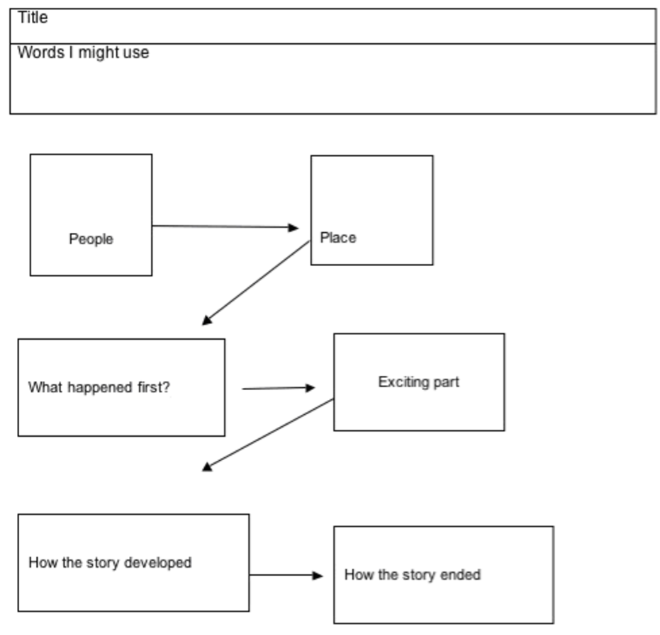
Writing frame taken from http://web.archive.org/web/20040804075009/http://www.kented.org.uk/ngfl/literacy/Writing-frames/frames1. html - Accessed on 21/06/07

Acknowledgements
Grateful acknowledgement is made to the following sources:
Other
Resource 2
Sale advertisement : Original source: http://www.religionomics.com/carrie/images/marketonEntebbeRoad (Accessed 2008)
Resource 4
A praise poem : Original source: My Drum – Meyerowitz, B., Copans, J. & Welch, T. (compilers)
Resource 5: Writing frame to support planning a story:
Writing frame taken from http://web.archive.org/web/20040804075009/http://www.kented.org.uk/ngfl/literacy/Writing-frames/frames1. html (Accessed 2008)
Every effort has been made to contact copyright holders. If any have been inadvertently overlooked the publishers will be pleased to make the necessary arrangements at the first opportunity.
Return to Literacy (primary) page

Section 3: Creating opportunities for communication
Key Focus Question: How can you create activities to promote communication in the additional language?
Keywords: information gap; interaction; meaningful; creating activities; groups

Learning Outcomes
By the end of this section, you will have:
- created activities for real communication in your additional language class;
- developed a ‘library’ of resources to stimulate natural communication;
- used group and pair work to develop interaction in the additional language.

Introduction
As a teacher, you need to make use of research findings related to what you are doing. Recent research indicates that people acquire language through participating in meaningful interaction in the language, in natural contexts. What does this mean?
- ‘Participating’: Each pupil should participate – or be actively involved.
- ‘Meaningful’: The activity should be relevant and have meaning for pupils.
- ‘Interaction’: Communication should be two-way (or three- or four-way).
- ‘Natural contexts’: The language used should be everyday language.
In this section, we look at how to stimulate this kind of interaction in your classroom, largely through the use of pictures. We suggest that you develop a selection of resources.
Interactive classroom work usually takes place in small groups. It will be helpful to read Key Resource: Using group work in your classroom.

1. Creating opportunities for ‘real’ communication
Motivating pupils to communicate with each other involves setting up activities they can carry out together, and are ‘real’. Groups are supportive and allow pupils to try out new language.
‘Real’ communication involves an ‘information gap’; in other words, pupils find out something from one another that they don’t know already. In the past, pupils may have been instructed to ask a classmate, whose name they knew well, ‘What is your name?’ There is no information gap here, so communication is not ‘real’.
Case Study 1 and Activity 1 show how finding missing information can be used in order to form groups or pairs. See also Resource 1: More information gap activities.

Case Study 1: Information gap activity to form groups
Liz Botha in East London, South Africa, wanted to divide a group of 40 teachers into groups of four, in a way that would help them communicate with one another.
She found a set of 16 pictures all on one page in a textbook (see Resource 2: Ideas for pictures). She made four copies of the page and cut ten pictures from each page so that she had ten sets of four pictures: shoes; flags, etc. She shuffled the pictures.
As the teachers arrived, she handed each one a picture, and told them not to show it to anyone. She then instructed them to move around the room, asking questions of the kind:
Question: Do you have a picture of a(n) .... ?
Answer: No, I don’t./Yes, I do.
They continued with this until they had gathered a group of four people with similar pictures.
Once groups were formed, members had to talk about themselves to one another, and find, through discussion, one thing that they had in common: perhaps all four had younger sisters, or liked or disliked a particular kind of food or music, etc.
They enjoyed the activity enormously, and ended up knowing one another well.
How can you do something similar in your classroom?

Activity 1: Find your partner
- Write up a list of words related to a recent lesson (see Resource 3: Words and meanings for some words).
- Give each pair of pupils one word from the list and two small pieces of paper. Ask them to split their word into half and to write one half on each of the small pieces of paper.
- Collect and mix up all the pieces of paper. Now give each pupil a half-word.
- Ask pupils to find the pupil who has the other half of their word, and stand with him/her.
- Pairs read their words to the class.
- Each pair then writes the meaning of their word on another piece of paper.
- Collect the meanings and the half-words.
- Give out the half-words again and repeat the matching process.
- Next, call out each meaning in turn and ask the pair to sit down when they hear their meaning. No one should comment on whether they have sat down correctly or not. The meanings eventually become clarified.
- Try the game again and see if they can play it more quickly and accurately.
Did this activity help your pupils to understand the meaning of the words? How do you know this?

2. Describe and draw
As a teacher, you should always be looking out for activities that develop the skill of listening with understanding.
Here, Activity 2 involves listening and drawing, or converting language information into visual information. It has a similar advantage to total physical response (TPR), as pupils do not have to produce language to show their understanding. However, it requires the one who is describing to be very clear and accurate – otherwise the consequences can be seen in the partner’s picture.

Case Study 2: Junk mail to describe and arrange
Lulu was always getting ‘junk mail’ pushed through her letter box: advertisements from different shops showing pictures of their wares. One day she decided to keep them, instead of throwing them in the bin.
She cut out the different household products: packets of Indomie, sugar and flour; boxes of washing powder and cereal, etc. She had many duplicates.
She drew six pictures of kitchen shelves, and stuck the household products onto three of them (Resource 4: Describe and arrange shows examples). Each of the three pictures was different. She then cut out duplicates of all the products on the kitchen shelves. She also had three empty kitchen shelves.
In her Grade 4 class the next day, three groups of six or seven pupils were given pictures of full shelves. The empty shelves went to the other three groups, and different pupils in these groups got the duplicate products.
She paired the groups, letting Group 1 (with the complete picture) sit near Group 2 (with the empty shelf and separate products). The members of Group 1 described how the products were arranged on the shelf, and the members of the other group arranged them on the empty shelf. They asked questions when they were not sure. This gave them practice in using words about positions in a ‘realistic’ situation.
The lesson went well. Lulu decided that next time she would extend her pupils’ vocabulary by asking them to sort and describe images of – or, if possible, actual – drums and artefacts from the local community.

Activity 2: Describe and draw
This activity is carried out in pairs or groups. One member describes and the other(s) draw(s). In a multigrade class, the older pupils might describe, while the younger draw.
- Find some very simple pictures or diagrams or draw your own, e.g. line drawing of a house or tree. You will need one picture per pair, or group, of pupils. The pictures can be the same, or all different.
- Introduce pupils to the vocabulary and sentence types that they will need to use, e.g. ‘Draw a square in the middle of the page.’ ‘Draw two chickens beside the house.’
- Hand out one picture per pair (or group), instructing ‘describers’ not to let their partners see them. The pupil with the picture describes it to the other pupil(s), who tries to draw what is described. They must not say what the picture is.
- At the end the describer and the drawer(s) compare their pictures. Start a whole class discussion: ‘Asanda’s circle is much smaller than the one in the picture.’ ‘Thabo’s chickens have big heads, but the ones in the picture have small heads.’ With practice, they will get better at this kind of activity.
Key Resource: Working with large classes and Key Resource: Working with multigrade classes gives further ideas for ways of working.

3. Making meaning: sequencing
As a teacher, you need to remember that human beings (including your pupils) always try to find meaning in what they do. Every activity you give your pupils should give them an opportunity to search for meaning.
Case Study 3 and the Key Activity explore ways to search for the meaning in passages and texts. Pupils practise some of the crucial skills involved in reading: prediction and anticipation (guessing what might happen next). They also have to interact with one another in order to solve a problem. Each person has a part to play in order to solve the ‘puzzle’ and find the meaning.

Case Study 3: Stories: taken apart and put together
Mrs Ndaba’s Grade 6 class had brought stories from home and illustrated them. On each page, they had written a sentence and drawn a picture to match it. The pages had been inserted into plastic sleeves in files to make books.
Her colleague, Ms Mdlalose, who taught the Grade 3s, had seen the illustrated stories, and asked to borrow them for a reading activity with her pupils. Mrs Ndaba came and watched.
Ms Mdlalose divided her class into five groups. She gave each group a story but she took the pages out of the file, and put the file in the middle of the table. She then gave each pupil in the group one page of the story, making sure that she mixed the order of the pages. Each pupil had to read the sentence on their page to the group. Through discussion, the group decided which sentence came first in the story, put all the sentences in order and put the pages back into the file in the correct order.
Mrs Mdlalose asked one pupil from each group to read their group’s story to the class and they commented about the order. As a class, they selected their favourite story and a five-minute drama was organised to perform this story.

Key Activity: The parts of a whole
You can use this kind of activity at any level.
- Select a short, well-written story or passage that your pupils can understand and relate to. You could use a story, a picture story or paragraph(s) like those in Resource 5: Making meaning, or a more complex passage in any language or subject area. Each group could have the same or a different story to work on.
- Cut it up into six or seven pieces. These could be paragraphs, sentences or groups of sentences depending on the age and competence of your pupils. Mount each piece on card.
- Give each group a set of the cut-up parts of the passage.
- Each member has a piece of the passage, and reads their piece to the others. As a group, they put the passage together in its correct order.
- With more experienced or able pupils, ask them to explain how they worked out the correct order.
- Read the passages or stories to the class.

Resource 1: More information gap activities
Teacher resource for planning or adapting to use with pupils
What is common?
Choose sets of six or eight pictures. Each set of pictures should have something in common. For instance, you might have six pictures which all have something in them that is made of glass or a set of six where someone is eating in every picture. Maybe you have six pictures that all show a baby, or show poverty, or kindness.
Divide your class into groups so that each group can have a set of pictures. Make sure that you have some spare sets, for any groups that finish quickly. Once a group has finished, you can collect their set of pictures and hand them to another group that has finished.
The members of the group should not show one another their pictures. They should ask the following kind of questions of the other people in the group:
Is there (a) …. in your picture?
Are there …. in your picture?
Does your picture show .... ?
The other members answer:
No, there isn’t/aren’t. or Yes, there is/are.
No, it doesn’t. or Yes, it does.
The person who identifies the common element is the winner.
The game is easier or more difficult depending on how abstract the common element is.
What do they do for a living?
Write a list of occupations, like the one below, on the board.
Doctor | Dentist | Teacher
Shopkeeper | Nurse | Manager
Clerk | Pilot | Engineer
Gardener | Bookkeeper | Police officer
Farmer | Fishmonger | Computer operator
Air hostess | Pharmacist | Food vendor
Florist | Scientist | Musician
Computer technician | Shop assistant | Garage mechanic
- Ask the pupils to say what they would like to do when they finish their studies. They might want to add occupations to those listed.
- Give out cards to pairs of pupils and let them write the name of an occupation on their card. On another card, they should write the meaning of the occupation.
- Ask one member from each pair to report to the class on the type of occupation they had, and its definition. The other pupils should comment on whether they think the definition is correct.
- Collect the occupation and definition cards, and distribute them randomly. Ask pupils to go round the class and find a partner with the appropriate definition or word.
- When the partners have found each other, they should stand together until everybody has finished the activity.
- Then ask them to make a sentence using the occupation they defined.

Resource 2: Ideas for pictures
Teacher resource for planning or adapting to use with pupils
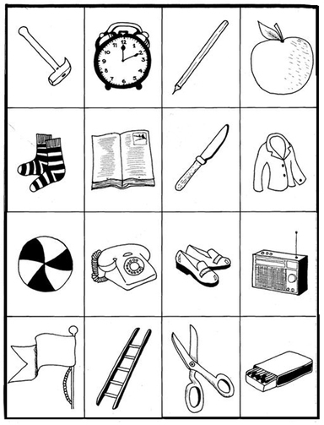
Original source: Books on display: New Day-by-Day English Course
Line drawings: Modern English Teacher, 10

Resource 3: Words and meanings – bones in the body
Teacher resource for planning or adapting to use with pupils
Word | Meaning
Humerus | The single bone found in the upper arm
Cranium | The skull, which protects the brain
Fibula | The smaller of the two bones found in the lower leg
Radius | One of the bones in the wrist that rotates as you twist your hand
Femur | The single bone in the top leg and longest bone in the body
Vertebrae | The bones that form the backbone and protect the nerves that pass through
Metacarpals | The bones found in the hand
Sternum | The breastbone, which protects the heart
Scapula | The bone commonly known as the shoulder blade on the back
Tibia | The bigger of the two bones found in the lower leg
Tarsus | A group of bones forming the upper foot and ankle

Resource 4: Describe and arrange
Teacher resource for planning or adapting to use with pupils
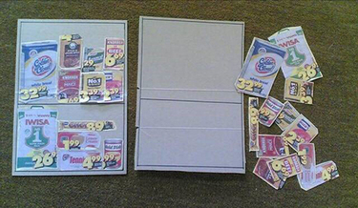
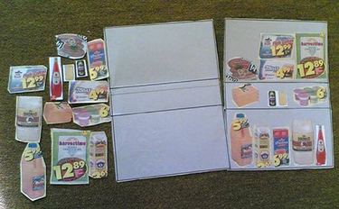
You can make similar games with house plans and pictures of furniture. Put them into your resource box to use again or for your pupils to use when they have time for reading and independent learning activities, and to practise their vocabulary. You would need to use local objects and prices.

Resource 5: Making meaning
Teacher resource for planning or adapting to use with pupils
Paragraph for older classes: The Zulu kings
The Zulu kings established the most powerful black dynasty Africa has ever known. The mighty Shaka, who founded the dynasty in the early 19th century, welded the Zulu nation into a formidable military unit. Known as the ‘Black Napoleon’, this first Zulu king was a ruthless, yet inspired, leader. Triumphant and merciless in battle, he led his people to greatness and ruled them with iron-handed discipline. His assassination by his treacherous half-brother, Dingane, did nothing to lessen the rule of terror. But the self-indulgent Dingane, although cruel and despotic, was no warrior and his reign ended in disaster. Defeated by the Boers at the battle of Blood River, Dingane was eventually forced to flee Zululand and died in exile. After his death the neighbouring territory of Natal became a white settlement and the course of Zulu history changed.
Adapted from ‘The Zulu Kings’ by Roberts, R. (1974) published by Hamish Hamilton.
Picture story for younger classes: The dog and the meat
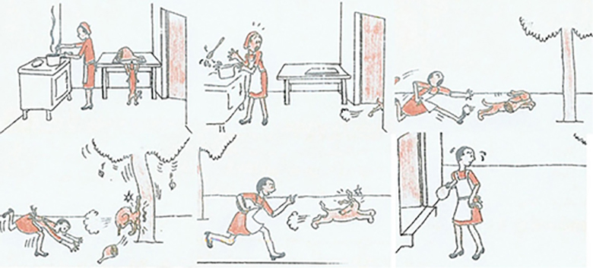
Pictorial story ‘The dog and the meat’ taken from Standard 2 Language Book, p.10, Published by Maskew Miller Longman

Acknowledgements
Grateful acknowledgement is made to the following sources:
Other
Resource 2 : Ideas for pictures : Original source:
Books on display: New Day-by-Day English Course
Line drawings: Modern English Teacher, 10
Resource 5: Making meaning: Original sources:
Adapted from ‘The Zulu Kings’ by Roberts, R. (1974) published by Hamish Hamilton.
Pictorial story ‘The dog and the meat’ taken from Standard 2 Language Book, p.10, Published by Maskew Miller Longman
Every effort has been made to contact copyright holders. If any have been inadvertently overlooked the publishers will be pleased to make the necessary arrangements at the first opportunity.
Return to Literacy (primary) page

Section 4: Ways to build on home language knowledge
Key Focus Question: How can you build on knowledge of the home language to develop competence in the additional language?
Keywords: building; vocabulary; concepts; additive bilingualism

Learning Outcomes
By the end of this section, you will have:
- used the home language to maximise creativity, understanding and development of ideas;
- understood the importance of interplay between the home language and the additional language.

Introduction
As a teacher, you want to maximise learning and skills in the additional language and so you need to make decisions about when and how to use the home language. Your choice of language should be based on what is best for your pupils’ learning, rather than on what is easiest for you.
In many schools, the home languages of the pupils are used at home, and then only in the first few years of school. This often leads to a view that the home language is not worth much. Teachers and parents forget that it is important to build on the pupils’ existing language knowledge and skills and use both languages.
This section shows how using the home language can maximise creativity, understanding and development of ideas, as well as development of the additional language.

1. Using home language to stimulate creativity
Your pupils come to school with a rich background of human interaction and experience of the world. They also have a language to describe their world. When they use their home language they can draw on this experience to fill their speech and writing with detailed description and imagery. As a teacher, you need to encourage this, and draw out the knowledge that they have.
When it comes to speaking or writing in the additional language, pupils will often not realise that they can still draw on this knowledge. Teachers, too, may forget that their task is to help pupils transfer their knowledge in and of their home language into the additional language, rather than building from scratch.
In this part, we suggest that you help your pupils to express what they know and imagine in their own language, and then to think of ways to carry a similar meaning across into the additional language.

Case Study 1: Writing in isiZulu to enrich English
Mrs Nonhlanhla Dlamini teaches English to 64 Grade 6 isiZulu-speaking pupils in the Nongoma district of KwaZulu-Natal, South Africa.
One day, she read and discussed examples of praise poems and stories with her pupils and suggested that they write their own. They were quite excited, but their initial attempts in English were very disappointing so she decided to try a different approach.
Mrs Dlamini asked her pupils to work in pairs to tell each other what they wanted to write and help each other to write their story or poem in isiZulu. Next, they worked in their pairs to write English versions. She reminded them not to do word-for-word translations because the grammar and vocabulary of the two languages is built up in different ways.
The second attempts at writing in English were much more interesting than their first attempts, though still not as rich in detail and interest as the Zulu versions.
Mrs Dlamini did some vocabulary building work with pupils to extend their range of verbs and adverbs in the additional language, as she noticed that this was an area of weakness. Next, she then asked pupils to rework their own writing, using a greater range of verbs and adverbs.
After signing their writing, pupils placed their poems and stories on a table at the back of the classroom. They enjoyed reading each other’s stories.
Mrs Dlamini noticed how many more verbs and adverbs became part of her pupils’ regular vocabulary as a result.

Activity 1: Word-pictures in two languages
Write on the board the ‘insults’ poem ‘You’, which appears in Resource 1: Poem.
- Read it with pupils and discuss each comparison, e.g. ‘head is like a hollow drum’ makes one think it is big and empty, etc.
- Ask them to write a ‘compliments’ poem, as a class, about a well-known person they admire.
- Decide with them which aspects of the person they will describe. If the person is athletic, they might choose physical attributes, legs, figure, walk, etc.
- Now distribute these attributes to groups, or individuals, and ask them to think of comparisons in the home language.
- When they feed back their comparisons, decide, as a class, on the best comparison for each attribute, and write them up, in the home language.
- Now discuss how they would say something similar in the additional language. Direct translation will not work, but try to create a similar impression.
- In this way, build up the poem with your class in the additional language.
- Ask them to make up a poem of their own – ‘insults’ or ‘compliments’. Pupils should make sure they cause no real offence!
How well did this approach help the pupils develop their vocabulary in the additional language?

2. Bilingual approaches
People often feel that a teacher should use only the additional language in class in order that pupils become as fluent as possible in it. This is not an unreasonable view and it does work well in certain situations. However, the reality in many African classrooms is that:
- there are no native or very competent speakers of the additional language (pupils or teachers) in the school;
- pupils have little exposure to the additional language outside of the classroom;
- most teachers do a lot of code-switching (i.e. alternating languages while they are talking);
- if only the additional language is used, pupils are lost most of the time, especially in the early years of learning the new language.
When pupils have learned the additional language for a few years only, and do not have much exposure to it outside the classroom, they can only understand and make sentences relating to everyday realities. They are often not yet able to use it to discuss ideas and concepts. In order to extend learning to discuss ideas, it can be useful to take a bilingual approach.

Case Study 2: Discussing ideas in the home language
In Kibaha, Zawadi Nyangasa led her Standard 7 English class in a lesson based on a story about a king and a shoemaker. She wanted them to think about the nature of true ‘wisdom’ and ‘cleverness’, and the purpose of education.
She read the story aloud to the class, stopping from time to time to ask questions to check understanding. Most of the questions and answers were in English, but there were times when she used the mother tongue to clarify a concept or to relate the story to the pupils’ life (see Resource 2: Lesson transcript).
After reading the story, she asked the pupils to discuss the following questions, in small groups of four to six. She encouraged them to use their mother tongue.
- Do you think the shoemaker was an educated person? Was he wise? Clever? Happy? What are your reasons for saying so?
- What are the important things that we learn at school? Why are they important?
They reported back in their mother tongue, and had a general discussion on the questions. She made notes on the board, also in the mother tongue.

Activity 2: Adults I admire
Read Resource 3: Safety and think about aspects of the reading that may cause difficulties for your class.
Read the passage with your pupils, discussing any unfamiliar words or concepts.
Ask them how the adults in their world behave:
- do they behave like the ones described in the first three paragraphs of the passage, or like those described in the fourth paragraph?
- is the behaviour of adults helpful to them as young people? Why, or why not?
Have this discussion in the home language. If it would encourage deeper discussion, let pupils discuss in small groups, and report back after 15 minutes or so.
Ask them to choose an adult they know whom they admire and write a description of this person, using a language of their choice. (See Resource 4: Who is my father?) They could work in pairs or groups of three or four.
Collect their work and give feedback. They may have shared deep feelings, so respond in a human way to the content, rather then focusing on the grammatical errors, etc. (See Key Resource: Assessing learning.)

3. Code-switching to promote thinking skills
Once skills and understanding are established in a well-known language, it is easier to transfer them to an additional language. Many academics also believe that if a person can look at a subject through the perspectives of two languages, their thinking skills are improved. It is important that you make sure your pupils see themselves as richer – rather than poorer – because they have two or more languages.
When your pupils have discussed ideas in the home language or lingua franca, it is valuable for them to find and learn ways of expressing these in the additional language. You need to continually think of ways to help them do this. This part offers you some ideas.

Case Study 3: Expressing ideas in English
Zawadi made sure that the Kiswahili notes from the lesson on the king and the shoemaker were not rubbed off the board.
In the next Standard 7 lesson, she started discussing with the pupils how they could answer, in English, the questions she had asked.
They talked about some of the key Kiswahili words or phrases they had used, terms like tabia, maumbile. What kind of person, or quality, did each term refer to? Did they know people with these qualities?
They also discussed, in the same way, some of the key English words in the questions: educated; wise; clever; happy; learned. She reminded them that there are not always direct translations for words from English into Kiswahili, or from Kiswahili into English. However, they found ways of expressing the ideas that were on the board in English. In the process, they learned new language structures and some new vocabulary.
Zawadi put these on the board, she asked them to work in groups and write English answers to her two questions. The group could create the answers together, but pupils had to write their answers individually.
Zawadi found that this code-switching helped her pupils develop their English much more.

Key Activity: The adult I want to be: a vision statement
Ask some of your pupils to share their descriptions of adults they admire with the class. Ask the class to identify one or two adults they admire in the community, and see if these adults would talk with the pupils.
Decide on a few questions to ask, e.g.:
- what is most important for you, in life?
- what life experiences have made you stronger?
- who had the greatest influence on you as you grew up?

Agree who is going to ask the questions, and how to record what the person says. Pupils and adults will probably use the home language.
After the visit, discuss what the pupils learned.
Ask your pupils: What qualities and values would you like to develop in yourselves as you become adults?
Work out home language and additional language terms for these, and write them up.
Ask them to write out their own ‘vision’ and/or ‘mission statement’ in the additional language. (Resource 5: Vision and mission statements gives examples.)

Resource 1: Poem
Teacher resource for planning or adapting to use with pupils
You!
Your head is like a hollow drum.
You!
Your eyes are like balls of flame.
You!
Your ears are like fans for blowing fire.
You!
Your nostril is like a mouse’s hole.
You!
Your mouth is like a lump of mud.
You!
Your hands are like drumsticks.
You!
Your belly is like a pot of bad water.
You!
Your legs are like wooden posts.
You!
Your backside is like a mountain-top.
Igbo
Teacher notes
The above poem is a series of similes. (In this case, the series of similes is also a series of insults!) A simile is a comparison, used to highlight certain qualities in a person or thing that is being described. When you read or hear a simile, you picture the ‘mouse’s hole’ (for instance), and that helps you understand something about the nostril. In analysing the simile further, you say to yourself, ‘What is a mouse’s hole like? It is quite big (compared to a nostril). It is dark inside. It is full of messy nests and it is dirty.’ Then we can see more clearly what the poet thinks about the person’s nose!
A simile is an explicit comparison. In other words, the writer or speaker is open about the fact that this is a comparison. A simile, in English, always uses the words ‘like’, or ‘as’, e.g. ‘Your nostril is like a mouse’s hole’ or ‘In the tunnel, it was as black as night.’
If the poet had written ‘Your nostril is a mouse’s hole’ this would have a similar impact, but this kind of comparison is called a metaphor. Here, the comparison is implicit. We are not told that a comparison is being made. The nostril is described as if it is a mouse’s hole.
Original source: Machin, N. African Poetry for Schools: Book 1

Resource 2: Lesson transcript
Background information / subject knowledge for teacher
Teacher (T) teaching Standard 7 English (reading lesson) to pupils (Ps)
T: What I want you to do now is, I will read first, and I will ask you to follow me at some times. Ne?
Ps: Yes.
T: Long ago, the King of Egypt wanted to know how his people lived. Where is Egypt? Yes?
P: Egypt is in the North of Africa.
T: (Repeats) You agree? Do you agree?
Ps: Yes (Chorus).
T: Right. One night he dressed like a poor man and went into the city. What is a city?
P: A town…
T: He listened to his people grumbling. His people were grumbling. When you grumble is when you…seem to be unhappy…
P: Grumblisha.
T: Jaaaa, gramblisha, siyagramblisha andithi?
Ps: Yes.
T: Now They said that they were poor and the food was expensive… They were grumbling….No one laughed in this town. No one sang, and no one was happy. Everybody was unhappy. Wonk’umntu wayequmbile kuledolophu. Kungeko nomnye ohlekayo.
When the king was walking back to his palace. You walk back to…you walk to…you walk to… the palace What is a palace? Siphokazi.
P: A palace is where a king lives.
T: Yes, good. (Repeats) Libhodwe, andithi.
Inside he heard someone singing. Inside a little shop. He went inside the shop. A young man was sitting on the floor, making shoes, and as he worked, he sang.
When the shoemaker saw that there was a visitor, he stood up and greeted him. Molo, mfondini. Then he gave the king some bread and water. Only what?
Ps: Bread and water.
T: Was the shoemaker aware that this was the king? In reality. He was not aware. Ne? He just said Oooh! Poor soul! Because why was he not aware? Why?
P: He dressed like a poor man.
T: (Repeats) Andithi. Just have a picture of Madiba wearing the old clothes. Ezikrazukileyo, ezinikiniki eme pha phandle Ela xesha akumazi ukuba uMadiba uqabe ipeyinti emnyama apha ebusweni okanye ipolishi emnyama. Do you have a picture of what I am saying?
Ps: Yes.
T: Now do you know Madiba when he comes to that door like that?
Ps: No.
T: No, nobody could know him, ne?
The teacher continued to read the story with the pupils, asking them questions about it. Most questions were of a similar kind to those recorded above. The pupils answered them briefly, in English. The lesson then proceeded as described in Case Study 2.

Resource 3: Safety
Teacher resource for planning or adapting to use with pupils
Safety starts with the spirit of Ubuntu by Buyi Mbambo
When I was growing up I felt safe. I could walk everywhere by myself; I could go to the forest to collect wood; I could go to the river, even if I was the only one on the long, winding footpath. The only things I was afraid of were imaginary ghosts, wild rats, and maybe the cattle I would cross paths with.
The sight of a human being, an adult, was a welcome one, because whatever came from them was filled with love and concern. Yes, adults would be angry that I was on my own late in the afternoon; they would wait for me and help me put the bucket on my head. They would make sure I took the safest route home; sometimes they would shout for people to meet me half way. On the way to and from school, there would always be an adult curious about where we were going, concerned about how late we were, or about our appearance.
In my mind, as a child, adults were nosey. They did not hesitate to go home and tell my parents they had seen me doing something wrong; by the time I reached home I would have been ‘talked to’ seriously by all adults, whether they knew me or not. Nosey or not, I had a privileged childhood, as did many of today’s adults.
A lot has changed for today’s children. Families have been broken up by a number of factors; the culture and spirit of concern and high regard for children, and for one another, has been destroyed. Children and families live more and more in isolation and there is a general hesitancy about becoming ‘involved’ in the affairs of your neighbour, even if your involvement could save a life.
Extract taken from: Children First
Building concepts and vocabulary
Words and phrases you could discuss in this passage are:
imaginary ghosts; route; curious; nosey; did not hesitate; a privileged childhood; culture and spirit of concern; in isolation; a general hesitancy; becoming ‘involved’.
See whether there are pupils who can explain these words and phrases. Try to explain in English, with the help of examples. Then do not hesitate to use home language equivalents to help them understand.
Building understanding of punctuation usage
One feature of the punctuation of this passage you could discuss is the use of the semi-colon (;). The semi-colon separates two pieces of writing which are structurally complete sentences. However, the meaning of the one piece has a close connection to the other, and you want to show that close connection through the punctuation you use. The reader does not pause as long for a semi-colon as for a full stop. Look with your pupils at the places where semi-colons are used, and talk about the structure of a sentence.

Resource 4: Who is my father?
 Example of pupils' work
My brother
My brother’s name is Ipyana Mwakipesile. He is 18 years old and he is like a father to me. My father died a long time ago. He plays a major role in our lives though he is a very young boy doing Standard I at Azania High School. He is responsible. He takes good care of us. He cooks food and cleans the house. He looks after baby because my mother passed away a few months ago. Every afternoon he closes the gate so that we are safe inside. He supports us in every way. We don’t feel that our mother is also no longer there for us. My brother always gives us that love we used to get from our parents. Every Saturday, he bakes cakes, does shopping as my mother used to do. My brother is like a father to us. We trust him, we love him.
My father
My dad was born and raised in Mbeya [from] where he later moved to Dar. He attended Minaki Secondary School and within those two years, his mother died. His father left him and his two younger sisters. He lived with his grandparents and then his aunt before being moved to an orphanage.
During his years in the orphanage, he had to face many adversaries and learned many lessons. He was exposed to bullies and often had to protect his sisters. Although it seemed that he had a hard time, he appreciated all that he had at the orphanage. The hardest thing for him was not having his own family.
As a result of his upbringing in the orphanage, he learned to fend for himself. In matric, he was made head boy at his high school. He also was very popular and took part in various cultural activities as well as sport.
After school he did his national service and saw many parts of Tanzania. He often shares stories and events that he experienced during his time in the army. His experiences in the orphanage helped him cope with life in the army and he was placed in the leader group, and became an instructor. My dad has always had very good and special friends and has always been in some or other leadership role. Here he discovered that he had a special talent for teaching. After doing his national service, he went to study to become a teacher.
At college he met a girl who became a very special person in his life. After his studies he because engaged to her. It did not work out and it was at this time that my mother came to work on the same staff as my father. They because friends and were later married.
In 1990 I was born and ever since, I have been close to him.
My father has played an important role in my life, and I someday wish to pass on this gift he has given to me. He has been my teacher, my sports coach, my mentor and most of all, my closest friend.
Adapted from ‘Children First’ Nov/Dec 2004/ Vol 8 No 58, pages 5, 6, and 7

Resource 5: Vision and mission statements – some examples
Background information / subject knowledge for teacher
A vision statement is usually short. It is focused on the future and what you aim to become in the future.
A mission statement is often a bit longer, and gives more detail of what has to be done to achieve the vision.
Here are two examples:
Vision statement for the School of St Jude, Northern Tanzania
To be an exemplary, modern and self-sustainable institution that effects a paradigm shift on the educational system in Tanzania by enabling Tanzanians to run successful and moral schools, thereby alleviating poverty and breaking the cycle of dependency on external aid.
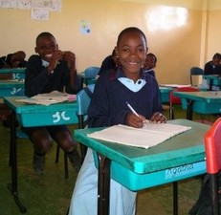
Original source: http://www.schoolofstjude.co.tz/AboutUs/WhoAreWe/tabid/71/Default.aspx (Accessed 2008)
Mission statement of an anonymous man
To be the person my children look to with pride when they say, ‘This is my dad.’
To be the one my children come to for love, comfort and understanding.
To be the friend known as caring and always willing to listen empathically to their concerns.
To be a person not willing to win at the cost of another’s spirit.
To be a person who can feel pain and not want to hurt another.
To be the person that speaks for the one that cannot, to listen for the one that cannot hear, see for the one without sight, and have the ability to say, ‘You did that, not I.’
To have my deeds always match my words through the grace of God.
Original source: Covey, S. et al. First Things First

Acknowledgements
Grateful acknowledgement is made to the following sources:
Other
Resource 1: Poem:
Original source: Machin, N. African Poetry for Schools: Book 1
Resource 2: Lesson transcript:
Adapted from: Umthamo 3, University of Fort Hare Distance Education Project
Resource 3: Safety:
Extract taken from: Children First
Resource 4: Who is my father?
Adapted from ‘Children First’ Nov/Dec 2004/ Vol 8 No 58, pages 5, 6, and 7
Resource 5: Vison and mission statements:
Original source: http://www.schoolofstjude.co.tz/AboutUs/WhoAreWe/tabid/71/Default.aspx (Accessed 2008)
Original source: Covey, S. et al. First Things First
Every effort has been made to contact copyright holders. If any have been inadvertently overlooked the publishers will be pleased to make the necessary arrangements at the first opportunity.
Return to Literacy (primary) page

Section 5: Supporting additional language learning
Key Focus Question: How can you build supportive relationships in the additional language?
Keywords: personal communication; pen-pals; sharing local information

Learning Outcomes
By the end of this section, you will have:
- begun developing relationships between pupils that support their learning in the additional language and help them reflect on their own learning;
- provided opportunities for pupils to communicate with proficient or mother-tongue speakers of the additional language,
- set up opportunities for communication with pupils beyond your school.

Introduction
Many pupils in Africa have few opportunities to interact with mother-tongue speakers of the additional language. Often, exposure to the language has to come through reading, listening to the radio or watching the TV.
Nevertheless, there are ways to get your pupils talking and writing to those who are more fluent in the additional language. You may also be able to help your pupils communicate, in the additional language, with pupils in another school.
This section looks at ways to do this.

1. Focus on everyday language
For people who learn language in a formal classroom, the phrases people use every day to interact with one another are often the last things that they learn.
There are ways to help your pupils to gain proficiency in phrases and sentences that they can use when they meet proficient speakers of the additional language. Each set of phrases or sentences should:
- be short and easy to learn;
- say something that the pupils need and want to say;
- be usable with a lot of people;
- allow the pupils to start a conversation and build a relationship;
- allow the pupils to learn more about the language from the person they are talking to;
- not provoke long responses from the other person.

Case Study 1: Learning isiZulu through relationships
Liz Botha in East London, South Africa, was learning isiZulu as an additional language through a local language project called TALK. The motto of the TALK project was, ‘Learn a little, and use it a LOT!’
She started by learning how to greet in isiZulu, and to tell people that she was learning isiZulu. She also learned to ask them to speak to her in isiZulu and help her with her language learning.
She looked for people to whom she could speak isiZulu, and found that there were a number of isiZulu-speaking hawkers selling fruit and vegetables in the streets near her home. She practised her sentences with them, and started to get to know them. She had a friend who taught her new phrases, and she found out, from her, how to ask for the price of something, and buy it. These were the sentences she used the next time she saw her hawker friends.
As time went by, she learned to tell them about herself and her family. Later, she told them short stories about what had happened to her the day before, or at the weekend. One of the hawkers, named Jabu, became a very special friend of hers, and taught her many new words and sentences. He eventually became involved in helping other people to learn isiZulu within the TALK project.

Activity 1: Building language learning relationships
Ask your pupils where they hear the additional language spoken. Who do they know who speaks it well? Who could they speak to in the additional language? Consider individuals outside and inside school, and also people that you could invite to your classroom. Consider a partnership with another school nearby, if it could promote interaction in the additional language.
Now that your pupils know who they want to speak to, work out what they would like to say to them.
Systematically, as a long-term project, help them to learn vocabulary. Concentrate on clear sounds and pronunciation. Let them practise in pairs.
Ideas for basic things to learn include:
- greetings and leave-taking;
- giving and asking names, and personal/family information;
- explaining that they are learners of the language and want help with learning more;
- buying things;
- talking about the weather;
- saying what happened yesterday;
- apologising, requesting, complimenting, etc.
Encourage them to practise with the people they decided on (above).
Spend some time each week asking about their progress.
What successes and difficulties have they had?
What new language have they learned?
What else have they learned?

2. Writing letters
In this part, we suggest that you motivate your pupils to write letters in the additional language. This could mean setting up long-distance relationships with speakers of the additional language, or they could write to friends who are closer.
You could introduce a pen-pal scheme (see Resource 1: Pen-pals) with another class. This can be a class in your country or in another country.
If pupils become confident writers and readers of letters while they are at primary school, they are more likely to be successful writers of letters later in life. As they write personal letters to friends, you can also introduce other styles of letter writing. This will equip them for later needs, such as applying for bursaries or jobs, letters to newspapers, letters of congratulation or condolence.

Case Study 2: Writing to console or complain
The pupils in Mrs Linda Ezenwa’s Primary 5 class were upset and couldn’t concentrate on their schoolwork. One of their classmates, Oluchi, had been killed in a bus crash. They missed their friend very much. They were also angry because they had heard that the bus had faulty brakes.
Mrs Ezenwa encouraged the pupils to talk about how they were feeling. She realised that they wanted to do something, so she asked if they would like to write to Oluchi’s family. She suggested that they write two letters: one in Igbo for her parents and grandparents and one in English for her brother and sister who had grown up in Onitsha. The pupils said that they wanted to tell Oluchi’s family members that they were thinking about them and also tell them all the good things about Oluchi.
Mrs Ezenwa helped them with an outline for their writing. Each pupil wrote their own letter in Igbo. In the next lesson, Mrs Ezenwa helped them to write one letter from the whole class in English and then each pupil signed it.
With Mrs Ezenwa’s help, they also wrote a letter in English to the bus company, requesting that all the buses be carefully checked to make sure they were roadworthy.
The class received replies to both the letters they had written. Mrs Ezenwa pinned these letters to the class notice board.
Mrs Ezenwa realised how this had motivated her pupils and given them important social skills. It had also helped them see the purpose of learning the additional language.

Activity 2: A letter to a friend or pen-pal
Read Resource 1 first, and set up your partner school.
- Give each pupil in your class the name of a pen-pal with whom they can establish a relationship. (If this is not possible, try to get each pupil to identify a pupil in another class or a relative or friend away from home they would like to correspond with.) If you already have a partner school, or you set one up (see Resource 1 for how to do this), keep in close contact with your partner teacher, to discuss potential problems and find solutions together.
- Discuss with your class the kinds of things they might like to say in their first letter. Over time, they could exchange information about their lives, their families, their friends, their interests, their dreams.
- Agree a format for the letter (see Resource 2: Writing letters), and let them start writing. Go round helping them with words and phrases that they need.
- Let them revise and edit their letters in pairs. (See Resource 3: Assessing pen-pal letters.) Take the letters in yourself, and give supportive and constructive feedback.
- Let pupils write out a final version of their letter, address the envelope and post it.
- With younger pupils, this could be a whole-class activity and you write what they want to say. They could write to another class in the school.
How can you support the development of these correspondence relationships?
How can you help where needed, while giving space for relationships to develop?

3. Creating books
Producing books that the pupils have written and made not only enhances their self-esteem, but also provides you with welcome classroom resources.
This part builds on the idea of a Big Book in Module 1, Section 5. It suggests that you motivate your pupils to bring their writing and drawing to a final stage by putting together a book. This can be shared with others in the class, or with a person, group or school in another place.
You need to think about how to plan and organise an activity like this. You will need to think about the kind of book to make (e.g. folding book), the visuals and layout of the book, and the type of book (e.g. songbook, storybook or non-fiction book).
You will need to think about the resources needed and where to get them. You may have to involve pupils in collecting some of these before you actually start the work in class. This kind of planning and preparation is vital if your classroom is to be effective in helping pupils learn (see Key Resource: Being a resourceful teacher in challenging circumstances).

Case Study 3: Making a class book
Mrs Umar, who teaches a class of 44 Primary 5 pupils in Sokoto, wanted to encourage them as writers and readers and so decided to make books with them in their additional language of English.
She told them that she wished to start a collection of books for the class and it would only grow if they produced some of their own books. They discussed what kinds of books they liked to read and she listed these on the board. The list included stories, poems, and books about sports and clothes. She then asked the class to form small groups of no more than six people interested in a particular kind of book.
Mrs Umar discussed with each group what kind of book they were going to write. One group decided to work in smaller groups of three to produce two sports books, one about football and the other about running. Another group wanted to write a storybook based on a traditional tale. Mrs Umar gave the groups time to plan their outlines before asking them to share their ideas with the rest of the class. The class gave feedback to each group. Over the next week, Mrs Umar gave the groups lesson time as well as homework time to work on their writing.
As each group finished their drafts, Mrs Umar read these through and gave feedback on ways to improve their books. The final drafts were completed over the next week and were put on display for the whole class to read.

Key Activity: Creating a book to share
- Suggest to your class that they make a book for their partner school (or for another purpose), containing songs, recipes and other local information. If you have a recipe book, show it to them. Some recipe books include pictures, information and stories about places and people related to the recipes.
- Decide which songs or recipes they will include and how they will be presented.
- Decide together what else will be in the book. See Resource 4: Songs and stories about processes – similar songs and stories could be included. Poems or descriptions from activities in Section 2 and Section 4 could be included.
- Think about illustrations, photographs, instructions for local games, stories or poems.
- Plan with your pupils who will do each piece of work, who will edit the work and when each task should be completed. (Module 2, Section 5, Resource 1: How stories are made into books tells how a book is put together by different people.)
- Carry out the plan. If possible, make copies of the book, so that you can keep one and send one to your partner school. Ask your partner school if they can send you a book they have made, too.
Where resources are limited, recycled paper, old calendars, newspapers and magazines are materials you may be able to gather locally for making books. For further ideas, see Key Resource: Being a resourceful teacher in challenging circumstances.

Resource 1: Pen-pals
Background information / subject knowledge for teacher
If you wish to be put in touch with a school in your own country or another country that is also making use of these materials, please contact National Teachers’ Institute at ntikad@yahoo.com or at the following address: National Teachers’ Institute, KM 5 Kaduna-Zaria Express Road, Rigachikun, Kaduna.
You can then set up a link between your class and a class of similar age at the other school, and arrange for every one of your pupils to have a pen-pal. This will give your pupils the advantage of having a friend to write to, and receive responses from, about matters of interest, using a common additional language or lingua franca. They will gain practice in reading and writing for a real purpose, and learn a lot about the other person, their family, school, country and lifestyle.
Before you introduce your pupils to the scheme, make sure that you have sorted out issues such as the provision of, and payment for, envelopes and stamps. You may be able to put all the letters in a large envelope and post this to the teacher.

Resource 2: Writing letters
Background information / subject knowledge for teacher
Pupils are likely to find letter writing more enjoyable (in either their mother tongue or the additional language) if they feel there is a real reason for writing and that someone will be interested in reading their letters. There will be a number of situations where using the additional language would be more appropriate. In every case, you will need to discuss which language to use.
You can arrange with teachers in another school for pupils in each school to write letters to those in the other (see Resource 1). You could also help your pupils to write a letter to a company to ask for a donation of money, goods or services for the school. If you have taken them to visit a place in your community such as a clinic, an agricultural project or a factory, you could help them to write a letter of thanks. There may be happy or sad occasions where it would be appropriate for them to write someone a letter of congratulations or condolence.
Whatever type of letter you choose, first discuss with pupils why people write letters and what they want to say in the particular type of letter chosen. Write their ideas on the chalkboard and help them to organise them into paragraphs. You may wish to use some of the following outlines.
When pupils have completed their letters, send them to the person or organisation to whom they are addressed. You could collect all the pupils’ letters and put them into one large envelope with the appropriate address. If you and the pupils are lucky, you will receive a reply!
Outline of a letter to a pen-pal at another school (or country)
Dear ……………….
I am very pleased that we are going to be pen-pals. In this letter I am going to introduce myself to you.
My full name is ………………………………. I am …. years old. As I don’t have a photograph to send you at present I will describe what I look like. [followed by sentences with this description]
I would like to tell you about my family. [followed by sentences about them]
We live in ………………… [followed by sentences about the place]
These are some of my favourite things. My favourite food is …………. My favourite music is ……………. My favourite subject at school is ………………
At the weekends I like to ………………………………………………….
When I finish school I hope to …………………………………………….
I am looking forward to hearing from you.
With best wishes
[Name and signature]

Outline of a letter of thanks after a school visit
Dear ……………….
I really enjoyed our visit to ……………….
What I found most interesting was …………………………….
I thought this was the most interesting because……………………
If our school has a chance to make another visit I would like to ……………….
Thank you very much for ……………………………………………….
Yours sincerely
[Name and signature]
Outline of a letter to a company requesting a donation
Dear ……… [name of person or Dear Sir or Dear Madam]
I am writing to ask for your help. Our school really needs…………………
We need this because ……………………………………………………….
I am writing to you because …………………. [reasons why this company could help].
I do hope you will be able to assist us.
Yours sincerely
[Name and signature]

Resource 3: Assessing pen-pal letters
Teacher resource for planning or adapting to use with pupils
- Does the letter create a lively and interesting picture of the writer? What details could be added to make it more interesting?
- Is the information clearly expressed? Is the letter easy to read?
- Are different topics dealt with in different paragraphs?
- Is it in the correct tense? (A description is likely to be in the present tense.) Is each verb in the present tense or, if not, is there a good reason for a different tense? (You can decide what other structure features you want to focus on in this activity.)

Resource 4: Songs and stories about processes
Teacher resource for planning or adapting to use with pupils
Here is a traditional Hausa song (with English translation) describing various processes through which grain goes before it is eaten. It was included in a booklet on ‘Processes and processing’. Such songs could be included in a recipe book. Stories follow which come from the same source, and could also be included in such a recipe or process book.
Noma alkama, Noma alkama
Noma alkama Noma alkama, Noma alkama,
[We plough the wheat]
Muna girbin alkama, Muna girbin alkama
Muna girbin alkama, Muna girbin alkama, Muna girbin alkama,
[We harvest the wheat]
Muna dafa alkama, Muna dafa alkama,
Muna dafa alkama Muna dafa alkama, Muna dafa alkama,
[We cook the wheat]
Muna chin alkama, Muna chin alkama,
Muna chin alkama, Muna chin alkama, Muna chin alkama,
[We eat the wheat]
Muna koshi, Muna koshi,
Muna koshi, Muna koshi, Muna koshi,
[Our stomachs are full of wheat]
The discovery of millet
Once upon a time there was a man with two wives. (In some parts of Africa, they say, ‘One wife – one trouble. Twelve wives – twelve troubles!’) The older wife could not have children, and so when she discovered that the younger wife was pregnant, she was very jealous. But there was nothing she could do.
The husband and his younger wife grew closer and closer. And this made the older wife even more jealous. So she decided to wait until after the birth.
But when the baby was born, it was a boy. The elder wife, according to custom, was supposed to take care of the baby and the amariya (younger wife) for a few months. The elder wife decided to go to the forest to look for something that she could cook for the younger wife that would poison her. She hoped that the younger wife would die, and then she would be able to bring up the baby as her own.
In the forest, the older wife found a plant that had some heads of corn growing on it. She had never seen anything quite like it before. She said, ‘This will make her sleep, a really deep sleep, so that she doesn’t wake up the next day. Then I can prepare a wonderful funeral.’
She cooked the millet and fed the amariya. To her surprise, the amariya didn’t fall into a deep sleep or die. Instead, she grew fat and looked healthier and lovelier by the day. The baby, too, thrived.
When the older wife saw the effects of the stuff she had been cooking and feeding to the younger wife, the older wife decided to taste it for herself. She liked the taste, and continued to cook and eat this new stuff. She also began to grow fatter and healthier.
Well, the husband couldn’t help noticing that his two wives looked so well, and the baby was so healthy. He wanted to taste whatever it was that they were eating. So they all became fat and healthy.
And, of course, in a village, word gets around very, very quickly. Before long, the rest of the villagers wanted to know what this family were eating. And so it was that millet was discovered.
The discovery of butter
There was once a young couple with a large herd of cattle and a large flock of sheep. The husband fed his family by milking the cows. In those days they stored the milk in calabashes.
The couple sometimes quarrelled and she could be seen running off to her mother, with her husband running after her, shouting and shaking his fist in the air.
One day when they quarrelled, the husband happened to be holding one of the calabashes of thick, creamy milk. When his wife ran off, the husband ran after her, as usual. But this time he forgot to put down the calabash of thick, creamy milk. As he ran shouting after his bride, he shook his fist holding the calabash in the air. The calabash of milk shook. And the thick, creamy milk inside shook. In fact, the husband ran so fast that the calabash of milk was shaken really hard.
When he couldn’t catch her, and he was out of breath, the man sat down. He was hot and thirsty after running after his wife and shouting. So he put the calabash to his lips to take a drink of the thick creamy milk. But it wasn’t milk that poured from the calabash. It was something much more like water! This was all his wife’s fault!
The man was puzzled. He sat down and looked inside the calabash. What had happened to the thick, creamy milk? How could it have turned into something watery? He took another mouthful. It was just the same. He put his hand inside the calabash and discovered that there was a lump of something. I’m sure you can guess what he found. Yes, that’s right, it was a lump of smooth, greasy butter. When the husband licked his fingers, he found that the lump of stuff tasted rather nice. It was like fat.
He rushed back to his place, found some maize bread, and smeared some of the fat from the calabash onto the lump of bread. The bread tasted much better than usual. His anger vanished. When his wife returned after a little while, he showed her what had happened, and gave her some of the fat to taste on bread.
For some time after that, whenever the butter was finished, the husband would start a quarrel with his wife so that he could take a calabash of thick, creamy milk with him as he ran after her. He knew that way the thick creamy milk would produce some butter.
One day when there was very little butter left, the wife took a calabash of thick creamy milk and shook it as hard as she could. She shook it, and shook it, and shook it. When she could shake it no more, she put the calabash down. You can guess what she found when she looked inside, can’t you? She found some butter, and some watery whey.
That evening when her husband came home, the young bride turned to her husband and said, ‘Perhaps if we just shake the calabash full of thick creamy milk really hard, it will make some more butter. Then we won’t have to quarrel any more.’
And so it was that they lived very happily, and became wealthy from bartering some of the thick, creamy milk of their cattle, and the butter, which they had learned to make.
Adapted from: Ngtetu, C. & Lehlakane, N., Inqolowa, The Discovery of Amazimba and The Discovery of Butter, Umthamo 3, University of Fort Hare Distance Education Project

Acknowledgements
Grateful acknowledgement is made to the following sources:
Other
Resource 4: Songs and stories about processes:
Adapted from: Ngtetu, C. & Lehlakane, N., Inqolowa, The Discovery of Amazimba and The Discovery of Butter, Umthamo 3, University of Fort Hare Distance Education Project
Every effort has been made to contact copyright holders. If any have been inadvertently overlooked the publishers will be pleased to make the necessary arrangements at the first opportunity
Return to Literacy (primary) page


www.tessafrica.net

