
Primary Subject Resources

Social Studies and the Arts

Module 2 Investigating History

Section 1 Investigating family histories
Section 2 Investigating how we used to live
Section 3 Using different forms of evidence in history
Section 4 Understanding timelines
Section 5 Using artefacts to explore
ENGLISH

TESSA (Teacher Education in Sub-Saharan Africa) aims to improve the classroom practices of primary teachers and secondary science teachers in Africa through the provision of Open Educational Resources (OERs) to support teachers in developing student-centred, participatory approaches. The TESSA OERs provide teachers with a companion to the school textbook. They offer activities for teachers to try out in their classrooms with their students, together with case studies showing how other teachers have taught the topic, and linked resources to support teachers in developing their lesson plans and subject knowledge.
TESSA OERs have been collaboratively written by African and international authors to address the curriculum and contexts. They are available for online and print use (http://www.tessafrica.net). The Primary OERs are available in several versions and languages (English, French, Arabic and Swahili). Initially, the OER were produced in English and made relevant across Africa. These OER have been versioned by TESSA partners for Ghana, Nigeria, Zambia, Rwanda, Uganda, Kenya, Tanzania and South Africa, and translated by partners in Sudan (Arabic), Togo (French) and Tanzania (Swahili) Secondary Science OER are available in English and have been versioned for Zambia, Kenya, Uganda and Tanzania. We welcome feedback from those who read and make use of these resources. The Creative Commons License enables users to adapt and localise the OERs further to meet local needs and contexts.
TESSA is led by The Open University, UK, and currently funded by charitable grants from The Allan and Nesta Ferguson Foundation, The William and Flora Hewlett Foundation and Open University Alumni. A complete list of funders is available on the TESSA website (http://www.tessafrica.net).
As well as the main body of pedagogic resources to support teaching in particular subject areas, there are a selection of additional resources including audio, key resources which describe specific practices, handbooks and toolkits.

TESSA Programme
The Open University
Walton Hall
Milton Keynes, MK7 6AA
United Kingdom
tessa@open.ac.uk

Except for third party materials and otherwise stated, this content is made available under a Creative Commons Attribution-Share Alike 4.0 licence: http://creativecommons.org/licenses/by-sa/4.0/. Every effort has been made to contact copyright holders. We will be pleased to include any necessary acknowledgement at the first opportunity.

TESSA_EnPA_SSA_M2 May 2016


This work is licensed under a Creative Commons Attribution-Share Alike 4.0 License

Contents
- Section 1: Investigating family histories
  - 1. Working in groups to discuss families
  - 2. Modelling making a timeline
  - 3. Helping pupils explore their past
  - Resource 1: Kinship chart
  - Resource 2: Another kinship chart
  - Resource 3: Lunda kinship terms
  - Resource 4: My timeline
  - Acknowledgements
- Section 2: Investigating how we used to live
  - 1. Gathering oral histories
  - 2. Investigating a historical event
  - 3. Thinking critically about evidence
  - Resource 1: Oral history
  - Resource 2: Possible interview questions
  - Resource 3: Ugandan independence
  - Resource 4: The exile of Ugandan Asians – a news report in 1972
  - Acknowledgements
- Section 3: Using different forms of evidence in history
  - 1. Thinking about the location of settlements
  - 2. Using mind maps to structure thinking about the past
  - 3. Fieldwork to investigate local history
  - Resource 1: Great Zimbabwe
  - Resource 2: Pictorial map of Great Zimbabwe
  - Resource 3: A mind map about keeping cattle
  - Resource 4: Cattle in traditional life – the Fulani
  - Resource 5: The role of cattle – past and present
  - Acknowledgements
- Section 4: Understanding timelines
  - 1. Building a timeline
  - 2. Introducing the concept of chronology
  - 3. Comparing African histories
  - Resource 1: Some important historical events since independence
  - Resource 2: Two histories of Zambia
  - Resource 3: Copperbelt strike
  - Resource 4: African timelines template
  - Resource 5: Key events in the move to independence
  - Acknowledgements
- Section 5: Using artefacts to explore the past
  - 1. Discussing artefacts in small groups
  - 2. Welcoming visitors to enhance the curriculum
  - 3. Interpreting evidence from artefacts
  - Resource 1: Using artefacts in the classroom
  - Resource 2: My artefact
  - Acknowledgements

Section 1: Investigating family histories
Key Focus Question: How can you structure small-group activities in your classroom to develop collaborative working and build self-confidence?
Keywords: family; history; confidence; investigation; small-group work; discussion

Learning outcomes
By the end of this section, you will have:
- structured your activities to help pupils understand themselves and their relationships with other family members;
- used small-group discussions to build pupils’ self-confidence as they investigate their family histories.

Introduction
Good teaching often starts by encouraging pupils to explore situations that they are already familiar with. In terms of history, this means using their own lives, and the lives of their immediate families, as a source of investigation. The skills used to explore this familiar history can then be used in the study of broader historical questions.
All of us have a history, which starts from the moment we are born. This will include all our experiences and all the people we interact with.
In this section, you start by exploring your pupils’ immediate family situations and their roles and responsibilities within the family. You will also look at the wider context of the extended family. As you work in this area, you will have to be sensitive to different backgrounds and family or other structures that your pupils live in.

1. Working in groups to discuss families
When investigating the family, it is useful to first explore pupils’ understanding of what a family is and show them the diversity among families. Celebrating such diversity helps pupils feel better about themselves when they realise how different families can be. Case Study 1 and Activity 1 explore different ways to do this.
In the case study, the teacher encourages his pupils to work in small groups (see Key Resource: Using group work in your classroom) and to remember the rules that they have agreed for small-group discussions.

Case Study 1: Using group work to explore my own family
Mr Nguzo is a social studies teacher at Muhimu Primary School in Tanzania. He wants his pupils in Standard 3 to learn about families and the roles of different family members.
He organises groups of not more than six; he puts pupils together who do not usually work with each other.
In the groups, pupils take it in turns to answer the following questions, which he has written on the board.
- What is your name?
- Who are your father and mother? What are their names?
- Who are your grandfathers and grandmothers? What are their names?
- How many sisters and brothers do you have? What are their names? Are they older or younger than you?
- How many cousins do you have? What are their names?
During the discussion, Mr Nguzo goes to each group to check that all the pupils are being given a chance to contribute. After 10 to 15 minutes, he asks the groups to share with the whole class what they have found out about different families: What were the similarities between the families? What were the differences? (For younger or less confident pupils, he would have to ask more structured questions, e.g. ‘Who had the most brothers?’)
Then he asks the groups to consider this question:
- What makes someone your sister, your brother, your aunt, etc.?
After 10 minutes, one member of each group presents their answers to question 6 to the class. Mr Nguzo prepares a large, basic kinship chart to help focus the discussion (see Resource 1: Kinship chart).
Mr Nguzo and the pupils note that although there are words in their language that express cousin, uncle and aunt, these relations are normally referred to as brother or sister; grandfather, father are usually simply father; grandmother, mother are similarly simply mother. There is a distinction between the uncles and aunts from the mother’s side and those from the father’s side. Mr Nguzo realises that teaching pupils about the relationships within families can be confusing for younger pupils.

Activity 1: Who am I?
- Before the lesson, prepare a kinship chart as a handout (see Resource 1).
- Ask the pupils to work in groups of three or four. One pupil volunteers to list all the people they know in their family and fill in the details on a kinship chart. (You may wish to select which pupil is chosen.)
- Pupils might want to draw pictures of their relatives on the chart.
- Share these charts with the class.
- Discuss the variation in families and emphasise how good this variety is.
- At the end of the lesson, display the kinship charts on the wall of the classroom.

2. Modelling making a timeline
When studying past events, it is important to help pupils understand the passage of time and how things change from generation to generation.
Developing the ways that young pupils look at their family histories will help them link events together as well as put them in sequence. Resource 2: Another kinship chart provides a family tree that will help pupils see relationships between family members, e.g. their cousin is their mother’s or father’s sister’s or brother’s child. See Resource 3: Lunda kinship terms for some Zambian terminology.

Case Study 2: Family histories
Joyce Phiri plans to teach about family relations over time with her Grade 5 pupils.
She cuts a series of pictures from magazines of people of different ages, doing different things, e.g. at a wedding, a school prize day, and writes numbers on the back of each picture. She tells her pupils that the photographs represent different events in one person’s life and asks her pupils, in groups of six, to sequence the photos in terms of the age of the person. She gives them 15 minutes to discuss the order and then asks each group to feed back. She asks why they chose the order they did and lists the clues they found in the pictures to help them order the events. They discuss the key events shown in the pictures and Mrs Phiri tells the pupils they have made a ‘timeline’ of life.

Activity 2: Pupils creating their own timeline
Resource 4: My timeline can be a starting point for your class to do their own timeline.
- First, discuss the importance of knowing one’s own origins and members of one’s family.
- Explain what a timeline is.
- Model (demonstrate) the making of a timeline yourself (you don’t have to use your own life – you could do a realistic one based anonymously on someone you know). Modelling is an excellent way of supporting pupils to learn a new skill/behaviour. Draw this timeline on the board and talk through what you are doing, or have one prepared on a large roll of paper. Remember to use a suitable scale – a year should be represented by a particular length. (When your pupils come to do their timelines, they could use 5 cm or the length of a hand if they don’t have rulers.)
- Ask pupils to write down key things they remember about their lives and also give them time to ask their parents/carers about when they first walked etc.
- Ask them to record any other information they want to include on their timeline.
- Support them as they make their timelines. You could encourage them to write in the main events that have happened to them personally, and in a different colour (or in brackets under the line) the main events that happened to their wider family (e.g. older sister went to college, father bought a field etc.).
- Display their timelines in the classroom.
- Pupils who finish quickly could be asked to imagine and draw a timeline of their future. What will be the main events when they are 20, 25, 40 etc.?

3. Helping pupils explore their past
Helping pupils to develop their understanding of past and present takes time, and involves giving them a range of activities where they have to observe, ask questions and make judgements about what they find out.
How can they develop skills to help them think about how things change over time? Case Study 3 and the Key Activity use the wider environment to extend your pupils’ understanding of time passing and things changing.

Case Study 3: Visiting an older citizen
Mr Kabwe Kato, Mrs Siame Sime and Miss Banda Benda planned their social studies classes together. They did not all do the same topic at the same time, but it helped them to share ideas.
They all read Key Resource: Using the local community/environment as a resource. They planned to take their classes to visit an older member of the community to talk to them about how the village has changed since they were a child. They decided to organise the classes into groups and each group would prepare questions to ask the elder. Each group would have a different area to think about such as games they played, food they ate, houses they lived in etc.

Key Activity: Using different sources to investigate family life in the past
Do a brainstorm with your class. Ask them to consider how they could investigate the ways in which life for their families has changed in the village/community over time. What sources could they use to find out about this?
They are likely to come up with ideas such as: using their own observations and memories to think about what has changed in their own lifetime; asking their parents; talking to other older people; talking to people in authority (such as the chief); looking at older maps; using a museum (if there is one); reading from books about the area etc.
Ask the pupils to gather stories from their own families about how life has changed for them over the last few generations. What was everyday life like for their grandparents and great grandparents? What are the family stories from previous times? Does the family have any old newspapers, photos, letters, etc. that help show what life used to be like?
Pupils could share their stories with each other in class and use them as a basis for presentations – these could include pictures of what they think life was like, role plays about life in the past, written factual accounts based on family stories and other documents, and imaginary stories e.g. ‘describe a day in the life of your grandmother when she was young’.

Resource 1: Kinship chart
 Teacher resource for planning or adapting to use with pupils
A kinship chart shows how each person is related or connected to the others and their family or community. Different cultures have different ways of describing relatives.
Below is a simple kinship chart for Zambia.
Me | My Parents | My Grandparents
 | Father________ | Grandfather________
 | Father________ | Grandmother________
My Brothers/ Sisters  ________  ________  ________ | Mother________ | Grandfather________
My Brothers/ Sisters  ________  ________  ________ | Mother________ | Grandmother________

Resource 2: Another kinship chart
Teacher resource for planning or adapting to use with pupils
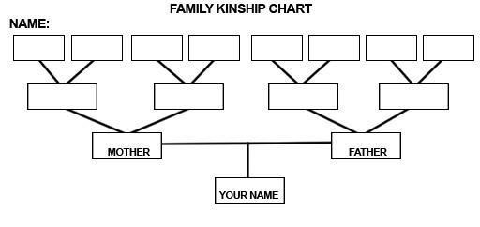

Resource 3: Lunda kinship terms
Teacher resource for planning or adapting to use with pupils
Lunda term | Explanation
mama | mother, aunt on mother's side
a-mama | mothers, mother's sisters
 | (Honorific 'mothers' in general)
mama wakansi | aunt, a younger ‘mother’, mother's
 | younger sister
mama wamukulumpi | aunt, mother's older sister
tata | father, uncle on father's side
a-tata | fathers, fathers' brothers
 | (Honorific 'fathers' in general)
tata wakansi | uncle, a younger ‘father’, father's
 | younger brother
tata wamukulumpi | uncle, father's older brother
yaya | older brother, sister or cousin
a-yaya | older relation
 | Used honorifically as well
mwanyikami | young brother
anyikijami | young brothers
muhela | sister (sister to brother)
a-hela | sisters (sisters to brother)
a-muhela | (honorific 'sister')
mandumi | uncle on mother's side
a-mandumi | mother's brothers
 | Used as honorific as well
tatankaji, tata wamumbanda | aunt on father's side (female father)
a-tatankaji, atata wamumbanda | father's sisters (used as honorific)
nkaka | grandfather, grandmother
a-nkaka | grandfathers, grandmothers
mwizukulu | grandchild

Resource 4: My timeline
Teacher resource for planning or adapting to use with pupils
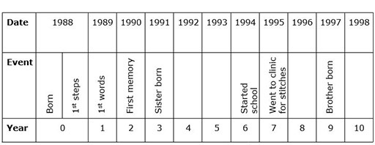

Acknowledgements
Every effort has been made to contact copyright holders. If any have been inadvertently overlooked the publishers will be pleased to make the necessary arrangements at the first opportunity.
Return to Social Studies and the Arts (primary) page

Section 2: Investigating how we used to live
Key Focus Question: How can you develop your pupils’ thinking skills in history, using oral and written sources?
Keywords: evidence; history; thinking skills; interviews; questions; investigations

Learning outcomes
By the end of this section, you will have:
- used oral history and documents to develop pupils’ thinking skills in history;
- planned and carried out activities that help pupils gather and use oral evidence to find out about past events.

Introduction
When we study history as part of social studies, we place a great deal of importance on the sources of evidence that can tell us something about the past.
There are two important ways of gathering evidence about the past – finding and analysing documents that record what happened and using oral history. Oral history is the gathering of people’s stories about particular events. We can also look at objects, pictures and buildings from the past to find out more.
In this section, you will encourage your pupils to investigate documents and conduct oral interviews in order to help build their understanding of their own past. It is important to encourage pupils to ask questions and listen to each other’s ideas, so they develop skills in assessing evidence and drawing conclusions.

1. Gathering oral histories
Teaching history does not only involve facts about historical events, but also the development of pupils’ historical skills. As a teacher, you need give your pupils the opportunity to develop and practise these skills. The kinds of events you explore with your pupils will depend on their ages. With younger children, you will also take more of a lead in helping them find out and understand what happened.
In this part, pupils will conduct oral interviews with an older family member or another member of the community. The aim of the interview is to find out how different their own lifestyles and interests are, compared with those of people in the past. By showing pupils how to conduct an oral interview, you can help develop important skills – being able to see the value of oral history and being able to listen. (Read Resource 1: Oral history now to find out more about this valuable resource.)
Case Study 1 shows how one teacher introduced her pupils to the idea of using oral history to find out about the past. Read this before trying Activity 1 with your class.

Case Study 1: Family oral histories
Every person has a history. Mrs Eunice Shikongo, a Grade 5 teacher at SheetheniSchool on the outskirts of Windhoek in Namibia, wants her pupils to explore their own family histories by interviewing one family member.
First, she discusses what oral evidence is, by encouraging pupils to share things they have learned from their grandparents. She asks them: ‘Has what you have learned been written down?’ Most agree that things learned in this way are not written, but passed on by word of mouth. Mrs Shikongo then explains that, by conducting an interview, pupils will collect oral evidence about what the past was like and will find out what a valuable source of evidence this can be.
She helps them compile a list of interesting questions to use to interview their family members (see Resource 2: Possible interview questions). The pupils then add their own questions to the list before carrying out these interviews at home.
The next day, they share their findings with the rest of their class. Mrs Shikongo summarises their findings on the board under the heading ‘Then’. Next, she asks them to answer the same questions about their own lives, and summarises this information under the heading ‘Now’. She asks them to think about how their lives are different from the lives of their family members in the past. She then asks the pupils, in pairs, to compare ‘Then’ and ‘Now’. Younger pupils write two/three sentences using words from the board. Older pupils write a short paragraph.

Activity 1: Oral interviews about childhood
- First organise your pupils into pairs. Then tell them to think of some questions they can ask an older person about his/her childhood. Give the pupils time to think up their questions and tell them how long they have to do this task – maybe two or three days. If you have younger pupils, you could work together to make up three or four questions they could remember and ask at home.
- When they have asked the questions at home, ask the pupils to share their information with their partners.
- Then ask each pair of pupils to join with another pair and share what they have found out.
- Now ask each group of four to complete a table to show how life has changed.
Older person | Me
I would travel to market by donkey | I travel to market by bus
- Discuss with the whole class how life has changed since their parents and/or grandparents or other older people were children. Pose questions that encourage them to reflect on why such changes have taken place. (Key Resource: Using questioning to promote thinking can help you think of the kinds of questions you need to ask to stimulate pupils. You could note some of these down before the lesson to remind you at this stage.)
- Make a list of the key changes on the board.

2. Investigating a historical event
As well as using oral histories to find out about life in the past, you can use written records with your pupils.
In this section, we look at how different sets of records can help pupils build up their understanding of the past. In Activity 2 and the Key Activity, pupils explore written records of past events and conduct oral interviews with community members. How you organise and gather resources together is part of your role and advice is given on how you might do this.

Case Study 2: Using written records to explore past events
Mr Kaguri is a teacher of a Primary 6 class in Kanungu district, Uganda. The anniversary of Ugandan independence is coming up and he wants his pupils to think about the events that led up to it and some of the things that it led to.
He sends his class to the library where they read up on the events. A daily newspaper, The Monitor, has just published supplements about the granting of independence on 9 October 1962. Mr Kaguri reads from these to his pupils to stimulate their interest. These articles contain profiles of the lives of some of the people who were involved. He divides his class into groups and asks each group to take one of these people and to research and then write a profile of that person on a poster, for display in the school hall. The poster must include how they were involved and what has happened to them since.
Mr Kaguri’s pupils then plan to present their findings to the whole school. Their posters are displayed around the hall and some of the pupils speak at the assembly.
Resource 3: Ugandan independence gives some background information.

Activity 2: Researching an important date in history
This activity is built on a visit to a museum, in this case the Uganda Museum, Kampala, but you could use a more local site or contact the education officer at the Uganda Museum as there may be materials available to schools where museum visits are not possible. (If it is not possible for you to visit a museum, you could also collect together some newspaper articles, pictures and books to help your pupils find out for themselves about an event.)
Decide on a particular historical event that you wish your pupils to investigate during the visit to the museum (or in class if you have the resources), e.g. Resource 4: The exile of Ugandan Asians – a news report in 1972. It is important that you focus the attention of your pupils on a particular event, especially if they are visiting a museum covering many years of the past.
- Divide the class into groups, giving each a different issue or aspect of the historical event to focus upon.
- Discuss what kinds of questions they might need to find the answers to as they read and look at the exhibitions (if at museum) or materials (if in school).
Back in class, ask the pupils in their groups to write up their findings on large posters. Display these in the classroom or school hall for all to see.

3. Thinking critically about evidence
This part is intended to extend your ideas of how to help pupils use oral history as a resource for finding out about the past. You will encourage them to think critically about the validity and reliability of such evidence, and to compare oral testimonies of a historical event with written evidence of the same event. Investigating the similarities and differences in the two types of evidence provides an exciting learning opportunity for pupils.

Case Study 3: Collecting oral testimonies
Mrs Kasigwa teaches social studies to Primary 6 at a small school in the Jinja district. Many of the families have older members who remember or were affected by the expulsion of Ugandan Asians in 1972. Resource 4 gives some background information. Mrs Kasigwa has invited two Asians, who have returned to the country, to speak about their experiences. (See Key Resource: Using the local community/environment as a resource as this will help you plan and organise such a visit.) They will come on consecutive days as they have businesses and have to arrange for other people to look after them.
Mrs Kasigwa warns her class that these two people were children, one a teenager and one younger, when they left – their memories will be different from those of their parents and from each other. Before the guests arrive, the pupils prepare some questions that they want to ask. Over two days, the visitors come and tell their stories. The pupils listen carefully and ask them questions.
In the next lesson, Mrs Kasigwa and the class discuss the similarities and differences between the two accounts. They think about why the two visitors have different views on the events.
Mrs Kasigwa lists the key points that came out of their stories and also stresses that, when they were young, the journey to another part of the world might have been more exciting and less worrying than it would have been to their parents. She explains that while these oral histories may give pupils some understanding of the exile, they may not always be accurate, and the stories that different people tell may vary considerably.
Mrs Kasigwa believes her class learned a valuable lesson in the uses and problems of gathering oral evidence of history.

Key Activity: Comparing oral interviews and written texts
- With your pupils, identify an important historical event (such as a local feud or uprising) that took place in your area in the past. If you can, find a short written text about it. Resource 4 gives one example you could use if you cannot find another event.
- In preparing this activity, you need to gain an understanding for yourself (as a teacher) about what people in your community know about the uprising or event in question. These ‘memories’ are the oral stories that have been passed down from person to person. Identify some key people who your pupils could talk to at home or could come into school.
- Send your pupils out in groups to interview these older people. Ask the pupils to record ten key points made by each interviewee. (Make sure that pupils only go in groups and that they are safe at all times.)
- Back in class, ask your pupils to feed back their key findings.
- Ask each group to design a poster of the event, including the key events and using some of the visitor’s comments to give a feeling of what it was like to be there.
- Display these in class.
- Discuss with your pupils whether they think they have enough clear evidence about what happened from the people they spoke to. If not, how could they find out more?

Resource 1: Oral history
 Background information / subject knowledge for teacher
Introduction
We all have stories to tell, stories about our lives and special events that have taken place. We give our experiences an order and organise such memories into stories. These stories could, if collected together with other people’s memories of the same event, allow us to build up a clearer picture of what actually happened.
Your local community will be a rich source for exploring what happened at a particular event or what it was like to live there 20 years ago. Your pupils could investigate the Ugandan Civil War or some other more local event.
What is oral history?
Oral history is not folklore, gossip, hearsay or rumour, but the real history of people told from their perspectives, as they remember it. It involves the systematic collection of living people’s stories of their own experiences. These everyday memories have historical importance. They help us understand what life is like. If we do not collect and preserve those memories, then one day they will disappear forever.
Your stories and the stories of the people around you are unique and can provide valuable information. Because we only live for so many years we can only go back one lifetime. This makes many historians anxious that they may lose valuable data and perspectives on events. Gathering these stories helps your pupils develop a sense of their own identities and how they fit into the story of their home area.
How do you collect people’s stories?
When you have decided what event or activity you want to find out about, you need to find people who were involved and ask if they are willing to tell you their stories.
Contact them to arrange a time of day and tell them what you want to talk about and what you will do.
You need to record what your interviewee says. You can do this by taking notes by hand or possibly by tape recording or video recording.
Having collected your information or evidence, it is important to compare and contrast different people’s views of the same event, so that you can identify the facts from the interpretations that different people put on the same event. You could ask your pupils, in groups, to interview different people and then to write a summary of their findings to share with the rest of the class. These could be made into a book about your class’s investigation into a particular event.
Adapted from original source: http://www.dohistory.org (Accessed 2008)

Resource 2: Possible interview questions
Teacher resource for planning or adapting to use with pupils
Below are some questions to use with a visitor to find out about an event in the past or how they used to do things in the past. Areas you could explore include:
- growing food;
- traditional dress;
- traditional healing;
- building houses;
- education.
These three sets of starter questions will help you support your pupils in thinking of their own questions.
(1) Historical events
- What historical events took place when you were young?
- What did you wear when you went to a party or a wedding?
- Which event do you remember most?
- What do you remember about it?
- What happened? Tell me the story as you remember it.
- Who else was with you?
- Could I speak to them about this still?
(2) Games
- What games did you play when you were a child?
- How did you play these games?
- Who taught you to play these games?
- When did you play them?
- Where did you play them?
- What other activities did you enjoy?
(3) Growing food
- What vegetables and fruit did you grow?
- How did you grow them?
- Where did you grow them?
- What tools did you use?
- What did vegetables cost at the time?
- Where did you buy them? Which ones did you buy?
- What else did you eat that you liked?
- Do you still eat these foods?

Resource 3: Ugandan independence
Background information / subject knowledge for teacher
The first Europeans to visit Uganda were the British explorers John Hanning Speke and James Grant when they were searching for the source of the Nile in 1862. They were followed by Samuel White Baker and Charles George Gordon commanding Egyptian troops.
The Anglo-American explorer Henry Morton Stanley, welcomed by Kabaka Mutesa I (reigned 1852–1884), reported the king's eagerness to understand Christianity. Soon both Protestant and Roman Catholic missionaries were working in Buganda. Within a decade the factions they created caused a civil war.
Once isolated, the region became, by 1890, a major object of the European nations’ scramble for African territory. Britain, after securing German recognition of its rights, moved to secure Buganda. Frederick Lugard, working for the British East Africa Company, ended the civil disturbances, and his successors used the Bugandan army to help conquer the other kingdoms and tribes. By 1896, a British protectorate administration had extended its authority over most of the region, and the name Uganda was adopted.
Final details concerning the administration of Uganda were settled by a series of agreements in 1900, the most comprehensive of which guaranteed special status to Buganda, including the continuation of its social and political system. Britain's almost 70 years of rule in Uganda was thus a centralised European bureaucracy superimposed on a federation of kingdoms and tribes. This worked well until the independence movements of the 1950s, when Buganda demanded separation from Uganda. Only after Kabaka Mutesa II was exiled for two years in 1953 was it possible to proceed with developing a united government.
After much experimenting, a federal constitution was promulgated in April 1962. The Uganda People's Congress won the elections, and Milton Obote became prime minister. Independence was granted in October 1962.
Events after independence
Dissension continued, however, and in May 1966 Obote sent the army into Buganda and drove the kabaka into exile. He then proclaimed a new republican constitution, which formally abolished the kingships, and became Uganda's first president of a unitary government. Bugandan recalcitrance, a fall-off in the economy, and charges of corruption led to an army coup in January 1971. Power devolved upon the army commander, Idi Amin, who began eight years of misrule. He increased the size of the army, eliminated his political opponents, and began a reign of terror directed at the people of Buganda, Obote's Lango people, and their neighbours the Acholi.
He also expelled approximately 70,000 Asians from the country. By 1978, Uganda was bankrupt, and the government was dependent on massive loans from Arab states friendly to Amin. Uganda went to war with neighbouring Tanzania in late 1978, and Tanzanian forces allied with Ugandan rebels drove Amin from the country early the following year. Three provisional presidents served before elections under a new constitution were held in December 1980. Obote's party was successful, and he became president once again of a changed Uganda. Once thriving, the nation had become an economic disaster, with an inflation rate of more than 200%, no consumer goods, few jobs, rampant thievery, famine in the north, and no effective government in the countryside. In 1982, after Tanzanian troops had been withdrawn, antigovernment guerrillas became active, and thousands of young men were arrested, suspected of being guerrillas. Thereafter, more than 100,000 Ugandans were killed or starved to death.
The constitutional government was overthrown in July 1985 in a coup by Acholi army officers; Obote fled the country and settled in Zambia. The new Acholi-dominated regime had little popular support, and quickly fell apart. After four days of fighting in Kampala in January 1986, National Resistance Army leader Yoweri Museveni took over the government.
Since Museveni's ascension to power, Uganda's economy has prospered. Foreign investment has increased and many Asian Ugandans have returned to open businesses. Museveni forbade the creation and activity of political parties, believing that parties would form along ethnic lines and further divide the nation.
The early 1990s saw an upsurge in terrorism in northern Uganda, the home of Museveni's political enemies. In the mid-1990s hundreds of Ugandan soldiers and civilians were killed in attacks by the Lord's Resistance Army, a Christian fundamentalist rebel faction led by a former faith healer. A new constitution was adopted in 1995 that established a democratic, though non-party, system of government.
Despite unrest and dissent in the north, presidential and legislative elections proceeded as planned in 1996. Museveni won 74% of the vote in Uganda's first presidential elections in 16 years. Opposition candidates, forced to run unaffiliated with a political party and limited to one month of campaigning, claimed the vote was unfair, but the elections were widely endorsed by international observers.
Adapted from: Microsoft Encarta
Articles containing text from articles and programmes associated with the granting of independence in 1962 can be found at http://www.ugpulse.com (Accessed 2008).
An obituary to Dr Milton Obote can be found at http://news.bbc.co.uk/go/pr/fr/-/2/hi/africa/4353286.stm and others should be available from Ugandan newspaper archives.

Resource 4: The exile of Ugandan Asians – a news report in 1972
Background information / subject knowledge for teacher
1972: Asians given 90 days to leave Uganda
The Ugandan leader, Idi Amin, has set a deadline for the expulsion of most of the country's Asians. General Amin said all Asians who are not Ugandan citizens – around 60,000 – must leave Uganda within 90 days. The military ruler's latest statement amended his original expulsion order two days ago when he said all the country's 80,000 Asians had to go. Asians, who are the backbone of the Ugandan economy, have been living in the country for more than a century. But resentment against them has been building up within Uganda's black majority.
Expulsion surprises Britain
General Amin has called the Asians ‘bloodsuckers’ and accused them of milking the economy of its wealth. Up to 50,000 Asians in the former UK colony are British passport holders. In a broadcast, General Amin said he would be summoning the British High Commissioner in Kampala to ask him to arrange for their removal. The expulsion order has taken Britain by surprise. General Amin overthrew Uganda's elected leader in a military-backed coup last year but the British authorities had regarded him as a man they could work with.
Some British MPs have warned that letting more Ugandan Asians into the UK could raise racial tensions. They are urging the government not to take them in. MP Ronald Bell said Uganda's Asians had no real links to Britain. Mr Bell said: ‘They were either born in India or have retained close connection with India. They have no connection with Britain either by blood or residence.’
Adapted from original source: http://www.bbc.co.uk (Accessed 2008)

Acknowledgements
Grateful acknowledgement is made to the following sources:
Text
Resource 1: Oral history: Adapted from original sourcehttp://www.dohistory.org (Accessed 2008)
Resource 3: Ugandan independence: Adapted from Microsoft Encarta
Resource 3: Articles containing text from articles and programmes associated with the granting of independence in 1962 can be found at http://www.ugpulse.com (Accessed 2008)
Resource 3: An obituary to Dr Milton Obote can be found at http://news.bbc.co.uk/go/pr/fr/-/2/hi/africa/4353286.stm (Accessed 2008)
Resource 4: The exile of Ugandan Asians – a news report in 1972: Adapted from original source http://www.bbc.co.uk (Accessed 2008)
Every effort has been made to contact copyright holders. If any have been inadvertently overlooked the publishers will be pleased to make the necessary arrangements at the first opportunity.
Return to Social Studies and the Arts (primary) page

Section 3: Using different forms of evidence in history
Key Focus Question: How can you use mind mapping and fieldwork to develop historical skills?
Keywords: historical skills; mind mapping; fieldwork; investigations; history; maps

Learning outcomes
By the end of this section, you will have:
- used pictorial maps to help pupils see the importance of the natural environment in human settlement patterns (see also Module 1, Section 2);
- used small-group investigations, including fieldwork, to develop pupils’ understanding of early African societies.

Introduction
In addition to looking at oral and written evidence, your pupils can also learn about the past from other sources, for example maps.
In this section, you will structure lessons and activities that will help pupils understand the factors that led to the emergence of strong African kingdoms in the past. It provides you with insight into the kinds of evidence and resources you can use.
It covers:
- using maps and other documents to examine factors in the natural environment that influenced the nature of the settlement and the kingdom;
- exploring the role of pastoral and agricultural practices in shaping African lifestyles and culture;
- exposing pupils to the material evidence that remains in and around settlements, which will help them examine how the past is reconstructed.

1. Thinking about the location of settlements
By looking at the local environment and the physical layout of the land, it is possible to think about why a community settled in a certain place.
Great Zimbabwe provides a good example. It is important that as a social studies teacher you understand a case like this, as it gives you the skills to relate these ideas to a number of different ancient African kingdoms and to your local setting. Using fieldwork, such as actual trips to a site, allows pupils to see for themselves why one place was chosen for settlement and why some developments survived longer than others.
Most settlements are where they are because the environment provides some kind of resource, such as water or trees, and/or the site provides protection from the elements and, in earlier times, from enemies. Villages and towns are often found near a stream or wood to provide water and wood for shelter and to burn for heat and cooking. By looking closely at your school’s local environment or your pupils’ home environment, whichever is easier, you can help them to begin to understand how settlements developed.
Maps from earlier times will show how a site has changed over time (this can build on the time walk activity from Module 2, Section 1).

Case Study 1: Investigating heritage sites
Ms Sekai Chiwamdamira teaches a Grade 6 class at a primary school in Musvingo in Zimbabwe. Her school is near the heritage site of Great Zimbabwe. She knows that many of her pupils pass by this magnificent site of stone-walled enclosures on their way to school. But she wonders whether they know why it is there. Sekai wants to help her pupils realise that the landscape and its natural resources played an important part in people’s decision to settle in Great Zimbabwe.
She begins her lesson by explaining how Great Zimbabwe was a powerful African kingdom that existed between 1300 and 1450 (see Resource 1: Great Zimbabwe). She asks the pupils to consider why the rulers of this kingdom chose to settle in the Zimbabwe Plateau rather than anywhere else in Africa. A map is her key resource for this discussion (see Resource 2: Pictorial map of Great Zimbabwe). One by one, she points out the presence of gold, ivory, tsetse fly, water supply and access to trade routes on the map; she asks her pupils to suggest how each of these led people to establish the settlement where they did. As her pupils suggest answers, Sekai draws a mind map on the board (see Key Resource: Using mind maps and brainstorming to explore ideas).
Sekai is pleased at the level of discussion and thinking that has taken place.

Activity 1: Using a map to gain information about Great Zimbabwe
Before the lesson, copy the map and questions from Resource 2 onto the chalkboard or have copies ready for each group.
- First, explain what a key represents on a map. Then divide the class into groups and ask each group to analyse the key relating to the map of Great Zimbabwe. Agree what each item on the key represents.
- Ask your pupils why they think the people first settled here. You could use the questions in Resource 2 to help them start their discussion.
- As they work, go around the groups and support where necessary by asking helpful questions.
- After 15 minutes, ask each group to list their ideas.
- Next, ask them to rank their ideas in order of importance.
- Write down their ideas on the chalkboard.
- Finally, ask pupils to vote on which they think are the three most important factors.
- With younger children, you could look at local features and ask them to think why people settled here.

2. Using mind maps to structure thinking about the past
In the past, cattle were always viewed as an important resource, and many farmers and communities still view cattle this way.
The purpose of Activity 2 is for pupils to investigate the traditional role of cattle in African societies using the local community as a source of information. They will then determine how much African farming societies have changed.
Case Study 2 and Activity 2 use mind mapping and a template to help pupils think about the task as they work together in groups to share ideas.

Case Study 2: Farming in Birnin Kebbi
There are many farmers living in the Birnin Kebbi area and many of the pupils in the school are children of farmers. Bilkisu wants to investigate with her class how important cattle were to the lifestyle and culture of the early African farmers who settled in Nigeria. She also wants her pupils to think about the extent to which African farming societies have changed. She plans to use the local community as a resource of information.
Bilkisu begins her lesson by explaining the important role of cattle in early African societies. She draws a mind map on the chalkboard that highlights the importance of cattle, and what cattle were used for. (See Key Resource: Using mind maps and brainstorming to explore ideas and Resource 3: A mind map about keeping cattle to help you question your pupils.) The class discuss these ideas.
In the next lesson, in small groups with a responsible adult, the pupils go out to interview local farmers. Bilkisu has talked with them beforehand to see who is willing to talk with her pupils.
The pupils had two simple questions to ask local farmers:
- Why are cattle important to you?
- What are the main uses of cattle?
Back in class, they share their findings and Bilkisu lists their answers on the chalkboard. They discuss what has changed over the years.

Activity 2: Farming old and new
Before the lesson, read Resource 4: Cattle in traditional life – the Fulani
- Explain to pupils why cattle were important to the people who live in northern Nigeria.
- Ask them, in groups, to list reasons why people used to keep cattle.
- For homework, ask them to find out from older members of the community how keeping cattle has changed.
- In the next lesson, ask the groups to copy and then fill out the template in Resource 5: The role of cattle – past and present to record their ideas.
- Share each group’s answers with the whole class and display the templates on the wall for several days so pupils can revisit the ideas.

3. Fieldwork to investigate local history
One way to reconstruct how societies in the past lived is to analyse buildings, artefacts, sculptures and symbols found on sites from a long time ago.
In this part, pupils go on a field trip to a place of historical interest. If this is not realistic for your class, it is possible to do a similar kind of task in the classroom by using a range of documents, photographs and artefacts. Pupils can start to understand how to investigate these and fill in some of the gaps for themselves about what used to happen.

Case Study 3: Organising a field trip
Aisha has already explored with her Primary 5 pupils that Sokoto Caliphate was a powerful political empire with a strong ruler. Now she wants them to think about how we know this. As her school is near Sokoto, she organises a field trip. She wants the pupils to explore the buildings and artefacts, and think about how historians used this evidence to construct the empire’s history.
At the site, the pupils take notes about what the buildings look like. They also describe and draw some of the artefacts and symbols that can be found in and around each of these buildings.
Back at school, they discuss all the things they saw and list these on the chalkboard. Aisha asks them to organise their findings under headings for the different types of building they have seen. The pupils then discuss what they think the different buildings were used for, based on what they looked like and the artefacts and sculptures that were found there. Aisha helps fill in the gaps by explaining aspects of Fulani culture and the meaning of some of the sculptures and artefacts. The ideas are displayed and other classes are invited to see the work.
See Key resource: Using the local community/environment as a resource.

Key Activity: Exploring local history
Before you start this activity, gather together as much information as you can about the local community as it used to be. You may have newspaper articles, notes of talks with older members of the community, names of people who would be happy to talk to your pupils.
- Organise your class into groups. Explain that they are going to find out about the history of the village using a range of resources. Each group could focus on one small aspect, for example the local shop, or church, or school.
- Look at the resources you have, if any, before going to talk to people.
- Give the groups time to prepare their questions and then arrange a day for them to go out to ask about their area.
- On return to school, each group decides how to present their findings to the class.
- Share the findings.
- You could make their work into a book about the history of your local area.

Resource 1: Great Zimbabwe
Background information / subject knowledge for teacher
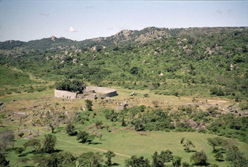
Great Zimbabwe, or ‘houses of stone’, is the name given to hundreds of great stone ruins spread out over a 500 sq km (200 sq mi) area within the modern-day country of Zimbabwe, which itself is named after the ruins.
The ruins can be broken down into three distinct architectural groups. They are known as the Hill Complex, the Valley Complex and the famous Great Enclosure. Over 300 structures have been located so far in the Great Enclosure. The types of stone structures found on the site give an indication of the status of the citizenry. Structures that were more elaborate were built for the kings and situated further away from the centre of the city. It is thought that this was done in order to escape sleeping sickness.
What little evidence exists suggests that Great Zimbabwe also became a centre for trading, with artefacts suggesting that the city formed part of a trade network extending as far as China. Chinese pottery shards, coins from Arabia, glass beads and other non-local items have been excavated at Zimbabwe.
Nobody knows for sure why the site was eventually abandoned. Perhaps it was due to drought, perhaps due to disease or it simply could be that the decline in the gold trade forced the people who inhabited Great Zimbabwe to look elsewhere.
The ruins of Great Zimbabwe have been a UNESCO World Heritage Site since 1986.
More information can be found at https://en.wikipedia.org/wiki/Great_Zimbabwe
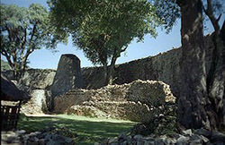

Adapted from original source: http://en.wikipedia.org/wiki/Great_Zimbabwe (Accessed 2008)

Resource 2: Pictorial map of Great Zimbabwe
Teacher resource for planning or adapting to use with pupils
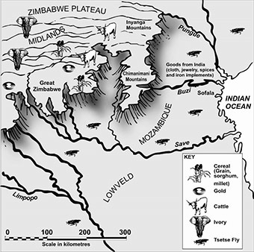
- Find Great Zimbabwe.
- Find the Zimbabwe Plateau. Why do you think the founders of Great Zimbabwe decided to build the settlement on a plateau?
- What natural resources were found in and around the region of Great Zimbabwe?
- Why were these resources important?
- What other environmental factors may have contributed to the people’s decision to settle on the Zimbabwe Plateau?
Original source: Dyer, C., Nisbet, J., Friedman, M., Johannesson, B., Jacobs, M., Roberts, B. & Seleti, Y. (2005). Looking into the Past: Source-based History for Grade 10. Cape Town: Maskew Miller Longman. ISBN 0 636 06045 4.

Resource 3: A mind map about keeping cattle
Teacher resource for planning or adapting to use with pupils
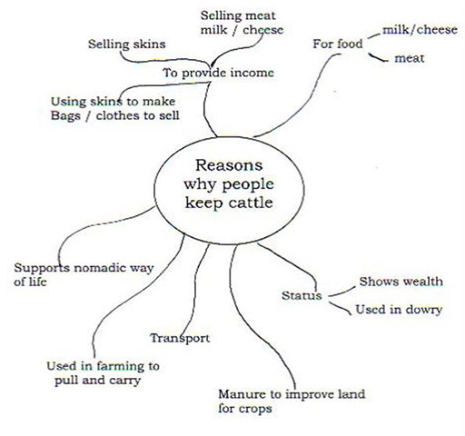

Resource 4: Cattle in traditional life – the Fulani
Background information / subject knowledge for teacher
The Fula or Fulani are an ethnic group of people spread over many countries in West Africa, including Nigeria. The ancient origins of the Fula people have been the subject of speculation over the years, but several centuries ago they appear to have begun moving from the area of present-day Senegal eastward.
The Fulani are traditionally a nomadic, pastoralist people, herding cattle, goats and sheep across the vast dry hinterlands (remote areas) of their domain, keeping somewhat separate from the local agricultural populations.
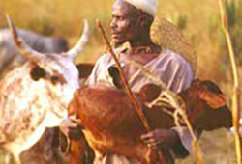
A Fulani family needs at least 100 heads of cattle in order to live completely off their livestock. When the number of livestock drops, the family must start farming to survive.
The Sokoto Fulani of Nigeria
The Sokoto Fulani are a sub-group of this much larger Fulani group and live in northern Nigeria alongside the Hausa people. The Sokoto region houses some of the ruling class of the Fulani, known as the Toroobe.
The area they occupy is open grassland with narrow forested zones. Camels, hyenas, lions, and giraffes inhabit this region. Though the temperatures are extremely hot during the day, they are much cooler at night.
What are their lives like?
The semi-nomadic Sokoto Fulani engage in some supplementary farming, along with animal breeding. Millet and other grains are their main crops. Milk, drunk fresh and as buttermilk, is their staple food, and meat is consumed only during ceremonial occasions. The cattle are herded by the men, although the women help with milking the cows. The women also make butter and cheese and do the trading at the markets. Among the Fulani, wealth is measured by the size of a family's herds.
The semi-nomadic Sokoto Fulani live in temporary settlements. During the harvest, the families live together in small huts that make up village compounds. During the dry season, the men leave their wives, children, the sick and the elderly at home while they take their herds to better grazing grounds. Each village has a chief or headman to handle village affairs.

Resource 5: The role of cattle – past and present
 Pupil use

The role of cattle in the past | The role of cattle today
Cattle were important for: | Cattle are important for:

Acknowledgements
Grateful acknowledgement is made to the following sources:
Photographs and images
Resource 1: Great Zimbabwe: Adapted from original source: http://en.wikipedia.org/wiki/Great_Zimbabwe (Accessed 2008)
Resource 2: Pictorial map of Great Zimbabwe: Dyer, C., Nisbet, J., Friedman, M., Johannesson, B., Jacobs, M., Roberts, B. & Seleti, Y. (2005). Looking into the Past: Source-based History for Grade 10. Cape Town: Maskew Miller Longman. ISBN 0 636 06045 4.
Every effort has been made to contact copyright holders. If any have been inadvertently overlooked the publishers will be pleased to make the necessary arrangements at the first opportunity.
Return to Social Studies and the Arts (primary) page

Section 4: Understanding timelines
Key Focus Question: How can you use timelines and other sources to develop understanding of cause and effect?
Keywords: timelines; historical change; chronology; history; historical sources; debate

Learning outcomes
By the end of this section, you will have:
- used timelines to represent historical change over time;
- helped pupils to identify the key events in a particular historical process;
- encouraged pupils to view history not just as a series of dates to be learned but as a process to be investigated;
- used a variety of sources to help pupils see that one event may have many causes.

Introduction
When developing an understanding of time past and passing, it is important to be able to sequence events into the order in which they happened.
Pupils often struggle with the concept of time. In this section, you will first help your pupils to divide time into periods that are more manageable and then, once they are able to do this, think about the order of events and why this is important. (With young pupils, this might be as simple as helping them order how they do certain tasks, leading on to more complex activities as their understanding grows.) You will then help your pupils identify the most important events in a particular passage of time. This can lead, with older pupils, into an analysis of cause and effect, and the understanding that there is usually more than one cause of an event.

1. Building a timeline
Investigating a particular period in history, and trying to sequence events in the order in which they happened, will help pupils begin to see the links between events and some of the possible causes. Understanding the causes of change in our countries and societies may help us to live our lives better.
The purpose of this part is to explore how using timelines in history can be a useful way to divide time into more manageable ‘bits’, so that we know which ‘bit’ or period we are dealing with. This is particularly important when we are teaching history, because it is crucial that pupils understand the idea of change over time.
From an early age, pupils need help to sort and order events. As they grow and experience life, they can revisit activities like these ones, using more complex sequences and events.
(Section 1 in this module used timelines to explore family history. You might find it helpful to look at that section if you have not done so already, particularly if you are working with younger pupils.)

Case Study 1: Ordering events
Ms Tetha Rugenza, who teaches history at a small school in Rwanda, wants to show her Grade 4 class how to divide up time into smaller periods. In order to do this, she plans a lesson where she and her pupils explore how to construct a timeline and divide it into periods.
Ms Rugenza decides to use the example of Rwanda. She draws a timeline on the board of the history of Rwanda. To help pupils understand the concept of periods, she divides the history of Rwanda into the pre-colonial, the colonial and the independence period. To give a sense of how long each of these periods is, she draws each period to scale.
She writes a list of important events, together with the date on which they took place, on separate pieces of paper and displays these on a table. Each event, she tells the class, falls into a particular period. She asks her pupils to work out which events fall into which period and in which order, doing a couple of examples herself. She calls out one event at a time and allows a pupil to come and stick it next to the appropriate place on the timeline. The rest of the class check that it has been put in the correct place. Through discussion, she helps the pupils if they are not sure where an event should go. She asks them if they can think of any other national events that should be placed on the timeline and adds them as appropriate.

Activity 1: Drawing timelines
Tell the class that they are going to make a timeline of the school year together.
- Start the lesson by asking your pupils to write down the most important events that have taken place in school during the year.
- Ask them to give each event a date if they can, or to find this out.
- Ask pupils to order these events from the beginning to the end of the school year.
- Help pupils to decide on how big they want their timelines to be and to create a scale accordingly.
- Ask pupils to mark out each month correctly in terms of their chosen scale and to write down the event dates on the left-hand side of the timeline – starting at the bottom of their timeline with the past, and working up to the present at the top.
- On the right-hand side of the timeline, ask pupils to write a short description of the appropriate event next to each date.
- Display the timelines for all to see.
(If you do not have enough resources for this to be done individually then it can be done in groups of up to five pupils.)
- Discuss as a whole class whether there are some school events that could happen at any time of the year. Are there some that have to happen at a particular time? Why? (End-of-year exams, for example – why can’t they happen at the start of the year?)

2. Introducing the concept of chronology
The study of time and the order in which events took place over time is called chronology. This part explores how you can help pupils understand this sequencing of events, the relationship between the order events happen and the outcomes. In using these activities with pupils, you will realise the importance this has on their understanding of the past.

Case Study 2: Ordering events
Mr Ngenda wants to show his Grade 5 pupils how chronology affects their understanding of events. He writes the following sentences on the chalkboard:
- A body of a man lies on the floor in the room.
- A man is arrested for murder.
- Two men go into the room.
- A man leaves the room.
- A man screams.
He asks the pupils to rearrange these sentences into an order that makes sense and to provide a reason for why they think the sentences should go in that particular order. Mr Ngenda uses this exercise to show how important it is to place events in a logical order.
However, he also wants pupils to begin to see the connections between events, and how one event influences another. He tells the class about the events in Rwanda since independence from Belgian rule to the genocide in April 1994. (See Resource 1: Some important historical events since independence.) Using some of these events, he and his pupils construct a timeline on the chalkboard. He has selected a short section of Resource 1 so that his pupils are not confused by too much information. He cuts these events up into strips and asks his pupils to put them in date order. He asks his pupils if they can identify the most important events that changed the course of Rwandan history.
Mr Ngenda is pleased that his pupils are beginning to see chronology as the first step in explaining why things happen.

Activity 2: Identifying key events
Ask pupils to use the summaries found in Resource 2: Two histories of Zambia and the account of a strike on the Copperbelt (see Resource 3: Copperbelt strike) to produce a simplified account of 20th-century Zambian history. They should:
- read through the account;
- underline what they think are the important events that took place;
- using the events that they have underlined, create a timeline. Remind them about the importance of listing the events in order;
- mark on their timeline the event they believe is the key event;
- explain below the timeline why they have chosen that particular event as most important. In other words, how did that event cause later events?
- share their answers and, by discussion, agree the key event and then discuss whether or not this key event was the only cause of later events.

3. Comparing African histories
Timelines can help us compare the similarities and differences in a series of events for different people, or different groups, or different countries.
For example, if your pupils drew timelines for themselves, there would be some events the same (starting school) and others different (birth of baby brother or sister for example).
Using timelines to compare the history of a variety of African countries during the time of moving to independence can help your pupils see common themes but also differences between their experiences.

Case Study 3: Examining the passage of different African countries to independence
Mrs Banda organised her class to work in groups to make a comparative multiple timeline that helped them to learn about the experiences of their own and other countries’ journey towards independence.
For each country that she chose she made a long strip of paper (she did this by sticking A4 pieces of paper together, one piece equalling five years). See Resource 4: African timelines template.
This would enable the groups, when finished, to place one under another to allow for easy comparison.
With her own books, and books and other materials borrowed from a colleague in a secondary school, the groups carried out their own guided research to find out the major events for each chosen country and then wrote each event in at the correct time on the chart. (For younger classes you could provide the events and dates yourself to help them construct the timeline.) Resource 5: Key events in the move to independence provides examples of some key dates and also suggests websites where further information can be found if necessary.
Mrs Banda made the timeline for ‘World events’ as an example (World War II, independence for India, first flight in space, the Cold War, Vietnam War, the invention of the Internet, Invasion of Iraq etc.).
She made sure that each ‘country’ wrote ‘Independence’ in the appropriate time spot in another colour.
When all the groups had finished, she asked them to line up their timelines one under the other neatly. This enabled easy comparison between the countries.

Key Activity: Comparing the African experience
- Follow the activity carried out in Case Study 3.
- When the timelines have been completed, let each group introduce their country and talk through their timeline.
- Prepare a series of questions for the class to answer, for example:
  - What are the major events on the timelines?
  - What similarities can you see between the experiences of different African countries?
  - What are the major differences?
  - Which countries were the first to gain independence and which were the last?
  - Which countries have suffered most from internal wars since independence?
  - What major events are soon to happen (e.g. South Africa hosting the World Cup in 2012)?
- (This sort of work can easily be extended. Groups can carry on researching their designated countries to find out more about them: languages spoken; major industries; agriculture; cities and towns etc. They could draw maps of their countries and label them. There are many possibilities.)

Resource 1: Some important historical events since independence
Background information / subject knowledge for teacher
1300s – Tutsis migrate into what is now Rwanda, which was already inhabited by the Twa and Hutu peoples.
1600s – Tutsi King Ruganzu Ndori subdues central Rwanda and outlying Hutu areas.
Late 1800s – Tutsi King Kigeri Rwabugiri establishes a unified state with a centralised military structure.
1858 – British explorer Hanning Speke is the first European to visit the area.
1890 – Rwanda becomes part of German East Africa.
1916 – Belgian forces occupy Rwanda.
1923 – Belgium granted League of Nations mandate to govern Ruanda-Urundi, which it ruled indirectly through Tutsi kings.
1946 – Ruanda-Urundi becomes UN trust territory governed by Belgium.
Independence
1957 – Hutus issue manifesto calling for a change in Rwanda's power structure to give them a voice commensurate with their numbers; Hutu political parties formed.
1959 – Tutsi King Kigeri V, together with tens of thousands of Tutsis, forced into exile in Uganda following inter-ethnic violence.
1961 – Rwanda proclaimed a republic.
1962 – Rwanda becomes independent with a Hutu, Gregoire Kayibanda, as president; many Tutsis leave the country.
1963 – Some 20,000 Tutsis killed following an incursion by Tutsi rebels based in Burundi.
1973 – President Gregoire Kayibanda ousted in military coup led by Juvenal Habyarimana.
1978 – New constitution ratified; Habyarimana elected president.
1988 – Some 50,000 Hutu refugees flee to Rwanda from Burundi following ethnic violence there.
1990 – Forces of the rebel, mainly Tutsi, Rwandan Patriotic Front (RPF) invade Rwanda from Uganda.
1991 – New multi-party constitution promulgated.
Genocide
1993 – President Habyarimana signs a power-sharing agreement with the Tutsis in the Tanzanian town of Arusha, ostensibly signalling the end of civil war; UN mission sent to monitor the peace agreement.
1994 April – Habyarimana and the Burundian president are killed after their plane is shot down over Kigali; RPF launches a major offensive; extremist Hutu militia and elements of the Rwandan military begin the systematic massacre of Tutsis. Within 100 days, around 800,000 Tutsis and moderate Hutus are killed; Hutu militias flee to Zaire, taking with them around 2 million Hutu refugees.
Adapted from: BBC NEWS:
http://news.bbc.co.uk/go/pr/fr/-/1/hi/world/africa/country_profiles/1070329.stm (Accessed 2008)

Resource 2: Two histories of Zambia
Teacher resource for planning or adapting to use with pupils
Account 1

Early history to the 19th century
Some Bantu-speaking peoples (probably including the ancestors of the Tonga) reached the region by c. AD 800, but the ancestors of most of modern Zambia's ethnic groups arrived from present-day Angola and Congo (Kinshasa) between the 16th and 18th centuries. By the late 18th century, traders (including Arabs, Swahili, and other Africans) had penetrated the region from both the Atlantic and Indian Ocean coasts; they exported copper, wax and slaves. In 1835, the Ngoni, a warlike group from South Africa, entered eastern Zambia. At about the same time, the Kololo penetrated western Zambia from the south, and they ruled the Lozi kingdom of Barotseland.
The colonial period
The Scottish explorer David Livingstone first came to the area that is now Zambia in 1851; he visited Victoria Falls in 1855, and in 1873 he died near Lake Bangweulu. In 1890, agents of Cecil Rhodes's British South Africa Company signed treaties with several African leaders, including Lewanika, the Lozi king, and proceeded to administer the region. The area was divided into the protectorates of Northwestern and Northeastern Rhodesia until 1911, when the two were joined to form Northern Rhodesia.
The mining of copper and lead began in the early 1900s. By 1909, the central railroad from Livingstone to Ndola had been completed and about 1,500 Europeans had settled in the country. In 1924, the British took over the administration of the protectorate. In the late 1920s extensive copper deposits were discovered in what soon became known as the Copperbelt, and by the late 1930s, about 4,000 European skilled workers and some 20,000 African labourers were engaged there. The Africans protested the discrimination and ill treatment to which they were subjected by staging strikes in 1935, 1940 and 1956. They were not allowed to form unions but did organise self-help groups that brought together persons of diverse ethnic backgrounds.
In 1946, delegates from these groups met in Lusaka and formed the Federation of African Welfare Societies, the first protectorate-wide African movement; in 1948, this organisation was transformed into the Northern Rhodesia African Congress. In the early 1950s, under the leadership of Harry Nkumbula, it fought strenuously, if unsuccessfully, against the establishment of the Federation of Rhodesia and Nyasaland (1953–63), which combined Northern Rhodesia, Southern Rhodesia (now Zimbabwe), and Nyasaland (now Malawi). The booming copper industry had attracted about 72,000 whites to Northern Rhodesia by 1958, and the blacks there experienced increasing white domination.
Independence and Kaunda
Kenneth Kaunda, a militant former schoolteacher, took over the leadership of the Africans from the more moderate Nkumbula and in 1959 formed a new party, the United National Independence Party (UNIP). Following a massive civil disobedience campaign in 1962, Africans were given a larger voice in the affairs of the protectorate.
On 24 October 1964, Northern Rhodesia became independent as the Republic of Zambia, with Kaunda as its first president; he was reelected in 1968 and 1973. The main problems faced by Kaunda in the first decade of independence were uniting Zambia's diverse peoples, reducing European control of the economy, and coping with white-dominated Southern Rhodesia (which unilaterally declared its independence as Rhodesia in November 1965).
Adapted from original source: http://www.onfoplease.com/ (Accessed 2008)
Account 2
In its early years, what is Zambia today had no recorded history. People moved around freely, establishing settlements where they could under the rule of African chiefs. Today, Zambia boasts some 70 ethnic groups scattered over the sparsely populated country. Arabs and whites, mostly from Britain, also relocated to Zambia over the years. The Arabs came in as traders and merchants, while the whites were missionaries, civil servants, commercial farmers, miners, adventurers and entrepreneurs. Over time, English became the official language used for business, government, commerce and schooling. The other major languages are Bemba, Lozi, Tonga and Nyanja.
The British South Africa Company ruled Northern Rhodesia from 1891 until 1923, The country's large mineral deposits were exploited at this time, boosting the country's white population and economic prospects. This mineral wealth in Zambia was one of the motivating factors in trying to form the Federation of Rhodesia (combining Southern and Northern Rhodesia) and Nyasaland (now Malawi). Under the federal structure, which came into being in 1953, despite vehement African opposition, the capital would be located in Salisbury (now Harare), the chief city in Southern Rhodesia. The federal legislature and the government would be in white-run Southern Rhodesia. Although whites were a miniscule minority in the Central African federation, they were the political majority in the federal government and federal parliament. Release of these details galvanised African nationalist leaders in Zambia and Malawi to mobilise to stop the federal idea from being implemented. Opposition from African nationalists in Southern Rhodesia was there, but it was not as vocal or strident as in the two northern territories. Whites in Malawi and Zambia favoured federation, as did their Southern Rhodesian counterparts, because it would augment their regional numbers and make it less likely that Zambia and Malawi could be turned over to the black majority.
Reluctantly, in 1962, the British government accepted Nyasaland's desire to opt out of the federation. At the local level, in 1948, two Africans were named to the Northern Rhodesian Legislative Council, which was the beginning of the recognition that blacks needed representation in the legislature. After negotiations among the Africans, the whites and the British government, a new constitution was agreed upon. It came into effect in 1962 and, for the first time, it was agreed that Africans would form the majority in the new Legislative Council.
On 31 December 1963, just ten years after its founding, the Federation of Rhodesia and Nyasaland was declared dead. African nationalists had triumphed. After that, it was just a question of time before Northern Rhodesia and Nyasaland would join most of the rest of Africa in the 1960s in winning majority rule and independence from European colonial rules. Less than a year after the federation's dissolution, Northern Rhodesia became the independent country of Zambia on 24 October 1964. The United National Independence Party (UNIP), successor to the banned Zambian African National Congress, won a majority of the seats under the new constitution. UNIP leader Kenneth David Kaunda became Zambia's democratically elected president. Soon, Kaunda and Zambia moved systematically to eliminate the opposition and turn the country into a one-party state, something that had become fashionable in Africa
Adapted from original source: http://www.pressconference.com/Uz-Z/Zambia.html (Accessed 2008)

Resource 3: Copperbelt strike
Teacher resource for planning or adapting to use with pupils
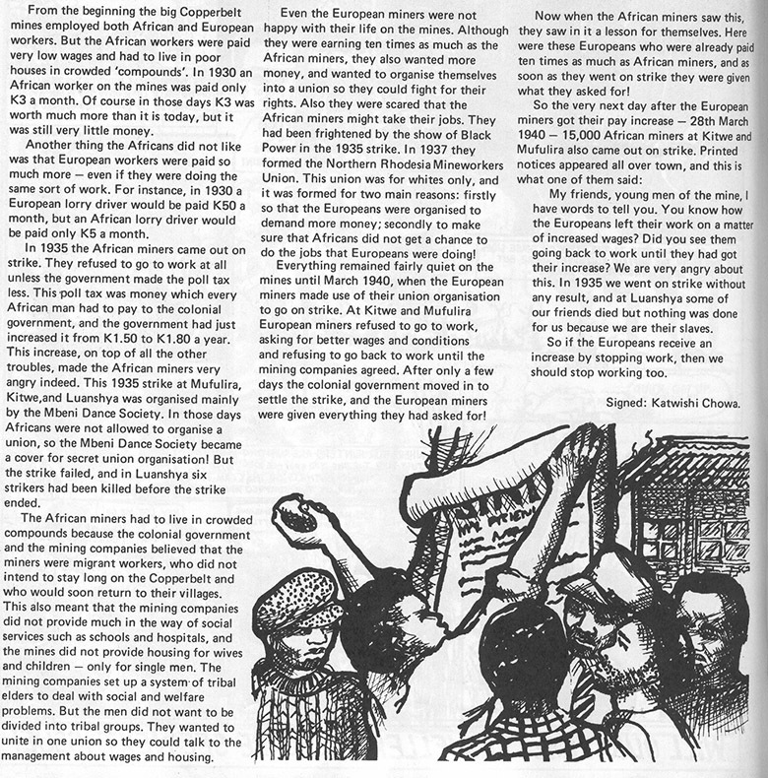
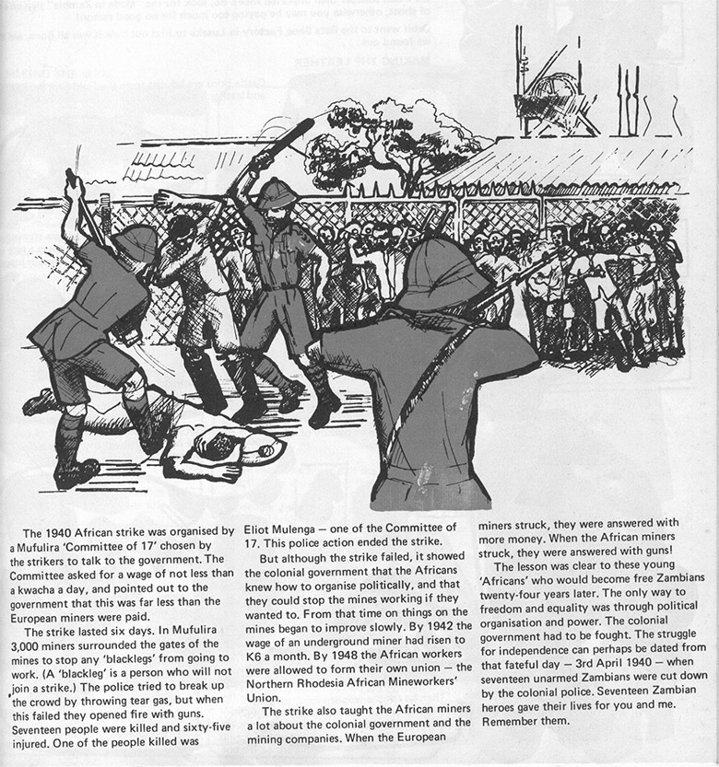
Original source: ORBIT Vol 5 No 5 pp14-15

Resource 4: African timelines template
Teacher resource for planning or adapting to use with pupils
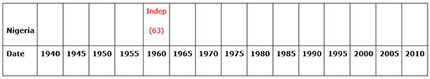
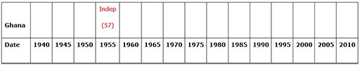
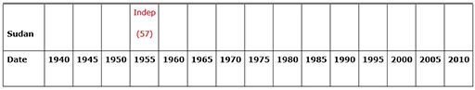
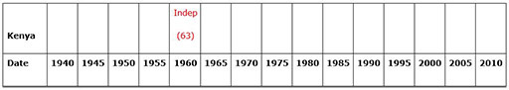
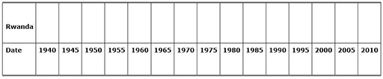
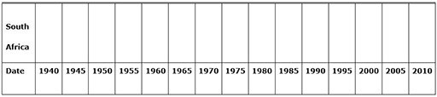
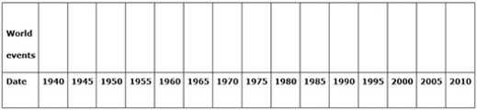

Resource 5: Key events in the move to independence
Background information / subject knowledge for teacher
1957 | Ghana becomes first independent black state in Africa under Kwame Nkrumah through Gandhi-inspired rallies, boycotts and strikes, forcing the British to transfer power over the former colony of the Gold Coast.
1958 | Chinua Achebe (Nigeria): Things Fall Apart, written in ‘African English’, examines Western civilisation's threat to traditional values and reaches a large, diverse international audience.
1958 | All-African People's Conference: Resolution on Imperialism and Colonialism, Accra, 5–13 December 1958
1954–  1962 | French colonies (Francophone Africa) oppose continued French rule despite concessions, though many eager to maintain economic and cultural ties to France – except in Algeria, with a white settler population of 1 million. Bitterly vicious civil war in Algeria ensues until independence is gained in 1962, six years after Morocco and Tunisia had received independence.
1958 | White (Dutch-descent) Afrikaners officially gain independence from Great Britain in South Africa.
1964 | Nelson Mandela,on trial for sabotage with other ANC leaders before the Pretoria Supreme Court, delivers his eloquent and courageous ‘Speech from the Dock’ before he is imprisoned for the next 25 years in the notorious South African prison Robben Island.
1960–  1961 | Zaire (formerly Belgian Congo, the richest European colony in Africa) becomes independent from Belgium in 1960. Then, in Elisabethville (now Lubumbashi), ‘charismatic nationalist Patrice Lumumba was ... martyred in 1961, with the connivance of the [US] Central Intelligence Agency and a 30-year-old Congolese colonel who would soon become president of the country, Joseph Deséré Mobutu.’ (Bill Berkeley, ‘Zaire: An African Horror Story’, The Atlantic Monthly, August 1993; rpt. Atlantic Online)
1962 | Algeria (of Arab and Berber peoples) wins independence from France; over 900,000 white settlers leave the newly independent nation.
1963 | Multi-ethnic Kenya (East Africa) declares independence from the British.
1963 | Charter of the Organisation of African Unity, 25 May 1963.
mid-60s | Most former European colonies in Africa gain independence and European colonial era effectively ends. However, Western economic and cultural dominance, and African leaders’ and parties’ corruption intensify the multiple problems facing the new nations.
1965 | Rhodesia: Unilateral Declaration of Independence Documents.
1966 | Bechuanaland gains independence and becomes Botswana.
1970s | Portugal loses African colonies, including Angola and Mozambique.
1976 | Cheikh Anta Diop (Senegal, 1923–1986), one of the great African intellectuals of the 20th century, publishes the influential and controversial book, The African Origin of Civilization, his project to ‘identify the distortions [about African history] we have learned and correct them for future generations’.
1980 | Zimbabwe (formerly Southern Rhodesia) gains independence from large white settler population after years of hostilities.
1970s–1980s | Police state of South African white minority rulers hardens to maintain blatantly racist and inequitable system of apartheid, resulting in violence, hostilities, strikes, massacres headlined worldwide.
1986 | Nigerian poet/dramatist/writer Wole Soyinka awarded the 1986 Nobel Prize in Literature.
1988 | Egyptian novelist and short story writer Nabuib Mahfouz awarded the 1988 Nobel Prize in Literature, the first prizewinning writer with Arabic as his native tongue.
1994 | The Hutus massacre up to a million Tutsis in Rwanda; then fearing reprisals from the new Tutsi government, more than a million Hutu refugees fled Rwanda in a panicked mass migration that captured the world's attention.
1996 | 500,000 of Hutu refugees streamed back into Rwanda to escape fighting in Zaire.
2001 | After 38 years in existence, the Organisation for African Unity (OAU) is replaced by the African Union.
Adapted from original source: http://www.africanhistory.about.com/gi/dynamic/offsite.htm?zi=1/XJ/Ya&sdn=africanhistory&cdn=education&tm (Accessed 2008)
Timeline – African countries in order of independence
Country | Colonial name | Colonial power | Independence date | First head of state
Ethiopia | establishment as the Kingdom of Aksum |  | 1st century BC | Menelik I
Liberia | Commonwealth of Liberia | American Colonization Society | 26 July 1847 | Joseph Jenkins Roberts
Libya | Libya | Italy | 24 December 1951 | Idris
Egypt | Egypt | Britain | 1922/1936/1953 | n/a
Sudan | Sudan | Britain | 1 January 1956 | Ismail al-Azhari
Tunisia | Tunisia | France | 20 March 1956 | Muhammad VIII al-Amin
Morocco | Morocco | France | 7 April 1956 | Mohammed V
Ghana | Gold Coast | Britain | 6 March 1957 | Kwame Nkrumah
Guinea | French West Africa | France | 2 October 1958 | Sékou Touré
Cameroon | Cameroun | France, Britain | 1 January 1960 | Ahmadou Ahidjo
Togo | French Togoland | France | 27 April 1960 | Sylvanus Olympio
Mali | French West Africa | France | 20 June 1960 | Modibo Keita
Senegal | French West Africa | France | 20 June 1960 | Léopold Senghor
Madagascar | Malagasy Protectorate | France | 26 June 1960 | Philibert Tsiranana
DR Congo | Belgian Congo | Belgium | 30 June 1960 | Patrice Lumumba
Somalia | Italian Somaliland, British Somaliland | Italy, Britain | 1 July 1960 | Aden Abdullah Osman Daar
Benin | French West Africa | France | 1 August 1960 | Hubert Maga
Niger | French West Africa | France | 3 August 1960 | Hamani Diori
Burkina Faso | French West Africa | France | 5 August 1960 | Maurice Yaméogo
Côte d'Ivoire | Côte d'Ivoire | France | 7 August 1960 | Félix Houphouët-Boigny
Chad | French Equatorial Africa | France | 11 August 1960 | François Tombalbaye
Central African Republic | French Equatorial Africa | France | 13 August 1960 | David Dacko
Congo | French Equatorial Africa | France | 15 August 1960 | Fulbert Youlou
Gabon | French Equatorial Africa | France | 17 August 1960 | Léon M'ba
Nigeria | Nigeria | Britain | 1 October 1960 | Nnamdi Azikiwe
Mauritania | French West Africa | France | 28 November 1960 | Moktar Ould Daddah
Sierra Leone | Sierra Leone | Britain | 27 April 1961 | Milton Margai
Tanzania | Tanganyika | Britain | 9 December 1961 | Julius Nyerere
Rwanda | Ruanda-Urundi | Belgium | 1 July 1962 | Grégoire Kayibanda
Burundi | Ruanda-Urundi | Belgium | 1 July 1962 | Mwambutsa IV
Algeria | Algeria | France | 3 July 1962 | Ahmed Ben Bella
Uganda | British East Africa | Britain | 9 October 1962 | Milton Obote
Kenya | British East Africa | Britain | 12 December 1963 | Jomo Kenyatta
Malawi | Nyasaland | Britain | 6 July 1964 | Hastings Kamuzu Banda
Zambia | Northern Rhodesia | Britain | 24 October 1964 | Kenneth Kaunda
Gambia | Gambia | Britain | 18 February 1965 | Dawda Kairaba Jawara
Botswana | Bechuanaland | Britain | 30 September 1966 | Seretse Khama
Lesotho | Basutoland | Britain | 4 October 1966 | Leabua Jonathan
Mauritius |  | Britain | 12 March 1968
Swaziland | Swaziland | Britain | 6 September 1968 | Sobhuza II
Equatorial Guinea | Spanish Guinea | Spain | 12 October 1968 | Francisco Macías Nguema
Guinea-Bissau | Portuguese Guinea | Portugal | 24 September 1973 | Luis Cabral
Mozambique | Portuguese East Africa | Portugal | 25 June 1975 | Samora Machel
Cape Verde |  | Portugal | 5 July 1975
Comoros |  | France | 6 July 1975
São Tomé and Príncipe |  | Portugal | 12 July 1975
Angola | Angola | Portugal | 11 November 1975 | Agostinho Neto
Seychelles |  | Britain | 29 June 1976
Djibouti | French Somaliland | France | 27 June 1977 | Hassan Gouled Aptidon
Zimbabwe | Southern Rhodesia | Britain | 18 April 1980 | Robert Mugabe
Namibia | South West Africa | South Africa | 21 March 1990 | Sam Nujoma
Eritrea | Eritrea | Ethiopia | 24 May 1993 | Isaias Afewerki
South Africa | South Africa | South Africa (apartheid) | 27 April 1994 | Nelson Mandela
Sahrawi Republic 1 | Spanish Sahara | Spain | 27 February 1976 | El-Ouali Mustapha Sayed
Adapted from original source: http://en.wikipedia.org/wiki/Decolonization_of_Africa#Timeline (Accessed 2008)

Acknowledgements
Grateful acknowledgement is made to the following sources:
Photographs and images
Resource 3: Copperbelt strike: ORBIT Vol 5 No 5 pp14-15
Text
Resource 1: Some important historical events since independence: Adapted from: BBC NEWS: http://news.bbc.co.uk/go/pr/fr/-/1/hi/world/africa/country_profiles/1070329.stm (Accessed 2008)
Resource 2: Two histories of Zambia – Account 1: Adapted from original source: http://www.onfoplease.com/ (Accessed 2008)
Resource 2: Two histories of Zambia – Account 2: Adapted from original source: http://www.pressconference.com/Uz-Z/Zambia.html (Accessed 2008)
Resource 5: Key events in the move to independence: Adapted from original source: http://www.africanhistory.about.com/gi/dynamic/offsite.htm?zi=1/XJ/Ya&sdn=africanhistory&cdn=education&tm (Accessed 2008)
Resource 5: Timeline – African countries in order of independence: Adapted from original source: http://en.wikipedia.org/wiki/Decolonization_of_Africa#Timeline (Accessed 2008)
Every effort has been made to contact copyright holders. If any have been inadvertently overlooked the publishers will be pleased to make the necessary arrangements at the first opportunity.
Return to Social Studies and the Arts (primary) page

Section 5: Using artefacts to explore the past
Key Focus Question: How can you use artefacts and other evidence to explore local and national history?
Keywords: artefacts; evidence; group working; local history; environment; questioning

Learning outcomes
By the end of this section, you will have:
- used artefacts to help pupils raise questions about and understand the past;
- developed lessons that allow pupils to think about their national history in relation to their own identities;
- involved local experts and the environment in your lessons to stimulate pupils’ interest in local history.

Introduction
Understanding who you are and having good self-esteem is enhanced if you have a strong sense of your identity and can see your place in the bigger pattern of life. Studying what happened in the past can contribute to this. Through the activities in this section, you will encourage your pupils to think about history as it relates to them. Using group work, inviting visitors into the classroom and using practical hands-on activities to investigate artefacts will allow your pupils to share ideas and develop their historical skills.

1. Discussing artefacts in small groups
Handling artefacts or looking at pictures of them provides a means for you to draw attention to both the factual aspects of history and the interpretation involved. Something that will help you in this work is collecting resources as and when you can. Often it is possible to find old utensils and artefacts from the home and in markets.
This part will help you to plan tasks for your pupils to think about how things that we use in our everyday lives have changed over time. For example, by looking at what we use for cooking now and what we used in the past, we can begin to think about how people used to live. We can compare utensils and, from this, speculate about what it would have been like to live in the past and use such artefacts. This will stimulate pupils’ thinking about themselves and their place in the local community and its history.

Case Study 1: Finding out about objects
Mr Ndomba, a Standard 5 history teacher in Mbinga township, Tanzania, has decided to use artefacts used in farming in his lesson to stimulate pupils’ interest and encourage them to think historically.
He organises the class into groups, giving each group an actual artefact or a picture of one. He asks the groups to look closely at their object or picture and to write as much as they can about it by just looking at it. His pupils do well, as they like discussion, and it is clear to Mr Ndomba that they are interested and enjoying speculating about their artefacts. (See Key Resource: Using group work in your classroom.)
After a few minutes, he asks each group to swap its picture or artefact with that of the next group and do the same exercise again. When they finish, he asks the two groups to join and share their views of the two pictures or artefacts. What do they think the artefacts are? What are they made of? What are they used for? How are they made? They agree on five key points to write about each artefact with one group doing one and the other group the second. Mr Ndoma puts the artefacts on the table with their five key points and makes a display for all to look at for a few days.
At the end of the week, he asks each group to write what they are certain they can say about the object on one side of a piece of paper and on the other side they write things they are not sure about, including any questions. For him, it is not so important that there is agreement on what the object is, but that there is lively, well-argued debate on what it might be used for and how old it might be.

Activity 1: Being a history detective using artefacts
Read Resource 1: Using artefacts in the classroom before you start.
- Ask your class to bring in any traditional objects that they have at home. Tell them that you want the object to be as old as possible, perhaps used by their grandparents or before. But remind them they have to look after it carefully so it is not damaged. Have a table ready to display them on when the pupils bring them in the next day.
- Explain to your pupils that they are going to be like detectives and piece together as much information and evidence as they can about their objects.
- Ask them, in pairs, to look at all the artefacts and try to name each one and make a list of them in their books. Just by looking and holding, ask them to note what they think each is made of, how it is made and what it might be used for. You could devise a sheet for them to use.
- As a whole class, look at each artefact in turn and discuss the different ideas. Agree which idea is most popular and ask the person who brought the object in what they know about it. Or send them home with some questions to ask and bring answers back to share with the class the next day.

2. Welcoming visitors to enhance the curriculum
One of the purposes of teaching history to your pupils is to allow them to understand and discover their own and their community’s identity. As a social studies teacher, even of primary school children, you should always be looking for interesting ways of helping pupils understand this past, their history. Considering how local customs, everyday tasks and the objects used for them have changed helps builds this identity.

Case Study 2: Investigating traditional dress
Mrs Noamasi has asked two older members of the local community to come to class in their traditional dress and talk about what has changed about traditional dress since they were young.
Before the visit, Mrs Noamasi reads Key Resource: Using the local community/environment as a resource and, with her class, prepares for the visit. Once the date and time have been agreed, the pupils devise some questions to ask the visitors about what has changed over time.
On the day of the visit, the classroom is organised and the welcome party goes to meet the visitors. The class is excited but shy with the visitors. However, the visitors are so pleased to come and talk that everyone soon relaxes and there is much discussion about the dress they are wearing and the importance of each piece. The visitors also brought some traditional clothes that belonged to their parents for the children to see.
After the visitors have left, Mrs Noamasi asks her pupils what they had learned that they did not know before, and she is surprised and pleased by what they remembered and liked about the event.

Activity 2: Exploring traditional crafts
This activity aims to put in place a frame that you, as a teacher, can use to conduct a classroom discussion about any aspect of social studies or history. In this case, we are looking at local artefacts and their traditional use.
- Arrange for your class to visit a local craftsperson or ask them to come to school to talk with your pupils about their craft now and how it used to be.
- Before the visit, you will need to organise the date and time and what you want to talk about, so the visitor can prepare what to bring.
- Next, with your class, decide what kinds of things they want to know and what questions they would like to ask about the artefacts that the visitor might show them or they might see on their visit. Maybe the visitor could demonstrate their craft for the class.
- On the day, tell your class to enjoy the visit and to be respectful to the adults.
- In the next lesson, discuss their findings and ask pupils, in groups of four, to choose one item, draw it and write what they can about it from memory and the notes they took. (See Key Resource: Using group work in your classroom.)
- Ask your pupils to put their work on the wall for all to read and see.
- You may be able to organise a craft lesson with the visitor, so your pupils can try the particular crafts.

3. Interpreting evidence from artefacts
History is always about balancing subjective claims (peoples’ personal accounts and opinions) against objective (independent) evidence. When exploring artefacts, rather than oral or written evidence, the same balancing applies. There are definite things that can be said about a pot for example, i.e. its shape, what it is made of etc. Something like ‘what it was used for’ can only be speculation, based on what we use such pots for now. By looking at the pot carefully, consulting old drawings and paintings and talking to others, we can build up a more certain picture of how it was used.
This part explores ways of helping pupils question their thinking and understanding about artefacts.

Case Study 3: Interpreting historical events using letters as artefacts
Mrs Minka decides to use a book of letters of how children remember the events of the Yaa Asantewaa War against the British in 1979. She plans to use the book A Story from Ghana: A History for Primary Schools as the text for the lesson. She chooses to read to the class the speech by Nana Yaa Asantewaa that galvanised the men of Asante to go to war. After studying these accounts carefully, Mrs Minka realises that they are based on subjective evidence, and thinks that it would be a good idea to compare them to more objective historical evidence in the lesson. Therefore, Mrs Minka gathers a range of documents and books written by historians that examine the events leading to the war. She makes a summary of the key ideas to use in class.
First, she asks each group to read the chosen paragraphs from A History from Ghana: A History for Primary Schools and then asks them to look at her chart of key events and thoughts by respected historians. Do they see any similarities or differences in these accounts of the same event? They discuss whether the subjective accounts in the book can be supported by the objective historical evidence put forward by historians. They agree that both give insights. The book is people’s perceptions and can vary according to their beliefs, but the chart just has facts.
At the end, Mrs Minka summarises for her class the difference between subjective and objective evidence when looking at the past.

Key Activity: Displaying some of our history
- Ask your class to bring in any old items they have in their homes, such as traditional dress, old cooking utensils, woodwork, masks, bead and craftwork, pots etc.
- Remember that for your pupils things that are only 20 or 30 years old will seem very old. The important part of the exercise is for them to gather evidence about the artefact and, by looking at lots of old objects, to develop some idea of how to make sense of life in the past. If you can, make sure you have also collected some items, so that you can give to those who are unable to bring in anything.
- Ask your pupils, in pairs, to produce a sheet (see Resource 2: My artefact) to display with the artefact.
- When the display is complete, ask other classes to visit your exhibition. You could even ask parents and the local community to come to see the exhibits. You may find out more from your visitors about some of your artefacts.

Resource 1: Using artefacts in the classroom
Background information / subject knowledge for teacher
The opportunity to handle actual artefacts is a unique experience. For some reason that no one is quite sure of, the act of touching an object, which obviously has its own history and story, inspires everyone. Pupils will inevitably be curious about the artefacts and this will naturally lead to good discussion.
Handling an artefact allows pupils to use their senses, develop questioning and problem-solving skills, strengthen their understanding of a period, and empathise with people from the past.
What is the purpose of an artefact handling session?
Artefact handling sessions can be used to:
- motivate pupils at the start of a new topic;
- attract and hold the attention of pupils;
- deepen their understanding of a topic they are studying;
- lead to an in-depth study within a broader unit of work;
- act as a bridge between several different subjects or units of study;
- assess pupils’ developing understanding at the end of a lesson.

What questions should I ask during an artefact handling session?
The type of question you ask will depend on what you are using the artefacts for. The questions below should help you get the most out of using the artefacts.
Questions about the physical characteristics of an object
- What does it look, feel, smell and sound like?
- How big is it?
- What shape is it?
- What colour is it?
- How heavy is it?
- Does it have any marks that show us how it was made, used and cared for?
- What is it made of?
- Is it mass-produced or unique?
- Is it complete or part of an object?
- Is it in good condition or worn/used?
- Has it been altered, adapted, repaired or changed?

Questions about the design and construction of an object
- What materials is it made of?
- Why were these materials chosen?
- Could different materials have been used?
- Is it attractive to look at?
- When and where might it have been made?
- Was it made by hand or machine?
- Who might have made it?
- Is it made in one piece or made up of different parts?
- Can it be taken apart?
- How is it put together?
- How might the object work?
- Is it decorated or plain?
- Are there any marks/images on the object?
- What do these tell us about the people who made the object or owned the object, and about the period we are studying?

Questions about the importance and value of an object
- What difference did the object make to people’s lives?
- How important was the object to: the people who made it; the people who used it or owned it; people today?
- What does the object tell us about the people who owned it?
- Is it mass-produced, rare or unique?
- Is the object financially/sentimentally/culturally/historically valuable?
- In what way is the object important today?

Questions about the function of an object
- What is it?
- Why was it made?
- How might it have been used?
- Who might have used it?
- What skills were needed to use it?
- What would it have been like to use it?
- Where might it have been used?
- Might it have been used with other objects?
- Has its use changed?

Teaching with objects – some approaches
Many of the approaches detailed below can also be used when interrogating documents, prints and paintings with pupils.
Visual stimulus
Objects can be used to stimulate discussion at the beginning of a lesson. The same objects can be used to recap what pupils have learned and to see if any of their ideas and understandings have changed in the course of the lesson.
Historical inquiry
A selection of objects can be used by pupils for an exercise in historical inquiry – obtaining information from sources. Allow time for pupils to look at the object carefully before exploring some of the following questions:
- What is it made of?
- What tools or techniques were needed to make it?
- Who might have made it?
- Did making it require specialist skills?
- Is it decorated? How?
- Who might have used it?
- What was it used for?
- Did it have a practical function, or was it used in other ways?
- How large or heavy is it?
- Is it a valuable or rare object?

Drawing comparisons and relating objects to each other
Use two objects or images side by side and ask pupils to draw comparisons, exploring the similarities and differences. Use groups of objects and talk about the relationships between them.
Representations and interpretation
Some artefacts may show evidence of a particular viewpoint or bias. Who created the object and for what purpose? Is it an item of propaganda? Does it tell the whole story? What doesn’t it tell?
Other activities using objects include
Prediction activities – show pupils an object and ask them to work out which period of history it relates to.
Case study – pupils can use a single object or group of objects to build up a case study, for example, life in West Africa before the slave trade.
Groupings – pupils can group objects into sets that have particular things in common (such as the materials they are made from, the country they originated from, how they were used). Pupils can consider how to curate a museum display by grouping objects in different ways.
Caption or label writing – pupils can write their own captions or exhibition labels, either from a modern viewpoint or as if they were writing at the time the object was made.
Emotional intelligence – pupils can list adjectives that describe how they feel about an object, demonstrating empathy as well as understanding.
Creative responses – pupils can respond to an object through creative writing, drama or art.
Which subjects can benefit from using artefacts?
Learning from objects is beneficial to subjects across the curriculum:
- History: sense of chronology, empathy and key skills.
- Science: properties of materials, observation, comparing, classification and questioning skills.
- English: asking and answering questions, contextual materials.
- Drama: stimulus materials, developing empathy.
- Art and Design: stimulus materials, contextual materials, still-life drawing.
Here are some pictures of Ghanaian artefacts to stimulate thinking.
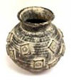 | 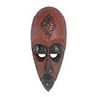 | 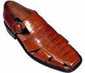

Resource 2: My artefact
Pupil use
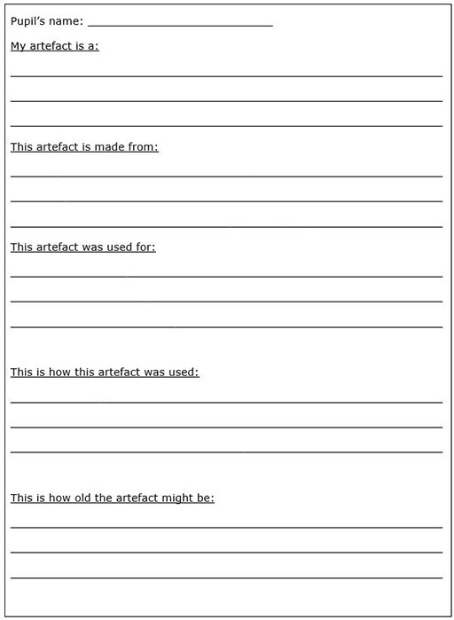

Acknowledgements
Every effort has been made to contact copyright holders. If any have been inadvertently overlooked the publishers will be pleased to make the necessary arrangements at the first opportunity.
Return to Social Studies and the Arts (primary) page


www.tessafrica.net

