

Handbooks and toolkits
Working with teachers

A handbook for teacher educators

ENGLISH

TESSA (Teacher Education in Sub-Saharan Africa) aims to improve the classroom practices of primary teachers and secondary science teachers in Africa through the provision of Open Educational Resources (OERs) to support teachers in developing student-centred, participatory approaches. The TESSA OERs provide teachers with a companion to the school textbook. They offer activities for teachers to try out in their classrooms with their students, together with case studies showing how other teachers have taught the topic, and linked resources to support teachers in developing their lesson plans and subject knowledge.
TESSA OERs have been collaboratively written by African and international authors to address the curriculum and contexts. They are available for online and print use (http://www.tessafrica.net). The Primary OERs are available in several versions and languages (English, French, Arabic and Swahili). Initially, the OER were produced in English and made relevant across Africa. These OER have been versioned by TESSA partners for Ghana, Nigeria, Zambia, Rwanda, Uganda, Kenya, Tanzania and South Africa, and translated by partners in Sudan (Arabic), Togo (French) and Tanzania (Swahili) Secondary Science OER are available in English and have been versioned for Zambia, Kenya, Uganda and Tanzania. We welcome feedback from those who read and make use of these resources. The Creative Commons License enables users to adapt and localise the OERs further to meet local needs and contexts.
TESSA is led by The Open University, UK, and currently funded by charitable grants from The Allan and Nesta Ferguson Foundation, The William and Flora Hewlett Foundation and Open University Alumni. A complete list of funders is available on the TESSA website (http://www.tessafrica.net).
As well as the main body of pedagogic resources to support teaching in particular subject areas, there are a selection of additional resources including audio, key resources which describe specific practices, handbooks and toolkits.

TESSA Programme
The Open University
Walton Hall
Milton Keynes, MK7 6AA
United Kingdom
tessa@open.ac.uk

Except for third party materials and otherwise stated, this content is made available under a Creative Commons Attribution-Share Alike 4.0 licence: http://creativecommons.org/licenses/by-sa/4.0/. Every effort has been made to contact copyright holders. We will be pleased to include any necessary acknowledgement at the first opportunity.

TESSA_EnPA_WWT May 2016


This work is licensed under a Creative Commons Attribution-Share Alike 4.0 License

Contents
- Working with the TESSA materials
  - About this guide
- 1 How are the TESSA materials structured? [Getting to know the TESSA materials]
  - A TESSA Section
- 2 Which TESSA materials are suitable for your teachers? [Curriculum mapping]
- 3 How will you plan to use the selected TESSA materials in your context? [Course design]
- 4 How can you adapt the TESSA materials for your context without losing their essence? [Materials adaptation]
- 5 How will you use the selected TESSA materials with your teachers? [Teaching and Learning]
- 6 How can you encourage reflective practice with TESSA activities through the kinds of assessment you use? [Assessment]
- 7 How can you evaluate and improve your use of the TESSA materials? [Reflective Practice]
- 8 How can you deepen your engagement with the TESSA community and others involved in working with teachers in an open educational resource (OER) environment? [Community of practice]

‘The education and training of teachers represent one of the greatest challenges for education systems in Sub-Saharan Africa. TESSA is an imaginative and creative response to that. Most importantly, it stresses the value of raising standards through international co-operation.’
Prof Jophus Anamuah-Mensah, TESSA Executive Chair
Why TESSA and this handbook?
TESSA provides collaboratively developed open educational resources (OERs) for teachers to use in their own classroom to support active learning methods and reflective practice.
This handbook is for teacher educators and others involved in planning and delivery of teacher development whether formal or less formal, and in a range of settings. It provides guidance and starting points on using TESSA materials to improve teachers’ classroom practices and raise pupil levels of achievement. This handbook draws on examples of TESSA use from across Sub Saharan Africa and in particular from TESSA consortium institutions. The guidance here complements TESSA: Working with Pupils (A Guide for Teachers).
‘The best thing about the TESSA materials is the fact that the strategies selected form a very practical part of it. Because each strategy you have is clear, and it is clear why that strategy is important and how to use it… In TESSA the strategies are explained so the teacher learns them...’
Prof Sinada, Open University of Sudan

‘The focus is on active learning and that is why I think I find myself comfortable with them [the activities]. This is the emphasis of TESSA, its strength.’
Prof F Keraro, Egerton University, Kenya

‘This is to say that I really enjoy going through TESSA modules. They are challenges that the new Emerging Africa teachers must avail themselves of. TESSA has made it clear to classroom teachers that the era of chalk and talk, excessive talk and boring lecture is gone. Our classroom practices should be activity learning based right from the beginning of the class to the end. Children want to do, act and enjoy lessons. The best way to know that your class is a failure is when the bell goes; if your pupils jump up and say hurray and run out of your class, they are indirectly saying thank God for the freedom from the bondage of a dull and weary lesson. Your class lessons should attract pupils to your class, not drive them away. The bell should make them say ouh ouh, not hurray we are free.’
Professor I.A. Olaofe, Ahmadu Bello University, Zaria, Nigeria

Working with the TESSA materials
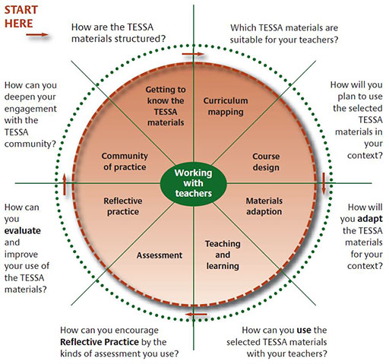

About this guide
This guide aims to support teachers to use TESSA materials and activities in their classrooms.
TESSA materials enhance and improve teaching and focus on developing teachers’ classroom practice in the key curriculum areas of literacy, life skills.

1 How are the TESSA materials structured? [Getting to know the TESSA materials]
All the TESSA materials are open educational resources; they are free to be used by anyone either online or downloaded and printed. They can be adapted, modified, or integrated with other materials in any form.
TESSA materials have been written by teacher educators from different countries in Sub-Saharan Africa.
The TESSA materials are organised into five module areas (see Table 1):
Literacy, Numeracy, Science, Social Studies and the Arts and Life Skills.
Each module area contains three modules, each of which has five sections (there are seventy-five sections in total). The focus in all sections is on developing teachers’ understanding of teaching and learning and improving their classroom practice. There is a progression of ideas both within the five sections of each module and within each section.
Table 1 The five TESSA module areas
Module Area | Module 1 | Module 2 | Module 3
Literacy | Reading and writing for a range of purposes | Using community voices in the classroom | Promoting communication in an additional language
Numeracy | Investigating number and pattern | Exploring shape and space | Investigating measurement and data handling
Science | Looking at life | Investigating materials | Energy and movement
Social Studies and the arts | Developing an understanding of place | Investigating history | Looking at the arts
Life skills | Personal development | Exploring social development | Community issues and citizenship
Further details of the seventy-five sections are in the ‘Summary Curriculum Framework’ (Appendix 1a).
The materials have been written in Africa by Africans. They reflect African culture and surroundings, and are available in four languages: English, French, Swahili and Arabic. In some countries they have been further adapted to suit local needs, although the differences between the various versions are fairly small. These are Ghana, Nigeria, Kenya, Togo, Uganda, Sudan, South Africa, Rwanda, Tanzania and Zambia.
Key Resources: Supporting all the TESSA sections is a series of ‘Key Resources’; these are referred to across all the module areas and cover issues such as ‘Using group work in your classroom’. The Key Resources can be accessed by clicking on the link in your country home page.
Audio resources: Enriching the TESSA text materials is a collection of audio resources. These can be found under your country homepage under the audio resources button in the left-hand navigation bar. There are several strands of audio resources including:
- ‘Story Story’ short dramas: A series of dramas showing scenes in and around a local school involving teachers, pupils, parents and other members of the community. For each drama there are questions for the teacher to consider and discuss.
- Teaching in Africa: A number of short clips in which teachers, pupils and educators talk about their experiences and ideas. These are intended to stimulate debate on the state of primary education and the teaching profession in Sub-Saharan Africa.

A TESSA Section
All TESSA sections follow the same pattern (see Table 2). Each section is designed to progressively develop the teachers’ practice through engagement with activities in their classroom. Each activity is expected to take one or two lessons at the most (unless they specify longer).
We suggest you print one TESSA section to look at whilst reading this explanation.
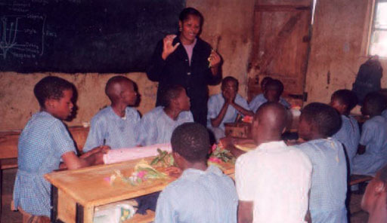
Table 2 Content of the TESSA sections
Key Focus Question | This is addressed to the teacher and summarises the area to be studied in the section.
Learning Outcomes | Each section has a maximum of three learning outcomes for the teacher. These centre on the development of classroom skills in the context of the curriculum of that module area.
Introduction | The introduction sets the scene for the section. It outlines classroom skills to be developed by the teacher and the curriculum content area across the section.
Narrative | The narrative of each section provides a rationale for the case studies and activities and highlights the purpose of each. It may briefly describe a relevant theoretical perspective, additional subject knowledge for the topic or the location of additional supporting resources.
Case Studies | Every section has three case studies, each linked to a particular activity. The case studies illustrate ideas and concepts by describing how one teacher has approached the linked activity or a similar activity in her/his classroom. They may often focus on one particular aspect of the activity or on a particular classroom situation – for example working with a multi-grade class, with very large numbers of pupils or in particularly challenging circumstances.
Activities | The three activities are at the heart of each section. They offer activities for the teacher to undertake in their classroom, with pupils or in the wider school and community. The activities build towards the final activity, known as the key activity. The activities are all learner centred and highly engaging for pupils. Some activities are very short – perhaps a twenty minute task – whilst others are projects stretching over several weeks. The majority should occupy one lesson.
Resources | Each section has up to six supporting resources. These can take a variety of forms including web links, articles, images, stories, posters, examples of pupils’ work, detailed lesson plans, poems and worksheets and template documents. They are chosen to enrich the teachers’ learning and support their delivery of the activities. The resources support the development of different dimensions of a teacher’s knowledge base, including:  - content knowledge  - pedagogical knowledge and  - pedagogical content knowledge.  A few of the resources are intended for use with pupils.  Icons are used to show the core purpose of a resource. These are:  - pupil use  - background information / subject knowledge for teachers  - teacher resource for planning or adapting to use with pupils  - examples of pupils’ work.

2 Which TESSA materials are suitable for your teachers? [Curriculum mapping]
TESSA materials are appropriate for pre-service, in-service and upgrading programmes at a variety of levels and for teachers with a huge range of existing skills. Teacher educators working in different contexts (universities, colleges, regions and districts) are able to use them in a variety of situations and programmes.
It is important to remember that TESSA is not an entire curriculum for a formal teacher education programme. The purpose of TESSA materials is to enhance most areas of teacher education curricula and less formal teacher development activities.
Mapping into a programme
For existing formal programmes the starting point is to look at both
- your own teacher education curriculum
- the TESSA curriculum framework
to decide where it will be most appropriate to use the TESSA materials.
The diagram shows the main areas of most teacher education curricula and the parts that TESSA supports:
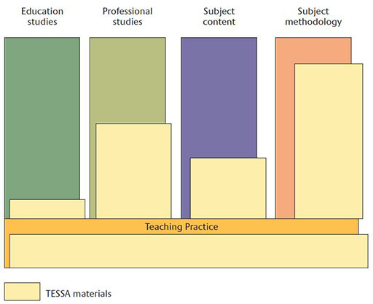
Figure 2 Overlap between TESSA materials and components of a teacher education curriculum
TESSA Snapshots: TESSA use in diploma and degree programmes
At the University of Education, Winneba (Ghana), the TESSA materials are integrated into teaching methodology courses in english, maths, basic science and environmental studies in the B Ed Primary.
At the Open University of Tanzania, the new Diploma in Primary Teacher Education was planned with the TESSA principles in mind. It has an active learning / activity based approach, linking theory and practice, and draws heavily on the TESSA materials. TESSA materials are integrated into methodology courses, teaching practice, classroom management modules and general teaching methods and strategies.
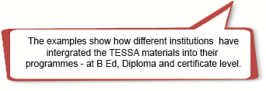
In the in-service upgrading programme – Advanced Certificate of Education – at University of Fort Hare (South Africa), the TESSA materials have been integrated into the courses which support the improvement of teaching skills in maths, science and technology.
In many institutions there are no existing materials to support teaching practice or school experience modules, and TESSA materials are then frequently used to support this part of the curriculum. Using the materials in this way is a good starting point as it familiarises teachers (and their supervisors/tutors) with the TESSA materials and there is often less resistance to their use than to integration in more formal taught parts of the curriculum.
TESSA Snapshots: TESSA use in non-accredited programmes
The National Teachers’ Institute in Nigeria is leading on delivering CPD workshops for all primary school teachers across the country (120,000 teachers in 2009 through 246 centres). These six-day workshops cover the four core subjects of the primary school curriculum with a focus on innovative techniques of teaching. For each subject a self-study manual has been written, based on principles of active learning and targeting pupil needs and interests. In 2008, revised subject manuals were produced; these integrated relevant TESSA activities and case studies thus enriching the NTI manuals. These books are distributed to teachers at workshops.A companion Resource Person’s Guide has also been developed and is used to help orient the centre coordinators and facilitators who run the CPD workshops.
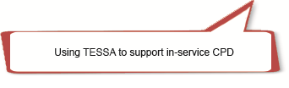

Ms Pauline Amos is a district supervisor for science working with teachers in primary schools across Nakuru district in Kenya. She uses the TESSA materials with teachers in schools in her area in less formal professional development exchanges.
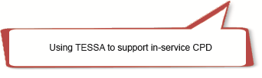
Mapping into a course
Having identified the most appropriate parts of your curriculum for enhancement with TESSA, you may then want to do more detailed curriculum mapping to identify particular TESSA sections or activities to integrate into formal and less formal courses or in response to individual teacher needs. This mapping exercise is best undertaken in a workshop with colleagues. Table 2 shows how using a table can be useful to support this exercise.
Table 3 How TESSA materials map against a curriculum from Egerton University (Kenya)
B Ed Course (primary) | Theme Topic | Suggested TESSA literacy module / section | Suggested TESSA activities / case studies | Teacher outcomes
Introduction to linguistics (sound production) | Articulation (pronunciation) | M1 S1  Supporting and assessing reading and writing | Activity 1: Using songs and rhymes to teach reading of words  Activity 2: Using groceries for reading | Used songs and rhymes to teach pronunciation  Used grocery packaging to teach pronunciation
Introduction to literacy (literary appreciation) | Story telling | M2 S1  Investigating stories | Activity 2 Discussing why specific stories were told  Activity 1 Investigating storytelling | Investigate pupils’ understanding of stories
Creative Writing (Writing) | Writing a narrative | M2 S1  Investigating Stories.  M2 S4  Using story and poetry | Key activity: Creating an original story  Activity 1 Drafting name / praise poems or songs | Exploring ways of writing original stories / poems
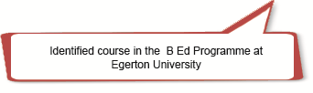
When using the TESSA materials to support teachers with their teaching practice, you might select specific TESSA materials for them. Alternatively, you might ask teachers to select the most appropriate sections or study units for their own needs (from the TESSA website, CDs or printed books), and then devise their own learning pathway through the material. In both cases you will need to ensure that the school (pupil) curriculum is considered in making the selection.
It is worth bearing in mind that adequate time needs to be allocated for teachers to browse and select from the TESSA materials. Teachers will find it helpful to have access to TESSA: Working with Pupils (Teachers’ Guide) available under ‘Teacher Educator Guidance’ on the TESSA website.
TESSA Snapshot: Providing access to the TESSA website
At Our Lady of Apostles (OLA) teacher training college in Cape Coast Ghana (working with The University of Cape Coast), the student teacher’s timetable has been amended and all teachers have one session per week in the computer labs to browse and study the TESSA materials – choosing activities and resources to use in their assignments, on campus micro teaching and in teaching practice in local schools.
‘One striking revelation about the relevance of the TESSA resources is evident in the manner in which our third-year student teachers who are currently on their “out-programme” crave for the resources to prepare their lesson notes in their various schools assigned.’
OLA TESSA Report
February 2009
TESSA Snapshot: TESSA in the B Ed course at Egerton University, Kenya
‘Essentially, as far as I am concerned it is the approach that TESSA is using that is important, it is not so much the content covered. As far as anyway the TESSA materials do not cover the entire curriculum in our schools, they are giving us examples… They are giving methods we can use.’
Prof Fred Keraro,
Egerton University, Kenya

3 How will you plan to use the selected TESSA materials in your context? [Course design]
Consideration of the complexities of your local circumstances and needs is important in establishing appropriate conditions to support the effective use of TESSA materials.
A first step is considering how to introduce the TESSA materials to your colleagues and achieve their buy-in. Achieving buy-in from your colleagues to the use of TESSA materials needs extensive discussion on repeated occasions. Colleagues need background information on the project and TESSA principles and time to explore the materials.
TESSA Snapshot
At the Kigali Institute of Education in Rwanda, all lecturers have access to a laptop but internet connectivity is not good. The Rev James Rutebuka, the Head of Primary Teacher Education and the TESSA coordinator, has organised CDs of all the TESSA materials (in both English and French) for all lecturers. He negotiated with the Institute senior management to use some Wednesday afternoon professional development/research sessions to introduce TESSA. In the following sessions, colleagues collectively explored different TESSA modules from the CDs.
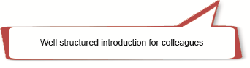
The next step is to consider the format of use of the TESSA materials, how teachers’ use of the TESSA materials will be supported and how you might assess this use. This will depend on a number of factors:
- The purpose and intended learning outcomes of your programme or course.
- The number of teachers on your programme and its format (on – campus, distance learning etc).
- Access to technology; internet and computers.
- Support: the number and frequency of contact sessions and the expertise of tutors/ supervisors/ mentors.
Across the TESSA consortium we have seen three different types of use of the TESSA materials – highly structured, loosely structured and guided use. (See Table 3). This list is not exhaustive but merely illustrative of the way in which the flexible nature of the materials enables effective use in a wide range of contexts and for different purposes.
Table 4 Different types of use of TESSA materials
Form of use of TESSA materials | Highly structured | Loosely structured | Guided use
Characteristics | Selection of a set of TESSA activities for all student teachers to carry out | Lecturers select appropriate TESSA activities for their own course | Designated time for student teachers to select TESSA activities
Teacher access to TESSA materials | New teacher books which include several TESSA sections | Website and printed TESSA sections | Website or CDs
Example | National Teachers’ Institute (NTI) (Nigeria); Open University of Sudan (OUS) | University of Education, Winneba (UEW) (Ghana); Egerton University (Kenya) | University of Pretoria (UoP) (South Africa) Our Lady of Apostles (OLA) College (Ghana)
The following TESSA snapshots show in more details the use of TESSA materials in different contexts:
Teachers on B Ed courses at the University of Pretoria (South Africa) are required to select TESSA materials from the TESSA website to use during their teaching practice. The teachers’ use of TESSA is mentioned in the letter from the University to the school mentor encouraging schools to also look at the TESSA materials. Teachers on the programme are required to include materials from their use of TESSA, including their registration on the TESSA website, in their portfolios. They are also required to discuss their experiences during group reflections and to give a written, structured reflection at the end of the practicum.
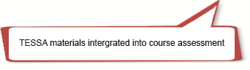

At the Open University of Sudan, academics have undertaken a comprehensive mapping exercise with the TESSA materials against both the teacher training curriculum and the school pupil curriculum to pull together a book of TESSA activities in Arabic. Many of their teachers are located in rural areas with little chance of access to the internet or regular support from institution staff. However, distribution channels for hard copy materials are well established. This book will be used by all teachers in the third and final teaching practice of their B Ed. In 2009, the cohort numbers 53,000. In Sudan, as in many countries across the world, the pupil curriculum is highly controlled and fixed, but by careful linking of the TESSA activities with the school curriculum, TESSA materials can be used ‘without alienating headteachers’.
Prof Sinada,
Open University of Sudan, 2009
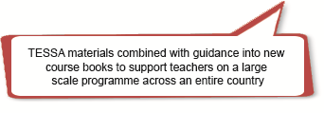

In Tanzania the 500 teachers on the new Diploma in Primary Teacher Education are given CDs containing all the TESSA materials in English and Kiswahili. However, not all teachers have access to a computer outside the study centre. A small selection of TESSA materials is printed to use during the face-to-face sessions. A small number of complete sets of TESSA materials is sent to regional centres for reference. (Printing costs prohibit more extensive use of printed materials.)
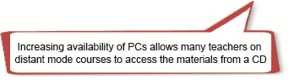

At the University of Fort Hare, TESSA materials are stored on the University intranet. Teachers across the university campus can access the TESSA materials without going onto the internet
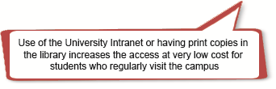

Teachers studying for a diploma through distance mode with the Kyambogo University in Uganda regularly visit their local Teachers’ College for support sessions. Few of these colleges have internet access or many computers. These teachers have print copies of a small number of TESSA sections, chosen by their lecturers, to link to specific topics.
You might want to support your teachers in finding local resources by developing a ‘resource room or area’ in your institution or study centres. Teachers could borrow materials for use in their classes and share materials that they develop. Teachers could be encouraged to put together a resource corner or cupboard in their school or classroom.
TESSA Snapshot
In Kenya, teachers in the third year of the B Ed (primary) programme at Egerton University are required to complete a project in their schools. Teachers are using the TESSA materials as a starting point for their projects. Each student teacher has been given a CD of the TESSA materials. Materials developed by teachers include a weather station, a food display and weighing scales.

4 How can you adapt the TESSA materials for your context without losing their essence? [Materials adaptation]
All the TESSA sections have specified learning outcomes which you should consider when adapting materials for your courses. In each section the activities are also organised in a particular sequence which scaffold the teacher towards the achievement of the learning outcomes in the final key activity. It is important to consider how the TESSA materials should be sequenced to best support the teachers’ learning and to enable teachers to make connections between ideas, strategies and subjects with space for their reflections on their experiences.
Using the first activity from a TESSA section will seldom – if ever – help teachers to achieve the section outcomes fully.
However, it is possible to design learning pathways and meet learning outcomes using extracts of TESSA sections in a sequence which provides a coherent learning journey for teachers. Similarly, teachers can design their own learning pathway including one or more TESSA activities or case studies in a sequence to achieve defined learning outcomes.
TESSA Snapshots
At the Open University of Tanzania, new study units have been constructed around sequences of TESSA activities with some adaptation. For example, the Mathematics Method Module study guide includes a section called ‘teaching different concepts in arithmetic’. Two of these concepts are ‘fractions’ and ‘time’. Each section has been developed around a number of TESSA materials to deliver the learning objectives. The fraction section comprises an introduction to teaching fractions, three activities from TESSA (without the case studies but with the relevant TESSA resources such as fraction strips, fraction discs and comparing fractions) to create a learning episode. In the ‘time’ section, one activity and case study from TESSA are used. In each case the introduction locates the activities and examples in the context of the Tanzanian primary school. Each of these sections develops teachers’ skills in building on pupils’ prior knowledge and using local resources in a coherent learning sequence.
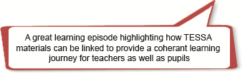

Miss Cindy Makoe in South Africa used the TESSA materials as the basis for discussion work on ‘shared reading’ in her tutorials with her pre-service student teachers; linking the discussions to lessons they were teaching in schools. She encouraged her student teachers to practise their shared reading before their class. Cindy requested help from the class teachers in evaluating the student teachers’ lessons on an evaluation form; these were later discussed with the student teachers.
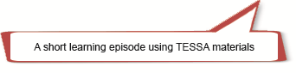
Access to TESSA Materials
The TESSA website offers many different versions of the TESSA materials contextualised for different environments. However, for many teachers and some teacher educators in Sub Saharan Africa, access to the internet is difficult.
Nonetheless, there are numerous alternative ways you can use to give teachers access to the TESSA materials:
offline
- TESSA materials can be downloaded onto your college, university or institution intranet and accessed by teachers on campus.
- Through the use of CDs. The TESSA website offers a tool to enable you to easily create CDs for distribution to teachers on your programmes or courses.
- Through use of SD cards. TESSA materials can be downloaded onto an SD card and view on a mobile device - a mobile phone or a tablet computer.
- Through use of ‘datasticks’ or ‘flashdrives’. Again, the TESSA materials can be downloaded to these for distribution to teachers.
in print
- TESSA materials can be printed (use the pdf version) from the TESSA website. You can print either individual sections or whole modules for distribution to teachers.
- Alternatively the Word file versions of the TESSA materials can be used, perhaps mixing the TESSA OERs with materials from other sources to create a workbook or course book unique to teachers on your programme.

5 How will you use the selected TESSA materials with your teachers? [Teaching and Learning]
For many teachers, learning through and from their classroom practice will be unfamiliar. The point of the TESSA materials is to help teachers actually do the TESSA activities in their classrooms/on teaching practice. So just giving teachers the copies of TESSA materials is not going to be enough. You need to prepare the teachers for classroom use of the materials, and help them reflect on their experience of use.
Preparation for use
TESSA preparation should always involve teachers experiencing the TESSA activities in a practical way before trying them out in classrooms with pupils, and this should include:
- discussion
- modelling/demonstration (video clips can be useful)
- micro teaching.
It is also essential that those working with teachers in their classrooms (tutors/supervisors and so on) are familiar with the TESSA approach and materials.
The TESSA audio materials are ideal for stimulating discussion at workshops if equipment (including speakers) is available.
TESSA Snapshots
In one TESSA project in Nigeria, teachers were introduced to the TESSA materials at a one-day workshop at a State Centre, prior to the use of TESSA materials in their classrooms. A senior teacher educator at the National Teachers’ Institute (NTI) led this orientation workshop. The supervisors were first briefed on the TESSA materials and the expected outcomes of the orientation programme, after which the teachers were taken through the aims and concept of the TESSA materials, schedule of activities and the expected outcomes of the orientation programme. Key elements were: sample lessons using the new classroom activities, extensive discussion time, choosing the TESSA sections to use, and agreeing when to use the activities. In the sample lessons, two different activities, for example, ‘Mapping the Local Environment’ and ‘Exploring Social Networks’, were used to demonstrate how to use the classroom activities in the TESSA materials. In Kaduna State, the mathematics and science teachers were anxious to know how to use stories and games in teaching. The audio drama piece titled ‘the Maths Game’ from the TESSA materials was used as an example to demonstrate how games can be used in teaching mathematics.
At the University of Education, Winneba, in Ghana, lecturers working with Early Years teachers discuss the TESSA materials in small group seminars, looking at how the materials can be adapted for use with this age group of pupils. Following the discussion, the group of teachers then observes the lecturer teaching one of the TESSA activities in a local school. The teachers then comment on the lesson and use the ideas to adapt other TESSA activities for their own context. If it’s not possible to observe in a real school setting, the teachers watch a video clip of the lesson during their seminar.
Use of the materials
To support teachers in using the materials in their schools it would be helpful to give your teachers the TESSA :Working with Pupils handbook.
Reflection on use in teachers’ own classrooms
Simply selecting the relevant TESSA sections, building them into a learning pathway into your curriculum/materials, and requiring teachers to try out the activities in their classrooms is not enough to bring about real improvement. Teachers need further support to help them understand and reflect fully on their classroom experiences with different sorts of activities. This could be through your teachers sharing their experiences:
- in tutorials/contact sessions
- in discussions with mentor/supervisors/ head teachers/inspectors
- through communication with a tutor by email, or
- through group discussions through online conferencing, or a teleconference.
Teachers can be helped to reflect constructively by sharing both good and bad experiences in a non-threatening way. Describing is a good starting point for reflection, but teachers also need to be encouraged to think about why things happened the way they did, and what they will take from this experience into their future practice.

6 How can you encourage reflective practice with TESSA activities through the kinds of assessment you use? [Assessment]
It’s important to remember that things that are assessed are considered important by teachers, so it’s worth thinking about good ways of giving credit for teachers’ efforts to use the TESSA materials with their pupils. But it’s key that the type of assessment you choose supports the type of learning the TESSA materials encourage. Assessment doesn’t necessarily have to be graded, but a task that is required helps the teacher to pause and think about their experiences, learning and how they can improve. When your teachers have taught a lesson using one or more TESSA activities, you could then use this simple task:
Write a brief description of what you (the teacher) did and what the pupils did during the activity.
- What were you pleased about?
- What, if anything, disappointed you?
- What surprised you?
- What did the pupils learn? Were there differences in what they learned?
- What did you learn from the experience of using this activity with your pupils?
Now that you have responded to these questions, how do you, the teacher, feel about the activity and the way in which you used it?
TESSA Snapshot
The National Commission for Colleges of Education in Nigeria developed a series of pre-service teacher manuals for student teachers preparing for micro-teaching and teaching practice. The five manuals have a focus on activity-learning through the use of diverse participatory, interactive, cooperative and collaborative strategies, and complement academic and methodological components of NCE courses. Each booklet contains nine sample tasks linking TESSA activities with the Nigerian nine-year basic education curriculum. The TESSA extracts include learning outcomes (the teaching skills teachers will develop through undertaking the activity), the activity to undertake with pupils, a case study and supporting resources. Teachers are encouraged to think about how they will modify the TESSA activity when developing their own lesson plan. Following the lesson, teachers are required to evaluate their lesson through answering a small number of questions, for example ‘Did the practical activities generate interest or excitement among your pupils?’ ‘Give an example of one part of the lesson that you would have handled differently. How would you have done this?’
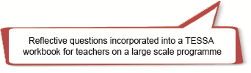

The Open University of Tanzania has built reflective questions into written course assignments for teachers.
These reflections, as well as reports on classroom observation of your teachers from peers or mentors/supervisors could be collected into a portfolio.
In some institutions, student teachers do not have a final examination at all. At the end of the year, they present the evidence of their own and their learners’ work contained in their portfolios to their own lecturers/ tutors, as well as external examiners.
TESSA Snapshot
At the University of Fort Hare (South Africa), lecturers in the B Ed (in-service) programme decided to encourage teachers to build portfolios of their work. The system works like this: teachers do activities throughout the semester. During their contact sessions, they share their work and assess themselves and each other. Some activities are also handed in to the tutors for assessment before being included in their portfolios.
At the end of each semester, teachers come together for ‘affirmation’ sessions. They present their portfolios and justify their work to their colleagues, their tutors and often outside moderators as well. This oral justification, together with the portfolio itself, is the basis for a negotiated decision on whether the teacher progresses to the next level of the programme. Also considered is their participation in the course, their ability to reflect on their experiences, and evidence of the impact of their work on their own learners.
You could also encourage your teachers to present their work to a broader audience through a conference presentation, a workshop with fellow teachers, or an article in a professional journal.

7 How can you evaluate and improve your use of the TESSA materials? [Reflective Practice]
When something new is tried out, it’s important to get feedback, to answer the question ‘What have I/we learned from using the TESSA materials with the teachers I/we work with?’
You can think about the experience on your own, but if you work with colleagues or people in the school community, you could also get feedback from them.
TESSA Snapshot
The ‘TESSA Feedback Tool’ was used to get feedback from Social Studies lecturers at Kyambogo University who used a series of TESSA activities with their student teachers. Notice particularly the question:
What constraints did you encounter in carrying out the TESSA assignment or experiment?
The answers given to this question will help the Kyambogo coordinator in planning for future sessions in which TESSA activities are integrated.
You could also ask your teachers/student teachers directly for their feedback. This could be in a survey questionnaire or less formally in a focus group discussion – a discussion guided by the broad questions such as:
- What was good?
- What was not so good?
- What improvements could be made?
In formal structured courses in which teachers are assessed, the effectiveness of the TESSA approach could also be evaluated through teachers’ assignments, or even through testing of teachers’ competences.
TESSA Snapshot
Teachers doing the B Ed at the Open University of Sudan are asked to practise fourteen key teaching strategies embodied and illustrated in the TESSA materials. Their teaching practice supervisors assess their competence in using these strategies effectively.
However, evaluation is only useful if the results of evaluation are used – the important question for the curriculum planning or TESSA implementation committees is: How can we do things better next time round? Figure 3 illustrates how you can use evaluation effectively.
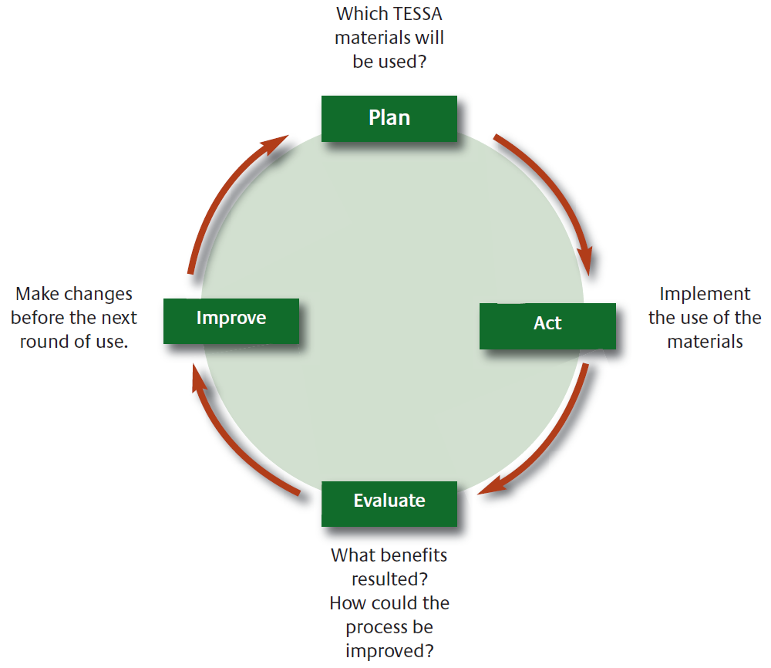
Figure 3 Using evaluation effectively

8 How can you deepen your engagement with the TESSA community and others involved in working with teachers in an open educational resource (OER) environment? [Community of practice]
The TESSA materials are OERs. This means that they can be freely shared, adapted and used by anyone.
But you need to start with the community closest to you – in your own context. If you are a teacher educator working in a college or university, these questions might help:
- To what extent do teacher educators at my institution work together?
- How could I benefit from increasing this collaboration?
- Am I personally prepared to put the effort into working together?
- How can I start a conversation about how to do this?
Teacher development may start in an institution, but schools and communities are involved as well.
- How can you share your TESSA experiences with others who work with teachers in schools and in your local community?
You can learn more about the TESSA community across Africa on the TESSA website, where you will find publications about TESSA and the use of the OER, as well as copies of the TESSA newsletters.
TESSA Snapshot
University of Fort Hare: TESSA Community Links
The Eastern Cape Province in South Africa is divided into twenty-three Department of Education Districts, responsible for supporting some 6000 schools. Through workshops and meetings the University of Fort Hare has been disseminating TESSA to District officials located across the Province, as well as directly with schools located in the surrounds of the university's three campuses.
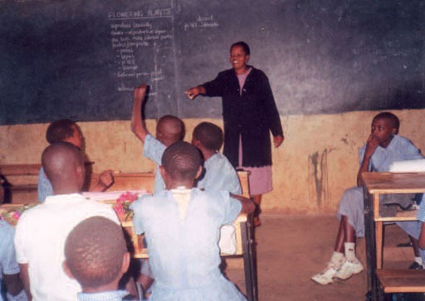


www.tessafrica.net

