12. Minor Disorders of Pregnancy

Study Session 12 Minor Disorders of Pregnancy 4
Introduction 4
Learning Outcomes for Study Session 12 4
12.1 Digestive and food-related disorders 4
12.1.1 Nausea, vomiting and hyperemesis gravidarum 4
12.1.2 Food dislikes and food cravings 6
12.1.3 Heartburn 8
12.1.4 Constipation 9
12.2 Swollen veins 9
12.2.1 Varicosities (varicose veins) 9
12.2.2 Haemorrhoids (piles) 10
12.3 Aches and pains 11
12.3.1 Back pain 11
12.3.2 Joint pain 12
Question 12
Answer 12
12.3.3 Leg cramps 12
Question 13
Answer 13
12.3.4 Sudden pain in the side of the lower belly 13
12.3.5 Abdominal cramps in early pregnancy 14
12.3.6 Headaches and migraines 15
12.4 Minor disorders in other body systems 16
12.4.1 Oedema 16
12.4.2 Frequency of urination 18
12.4.3 Vaginal discharge 18
12.4.4 Feeling hot or sweating a lot 19
12.4.5 Dyspnoea (shortness of breath) 20
Question 20
Answer 20
12.4.6 Difficulty in getting up and down 20
12.4.7 Chloasma (the mask of pregnancy) 21
12.5 Changing feelings and emotions 21
12.5.1 Sudden changes in feelings 21
12.5.2 Worry and fear 22
12.5.3 Sleep problems 22
12.5.4 Strange dreams and nightmares 24
12.5.5 Forgetfulness 24
12.5.6 Feelings about sex 25
12.6 Conclusion 25
Summary of Study Session 12 25
Self-Assessment Questions (SAQs) for Study Session 12 26
SAQ 12.1 (tests Learning Outcomes 12.1 and 12.2) 26
Answer 27
SAQ 12.2 (tests Learning Outcomes 12.1 and 12.2) 27
Matching quiz 27
Solution 28

Study Session 12 Minor Disorders of Pregnancy

Introduction
During pregnancy, a woman’s body changes in many ways — as you learned in Study Session 7. These changes can sometimes be uncomfortable, but most of the time they are normal. They can occur at any time during the pregnancy. In this study session, you will learn about some of the most common minor disorders of pregnancy, and discuss ways to help women feel better, or at least to stop worrying about them. We will also explain how to tell when a woman’s discomfort may be a sign that there could be a problem that requires further investigation and management, or even that something dangerous is happening with her pregnancy. Most of the minor disorders during pregnancy can be minimised with good education and prompt treatment. You should also know about some remedies that are dangerous for pregnant women and may hurt the baby.

Learning Outcomes for Study Session 12
When you have studied this session, you should be able to:
12.1 Define and use correctly all of the key words printed in bold. (SAQ 12.1)
12.2 Identify minor disorders or problems that women could develop during pregnancy and describe their relevant management. (SAQs 12.2 and 12.3)

12.1 Digestive and food-related disorders
There are several very common disorders of pregnancy that relate to food, or the digestion of food. Another way of classifying these disorders is to think of them as affecting the gastrointestinal system.

12.1.1 Nausea, vomiting and hyperemesis gravidarum
Many women have nausea and vomiting in the first trimester (3 months) of pregnancy, which is often called morning sickness. It happens commonly in the morning when the woman gets out of bed. Excessive salivation is an infrequent but troublesome complaint which is associated with a condition called hyperemesis gravidarum — caused by severe and frequent nausea and vomiting during pregnancy.
Hyperemesis is pronounced ‘hye-pur-em-ee-sis’ and means ‘excessive vomiting’. Gravidarum is pronounced ‘gra-vid-ah-room’ and means ‘during pregnancy’.
Hyperemesis gravidarum is a serious disorder, for which the woman needs to be admitted to hospital or a health centre.
The diagnosis of hyperemesis gravidarum is made if the woman loses 5 kg or more of her body weight due to frequent vomiting, loss of body fluids and nausea, making her fearful of eating, and is confirmed by the appearance of acidic chemicals (called ketone bodies) in her urine. The body starts to produce ketone bodies when it begins to break down proteins in a person’s muscles because there is no other energy source to keep them alive. The ketone bodies can be detected in urine by a dipstick test, which you can do in the woman’s home or at the Health Post if you have been provided with the appropriate dipsticks and shown how to ‘read’ the colour change if ketone bodies are present. A positive test result means she must be referred immediately to get replacements for the nutrition, body fluids and essential chemicals that she has lost, and receive preventive treatment to avoid further occurrence.
Management of mild nausea
If the nausea is mild, encourage the woman to try any of these remedies:
- Before bed or during the night, eat a food that contains protein, such as beans, nuts or cheese.
- Eat a few bananas, dry bread, dry kita, or other grain food upon waking up in the morning.
- Eat many small meals instead of two or three larger ones, and take small sips of liquid often.
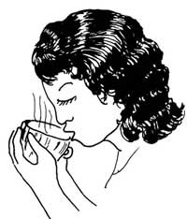
- Drink a cup of mint, cinnamon or ginger tea two or three times a day, before meals. Put a teaspoon of mint leaves, or a stick of cinnamon, in a cup of boiling water and let the tea sit for a few minutes before drinking it. To make ginger tea, boil crushed or sliced ginger root in water for at least 15 minutes.

12.1.2 Food dislikes and food cravings
A pregnant woman may suddenly dislike a food that she usually likes. It is OK not to eat that food, and she will probably begin to like it again after the birth. She should be careful that the rest of her diet contains a lot of nutritious food. You will learn what advice to give women about good nutrition during pregnancy in Study Session 14.
A food craving (also known as pica) is a strong desire to eat a certain food, or even something that is not food at all, like black soil, chalk or clay (Figure 12.1). If a woman gets a craving for nutritious foods (like beans, eggs, fruits or vegetables), it is OK for her to eat as much as she wants.
Pica is pronounced ‘pye-kah’.
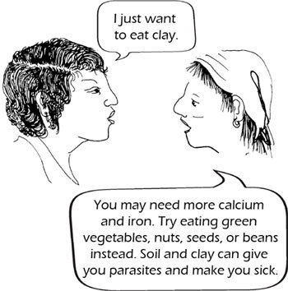
Figure 12.1 Food cravings are common in early pregnancy.
A woman who craves to eat things that are not food, like soil or clay, should be advised not to eat them. They may poison her and her baby. They may also give her parasites, like worms, that can make her sick. Encourage her to eat iron-rich and calcium-rich foods instead (see the advice in Figure 12.1).

12.1.3 Heartburn
A burning feeling or pain in the stomach, or between the breasts, is called indigestion or heartburn. Heartburn happens because the growing baby crowds the mother’s stomach and pushes it higher than usual (Figure 12.2). The acids in the mother’s stomach that help digest food are pushed up into her chest, where they cause a burning feeling. Reassure her that this is not dangerous and usually goes away after the birth.
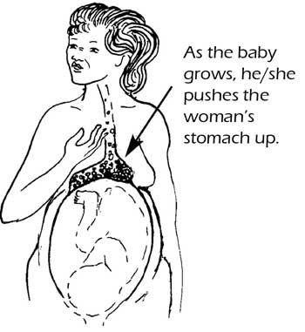
Figure 12.2 Heartburn in pregnancy may be due to the baby crowding the mother’s stomach.
Management
Here are some things a woman can try to make herself feel more comfortable:
- Keep her stomach less full by eating smaller meals more often, and by eating foods and drinking liquids separately.
- Avoid eating spicy or greasy foods, drinking coffee, or smoking cigarettes, as all of them can irritate the stomach.
- Regularly eat papaya or pineapple, which have enzymes (special chemicals) that help the stomach to digest food.
- Keep her head higher than her stomach when lying down or sleeping. This will keep her stomach acids in her stomach and out of her chest.
- Calm the acids in the stomach by drinking milk, or taking a low-salt antacid (stomach-calming liquid or tablet) that contains no aspirin, but advise her to try other methods before using drugs like antacids.

12.1.4 Constipation
Some pregnant women have difficulty in passing stools. This is called constipation. It is caused by hormonal changes that decrease the rhythmic muscular movements of the gut (peristalsis), which push food along the intestines. This results in an increase in ‘emptying time’, how long it takes for a meal to be digested and the waste matter expelled as stools.
Management
To prevent or treat constipation, a pregnant woman should:
- Eat more fruits and vegetables.
- Eat whole grains (brown rice and whole wheat, instead of white rice or white flour).
- Drink at least eight cups of clean water a day.
- Walk, move and exercise every day.
- Try home or plant-based remedies that will soften the stool or make it slippery, e.g. remedies made from telba seed, certain fruits, or fibre plants like gomen.

12.2 Swollen veins
There are many reasons why pregnant women may develop swollen veins in different parts of the body. Here are two of the most common.

12.2.1 Varicosities (varicose veins)
Genital varicosities can cause bleeding if they tear during birth, so refer a woman who has this problem to a health centre.
Swollen blue veins that appear in the legs are called varicosities, or varicose veins, and are very common in pregnancy. Sometimes these veins hurt. Pressure by the enlarging uterus on the veins that return blood to the heart from the legs is a major factor in the development of varicosities in the leg veins. Very rarely, swollen veins may develop in the external genitalia and these are very painful.
Management
If the swollen veins are in the legs, they may feel better if the woman puts her feet up often. Strong stockings or elastic bandages may also help. If the swollen veins are around the genitals, a panty-girdle or sanitary pad may help to support them.

12.2.2 Haemorrhoids (piles)
Haemorrhoids (also known as piles) are swollen veins around the anus. They may burn, hurt, or itch. Sometimes they bleed when the woman passes a stool, especially if she is constipated. Sitting or standing a lot can make haemorrhoids worse.
Management
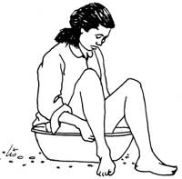
The woman should try to avoid getting constipated by eating a lot of fruit and vegetables and drinking plenty of fluids. Straining to pass hard stools makes haemorrhoids worse. Sitting in a cool bath or lying down can help.

12.3 Aches and pains

12.3.1 Back pain
Many pregnant women get back pain. The weight of the baby, the uterus and the amniotic fluid, changes her posture and puts a strain on the woman’s bones and muscles. Too much standing in one place, or leaning forward, or hard physical work, can cause back pain. Most kinds of back pain are normal in pregnancy, but it could also be caused by a kidney infection.
Management
Encourage the woman’s husband, children, other family members or friends to massage the woman’s back. A warm cloth or hot water bottle on her back may also feel good. Her family can also help by doing some of the heavy work, such as carrying small children, washing clothes, farming, and milling grain. A tight girdle, or a belt worn about the hips, together with frequent bed rest, may relieve severe back pain.

12.3.2 Joint pain
Hormones in the third trimester (six to nine months of pregnancy) act on the woman’s joints so they get softer and looser. This makes her joints more flexible, including the joints between the bones in her pelvis (recall the anatomy of the pelvis in Study Session 6, particularly Figure 6.1).

Question
Why do you think this natural loosening of the joints in the pelvis is beneficial in late pregnancy?

Answer
It helps to create a more flexible space in the pelvis for the baby to pass down the birth canal during labour and delivery.
End of answer
Sometimes a pregnant woman’s joints get too loose and uncomfortable, especially the hips, and she may develop an unstable pelvis, which produces pain. Joint pain is not dangerous, but the woman can more easily sprain her ankles or other joints.

12.3.3 Leg cramps
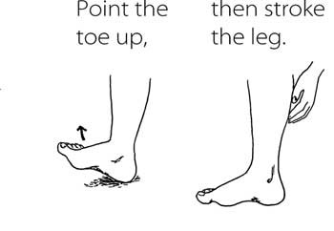
Many pregnant women get foot or leg cramps — sharp sudden pain and tightening of a muscle. These cramps especially come at night, or when women stretch and point their toes. To stop the cramp, flex the foot (point it upward) and then gently stroke the leg to help it relax (do not stroke hard).
Management
To prevent more cramps, a woman should not point her toes (even when stretching), and she should eat more foods high in calcium and potassium, which can help.

Question
Can you list some calcium-rich foods?

Answer
Yellow vegetables such as yams and carrots, lime, milk, curd, yogurt, cheese, green leafy vegetables, bone meal and egg shells, molasses, soybeans and sardines.
End of answer

12.3.4 Sudden pain in the side of the lower belly
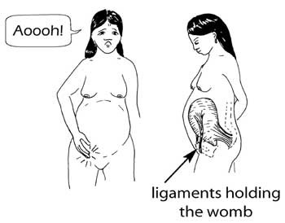
The uterus is held in place ‘suspended’ by ligaments on each side. Ligaments are like ropes that attach the uterus to the mother’s abdomen. A sudden movement will sometimes cause a sharp pain in these ligaments. This is not dangerous. The pain will usually stop in a few minutes. It may help to stroke the belly gently, or to put a warm cloth on it.

12.3.5 Abdominal cramps in early pregnancy
The woman may have an ectopic pregnancy implanted in a fallopian tube, or she may be having a miscarriage. She should get medical help immediately.
It is normal to have mild abdominal cramps (like mild monthly bleeding cramps) at times during the first trimester of pregnancy. These cramps happen because the uterus is growing. However, cramps that are regular (come and go in a pattern), or constant (always there), or are very strong or painful, or come with spotting or bleeding from the vagina, are warning signs.

12.3.6 Headaches and migraines
Headaches are common in pregnancy, but are usually harmless. Headaches may stop if the woman rests and relaxes more, drinks more juice or water, or gently massages her temples. It is OK for a pregnant woman to take two paracetamol tablets with a glass of water once in a while. However, headaches late in pregnancy may be a warning sign of pre-eclampsia, especially if there is also high blood pressure, or swelling of the face or hands. Pre-eclampsia is discussed in detail later in this Module, in Study Session 19.
If you suspect pre-eclampsia, refer the woman to the nearest health facility immediately.
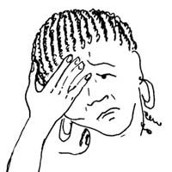
Some women have migraine headaches. These are strong headaches, often on the side of the head. The woman may see spots and feel nauseated. Bright light or sunshine can make them worse. Migraines may get worse in pregnancy.
Management
Unfortunately, migraine medicine is very dangerous in pregnancy. It can cause labour to start too soon, and it may also harm the baby. It is better for a pregnant woman with a migraine to take 500 to 1,000 mg (milligrams) of paracetamol with a glass of water, and rest in a dark room. Although coffee and black tea are usually not healthy in pregnancy, they are OK occasionally, and they may help to cure a migraine.

12.4 Minor disorders in other body systems

12.4.1 Oedema
If you suspect that oedema might be a sign of pre-eclampsia, refer the woman to the nearest health facility immediately.
Swelling of the feet and ankles is very common in pregnancy, especially in the afternoon, or in hot weather. It is due to oedema, the retention of fluids in the body tissues. Under the force of gravity, the retained fluid tends to sink down the body and collect in the feet. Advise the woman to sit with her feet raised as often as possible, to allow the fluid to be absorbed back into the circulatory system. Swelling of the feet is usually not dangerous, but severe swelling when the woman wakes up in the morning, or swelling of the hands and face at any time, can be signs of pre-eclampsia, which is a very serious (even life-threatening) condition.
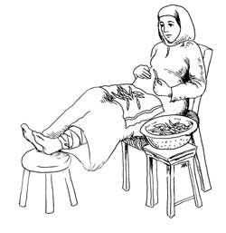
Management
Swelling in the feet may improve if the woman puts her feet up for a few minutes at least two or three times a day, avoids eating packaged foods that are very salty, and drinks more water or fruit juices.

12.4.2 Frequency of urination
Urinary frequency is a common complaint throughout pregnancy, especially in the first and last months. This happens because the growing fetus and uterus presses against the bladder. It will stop once the baby is born. If urinating hurts, itches, or burns, the woman may have a bladder infection. The diagnosis and management of urinary tract infections are discussed in Study Session 18.

12.4.3 Vaginal discharge
Discharge is the wetness all women have from the vagina. A woman’s body uses this discharge to clean itself from the inside. For most women, the discharge changes during their monthly cycle. Pregnant women often have a lot of discharge, especially near the end of pregnancy. It may be clear or yellowish. This is normal. However, the discharge can be a sign of an infection if it is white, grey, green, lumpy, or has a bad smell, or if the vagina itches or burns.
You should refer all suspected cases of vaginal infection to the nearest health facility.

12.4.4 Feeling hot or sweating a lot
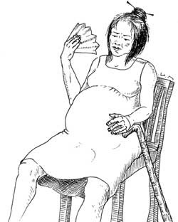
Feeling hot is very common in pregnancy, and as long as there are no other warning signs (such as signs of infection), the woman should not worry. She can dress in cool clothes, bathe frequently, use a paper fan or a large leaf, and drink plenty of water and other fluids.

12.4.5 Dyspnoea (shortness of breath)
Many women get short of breath (cannot breathe as deeply as usual) when they are pregnant. This condition is called dyspnoea.
Dyspnoea is pronounced
‘dissp-nee-ah’.

Question
Why do you think shortness of breath is a common problem, especially later in pregnancy?

Answer
Breathlessness is because the growing baby crowds the mother’s lungs, and she has less room to breathe.
End of answer
Management
Reassure women who are breathless near the end of pregnancy that this is normal. But if a woman is also weak and tired, or if she is short of breath all of the time, she should be checked for signs of sickness, heart problems, anaemia, or poor diet. Get medical advice if you think she may have any of these problems.

12.4.6 Difficulty in getting up and down
It is better if a pregnant woman does not lie flat on her back, because it can be difficult for her to get up again, and because when a woman is on her back, the weight of the uterus presses on the big blood vessels that return blood to her heart. This can temporarily reduce the supply of oxygen to her brain, and she may feel dizzy. If the woman wants to be on her back, she should put something behind her back and under her knees so she is not lying completely flat.
A pregnant woman should also be careful how she gets up. She should not sit up like the woman in Figure 12.3(a). Instead, she should roll to the side and push herself up with her hands, as in Figure 12.3(b).
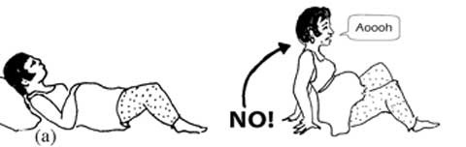
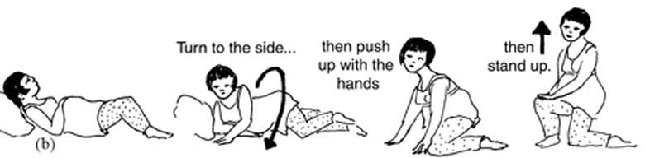
Figure 12.3 (a) Getting up without turning onto one side first can tear the muscles of the abdomen. (b) Turning to the side and pushing up with the hands is much safer and more comfortable.

12.4.7 Chloasma (the mask of pregnancy)
You already know what chloasma looks like from Study Session 8. Reassure the woman that the dark colouration is not harmful and that usually most of the colour goes away after the birth. A woman may be able to avoid developing dark areas on her face by wearing a hat when she goes out in the sun.

12.5 Changing feelings and emotions
Pregnancy is an important time in a woman’s life. Her baby is growing inside her, her body is changing, and she needs more food and more rest. As a woman’s body changes, her relationships, her sexuality, and her work life can change too.

12.5.1 Sudden changes in feelings
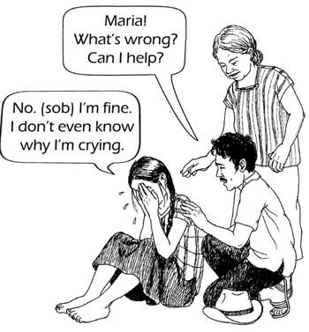
Pregnancy can make women very emotional. Some women laugh or cry for no clear reason. Some feel depressed, angry, or irritable. Odd laughing or crying, and other sudden mood changes or strong feelings, are normal. They usually pass quickly. But do not ignore a woman’s feelings simply because she is pregnant. Her feelings are real.

12.5.2 Worry and fear
Many women worry when they are pregnant, especially about the baby’s health and about giving birth. A woman’s worries about other problems in her life may also become stronger when she is pregnant. Such worries are normal. They do not mean that something bad will happen. Women with these feelings need emotional support, like someone to listen to their worries and encourage them to feel hopeful. They may also need help to solve the problems they are having in their lives, like problems with their partners, money, drugs or alcohol, or other issues.

12.5.3 Sleep problems
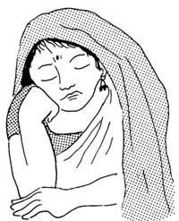
Some pregnant women feel sleepy much of the day. This is normal during the first three months. Their bodies are telling them to slow down and rest. There is no need to intervene unless the woman also feels weak, which may be a sign that she has a more serious problem, like a sickness, depression or anaemia.
Sometimes pregnant women have problems in sleeping; they may find it difficult to get to sleep, or they wake up after a short time and cannot get back to sleep. This problem is called insomnia.
Management of insomnia
If a pregnant woman cannot sleep because she is uncomfortable or restless, it may help if:
- She lies on her side with something comfortable between her knees and at her lower back. She can use a pillow, a rolled-up blanket, banana leaves, or some other padding.
- Someone gives her a massage.
- She drinks herbal teas that help her sleep.

12.5.4 Strange dreams and nightmares
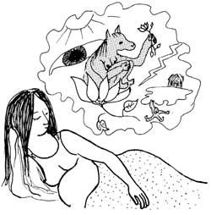
Pregnant women may have strong, vivid dreams. They can be beautiful, strange, or frightening. For many people, dreams are an important way of understanding themselves and the world. Some people believe that dreams can tell us about the future, or give us messages from spirits. But usually, when something happens in a dream, it does not mean that it will happen to us in life. The events in the dream may be telling us what we are afraid of, or what we desire. Or they may simply be stories our minds make up while we sleep. Pregnant women who are having frightening dreams may need someone to talk to about their hopes, fears and feelings.

12.5.5 Forgetfulness
Some women are more likely to forget things when they are pregnant. For most women, this is not a big problem. But some may worry if they do not know it is normal. No one knows why women become more forgetful when they are pregnant, but it is common.

12.5.6 Feelings about sex
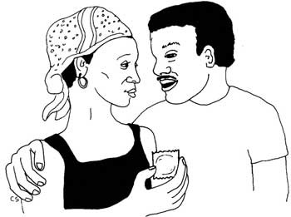
Some women do not want much sex when they are pregnant. Others want sex more than usual. Both feelings are normal. Having sex, and not having sex, are both OK for the woman and her baby. Sex is not dangerous for the baby. Sometimes sex is uncomfortable in pregnancy. A woman and her partner can try different positions for making love. It may feel better with the woman on top, or in a sitting or standing position, or with the woman lying on her side. When a pregnant woman has sex, it is important to avoid infection by advising her to have safe sex by using condoms to prevent HIV/AIDS and other sexually transmitted infections.

12.6 Conclusion
The techniques you learned earlier (in Study Session 8) will enable you to ask sensitive questions when women come to you for antenatal care, so you can discover if they have any minor disorders that you can help them to manage. Effective questioning will also reveal danger signs that require referral to a health facility. In the next study session, you will increase your skills in dealing with clients when we teach you about the health promotion issues you will need to discuss with pregnant women in your community.

Summary of Study Session 12
In Study Session 12, you have learned that:
- A woman’s body changes during pregnancy. These changes can sometimes cause discomfort, but mostly they are normal and will resolve themselves after the baby is born.
- You can minimise most of the minor disorders during pregnancy with advice on diet, exercise, and with simple home remedies that are known to be safe and help women feel better.
- Sometimes these minor problems may become more serious, or signal a serious underlying health problem that needs referral to a health facility.
- Some remedies (e.g. migraine medicine) are dangerous for pregnant women, and may hurt the baby as well as the mother.
- Minor disorders of pregnancy that you may encounter in dealing with pregnant women can be categorised according to which of the body systems is involved.
- Gastrointestinal disorders include nausea and vomiting, dislike of some foods, heartburn, pica (food cravings), constipation and haemorrhoids (piles).
- Musculoskeletal and skin disorders include back pain, aches and pains in the joints, difficulty in getting up and down, feeling hot or sweating a lot, the mask of pregnancy (chloasma), sudden pain in the side of the lower belly, cramps in early pregnancy, and leg cramps.
- Cardiovascular disorders include varicosities, and dyspnoea (shortness of breath).
- Genitourinary disorders include frequency of urination, and vaginal discharge (wetness from the vagina).
- Nervous system disorders include sleepiness and insomnia, headaches, changing feelings and emotions, worry and fear, strange dreams and nightmares, forgetfulness, and changing feelings about sex.

Self-Assessment Questions (SAQs) for Study Session 12
Now that you have completed this study session, you can assess how well you have achieved its Learning Outcomes by answering these questions. Write your answers in your Study Diary and discuss them with your Tutor at the next Study Support Meeting. You can check your answers with the Notes on the Self-Assessment Questions at the end of this Module.

SAQ 12.1 (tests Learning Outcomes 12.1 and 12.2)
A 22-year old pregnant woman at 34 weeks of gestation tells you that she craves to eat clay soil. She also tells you that she has developed darker brown patches on her face, and that her feet and ankles swell up during the day.
- Identify the minor disorders of pregnancy this woman is displaying, using their medical names.
- What advice should you give her to manage her symptoms?

Answer
- The medical names for the minor disorders of pregnancy that this woman is displaying are pica, chloasma, and oedema.
- Management:
Pica: Clay soil is not food, and it may give her parasites that can make her sick. You should advise her not to eat clay, but encourage her to eat iron-rich foods (like chicken, fish, pumpkin, beans, peas, meat — especially liver, kidney, and other organ meats — and whole grain products) and calcium-rich foods (like yellow vegetables, milk, curd, yogurt, cheese, and green leafy vegetables).
Chloasma: Reassure her that the brown patches are normal and they will fade after the baby is born. She can minimise them by wearing a hat when she is in bright sunlight.
Oedema: Advise her to put her feet up for a few minutes at least two or three times a day. This will help the fluid in her lower legs to be absorbed back into her circulation. Encourage her to eat fewer packaged foods that are very salty and to drink more water or fruit juices.
End of answer

SAQ 12.2 (tests Learning Outcomes 12.1 and 12.2)
Match the correct management with each of the disorders.

Matching quiz

Options
Dress in cool clothes, bathe frequently, and use a fan

Drink herbal teas that help her to sleep

Eat a lot of vegetables and fruits, and sit in a cool bath

Flex the foot and gently stroke the leg

Put the feet up and wear strong stockings

Take two paracetamol tablets with a glass of water

Matches
Haemorrhoids

Insomnia

Leg cramps

Mild headache

Sweating a lot

Varicosities in
the legs

Solution

Pair 1
Eat a lot of vegetables and fruits, and sit in a cool bath

Haemorrhoids

Pair 2
Drink herbal teas that help her to sleep

Insomnia

Pair 3
Flex the foot and gently stroke the leg

Leg cramps

Pair 4
Take two paracetamol tablets with a glass of water

Mild headache

Pair 5
Put the feet up and wear strong stockings

Varicosities in
the legs

Pair 6
Dress in cool clothes, bathe frequently, and use a fan

Sweating a lot

