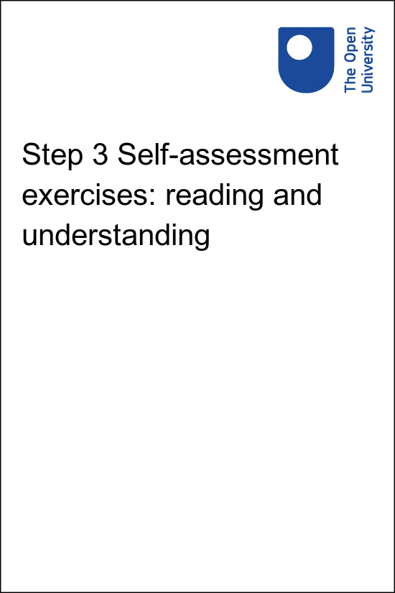

Am I ready to study in English

Step 3 Self-assessment exercises: reading and understanding

Copyright © 2020 The Open University
All rights reserved. No part of this publication may be reproduced, stored in a retrieval system, transmitted or utilised in any form or by any means, electronic, mechanical, photocopying, recording or otherwise, without written permission from the publisher.

Contents
- Step 3 Self-assessment exercises: reading and understanding
  - 3.1 Read and understand academic course books and materials
  - 3.2 Task 1: Arts
  - 3.3 Task 2: Maths
  - 3.4 Task 3: Science
- Solutions

Step 3 Self-assessment exercises: reading and understanding

3.1 Read and understand academic course books and materials
These exercises are designed to help you assess how easy you find it to understand course materials: to get the overall meaning and the key ideas. You can choose:
- Task 1 (Arts course),
- Task 2 (Maths course),
- Task 3 (Science course),
- or if you wish, you can do all three.

3.2 Task 1: Arts
The following extract is from The Open University course A103 An introduction to the humanities. (The course material here refers to the 1960s.)
Please read the text and comments in the suggested answers 1 to 6, listed below. Select the answers you feel are most accurate in relation to the text.

Abstract
Affluence came to America during the Second World War, and (though there were still many pockets of severe poverty) continued thereafter; economic recovery began in Europe from 1948 onwards.
Slowly the economic basis was established for the production, consumption and international exchange of new consumer goods. Between the mid-fifties and the mid-sixties there was a great increase in the number of multinational companies. New purchasers appeared in the market place: particularly young married couples, the working class in general, racial and ethnic minorities, those in the regions and provinces asserting themselves for the first time against metropolitan dominance, and women and girls.
Economic change combined with demography, specifically the ‘baby boom’ at the end of the Second World War, producing by the beginning of the sixties an unprecedentedly large, and unprecedentedly well-off, teenage presence in the market place (and young people could operate as producers as well as consumers).
Major technological developments of importance are those in television (including Telstar), 45-rpm records and transistor radios, in electronic synthesizers, in advanced consumer products, refrigerators, washing machines, and so on, and in the development of the contraceptive pill. Ideologically conservative forces were strong, reinforced by the frigid influences of the Cold War and hysteria in the United States about ‘un-American’ activities.
Affluence and consumerism were taken as validating the perfections of existing society. However, new critiques of society were appearing in the fifties, and formed the basis for the much more rapid and extended circulation of critical ideas in the sixties: neo-Marxism (Marcuse), the beginnings of structuralism, the ‘New Left’, the establishment of sociology departments, particularly in the European universities, and the first limited circulation of the notions of the American Beats. Old racial boundaries were crossed in a much more comprehensive way than ever before as young whites adopted and adapted black rhythm 'n blues.

Questions

Activity 1

Having read the extract in the box above, decide which of the following statements are most appropriate.
Please select either (a) or (b) in each case. You can find the relevant section of the text for each question in the answers at the bottom of the activity.
The first example has been done for you.
a) America became a poor country after the war.
b) America became a rich country after the war.
Answer: b is correct because, ‘affluence’ (line 1) means rich.

a) There was a growth in trading between countries.
b) There was a decline in trading between countries.
View answer - Part

a) The population increased in the '50s and '60s.
b) The population decreased in the '50s and '60s.
View answer - Part

a) The greatest advances were in entertainment.
b) The greatest advances were in technological developments.
View answer - Part

a) America was becoming more ideolgically traditional.
b) America was becoming more ideologically liberal.
View answer - Part

a) Everyone approved of the new form of society.
b) People were begining to be critical of society.
View answer - Part

View answer - Part

3.1.1 Self-assessment
- (A) I got all the answers right and found it easy to do.
- (B) I got most of the answers right, but it took me longer than 15 minutes.
- (C) I found this difficult and got most of the answers wrong.
Please now turn to your Step 8 Self-assessment grid and note in the appropriate column for this task whether your self-assessment is A, B or C.

3.3 Task 2: Maths
The paragraphs numbered 1–7, below, are adapted from MU120 Unit 0, Preparing for open mathematics.
Please read through all seven paragraphs and choose a heading from the box which seems to sum up the theme of each paragraph in turn.
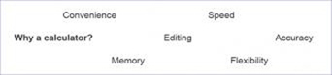

Sample Answer

1 Why a calculator?
The course makes use of a calculator in order to help you to learn and understand the mathematics in the course – a calculator is not, as some people still seem to believe, a substitute for learning mathematics. In fact, using a calculator can enable you to see the underlying mathematics more readily in several ways.
Some advantages of the course calculator are given below, but as you work with the calculator you may find other useful aspects to add to your list.

SAQ2

The calculator takes the tedium out of long calculations with numbers that would be fearsome to do in your head or time-consuming to do with pencil and paper. For example, the calculator takes about the same time to multiply 123.57 by .598 as to do 2 x 2.

View answer - SAQ2

SAQ3

You can correct mistakes in the input for a calculation easily and investigate what happens if you change one number in the calculation, for example, the interest rate or the price of an article.

View answer - SAQ3

SAQ4

The calculator does not make mistakes in the way that human brains tend to do. Human fingers do, however, make mistakes sometimes; and the calculator may not be doing what you think you told it to do. So correcting errors and estimating the approximate size of answers are important skills in double-checking your calculator calculations. (Just as they are for checking calculations done in your head or on paper!)

View answer - SAQ4

SAQ5

The calculator retains numbers, formulas and programs which you have stored in it, even when it is turned off. You can recall them when you need them and so save time by not having to enter the same information again.

View answer - SAQ5

SAQ6

The calculator is very useful for ordinary arithmetic and yet it can also perform many functions commonly associated with a computer and deal with quite advanced mathematics. It is useful for both beginners and experts alike, because it has a variety of modes of operation.

View answer - SAQ6

SAQ7

The calculator is small and slips conveniently into a bag or pocket. You will be able to carry it around with you and use it unobtrusively as and when you want – perhaps in a shop, on a train or in a restaurant.

View answer - SAQ7

3.3.1 Self-assessment
- (A) My answers match the above list and I found the task easy to do. I did it in less than 5 minutes.
- (B) Most of my answers match, but it took me longer than 5 minutes.
- (C) I found this difficult. It took me a long time. Or, most of the answers do not match the above list.
Please now turn to your Step 8 Self-assessment grid and note in the appropriate column for this task whether your self-assessment is A, B or C.

3.3.2 Advice on reading and understanding academic texts
- When reading new materials, first read through a complete section without stopping to get a general idea of the overall meaning.
- Try to guess unfamiliar words from the context.
Then, read the section again and check key words in an English-to-English dictionary.
- Write the definitions in English, not in your first language.
- Write a sentence or two in English, in your own words, summarising the main ideas in the text.

3.4 Task 3: Science
The following extract is from The Open University course S154 Science starts here. Please read the text in the box below then answer the questions that follow it.

Keeping our water clean
Pollution from domestic sewage can lead to more than one sort of problem. Most obviously, sewage is a source of water-borne diseases such as cholera and typhoid fever. A second problem with sewage is that the bacteria that break it down, during a process called respiration, use dissolved oxygen from the water to do so. This same dissolved oxygen also supports the other aquatic life. The more sewage there is in the water, the more bacteria are required to break it down and the more dissolved oxygen they use, leaving less oxygen for fish and other aquatic animals. Once the oxygen in the water is used up, animals that need oxygen die. It isn't long before the water begins to smell distinctly unpleasant due to the gases released when the sewage begins to be broken down by bacteria that can live without oxygen. If you've ever stirred up the mud at the bottom of a stagnant pond, you will know exactly what we mean.
Agricultural activities pose problems through both crop spraying and the use of fertilisers. Crop spraying is carried out to prevent damage to crops from weeds and various forms of pests. However, such spraying can disperse herbicides and pesticides over a wide area so that they end up in water that drains into rivers and lakes. In high enough doses these pollutants may be toxic and, like lead and mercury, they can accumulate in the tissues of animals and so end up in our bodies too. Fertilisers contain nutrients, substances essential for the healthy growth of all plants and animals. However, when fertiliser seeps into lakes and rivers by drainage off the land it can lead to excessive plant growth. As a lake surface becomes covered with water weed, oxygen can no longer be dissolved in the water to replenish what is being used by fish and other aquatic animals. Once again, starved of oxygen, the animal life soon begins to die, and the water becomes stagnant and foul-smelling.

Having read the passage above, which of the following statements are true?
Please select either option (a) or (b) in each case, then compare your answer with those below.
The first one has been done for you as an example.

Question 1

- (a) Cholera and Typhoid fever can be carried in water polluted by sewage.
- (b) Oxygen released from sewage smells unpleasant.
- (a) is correct.
- (b) is incorrect, because the smell is caused by gases given off by bacteria which survive when there is no oxygen present.

Question 2

- (a) Some bacteria use oxygen to break down sewage.
- (b) Sewage accumulates in river mud, where it helps plant growth.

View answer - Question 2

Question 3

- (a) Aquatic animals need nutrients from fertiliser for healthy growth.
- (b) Drainage of fertilizer into lakes may pollute the water.

View answer - Question 3

Question 4

- (a) Fertiliser from farmland will break down sewage in rivers.
- (b) Herbicide and pesticide concentration can build up in humans.

View answer - Question 4

Question 5

- (a) Oxygen can be dissolved in lake water.
- (b) Fish and other aquatic animals cause water in a lake to stagnate.

View answer - Question 5

Question 6

The first paragraph is best summarised by the sentence:
- (a) Crop spraying, agricultural fertiliser, industrial waste and domestic sewage can all contaminate water.
- (b) Sewage can pollute water both by introducing water-borne diseases and by reducing the amount of oxygen available for aquatic animals.

View answer - Question 6

3.4.1 Self-assessment
- (A) I got all the answers right and found it easy to do.
- (B) I got most of the answers right, but it took me longer than 15 minutes.
- (C) I found this difficult and got most of the answers wrong.
Please now turn to your Step 8 Self-assessment grid and note in the appropriate column for this task whether your self-assessment is A, B or C. Please open this in a separate window.
Now go to Step 4 Self-assessment exercises: identifying points and expressing ideas.

Solutions

Activity 1

Part

Answer
Right:
a) There was a growth in trading between countries.
Wrong:
b) There was a decline in trading between countries.
Back to - Part

Part

Answer
Right:
a) The population increased in the '50s and '60s.
Wrong:
b) The population decreased in the '50s and '60s.
Back to - Part

Part

Answer
Right:
b) The greatest advances were in technological developments.
Wrong:
a) The greatest advances were in entertainment.
Back to - Part

Part

Answer
Right:
a) America was becoming more ideolgically traditional.
Wrong:
b) America was becoming more ideologically liberal.
Back to - Part

Part

Answer
Right:
b) People were begining to be critical of society.
Wrong:
a) Everyone approved of the new form of society.
Back to - Part

Part

Answer

Question | Option | Comment
2 | a | there was ‘international exchange’ (paragraph 2)
3 | a | there was a ‘baby boom’ (paragraph 3) after the war
4 | b | see paragraph 4
5 | a | ‘traditional’ means conservative (paragraph 4)
6 | b | ‘critiques’ (paragraph 5) means expressing opposing ideas

Back to - Part

SAQ2

Answer
Speed
Back to - SAQ2

SAQ3

Answer
Editing
Back to - SAQ3

SAQ4

Answer
Accuracy
Back to - SAQ4

SAQ5

Answer
Memory
Back to - SAQ5

SAQ6

Answer
Flexibility
Back to - SAQ6

SAQ7

Answer
Convenience
Back to - SAQ7

Question 2

Answer
- The correct answer is (a).
- (b) is incorrect because the article does not suggest that sewage accumulates (builds up) in mud, nor that it helps plant growth.
Back to - Question 2

Question 3

Answer
- The correct answer is (b).
- (a) is incorrect because nutrients from fertiliser actually cause aquatic animals to be starved of oxygen.
Back to - Question 3

Question 4

Answer
- The correct answer is (b).
- (a) is incorrect because the article does not describe any connection between fertiliser and sewage.
Back to - Question 4

Question 5

Answer
- The correct answer is (a).
- (b) is incorrect because it is bacteria in sewage which use up the oxygen in the water.
Back to - Question 5

Question 6

Answer
- The correct answer is (b).
- Although the statement in (a) is correct, paragraph one only discusses sewage; industrial waste is not mentioned in the extract.
Back to - Question 6

