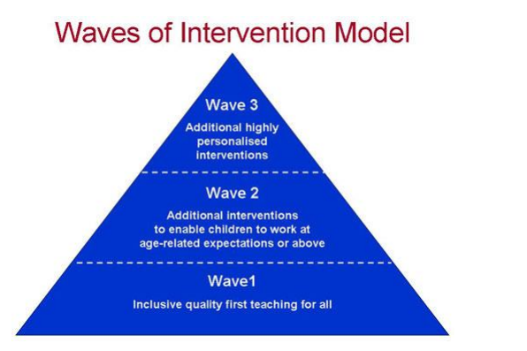
Special Needs Waves of Intervention Model
http://www.ashford-primary.surrey.sch.uk/docs/Waves%20of%20Intervention%20Model.pdf

