Tam O’Shanter
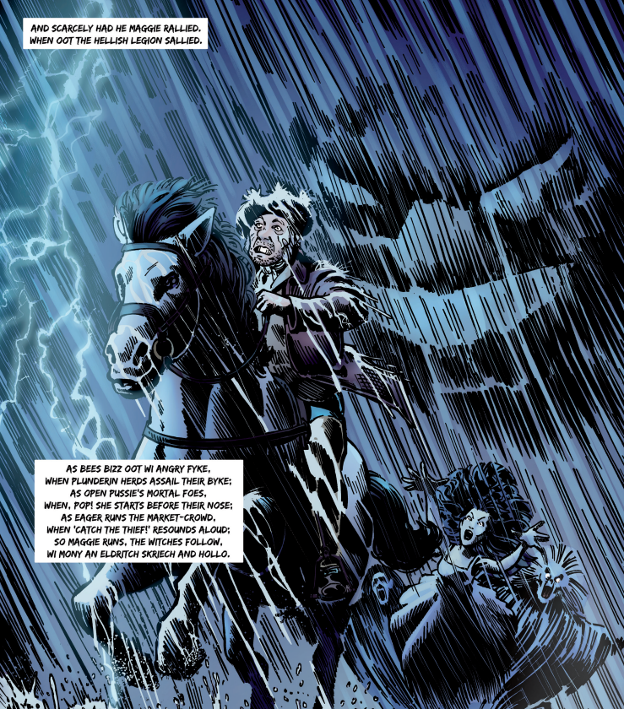
And __________ had he Maggie rallied,
When out the __________ legion sallied.
As bees buzz out with angry ______,
When __________ herds assail their hive;
As a wild hare’s ______ foes,
When, pop! she starts _______ before their nose;
As _______ runs the market-crowd,
When ‘ Catch the thief! ’ __________ aloud:
So Maggie runs, the _______ follow,
With many an unearthly _______ and______.
eager resounds running plundering scream witches

witches holler wrath hellish mortal scarcely

