Tam O’Shanter

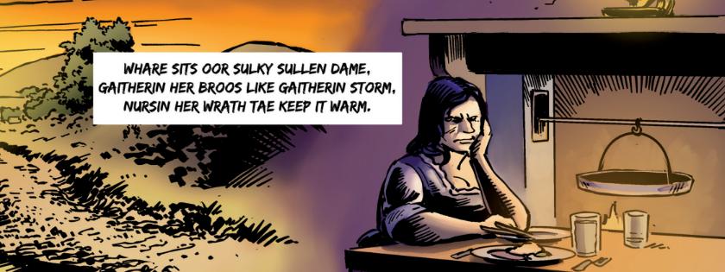

- How does the Poet describe Tam?

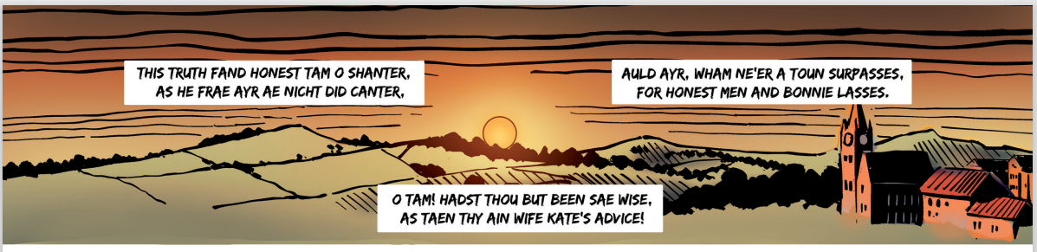

- Match the Scots to the English .

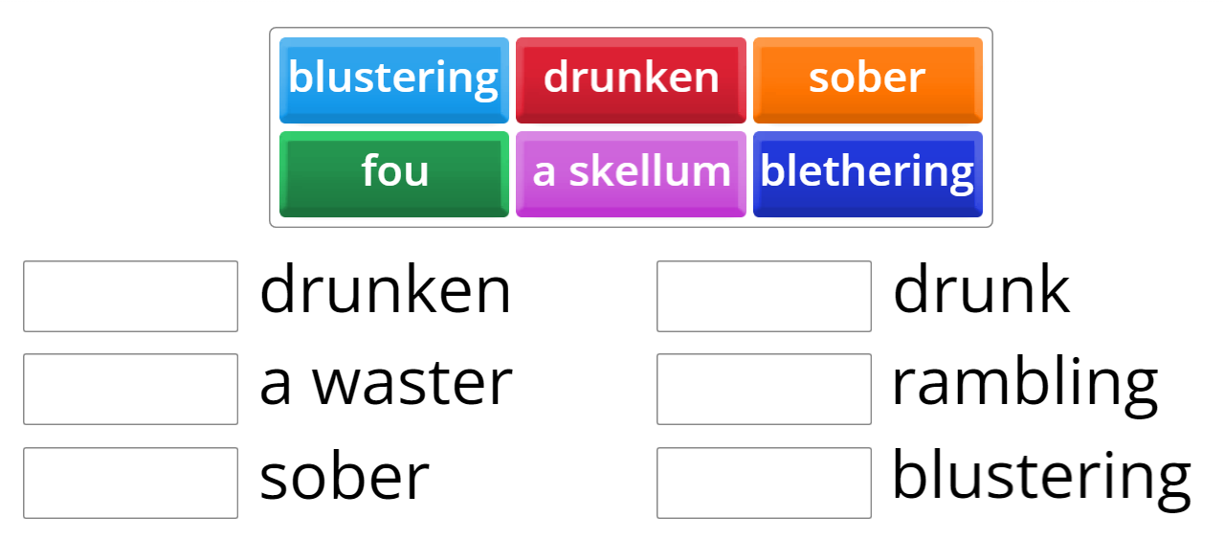

- How does Kate, Tam’s wife, describe her husband?

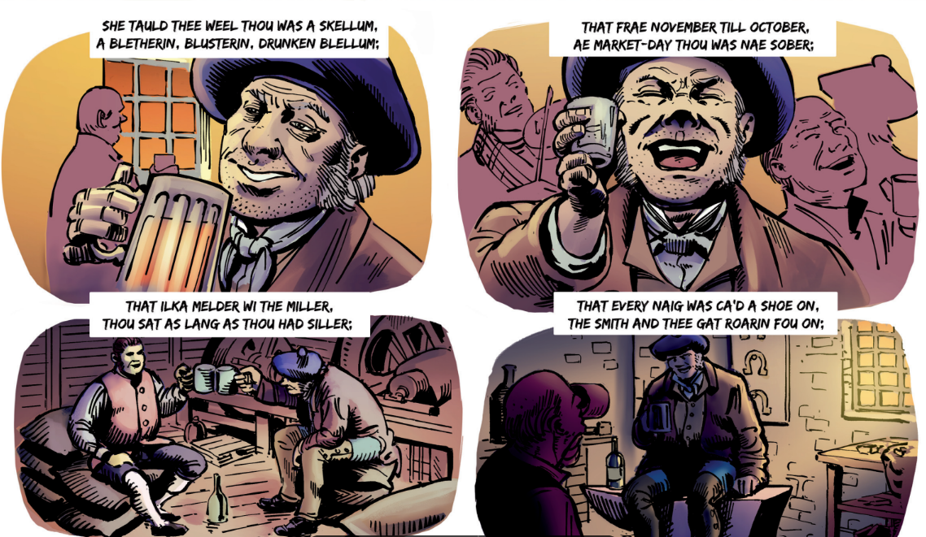

- Finally she predicts what is going to happen to Tam. What does she see ahead of him?
