Scots Language at Halloween
Task: Use some of the words from the box below (or any other Scots words you know) to write a paragraph about how Halloween has traditionally been celebrated in Scotland.
Try to use at least 3 Scots words in your paragraph
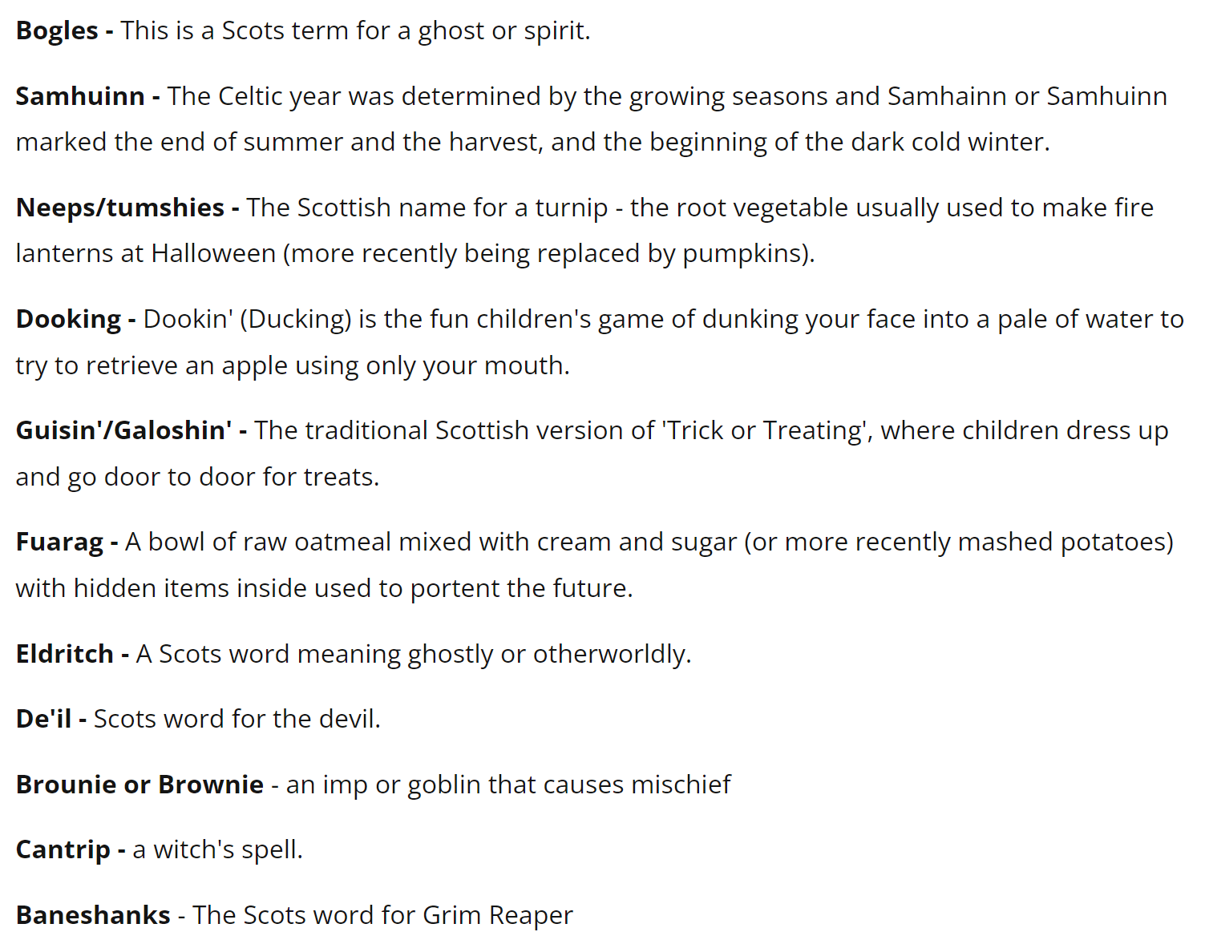
Write your paragraph here:

