Screenshots from Lesson Chat
Wed 30th October – S3 Humanities – Halloween and Scots Language
- Poll shared in chat at the beginning of the lesson asking learners to rate their own confidence levels in literacy. Poll was anonymous. Some learners mentioned in the chat that they find some elements of literacy harder than others (e.g. reading).
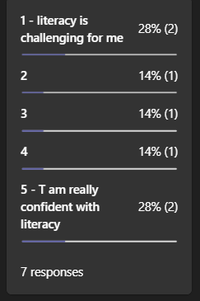

- Comments after listening to the Scot’s ghost story; ‘The Candle’ by Alan Bissett
- Last comment from a learner expressed that they “be really bad at this” before the task because of their limited knowledge of Scots.
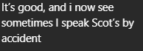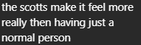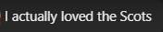

- Second poll shared at end of the class and this time learners asked to rate their confidence in literacy in Scots. Less engagement this time but higher scores given. A few positive comments shared by learners too.

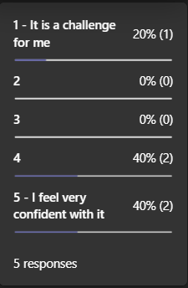
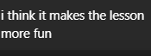
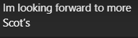
- Responses to the ‘write in Scots’ task – learners asked to write a paragraph about Halloween in Scotland using at least 3 Scots words:
