Unit 6 Application Task – Lesson Reflection
Wed 6th May – S3 Humanities – Scots and Self-Expression

As we come to the end of the school year, the S3 cohort in particular are reflecting on the past year and the progress they have made as an i-Sgoil learner. This is especially important as they enter senior phase, a time which, for many learners, comes with added anxiety caused by assessment and certificated courses. In order to best prepare learners for this next step, we are helping them to engage in reflective activities that help them to see how much they have achieved in the past year in the hope that this will build their confidence for the transition to S4.
In the past, this class has responded well to tasks based around Scots and some have commented that Scots in something that is used in their homes and so familiar to them.
Using the youtube video of the poem ‘Whit Noo?’, written and performed by Lisa Kennedy as a starter, a discussion around the importance of language as part of identity will be held, linking to how speaking authentically can build confidence and how everyone deserves for their voice to be heard.
The task set for this particular lessons asks them to write a reflective paragraph and then translate all or just the key words into Scots using their own knowledge of Scots and the English-Scots online translation dictionary provided.
Some learners completed this task before the rest of the class so as an extension task they played around with the Scots sentence builder to help improve their Scots vocabulary.

What went well?
This group of learners has responded well to Scots based tasks in the past and enjoy the connection to their Scottish heritage and history. Interestingly, at the start of this lesson, one learner made a connection between the historical restrictions placed on Scots speakers and current political conflicts between larger and smaller countries.
Attendance during the lesson was not great with only 8 learners present, however, of this 8, 5 of them submitted the assignment task and all but one had given the written Scots aspect of the task a really good go.
The translation dictionary made a real difference in terms of confidence levels. In previous tasks I hadn’t provided one and can see how that it is something that learners are really glad of and willing to use to enhance their work.
The reflections made by the learners were really insightful and for one learner in particular, the Scots paragraph felt more naturally written with her familiarity with the language coming through clearly.
I also completed this task myself to give the learners an example answer to help them get started. This was my first attempt at written Scots, which I explained to the learners and I think encouraged some of the more reluctant Scots writers to have a go!
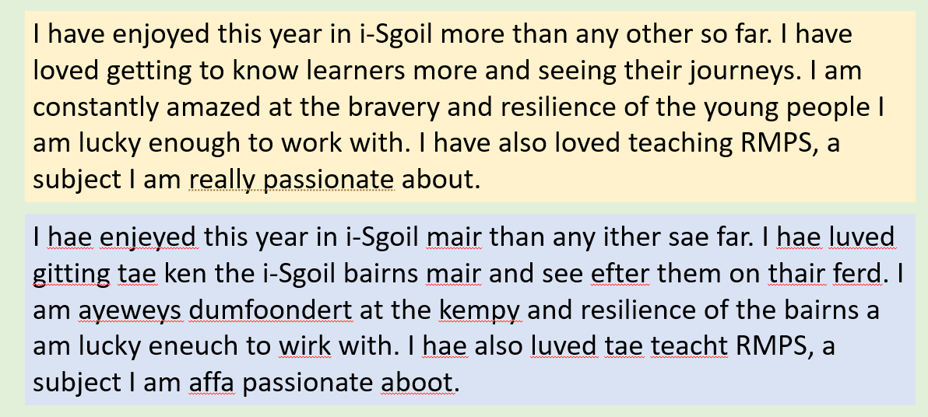

What would I do differently if I deliver this lesson again?
I underestimated how easy some of the learners who are more comfortable with Scots would find this task! They finished much more quickly than the rest of the class and I didn’t originally have an extension task planned. This led to a bit of a frantic google but I happened upon the Scots Language Centre website and their ‘Sentence Builder’ interactive game. Although this is clearly pitched at young learners, it worked well as an extension for those keen to increase their vocab. The fact that it reads the words out loud was also really helpful.

What are my next steps?
As there were a lot of learners missing during this lesson, I plan to ask that this task is completed during the weekly catch-up session as I feel that it is something that a lot of learners would enjoy completing and will also present staff with an insight into any individual concerns about transition.

Examples of learners work:
