
Persona Card - Learning Design

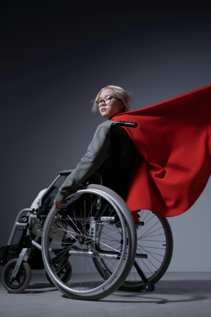 | Name: Alex  Gender: Non-binary  Age: 25  Lives in ... with ... Likes ...  Alex lives at home with their family and an assistance dog that they adore. They love chatting to friends online, taking the dog to the park and drawing.
Education and experience | Alex has a degree in psychotherapy
Role and responsibilities | Alex works part time as a counsellor for an LGBTQ+ charity
Technical skills | Alex has very good computer skills
Subject domain skills and knowledge | Counselling skills including diversity and equality
Motivation and desires | As a queer, disabled person themselves, Alex has a passion for helping those in the LGBTQ+ community and wants to create online learning around improving your mental health
Goals and expectations | Alex wants to complete the H880 module on TEL and potentially complete a post grad certificate in teaching
Obstacles to their success | Alex has physical disabilities, autism, ADHD and mental health problems. They also have low self-worth and sometimes have to spend whole days in bed due to pain and depression.
Unique assets | Alex has good empathy and great debating skills.

