
Persona Card - Learning Design

This work by the OU H817 module “Openness and innovation in elearning” (http://www3.open.ac.uk/study/postgraduate/course/h817.htm) is licensed under a Creative Commons Attribution-NonCommercial-ShareAlike 2.0 UK: England & Wales License.

See http://www.ld-grid.org/resources/representations-and-languages/personas for a short introduction to personas. To use this template, open it at http://goo.gl/m1Fp6, make a copy and edit.

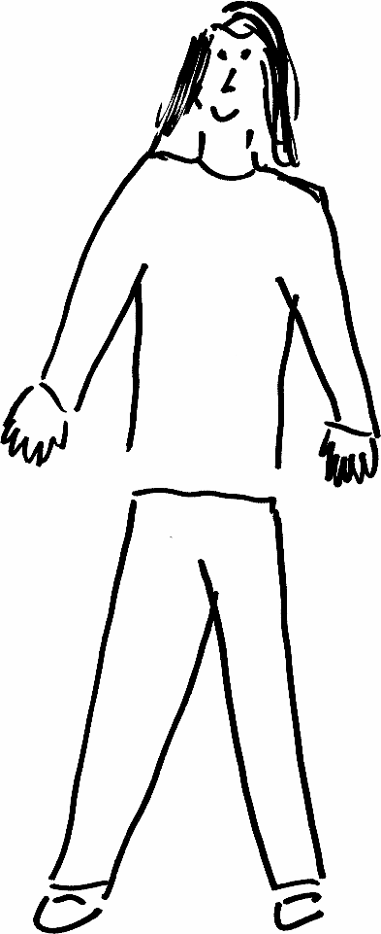 | Name: Nell  Gender: Female  Age:35  Lives in Ireland with her partner Likes learning and reading
Education and experience | Qualified as a teacher age 21. Taught English at secondary school. Is now deputy head for a secondary school. Is currently doing her masters in education
Role and responsibilities | Deputy head
Technical skills | Computer skills good
Subject domain skills and knowledge | English  pedagogy
Motivation and desires | Career development  Driven by love of her subject and of teaching
Goals and expectations | Expects high quality  Expects challenging material  Wants engagement from others
Obstacles to their success | Time- busy career
Unique assets | Background in pedagogy  Driven

