
Persona Card - Learning Design

This work by the OU H817 module “Openness and innovation in elearning” (http://www3.open.ac.uk/study/postgraduate/course/h817.htm) is licensed under a Creative Commons Attribution-NonCommercial-ShareAlike 2.0 UK: England & Wales License.

See http://www.ld-grid.org/resources/representations-and-languages/personas for a short introduction to personas. To use this template, open it at http://goo.gl/m1Fp6, make a copy and edit.

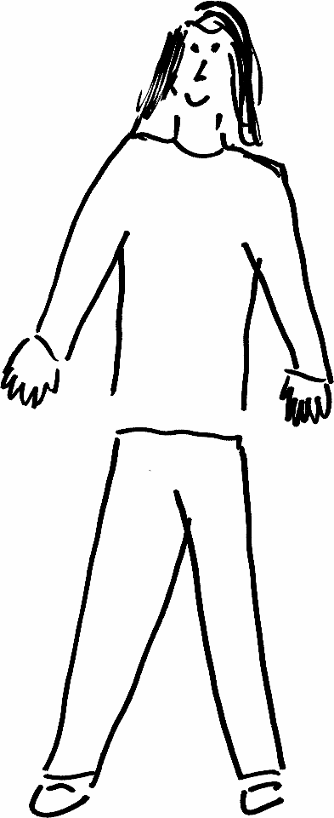 | Name: Lucy Adams Gender: Female  Age:23  Lives in ... with ... Likes ...  Lucy lives in Bexhill-on-Sea with her partner and 2 dogs. Lucy works at a Forest School nursery with children aged 3-4. Lucy has lived in this area since she was 18 and loved being by the seaside, and have met many of her friends at the local art galleries.
Education and experience | Lucy completed her leave 2 and level 3 in early childhood education. Lucy worked as an apprentice for 2 years and then did her studies part-time while working in a nursery 4 days per week.
Role and responsibilities | Lucy is a room leader in the nursery, and she has 9 key children, who she observes and support in reaching developmental goals. Lucy also is deputy forest school leader and aiming to complete her level 3 in Forest school lead.
Technical skills | Lucy has worked in childcare from the age of 17 and has 6 years’ experience in babysitting, nannying and being an early years educator at a nursery.
Subject domain skills and knowledge | Early Years Education  Forest School planning and safety  EYFS curriculum planning.  Safeguarding children
Motivation and desires | Lucy would like to specialize as a health and wellbeing champion for her setting and would like to receive further education in topics to support the holistic development of a child. Topic she would like to learn: Oral Health in children, mental wellbeing for children, physical health and nutrition.
Goals and expectations | Lucy would like to achieve one certificate within 12 months, as she only has 2 evening free per week to dedicate to studies.
Obstacles to their success | Lucy has dyslexia and can find reading on a screen much harder, compare to printed materials. Lucy tends to find hands-on learning and activities more useful in understanding topics and are able to reflect through physically dealing with challenges or obstacles.
Unique assets | Lucy can speak Spanish as a second language and are able to communicate fluently in both English and Spanish.

