
Persona Card - Learning Design

This work by the OU H817 module “Openness and innovation in elearning” (http://www3.open.ac.uk/study/postgraduate/course/h817.htm) is licensed under a Creative Commons Attribution-NonCommercial-ShareAlike 2.0 UK: England & Wales License.

See http://www.ld-grid.org/resources/representations-and-languages/personas for a short introduction to personas. To use this template, open it at http://goo.gl/m1Fp6, make a copy and edit.

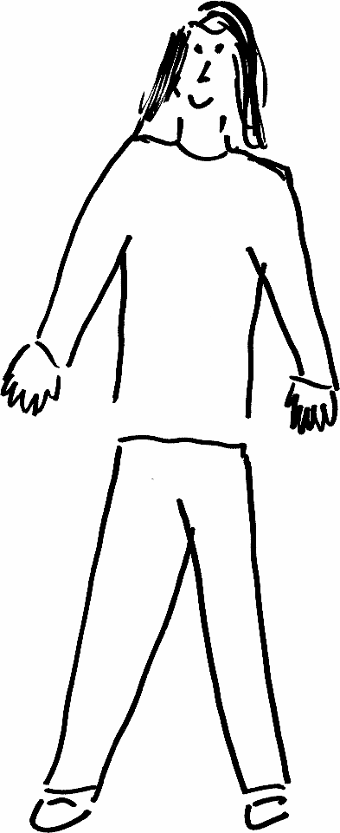 | Name: Meera  Gender: female  Age:41  Lives in the UK ... with 2 children with additional needs... Likes ...her pet dog
Education and experience | Struggled at school, a few GCSEs, no A levels.
Role and responsibilities | Works full-time, juggles caring for family, household duties, work and studying
Technical skills | Ok at IT but can struggle at times
Subject domain skills and knowledge | None – open access but has an interest in the law
Motivation and desires | Wants to do something for herself and a career in law
Goals and expectations | Wants to complete the MOOC to see if she can do it, to give her confidence in her ability, and see if she is ready to study for a law degree
Obstacles to their success | Herself – lack of confidence; time poor; she also suspects she is dyslexic.
Unique assets | Time management and life experience – Meera juggles everything, and is very organised. She also bring great understanding of other people and their own challenges.

