
Persona Card - Learning Design

This work by the OU H817 module “Openness and innovation in elearning” (http://www3.open.ac.uk/study/postgraduate/course/h817.htm) is licensed under a Creative Commons Attribution-NonCommercial-ShareAlike 2.0 UK: England & Wales License.

See http://www.ld-grid.org/resources/representations-and-languages/personas for a short introduction to personas. To use this template, open it at http://goo.gl/m1Fp6, make a copy and edit.

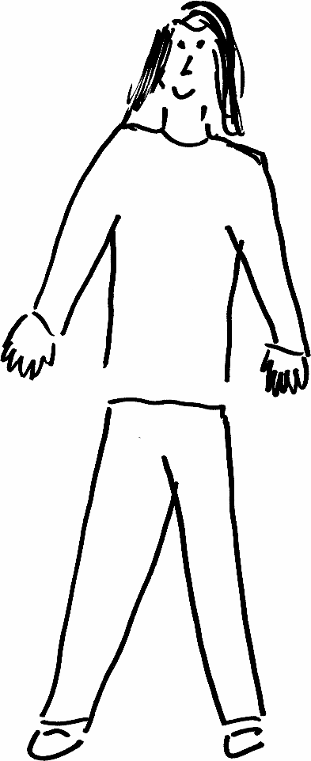 | Name: Milika Phiri  Gender: Female  Age: 35  Lives in Chipata Zambia with her husband and two children. She likes interactive discussions
Education and experience | Milika holds a degree in Biomedical Sciences. She was educated in a rural area and have never experienced online learning. Actually, here geographical location has poor network
Role and responsibilities | She is a mother and head of a biomedical laboratory at a busy local hospital. She sometimes works late up to 8 pm in the evening.
Technical skills | She has knowledge of zoom and other similar communication tools. She is also an experienced scientist
Subject domain skills and knowledge | Milika has excellent listening abilities, analytical, and adapts easily to new environments and activities. She loves courses that are easily accessible, however, she has poor access to internet and has low internet skills.
Motivation and desires | Here motivation is a better income through upgrading her skills and educational qualifications. She is determined to complete her education on time
Goals and expectations | Milikas goals are to complete her education at all costs. She expected it to be tough but manageable with the support of her family
Obstacles to their success | Her goals for education are hampered by poor internet skills and poor access to the internet as well as a tight work schedule
Unique assets | Milika brings her hard work and commitment tp the course

