
Persona Card - Learning Design

This work by the OU H817 module “Openness and innovation in elearning” (http://www3.open.ac.uk/study/postgraduate/course/h817.htm) is licensed under a Creative Commons Attribution-NonCommercial-ShareAlike 2.0 UK: England & Wales License.

See http://www.ld-grid.org/resources/representations-and-languages/personas for a short introduction to personas. To use this template, open it at http://goo.gl/m1Fp6, make a copy and edit.

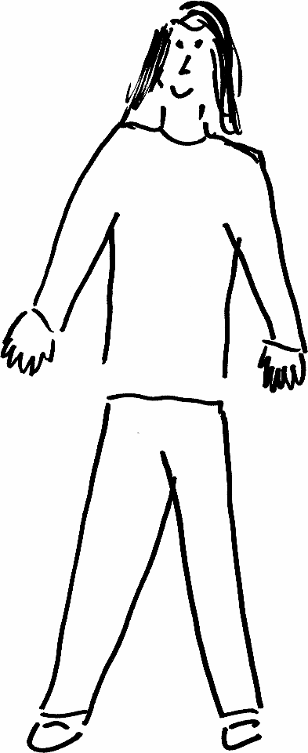 | Name: Maya Winfrey  Gender: female  Age: 45  Lives in ...South Africa with .Her 2 cats .. Likes Travelling and reading ...
Education and experience | None, just formal education
Role and responsibilities | Enjoying life
Technical skills | Crochet
Subject domain skills and knowledge | Life informal education
Motivation and desires | The pursuit of happiness and meeting people with positive mindsets
Goals and expectations | To live life to the fullness and set no expectations
Obstacles to their success | People and their opinions and lack of open mindedness
Unique assets | Being kind in a world that seem lacking in every way

