
Persona Card - Learning Design

This work by the OU H817 module “Openness and innovation in elearning” (http://www3.open.ac.uk/study/postgraduate/course/h817.htm) is licensed under a Creative Commons Attribution-NonCommercial-ShareAlike 2.0 UK: England & Wales License.

See http://www.ld-grid.org/resources/representations-and-languages/personas for a short introduction to personas. To use this template, open it at http://goo.gl/m1Fp6, make a copy and edit.

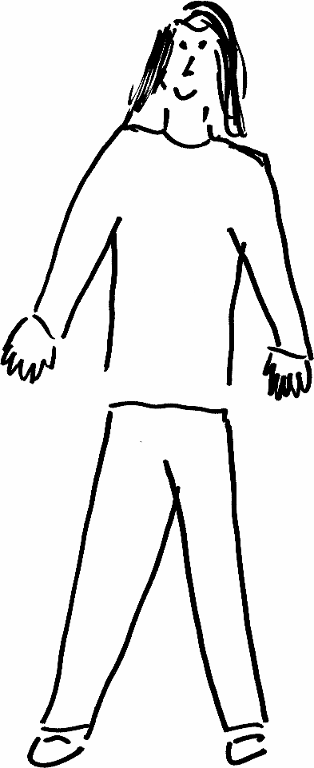 | Name: Asiya Gender:F Age: 29  Lives in Birmingham with no one Likes cooking, tennis, blogging
Education and experience | Degree and Masters in Mathematics; PGCE  Secondary school teacher at conventional school; wants to move into working in an online school
Role and responsibilities | Aspiring Head of Department and senior leader in online school  Currently Deputy HoD in conventional school, with particular responsibility for KS5
Technical skills | Confident with standard Office software and dedicated mathematical software such as Cabri, Geogebra. Can use the school’s standard VLE confidently but not an expert user
Subject domain skills and knowledge | Expertise in face to face pedagogy; recognised as highly competent teacher, with very strong subject knowledge.  Specific interest in online learning having taken her masters at a distance learning institution
Motivation and desires | Change in career direction to create better work-life balance – reduce expectation of extra-curricular involvement and avoid classroom behaaviour issues
Goals and expectations | Increasing expertise in online delivery and understanding of pedagogical differences
Obstacles to their success | Demanding job which can be particularly intense at some times of year could impact progress.  Lack of comprehension of new career goals from family, who live near her
Unique assets | Combination of personal experience of online learning with expertise in face to face learning.

