Persona Card - Learning Design
This work by the OU H817 module “Openness and innovation in elearning” (http://www3.open.ac.uk/study/postgraduate/course/h817.htm) is licensed under a Creative Commons Attribution-NonCommercial-ShareAlike 2.0 UK: England & Wales License. This document: http://goo.gl/m1Fp6

Do not ask for permission to edit this document. To use this template, click here to create a personal copy which you can edit.

See http://www.ld-grid.org/resources/representations-and-languages/personas for a short introduction to personas.

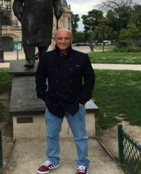 | Name: Peter  Gender: Male  Age:55  Lives in ... with ... Likes …  Lives alone and semi retired with own business. Experienced masters level student who has studied diverse subjects. A nursenot a formal educator. Likes reading, travelling, music and football.
Education and experience | Bsc Social Science and dip social policy and criminology.  Also dip Mental health nursing and level 7 non-medical prescribing, mental health science and creative writing.
Role and responsibilities | Self employed with own business. Single and no dependents
Technical skills | Good analytical and writing skills. Research experience.
Subject domain skills and knowledge | Experienced with delivering training and mentoring others.
Motivation and desires | Self development. May pursue a career in writing or education (or both).
Goals and expectations | Wants to achieve understand and prove it via assessment to get at least a merit grade. Expects to do wider reading.
Obstacles to their success | Time management - studying a module in another subject.
Unique assets | Background in social science. Good interpersonal awareness and skills

