
Persona Card - Learning Design

This work by the OU H817 module “Openness and innovation in elearning” (http://www3.open.ac.uk/study/postgraduate/course/h817.htm) is licensed under a Creative Commons Attribution-NonCommercial-ShareAlike 2.0 UK: England & Wales License.

See http://www.ld-grid.org/resources/representations-and-languages/personas for a short introduction to personas. To use this template, open it at http://goo.gl/m1Fp6, make a copy and edit.

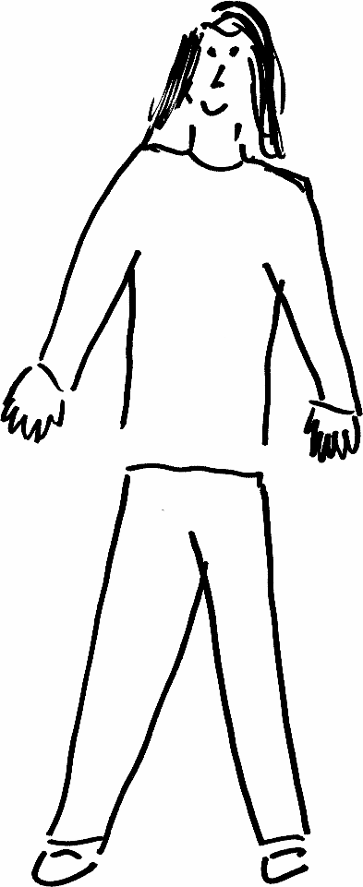 | Name: Ana  Gender: F Age: 36  Lives in Birmingham with partner and 2 children Likes travelling, eating out and learning new languages
Education and experience | Ana is a secondary school Spanish teacher and has a background in language teaching. She is Spanish and has a degree in English Language from the University of Salamanca.
Role and responsibilities | Ana works part-time as a Spanish teacher and has childcare responsibilities for two young children under the age of 5.
Technical skills | Ana is proficient in Microsoft applications such as Word, Excel, Teams and OneNote. She is an avid user of social media and has Facebook and Instagram accounts which she uses to keep in touch with friends and family in Spain.
Subject domain skills and knowledge | Ana has a bachelor’s degree in English Language and holds a PGCE in Modern Foreign Languages.
Motivation and desires | Ana would like to work more from home and due to childcare responsibilities, would like to move into online language teaching.
Goals and expectations | Ana would like to better understand good pedagogical practices for online teaching and learning as well as curriculum design.
Obstacles to their success | Ana has limited time available to study and will need to study in short bursts and using mobile technology when travelling to and from work. English is not her first language.
Unique assets | Ana has a background in teaching and taught online during the pandemic using Google Classrooms.

