
Persona Card - Learning Design

This work by the OU H817 module “Openness and innovation in elearning” (http://www3.open.ac.uk/study/postgraduate/course/h817.htm) is licensed under a Creative Commons Attribution-NonCommercial-ShareAlike 2.0 UK: England & Wales License.

See http://www.ld-grid.org/resources/representations-and-languages/personas for a short introduction to personas. To use this template, open it at http://goo.gl/m1Fp6, make a copy and edit.

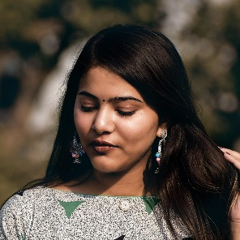 | Name: Aanya Gender:  Female  Age: 34  Lives in Dumfries, Scotland  ... with her husband and daughter  ... Likes ... Cooking, dance, photography
Education and experience | Degree in English Literature, TESOL certificate
Role and responsibilities | ESOL tutor at a local FE college
Technical skills | Can use email, Teams, Word, PowerPoint, and image editing software confidently
Subject domain skills and knowledge | Communicating with and teaching English to students who speak other languages. Excellent at spelling and grammar. Encourages her students to read as much as possible.
Motivation and desires | Wants to provide a good life for her daughter and make a difference to her students
Goals and expectations | Hopes to improve her digital skills and provide better digital instruction for her students, who often struggle with technology
Obstacles to their success | Limited time due to her work and care responsibilities for her grandmother. Mild hearing impairment and anxiety
Unique assets | Warm and calming personality, compassion, creativity

