
Persona Card - Learning Design

This work by the OU H817 module “Openness and innovation in elearning” (http://www3.open.ac.uk/study/postgraduate/course/h817.htm) is licensed under a Creative Commons Attribution-NonCommercial-ShareAlike 2.0 UK: England & Wales License.

See http://www.ld-grid.org/resources/representations-and-languages/personas for a short introduction to personas. To use this template, open it at http://goo.gl/m1Fp6, make a copy and edit.

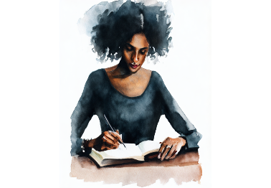 | Name: ‘Hannah’ Persona  Age:47  Gender: Female  Lives in ... with ... Likes ...  Hannah lives in South London, England.  Her hobbies include reading, surfing the internet, going to the gym, outdoor activities, wildlife, and group writing.
Education and experience | She holds an MA in creative writing, a PEGC in Teacher Training, Mentoring and Coaching, and a BA Hons in social care. She has Jamaican heritage, two grown children, enjoys family life, and has been writing for over 10 years with an online presence.
Role and responsibilities | She works part-time in adult social care and, at other times, on her online writing platforms.
Technical skills
  Useful are her strong computer skills and ability to analyse data and calculations.
Subject domain skills and knowledge | She has creative writing and e-learning skills and has created several interactive works online. She has knowledge of applying technology in communication. The writing networks are useful for strengthening her writing and have interest in authors’ works. Technology-Enhanced Learning in Online Teaching can develop innovative skills to enhance her teaching and learning.
Motivation and desires | She can relate well and has strong people skills. Has published short pieces and narratives, and has used research skills widely to study authors and writing.
Goals and expectations | To complete the TEL course, she plans to develop the following: online, design, innovative, virtual reality and enhanced e-learning teaching skills.
Obstacles to their success | She will reduce the time spent online.
Unique assets | Is her history of writing and in using modern technology.

