
Persona Card - Learning Design

This work by the OU H817 module “Openness and innovation in elearning” (http://www3.open.ac.uk/study/postgraduate/course/h817.htm) is licensed under a Creative Commons Attribution-NonCommercial-ShareAlike 2.0 UK: England & Wales License.

See http://www.ld-grid.org/resources/representations-and-languages/personas for a short introduction to personas. To use this template, open it at http://goo.gl/m1Fp6, make a copy and edit.

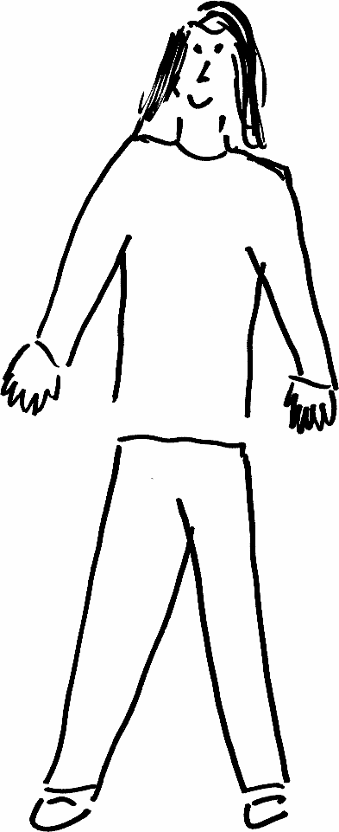 | Name:  Mia Layne  Gender: Female  Age: 46  Lives in ... Surrey  with ... Husband, 3 teenage sons, dog and a tarantula  Likes ...Saturday mornings when my hubby and boys are at football, Paddleboarding, Hiking and Yoga
Education and experience | I have a bachelors degree in social science, have been a stay at home mum for last 15 years  Level 2 teaching assistsant
Role and responsibilities | I work part time as a teaching assistant in my local primary school.
Technical skills | I can type / email/ use social media but my technical knowledge is outdated
Subject domain skills and knowledge | I’m still interested in social science . I also have classroom experience and experience with young learners with special needs
Motivation and desires | I would like to improve my technical skills and knowledge and am motivated by my desire to be more than a mum to my boys
Goals and expectations | Have great technical knowledge and skills
Obstacles to their success | After taking a long career to raise a family i worry my lack of technical skills and knowledge will hold me back
Unique assets | Diverse, Imaginative graduate of the university of life, determined, great at multi tasking

