Picture  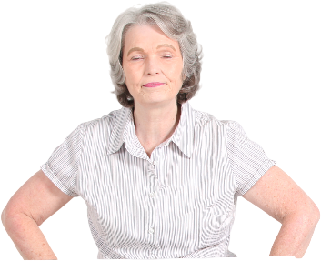 | Name: Marge  Gender: Female  Age: 62  Lives in: Cardiff  Lives with: Husband  Likes: Gardening, reading, weekends away in the caravan, her 2 cockerpoo dogs
Education and experience | BA Business, PGCE Teaching in Higher Education, Masters in Career Education
Role and responsibilities | 2 sons left home one in university, one in the military, works for a university in professional services
Technical Skills | Microsoft office skills – outlook, excel, Powerpoint, zoom and teams
Subject domain skills and knowledge | Many years in her current role, lots of knowledge and skills from previous roles in business development, employer engagement, teaching students, commercial training, project management
Motivation and desires | Enjoys learning still, loves to travel, wants work life balance, compressed hours, likes remote/hybrid working,
Goals and expectations | wants a final challenging role and one more promotion before retirement
Obstacles to their success | Gender, age (written off as a menopausal woman), young energetic, quick thinking colleagues, self-confidence and self esteem due to previous treatment in the work place.
Unique assets | Experience, generous with time and knowledge, coach and mentor, lots of life experiences, fun and kind character. A bit chatty and probably undiagnosed ADHD !

