
Persona Card - Learning Design

This work by the OU H817 module “Openness and innovation in elearning” (http://www3.open.ac.uk/study/postgraduate/course/h817.htm) is licensed under a Creative Commons Attribution-NonCommercial-ShareAlike 2.0 UK: England & Wales License.

See http://www.ld-grid.org/resources/representations-and-languages/personas for a short introduction to personas. To use this template, open it at http://goo.gl/m1Fp6, make a copy and edit.

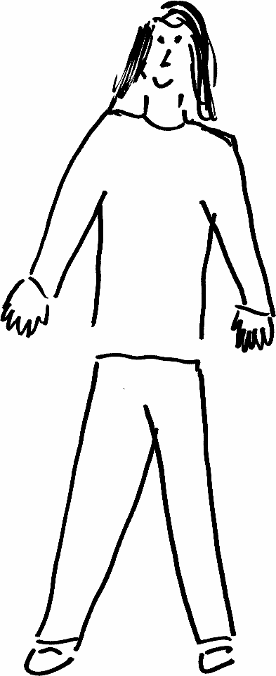 | Name: John Ande Gender: Male  Age: 22  Lives in Switzerland with his pet. He likes singing.
Education and experience | Bachelor’s degree in Politics
Role and responsibilities | - Works in the civil service  - Part time realtor
Technical skills | - Musical composition  - Public speaking
Subject domain skills and knowledge | - Negotiation  - Listening, speaking  - Administrative
Motivation and desires | - Wants to improve English speaking skills to gain confidence when speaking English in meetings.
Goals and expectations | - To attain C2 English in one year.
Obstacles to their success | - Work schedule.  - Family responsibilities
Unique assets | - Self-motivated

