
Persona Card - Learning Design

This work by the OU H817 module “Openness and innovation in elearning” (http://www3.open.ac.uk/study/postgraduate/course/h817.htm) is licensed under a Creative Commons Attribution-NonCommercial-ShareAlike 2.0 UK: England & Wales License.

See http://www.ld-grid.org/resources/representations-and-languages/personas for a short introduction to personas. To use this template, open it at http://goo.gl/m1Fp6, make a copy and edit.

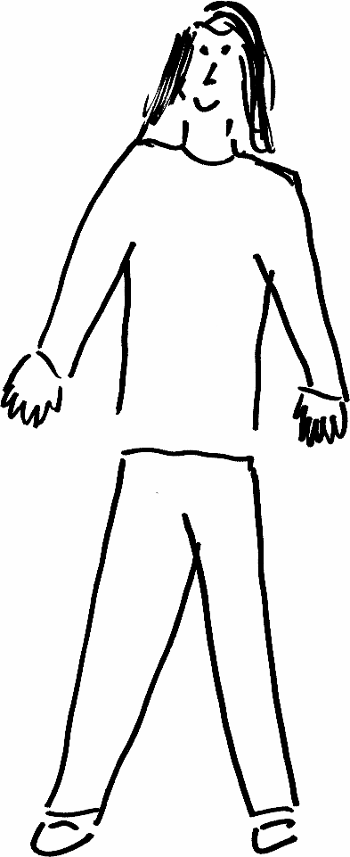 | Name: Gender: Age:  Lives in ... with ... Likes ...
Education and experience
Role and responsibilities
Technical skills
Subject domain skills and knowledge
Motivation and desires
Goals and expectations
Obstacles to their success
Unique assets

