“Respect oor mither tongue”

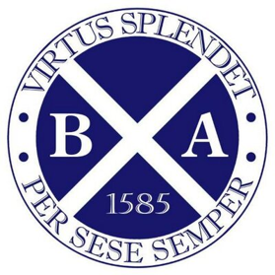

A Guide for teachers in Scots speaking communities.
Inclusion, literacy, confidence and validation.

Jamie Fairbairn, Banff Academy
Scots Schuil o the Year 2020

😮Did you know the word WOW! is a Scots word written down by Gavin Douglas in 1513.
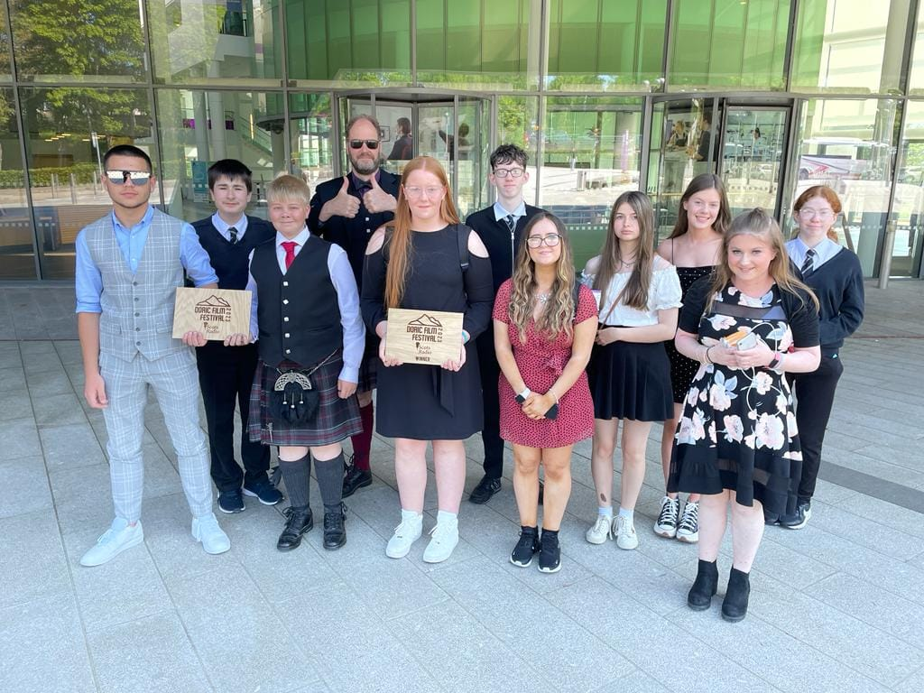

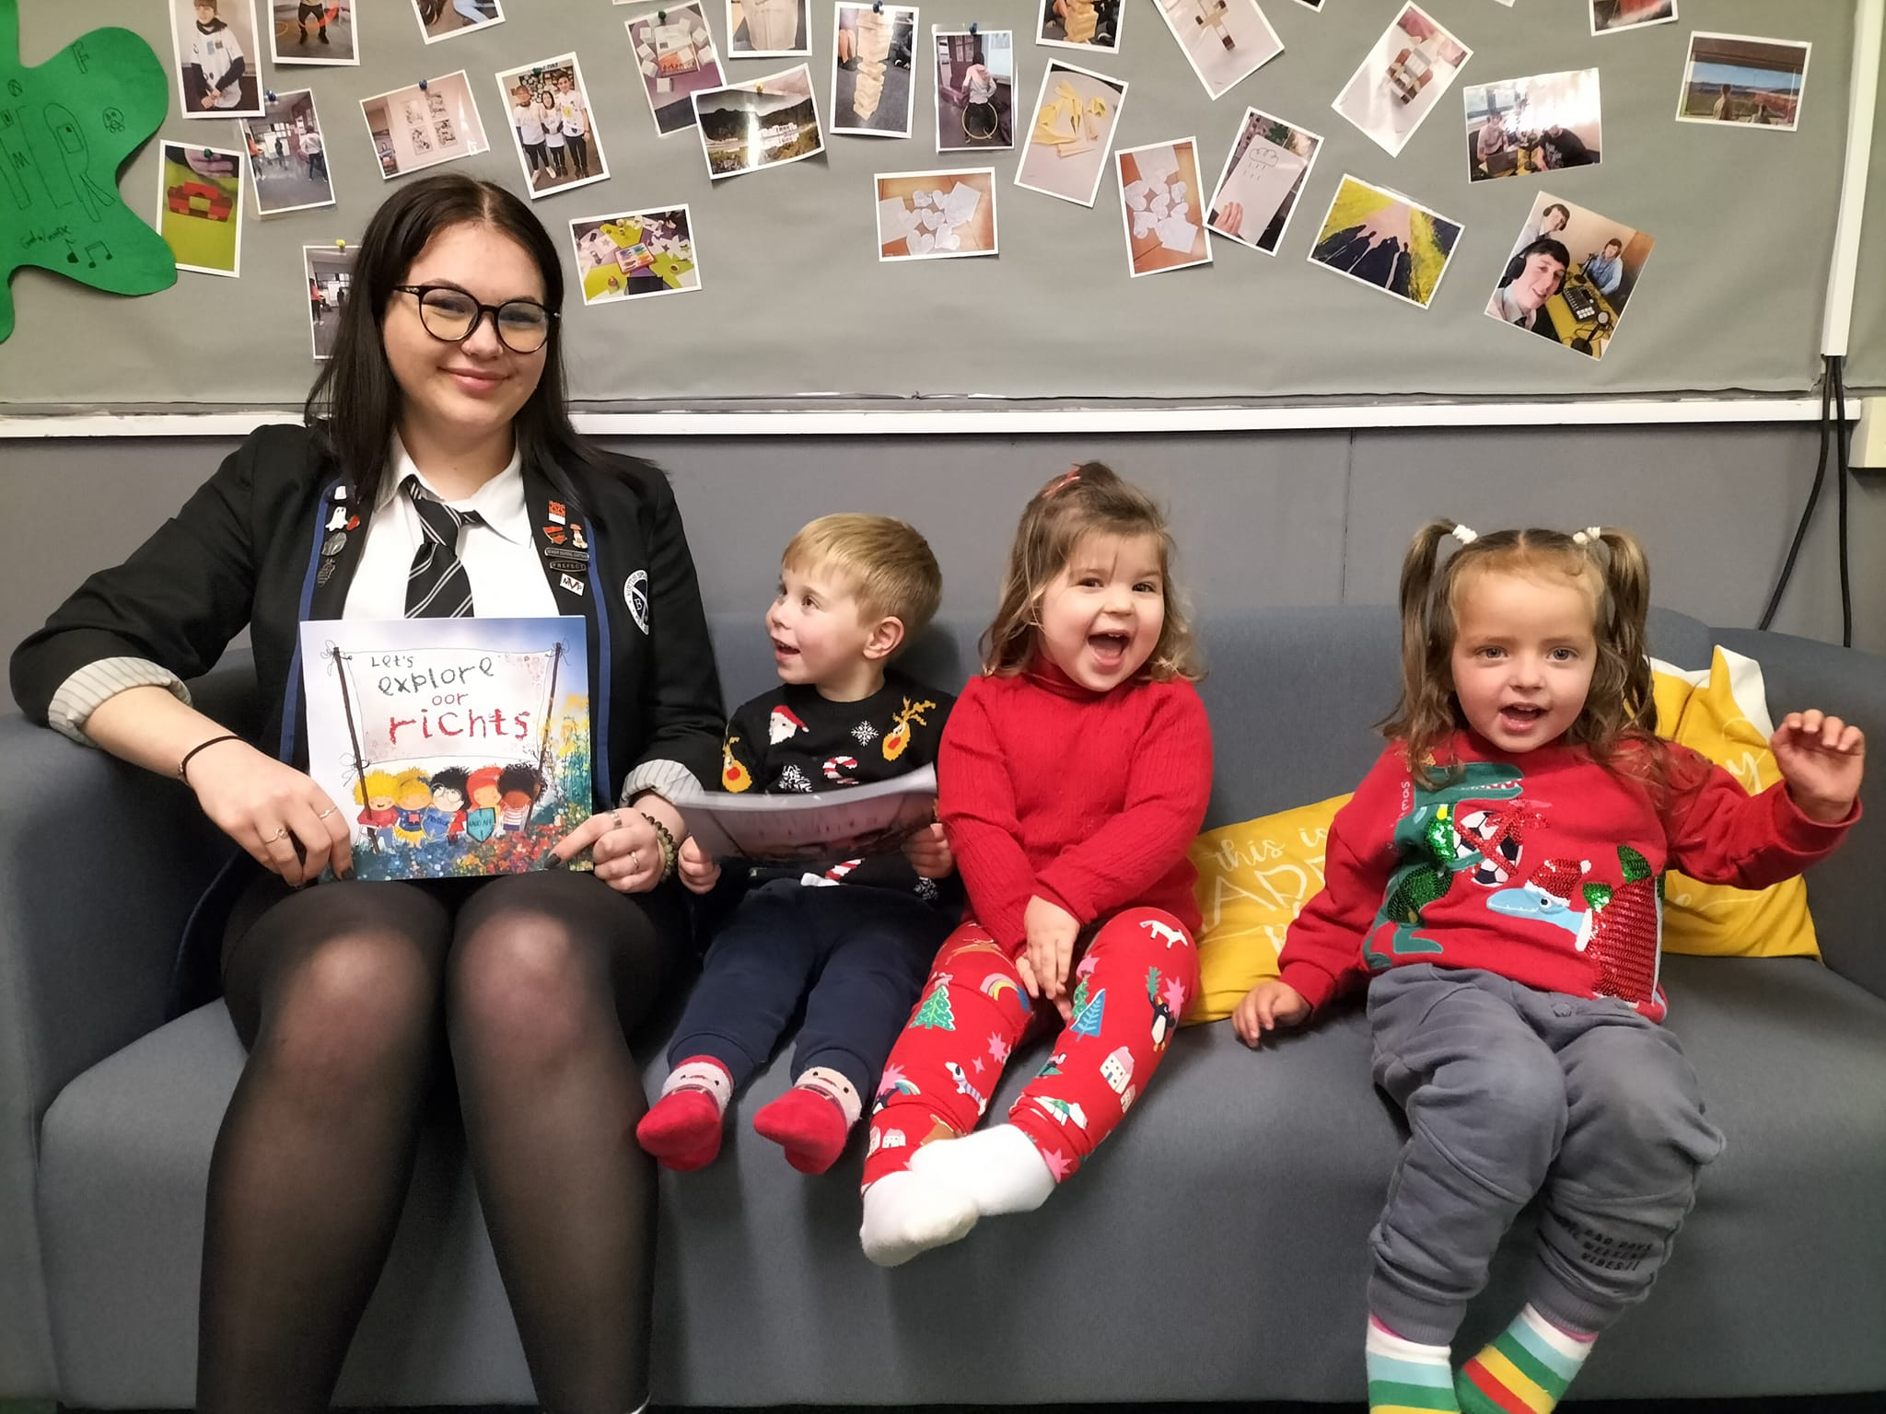
You teach in a Scots speaking catchment area.
Scots has been spoken here for at least 700 years, the language of trade accompanying the arrival of the Burgh towns, replacing Gaelic along the coast and spreading inland. Words like loon and glaikit have been around for over 500 years. According to the census, between 40-60% of households in our catchment area speak Scots. That means that about half of our pupils will be speaking to friends and family in Doric and texting and messaging each other in Doric. The majority will understand Doric. Doric is heard in the corridors, on the sports parks, in the canteen queues, and in classrooms. That means that a lot of the bairns’ self-esteem and identity is tied up with the way they speak and communicate with their loved ones, starting from the words they hear in their parents’ and carers’ bosies as babies. This sense of identity will be damaged if pupils feel that the way they speak is wrong, or lesser. A lot of teachers have been brought up in Doric speaking households too, or other dialects of Scots. Many pupils walk into a class with their L1, Scots, in their heads. Some may have to adjust in order to carry out their education in English. Some are very good at this, used to switching back and forth depending on who they are speaking to - some find it harder to do. You don’t have to be a Doric speaker to help validate it or include it into learning. See CfE Briefing 17 for more information.
But what is Doric, and how does that differ from Scots?
Doric is the northeast dialect of Scots. It shares many words with Scots spoken in other parts of Scotland, like braw (great), ken (know), mair (more), scunnert (fed up), footer (time waste), ben (through), oxter (armpit) but also has words and phrases unique to the north east, such as loon (boy), quine (girl), div (do), nikkum (cheeky person), moo (mouth), fly cuppie (cup of tea), bosie (cuddle) and the use of ‘f’ for ‘wh’ in questions such as far? (where), fit? (what), foo? (how), fan? (when), fit wye? (why). There is also a lot of dialect variety along the coast, between the villages and towns. For example, the name for a seagull will vary from pewlie, scurrie, gow and maw depending on where you live.
The potential
We have a wonderful opportunity to further celebrate language diversity at Banff Academy and get the community onside. The more languages you speak the more paths to the hearts and minds of others, and Scots should be part of that mix, particularly as many bairns have that additional skill (and others want to use it), and it is an additional way to relate to the local community. People in the area are proud of their Doric heritage and respond very positively when we value it. In addition, we have many pupils who can speak other languages, such as Polish, Lithuanian and Ukranian, which should also be celebrated, and a multi-lingual classroom should be OK. Many of these pupils, who already speak two or more languages, are able to learn English and Scots, as well as languages like French, German and Spanish and have been excellent Scots Language pupils. The future looks to some growth areas: tourism, creative industries, health and Artificial Intelligence applications.
Skills and attributes
Banff Academy has been working formally with Scots for a decade, using interdisciplinary pedagogy to explore history, literacy, weather, landscape, community, literature, story-writing and linguistics, often through creative projects. It fits very well with the concept of project-based learning, and the SLP skills are all relevant.
Skills and Scots
Skill | Why is it important? | How to engage pupils and others
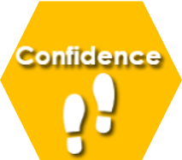 | Pupil confidence and self-esteem is tied up with the language they heard in early development. It is a crucial part of who they are. | - Don’t criticise a youngster for speaking Scots – that’s like criticising who they are, their family and community.  - Ask about a word or phrase a pupil uses, show interest, share words  - Encourage a pupil to give a presentation in Doric – good oracy is good oracy in all languages.
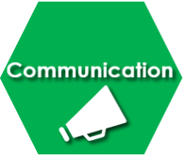 | We have amazing Doric writers in the school who have won writing competitions.  Many pupils speak Doric at home and with friends and text each other in Doric. | - If you speak some Doric, speak to pupils in their mither tongue – they love it and feel valued and included!  - The current generation may be writing more Doric than ever before – in texts on their phones  - Do an exercise allowing pupils to write in Doric  - Greet a pupil in Doric in the corridor or as they come into class – a friendly fit like? goes a long way.
 | Being bilingual develops emotional intelligence, as does appreciating other folks’ language, culture and communities. | - Listen to pupils speaking Doric, value what they say  - Ask questions like – what spaces do you feel comfortable speaking Doric? And where do you not feel comfortable speaking Doric? Why?  - Where and in what situations is Doric spoken in the community?  - Should you be in control of when you speak Doric or English?
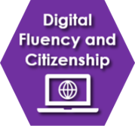 | Lots of bairns text and message each other in Scots, because it is the comfortable, familiar way of communicating. It’s an extra skill for expression. Scots learning in S3 is done via a self-learning website. | - Swiftkey can set phones to any language, including Scots – it contains the entire concise Scots Dictionary and makes typing Scots much easier.  - Encourage young people to use online Scots dictionaries and Apps:  https://www.scots-online.org/dictionary/  https://apps.apple.com/gb/app/scots-dictionary-for-schools/id940655692

 | Scots learning is very suited to project-based learning, working in teams and having a community impact. | - Make films with doric scripts  - Work with partners, e.g. Historic Scotland, National Library of Scotland, The Vinery, Banff Castle, Tourism organisations, Portsoy Boat Festival.  - Give a community project a language element.
 | Young people can work together to work towards the validation of Doric in the school and wider community. There are many years of bias against Scots, so this is no easy task. | - Ask pupils to debate standardisation of Scots and Doric  - Work on community plans  - Get pupils involved in inclusive education solutions
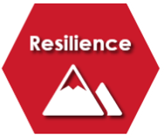 | Resilience is important, because Scots and Scots speakers have suffered from prejudice. It therefore requires courage to stand up for your language and culture. | - Encourage young people to show an interest in community, culture and language.  - Model a respect of language, culture and community.  - Ask questions, listen  - Be a leader and champion
 | It is important that young people deepen skills, improve their vocabulary and show their creativity for the benefit of the school and wider community | - Encourage young people to write stories in Doric – it can be rich and expressive.  - There are now many story writing competitions – encourage pupils to enter.  - Devise creative projects with an output relevant to the community.

Qualifications for pupils- Young people can achieve the Scots Language Award level 4 in S3, and levels 4-6 in S4-6. It can be studied as a unit for the Scottish Studies Award.
Teacher training on offer
The Open University and Education Scotland offer teacher training CPD in Scots teaching. The course, piloted at Banff Academy, is available for any teacher to sign up for a GTCS accredited 60 hour masters level course. Trained GTCS Scots teachers at the Academy are: Dr Fairbairn, Miss Logan, Mrs McGillivray, Mr McClymont, Mr Robertson, Mr Saunders and Mrs Slinger. Miss Macrae, Miss Farquhar and Mr Lillie have also studied on the course, and Mrs Sutherland will also be teaching Scots. Mr Robertson and Mr Clelland are currently on the course. The PBL department engage with Scots within projects. Dr Fairbairn is a tutor on the professional learning Scots course. Please ask any of these staff if you have any questions or training needs.

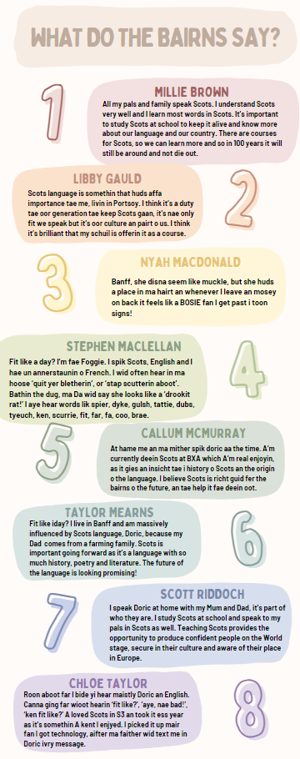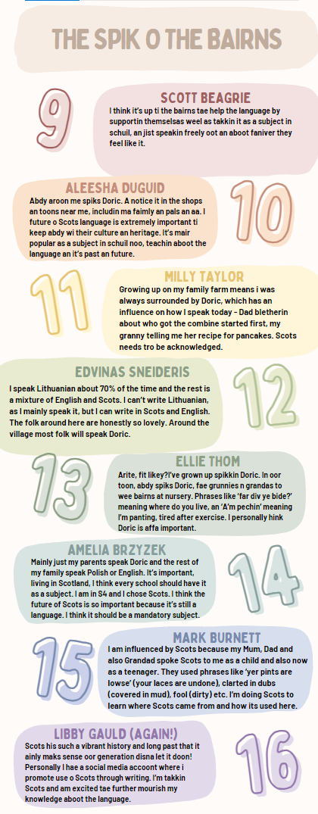

More about the story of Scots at Banff Academy here:
www.thebottleimp.org.uk/2023/07/fae-tantallon-tae-tiktok-a-decade-o-scots-at-schuil/

Verbs (action words) in Doric | Verbs (action words) in English |  | Nouns in Doric | Nouns in English
Bide | Stay, live |  | Ba | Ball
Birl | Spin around |  | Bairn | Child
Blad | Spoil |  | Bosie | Hug
Brak | Break |  | Cloot | Cloth
Claik | Gossip |  | Claes | Clothes
Canna | Can’t |  | Craiter | Creature, person
Clap | Pet, stroke |  | The day, iday | Today
Cowp | Turn over, upside down |  | Freen | Friend
Dae | Do |  | Guff | Smell
Dird | Thump or beat |  | Hoose | House
Ding | Strike, knock |  | Heid | Head
Fleg | Frighten |  | Lass | Girl
Footer | Fiddle with |  | Loon | Lad, boy
Gaan | Going |  | Merrie Dancers | The Northern Lights
Greet | Weep, cry |  | The morn, imorn | Tomorrow
Haud | Hold, keep |  | Tatties | Potatoes
Hiv | Have |  | Kye | Cattle
Ken | Know |  | Neeps | Turnips
Mak | Make |  | Quine | Girl
Mine on | Remember |  | Sharn | Cow dung
Pleep | Complain, whine |  | Strae | Straw
Skraich | Screech |  | Toon | Town
Tak | Take |  | Yowe | Ewe
Prepositions in Doric | Prepositions in English |  | Pronouns in Doric | Pronouns in English
Afore | Before |  | Hit | It
Ahin | Behind |  | Ma | My
Atween | Between |  | Thon | That
Eftir | After |  | Faa | Who
Fae | From |  | Fit | What, which
Oot | Out |  | Wir, oor | Our
Ower | Over |  | Ye | You
Tae, til, ti | To |  | Ess | these
Adjectives in Doric | Adjectives in English |  | Numbers in Doric | Numbers in English
Aal | Old |  | Een, Ae | One
Fantoosh | Fancy, elaborate |  | Twa | Two
Feart | Afraid |  | Fower | Four
Gyte | Crazy |  | Sax | Six
ill-tricket | Mischievous |  | Siven, seeven | Seven
Muckle | Big |  | Echt | Eight
Peelie-wally | Sickly, not well |  | Hunner | Hundred
Reid | Red |  | Thoosan | thousand
Shilpit | Feeble
Stoorie | Dusty |  | Ay, ay. Fit like iday? ….Nae bad, foo’s yersel?  Hello. How are you today? ….Not bad, how are you?
Thraan | Stubborn
Unco, unca | Strange

Some useful vocabulary for teachers in a Doric speaking catchment area. Please ask if you want more.

