I linked Burns Night to a First Level poetry study which we found to be rich in language, culture, rhythm and Scots / Shetland heritage.
Curriculum for Excellence outcomes – First Level (LIT 1-01a, LIT 1-07a, LIT 1-10a, LIT 1-11a, ENG 1-12a, ENG 1-17a).
The focus texts are:
- Robert Burns – To a Mouse
- R.W. Tait – Moose, Moose, Meeserie

Poetry & Scotland: “From Mouse to Moose”

Learning Intentions
- I can listen to and discuss Scots language poetry.
- I can identify rhythm, rhyme and repetition.
- I can compare two poems.
- I understand why Robert Burns is important in Scotland.

Introduction task: Burns Night Mystery Box
Fill a box with:
- Tartan fabric
- Oats
- A (toy) mouse
- A small Scottish flag
- A poem scroll
Children explore and predict what today’s learning is about.
Find out what we already know or introduce Robert Burns to those unfamiliar.
- Lived a long time ago in Scotland.
- Wrote in Scots.
- Celebrated every year on Burns Night (25th January).
- Famous for caring about ordinary people and animals.

Listen to the poem – we used Bill Paterson’s version from Poems and songs | National Trust for Scotland - asked class to focus on rhythm and sound then consider the following questions:
- How does the farmer feel about the mouse?
- Why is the mouse scared?
- Is he kind or cross?
Create a class word wall with the following vocabulary:
- “wee”
- “beastie”
- “sleekit”
- “bickerin”
Children guess meanings using context and actions, bearing in mind when decoding that it was written over 250 years ago.

Part 2: Meet da Moose – A Shetlaen Voice
Introduce R.W. Tait and share his poem in Shetlaen:
Read Moose, Moose, Meeserie. (found in Nordern Lights – an anthology of Shetland Verse and Prose compiled and edited by John Graham and T A Robertson)
Add to the class word wall the following vocabulary and any other words they may wish to incude:
- “fantin”
- “gyaan”
- “trowe”
- “no leetin”

How do we think the author feels about the mouse? Is it the same or different to RB?

Compare & Contrast (Active Learning)
Create a Venn diagram to show differences / similarities
Creative Task
Draw the mouse and write 3 describing words around it.

Assessment: Can they identify feelings in the poem? Ask classmates to see if they can guess which mouse they are describing

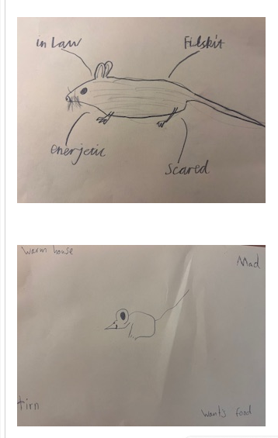

Part 3 : Poetry Performance Workshop
In small groups:
Focus on:
- Expression
- Clear speaking
- Rhythm

Cross-Curricular Links
- Social Studies: Scottish culture & traditions
- Expressive Arts: Drama performance
- Music: Rhythm and beat
- Art: Illustrating imagery

Differentiation Ideas
Support:
- Picture glossary of Scots words
- Sentence stems
- Partner talk before writing
Challenge:
- Identify rhyming patterns
- Write in Scots vocabulary independently
- Compare tone and theme

Potential follow up task: Create my own poem inspired by Scots language.

